Supporting Information

Mechanism-guided Mn₃O₄/GDY nanoplatform intercepts neutrophil-driven oxidative amplification to treat inflammatory bowel disease

Ziheng An ^{1, 2, 3, #}, Manlin Li ^{2, #}, Jin Wang ^{4, #}, Xing Dai ², Junxi Wu ⁵, Wenmiao Shu ⁵, Mingsong Shi ⁶, Yaqin Zhang ⁷, Guangxin Duan ^{2,}*, Xin Tian ^{2,} *, Ling Wen ^{1,} *, Mingyuan Gao ^{2, 8}

¹ Department of Radiology, The Fourth Affiliated Hospital of Soochow University, Suzhou 215123, China
² State Key Laboratory of Radiation Medicine and Protection, School of Radiation Medicine and Protection, Collaborative Innovation Center of Radiological Medicine of Jiangsu Higher Education Institutions, Soochow University, Suzhou 215123, China
³ Department of Radiology, Nanjing Mei Shan Hospital, Nanjing 210039, China
⁴ Department of Toxicology, School of Public Health, Medicine College, Soochow University, Suzhou 215123, China
⁵ Department of Biomedical Engineering, University of Strathclyde, Glasgow, G4 0NW, UK
⁶ NHC Key Laboratory of Nuclear Technology Medical Transformation, Mianyang Central Hospital, School of Medicine, University of Electronic Science and Technology of China, Mianyang, Sichuan, 621099, China
⁷ Department of Radiology, The Fifth Affiliated Hospital, Sun Yat-sen University, Zhuhai, 519000, China
⁸ School of Life Sciences, Biomedical Basic Research Center of Jiangsu, Soochow University, Suzhou 215123, China

1. Experimental Section
Materials: The monomer hexakis-[(trimethylsilyl)ethynyl]benzene (TMS-HEB) was obtained from Nanjing XFNANO Materials Tech Co., Ltd. Manganese(II) acetate tetrahydrate (MnAc₂·4H₂O), ferrous(II) chloride (FeCl₂), FITC-inulin were acquired from Aladdin Biochemical Technology Co., Ltd. 5,5-Dimethyl-1-pyrroline N-oxide (DMPO) and 5-tert-Butoxycarbonyl-5-methyl-1-pyrroline N-oxide (BMPO), Live/dead kit, Cell Counting Kit-8 were purchased from Dojindo Laboratories. Copper(I) chloride (CuCl), 3,3′,5,5′-tetramethylbenzidine (TMB), xanthine (Xan), xanthine oxidase (XOD), and lipopolysaccharide (LPS) were purchased from Sigma-Aldrich. Tetrahydrofuran (THF), N,N-dimethylformamide (DMF), hydrogen peroxide (H₂O₂), and other reagents were of analytical reagent grade and acquired from Sinopharm Chemical Reagent Co., Ltd. 2′,7′-dichlorodihydrofluorescein diacetate (DCFH-DA), JC-1 kit were obtained from Beyotime Biotechnology. CXCR4 (60042-1-ig), ZO-1 (21773-1-ap), Claudin-1 (28674-1-ap), MPO (22225-1-ap), and Ly6G (32346-1-ap) were purchased from Proteintech.
Bioinformatic analysis of clinical IBD transcriptomic data: The GEO dataset GSE193677 (https://www.ncbi.nlm.nih.gov/geo/query/acc.cgi?acc=GSE193677), containing intestinal biopsy transcriptomic profiles from patients with IBD and healthy controls[1], was used for clinical bioinformatic analysis. After normalization and annotation, differential gene expression analysis was conducted using the limma package in R. Differentially expressed genes were identified based on adjusted P value and fold-change criteria. Functional enrichment analyses, including GO biological process and KEGG pathway analyses, were performed using clusterProfiler. GSEA was further carried out on the ranked gene list to identify coordinated biological programs associated with IBD. To evaluate oxidative stress-associated transcriptional changes, ROS-related genes were extracted and analyzed separately. Immune cell infiltration in intestinal tissues was inferred using the xCell algorithm, and the results were independently validated using CIBERSORT. Relevant visualization, including volcano plots, enrichment plots, scatter plots, and violin plots, was generated in R.
Preparation of GDY: HEB-TMS (16.8 mg) and CuCl (2.4 mg) were added to the DMF solution and stirred at 60°C for 24 h. After the reaction, the product was sequentially washed with DMF, dichloromethane, THF, and ethanol. The solvent was then removed under vacuum and obtained CuO/GDY powder. Subsequently, GDY was obtained by removing CuO with 0.5 M HCl. Finally, the GDY was dispersed in deionized water and sonicated in an ice bath to produce sheet-like GDY.
Fabrication of Mn₃O₄/GDY: The GDY was firstly dispersed in DMF and stirred at 80°C. Then, 1.2 mL of Mn(Ac)₂·4H₂O solution (12.5 mg/mL) was added dropwise, and the reaction mixture was maintained at 80°C for 1h. The product was collected by centrifugation and washed with deionized water. For hydrothermal treatment, the composite was redispersed in 10 mL of water, sealed in a Teflon-lined autoclave, and heated at 180°C for 10 h. The final product was collected by centrifugation, washed, and dried at 60°C overnight.
Characterizations: The morphological and elemental composition of the Mn₃O₄/GDY was characterized by a TEM equipped with energy-dispersive X-ray spectroscopy using a Talos F200X G2 microscope (Thermo Scientific). Power XRD patterns were recorded on a Bruker D8 Advance instrument. XPS measurement was performed on a Thermo ESCALAB 250Xi. Raman spectra were recorded using a Horiba LabRAM Soleil Raman spectrometer, with the 532 nm line of an Ar ion laser as the excitation source. The Mn content was analyzed using ICP-MS (ELEMENT 2, Thermo Scientific).
Computational models and methods: According to the crystal structure of Mn₃O₄[2], which contains both tetrahedrally coordinated Mn(II) and octahedrally coordinated Mn(III) centers. Based on our experimental characterizations, the Mn(II) content markedly decreased whereas the Mn(IV) content increased significantly after integration with GDY, suggesting that the Mn(II) sites are likely involved in the interfacial coupling with GDY and undergo valence-state transformation. Therefore, the theoretical calculations were mainly focused on the binding mode and interaction mechanism between the Mn(II) sites and the GDY framework. To model the interfacial interaction while maintaining structural stability, the original four-coordinate Mn(II) site was simplified to a three-coordinate configuration to allow its interaction with GDY. A cubic Mn₄O₄ cluster was first constructed, in which each Mn(II) center adopted a three-coordinate environment. To avoid excessive net magnetic moments arising from multiple Mn centers, only one active Mn(II) site was retained, while the other three Mn(II) ions were replaced by Mg(II), yielding the MnMg₃O₄ cluster model used in this work. In addition, a triangular GDY fragment containing the characteristic benzene ring, C–C, and C≡C units was constructed to represent the local structure of GDY.
All density functional theory (DFT) calculations were performed using the Gaussian 09 program[3]. Geometry optimizations were carried out at the PBE-D3/def2-SVP level of theory[4-6]. The polarizable continuum model (PCM) was employed to account for solvation effects[7]. The optimized structures were analyzed in terms of adsorption geometry, bond lengths, and spin moments. Localized orbital bonding analysis (LOBA) was further performed using the Multiwfn program to determine the oxidation-state evolution of the Mn center upon interaction with GDY[8].
ESR spectroscopic measurements: The ESR measurements were carried out using a Bruker E500 spectrometer. The spin traps BMPO and DMPO were employed to determine the formation of ROS. Xan/XOD and Fenton reaction systems were used to generate O₂^{•−} and •OH, respectively. The final concentration of each component is described in each figure caption. The spin adducts were detected at the following settings, unless otherwise stated: 20 mW microwave power, 1 G field modulation and 100 G scan range. All the ESR measurements were performed in triplicates at ambient temperature. The scavenging effect was determined by comparison with a control group lacking nanomaterials.
H₂O₂ scavenging activity of Mn₃O₄/GDY: The H₂O₂ concentration was quantitative determined using a colorimetric assay kit based on the oxidation of Fe²⁺ to Fe³⁺, which subsequently reacts with xylenol orange to produce a purple color proportional to the concentration of H₂O₂ in the sample. This reaction results in a characteristic absorbance decrease at 560 nm.
Measurement of intracellular ROS: IEC-6 cells were treated with H₂O₂ (0.6 mM) in the absence or presence of 20 μg/mL GDY and Mn₃O₄/GDY, respectively. After 2 h treatment, cells were stained with DCFH-DA and Hoechst 33342 for 20 min in the dark at the room temperature and washed them with PBS once. The fluorescent images of the cells were performed using a laser confocal microscopy (FV1200, Olympus). Cells treated with H₂O₂ alone were used as a positive control.
Measurement of mitochondrial membrane potential: IEC-6 cells, treated with Mn₃O₄/GDY and H₂O₂ as described above, were labeled with the fluorescent potentiometric dye JC-1 for 20 min at 37 ºC. After cells were washed three times with PBS, the fluorescence was detected using a laser confocal scanning microscope (FV1200, Olympus). Cells treated with H₂O₂ alone were used as a positive control.
Anti-inflammatory activity of Mn₃O₄/GDY in vitro: RAW 264.7 cells were treated with LPS (2 μg/mL) in the absence or presence of 20 μg/mL GDY and Mn₃O₄/GDY, respectively. After 24 h treatment, the supernatants were collected, and the levels of inflammatory cytokines IL-1𝛽, IL-6, and IL-10 were measured using ELISA kits according to the instruction.
In vitro permeability assay: Caco-2 cells were grown on Transwell® inserts (Sigma Aldrich) to mimic intestinal permeability assay. The medium was replaced every 24 h. Transepithelial electrical resistance (TEER) was measured every 3 days to monitor monolayer integrity. To generate an inflammation model, 3% DSS was added to both the apical and basement medium for 24 h. Then, FITC-dextran 4000 (Sigma Aldrich) solution was put in the apical medium. Cells were treated with 20 μg/mL GDY or Mn₃O₄/GDY, and permeability was evaluated by measuring the fluorescence intensity of the basement medium at different points using fluorometry.
Stability of Mn₃O₄/GDY in vitro: SGF was prepared by dissolving NaCl (3.2 g) and pepsin (0.2 g) in 100 mL of deionized water, and the pH was adjusted to 2.0 with a dilute HCl solution. Mn₃O₄/GDY was resuspended into of SGF and incubated at 37 ℃ for 2 h. The solution was then centrifuged at 5000 rpm for 10 min and resuspended in deionized water. The retained O₂^{•-} scavenging capability and morphological characteristics of the collected Mn₃O₄/GDY were examined by ESR and TEM respectively, as described above.
Animals and DSS-induced IBD mouse model: Eight-week old female C57BL/6J mice were obtained from SPF Skbex Biotechnology Co., Ltd., and acclimatized for 7 days before inclusion in the study. Mice were received 3% DSS in drinking water for 7 days to establish the DSS-induced IBD mouse model.
Ex vivo and in vivo imaging: To compared the accumulation of Mn₃O₄/GDY in colon tissues between healthy and IBD mice, mice were fasted for 12 h and then 5 mg/kg Cy5.5-labeled Mn₃O₄/GDY were orally administered (n = 4). At 30 min after administration, the cecum-colon organs were separated. After washing three times with PBS, the fluorescence intensity was detected by an in vivo imaging system (IVIS, Lumina XRMS Series III, PerkinElmer).
To assess the targeting effect of Mn₃O₄/GDY toward the inflamed intestine tissues, mice were first fasted for 12 h. Then, 5 mg/kg Cy5.5-labeled Mn₃O₄/GDY were orally administered into DSS-induced IBD mice, and in vivo imaging was conducted by IVIS at 12 h after administration.
For SPECT imaging, ¹⁷⁷Lu-labeled Mn₃O₄/GDY were orally administered into IBD mice. The in vivo SPECT imaging and semiquantitative analysis were performed at 1, 3, 6, 12, and 24 h postadministration using a nanoScan SPECT/CT (iThera Medical,).
Treatment of the DSS-induced IBD mouse: Mice were randomly divided into five groups (n = 5 in each group). The control group was given normal drinking water. The IBD mice were given drinking water including 3% DSS for 7 days, during which the PBS, GDY (5 mg/kg), Mn₃O₄/GDY (5 mg/kg), and 5-ASA (25 mg/kg) were given every day by oral administration. The body weight, stool consistency, and fecal blood of mice were recorded daily to determine the DAI scores. On day 8, all mice were euthanized and sacrificed. The major organs including colon, spleen, liver, lung, kidney, and heart were collected for further analysis. The colon tissues were collected and then used for H&E staining, immunofluorescence staining, ELISA, and western blot.
Histological analysis and immunofluorescence: Colon tissue samples were fixed in a solution of 4 % paraformaldehyde and embedded in paraffin. The samples were then sectioned and stained with H&E to evaluate the severity of colonic damage. For immunofluorescence staining, colon tissues were performed using anti-ZO-1 antibody, anti-Claudin-1 antibody, anti-Ly6G antibody, and Alexa Fluor-conjugated secondary antibody to estimate the relative protein expression levels in the different groups.
ELISA: To determine the concentrations of different cytokines in colon tissues, 100 mg of colon segments were homogenized in 1 mL RIPA lysis buffer containing 1% PMSF at 4 °C. Next, the samples were centrifuged for 10 min at 10,000 × g at 4 °C. The supernatants were detected quantitatively using ELISA kits of IL-6, IL-1β, and IL-10 according to the manufacturer’s instructions.
Western blot: The total proteins from colon tissues were extracted and extracted and quantified by BCA concentration protein assay kit. SDS-PAGE gel was prepared for an equal amount of protein from each sample to run and then transferred to PVDF membrane. PVDF membrane was blocked with 5% skim milk and incubated with primary antibodies (including ZO-1, Claudin-1, CXCR4, and MPO) at 4℃ overnight, followed by incubation with secondary horseradish peroxidase-conjugated antibodies for 1 h at room temperature. Protein bands were then visualized using an enhanced chemiluminescence (ECL) detection system.
Biosafety assessment in vivo: Healthy mice were orally administrated with 5 mg/kg Mn₃O₄/GDY once a day for 7 days (n = 3). After euthanizing the mice at 8 day, the major organs were collected for H&E staining.
RNA-sequencing analysis: On day 8, mice were euthanized and colon tissues were collected (n = 3 per group). Total RNA was extracted using TRIzol reagent according to the manufacturer’s protocol. mRNA sequencing was carried out on the Illumina HiSeq 4000 platform. Transcript abundance was normalized as fragments per kilobase of transcript per million mapped reads (FPKM). Differential gene expression analysis between the two groups was performed using the DEGseq package. Genes with P < 0.05 and |log2(fold change)| ≥ 1 were considered differentially expressed genes (DEGs).
Statistical analysis: All the data are presented as mean ± standard deviation (SD). The number of independent replicates of experiments is shown in the figure captions (n ≥ 3). Statistical tests were carried out using GraphPad Prism software (version 9.5.0) with appropriate statistical methods. p < 0.05 is considered statistically significant.

2. Supplementary Figures

Fig. S1 Lollipop plots showing the GSEA enrichment results of the GSE193677 dataset, using fold change in the IBD group as the weighting metric. (a) Biological processes, (b) KEGG pathways.

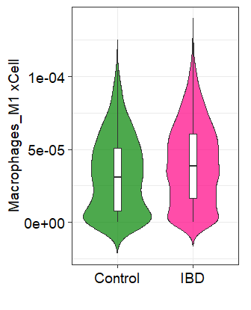
Fig. S2 Violin plots illustrate the differences in xCELL-derived infiltration scores of M1 Macrophages between control and IBD groups

Fig. S3 (a) Scatter plot showing immune cell infiltration scores in IBD intestinal tissues estimated using the CIBERSORT algorithm. Violin plots depict the differences in CIBERSORT-derived infiltration scores of Neutrophils (b) and M1 Macrophages (c) between control and IBD groups.

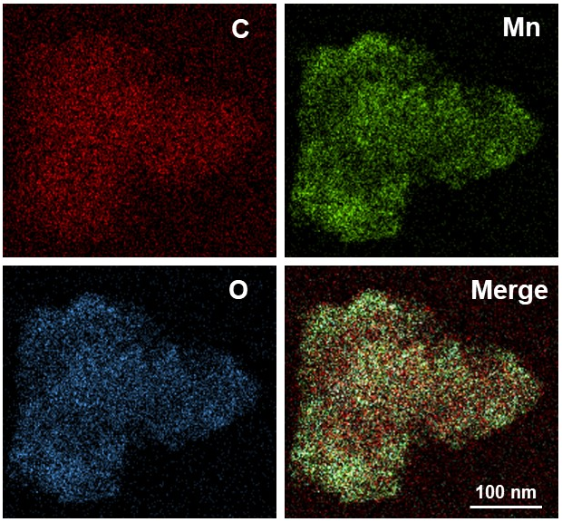
Fig. S4 EDS mapping of Mn₃O₄/GDY.

Fig. S5 Zeta potential of Mn₃O₄/GDY.

Fig. S6 Changes of the O₂^{•-} scavenging activity of various samples at indicated time points.

Fig. S7 Proposed reaction pathway for the scavenging of O₂^{•-} by Mn₃O₄/GDY.

Fig. S8 Changes of the •OH scavenging activity of various samples at indicated time points.

Fig. S9 Reaction equations for ROS scavenge by Mn₃O₄/GDY.

Fig. S10 Cell viability of IEC-6 cells (a) and RAW264.7 cells (b) treated by GDY and Mn₃O₄/GDY for 24 h.

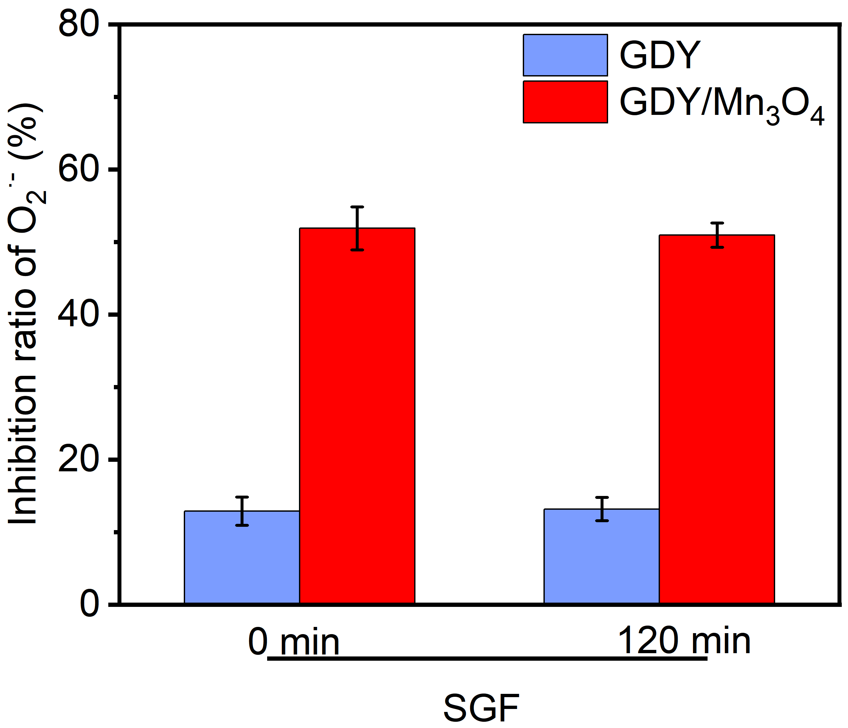
Fig. S11 Changes of the O₂^{•-} scavenging activity of GDY and Mn₃O₄/GDY before and after SGF treatment.

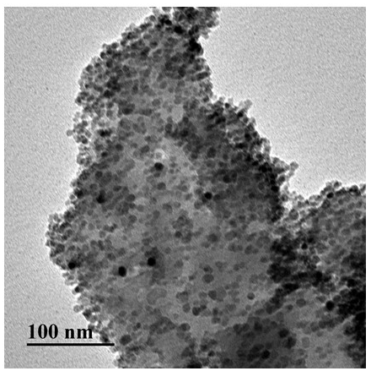
Fig. S12 Representative TEM image of Mn₃O₄/GDY after SGF treatment for 2 h.

Fig. S13 Volcano plots of DSS-induced IBD mice versus control (a), and Mn₃O₄/GDY versus DSS group (b).

Fig. S14 Representative GSEA analysis of DEGs between DSS-treated and control groups.

Fig. S15 Representative GSEA analysis of DEGs between Mn₃O₄/GDY-treated and DSS groups.

Fig. S16 Cross-species pathway enrichment analysis of concordantly regulated genes. Lollipop plots showing biological process (a) and KEGG pathway (b) enrichment analyses of genes located in quadrants 1 and 3 identified from the cross-species comparison between human IBD samples versus healthy controls and DSS-induced colitis mice versus control mice. (c) Lollipop plot showing biological process enrichment analysis of genes located in quadrants 2 and 4 identified from the cross-species comparison between human IBD samples versus controls and Mn₃O₄/GDY-treated mice versus DSS-treated mice.

Fig. S17 Mitochondrial membrane potential in cells stained with JC-1 dye was measured with confocal microscopy. Scale bar = 10 μm.

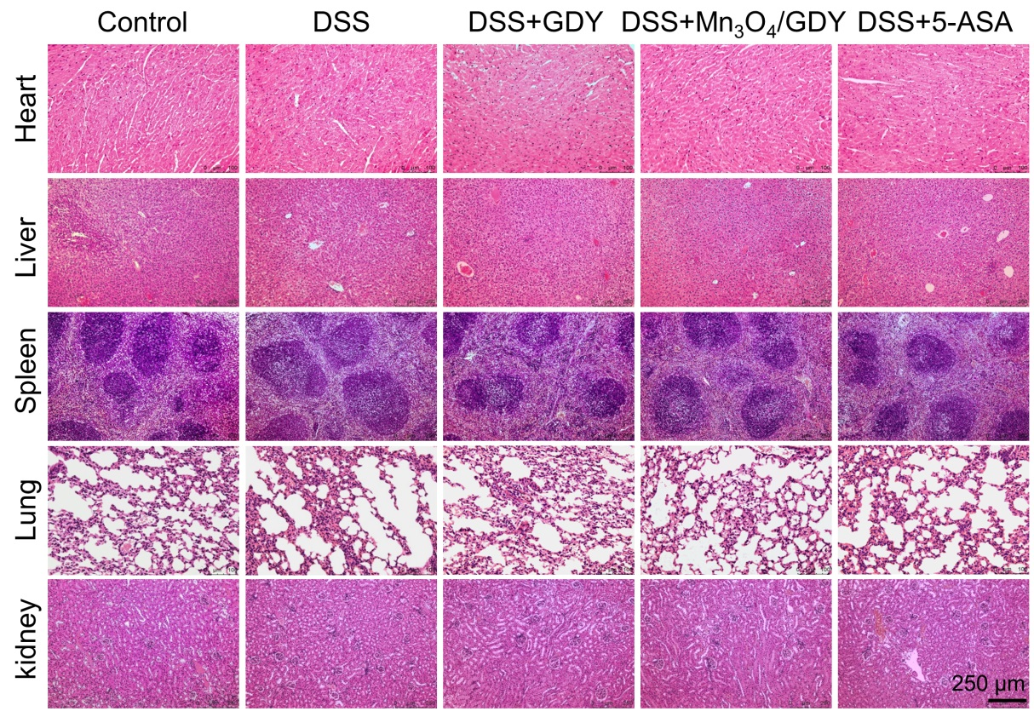
Fig. S18 Representative images of H&E staining of histological sections of the major organs in mice after Mn₃O₄/GDY daily for 7 days.

References:
1. Argmann C, Hou R, Ungaro RC, Irizar H, Al-Taie Z, Huang R, Kosoy R, Venkat S, Song W-M, Di'Narzo AF: Biopsy and blood-based molecular biomarker of inflammation in IBD. Gut. 2023; 72:1271-1287.
2. Jarosch D: Crystal structure refinement and reflectance measurements of hausmannite, Mn3O4. Mineral Petrol. 1987; 37:15-23.
3. Frisch M, Trucks G, Schlegel H, Scuseria G, Robb M, Cheeseman J, Scalmani G, Barone V, Mennucci B, Petersson G: Gaussian 09, Revision E. 01, Wallingford, Connecticut: Gaussian. Inc https://gaussian com/[accessed May 14 2021]. 2009.
4. Perdew JP, Burke K, Ernzerhof M: Generalized gradient approximation made simple. Phys Rev Lett. 1996; 77:3865.
5. Grimme S, Antony J, Ehrlich S, Krieg H: A consistent and accurate ab initio parametrization of density functional dispersion correction (DFT-D) for the 94 elements H-Pu. The Journal of chemical physics. 2010; 132.
6. Weigend F, Ahlrichs R: Balanced basis sets of split valence, triple zeta valence and quadruple zeta valence quality for H to Rn: Design and assessment of accuracy. Physical Chemistry Chemical Physics. 2005; 7:3297-3305.
7. Scalmani G, Frisch MJ: Continuous surface charge polarizable continuum models of solvation. I. General formalism. The Journal of chemical physics. 2010; 132.
8. Lu T, Chen F: Multiwfn: A multifunctional wavefunction analyzer. J Comput Chem. 2012; 33:580-592.

