Table S1 Multiple comparisons of pollen germination rate of F. chinensis under different medium components
Combinations | S  (sucrose)  （g·L⁻¹） | B  (boric acid)  （g·L⁻¹） | C  (calcium nitrate)  （g·L⁻¹） | P  (pH) | Germination rate (%)  Mean±SD
1 | 50 | 0.05 | 0.05 | 5 | 49.49±9.07F
2 | 50 | 0.1 | 0.1 | 6 | 65.94±2.82D
3 | 50 | 0.2 | 0.2 | 7 | 56.95±2.38E
4 | 100 | 0.05 | 0.1 | 7 | 69.99±2.78D
5 | 100 | 0.1 | 0.2 | 5 | 75.00±1.60C
6 | 100 | 0.2 | 0.05 | 6 | 83.76±2.93B
7 | 150 | 0.05 | 0.2 | 6 | 86.28±1.14B
8 | 150 | 0.1 | 0.05 | 7 | 91.26±1.86A
9 | 150 | 0.2 | 0.1 | 5 | 82.69±2.44B
10 | 150 | 0.1 | 0.05 | 6 | 92.62±1.31A

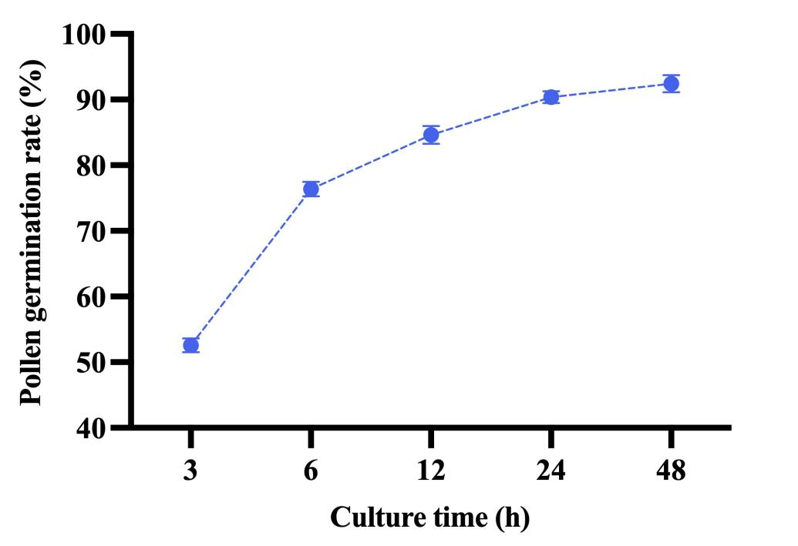
Figure S1 Pollen germination rate at 25°C for different incubation durations.

