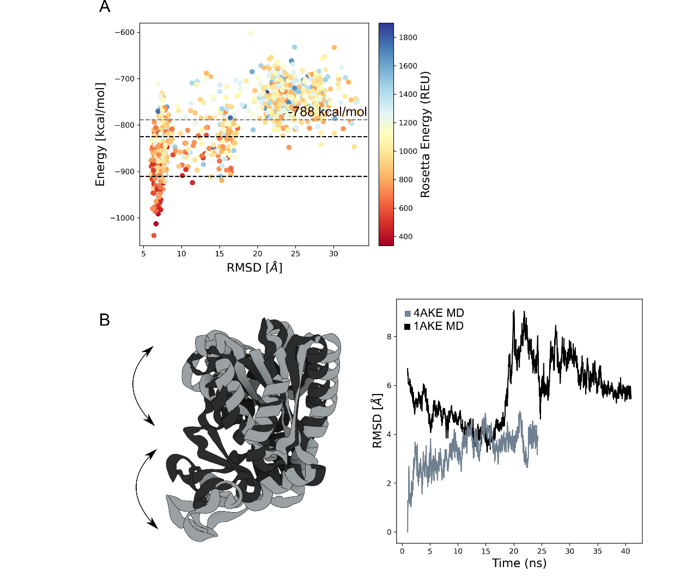
Support Information

Figure S1. Adenylate kinase A. AWSEM force field vs RMSD profile plot. Each dot represents a protein prediction scored with AWSEM force-field and colored by the Rosetta energy score function ref15. The grey dashed line is the Energy mean filter. The black dashed line represent the X-ray structures energy value; B. left panel: overlap between the X-ray structure; right panel: Root-mean-square deviation (RMSD) plot of the 4AKE (light-grey) and 1AKE (dark-grey) protein during molecular dynamics simulation.

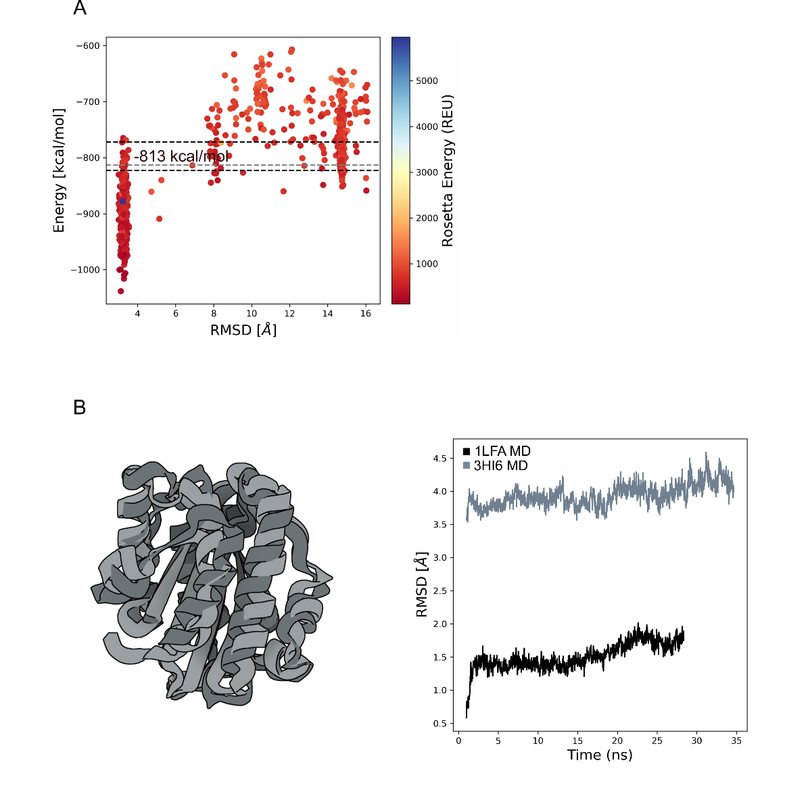
Figure S2. αI-domains of LFA-1. A. AWSEM force field vs RMSD profile plot. Each dot represents a protein prediction scored with AWSEM force-field and colored by the Rosetta energy score function ref15. The grey dashed line is the Energy mean filter. The black dashed line represent the X-ray structures energy value; B. left panel: overlap between the X-ray structure; right panel: Root-mean-square deviation (RMSD) plot of the 3HI6 (light-grey) and 1LFA (dark-grey) protein during molecular dynamics simulation.
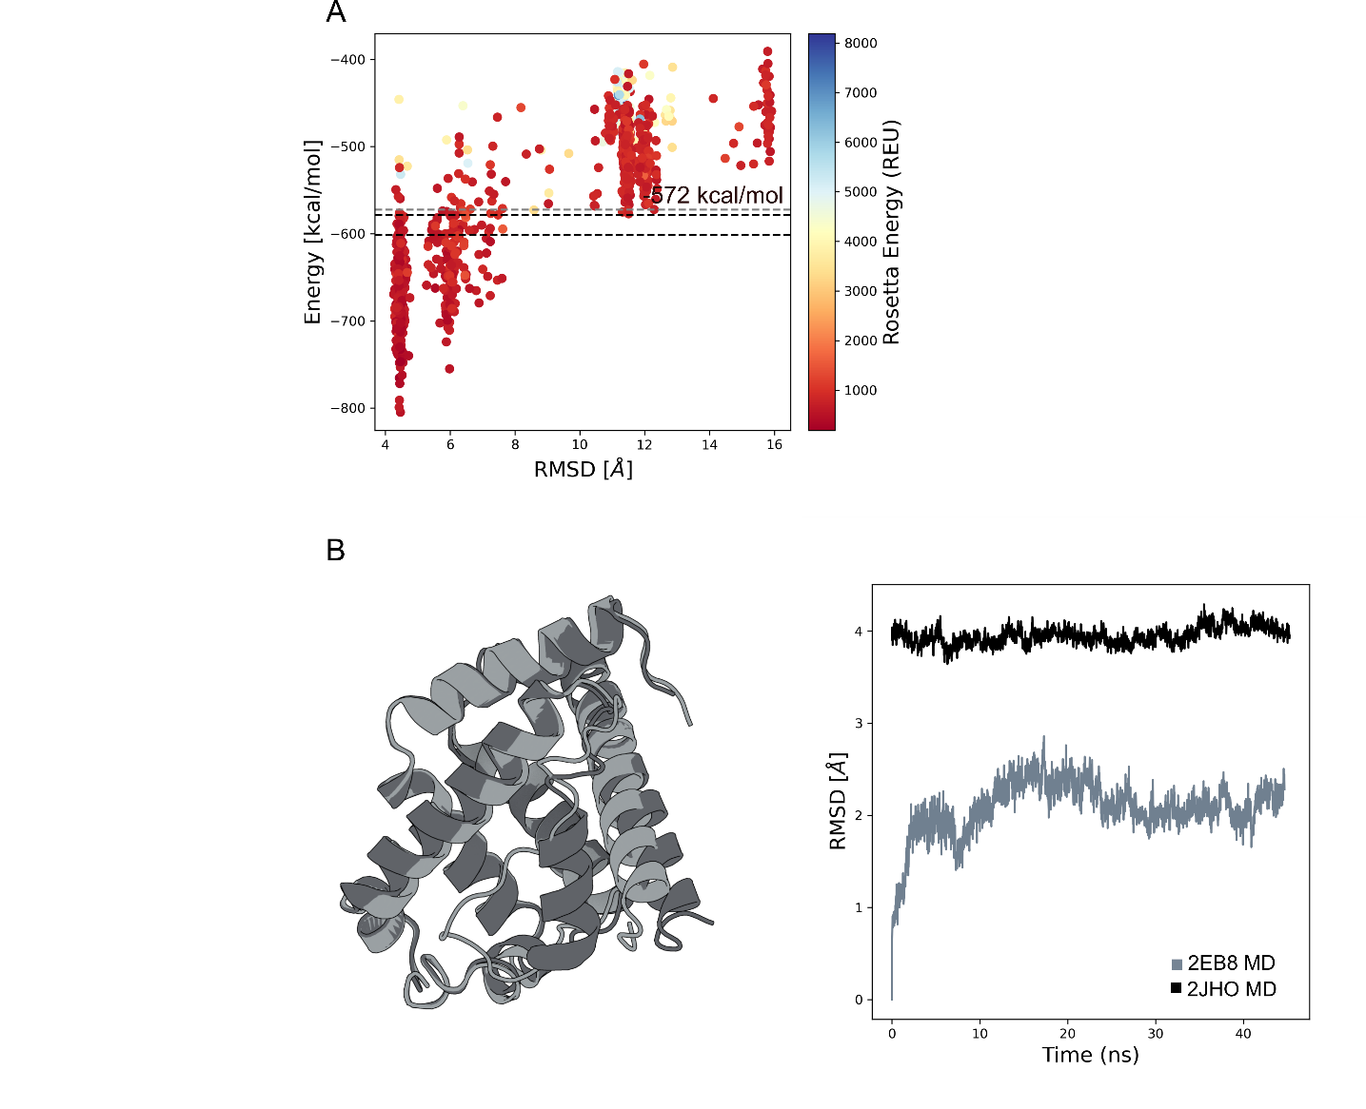

Figure S3. Myoglobin protein. A. AWSEM force field vs RMSD profile plot. Each dot represents a protein prediction scored with AWSEM force-field and colored by the Rosetta energy score function ref15. The grey dashed line is the Energy mean filter. The black dashed line represent the X-ray structures energy value; B. left panel: overlap between the X-ray structure; right panel: Root-mean-square deviation (RMSD) plot of the 2EB8 (light-grey) and 2JHO (dark-grey) protein during molecular dynamics simulation.
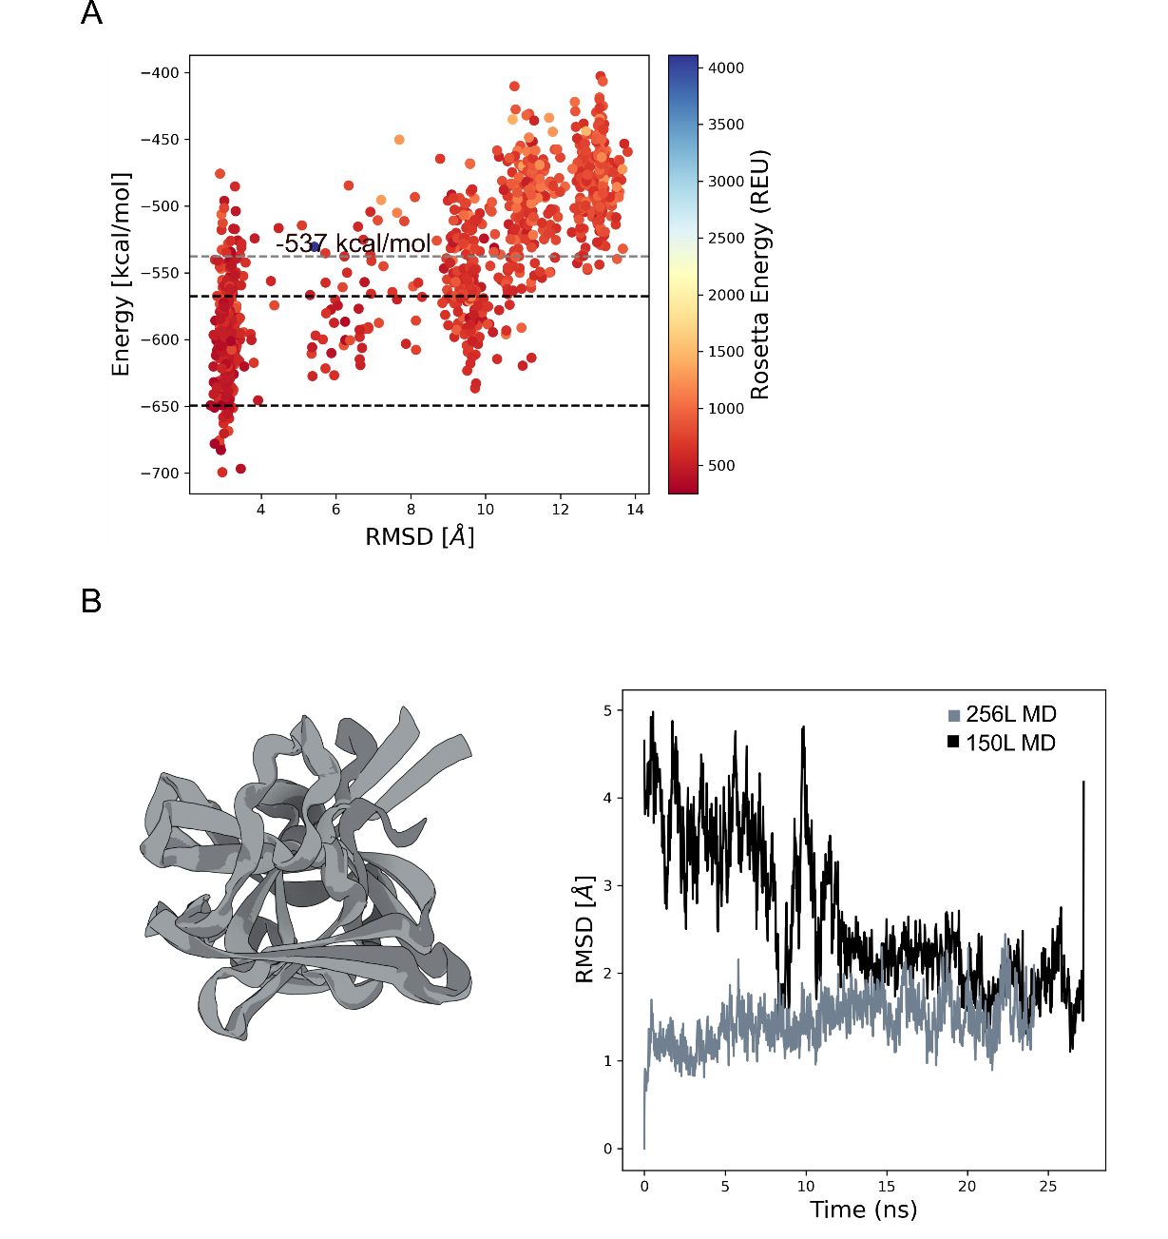
Figure S4. T4 lysozyme. A. AWSEM force field vs RMSD profile plot. Each dot represents a protein prediction scored with AWSEM force-field and colored by the Rosetta energy score function ref15. The grey dashed line is the Energy mean filter. The black dashed line represent the X-ray structures energy value; B. left panel: overlap between the X-ray structure; right panel: Root-mean-square deviation (RMSD) plot of the 256L (light-grey) and 150L (dark-grey) protein during molecular dynamics simulation.

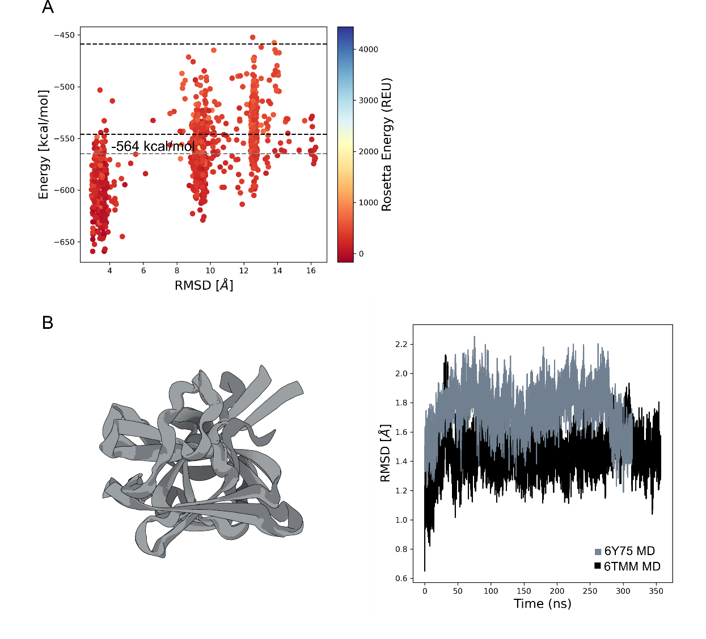

Figure S5. Tetrahymena thermophila-BIL2. A. AWSEM force field vs RMSD profile plot. Each dot represents a protein prediction scored with AWSEM force-field and colored by the Rosetta energy score function ref15. The grey dashed line is the Energy mean filter. The black dashed line represent the X-ray structures energy value; B. left panel: overlap between the X-ray structure; right panel: Root-mean-square deviation (RMSD) plot of the 6Y75 (light-grey) and 6TMM (dark-grey) protein during molecular dynamics simulation.
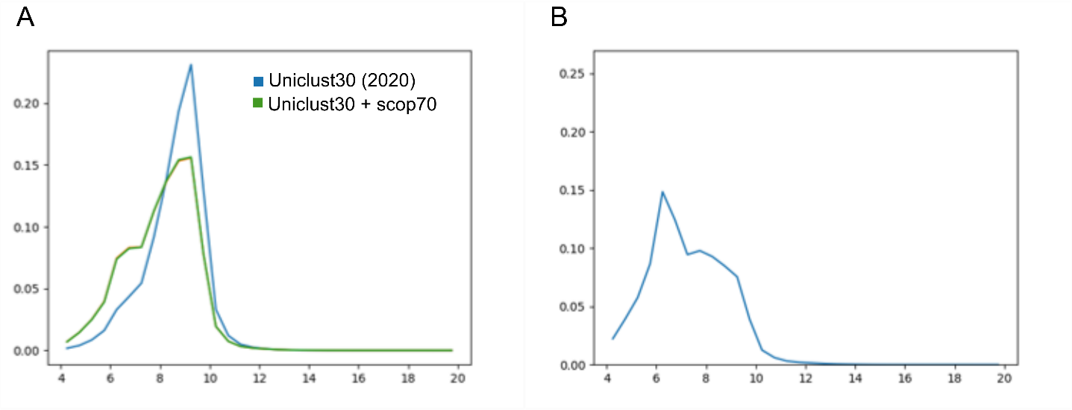
Figure S6. Probability distance distribution: MSA effect. Probability distance distribution between S93 and H98 calculated for the protein structure 2EB8. A. Probability distribution plot obtained with trRosetta-MSA protocol using Uniclust30 database (blue) and Uniclust30/scop70 (green). B. Probability distance distribution plot obtained with trRosetta-deepMSA protocol using Uniclust30 database (blue).

