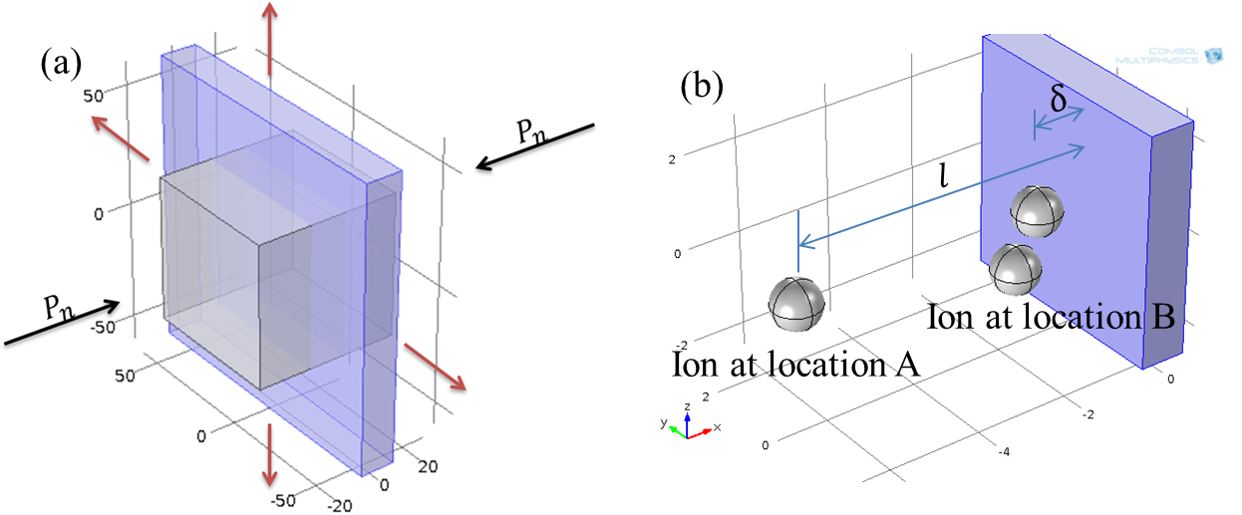
Figure S1 Analysis of electro-mechanical stresses on spore coats under electric fields. (a) Equibiaxial mode of MR model. A unit volume of spore coat becomes thinner caused by the compression force. (b) Spores immersed in ionic buffer. Ions at location A are carried to location B under electric fields, leading a difference of concentrations.
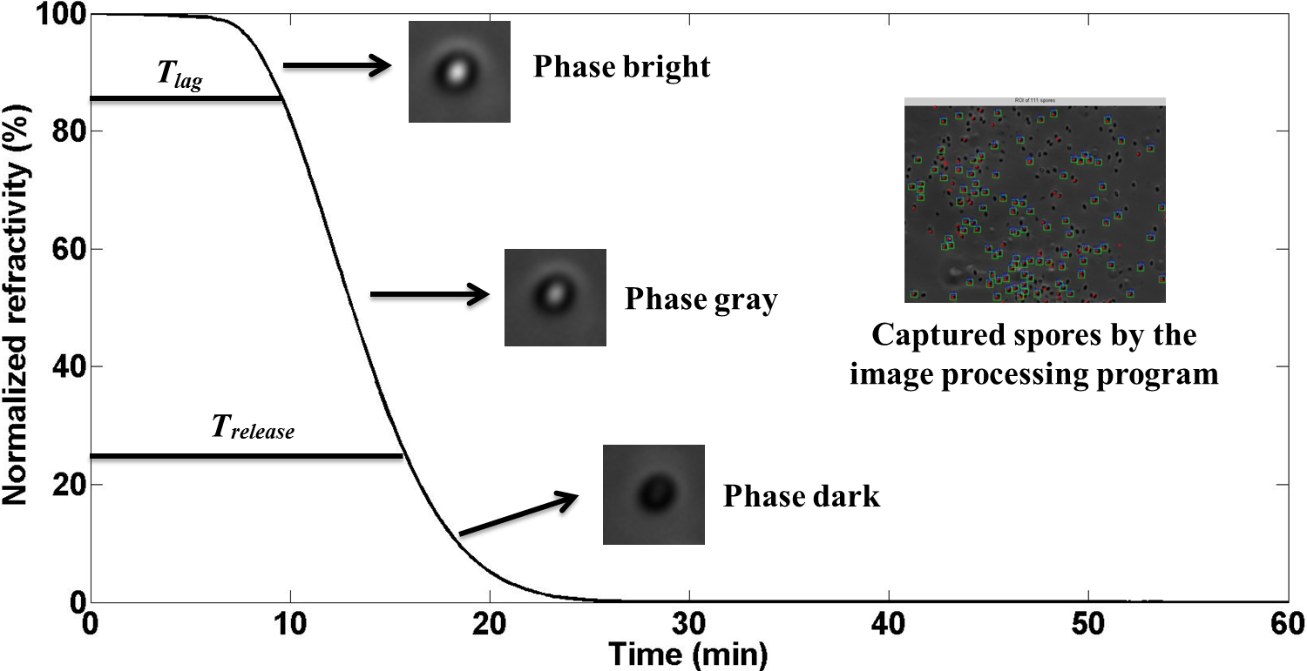
Figure S2 Phase change monitored by phase-contrast microscopy. The phase state of the refractivity curve corresponds to T_{lag} and T_{release}. T_{lag} corresponds to phase bright and T_{release} corresponds to phase dark. While between T_{lag} and T_{release}, phase gray appears. The red stars of the panel of the image processing program show the captured spores. Among the captured spores the green squares show the phase changed spores.
Figure S3 Refractivity kinetics during spore germination. (a) Control, (b) 15 kV cm⁻¹, 50 pulses in saline. Mean and standard deviation of T_{lag} in (b) are smaller than those in (a), indicating that higher homogeneity occurs after PEF treatment.
Figure S4 Peak intensity of DPA release kinetics during spore germination. T_{rise} is used to measure speed of DPA release. The panel shows the normalized peak intensity of PEF-treated spores under different treatment conditions. (A) 7.5 kV cm⁻¹, 1 pulse in DI water, (B) 7.5 kV cm⁻¹, 50 pulses in DI water, (C) 7.5 kV cm⁻¹, 1 pulse in saline, (D) 7.5 kV cm⁻¹, 50 pulses in saline, (E) 15 kV cm⁻¹, 1 pulse in saline, (F) 15 kV cm⁻¹, 50 pulses in saline.
Figure S5 Hydrophobicity measurement at OD₆₀₀ with n-hexadecane. (dashed line) 15 kV cm⁻¹, 50 pulses in DI water, (solid line) 15 kV cm⁻¹, 50 pulses in saline.
Table S1 Percentage of spores with concave shape
Concavity | Treatment Condition
Concavity | 15 kV cm⁻¹, 1 pulse in DI water | 15 kV cm⁻¹, 50 pulses in DI water | 15 kV cm⁻¹, 1 pulse in saline | 15 kV cm⁻¹, 50 pulses in saline
Percentage (No. of spores examined) | 7.70% (91) | 11.80% (220) | 12.30% (194) | 10.40% (241)

Table S2 Absorbance of OD₆₀₀
Absorbance of OD₆₀₀ | Treatment Condition
Absorbance of OD₆₀₀ | Control in DI water | Control in saline | 15 kV cm⁻¹, 1 pulse in DI water | 15 kV cm⁻¹, 50 pulses in DI water | 15 kV cm⁻¹, 1 pulse in saline | 15 kV cm⁻¹, 50 pulses in saline
OD₆₀₀ | 0.374±0.003 | 0.332±0.009 | 0.391±0.003 | 0.222±0.006 | 0.315±0.010 | 0.356±0.010

Table S3 pH measurement at different concentrations
pH measurement at three concentrations | Treatment Condition
pH measurement at three concentrations | Control in DI water | Control in saline | 15 kV cm⁻¹, 1 pulse in DI water | 15 kV cm⁻¹, 50 pulses in DI water | 15 kV cm⁻¹, 1 pulse in saline | 15 kV cm⁻¹, 50 pulses in saline
2×10⁷ | 5.76±0.015 | 5.73±0.058 | 5.74±0.015 | 5.84±0.047 | 5.72±0.012 | 5.65±0.036
2×10⁵ | 5.61±0.065 | 5.57±0.031 | 5.58±0.055 | 5.61±0.064 | 5.53±0.010 | 5.45±0.012
2×10³ | 5.53±0.021 | 5.55±0.010 | 5.62±0.012 | 5.64±0.031 | 5.57±0.015 | 5.47±0.006

