Supplementary Material for: Bedside Diffuse Optical Tomography of Disrupted Brain Connectivity During Acute Stroke.

Karla M. Bergonzi^{*,1}, Broc A. Burke*^{,2}, Arefeh Sherafati³, Andrew K. Fishell⁴, Tracy M. Burns-Yocum⁵, Silvina L. Ferradal⁶, Ben J. Palanca¹, Rajat Dhar⁷, Gyanendra Kumar⁸, Jin-Moo Lee^{4,7,9}, Joseph P. Culver^{**,3,4,9,10}, and Adam T. Eggebrecht^{**,4,9,10}

*Co-first authors.
*Co-senior authors.
¹ L3Harris, 400 Initiative Dr, Rochester, New York, 14624
² Department of Anesthesiology, Washington University School of Medicine, St. Louis, Missouri 63110, USA
³ Department of Physics, Washington University, St. Louis, Missouri 63130, USA
⁴ Division of Biology and Biomedical Sciences, Washington University School of Medicine, St. Louis, Missouri 63110, USA
⁵ Department of Psychological and Brain Sciences, Indiana University Bloomington, Indiana, 47405, USA, USA
⁶ Department of Intelligent Systems Engineering, Luddy School of Informatics, Computing, and Engineering, Indiana University, Bloomington, Indiana 47408, USA
⁷ Department of Neurology, Washington University School of Medicine, St. Louis, Missouri 63110, USA
⁸ Department of Neurology, Mayo Clinic, Scottsdale, Arizona, USA
⁹ Mallinckrodt Institute of Radiology, Washington University School of Medicine, St. Louis, Missouri 63110, USA
¹⁰ Department of Biomedical Engineering, Washington University, St. Louis, Missouri 63130, USA

Correspondence to:

Adam T. Eggebrecht, Mallinckrodt Institute of Radiology; Washington University School of Medicine; 660 S. Euclid Ave, St Louis, MO, 63110; USA. Ph: 314-747-8290. Fax: 314-747-5191.
Broc A. Burke, Department of Anesthesiology; Washington University School of Medicine; Campus Box 8054; 660 S. Euclid Ave, St Louis, MO, 63110; USA. Ph: 314-362-1196, Fax: 314-747-3977.

Email: aeggebre@wustl.edu, broc@wustl.edu

This PDF file includes: Figures S1 to S3

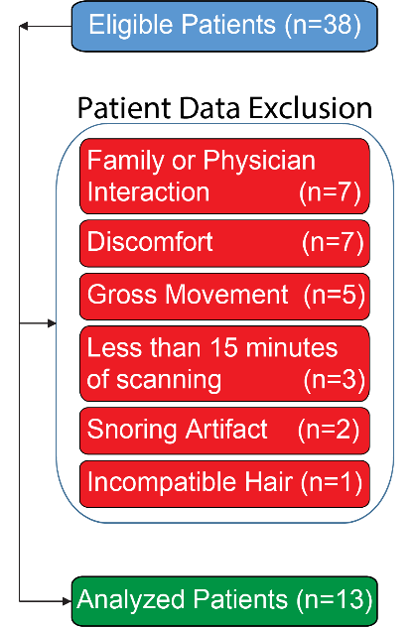

Fig. S1 – Patient Data Exclusion. Consent for this study was acquired from 38 patients within the first 72 hours since last known normal. The primary analyses focus on n=13 patients. Patients' data were removed from analyses due to (1) family or physician interaction (n=7); (2) general discomfort (n=7); (3) gross movement due to general agitation (n=5); (4) less than 15 minutes data collection (n=3); (5) strong snoring artifact (n=2); and (7) incompatible hair (corn-rows that made adequate coupling with the cap impossible; n=1).

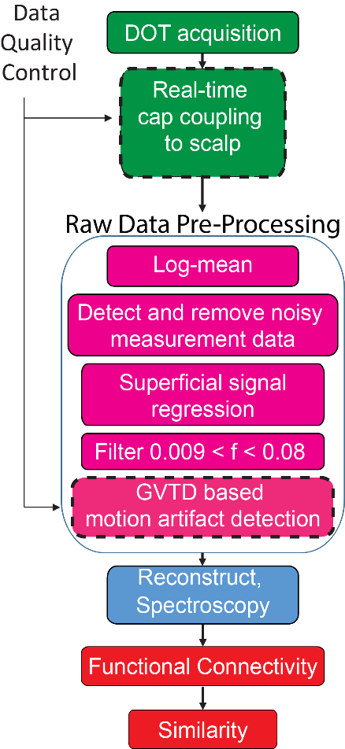

Fig. S2 – Clinical HD-DOT Data Acquisition and Processing Pipeline. Following cap placement with real-time clinical cap coupling to scalp (Figure 2), DOT data acquisition and continued real-time cap coupling to scalp begins (shown in green above). After completion of the imaging session, the data was pre-processed prior to tomographic reconstruction of the hemoglobin chromophores (shown in magenta above). After performing a log-mean on the measured light levels, system noise was reduced by removing measurement channels with greater than 7.5% standard deviation from their mean. Furthermore, superficial and systemic hemodynamic variance was removed through regression of the averaged low-noise first nearest-neighbor measurements. The final two steps prior to reconstruction band-pass the signal for functional connectivity analysis (0.009 Hz to 0.08 Hz) and remove motion artifacts using global variance of the temporal derivatives (GVTD, Figure S3). Volumetric reconstruction was then performed for 750 and 850 nm using NIRFAST on an MNI152 atlas (shown in blue above). Functional connectivity and similarity (shown in red above) were then performed using seed based temporal correlation and the process shown in Figure 4 respectively.

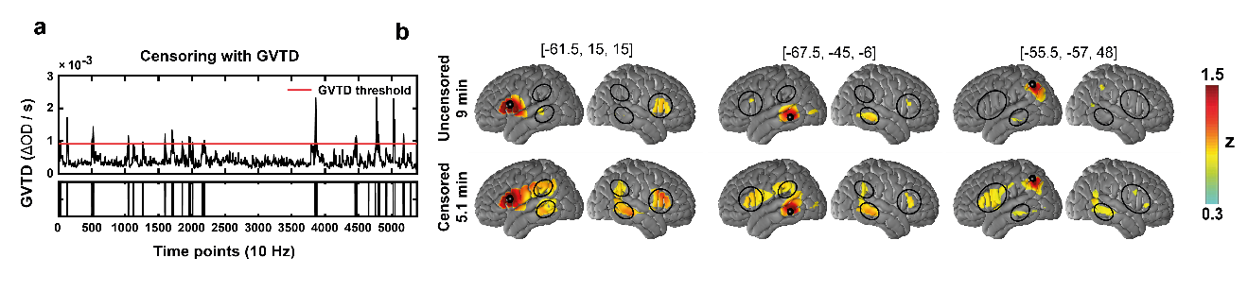

Fig. S3 – Example of GVTD Motion Correction. The GVTD metric is calculated as the root mean square across measurements of the temporal derivative in light levels as a data driven method of motion detection. a) The time course of this metric for an example subject for a 9-minute imaging session is shown (top, black) with a GVTD threshold of 0.0009 (ΔOD/s) (top, red). All timepoints with values above the threshold that are identified for removal are shown (bottom) with a total of 5.1 minutes of low-motion data remaining. b) The z scores for the functional connectivity maps of 3 representative seed locations (small solid black circles) are shown for the example patient. The top row shows the calculated fc-maps without motion correction while the bottom row shows the fc-maps after removing high-motion timepoints using GVTD. Black circles highlight regions with notable increases in calculated functional connectivity after motion correction.

