Supplementary Information
Supplementary Figures

Supplementary Figure S1. Associations between candidate neddylation-associated genes and chemokine/chemokine receptor expression in LSCC.
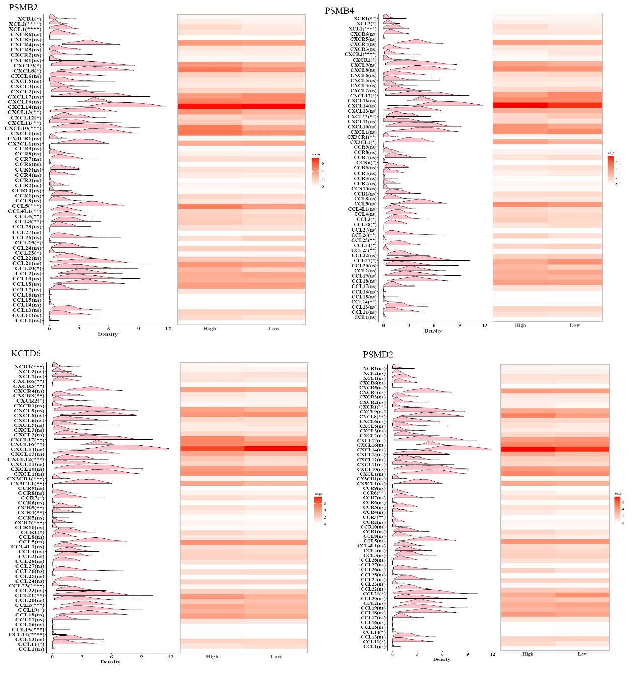
(A–D) Expression patterns of chemokines and chemokine receptors stratified by the expression levels of PSMB2 (A), PSMB4 (B), KCTD6 (C), and PSMD2 (D) in laryngeal squamous cell carcinoma (LSCC). Ridgeline plots show the expression distributions of individual chemokines and chemokine receptors across LSCC samples, and the accompanying heatmaps summarize their expression patterns in the high- and low-expression groups of each candidate gene. Statistical annotations indicate differences between the high- and low-expression groups. ns, not significant; *, P < 0.05, **, P < 0.01, ***, P < 0.001, ****, P < 0.0001.

Supplementary Figure S2. Associations between candidate neddylation-associated genes and immune checkpoint-related molecule expression in LSCC.
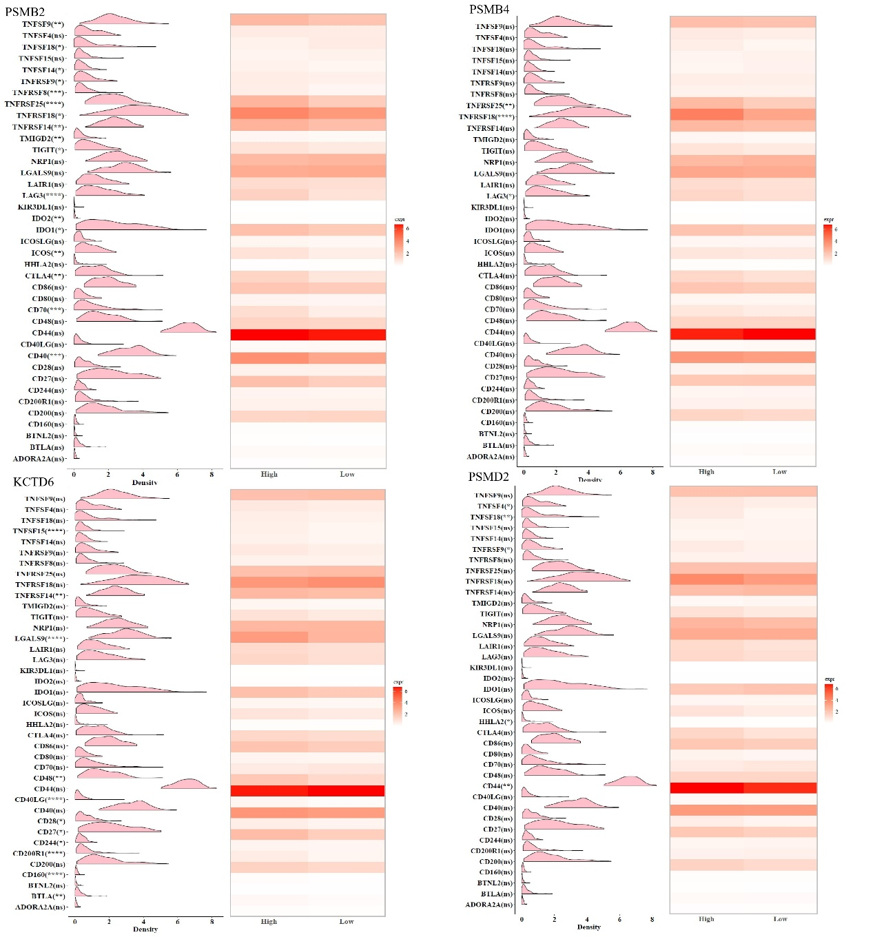
(A–D) Expression patterns of immune checkpoint-related molecules stratified by the expression levels of PSMB2 (A), PSMB4 (B), KCTD6 (C), and PSMD2 (D) in LSCC. Ridgeline plots show the expression distributions of individual immune checkpoint-related genes, whereas heatmaps illustrate their expression patterns in the corresponding high- and low-expression groups. The analyzed molecules include immune inhibitory and regulatory factors such as CTLA4, TIGIT, LAG3, IDO1, BTLA, and related immune-regulatory genes. Statistical annotations indicate differences between the high- and low-expression groups. ns, not significant; *, P < 0.05, **, P < 0.01, ***, P < 0.001, ****, P < 0.0001.

Supplementary Figure S3. Associations between candidate neddylation-associated genes and co-stimulatory immune molecule expression in LSCC.
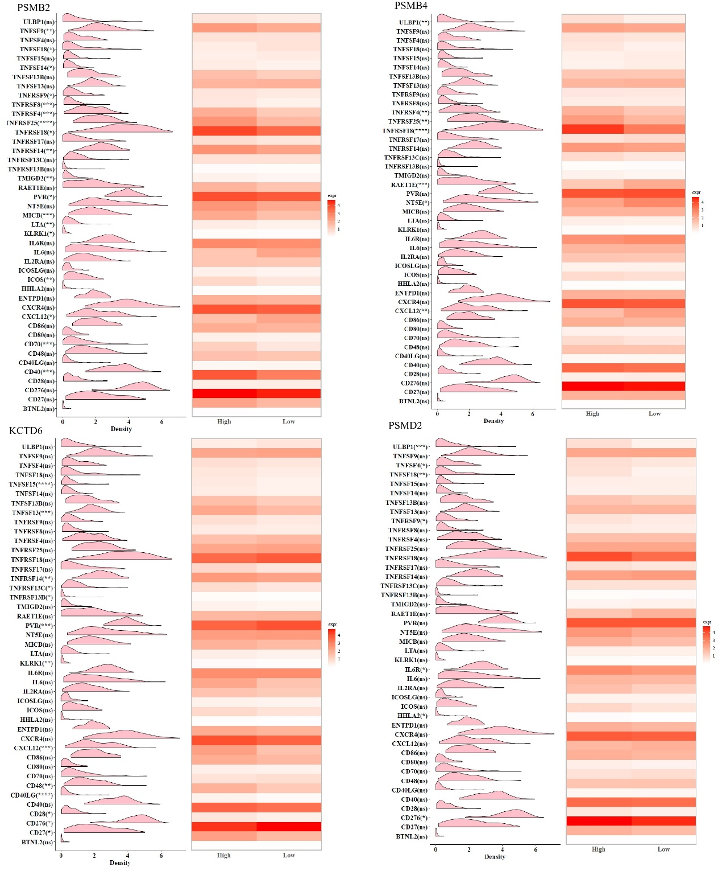
(A–D) Expression patterns of co-stimulatory and immune activation-related molecules stratified by the expression levels of PSMB2 (A), PSMB4 (B), KCTD6 (C), and PSMD2 (D) in LSCC. Ridgeline plots show the expression distributions of individual immune-related genes, and heatmaps summarize their expression patterns in the high- and low-expression groups of each candidate gene. Representative molecules include members of the TNF/TNFR superfamilies, CD27, CD28, CD40, CD70, CD80, CD86, CXCL12, CXCR4, and other immune activation-associated genes. Statistical annotations indicate differences between the high- and low-expression groups. ns, not significant; *, P < 0.05, **, P < 0.01, ***, P < 0.001, ****, P < 0.0001.

Supplementary Figure S4. Associations between candidate neddylation-associated genes and major histocompatibility complex-related gene expression in LSCC.
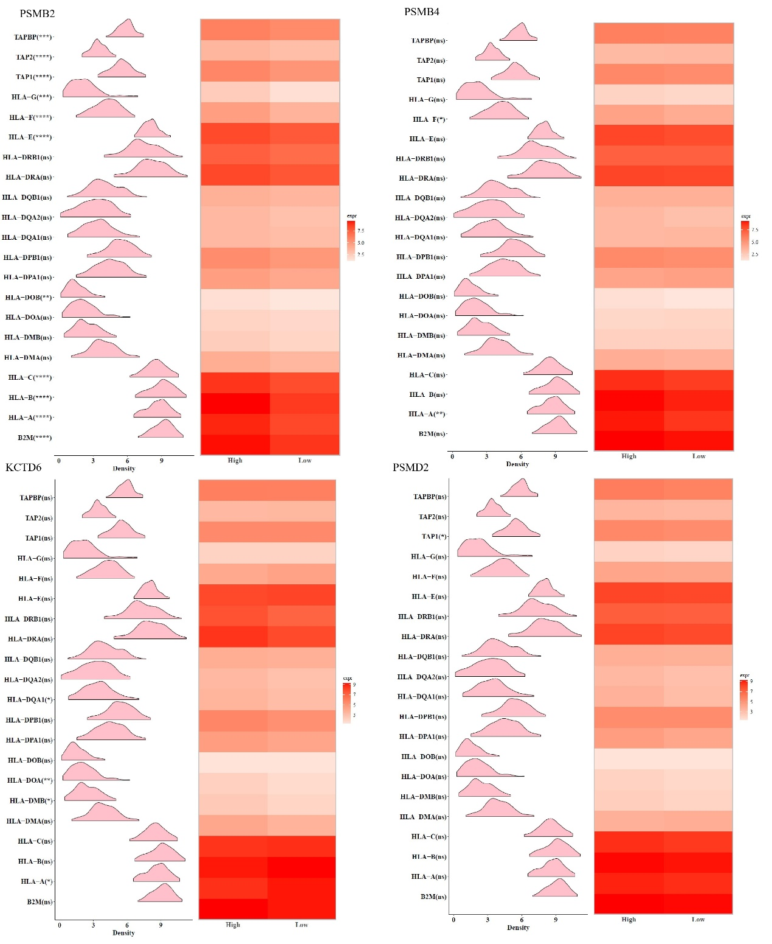
(A–D) Expression patterns of major histocompatibility complex (MHC)-related genes stratified by the expression levels of PSMB2 (A), PSMB4 (B), KCTD6 (C), and PSMD2 (D) in LSCC. Ridgeline plots show the expression distributions of individual MHC-related genes, whereas heatmaps summarize their expression patterns in the high- and low-expression groups of each candidate gene. The analyzed genes include MHC class I- and class II-related molecules and antigen-processing components, including HLA-A, HLA-B, HLA-C, HLA-DRA, HLA-DRB1, B2M, TAP1, TAP2, and TAPBP. Statistical annotations indicate differences between the high- and low-expression groups. ns, not significant; *, P < 0.05, **, P < 0.01, ***, P < 0.001, ****, P < 0.0001.

Supplementary Figure S5. Correlation analyses between candidate neddylation-associated gene expression and immune cell infiltration in laryngeal squamous cell carcinoma.
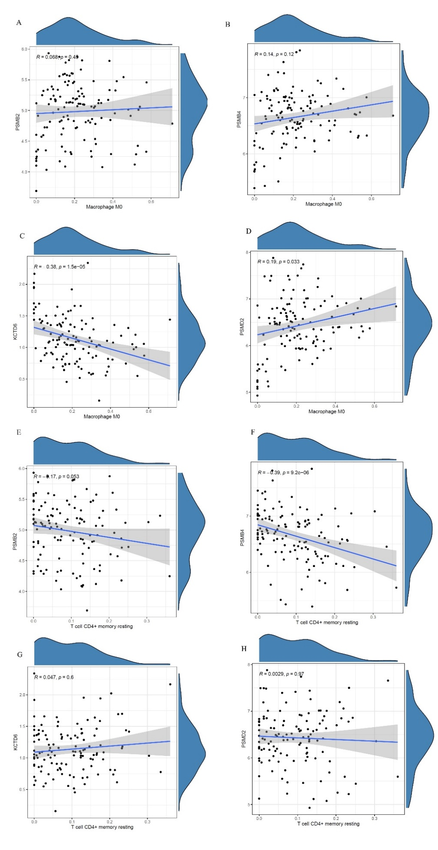
(A) No significant correlation between PSMB2 and macrophage M0 infiltration (Pearson R = 0.068, p = 0.45). (B) No significant correlation between PSMB4 and macrophage M0 infiltration (R = 0.14, p = 0.12). (C) Significant negative correlation between KCTD6 and macrophage M0 infiltration (R = −0.38, p = 1.5 × 10⁻⁵). (D) Significant positive correlation between PSMD2 and macrophage M0 infiltration (R = 0.19, p = 0.033). (E) Weak non-significant negative correlation between PSMB2 and resting CD4+ memory T-cell infiltration (R = −0.17, p = 0.053). (F) Significant negative correlation between PSMB4 and resting CD4+ memory T-cell infiltration (R = −0.39, p = 9.2 × 10⁻⁶). (G) No significant correlation between KCTD6 and resting CD4+ memory T-cell infiltration (R = 0.047, p = 0.60). (H) No significant correlation between PSMD2 and resting CD4+ memory T-cell infiltration (R = 0.003, p = 0.97). Marginal density distributions are shown for each variable. Correlation method: Pearson.
Supplementary Figure S6. Genomic alterations and regulatory network characteristics of candidate neddylation-associated genes in laryngeal squamous cell carcinoma.
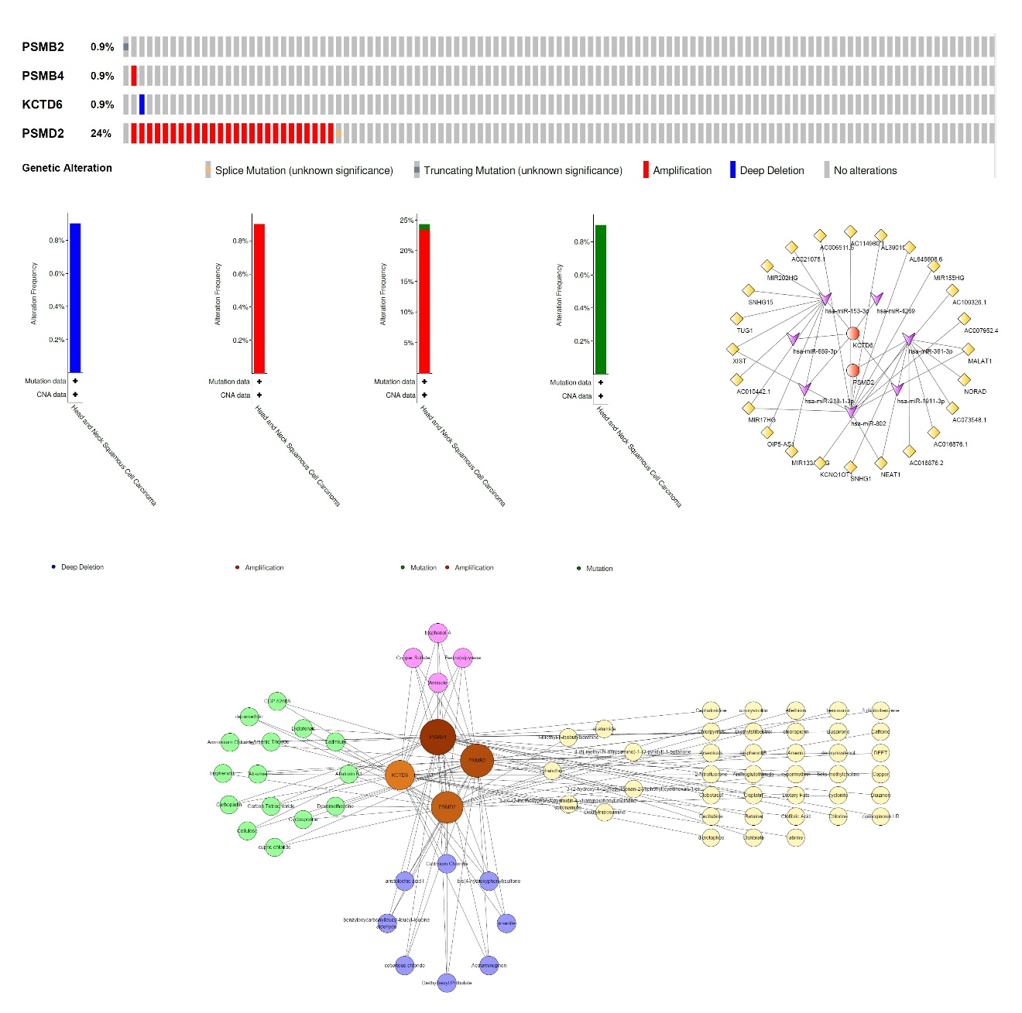
(A) Oncoprint summarizing somatic genetic alterations in PSMB2, PSMB4, KCTD6, and PSMD2 in the TCGA-LSCC cohort. PSMD2 shows the highest alteration frequency (24%, predominantly amplification); PSMB2, PSMB4, and KCTD6 are each altered in ~0.9% of cases. Alteration types: amplification (red), deep deletion (blue), truncating mutation (light blue), splice mutation (light gray). (B) Copy number variation (CNA) and somatic mutation frequency of KCTD6 in head and neck squamous cell carcinoma (HNSCC). (C) CNA and mutation frequency of PSMB4 in HNSCC. (D) CNA and mutation frequency of PSMD2 in HNSCC, showing predominant amplification consistent with the LSCC oncoprint. (E) CNA and mutation frequency of PSMB2 in HNSCC. (F) Chemical-gene regulatory network based on Comparative Toxicogenomics Database (CTD) analysis, showing reported associations between environmental chemicals (bisphenol A, benzo[a]pyrene, copper sulfate, amitrole) and the four candidate genes. (G) Predicted ceRNA regulatory network involving PSMD2 and KCTD6. Diamond nodes = miRNAs; circle nodes = lncRNAs/genes. Key predicted axes: PSMD2-hsa-miR-361-3p-MALAT1 and KCTD6-hsa-miR-153-3p-SNHG15.

Supplementary Table S3. Primer sequences used for qRT-PCR validation.
Primer sequences for the four candidate target genes (KCTD6, PSMB2, PSMB4, PSMD2) and the reference gene β-actin. Primers were designed against the canonical human RefSeq mRNA (KCTD6 NM_153331.3, PSMB2 NM_002794.5, PSMB4 NM_002796.3, PSMD2 NM_002808.5, ACTB NM_001101.5) using Primer3 and verified by BLAST against the entire human refseq_rna database. Each pair has the intended target gene as the unique top BLAST hit at 100 % identity for both forward and reverse primer. KCTD6, PSMB2, PSMB4, and PSMD2 amplicons span at least one exon-exon junction. ACTB primers reside in the 3' untranslated region for true gene-specificity; this region does not span an exon-exon junction, so DNase I treatment of total RNA and a no-reverse-transcriptase control are mandatory (Methods, Sections 4.9.2 and 4.9.3).
Gene | Forward primer (5' to 3') | Reverse primer (5' to 3') | Amplicon (bp) | Tm (°C) | GC %
KCTD6 | AACCTGGGCTCTTGAAGACG | ACTGGGTCAGTCATCATATAGCC | 75 | 60.0 / 59.4 | 55.0 / 47.8
PSMB2 | GAGGAGCTCCAGAAACGCTT | TGGGAGGGAGGACATGATGT | 133 | 60.0 / 60.0 | 55.0 / 55.0
PSMB4 | ATGGAGAGAGCTTCCTCGGT | GGGCATCTCGGTAGTACAGC | 195 | 60.0 / 60.0 | 55.0 / 60.0
PSMD2 | CACATCAGGGAGTGGCTGTT | AGAGATGAGGGCCAGTGCTA | 152 | 60.0 / 60.0 | 55.0 / 55.0
β-actin (ACTB) | GCCGAGGACTTTGATTGCAC | TGTGTGGACTTGGGAGAGGA | 145 | 59.8 / 60.1 | 55.0 / 55.0

Supplementary Table S4. Relative mRNA expression of KCTD6, PSMB2, PSMB4, and PSMD2 in five paired LSCC tumor and adjacent non-tumor tissues by qRT-PCR.
Gene | Tumor (mean ± SD) | Adjacent (mean ± SD) | Direction in tumor | P value* | Significance
KCTD6 | 1.920 ± 0.350 | 2.835 ± 0.467 | ↓ Downregulated | 0.058 | ns
PSMB2 | 6.690 ± 0.400 | 5.250 ± 0.380 | ↑ Upregulated | 0.011 | *
PSMB4 | 8.395 ± 0.300 | 7.610 ± 0.500 | ↑ Upregulated | 0.095 | ns
PSMD2 | 8.510 ± 0.687 | 7.195 ± 0.260 | ↑ Upregulated | 0.066 | ns
Relative mRNA expression of KCTD6, PSMB2, PSMB4, and PSMD2 in five paired LSCC tumor and adjacent non-tumor tissues, normalized to β-actin and calculated using the 2^(-Delta Delta Ct) method. Each sample was assayed in technical triplicate; values are mean ± standard deviation across triplicate reactions per group. *Two-tailed Welch t-test (Methods, Section 4.9.5). Significance: *P < 0.05; ns, not significant.

