Table 1 Single-factor Experimental Design Table
Concentration setting of L-cys |  |  |  | Concentration setting of Trehalose |  |  |  | Setting of soaking time
L-cys concentration (g L⁻¹) | Soaking Time (min) |  | Trehalose concentration (g L⁻¹) |  | Soaking Time (min) |  | L-cys concentration (g L⁻¹) |  | Trehalose concentration (g L⁻¹) |  |  | Soaking Time (min)
0 |  | 0 | 0 |  |  | 0 | 0 |  |  | 0 | 0
1.5 |  | 6 | 0.5 |  |  | 6 | 2.5 |  |  | 1.5 | 2
2.0 |  | 6 | 1.0 |  |  | 6 | 2.5 |  |  | 1.5 | 4
2.5 |  | 6 | 1.5 |  |  | 6 | 2.5 |  |  | 1.5 | 6
3.0 |  | 6 | 2.0 |  |  | 6 | 2.5 |  |  | 1.5 | 8
3.5 |  | 6 | 2.5 |  |  | 6 | 2.5 |  |  | 1.5 | 10

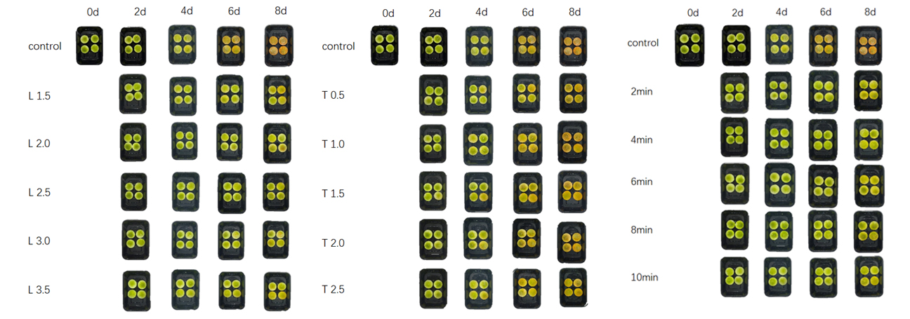
Figure. S1 Single-factor experimental of the appearance.

Table 2 Levels of Response Surface Experimental Design
level | factor
level | L-cys | Threhalose | Time
-1 | 2.0(g/L) | 1.0(g/L) | 2(min)
0 | 2.5 | 1.5 | 4
1 | 3.0 | 2.0 | 6

NO. | L-cys | Threhalose | Time | BI
1 | 2.0(g/L) | 1.0(g/L) | 4(min) | 16.9222
2 | 3.0 | 1.0 | 4 | 16.9215
3 | 2.0 | 2.0 | 4 | 16.9293
4 | 3.0 | 2.0 | 4 | 16.9052
5 | 2.0 | 1.5 | 2 | 16.9433
6 | 3.0 | 1.5 | 2 | 16.9235
7 | 2.0 | 1.5 | 6 | 16.9121
8 | 3.0 | 1.5 | 6 | 16.9191
9 | 2.5 | 1.0 | 2 | 16.9224
10 | 2.5 | 2.0 | 2 | 16.9149
11 | 2.5 | 1.0 | 6 | 16.9111
12 | 2.5 | 2.0 | 6 | 16.9116
13 | 2.5 | 1.5 | 4 | 16.8688
14 | 2.5 | 1.5 | 4 | 16.8697
15 | 2.5 | 1.5 | 4 | 16.8691
16 | 2.5 | 1.5 | 4 | 16.8715
17 | 2.5 | 1.5 | 4 | 16.8739
Table 3 Response Surface Experiment Results

Table 4 Analysis of Variance for Regression Equation
Source | Sum of Squares | df | Mean Square | F-value | p-value
Model | 0.0095 | 9 | 0.0011 | 80.89 | < 0.0001 | significant
A-L-cys | 0.0002 | 1 | 0.0002 | 13.49 | 0.0079
B-Threhalose | 0.0000 | 1 | 0.0000 | 2.50 | 0.1576
C-Time | 0.0003 | 1 | 0.0003 | 24.04 | 0.0017
AB | 0.0001 | 1 | 0.0001 | 10.45 | 0.0144
AC | 0.0002 | 1 | 0.0002 | 13.70 | 0.0076
BC | 0.0000 | 1 | 0.0000 | 1.22 | 0.3057
A² | 0.0036 | 1 | 0.0036 | 274.43 | < 0.0001
B² | 0.0016 | 1 | 0.0016 | 125.01 | < 0.0001
C² | 0.0026 | 1 | 0.0026 | 195.63 | < 0.0001
Residual | 0.0001 | 7 | 0.0000
Lack of Fit | 0.0001 | 3 | 0.0000 | 5.46 | 0.0673 | not significant
Pure Error | 0.0000 | 4 | 0.0000
Cor Total | 0.0096 | 16
 | R² | 0.9905
 | Adjusted R² | 0.9782
 | Predicted R² | 0.8746

Regression Equation: BI=+16.87-0.0047A-0.0020B-0.0063C-0.0059AB+0.0067AC+0.0020BC
+0.0292A²+0.0197B²+0.0247C²

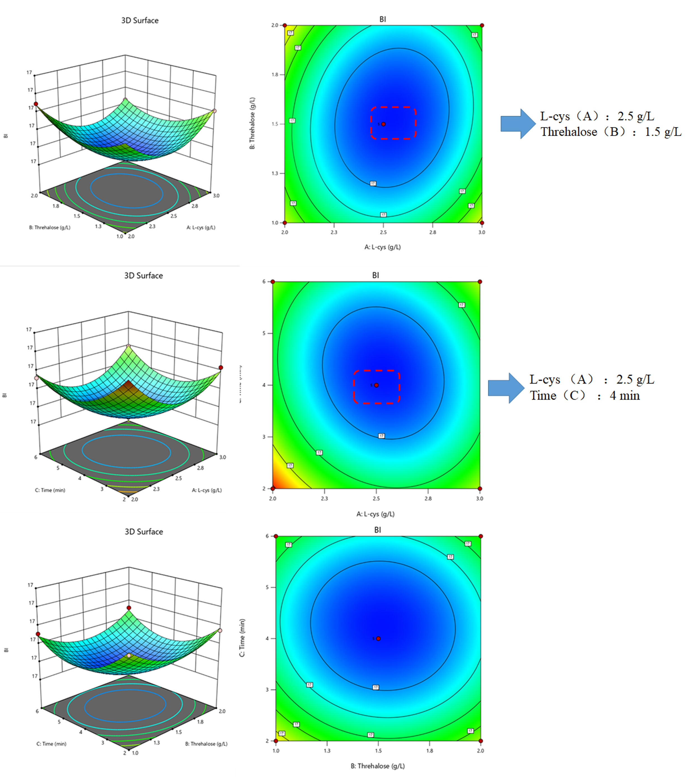
Figure. S2 3D surface and contour plots of response surface methodology experiments.

