Supplementary Information
Ionic liquid-induced support disorder modulates the electronic structure of La-O subnanoclusters
Jie Wang^{a,b}, Jielin Huang^{a,*}, Hongpeng Zhang^{a,b}, Jian Li^{a,b}, Shijie Xuª, Songsong Chen^{a,c}, Junping Zhang^{a,c}, Li Dong^{a,c,*}, Tengfei Zhang^{d,*}, Suojiang Zhang^{a,c,*}
ª Center of Ionic Liquids and Green Energy, Beijing Key Laboratory of Solid State Battery and Energy Storage Process, State Key Laboratory of Mesoscience and Engineering, Institute of Process Engineering, Chinese Academy of Sciences, Beijing 100190, China
^{b} School of Chemical Engineering, University of Chinese Academy of Sciences, Beijing 100049, China
^{c} Longzihu New Energy Laboratory, State Key Laboratory of Green Chemical Synthesis and Conversion, Henan University, Zhengzhou 450000, P. R. China
^{d} Key Laboratory of Low Carbon Energy and Chemical Engineering, Shandong University of Science and Technology, Qingdao 266590, China
*Corresponding author. E-mail address: huangjielin2021@ipe.ac.cn (J. Huang); ldong@ipe.ac.cn (L. Dong); zhangtf@sdust.edu.cn (T. Zhang); sjzhang@ipe.ac.cn (S. Zhang).

Supplementary Methods
Theoretical calculations
All calculations were performed using the density functional theory (DFT) technique using the Vienna ab initio simulation package (VASP). Spin-polarized calculations were performed using the generalized gradient approximation (GGA) combined with the Perdew-Burke-Ernzerhof (PBE) method to determine the exchange and correlation energies. The projector-augmented wave (PAW) method was used to represent the core–valence electron interactions. For geometry optimization calculations, forces were converged below 0.03 eV/Å. The SCF convergence energy was 1 × 10⁻⁴eV. A 2 × 2 × 1 k-point mesh was used to perform all the calculations.
One layer graphene was constructed for calculating the adsorption energies and Gibbs free energies. A small LaO structure with two La atoms and two O atoms were placed on the surface of graphene for building the La-CN sample. As a comparison, 21 N atoms was moved out from the graphene to build the La-CN-2IL structure, in order to construct a g-C₃N₄ structure that is more amorphous. Also, a small LaO structure with two La atoms and two O atoms were placed on the surface of graphene for building the La-CN-2IL sample. For each, a vacuum of 15 Å was used to simulate the surface under periodic boundary conditions.
The adsorption energy (E_{ads}) of the urea and the other molecule on the surface was calculated as follows (eq 1):
E_{ads}=E_{adsorbate+surface}$−$E_{surface}$−$E_{gas’} (1)
According to the definition of ΔG [1-3],
∆G=∆E +∆E_{ZPE}$−$T∆S+∆G_{U}+∆G_{pH}+∆G_{field}
ΔE is directly calculated by DFT. ΔE_{ZPE} is obtained by calculating the vibration frequency of the intermediate (the ZPE corrects for the vibration of adsorbate at 0 K). Due to the conservation of elements before and after each calculation step, in the calculation, ΔE_{ZPE} can be approximated as 0.
Because of the temperature we defined as 0 K, TΔS = 0 [4].
ΔG_{pH} is the contribution of H⁺ concentration change to the Gibbs free energy. Due to the absence of pH changes in the gas-solid reaction, it can be ignored as 0 [5]. ΔG_{U} is the contribution of free energy in electrode potential. Electrocatalysis is not involved in this experiment, so it is ignored.
The correction term for electric double layer free energy, known as ΔG_{field}, has negligible effect on overall free energy and can be ignored [3].
For model optimization and simulation of reactions under ER and LH mechanisms, the calculations are performed at 0 K at a fixed cell volume, the differences in the Gibbs free energy should equal the differences in the total energy. However, the MvK mechanism was acquired under high temperature, the calculated temperature was set as 800 K. By this definition, a negative value of E_{ads} corresponds to exothermic and spontaneous adsorption processes.
For CO₂RR, the barrier energy, ΔE, for a difference between transition state energy difference and standard product formation enthalpy is defined as follows. The energy barrier calculation of *-IS₁ to *IS₂ on La/C₃N₄ as an example (eq 2):
∆E=(E_{IS2-La/C3N4}$−$E_{stab-La/C3N4}) $−$(E_{IS1-La/C3N4}$−$E_{stab-La/C3N4}) (2)
where E_{IS1-La/C3N4} and E_{IS2 -La/C3N4} are the energies of the IS₁ and IS₂ on La/C₃N₄, E_{stab-La/C3N4} is the energy of the La/C₃N₄ surface slab.
The differences in the Gibbs free energy should equal the differences in the total energy. By this definition, the lower the ΔE is, the easier it is to react.
[1] W. Song, C. Li, P. Ma, X. Liu, Y. Guo, M. Jia, W. Zhang, C. He, Computational screening of transition metal atom doped C₃N as electrocatalysts for nitrogen fixation, Mol. Catal. 535 (2023) 112888.
[2] X. Mao, Z. Gu, C. Yan, A. Du, Unlocking the potential of ruthenium catalysts for nitrogen fixation with subsurface oxygen, J. Mater. Chem. A 9 (2021) 6575-6582.
[3] X. Liao, R. Lu, L. Xia, Q. Liu, H. Wang, K. Zhao, Z. Wang, Y. Zhao, Density functional theory for electrocatalysis, Energy Environ. Mater. 5 (2021) 157-185.
[4] W. Kong, J. Xu, Y. Tong, Y. Ding, J. Wang, B. Li, X. Wei, L. Zhao, Construction of dual active sites for efficient alkaline hydrogen evolution: single-metal-atoms supported on BC₂N monolayers, Phys. Chem. Chem. Phys., 24 (2022) 29141-29150.
[5] Z. Wu, M. Karamad, X. Yong, Q. Huang, D. Cullen, P. Zhu, C. Xia, Q. Xiao, M. Shakouri, F. Chen, J. Kim, Y. Xia, K. Heck, Y. Hu, M. Wong, Q. Li, I. Gates, S. Siahrostami, H. Wang, Electrochemical ammonia synthesis via nitrate reduction on Fe single atom catalyst, Nat. Commun. 12 (2021) 2870.

Supplementary Figure 1. FTIR spectra of La-CN, La-CN-1IL, La-CN-2IL and La-CN-3IL. The spectra are vertically offset for clarity.
All samples exhibit characteristic absorption bands of g-C₃N₄ in the 1200-1700 cm⁻¹ region, attributed to C-N/C=N stretching vibrations of the heptazine framework, and a band at approximately 800 cm⁻¹, corresponding to the breathing vibration of the triazine units. With increasing IL loading from La-CN to La-CN-3IL, no new peaks appear and no existing peaks disappear, but the absorption bands gradually broaden and the fine structure becomes less resolved, indicating that the g-C₃N₄ framework remains chemically intact while the structural disorder increases. The broad absorption bands in the 3000-3750 cm⁻¹ region correspond to N-H/O-H stretching vibrations. The spectra were recorded using the KBr pellet method in the range of 750-3750 cm⁻¹ with a resolution of 4 cm⁻¹.

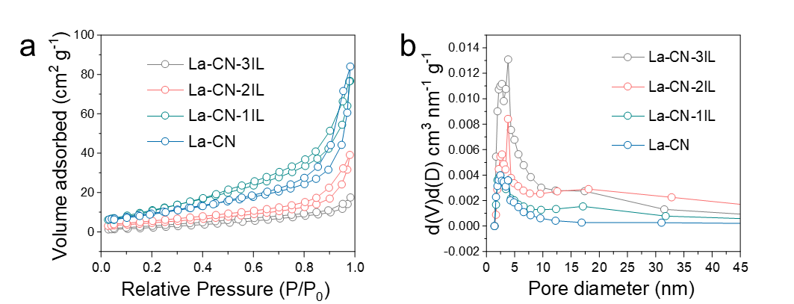
Supplementary Figure 2. N₂ adsorption–desorption isotherms and pore size distributions of La-CN, La-CN-1IL, La-CN-2IL and La-CN-3IL. a N₂ adsorption-desorption isotherms measured at 77 K. b Barrett-Joyner-Halenda (BJH) pore size distributions derived from the desorption branches.
All samples exhibit type-IV isotherms with distinct capillary condensation steps at high relative pressures (P/P₀ > 0.8), indicating the presence of mesopores. The adsorbed volume decreases monotonically with increasing IL loading, from approximately 85 cm³ g⁻¹ for La-CN to 18 cm³ g⁻¹ for La-CN-3IL at P/P₀ ≈ 0.99. All samples show a single mesopore peak centered at approximately 2-3 nm. With increasing IL loading, the peak intensity increases progressively and the peak position shifts from approximately 2 nm (La-CN and La-CN-1IL) to approximately 2.5 nm (La-CN-2IL) and further to approximately 3 nm (La-CN-3IL), accompanied by peak broadening. The decrease in BET surface area (Supplementary Table 1) and the increase in mesopore peak intensity together indicate that IL treatment transforms the g-C₃N₄ nanosheets from tightly ordered stacking to loosely disordered stacking.
Supplementary Table 1. Specific surface area and pore volume of La -CN samples.
Samples | Surface area ª  (m² g⁻¹) | Pore diameter ^{b} (nm) | Pore volume ^{c}  (cm³ g⁻¹)
La -CN | 68.801 | 3.845 | 0.130
La-CN-IL | 44.035 | 3.812 | 0.134
La-CN-2IL | 41.937 | 3.801 | 0.106
La-CN-3IL | 34.487 | 3.794 | 0.103
a Surface area derived from the BET equation;
b Pore diameter, obtained from the BJH method desorption;
c Pore volume, obtained from the volume of nitrogen adsorbed at a relative pressure of 0.99.

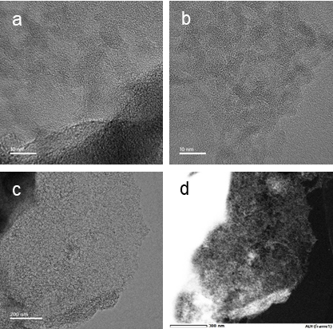
Supplementary Figure 3. TEM images of La-CN and La-CN-IL. a High-resolution TEM image of La-CN showing the typical amorphous contrast without discernible lattice fringes, indicating the absence of long-range crystalline order. The darker contrast in the lower-right region corresponds to stacked or folded sheet areas. b High-resolution TEM image of La-CN-IL showing more uniform amorphous contrast with no observable lattice fringes or crystalline particles, suggesting a more homogeneous and flattened sheet structure compared with La-CN. c Low-magnification TEM image of La-CN-IL showing a continuous two-dimensional sheet morphology with irregular, serrated edges and a uniform internal contrast. d Dark-field TEM image showing the selected area for EDS elemental mapping, displaying an irregular, fluffy agglomerated morphology with bright regions corresponding to thinner areas of the sample. Scale bars: 10 nm (a,b), 200 nm (c), 300 nm (d).
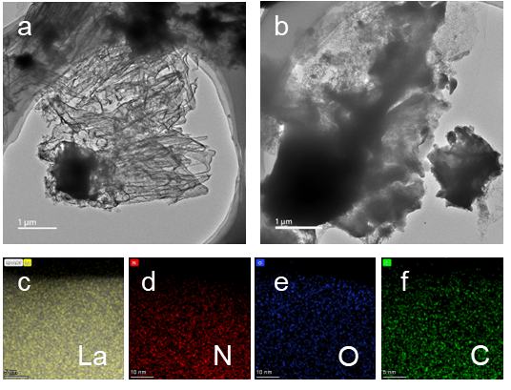
Supplementary Figure 4. Low-magnification TEM images and EDS elemental mapping of La-CN and La-CN-IL. a Low-magnification TEM image of La-CN showing a micron-scale layered agglomerate with clearly discernible sheet wrinkles and folds, where bright regions correspond to thinner sheet areas and dark regions correspond to stacked or thickened sheets. b Low-magnification TEM image of La-CN-IL showing an irregular block-like agglomerate with significantly weakened layered features compared with La-CN, indicating that the ordered layered stacking is disrupted and transformed into a disordered, densely packed structure. c-f EDS elemental mapping of La-CN-IL showing the distribution of La (yellow, c), N (red, d), O (blue, e) and C (green, f). All elements are homogeneously distributed over the entire scanned region, with no local enrichment or aggregation of La species detected, confirming the uniform dispersion of La-O subnanoclusters on the g-C₃N₄ support. Scale bars: 5 nm (c, f), 10 nm (d, e).
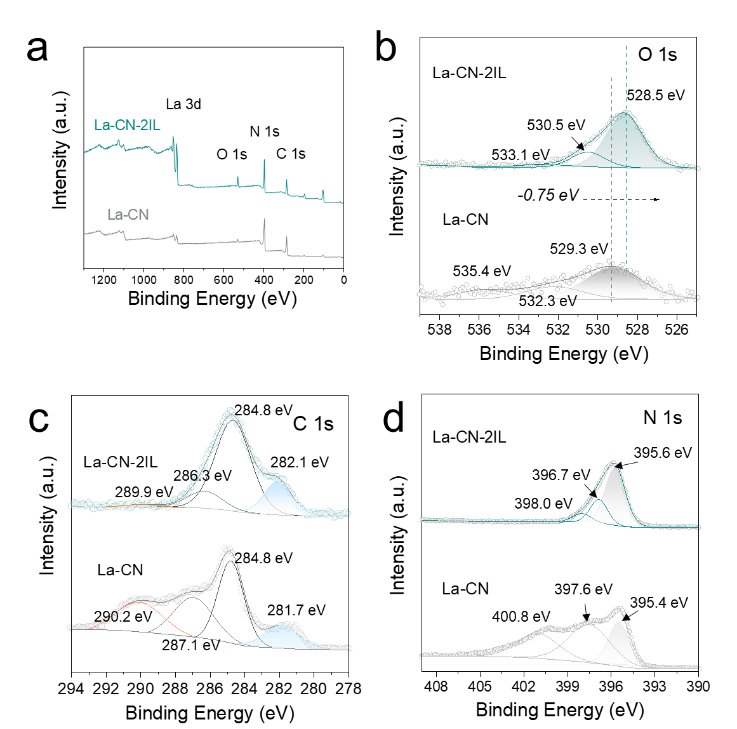
Supplementary Figure 5. XPS spectra of La-CN and La-CN-2IL. a Survey XPS spectra showing the presence of C 1s (~285 eV), N 1s (~400 eV), O 1s (~530 eV) and La 3d (~840 eV) in both samples, with no additional elements detected after IL treatment. b High-resolution O 1s spectra deconvoluted into three components corresponding to metal-bonded oxygen (529.3 eV for La-CN; 528.5 eV for La-CN-2IL), surface hydroxyl/adsorbed oxygen (532.3 eV for La-CN; 530.5 eV for La-CN-2IL) and adsorbed water (535.4 eV for La-CN; 533.1 eV for La-CN-2IL). The O 1s peaks of La-CN-2IL exhibit an overall negative shift of approximately 0.75 eV relative to La-CN, indicating increased electron density around the O atoms and enhanced La-O interaction upon IL modification. c High-resolution C 1s spectra of La-CN and La-CN-2IL. The peaks at 284.8 eV correspond to adventitious carbon used for charge correction. The components show divergent shifts: the N-C=N framework carbon shifts from 287.1 eV to 286.3 eV, the π-π* satellite shifts from 290.2 eV to 289.9 eV (both towards lower binding energy), and the low-binding-energy component shifts from 281.7 eV to 282.1 eV (towards higher binding energy). d High-resolution N 1s spectra showing the conjugated N peak shifting from 395.4 eV to 395.6 eV and the bridging N peak shifting from 397.6 eV to 398.0 eV. These shifts provide evidence for the introduction of nitrogen vacancies upon IL treatment. All binding energies were calibrated against the adventitious C 1s peak at 284.8 eV.

Supplementary Figure 6. K²-weighted EXAFS k-space spectra of La-CN, La-CN-2IL, La foil and La₂O₃ references. The spectra show the oscillatory EXAFS signals at the La L₃-edge. La foil exhibits low oscillation amplitudes across the entire k-range, while La₂O₃ shows pronounced high-amplitude oscillations. The La-CN and La-CN-2IL samples display similar oscillation patterns with amplitudes lower than that of La₂O₃. Notably, the oscillation amplitude of La-CN-2IL is slightly lower than that of La-CN, suggesting a decrease in the average coordination number and/or an increase in structural disorder around the La species after IL modification, consistent with the EXAFS fitting results (Supplementary Table 2).

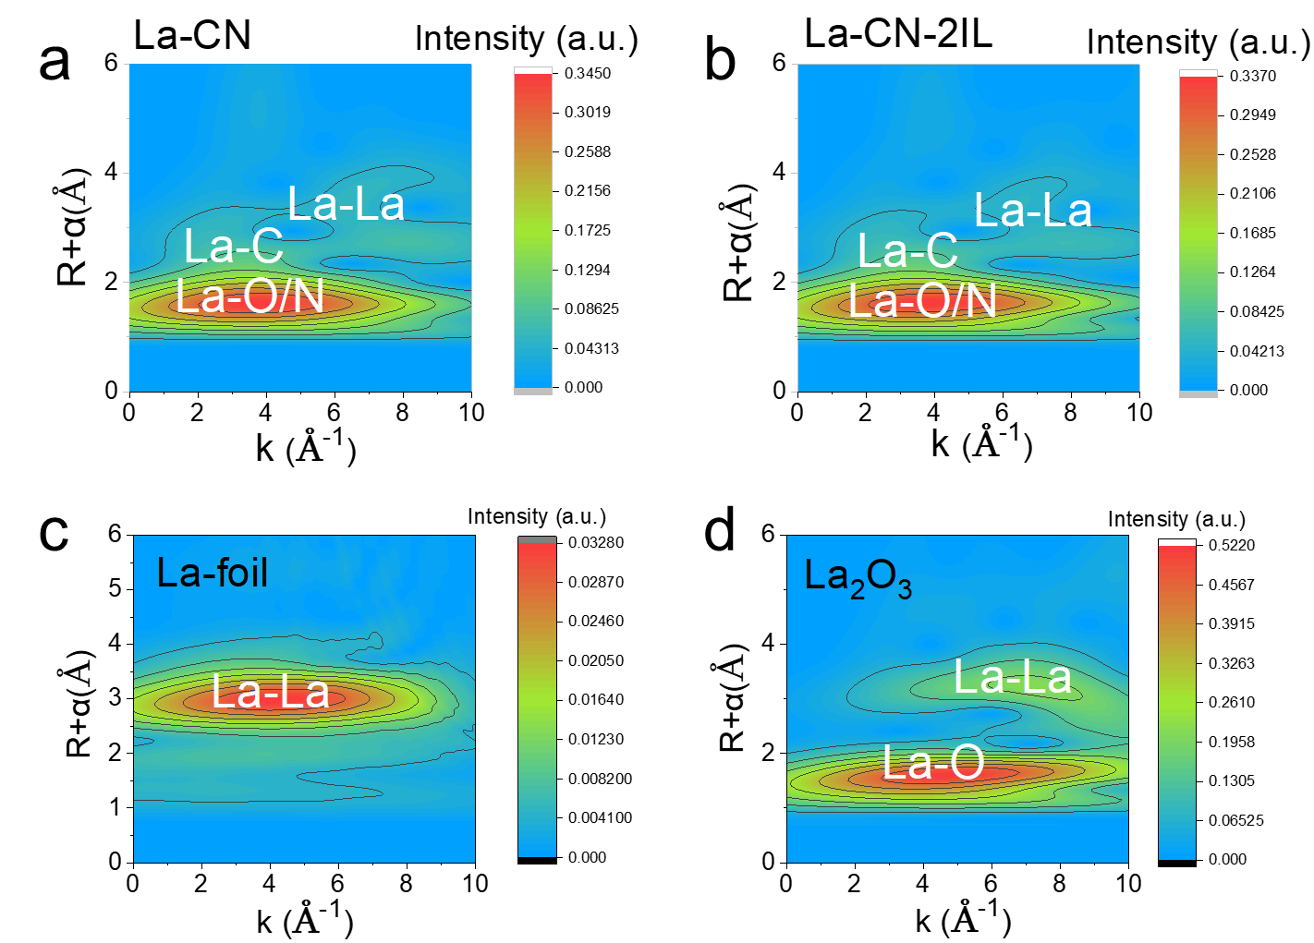
Supplementary Figure 7. Wavelet-transform EXAFS (WT-EXAFS) contour plots of La-CN, La-CN-2IL and reference samples. a WT-EXAFS of La-CN showing three distinct signal regions corresponding to La-O/N (R ≈ 1-2 Å), La-C (R ≈ 2-3 Å) and La-La (R ≈ 3-4 Å) scattering paths, with a maximum intensity of 0.3450. b WT-EXAFS of La-CN-2IL showing the same three signal regions as La-CN with similar distribution positions, but with a slightly decreased maximum intensity of 0.3370. c WT-EXAFS of La foil showing only a strong La-La signal at approximately 3 Å, with no observable La-O/N or La-C signals and a low maximum intensity of 0.0328, consistent with the metallic La structure. d WT-EXAFS of La₂O₃ showing a strong La-O signal at low R and La-La signals at higher R, with a maximum intensity of 0.5220, reflecting the well-ordered crystalline oxide structure. The slightly reduced WT-EXAFS intensity of La-CN-2IL compared with La-CN further supports the increased local structural disorder around La species after IL modification.

Supplementary Table 2. EXAFS fitting parameters at the La K-edge for various samples（set Ѕ₀²=0.95）
 | shell | CNª | R^{b}(Å) | σ^{2c}(Å²) | ΔE₀^{d}(eV) | R factor
La-foil | La-La | 12* | 3.62±0.08 | 0.0117 | -1.1±0.7 | 0.009
LaO | La-O | 6* | 2.34±0.09 | 0.0079 | 4.4±0.7 | 0.015
LaO | La-La | 12* | 3.90±0.05 | 0.0051 | 4.4±0.7 | 0.015
La-CN | La-O | 4.83±0.6 | 2.46±0.09 | 0.0077 | -9.9±0.1 | 0.005
La-CN | La-N | 2.75±0.5 | 2.67±0.01 | 0.0078 | -9.9±0.1 | 0.005
La-CN | La-La | 1.10±0.1 | 3.84±0.05 | 0.0073 | -9.9±0.1 | 0.005
La-CN-2IL | La-O | 5.03±0.4 | 2.49±0.09 | 0.0128 | -9.9±0.3 | 0.004
La-CN-2IL | La-N | 2.57±0.1 | 2.70±0.04 | 0.0139 | -9.9±0.3 | 0.004
La-CN-2IL | La-La | 1.37±0.1 | 3.83±0.01 | 0.0102 | -9.9±0.3 | 0.004
ªCN: coordination numbers; ^{b}R: bond distance; ^{c}σ²: Debye-Waller factors; ^{d} ΔE₀: the inner potential correction. R factor: goodness of fit. Error bounds that characterize the structural parameters obtained by EXAFS spectroscopy were estimated as CN±20%; R ± 1%; σ² ± 20%.

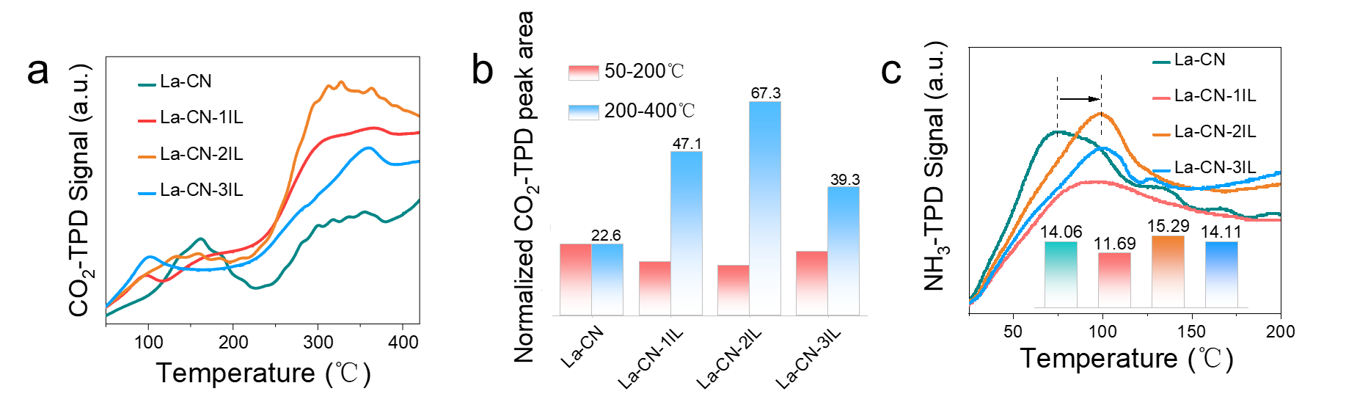
Supplementary Figure 8. CO₂-TPD and NH₃-TPD profiles of La-CN, La-CN-1IL, La-CN-2IL and La-CN-3IL. a CO₂-TPD curves showing desorption peaks in the low-temperature region (50-200 °C) and the medium-temperature region (200-400 °C). The desorption intensity follows the order La-CN-2IL > La-CN-1IL > La-CN-3IL > La-CN at the same temperature, indicating that La-CN-2IL possesses the highest density of basic sites. b Normalized CO₂-TPD peak areas. The medium-temperature region (200-400 °C, blue) contributes predominantly to the total CO₂ desorption. The medium-temperature peak areas are 22.6 for La-CN, 47.1 for La-CN-1IL, 67.3 for La-CN-2IL and 39.3 for La-CN-3IL, confirming that La-CN-2IL exhibits the highest medium-strong basic site density among all samples. c NH₃-TPD curves showing desorption peaks at 50-150 °C (weak acid sites). The integrated peak areas are 14.06 for La-CN, 11.69 for La-CN-1IL, 15.29 for La-CN-2IL and 14.11 for La-CN-3IL. The peak position of La-CN-2IL shifts to higher temperature compared with La-CN (inset), indicating slightly stronger acid strength. These results demonstrate that La-CN-2IL possesses the optimized surface acid-basic properties, consistent with its superior catalytic performance.
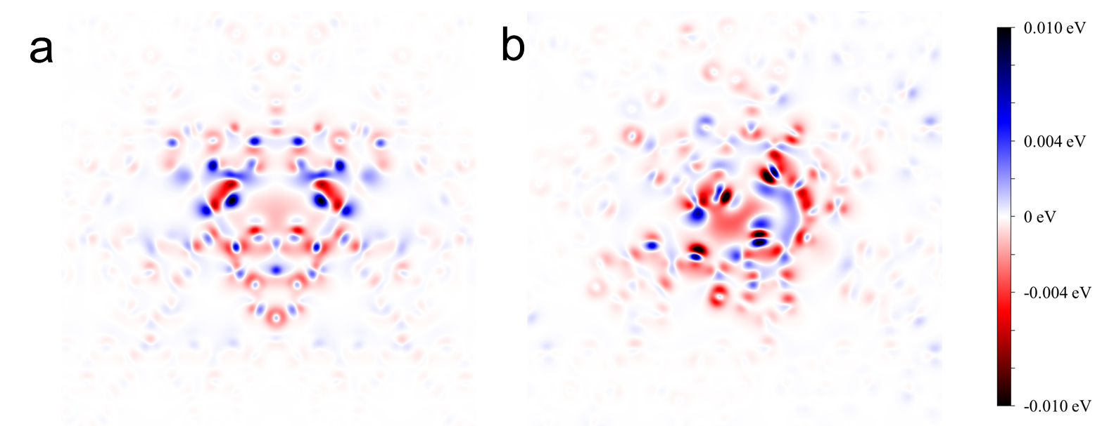
Supplementary Figure 9. 2D charge density difference slices of La-CN and La-CN-IL. a 2D slice of La-CN showing charge redistribution highly localized around the La-N bonds at the interface between the La cluster and the g-C₃N₄ support. The electron accumulation (blue) and depletion (red) regions are symmetrically distributed along the La-N coordination bonds, indicating a highly localized and ordered charge transfer with clear boundaries. b 2D slice of La-CN-IL showing a significantly expanded charge redistribution region with increased interweaving of electron accumulation and depletion contours. The charge transfer extends over a larger interfacial area and the charge distribution exhibits reduced symmetry compared with La-CN, indicating enhanced charge delocalization due to the presence of surface nitrogen vacancies. The isosurface value is set at 0.010 eV (blue, electron accumulation) and -0.010 eV (red, electron depletion). The enhanced charge delocalization and asymmetric electron distribution at the LaO-g-C₃N₄ interface in La-CN-IL indicate improved surface electron excitation capability upon defect introduction. The colour scale bar represents the charge density difference in eV.

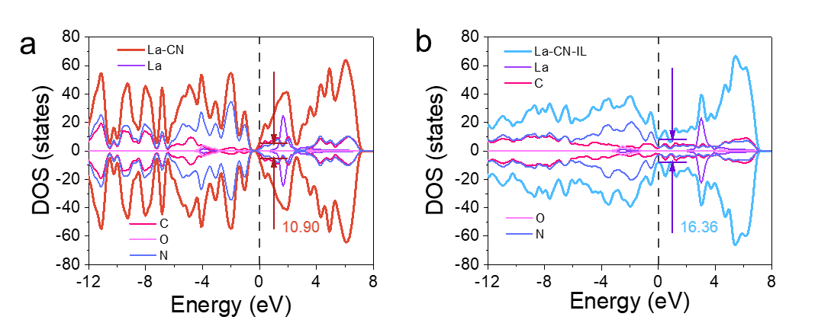
Supplementary Figure 10. Projected density of states (PDOS) of La-CN and La-CN-IL. a PDOS of La-CN showing the total DOS (red) with contributions from La (purple), C (magenta), O (light pink) and N (blue) orbitals. The DOS at the Fermi level (set to 0 eV) is 10.90 states eV⁻¹. The La orbitals exhibit a distinct feature near the Fermi level, and the total DOS shows dense, high-amplitude oscillations in the valence band region (-12 to 0 eV). b PDOS of La-CN-IL showing the total DOS (light blue) with contributions from La (purple), C (magenta), O (light pink) and N (blue) orbitals. The DOS at the Fermi level increases significantly to 16.36 states eV⁻¹, with enhanced La orbital intensity near the Fermi level compared with La-CN. The total DOS in the conduction band region (0-8 eV) shows substantially higher amplitude in La-CN-IL than in La-CN. Orbital overlaps between La, C, N and O are observed near the Fermi level in both samples. The increased DOS at the Fermi level and the broader energy distribution in La-CN-IL indicate enhanced electronic communication between the LaO clusters and the defective g-C₃N₄ support, which facilitates surface electron transfer. The Fermi level is set to 0 eV (dashed line).

Supplementary Table 3. Summary of computed Bader charge and corresponding atomic state value for La, O, average C and average N atoms over La-CN and ionic liquid modified La-CN (La-CN-IL) catalysts.
Sample | Atom | Bader charge | State value
La-CN | La1 | 9.049 | 3.901
La-CN | La2 | 9.052 | 3.896
La-CN | O1 | 7.173 | -2.346
La-CN | O2 | 7.139 | -2.277
La-CN | Average C | 2.502 | 2.996
La-CN | Average N | 6.136 | -2.272
La-CN-IL | La1 | 9.074 | 3.853
La-CN-IL | La2 | 9.059 | 3.882
La-CN-IL | O1 | 7.171 | -2.341
La-CN-IL | O2 | 7.170 | -2.339
La-CN-IL | Average C | 2.739 | 2.521
La-CN-IL | Average N | 6.145 | -2.290

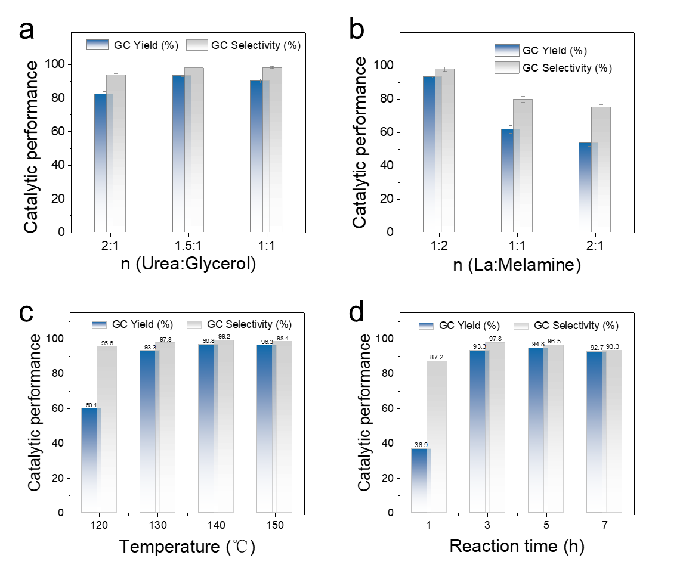
Supplementary Figure 11. Optimization of reaction conditions for urea-glycerol conversion to GC over La-CN-2IL. a Effect of urea-to-glycerol molar ratio on GC yield (blue bars) and selectivity (grey bars). The GC yield reaches a maximum at a urea-to-glycerol ratio of 1.5:1, while the selectivity remains above 95% across all tested ratios. b Effect of La-to-melamine precursor molar ratio on GC yield and selectivity. The optimal performance is achieved at a La:melamine ratio of 1:2; higher La loadings lead to a significant decrease in both yield and selectivity due to possible aggregation of La species. c Effect of reaction temperature on GC yield and selectivity. The GC yield increases from 60.1% at 120 °C to 96.8% at 140 °C, then slightly decreases at 150 °C, with the selectivity reaching 99.2% at 140 °C. d Effect of reaction time on GC yield and selectivity. The GC yield increases rapidly to 93.3% at 3 h and reaches a maximum of 94.8% at 5 h, followed by a slight decrease at 7 h. The selectivity remains above 96% for reaction times up to 5 h. Error bars in a and b represent the standard deviation from three independent measurements. Reaction conditions: La-CN-2IL catalyst 50 mg, 10 Kpa. The optimal conditions are identified as urea:glycerol=1.5:1, La:melamine=1:2, temperature=130 °C, and reaction time=3 h.

Supplementary Figure 12. Recycling stability test of La-CN-2IL catalyst for GC production. GC yield (blue bars) and selectivity (grey bars) over six consecutive cycles. The GC yield decreases slightly from 93.3% in the first cycle to 89.7% in the fifth cycle, then recovers to 90.2% in the sixth cycle, with selectivity remaining above 95.6% throughout all cycles. The minimal decline in catalytic performance (less than 3.6 percentage points over six cycles) demonstrates the excellent reusability and stability of La-CN-2IL, indicating no significant loss of active species during the recycling process. Reaction conditions: 130 °C, 3 h, urea:glycerol = 1.5:1, catalyst 50 mg, 10 kPa.
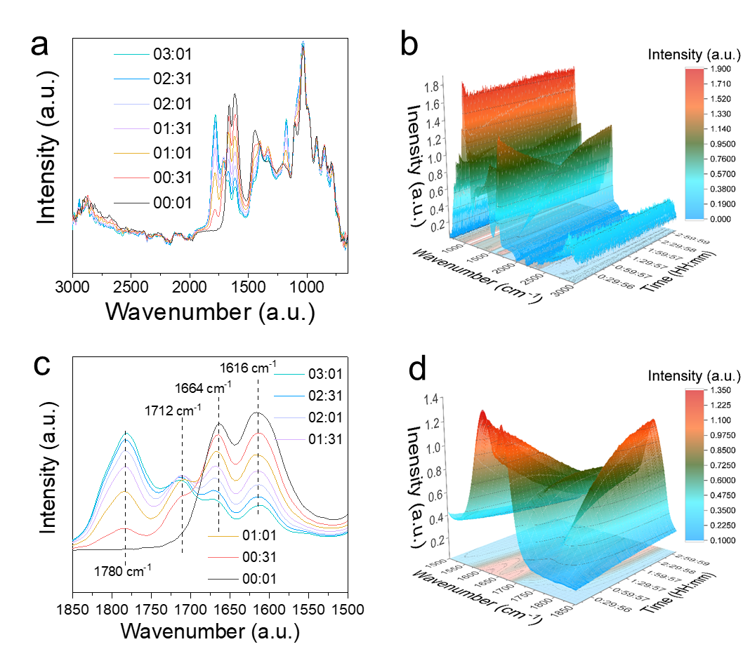
Supplementary Figure 13. React IR spectra during urea-glycerol conversion to GC over La-CN-2IL. a Full-range 2D stacked spectra at selected reaction times (00:01, 00:31, 01:01, 01:31, 02:01, 02:31 and 03:01), with colours transitioning from grey (initial) to cyan (final). The main absorption bands are observed in the 1000-1700 cm⁻¹ region. b 3D waterfall plot of the full-range spectra showing the time-dependent evolution of IR signals. c Enlarged 3D waterfall plot focusing on the carbonyl/product region, showing dynamic intensity changes without significant band distortion over time. d 2D enlarged spectra in the 1850-1500 cm⁻¹ region, revealing the evolution of resolved peaks corresponding to different species: 1780 cm⁻¹ (GC), 1712 cm⁻¹ (HGC C=O), 1664 cm⁻¹ (urea C=O), 1452 cm⁻¹ (C-NH₂), and 1328 cm⁻¹ (HGC-NH₂). The absorption in the 1000-1700 cm⁻¹ region also includes contributions from the g-C₃N₄ framework (C=N/C-N stretching vibrations). The spectra were collected with a resolution of 4 cm⁻¹ at 15 s intervals over a total acquisition time of 3.5 h.

Supplementary Figure 14. React IR intensity profiles of key species during urea-glycerol conversion to GC over La-CN-2IL. The left y-axis shows the IR absorption intensity (a.u.) and the right y-axis shows the reaction temperature (°C). The temperature profile (red dotted curve) increases rapidly from 80 °C to approximately 130 °C within the first 30 min and then remains constant at ~130 °C for the remainder of the reaction. The intensity profiles of five characteristic peaks are shown: 1664 cm⁻¹ (light blue, R-C=O, monotonically decreasing), 1452 cm⁻¹ (light yellow, C-NH₂, slowly decreasing), 1328 cm⁻¹ (green, HGC-NH₂, first rising then falling), 1712 cm⁻¹ (dark blue, HGC C=O, first rising then falling), and 1780 cm⁻¹ (purple, GC, continuously increasing). The monotonic decay of the urea-related peaks (1664 and 1452 cm⁻¹) indicates continuous urea consumption, while the rise-and-fall behavior of the HGC intermediate peaks (1328 and 1712 cm⁻¹) confirms its transformation to the final product GC, whose signal increases steadily throughout the reaction. The data were collected at 15 s intervals over a total acquisition time of 3.5 h.

