Supplementary Table 1. Baseline characteristics of participants with a SARS-CoV-2 infection who provided a nasopharyngeal swab and/or day 28 post-infection blood sample.
 | Nasopharyngeal swab sample |  |  | Day 28 post-infection blood sample
 | Moderna  (N=15) | Novavax  (N=21) | Control*  (N=11) | Moderna  (N=35) | Novavax  (N=32) | Control*  (N=30)
Age (years), median (IQR) | 34.7  (27.0, 53.0) | 32.5  (26.9, 40.2) | 39.9  (28.1, 51.1) | 34.7  (25.7, 53.7) | 32.4  (26.8, 41.8) | 43.6  (35.4, 51.1)
<50, n (%) | 11 (73.3) | 19 (90.5) | 7 (63.6) | 24 (68.6) | 30 (93.8) | 20 (66.7)
≥50, n (%) | 4 (26.7) | 2 (9.5) | 4 (36.4) | 11 (31.4) | 2 (6.3) | 10 (33.3)
Female, n (%) | 11 (73.3) | 17 (81.0) | 9 (81.8) | 21 (60.0) | 26 (81.3) | 25 (83.3)
Comorbidities, n (%)
Obesity (BMI ≥30 kg/m²) | 3 (20.0) | 6 (28.6) | 2 (18.2) | 5 (14.3) | 10 (31.3) | 5 (16.7)
Hypertension | 1 (6.7) | 1 (4.8) | 0 | 2 (5.7) | 1 (3.1) | 1 (3.3)
Diabetes mellitus | 0 | 0 | 0 | 0 | 0 | 0
Cardiovascular disease | 0 | 0 | 0 | 0 | 0 | 0
BMI: body mass index; IQR: interquartile range. *This was a non-randomised arm.
Supplementary Table 2. Paired SARS-CoV-2 IgG, sVNT and IFNγ responses (median and interquartile ranges [IQR]) at the pre-infection and day 28 post-infection visits for participants with SARS-CoV-2 infection, by vaccine arm and timepoint. This analysis only includes the first SARS-CoV-2 infection event for each participant and excludes SARS-CoV-2 infections that occurred within 14 days of enrolment or after the 12-month visit. The preceding study visit for 0-6 months is day 0 (control arm) or day 28 (vaccine arms), and for 7-12 months is 6 months (all arms).
 | 0-6 months |  |  |  |  |  | 7-12 months
 | Moderna  (N=13) |  | Novavax  (N=17) |  | Control  (N=18) |  | Moderna  (N=22) |  |  | Novavax  (N=15) |  | Control  (N=12)
 | Pre | Post | Pre | Post | Pre | Post |  | Pre | Post | Pre | Post | Pre | Post
IgG
WT  (BAU/mL) | 6908  (5315, 9710) | 3014  (2162, 3397) | 2245  (1506, 4443) | 2314  (1722, 4222) | 1142  (588, 1843) | 2396  (2225, 3544) |  | 2049  (1371, 3214) | 3451  (2000, 4352) | 1801  (920, 2963) | 2416  (1820, 3710) | 981  (535, 1591) | 2345  (1643, 3456)
BA.1  (RU/mL) | 969  (737, 1317) | 518  (463, 790) | 282  (193, 630) | 534  (391, 650) | 149  (115, 194) | 500  (404, 632) |  | 327  (212, 574) | 614  (357, 747) | 312  (127, 366) | 608  (560, 761) | 133  (77, 225) | 483  (297, 845)
BA.4/5  (EU/mL) | 1204  (556, 1744) | 790  (615, 1083) | 383  (274, 608) | 693  (616, 779) | 175  (126, 271) | 846  (571, 1098) |  | 433  (280, 681) | 623  (383, 870) | 348  (157, 519) | 573  (304, 1068) | 179  (93, 343) | 575  (275, 813)
JN.1  (EU/mL) | 902  (608, 1256) | 554  (490, 624) | 288  (162, 453) | 497  (315, 681) | 105  (69, 170) | 441  (330, 644) |  | 279  (176, 462) | 481  (275, 743) | 169  (83, 267) | 419  (239, 564) | 100  (58, 174) | 391  (143, 542)
sVNT
WT  (U/mL) | 262,388  (152,577, 298,312) | 72,022  (62,097, 84,895) | 66,172  (54,936, 120,527) | 62,817  (54,526, 103,507) | 52,521  (37, 118, 82,527) | 68,924  (45,346, 82,913) |  | 81,762  (60,681, 146,718) | 55,732  (36,547, 76,103) | 74,669  (39,559, 133,556) | 56,541  (35,311, 106,796) | 40,930  (26,462, 65,548) | 58,735  (36,346, 86,641)
BA.1  (U/mL) | 60, 373  (32,247, 88,336) | 28,116  (19,182, 95,012) | 14,566  (8888, 26,140) | 39,730  (23,211, 54,549) | 10,753  (6960, 18,791) | 28,504  (18,407, 47,208) |  | 25,151  (11,592, 42,658) | 38,561  (17,565, 74,325) | 16,925  (5367, 30,141) | 34,702  (13,801, 69,913) | 8542  (4293, 18,635) | 40,603  (16,973, 87,233)
BA.4/5  (U/mL) | 119,207  (71,813, 204,331) | 88,196  (56,268, 272,975) | 20,856  (13,937, 46,104) | 124,625  (87,575, 158,762) | 11,606  (6104, 20,881) | 108,481  (72,792, 166,237) |  | 50,723  (31,050, 124,175) | 74,702  (54,884, 153,445) | 28,982  (16,108, 55,677) | 111,612  (53,922, 128,334) | 15,269  (8210, 34,065) | 94,948  (46,254, 231,964)
IFNγ
Ag1  (IU/mL) | 1.11  (0.28, 5.78) | 0.52  (0.30, 1.09) | 1.86  (1.02, 2.28) | 1.36  (0.97, 2.26) | 0.80  (0.49, 1.14) | 0.67  (0.26, 1.63) |  | 0.83  (0.22, 1.73) | 0.72  (0.25, 1.60) | 0.80  (0.61, 1.45) | 0.77  (0.35, 1.91) | 0.48  (0.13, 0.56) | 0.51  (0.18, 1.04)
Ag2  (IU/mL) | 1.70  (0.41, 2.73) | 0.94  (0.42, 2.67) | 2.69  (1.50, 3.60) | 2.46  (1.53, 3.75) | 1.24  (0.75, 1.90) | 1.17  (0.74, 3.20) |  | 1.63  (0.45, 4.22) | 1.47  (0.48, 1.83) | 2.01  (1.08, 2.79) | 2.06  (0.45, 3.10) | 0.53  (0.19, 1.24) | 0.94  (0.24, 1.61)
Ag: antigen; IFNγ: interferon-gamma; sVNT: surrogate virus neutralisation test; WT: wildtype.
 | Post-infection vs pre-infection |  |  |  |  |  | Moderna vs Novavax
 | 0-6 months |  |  | 7-12 months |  |  | 0-6 months |  | 7-12 months
 | Moderna  (N=13) | Novavax  (N=17) | Control  (N=18) | Moderna  (N=22) | Novavax  (N=15) | Control  (N=12) | Pre-infection  (N=30) | Post-infection  (N=30) | Pre-infection  (N=37) | Post-infection  (N=37)
IgG
WT | 0.51  (0.34, 0.75) | 1.05  (0.74, 1.50) | 2.24  (1.48, 3.40) | 1.41  (1.15, 1.72) | 1.90  (1.34, 2.69) | 2.17  (1.29, 3.67) | 2.73  (1.77, 4.22) | 1.40  (0.89, 2.19) | 1.33  (0.96, 1.86) | 1.20  (0.85, 1.71)
BA.1 | 0.76  (0.54, 1.08) | 1.68  (1.10, 2.56) | 3.87  (2.53, 5.91) | 1.51  (1.28, 1.78) | 3.16  (2.14, 4.66) | 3.75  (2.25, 6.26) | 2.75  (1.75, 4.34) | 1.29  (0.87, 1.91) | 1.47  (1.06, 2.04) | 0.85  (0.63, 1.15)
BA.4/5 | 0.91  (0.58, 1.44) | 1.92  (1.20, 3.07) | 4.58  (2.86, 7.34) | 1.28  (1.02, 1.60) | 2.63  (1.81, 3.84) | 2.88  (1.43, 5.82) | 2.85  (1.78, 4.57) | 1.27  (0.89, 1.81) | 1.61  (1.13, 2.29) | 0.96  (0.61, 1.51)
JN.1 | 0.71  (0.44, 1.13) | 1.76  (1.18, 2.60) | 4.33  (3.03, 6.19) | 1.49  (1.20, 1.86) | 3.01  (2.12, 4.27) | 3.24  (1.77, 5.94) | 3.24  (2.13, 4.94) | 1.48  (1.00, 2.18) | 1.88  (1.37, 2.58) | 1.12  (0.70, 1.77)
sVNT
WT | 0.40  (0.28, 0.56) | 0.86  (0.64, 1.16) | 1.11  (0.80, 1.54) | 0.63  (0.53, 0.74) | 0.98  (0.73, 1.31) | 1.39  (1.06, 1.80) | 2.98  (2.02, 4.41) | 1.11  (0.69, 1.78) | 1.24  (0.88, 1.75) | 0.90  (0.59, 1.36)
BA.1 | 0.48  (0.12, 1.94) | 2.16  (1.54, 3.03) | 3.19  (2.09, 4.88) | 1.38  (1.02, 1.87) | 2.39  (1.17, 4.89) | 3.38  (1.59, 7.22) | 3.85  (2.13, 6.96) | 0.56  (0.15, 2.17) | 1.91  (1.20, 3.02) | 1.44  (0.66, 3.12)
BA.4/5 | 1.12  (0.63, 2.00) | 3.78  (2.08, 6.86) | 8.77  (5.63, 13.7) | 1.57  (1.02, 2.42) | 4.45  (2.98, 6.66) | 4.92  (2.54, 9.53) | 5.05  (2.46, 10.4) | 0.97  (0.47, 1.99) | 2.18  (1.39, 3.41) | 0.93  (0.48, 1.79)
IFNγ
Ag1 | 0.39  (0.13, 1.15) | 0.80  (0.44, 1.44) | 0.90  (0.46, 1.75) | 1.20  (0.72, 2.01) | 1.04  (0.62, 1.76) | 1.28  (0.87, 1.89) | 0.82  (0.33, 2.00) | 0.47  (0.20, 1.08) | 0.75  (0.31, 1.82) | 0.91  (0.40, 2.07)
Ag2 | 0.52  (0.27, 1.00) | 0.93  (0.54, 1.58) | 1.15  (0.66, 1.99) | 1.15  (0.83, 1.59) | 0.88  (0.29, 2.66) | 0.87  (0.28, 2.67) | 0.56  (0.28, 1.11) | 0.46  (0.22, 0.99) | 0.71  (0.27, 1.88) | 0.79  (0.33, 1.88)
Supplementary Table 3. Geometric mean ratios of SARS-CoV-2 IgG, sVNT and IFNγ responses in the post- vs pre-infection timepoints and Moderna vs Novavax for participants with SARS-CoV-2 infection. This analysis only includes the first SARS-CoV-2 infection event for each participant and excludes SARS-CoV-2 infections that occurred within 14 days of enrolment or after the 12-month visit. The preceding study visit for 0-6 months is day 0 (control arm) or day 28 (vaccine arms), and for 7-12 months is 6 months (all arms).
Ag: antigen; IFNγ: interferon-gamma; sVNT: surrogate virus neutralisation test; WT: wildtype.
Supplementary Table 4. SARS-CoV-2 IgG, sVNT and IFNγ responses (median and interquartile ranges [IQR]) at the preceding study visit for participants with and without SARS-CoV-2 infection, by vaccine arm and timepoint. This analysis only includes the first SARS-CoV-2 infection event for each participant and excludes SARS-CoV-2 infections that occurred within 14 days of enrolment or after the 12-month visit. This analysis excludes participants who experienced a ≥1.2 fold-change of Spike-specific SARS-CoV-2 WT IgG between study visits. The preceding study visit for 0-6 months is day 0 (control arm) or day 28 (vaccine arms), and for 7-12 months is 6 months (all arms).
 | 0-6 months |  |  |  |  |  |  | 7-12 months
 | Moderna  (N=159) |  | Novavax  (N=142) |  | Control  (N=106) |  |  | Moderna  (N=147) |  | Novavax  (N=123) |  | Control  (N=94)
SARS-CoV-2 infection | Yes  (N=18) | No  (N=141) | Yes  (N=22) | No  (N=120) |  | Yes  (N=20) | No  (N=86) | Yes  (N=39) | No  (N=108) | Yes  (N=28) | No  (N=95) | Yes  (N=24) | No  (N=70)
IgG
WT  (BAU/mL) | 6908  (5315, 9710) | 6961  (4581, 10,607) | 2245  (1507, 4443) | 3310  (1805, 5606) |  | 1142  (588, 1843) | 1579  (724, 2882) | 2049  (1371, 3214) | 2880  (1567, 4997) | 1801  (920, 2963) | 1667  (887, 2749) | 981  (535, 1591) | 1610  (874, 2480)
BA.1  (RU/mL) | 969  (737, 1317) | 983  (641, 1505) | 282  (193, 630) | 398  (231, 710) |  | 149  (115, 194) | 201  (77, 388) | 327  (212, 574) | 497  (292, 804) | 312  (127, 366) | 282  (166, 520) | 133  (77, 225) | 244  (138, 415)
BA.4/5  (EU/mL) | 1204  (556, 1744) | 1146  (699, 1921) | 383  (274, 608) | 520  (304, 872) |  | 175  (126, 271) | 298  (130, 647) | 433  (280, 681) | 562  (335, 1021) | 348  (157, 519) | 372  (209, 665) | 179  (93, 343) | 381  (206, 569)
JN.1  (EU/mL) | 902  (608, 1256) | 798  (569, 1225) | 288  (162, 453) | 354  (196, 520) |  | 105  (69, 170) | 206  (86, 360) | 279  (176, 462) | 383  (241, 539) | 169  (83, 267) | 224  (143, 427) | 100  (58, 174) | 201  (110, 350)
sVNT
WT  (U/mL) | 262,388  (152,577, 298,312) | 228,936  (132,265, 357,289) | 66,173  (54,936, 120,527) | 97,562  (60,594, 174,768) |  | 52,521  (37,118, 82,527) | 76,043  (39,253, 163,027) | 81,762  (60,681, 146, 718) | 88,648  (53,532, 164,259) | 74,669  (39,559, 133,556) | 59,048  (40,305, 102,744) | 40,930  (26,462, 65,548) | 59,531  (30,978, 99,801)
BA.1  (U/mL) | 60,373  (32,247, 88,336) | 56,442  (29,849, 150,261) | 14,566  (8888, 26,140) | 19,853  (11,200, 40,124) |  | 10,753  (6960, 18,791) | 17,976  (9756, 30,366) | 25,151  (11,592, 42,658) | 28,331  (14,079, 65,283) | 16,925  (5367, 30,141) | 17,060  (7938, 37,110) | 8542  (4293, 18,635) | 21,181  (8694, 47,208)
BA.4/5  (U/mL) | 119,207  (71,813, 204,331) | 130,331  (69,435, 230,518) | 20,856  (13,937, 46,104) | 37,911  (16,713, 111,048) |  | 11,606  (6104, 20,881) | 22,322  (8077, 68,992) | 50,723  (31,050, 124,175) | 65,626  (34,365, 181,042) | 28,982  (16,108, 55,677) | 37,491  (15,591, 76,919) | 15,269  (8210, 34,065) | 44,539  (16,129, 95,805)
IFNγ
Ag1  (IU/mL) | 1.11  (0.28, 5.78) | 1.48  (0.78, 2.57) | 1.86  (1.02, 2.28) | 1.40  (0.84, 2.17) |  | 0.80  (0.49, 1.14) | 0.78  (0.53, 1.49) | 0.83  (0.22, 1.73) | 0.55  (0.31, 1.14) | 0.80  (0.61, 1.45) | 0.67  (0.36, 1.29) | 0.48  (0.13, 0.56) | 0.49  (0.21, 0.87)
Ag2  (IU/mL) | 1.70  (0.41, 2.73) | 2.72  (1.20, 4.62) | 2.69  (1.50, 3.60) | 1.89  (1.28, 3.21) |  | 1.24  (0.75, 1.90) | 1.31  (0.67, 2.12) | 1.63  (0.45, 4.22) | 0.98  (0.52, 2.45) | 2.01  (1.08, 2.79) | 1.22  (0.56, 2.19) | 0.53  (0.19, 1.24) | 0.83  (0.39, 1.36)
Ag: antigen; IFNγ: interferon-gamma; sVNT: surrogate virus neutralisation test; WT: wildtype.
Supplementary Table 5. Survival time to SARS-CoV-2 infection, by IgG, sVNT and IFNγ levels at day 0 (control arm) or day 28 (vaccine arms). The 10th, 20th and 30th percentiles of survival times (days [95% confidence intervals]) were calculated. Immune levels were categorised to low (< 25th percentile), medium (25th-75th percentile), or high (>75th percentile).
 | 10th percentile |  |  | 20th percentile |  |  | 30th percentile
 | Low | Medium | High | Low | Medium | High | Low | Medium | High
IgG WT | 131  (55, 198) | 168  (76, 220) | 156  (105, 217) | 198  (63, -) | 232  (219, 259) | 230  (191, 303) | 343  (150, -) | 301  (241, -) | 354  (234, -)
IgG BA.1 | 81  (31, 199) | 168  (91, 219) | 156  (97, 223) | 199  (57, 343) | 232  (205, 261) | 229  (194, 314) | 325  (106, -) | 286  (242, -) | 354  (230, -)
IgG BA.4/5 | 106  (31, 199) | 168  (91, 217) | 169  (91, 229) | 199  (81, 325) | 230  (198, 261) | 236  (205, 354) | 310  (150, -) | 286  (241, -) | 361  (242, -)
IgG JN.1 | 131  (31, 198) | 141  (81, 222) | 169  (105, 217) | 198  (55, 310) | 235  (220, 275) | 229  (191, 303) | 292  (150, -) | 327  (248, -) | 314  (229, -)
sVNT WT | 106  (31, 199) | 159  (91, 220) | 98  (105, 216) | 199  (106, 359) | 237  (219, 286) | 229  (173, 261) | 343  (198, -) | 327  (255, -) | 276  (230, 361)
sVNT BA.1 | 63  (31, 150) | 170  (91, 222) | 173  (138, 217) | 199  (59, 359) | 237  (219, 276) | 229  (194, 275) | 359  (131, -) | 310  (242, -) | 303  (229, -)
sVNT BA.4/5 | 81  (55, 186) | 146  (91, 216) | 194  (105, 228) | 186  (63, 292) | 235  (198, 272) | 230  (217, 324) | 292  (131, -) | 306  (248, -) | 354  (230, -)
IFNγ Ag1 | 48  (31, 198) | 216  (57, 232) | 99  (57, 199) | 198  (31, 282) | 286  (216, -) | 208  (96, 285) | 261  (106, -) | -  (286, -) | 285  (173, -)
IFNγ Ag2 | 110  (31, 219) | 146  (55, 230) | 168  (57, 217) | 219  (31, 286) | 282  (148, -) | 232  (99, 285) | 261  (110, -) | -  (282, -) | 285  (216, -)
sVNT: surrogate virus neutralisation test; IFNγ: interferon-gamma; WT: wildtype; Ag: antigen; CI: confidence interval.
Supplementary Figure 1. Distribution of clades/lineages identified from participants with SARS-CoV-2 infection, by arm. A total of 40 swabs were collected from 153 participants with a SARS-CoV-2 infection (26.1%): (A) All arms, (B) Moderna (n=11, 27.5%), (C) Novavax (n=17, 42.5%), (D) control (n=12, 30.0%). Coloured bars denote the counts of each clade/lineage. The yellow line denotes the proportion of participants with infection that provided a swab sample.
(A)  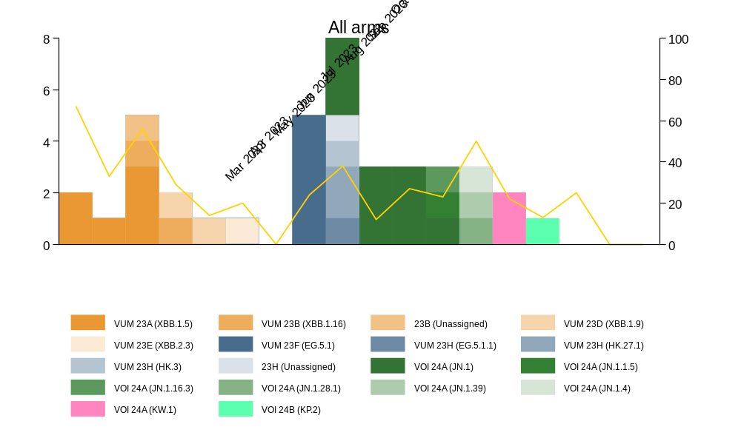 | (B)  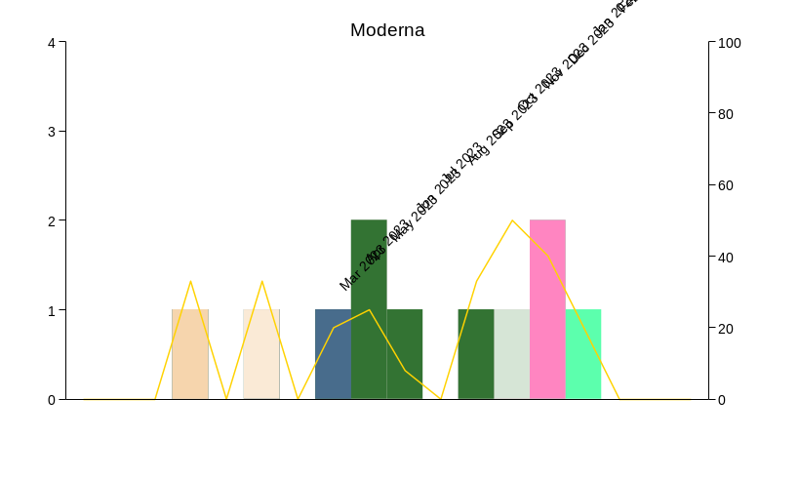
(C)  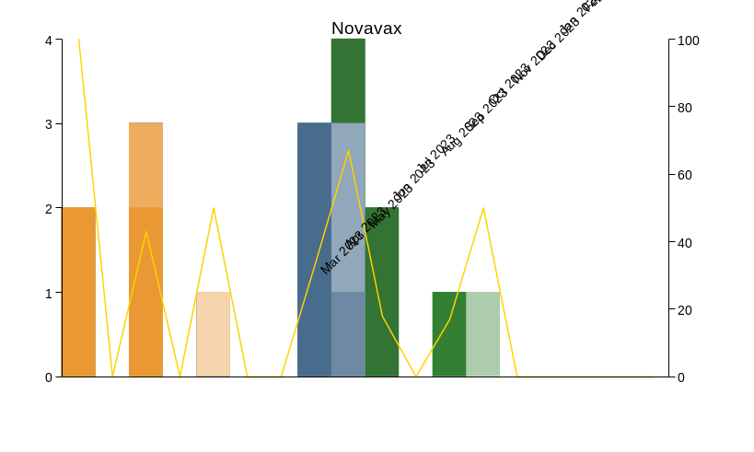 | (D)  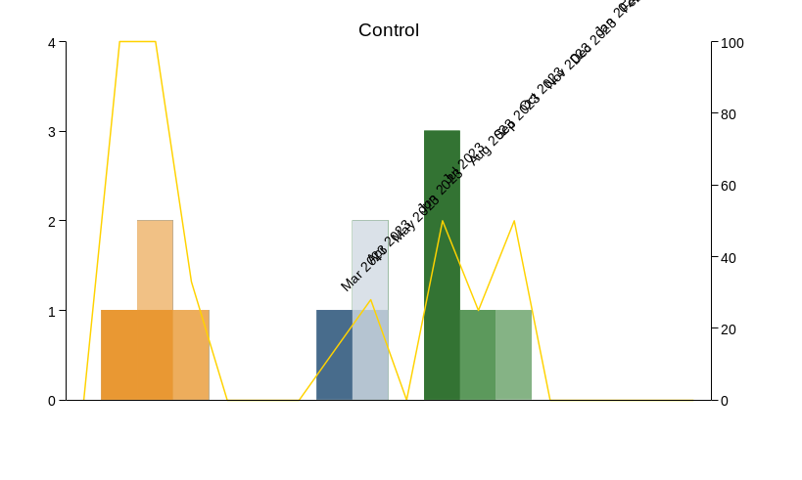
VOC: variant of concern; VUM: variant under monitoring. | 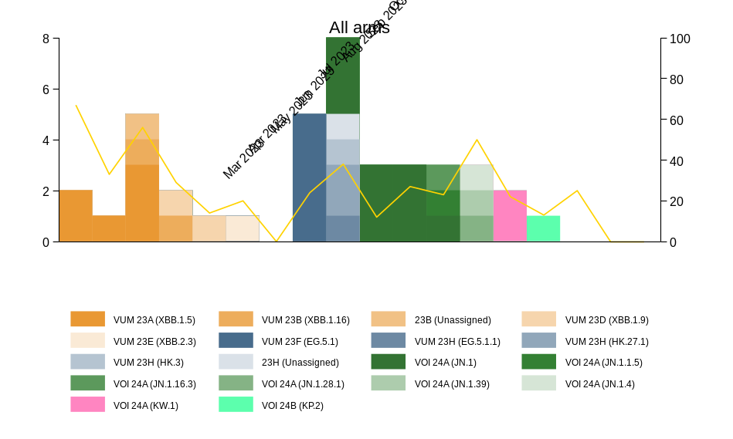

IgG |  | sVNT |  | IFNγ
WT  (BAU/mL) | 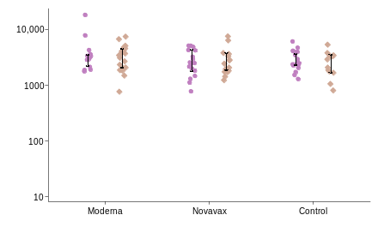 | WT  (U/mL) | 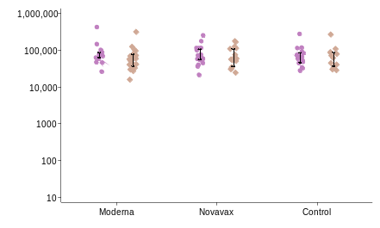 | Ag1  (IU/mL) | 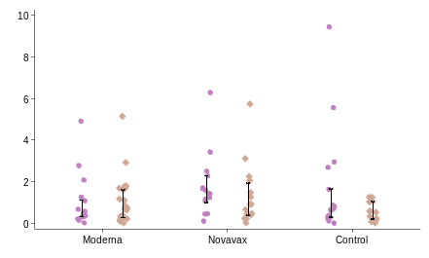
BA.1  (RU/mL) | 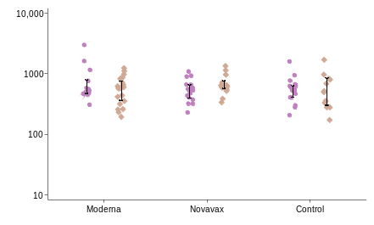 | BA.1  (U/mL) | 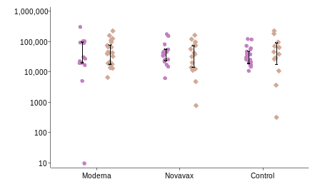 | Ag2  (IU/mL) | 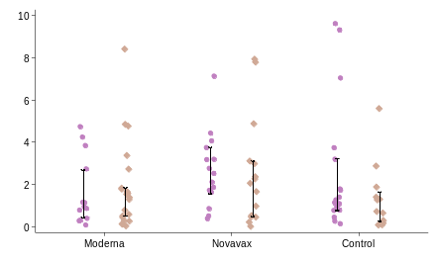
BA.4/5  (EU/mL) | 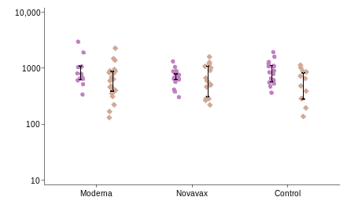 | BA.4/5  (U/mL) | 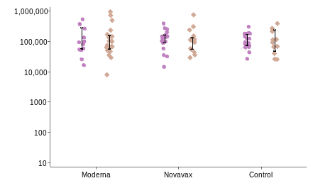
JN.1  (EU/mL) | 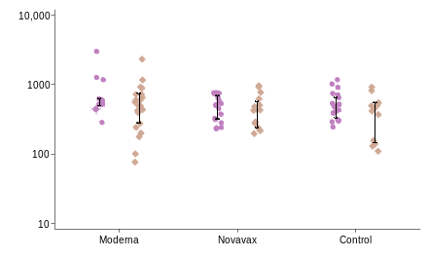
Supplementary Figure 2. SARS-CoV-2 IgG, sVNT and IFNγ response at day 28 post-infection for participants with SARS-CoV-2 infection, by arm and timepoint. This analysis only includes the first SARS-CoV-2 infection event for each participant and excludes SARS-CoV-2 infections that occurred within 14 days of enrolment or after the 12-month visit. Graphs for IFNγ are in the linear scale due to small values. Solid lines are medians and interquartile ranges (IQR). 0-6 months: Moderna (N=13), Novavax (N=17), Control (N=18); 7-12 months: Moderna (N=22), Novavax (N=15), Control (N=12).
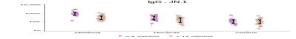
Ag: antigen; BAU: binding antibody units; EU: ELISA units; IFNγ: interferon-gamma; IU: international units; RU: relative units; sVNT: surrogate virus neutralisation test; U: units; WT: wildtype.
IgG |  | sVNT |  | IFNγ
WT  (BAU/mL) | 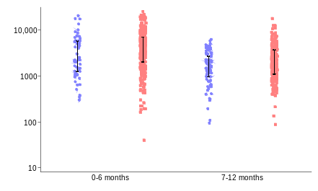 | WT  (U/mL) | 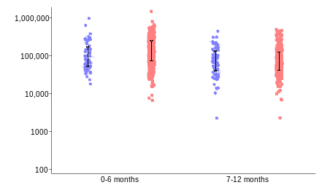 | Ag1  (IU/mL) | 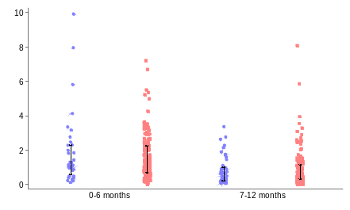
BA.1  (RU/mL) | 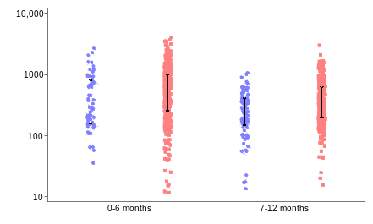 | BA.1  (U/mL) | 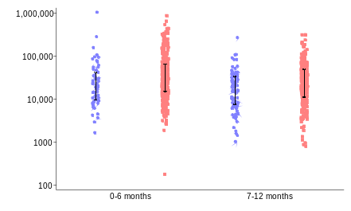 | Ag2  (IU/mL) | 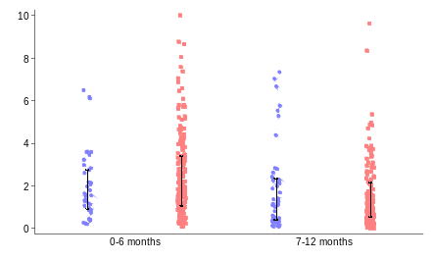
BA.4/5  (EU/mL) | 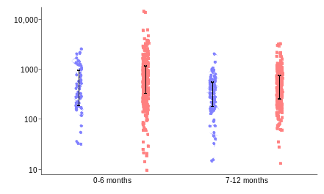 | BA.4/5  (U/mL) | 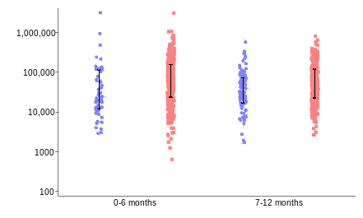 | Ag: antigen; BAU: binding antibody units; EU: ELISA units; IFNγ: interferon-gamma; IU: international units; RU: relative units; sVNT: surrogate virus neutralisation test; U: units; WT: wildtype.
JN.1  (EU/mL) | 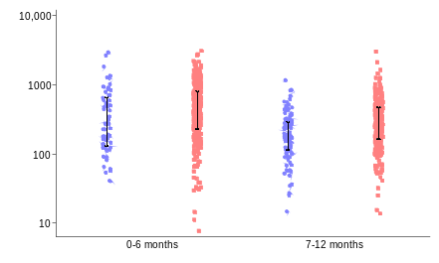
Supplementary Figure 3. SARS-CoV-2 IgG, sVNT and IFNγ responses at the preceding study visit for participants with and without SARS-CoV-2 infection, by timepoint. This analysis only includes the first SARS-CoV-2 infection event for each participant and excludes SARS-CoV-2 infections that occurred within 14 days of enrolment or after the 12-month visit. This analysis excludes participants who experienced a ≥1.2 fold-change of Spike-specific SARS-CoV-2 WT IgG between study visits. The preceding study visit for 0-6 months is day 0 (control arm) or day 28 (vaccine arms), and for 7-12 months is 6 months (all arms). Graphs for IFNγ are in the linear scale due to small values. A zero value for sVNT BA.1 0-6 months was not plotted to maintain visualisation on the logarithmic scale. Solid lines are medians and interquartile ranges (IQR). 0-6 months: IgG (N=436), sVNT (N=436), IFNγ (N=235); 7-12 months: IgG (N=427), sVNT (N=427), IFNγ (N=231).

Supplementary Figure 4. SARS-CoV-2 IgG, sVNT and IFNγ responses at 6- and 12-months post-enrolment for participants with and without SARS-CoV-2 infection, by vaccine arm. This analysis only includes the first SARS-CoV-2 infection event for each participant and excludes SARS-CoV-2 infections that occurred within 14 days of enrolment or after the 12-month visit. This analysis excludes participants who experienced a ≥1.2 fold-change of Spike-specific SARS-CoV-2 WT IgG between study visits. Graphs for IFNγ are in the linear scale due to small values. A zero value for sVNT BA.1 0-6 months was not plotted to maintain visualisation on the logarithmic scale. Solid lines are medians and interquartile ranges (IQR). 6 months: IgG (N=434), sVNT (N=434), IFNγ (N=233); 12 months: IgG (N=426), sVNT (N=426), IFNγ (N=242).
 | 6 months | 12 months
IgG
WT  (BAU/mL) | 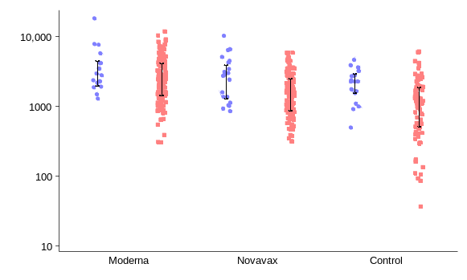 | 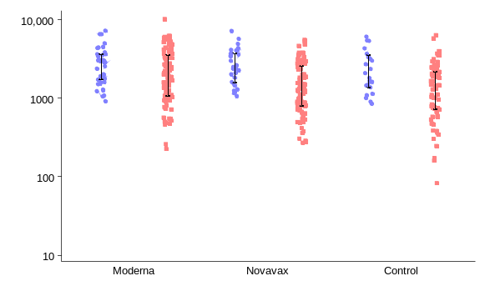
BA.1  (RU/mL) | 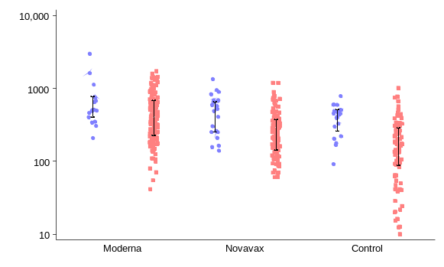 | 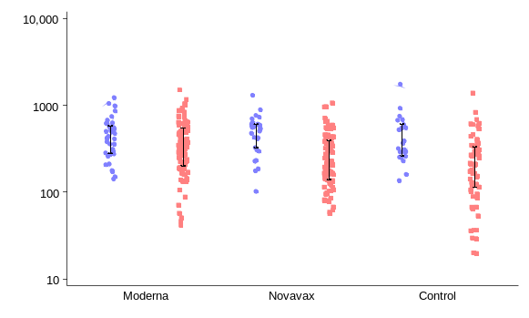
BA.4/5  (EU/mL) | 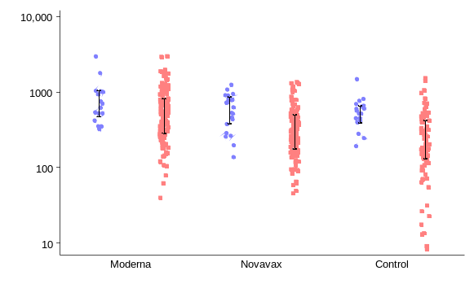 | 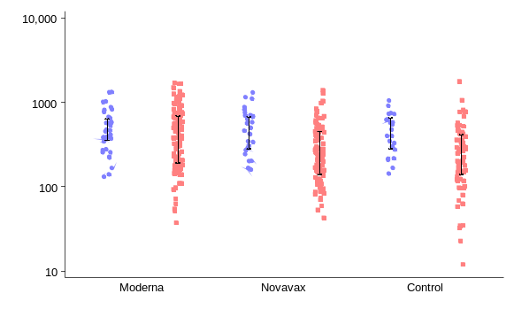
JN.1  (EU/mL) | 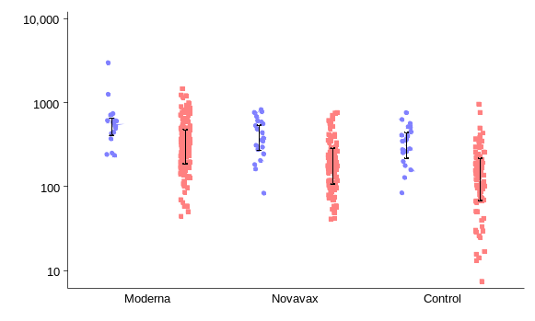 | 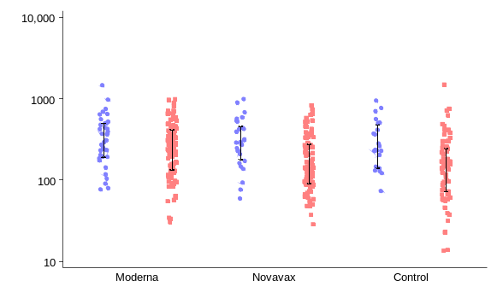
sVNT
WT  (U/mL) | 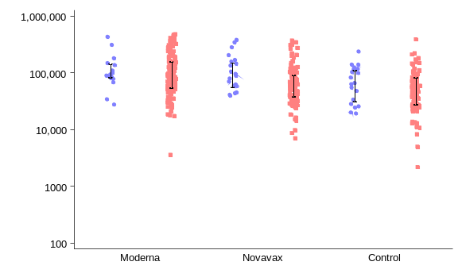 | 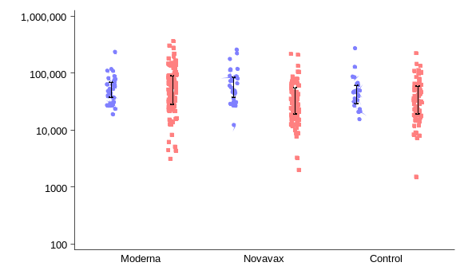
BA.1  (U/mL) | 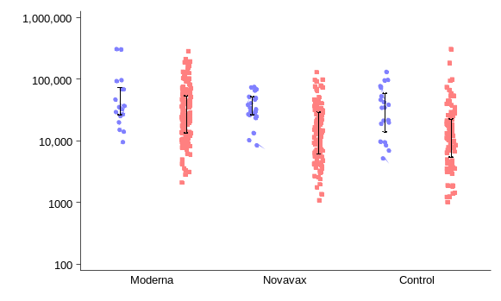 | 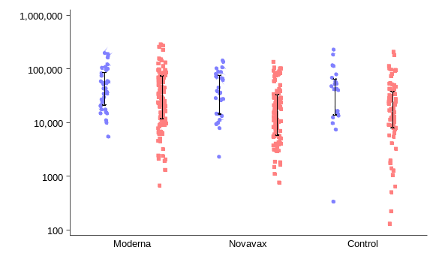
BA.4/5  (U/mL) | 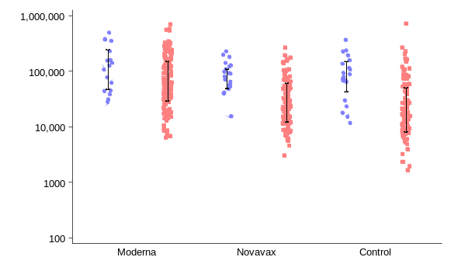 | 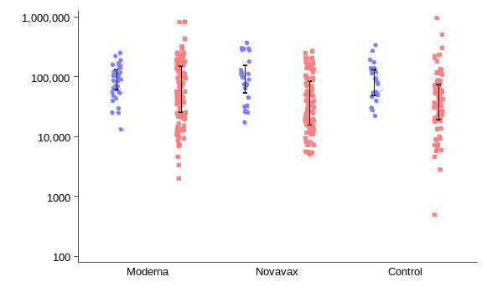
IFNγ
Ag1  (IU/mL) | 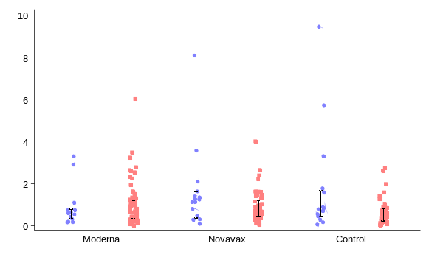 | 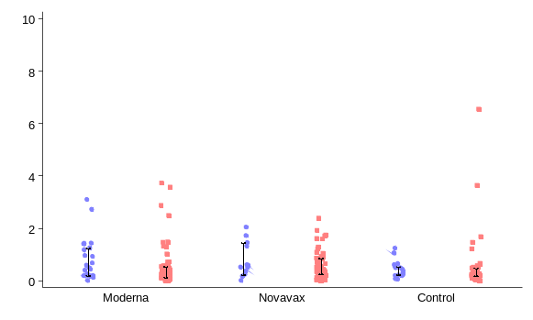
Ag2  (IU/mL) | 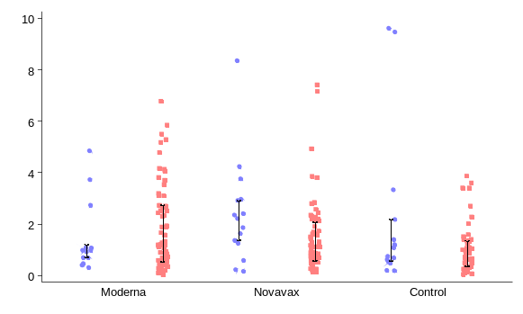 | 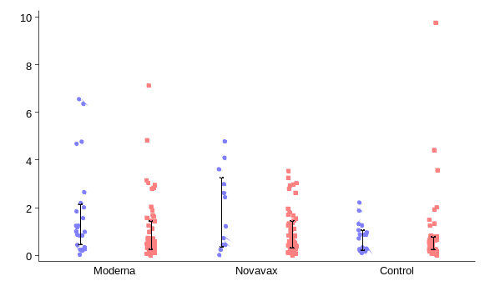
Ag: antigen; BAU: binding antibody units; EU: ELISA units; IFNγ: interferon-gamma; IU: international units; RU: relative units; sVNT: surrogate virus neutralisation test; U: units; WT: wildtype.
Supplementary Figure 5. (A) Kaplan-Meier curves of SARS-CoV-2 infection and (B) survival time to infection, by vaccine and control arms. This analysis only includes the first SARS-CoV-2 infection event for each participant and excludes SARS-CoV-2 infections that occurred within 14 days of enrolment or after the 12-month visit. For participants whose first SARS-CoV-2 infection occurred within 14 days of enrolment but had a subsequent infection before the 12-month visit, the second infection was used in this analysis. The 10th, 20th and 30th percentiles of survival times (days [95% confidence intervals]) were calculated.
(A)
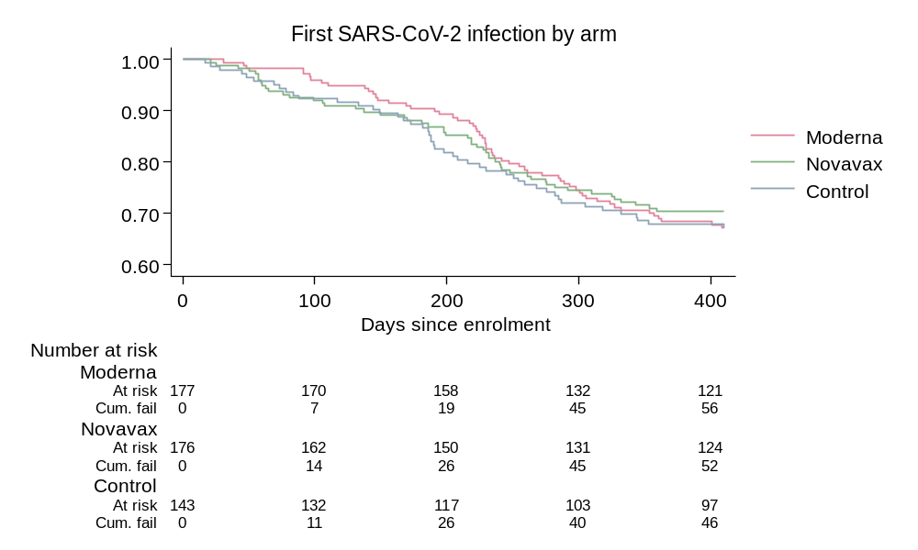
(B)
Arm | 10th percentile | 20th percentile | 30th percentile
Moderna | 191  (138, 225) | 247  (223, 301) | 357  (285, -)
Novavax | 137  (63, 199) | 240  (198, 310) | -  (264, -)
Control | 149  (73, 188) | 216  (182, 282) | 332  (245, -)

IgG |  | sVNT |  | IFNγ
WT | 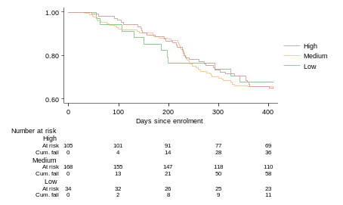 | WT | 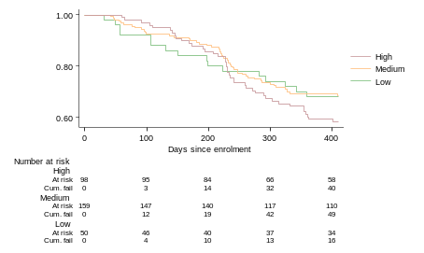 | Ag1 | 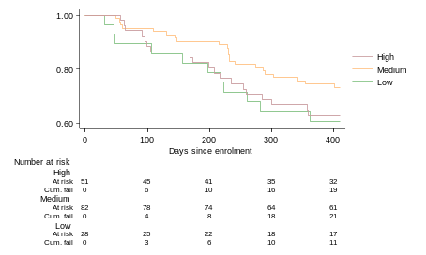
BA.1 | 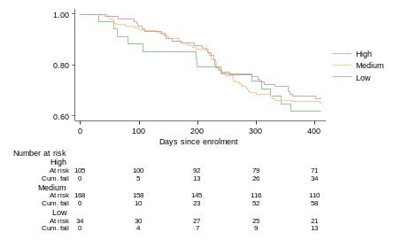 | BA.1 | 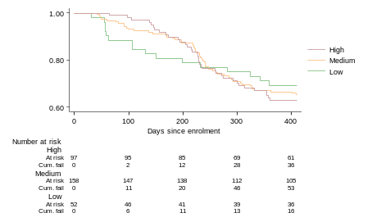 | Ag2 | 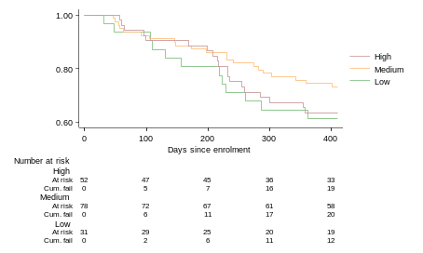
BA.4/5 | 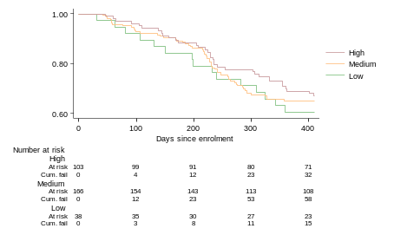 | BA.4/5 | 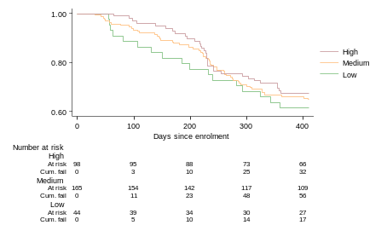
JN.1 | 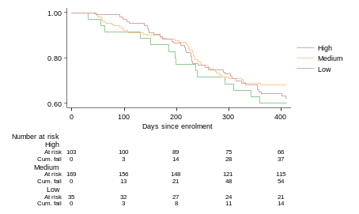
Supplementary Figure 6. Kaplan-Meier curves of SARS-CoV-2 infection, by SARS-CoV-2 IgG, sVNT and IFNγ responses at the preceding study visit. This analysis only includes the first SARS-CoV-2 infection event for each participant and excludes SARS-CoV-2 infections that occurred within 28 days of enrolment or after the 12-month visit. For participants whose first SARS-CoV-2 infection occurred within 28 days of enrolment but had a subsequent infection before the 12-month visit, the second infection was used in this analysis. Participants in the control arm were excluded from this analysis. Immune levels at the preceding study visit were measured at day 0 (control arm) or day 28 (vaccine arms). Low (< 25th percentile), medium (25th-75th percentile), high (>75th percentile).
sVNT: surrogate virus neutralisation test; IFNγ: interferon-gamma; WT: wildtype; Ag: antigen.

