Supplementary Information for
True polar wander of Mars during the Late Amazonian revealed by polar ice caps
Shubin Xu^{1,2}, Tao Wang¹*, Jing Shi^{3,4}, Zheng Gong¹, Ling Chen⁵
¹Frontiers Science Center for Critical Earth Material Cycling, School of Earth Sciences and Engineering, Nanjing University, Nanjing, China. ²The First Geological Brigade of Jiangsu Geological Bureau, Nanjing, China. ³Institut de Physique du Globe de Paris, Université Paris Cité, CNRS, Paris, France. ⁴SKLab-DeepMinE, MOEKLab-OBCE, School of Earth and Space Sciences, Peking University, Beijing, China. ⁵State Key Laboratory of Lithospheric and Environmental Coevolution, Institute of Geology and Geophysics, Chinese Academy of Sciences, Beijing, China.
*Corresponding author. Email: twang0630@nju.edu.cn
This file includes:
Text S1 to S4, Figure S1 to S13, Table S1 and S2.

Contents
Text S1. Temporal Constraints on Polar Ice Cap Evolution Model
Text S2. Scaling of TPW Susceptibility on Mars Relative to Earth
Text S3. Load Magnitude Required to Produce the Late Amazonian TPW of Mars
Text S4. Mantle Viscosity Inferred from the Late Amazonian TPW Kinematics
Figure S1. SHARAD orbital coverage and study areas.
Figure S2. Radargram slices and identified discontinuity interfaces (values listed in Table S1) used to construct the contour maps in Fig. 2c, d.
Figure S3. Radargram slices and identified discontinuity interfaces (continued from Fig. S2).
Figure S4. Radargram slices and identified discontinuity interfaces (continued from Fig. S3).
Figure S5. Radargram slices and identified discontinuity interfaces (continued from Fig. S4).
Figure S6. The low-frequency orbital radar Marsis slices penetrating through the SPLD.
Figure S7. Comparison of discontinuity picks with previous studies.
Figure S8. Distribution of dissected mantle terrains and deposit-filled craters in relation to the Late Amazonian TPW.
Figure S9. The buried spiral troughs in the Gemina Lingula unit of the NPLD.
Figure S10. Fitting results and residuals of surface spiral troughs within the Gemina Lingula 2, excluding the buried ones.
Figure S11. Fitting results and residuals of spiral troughs in the SPLD.
Figure S12. Uncertainty evaluation of interface picking in incoherently stacked radargrams, using surface echoes as a reference.
Figure S13. The buried spiral troughs in the Ultima Lingula unit of the SPLD.
Table S1. Tracing results of discontinuity interfaces between the upper and lower sequences of the polar ice caps.
Table S2. Linear regression results of individual spiral troughs in four regions, fitted using the four optimal spiral centers, respectively.

Text S1. Temporal constraints on polar ice cap evolution model
Establishing an absolute chronology for the Late Amazonian True Polar Wander (TPW) is limited by the lack of direct dating of polar ice deposits. Nonetheless, stratigraphic relationships revealed by orbital radar and crater‑retention surface ages provide critical boundary conditions for the structural evolution model. Three inferences underpin our evolution model: (1) the lower sequences of north polar layered deposits (NPLD1) may have formed prior to 30 million years (Ma); (2) the bulk of south polar layered deposits (SPLD) was already in place by 30 Ma or earlier; and (3) during the past ~5 Ma, climatic conditions favored net accumulation at the north pole to form the upper sequences of north polar layered deposits (NPLD2) while the south pole remained equilibrium or experienced slow net ablation.
The SPLD retain a mean apparent surface age of 30–100 Ma¹, indicating that the bulk of the SPLD was already in place by at least 30 Ma. If this were not the case, then even at the slowest net accumulation rate (~0.13 mm/yr; ref. 2), 30 Ma would have produced an ice layer of >3 km thick to refresh the surface. In contrast, the NPLD2 are widely estimated to be younger than 5 Ma^{3–6}, whereas the ages of the buried NPLD1 and the discontinuity interface remain unconstrained. An obvious question is why the bulk of the SPLD, formed prior to ~30 Ma, has been preserved to the present, while deposits have experienced net accumulation only at the north pole to form the NPLD2 after ~5 Ma. Orbital forcing models⁷ indicate that before ~5 Ma, mean obliquity was ~35°, corresponding to high insolation at northern high latitudes (~350 W m⁻²), under which net ice accumulation at the north pole was dynamically inhibited⁶. Obliquity decreased to ~25° by ~5 Ma, enabling net accumulation at the north pole^{3,6}. In contrast, the aphelion during winter and higher elevation at the south pole result in substantially lower temperatures, while CO₂ ice and dust-rich layers formed prior to ~30 Ma suppress sublimation and preserve the underlying ice^{8,9}. Deposition on the portion of the SPLD not covered by perennial ice may have largely ceased at about 5 Ma¹⁰.
Despite the considerable uncertainty in the absolute temporal framework of the polar ice cap evolution model, the relative kinematic sequence is rigorously defined by spatial superposition. The spatial offsets of deep stratigraphic discontinuities and younger surface spiral structures demonstrate that the basal topographic template predates the atmospheric regime responsible for the present-day trough geometries. The progressive evolution from a symmetric initial state to the highly eccentric modern configuration therefore stands as a robust geometric necessity, independent of the precise absolute chronology.
A major erosional interface between the NPLD1 and NPLD2 indicates a dramatic climatic shift prior to the deposition of the upper sequence. Although the absolute age of NPLD1 remains unconstrained, the stratigraphic relationship and the antiquity of the underlying template suggest that it may be significantly older—potentially predating 30 Ma. Therefore, we adopt 30 Ma as the latest permissible start time for the Late Amazonian TPW, providing a conservative upper bound on the drift rate of 2.7 cm yr⁻¹.

Text S2. Scaling of true polar wander susceptibility on Mars relative to Earth
The susceptibility of a terrestrial planet to TPW is fundamentally controlled by the ratio between perturbations in the inertia tensor and the pre-existing rotational stability, given by ${∆I}/{\left(C-A\right)}$ ^{11,12}. The polar and mean equatorial principal moments of inertia are denoted as $C$ and $A$, and $∆I$ is the perturbation to the moment of inertia. For Mars¹³, $C_{M}=2.68125×{10}^{36} kg∙m^{2}$ and $A_{M}=2.66589×{10}^{36} kg∙m^{2}$, whereas for Earth¹⁴, $C_{E}=8.03685×{10}^{37} kg∙m^{2}$ and $A_{E}=8.01017×{10}^{37} kg∙m^{2}$. The ratio of the difference in principal moments of inertia between Mars and Earth is therefore:
$$e_{1}=\frac{C_{M}-A_{M}}{C_{E}-A_{E}}≈\frac{1}{17}. (1)$$
The perturbation to inertia $∆I$ induced by a surface mass anomaly is proportional to $ρV∙R^{2}$, where $ρ$ is the density, $V$ is the anomaly volume, and $R$ is the planetary radius. The average mantle densities of Mars and Earth¹⁵ are 3.64 g/cm³ and 4.40 g/cm³, with radii of 3,370 km and 6,370 km, respectively. If the critical dimensionless parameter ${∆I}/{\left(C-A\right)}$ required to initiate TPW is the same for both planets, the ratio of the required volumetric perturbations is
$$e_{2}=\frac{V_{M}}{V_{E}}=e_{1}∙\frac{ρ_{E}}{ρ_{M}}∙\frac{{R_{E}}^{2}}{{R_{M}}^{2}}≈\frac{1}{4} . (2)$$
This result indicates that Mars requires approximately one-quarter of the anomaly volume needed on Earth to trigger a comparable TPW event, reflecting its higher intrinsic susceptibility to rotational reorientation.

Text S3. Load magnitude required to produce the Late Amazonian TPW of Mars
For a surface load situated at colatitude $ϕ$, the resulting TPW angle $δ$ can be approximated by the geometric relation in Equation 3 (from ref. 16).‌
$$Q\sin\left(2ϕ\right)=\sin\left(2δ\right). (3)$$
where $Q$ is the dimensionless load size normalized by the remnant rotational bulge. Assuming a mid-latitude loading configuration with $ϕ=45°$, the observed TPW angle of $δ=6.8°$ yields $Q≈0.24$.
This value indicates that the load responsible for the inferred TPW is moderate, corresponding to only ~10% of the effective dimensionless load associated with the Tharsis rise¹⁷. Scaling relative to the estimated mass of the Tharsis rise (∼10⁻³ of the Martian mass), the surface load required to produce the observed TPW corresponds to approximately 10⁻⁴ of the total mass of Mars.
Importantly, this estimate assumes that Mars behaves as a rigid body, for which the fossil rotational bulge is supported by an elastic lithosphere. Under this assumption, TPW is controlled solely by the instantaneous balance between the applied load and the pre-existing rotational stability. However, for a viscoelastic planet, viscous relaxation following load emplacement progressively modifies the inertia tensor over geological time, allowing the planet to more fully reorient toward its principal axes of inertia¹⁸. Consequently, the effective $Q$ required to produce the observed TPW is likely smaller than this rigid-body estimate, implying that even relatively modest mass anomalies could be sufficient to drive the Late Amazonian polar reorientation of Mars.

Text S4. Mantle viscosity inferred from the Late Amazonian TPW kinematics
The TPW rate provides a direct constraint on the rheological properties of the planetary interior, particularly the effective viscosity of the mantle. For a viscoelastic planet undergoing reorientation, the characteristic response can be related to the load parameter $Q$ (Eq. 3) and the TPW angular rate $ω_{TPW}$. By combining the standard relaxation framework for TPW^{12,19}, the effective mantle viscosity can be expressed as:
$$η=\frac{Q}{4ω_{TPW}}\frac{{(C}_{M}-A_{M})ρ_{M}g_{M}}{mR_{M}}. (4)$$
where $ρ_{M}$, $g_{M}$, $R_{M}$ and $m$ are the mantle density, surface gravity, radius, and mass of Mars, respectively. Using $ρ_{M}$= 3.64 g/cm³, $g_{M}$= 3.71 m/s², $Q$= 0.25, and an average TPW angular rate of $ω_{TPW}$= 2.5×10⁻¹⁶ rad/s (equivalent to ~ 2.7 cm/yr), we obtain an effective mantle viscosity of ~2.4×10²² Pa·s. This value is comparable to the result of ref. 20, who derived the TPW curve based on a viscosity theory using a Maxwell viscoelastic Mars model with an elastic lithospheric thickness of 110 km. Under the assumption of hydrostatic equilibrium during reorientation²¹, we can also obtain a Martian mantle viscosity of ~1.7×10²² Pa·s through the interpolation of TPW rate. However, our estimation assumes a simplified viscoelastic response and does not explicitly account for the mechanical influence of the thick, cold Martian lithosphere, which is expected to suppress viscous relaxation and modify the relationship between TPW rate and mantle viscosity. In addition, the TPW rate adopted here represents a time-averaged value, and if the peak reorientation rate were higher, the inferred viscosity would be correspondingly lower.
In conjunction with previous constraints from glacial isostatic adjustment²², seismic structure²³, and orbital evolution studies²⁴, these results indicate that a mantle viscosity on the order of ${10}^{22}$ Pa·s is both physically plausible and sufficient to accommodate the inferred TPW on Mars. Combined with the load estimates above, this result indicates that the Late Amazonian TPW on Mars can be explained by modest mass perturbations acting within a mantle of plausible viscosity.

Figure S1 to S13.
Figure S1 | SHARAD orbital coverage and study areas. Gray lines denote SHARAD orbits (every other orbit) used in this study, with dashed lines indicating the selected ranges. a, north polar ice cap. b, south polar ice cap. Red dashed areas mark the regions where the discontinuity relief contours were mapped (see Fig. 2c, d). The magenta solid line in a corresponds to the footprint of Trace ID 00529701 shown in Fig. S7.

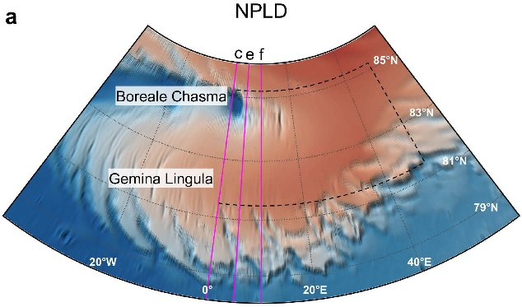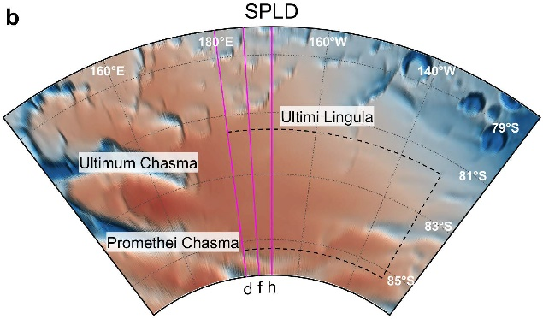
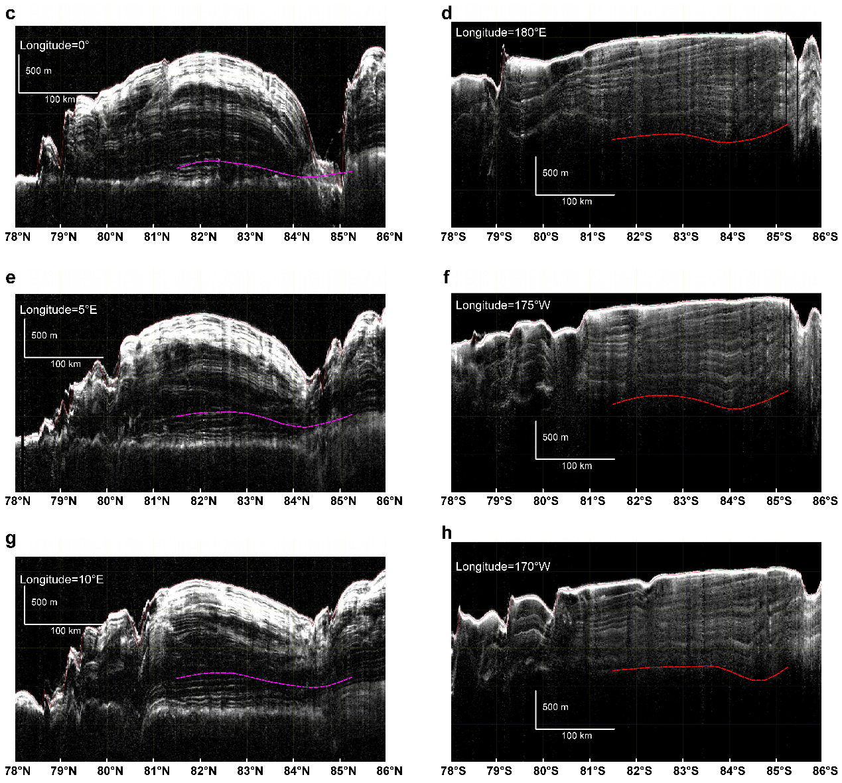
Figure S2 | Radargram slices and identified discontinuity interfaces (values listed in Table S1) used to construct the contour maps in Fig. 2c, d. a, b, Locations of the radar slices (magenta lines). c, e, g (left panels) and d, f, h (right panels) are results for the NPLD (dashed magenta lines) and the SPLD (dashed red lines), respectively. The longitude ranges for interface picking are 0°–10° E (NPLD) and 170° W–180° W (SPLD), at 5° intervals. The latitude ranges are 81.50° N–85.25° N and 81.50° S–85.25° S, at 0.25° intervals.
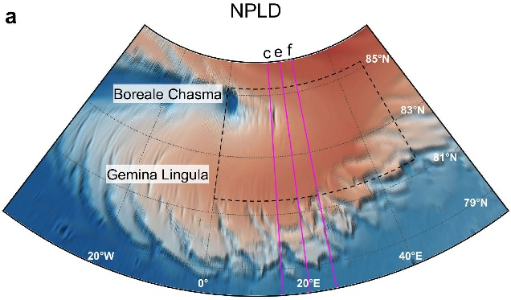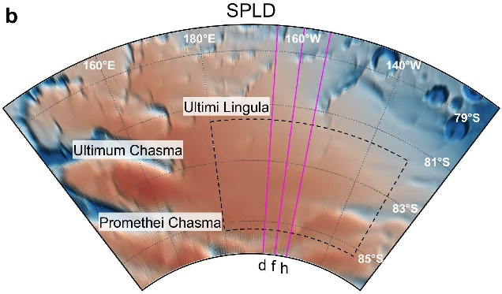
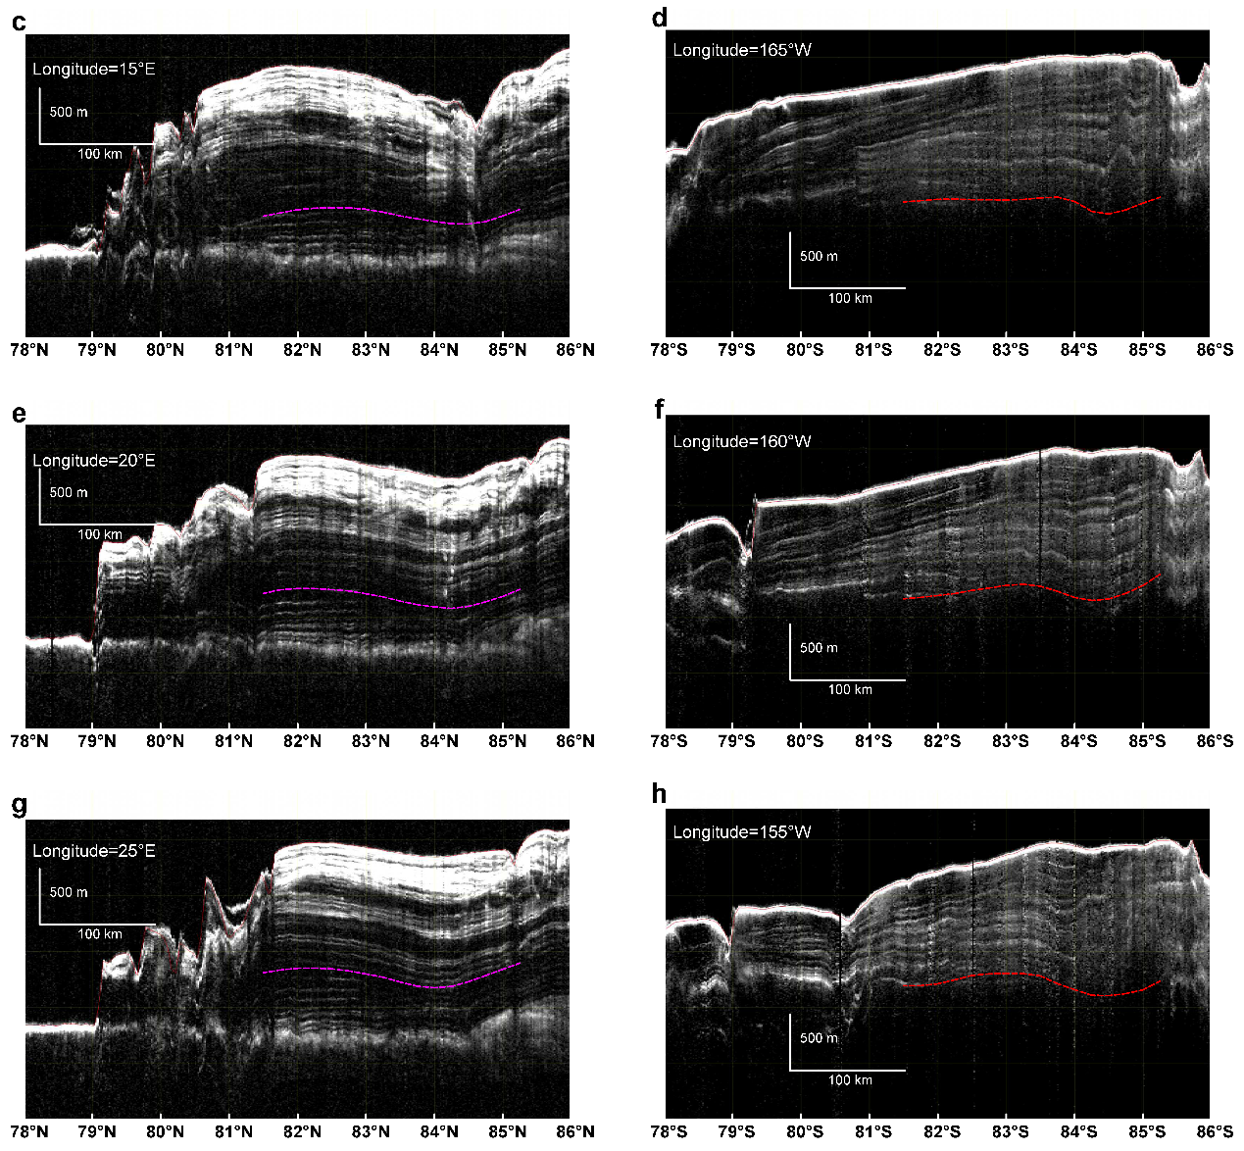
Figure S3 | Radargram slices and identified discontinuity interfaces (continued from Fig. S2). Longitude ranges are 15°E–25° E (NPLD) and 155°W–165° W (SPLD).

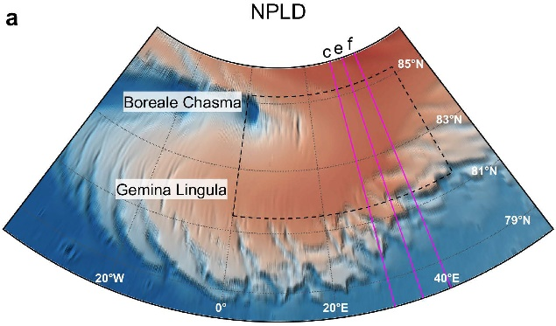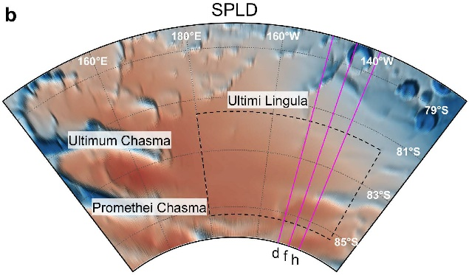
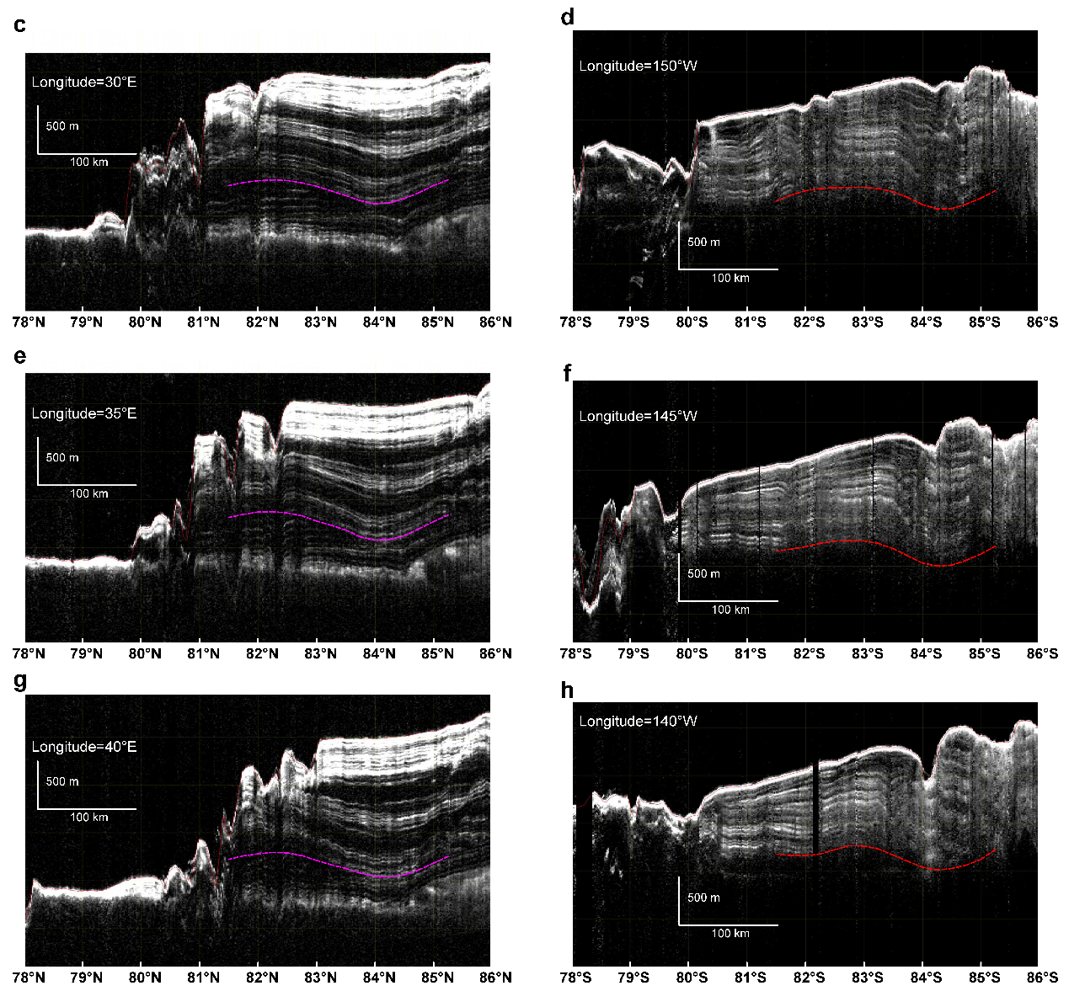
Figure S4 | Radargram slices and identified discontinuity interfaces (continued from Fig. S3). Longitude ranges are 30°E–40° E (NPLD) and 140°W–150° W (SPLD).
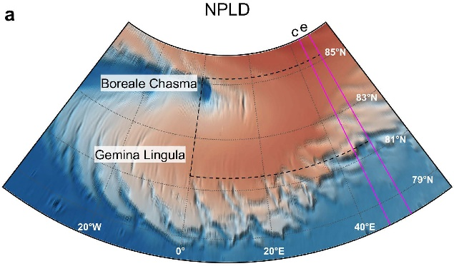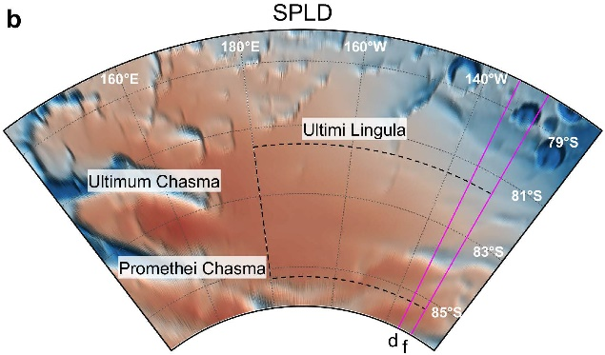
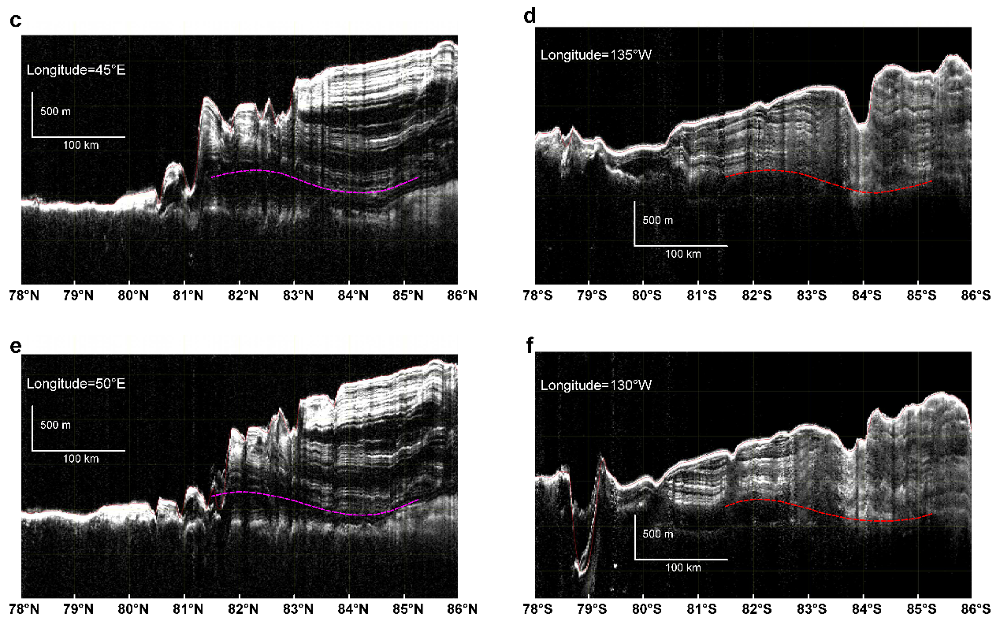
Figure S5 | Radargram slices and identified discontinuity interfaces (continued from Fig. S4). Longitude ranges are 45°E–50° E (NPLD) and 130°W–135° W (SPLD).
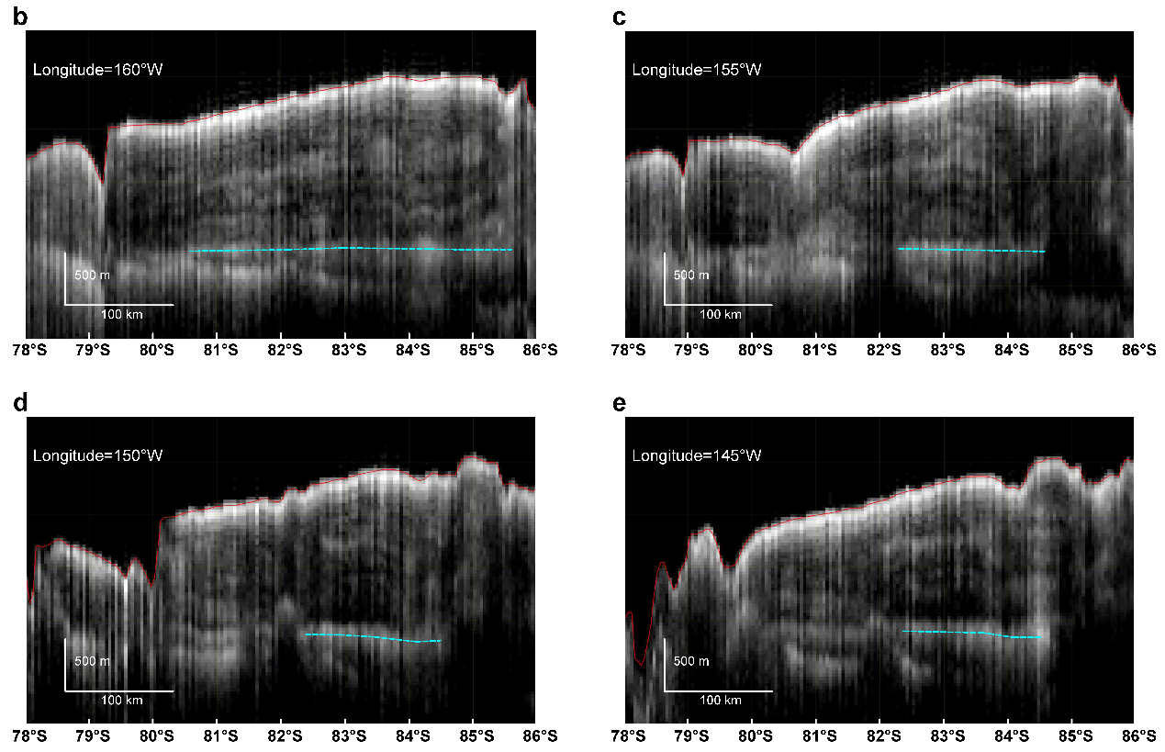
Figure S6 | The low-frequency orbital radar (the Mars Advanced Radar for Subsurface and Ionospheric Sounding) slices penetrating through the SPLD. a, Locations of the slices (magenta lines). b, c, d and f, Radargram profiles extracted at longitudes 145°W, 150°W, 155°W and 160°W. The radargrams reveal flat basal reflections (cyan lines) and few clutter echoes within the selected latitude range (81.50°S–85.25°S).

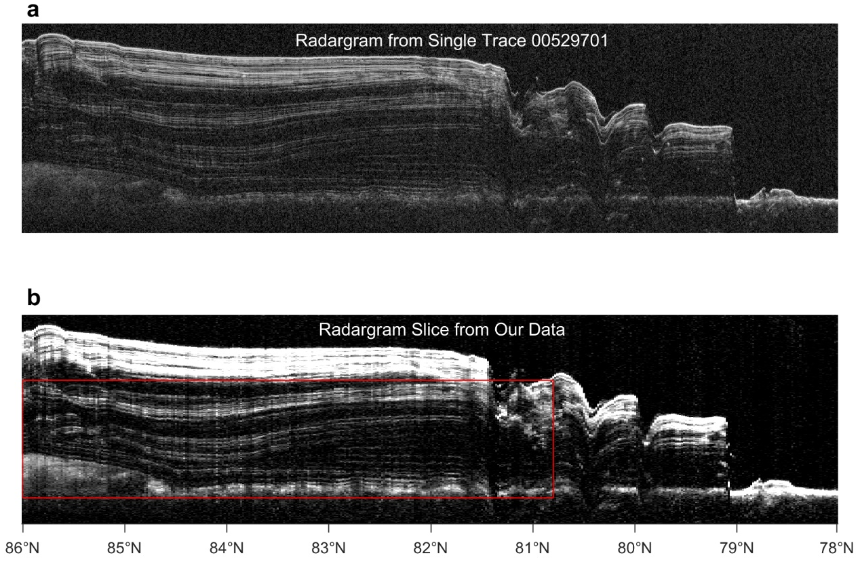
Figure S7 | Comparison of discontinuity picks with previous studies. a, Radargram product of trace ID 00529701 after time-to-depth conversion, used by ref. 25 and ref. 26. b, Radargram extracted from our data volume along the same footprint as in a. Our radargram shows clearer and more interpretable reflectors, and provides a comparison of discontinuities. c, The region marked by the red rectangle in panel b. The green dashed line is adapted from ref. 25, the cyan dashed line is adapted from ref. 26, and the red line is our pick. Our results are consistent with previous studies, with mean absolute errors of 16.9 m (relative to the green line) and 19.9 m (relative to the cyan line).

Figure S8 | Distribution of dissected mantle terrains and deposit-filled craters in relation to the Late Amazonian TPW. Yellow filled circles denote dissected mantle terrains²⁷. Regions of higher concentration (black arrows) are located on the eccentric side of the Lingula units. Blue filled circles represent craters filled with deposits^{28,29}, and their concentrated distributions (black arrows) align with the eccentric direction of the Lingula units. The asymmetric distributions of these two pole‑related geomorphic units support the occurrence of the Late Amazonian TPW and are consistent with the inferred polar motion path.
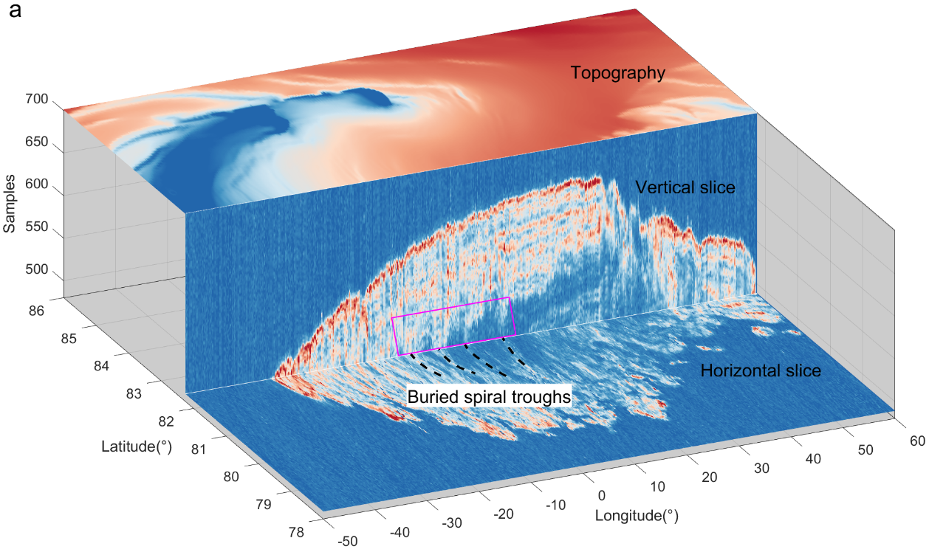
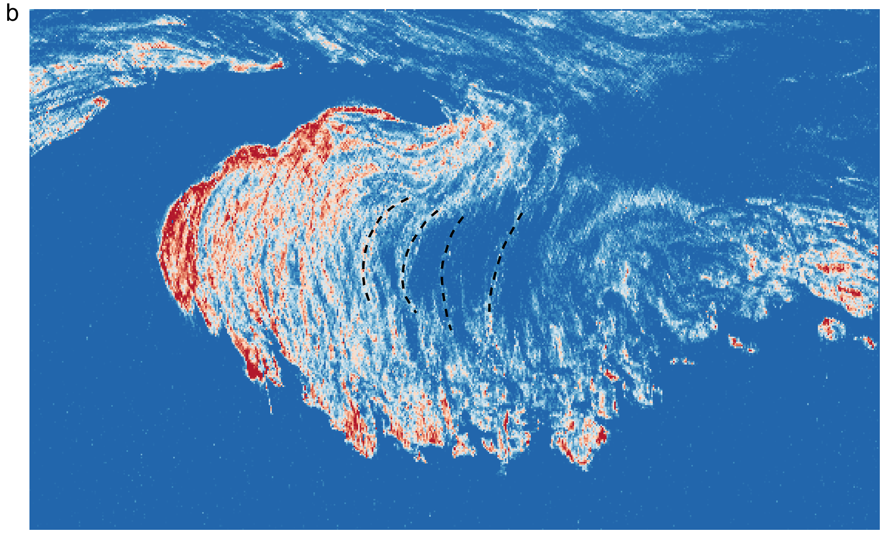
Figure S9 | The buried spiral troughs in the Gemina Lingula unit of the NPLD. a, Horizontal and vertical slices of our SHARAD dataset reveal internal spiral-reflection features (black dashed lines). The topographically flat terrain above these spiral features and their vertical extension (magenta region) rule out the possibility of radar clutter. b, Horizontal slice of the Gemina Lingula unit used to extract the geometries of the buried spiral troughs.

Figure S10 | Fitting results and residuals of surface spiral troughs within the Gemina Lingula 2, excluding the buried ones. Compared with Extended Data Fig. 2b, the fitting residual shows considerably weaker convergence without the buried STs included in the inversion.
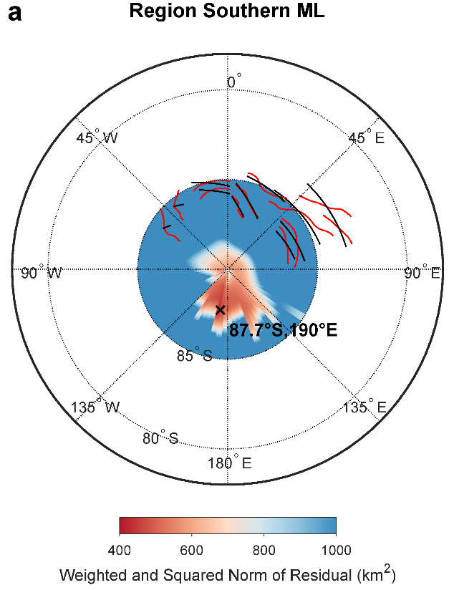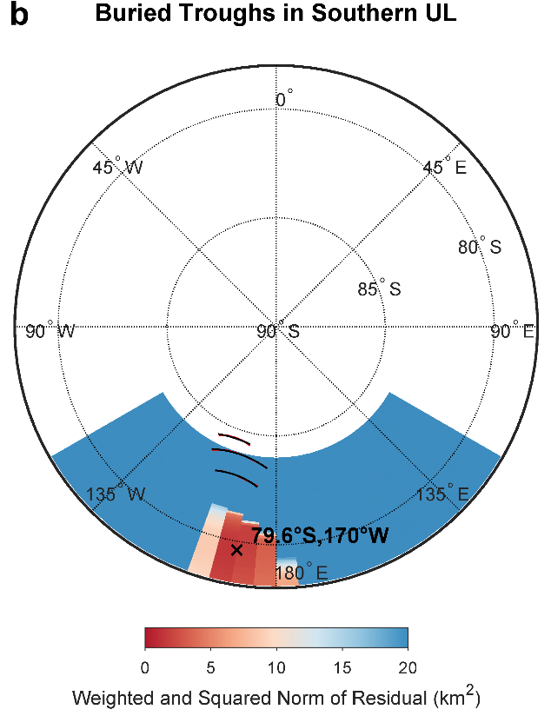
Figure S11 | Fitting results and residuals of spiral troughs in the SPLD. a, b, Fitting results for the southern Main Lobe and Ultima Lingula (UL) regions, respectively. Crosses mark the optimal spiral centers. Red curves denote the picked spiral troughs, and black curves are synthetic spirals generated using the optimal centers. Owing to the irregular geometries of the surface spiral troughs in the SPLD, the fitting yields poorly matched geometries. c, Comparison of the southern fitted centers (orange) with their antipodal projections and the northern results (blue). The two sets of centers differ by approximately 2.74° and 3.33° in great-circle distance. Two previously proposed theoretical paleopoles, derived from deformed shorelines (DS, black circle; ref. 30, with the lithospheric thickness of 300 km) and Tharsis load removal (TR, arrow pointing to 71°N, 100°W; ref. 17) are also plotted.
Figure S12 | Uncertainty evaluation of interface picking in incoherently stacked radargrams, using surface echoes as a reference. a, Region of picked discontinuities in Fig. 2c. The white cross marks the center of a stacking bin of size 0.02° (latitude) × 0.3° (longitude). b–j, Stacking results of all traces within the bin. The horizontal axis represents sample points at a sampling interval of 0.0375 μs, and the vertical axis shows the normalized echo power. Gray solid lines represent individual original traces, and red solid lines denote the stacked average trace. Short black lines indicate the positions of maximum surface echo energy picked from each original trace, and the red dashed lines show the corresponding position after stacking. Picked two-way travel times are converted to depths using the velocity in water ice (V = 170 m/μs). The root-mean-square errors (RMSE) for each panel range from 4.2 to 15.2 m which is of the same order as the vertical resolution of the radar in ice (~8.5 m). Larger RMSE values occur in areas with pronounced topographic relief, as expected.

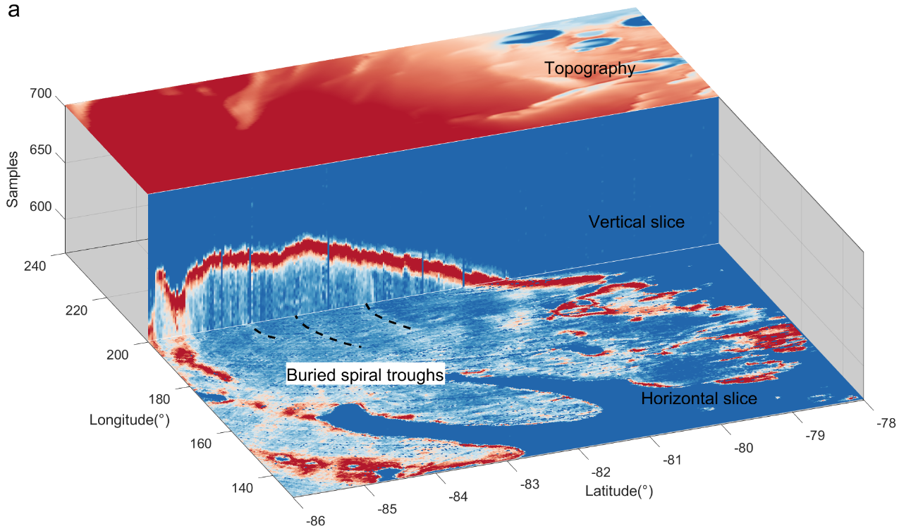
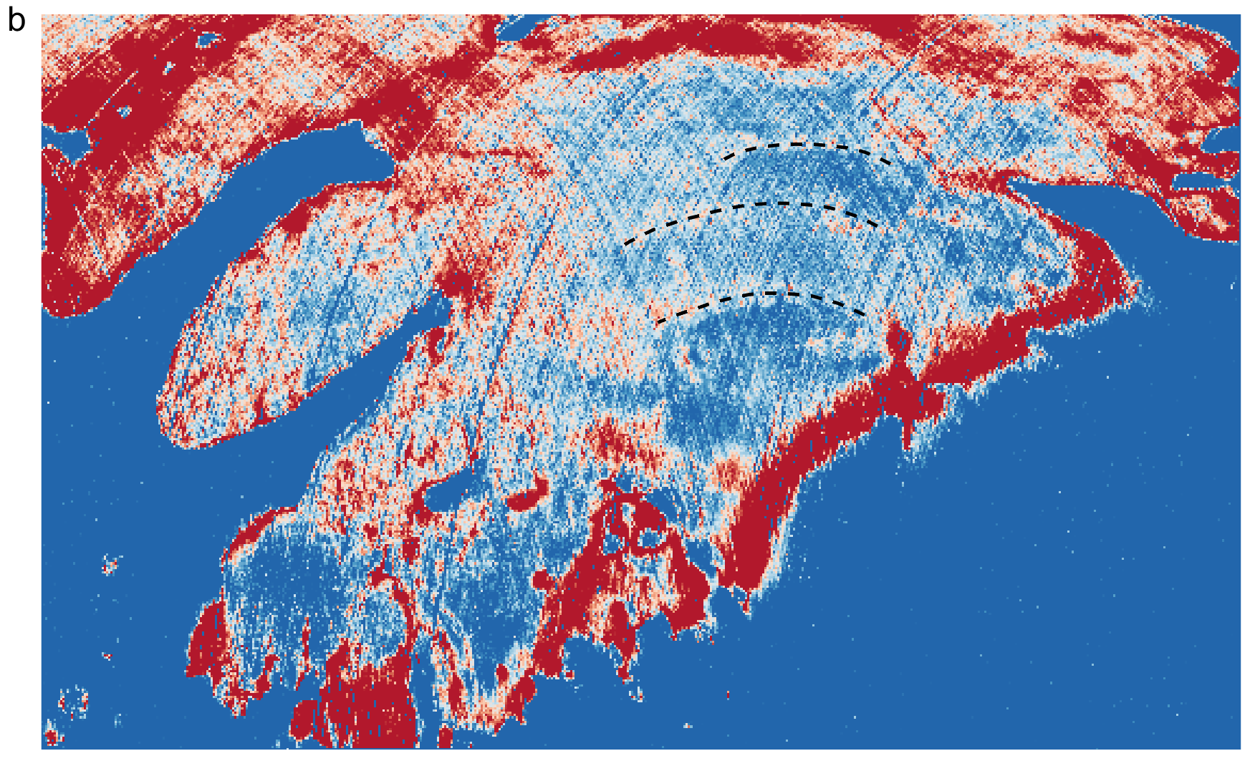
Figure S13 | The buried spiral troughs in the Ultima Lingula unit of the SPLD. a, Horizontal and vertical slices of our SHARAD dataset reveal internal spiral-reflection features (black dashed lines). b, Horizontal slice of the Ultima Lingula unit faintly reveals the buried spiral features.

Table S1 and S2.
Table S1. Tracing results of discontinuity interfaces between the upper and lower sequences of the polar ice caps. The interfaces were traced within longitude ranges of 0°–50°E (NPLD) and 130°W–180°W(SPLD) at 5° intervals, and latitude ranges of 81.50°N–85.25°N and 81.50°S–85.25°S at 0.25° intervals. The elevation values are referenced to the Mars Orbiter Laser Altimeter (MOLA).
NPLD discontinuity interfaces |  |  | SPLD discontinuity interfaces
Longitude (°) | Latitude (°) | Elevations (m) | Longitude (°) | Latitude (°) | Elevations (m)
0 | 81.5 | -4712.81 | 230 | -85.25 | 1636.18
0 | 81.75 | -4663.73 | 230 | -85 | 1590.02
0 | 82 | -4627.12 | 230 | -84.75 | 1569.65
0 | 82.25 | -4614.65 | 230 | -84.5 | 1556.19
0 | 82.5 | -4624.57 | 230 | -84.25 | 1556.19
0 | 82.75 | -4646.03 | 230 | -84 | 1564.04
0 | 83 | -4666.25 | 230 | -83.75 | 1580.87
0 | 83.25 | -4695.89 | 230 | -83.5 | 1613.93
0 | 83.5 | -4735.42 | 230 | -83.25 | 1646.2
0 | 83.75 | -4779.16 | 230 | -83 | 1696.3
0 | 84 | -4813.17 | 230 | -82.75 | 1734.56
0 | 84.25 | -4832 | 230 | -82.5 | 1772.59
0 | 84.5 | -4824.11 | 230 | -82.25 | 1794.31
0 | 84.75 | -4798.23 | 230 | -82 | 1796.49
0 | 85 | -4776.92 | 230 | -81.75 | 1772.12
0 | 85.25 | -4753.36 | 230 | -81.5 | 1719.55
5 | 81.5 | -4501.48 | 225 | -85.25 | 1664.51
5 | 81.75 | -4472.58 | 225 | -85 | 1617.67
5 | 82 | -4453.7 | 225 | -84.75 | 1583.05
5 | 82.25 | -4447.41 | 225 | -84.5 | 1553.26
5 | 82.5 | -4444.89 | 225 | -84.25 | 1530.83
5 | 82.75 | -4445.22 | 225 | -84 | 1538.68
5 | 83 | -4458.09 | 225 | -83.75 | 1573.45
5 | 83.25 | -4494.59 | 225 | -83.5 | 1621.08
5 | 83.5 | -4539.9 | 225 | -83.25 | 1668.46
5 | 83.75 | -4595.27 | 225 | -83 | 1722.77
5 | 84 | -4626.74 | 225 | -82.75 | 1761.53
5 | 84.25 | -4644.75 | 225 | -82.5 | 1778.33
5 | 84.5 | -4615.8 | 225 | -82.25 | 1786.22
5 | 84.75 | -4578.64 | 225 | -82 | 1771.01
5 | 85 | -4535.88 | 225 | -81.75 | 1747.64
5 | 85.25 | -4478.4 | 225 | -81.5 | 1710.48
10 | 81.5 | -4396.39 | 220 | -85.25 | 1727.58
10 | 81.75 | -4366.5 | 220 | -85 | 1623.38
10 | 82 | -4339.75 | 220 | -84.75 | 1563.64
10 | 82.25 | -4325.98 | 220 | -84.5 | 1528.6
10 | 82.5 | -4324.91 | 220 | -84.25 | 1512.73
10 | 82.75 | -4334.74 | 220 | -84 | 1543.51
10 | 83 | -4367.86 | 220 | -83.75 | 1604.23
10 | 83.25 | -4406.48 | 220 | -83.5 | 1670.54
10 | 83.5 | -4441.87 | 220 | -83.25 | 1732.51
10 | 83.75 | -4468.54 | 220 | -83 | 1762.92
10 | 84 | -4492.09 | 220 | -82.75 | 1767.26
10 | 84.25 | -4512.57 | 220 | -82.5 | 1725.13
10 | 84.5 | -4515.45 | 220 | -82.25 | 1679.36
10 | 84.75 | -4494.33 | 220 | -82 | 1662.84
10 | 85 | -4442.96 | 220 | -81.75 | 1663.92
10 | 85.25 | -4384.64 | 220 | -81.5 | 1679.06
15 | 81.5 | -4415.21 | 215 | -85.25 | 1710.35
15 | 81.75 | -4384.73 | 215 | -85 | 1627.35
15 | 82 | -4357.69 | 215 | -84.75 | 1561.95
15 | 82.25 | -4344.67 | 215 | -84.5 | 1511.37
15 | 82.5 | -4339.64 | 215 | -84.25 | 1502.82
15 | 82.75 | -4340.9 | 215 | -84 | 1534.05
15 | 83 | -4353.39 | 215 | -83.75 | 1609
15 | 83.25 | -4377.97 | 215 | -83.5 | 1684.27
15 | 83.5 | -4411.36 | 215 | -83.25 | 1738.59
15 | 83.75 | -4438.03 | 215 | -83 | 1764.37
15 | 84 | -4461.58 | 215 | -82.75 | 1769.41
15 | 84.25 | -4482.06 | 215 | -82.5 | 1762.98
15 | 84.5 | -4484.94 | 215 | -82.25 | 1739.08
15 | 84.75 | -4463.82 | 215 | -82 | 1703.68
15 | 85 | -4412.45 | 215 | -81.75 | 1678.56
15 | 85.25 | -4354.13 | 215 | -81.5 | 1658.19
20 | 81.5 | -4289.47 | 210 | -85.25 | 1765.53
20 | 81.75 | -4256.95 | 210 | -85 | 1687.02
20 | 82 | -4245.52 | 210 | -84.75 | 1623.37
20 | 82.25 | -4246.22 | 210 | -84.5 | 1577.61
20 | 82.5 | -4255.34 | 210 | -84.25 | 1576.32
20 | 82.75 | -4266.97 | 210 | -84 | 1619.96
20 | 83 | -4292.54 | 210 | -83.75 | 1695.59
20 | 83.25 | -4319.89 | 210 | -83.5 | 1754.24
20 | 83.5 | -4357.47 | 210 | -83.25 | 1786.35
20 | 83.75 | -4389.01 | 210 | -83 | 1799.79
20 | 84 | -4408.41 | 210 | -82.75 | 1798.13
20 | 84.25 | -4423.23 | 210 | -82.5 | 1796.41
20 | 84.5 | -4404.3 | 210 | -82.25 | 1786.23
20 | 84.75 | -4365.05 | 210 | -82 | 1763.57
20 | 85 | -4316.68 | 210 | -81.75 | 1718.57
20 | 85.25 | -4253.59 | 210 | -81.5 | 1655.88
25 | 81.5 | -4189.29 | 205 | -85.25 | 1736.52
25 | 81.75 | -4164.12 | 205 | -85 | 1657.66
25 | 82 | -4149.17 | 205 | -84.75 | 1623.68
25 | 82.25 | -4146.51 | 205 | -84.5 | 1606.06
25 | 82.5 | -4153.89 | 205 | -84.25 | 1609.84
25 | 82.75 | -4171.98 | 205 | -84 | 1659.35
25 | 83 | -4199.23 | 205 | -83.75 | 1713.73
25 | 83.25 | -4228.88 | 205 | -83.5 | 1782.97
25 | 83.5 | -4271.65 | 205 | -83.25 | 1802.5
25 | 83.75 | -4308.81 | 205 | -83 | 1805.73
25 | 84 | -4323.11 | 205 | -82.75 | 1800.96
25 | 84.25 | -4311.31 | 205 | -82.5 | 1786.54
25 | 84.5 | -4269.72 | 205 | -82.25 | 1747.24
25 | 84.75 | -4214.34 | 205 | -82 | 1711.4
25 | 85 | -4158.5 | 205 | -81.75 | 1695.11
25 | 85.25 | -4103.12 | 205 | -81.5 | 1695.11
30 | 81.5 | -4181.38 | 200 | -85.25 | 1881.45
30 | 81.75 | -4149.91 | 200 | -85 | 1780.97
30 | 82 | -4130.73 | 200 | -84.75 | 1710.49
30 | 82.25 | -4122.63 | 200 | -84.5 | 1660.15
30 | 82.5 | -4128.93 | 200 | -84.25 | 1648.06
30 | 82.75 | -4151.74 | 200 | -84 | 1674.24
30 | 83 | -4188.37 | 200 | -83.75 | 1729.79
30 | 83.25 | -4236.61 | 200 | -83.5 | 1774.94
30 | 83.5 | -4285.98 | 200 | -83.25 | 1792.33
30 | 83.75 | -4339.09 | 200 | -83 | 1781.57
30 | 84 | -4372.48 | 200 | -82.75 | 1757.99
30 | 84.25 | -4362.1 | 200 | -82.5 | 1737.73
30 | 84.5 | -4318.89 | 200 | -82.25 | 1709.45
30 | 84.75 | -4256.97 | 200 | -82 | 1691.53
30 | 85 | -4181.07 | 200 | -81.75 | 1674.68
30 | 85.25 | -4121.31 | 200 | -81.5 | 1662.25
35 | 81.5 | -4185.73 | 195 | -85.25 | 1752.08
35 | 81.75 | -4154.27 | 195 | -85 | 1699.94
35 | 82 | -4129.57 | 195 | -84.75 | 1640.85
35 | 82.25 | -4126.34 | 195 | -84.5 | 1605.02
35 | 82.5 | -4138.93 | 195 | -84.25 | 1628.29
35 | 82.75 | -4168.03 | 195 | -84 | 1715.18
35 | 83 | -4223.08 | 195 | -83.75 | 1753.79
35 | 83.25 | -4267.56 | 195 | -83.5 | 1746.19
35 | 83.5 | -4317.27 | 195 | -83.25 | 1732.72
35 | 83.75 | -4388.16 | 195 | -83 | 1728.11
35 | 84 | -4421.55 | 195 | -82.75 | 1730.9
35 | 84.25 | -4416.34 | 195 | -82.5 | 1730.9
35 | 84.5 | -4376.47 | 195 | -82.25 | 1736.33
35 | 84.75 | -4306.04 | 195 | -82 | 1734.15
35 | 85 | -4230.14 | 195 | -81.75 | 1722.21
35 | 85.25 | -4162.18 | 195 | -81.5 | 1710.26
40 | 81.5 | -4277.34 | 190 | -85.25 | 1748.24
40 | 81.75 | -4241.44 | 190 | -85 | 1647.16
40 | 82 | -4220.13 | 190 | -84.75 | 1575.75
40 | 82.25 | -4204.86 | 190 | -84.5 | 1577.48
40 | 82.5 | -4209.42 | 190 | -84.25 | 1631.81
40 | 82.75 | -4237.58 | 190 | -84 | 1700.24
40 | 83 | -4287.48 | 190 | -83.75 | 1753.44
40 | 83.25 | -4333.57 | 190 | -83.5 | 1766.38
40 | 83.5 | -4371.42 | 190 | -83.25 | 1756.61
40 | 83.75 | -4421.41 | 190 | -83 | 1754.43
40 | 84 | -4453.54 | 190 | -82.75 | 1751.18
40 | 84.25 | -4462.29 | 190 | -82.5 | 1750.51
40 | 84.5 | -4438.82 | 190 | -82.25 | 1745.55
40 | 84.75 | -4386.94 | 190 | -82 | 1729.77
40 | 85 | -4317.29 | 190 | -81.75 | 1718.39
40 | 85.25 | -4247.61 | 190 | -81.5 | 1704.88
45 | 81.5 | -4294.26 | 185 | -85.25 | 1833.73
45 | 81.75 | -4256.5 | 185 | -85 | 1764.52
45 | 82 | -4228.97 | 185 | -84.75 | 1695.18
45 | 82.25 | -4213.32 | 185 | -84.5 | 1644.84
45 | 82.5 | -4221.73 | 185 | -84.25 | 1600.62
45 | 82.75 | -4246.95 | 185 | -84 | 1596.59
45 | 83 | -4300.16 | 185 | -83.75 | 1630.82
45 | 83.25 | -4360.27 | 185 | -83.5 | 1683.62
45 | 83.5 | -4410.2 | 185 | -83.25 | 1727.44
45 | 83.75 | -4444.81 | 185 | -83 | 1755.05
45 | 84 | -4461.09 | 185 | -82.75 | 1772.89
45 | 84.25 | -4467.37 | 185 | -82.5 | 1775.07
45 | 84.5 | -4458.25 | 185 | -82.25 | 1768.55
45 | 84.75 | -4421.8 | 185 | -82 | 1743.57
45 | 85 | -4360.61 | 185 | -81.75 | 1706.64
45 | 85.25 | -4296.81 | 185 | -81.5 | 1657.17
50 | 81.5 | -4354.26 | 180 | -85.25 | 1865.28
50 | 81.75 | -4321.41 | 180 | -85 | 1778.91
50 | 82 | -4303.69 | 180 | -84.75 | 1715.82
50 | 82.25 | -4311.74 | 180 | -84.5 | 1670.17
50 | 82.5 | -4337.54 | 180 | -84.25 | 1643.5
50 | 82.75 | -4366.03 | 180 | -84 | 1622.87
50 | 83 | -4404.15 | 180 | -83.75 | 1631.3
50 | 83.25 | -4450.62 | 180 | -83.5 | 1666.31
50 | 83.5 | -4496.61 | 180 | -83.25 | 1702.12
50 | 83.75 | -4532.4 | 180 | -83 | 1733.81
50 | 84 | -4557.99 | 180 | -82.75 | 1735.85
50 | 84.25 | -4564.28 | 180 | -82.5 | 1730.43
50 | 84.5 | -4555.16 | 180 | -82.25 | 1718.55
50 | 84.75 | -4518.71 | 180 | -82 | 1703.88
50 | 85 | -4460.34 | 180 | -81.75 | 1683.31
50 | 85.25 | -4394.79 | 180 | -81.5 | 1664.98

Table S2. Linear regression results of individual spiral troughs in four regions, fitted using the four optimal spiral centers, respectively. $a$ is the derived scale factor, and $β$ is fitted pitch angle of each spiral. The mean and maximum values are calculated after excluding spiral troughs with $β$ greater than 80° (highlighted in red). The similarity in spiral scales and pitch angles across the four regions suggests that the spiral troughs were likely formed under wind fields of comparable scale and intensity.
Regions | Spiral Troughs No. | Fitting a(km) | Fitting $β$ (°) | Ave_a(km) | Max_a(km) | Ave_$β$ (°)
Gemina Lingula 1 | 1 | 145.28 | 38.12 | 230.41 | 277.37 | 62.46
Gemina Lingula 1 | 2 | 251.02 | 63.23 | 230.41 | 277.37 | 62.46
Gemina Lingula 1 | 3 | 214.69 | 63.86 | 230.41 | 277.37 | 62.46
Gemina Lingula 1 | 4 | 274.26 | 65.26 | 230.41 | 277.37 | 62.46
Gemina Lingula 1 | 5 | 260.02 | 66.76 | 230.41 | 277.37 | 62.46
Gemina Lingula 1 | 6 | 190.24 | 67.42 | 230.41 | 277.37 | 62.46
Gemina Lingula 1 | 7 | 277.37 | 72.60 | 230.41 | 277.37 | 62.46
Gemina Lingula 1 | 8 | 290.54 | 80.50 | 230.41 | 277.37 | 62.46
Gemina Lingula 1 | 9 | 315.98 | 88.41 | 230.41 | 277.37 | 62.46
Gemina Lingula 2 | 1 | 98.73 | 41.41 | 181.17 | 229.18 | 54.54
Gemina Lingula 2 | 2 | 181.72 | 52.37 | 181.17 | 229.18 | 54.54
Gemina Lingula 2 | 3 | 220.06 | 52.84 | 181.17 | 229.18 | 54.54
Gemina Lingula 2 | 4 | 151.10 | 56.93 | 181.17 | 229.18 | 54.54
Gemina Lingula 2 | 5 | 206.23 | 56.93 | 181.17 | 229.18 | 54.54
Gemina Lingula 2 | 6 | 229.18 | 66.74 | 181.17 | 229.18 | 54.54
Gemina Lingula 2 | 7 | 275.46 | 84.45 | 181.17 | 229.18 | 54.54
Gemini Scopuli | 1 | 278.32 | 54.33 | 258.65 | 334.80 | 65.32
Gemini Scopuli | 2 | 229.27 | 55.00 | 258.65 | 334.80 | 65.32
Gemini Scopuli | 3 | 268.73 | 60.77 | 258.65 | 334.80 | 65.32
Gemini Scopuli | 4 | 243.37 | 62.16 | 258.65 | 334.80 | 65.32
Gemini Scopuli | 5 | 318.09 | 66.19 | 258.65 | 334.80 | 65.32
Gemini Scopuli | 6 | 246.94 | 69.65 | 258.65 | 334.80 | 65.32
Gemini Scopuli | 7 | 245.69 | 70.32 | 258.65 | 334.80 | 65.32
Gemini Scopuli | 8 | 162.61 | 70.74 | 258.65 | 334.80 | 65.32
Gemini Scopuli | 9 | 334.80 | 78.71 | 258.65 | 334.80 | 65.32
Gemini Scopuli | 10 | 174.89 | 81.69 | 258.65 | 334.80 | 65.32
Gemini Scopuli | 11 | 311.01 | 82.29 | 258.65 | 334.80 | 65.32
Main Lobe | 1 | 276.42 | 51.89 | 276.29 | 374.85 | 63.89
Main Lobe | 2 | 374.85 | 52.92 | 276.29 | 374.85 | 63.89
Main Lobe | 3 | 319.64 | 55.71 | 276.29 | 374.85 | 63.89
Main Lobe | 4 | 323.17 | 56.98 | 276.29 | 374.85 | 63.89
Main Lobe | 5 | 239.48 | 60.80 | 276.29 | 374.85 | 63.89
Main Lobe | 6 | 257.07 | 62.84 | 276.29 | 374.85 | 63.89
Main Lobe | 7 | 215.53 | 68.94 | 276.29 | 374.85 | 63.89
Main Lobe | 8 | 306.66 | 70.12 | 276.29 | 374.85 | 63.89
Main Lobe | 9 | 227.33 | 72.99 | 276.29 | 374.85 | 63.89
Main Lobe | 10 | 219.72 | 73.90 | 276.29 | 374.85 | 63.89
Main Lobe | 11 | 279.29 | 75.75 | 276.29 | 374.85 | 63.89
Main Lobe | 12 | 196.33 | 81.74 | 276.29 | 374.85 | 63.89
Main Lobe | 13 | 239.24 | 86.05 | 276.29 | 374.85 | 63.89
Main Lobe | 14 | 224.79 | 92.93 | 276.29 | 374.85 | 63.89
Main Lobe | 15 | 239.64 | 97.58 | 276.29 | 374.85 | 63.89
Main Lobe | 16 | 155.37 | 99.16 | 276.29 | 374.85 | 63.89

References
1. Koutnik, M., Byrne, S. & Murray, B. South Polar Layered Deposits of Mars: The cratering record. J. Geophys. Res. Planets 107, 10–1 (2002).
2. Becerra, P. et al. Timescales of the Climate Record in the South Polar Ice Cap of Mars. Geophys. Res. Lett. 46, 7268–7277 (2019).
3. Laskar, J., Levrard, B. & Mustard, J. F. Orbital forcing of the Martian polar layered deposits. Nature 419, 375–377 (2002).
4. Smith, I. B., Putzig, N. E., Holt, J. W. & Phillips, R. J. An ice age recorded in the polar deposits of Mars. Science 352, 1075–1078 (2016).
5. Fishbaugh, K. E. & Hvidberg, C. S. Martian north polar layered deposits stratigraphy: Implications for accumulation rates and flow. J. Geophys. Res. Planets 111, 2005JE002571 (2006).
6. Levrard, B., Forget, F., Montmessin, F. & Laskar, J. Recent formation and evolution of northern Martian polar layered deposits as inferred from a Global Climate Model. J. Geophys. Res. Planets 112, 2006JE002772 (2007).
7. Laskar, J. et al. Long term evolution and chaotic diffusion of the insolation quantities of Mars. Icarus 170, 343–364 (2004).
8. Montmessin, F. et al. On the origin of perennial water ice at the south pole of Mars: A precession‐controlled mechanism? J. Geophys. Res. Planets 112, 2007JE002902 (2007).
9. Kieffer, H. H., Titus, T. N., Mullins, K. F. & Christensen, P. R. Mars south polar spring and summer behavior observed by TES: Seasonal cap evolution controlled by frost grain size. J. Geophys. Res. Planets 105, 9653–9699 (2000).
10. Herkenhoff, K. Surface Ages and Resurfacing Rates of the Polar Layered Deposits on Mars. Icarus 144, 243–253 (2000).
11. Lau, H. C. P. & Al Asad, M. M. True and Apparent Polar Wander From Sluggish to Active Lid Tectonics. J. Geophys. Res. Solid Earth 130, e2024JB030886 (2025).
12. Tsai, V. C. & Stevenson, D. J. Theoretical constraints on true polar wander. J. Geophys. Res. Solid Earth 112, 2005JB003923 (2007).
13. Xu, C. & Jiang, Y. Determining the moment of inertia of triaxial Mars with updated global gravity models. Earth Planet. Phys. 7, 615–619 (2023).
14. Liu, C., Huang, C. & Zhang, M. The principal moments of inertia calculated with the hydrostatic equilibrium figure of the Earth. Geod. Geodyn. 8, 201–205 (2017).
15. Yoshizaki, T. & McDonough, W. F. Earth and Mars – Distinct inner solar system products. Geochemistry 81, 125746 (2021).
16. Matsuyama, I., Nimmo, F. & Mitrovica, J. X. Planetary Reorientation. Annu. Rev. Earth Planet. Sci. vol. 42 605–634 (2014).
17. Matsuyama, I. & Manga, M. Mars without the equilibrium rotational figure, Tharsis, and the remnant rotational figure. J. Geophys. Res. Planets 115, 2010JE003686 (2010).
18. Moore, K. M., Chan, N.-H., Daradich, A. & Mitrovica, J. X. Time-dependent rotational stability of dynamic planets with viscoelastic lithospheres. Icarus 289, 34–41 (2017).
19. Goldreich, P. & Toomre, A. Some remarks on polar wandering. J. Geophys. Res. 1896-1977 74, 2555–2567 (1969).
20. Chan, N. ‐H. et al. Time‐dependent rotational stability of dynamic planets with elastic lithospheres. J. Geophys. Res. Planets 119, 169–188 (2014).
21. Hu, H. X. S., Van Der Wal, W. & Vermeersen, L. L. A. Rotational dynamics of tidally deformed planetary bodies and validity of fluid limit and quasi-fluid approximation. Icarus 321, 583–592 (2019).
22. Broquet, A. et al. Glacial isostatic adjustment reveals Mars’s interior viscosity structure. Nature 639, 109–113 (2025).
23. Charalambous, C. et al. Seismic evidence for a highly heterogeneous Martian mantle. Science 389, 899–903 (2025).
24. Samuel, H., Lognonné, P., Panning, M. & Lainey, V. The rheology and thermal history of Mars revealed by the orbital evolution of Phobos. Nature 569, 523–527 (2019).
25. Holt, J. W. et al. The construction of Chasma Boreale on Mars. Nature 465, 446–449 (2010).
26. Putzig, N. E. et al. Subsurface structure of Planum Boreum from Mars Reconnaissance Orbiter Shallow Radar soundings. Icarus 204, 443–457 (2009).
27. Milliken, R. E., Mustard, J. F. & Goldsby, D. L. Viscous flow features on the surface of Mars: Observations from high‐resolution Mars Orbiter Camera (MOC) images. J. Geophys. Res. Planets 108, 2002JE002005 (2003).
28. Conway, S. J. et al. Climate-driven deposition of water ice and the formation of mounds in craters in Mars’ north polar region. Icarus 220, 174–193 (2012).
29. Sori, M. M., Bapst, J., Becerra, P. & Byrne, S. Islands of ice on Mars and Pluto. J. Geophys. Res. Planets 124, 2522–2542 (2019).
30. Perron, J. T., Mitrovica, J. X., Manga, M., Matsuyama, I. & Richards, M. A. Evidence for an ancient Martian ocean in the topography of deformed shorelines. Nature 447, 840–843 (2007).

