Supplementary Materials
Supplementary Tables
Table S1 Descriptive Statistics and Centrality Metrics of Digital Addiction and Health Risk Behavior Nodes
Table S2 Simulated Changes in Overall Network Activation Following Aggravating Interventions at Each Node
Table S3 Simulated Changes in Overall Network Activation Following Alleviating Interventions at Each Node
Supplementary Figures
Figure.S1. Stability test of 1000 bootstrap tests for bridge centrality index in full sample.

Figure S2. Stability test of 1000 bootstrap tests for expectedInfluence centrality index

Figure S3. Accuracy of edge weights. Red dots show original edge weights; black dots and gray areas represent bootstrap estimates and 95% CIs.

Table S1 Descriptive Statistics and Centrality Metrics of Digital Addiction and Health Risk Behavior Nodes
Variable | Mean | SD | Proportion
PSU | 3.165 | 0.964 | 51.40%
SMA | 2.227 | 0.686 | 45.40%
GD | 1.681 | 0.71 | 37.60%
SD | 0.378 | 0.551 | 30.40%
RB | 0.364 | 0.413 | 38.40%
AV | 0.322 | 0.336 | 32.50%
SS | 0.257 | 0.508 | 24.50%
US | 0.063 | 0.252 | 11.30%

Table S2 Simulated Changes in Overall Network Activation Following Aggravating Interventions at Each Node
Intervention item | Sum score | 95% CI Lower | 95% CI Upper | t | P
AV | 4.06 | 3.999078571 | 4.120921429 | 25.145 | <0.001
RB | 4.0436 | 3.983641714 | 4.103558286 | 24.968 | <0.001
SS | 4.0418 | 3.977963468 | 4.105636532 | 24.15 | <0.001
US | 3.9736 | 3.905721137 | 4.041478863 | 21.905 | <0.001
SD | 3.9634 | 3.900406848 | 4.026393152 | 22.567 | <0.001
GD | 3.821 | 3.759860992 | 3.882139008 | 19.685 | <0.001
SMA | 3.6786 | 3.619454665 | 3.737745335 | 16.729 | <0.001
PSU | 3.5498 | 3.491852945 | 3.607747055 | 13.898 | <0.001
Table S3 Simulated Changes in Overall Network Activation Following Alleviating Interventions at Each Node
Intervention item | Sum score | 95% CI Lower | 95% CI Upper | t | P
RB | 1.98 | 1.932235529 | 2.027764471 | -23.237 | <0.001
AV | 2.0326 | 1.984768508 | 2.080431492 | -21.888 | <0.001
PSU | 2.1334 | 2.079315606 | 2.187484394 | -18.369 | <0.001
SD | 2.1578 | 2.107453105 | 2.208146895 | -18.331 | <0.001
SMA | 2.178 | 2.122333773 | 2.233666227 | -17.069 | <0.001
GD | 2.2014 | 2.148194935 | 2.254605065 | -16.848 | <0.001
SS | 2.2618 | 2.210659836 | 2.312940164 | -15.641 | <0.001
US | 2.4544 | 2.400749892 | 2.508050108 | -10.657 | <0.001

Table S4. Pairwise Comparisons of Simulated Alleviating Intervention Effects Across Nodes
Node1 | Node2 | Mean1 | Mean2 | Mean_diff | t | p
RB | US | 1.98 | 2.4544 | -0.4744 | -12.9404 | <0.001
AV | US | 2.0326 | 2.4544 | -0.4218 | -11.534 | <0.001
PSU | US | 2.1334 | 2.4544 | -0.321 | -8.25246 | <0.001
US | SD | 2.4544 | 2.1578 | 0.2966 | 7.938076 | <0.001
SS | RB | 2.2618 | 1.98 | 0.2818 | 7.806548 | <0.001
SMA | US | 2.178 | 2.4544 | -0.2764 | -7.03823 | <0.001
GD | US | 2.2014 | 2.4544 | -0.253 | -6.68871 | <0.001
AV | SS | 2.0326 | 2.2618 | -0.2292 | -6.47575 | <0.001
GD | RB | 2.2014 | 1.98 | 0.2214 | 6.067729 | <0.001
SMA | RB | 2.178 | 1.98 | 0.198 | 5.360773 | <0.001
SS | US | 2.2618 | 2.4544 | -0.1926 | -5.14301 | <0.001
RB | SD | 1.98 | 2.1578 | -0.1778 | -5.02114 | <0.001
GD | AV | 2.2014 | 2.0326 | 0.1688 | 4.627302 | <0.001
PSU | RB | 2.1334 | 1.98 | 0.1534 | 4.149392 | <0.001
SMA | AV | 2.178 | 2.0326 | 0.1454 | 3.844116 | <0.01
AV | SD | 2.0326 | 2.1578 | -0.1252 | -3.55064 | <0.05
PSU | SS | 2.1334 | 2.2618 | -0.1284 | -3.38793 | <0.05
SS | SD | 2.2618 | 2.1578 | 0.104 | 2.814607 | 0.137
PSU | AV | 2.1334 | 2.0326 | 0.1008 | 2.699778 | 0.195
SMA | SS | 2.178 | 2.2618 | -0.0838 | -2.16125 | 0.86
GD | PSU | 2.2014 | 2.1334 | 0.068 | 1.759643 | 1
GD | SMA | 2.2014 | 2.178 | 0.0234 | 0.594284 | 1
GD | SS | 2.2014 | 2.2618 | -0.0604 | -1.61957 | 1
GD | SD | 2.2014 | 2.1578 | 0.0436 | 1.173785 | 1
PSU | SMA | 2.1334 | 2.178 | -0.0446 | -1.13923 | 1
PSU | SD | 2.1334 | 2.1578 | -0.0244 | -0.64868 | 1
SMA | SD | 2.178 | 2.1578 | 0.0202 | 0.527861 | 1
AV | RB | 2.0326 | 1.98 | 0.0526 | 1.527906 | 1

Table S5. Pairwise Comparisons of Simulated Aggravating Intervention Effects Across Nodes
Node1 | Node2 | Mean1 | Mean2 | Mean_diff | t | p
PSU | AV | 3.5498 | 4.06 | -0.5102 | -11.7625 | <0.001
PSU | RB | 3.5498 | 4.0436 | -0.4938 | -11.752 | <0.001
PSU | SS | 3.5498 | 4.0418 | -0.492 | -11.3564 | <0.001
PSU | SD | 3.5498 | 3.9634 | -0.4136 | -9.48243 | <0.001
PSU | US | 3.5498 | 3.9736 | -0.4238 | -9.28534 | <0.001
SMA | AV | 3.6786 | 4.06 | -0.3814 | -8.78857 | <0.001
SMA | RB | 3.6786 | 4.0436 | -0.365 | -8.53158 | <0.001
SMA | SS | 3.6786 | 4.0418 | -0.3632 | -8.14535 | <0.001
SMA | SD | 3.6786 | 3.9634 | -0.2848 | -6.43427 | <0.001
GD | PSU | 3.821 | 3.5498 | 0.2712 | 6.356373 | <0.001
SMA | US | 3.6786 | 3.9736 | -0.295 | -6.34289 | <0.001
GD | AV | 3.821 | 4.06 | -0.239 | -5.45037 | <0.001
GD | RB | 3.821 | 4.0436 | -0.2226 | -5.12698 | <0.001
GD | SS | 3.821 | 4.0418 | -0.2208 | -4.9615 | <0.001
GD | US | 3.821 | 3.9736 | -0.1526 | -3.31698 | <0.05
GD | SMA | 3.821 | 3.6786 | 0.1424 | 3.280791 | <0.05
GD | SD | 3.821 | 3.9634 | -0.1424 | -3.17589 | <0.05
PSU | SMA | 3.5498 | 3.6786 | -0.1288 | -3.09523 | 0.055
AV | SD | 4.06 | 3.9634 | 0.0966 | 2.137366 | 0.913
AV | SS | 4.06 | 4.0418 | 0.0182 | 0.406829 | 1
AV | RB | 4.06 | 4.0436 | 0.0164 | 0.380577 | 1
AV | US | 4.06 | 3.9736 | 0.0864 | 1.857253 | 1
SS | RB | 4.0418 | 4.0436 | -0.0018 | -0.04067 | 1
SS | US | 4.0418 | 3.9736 | 0.0682 | 1.436417 | 1
SS | SD | 4.0418 | 3.9634 | 0.0784 | 1.735882 | 1
RB | US | 4.0436 | 3.9736 | 0.07 | 1.507889 | 1
RB | SD | 4.0436 | 3.9634 | 0.0802 | 1.795216 | 1
US | SD | 3.9736 | 3.9634 | 0.0102 | 0.217846 | 1

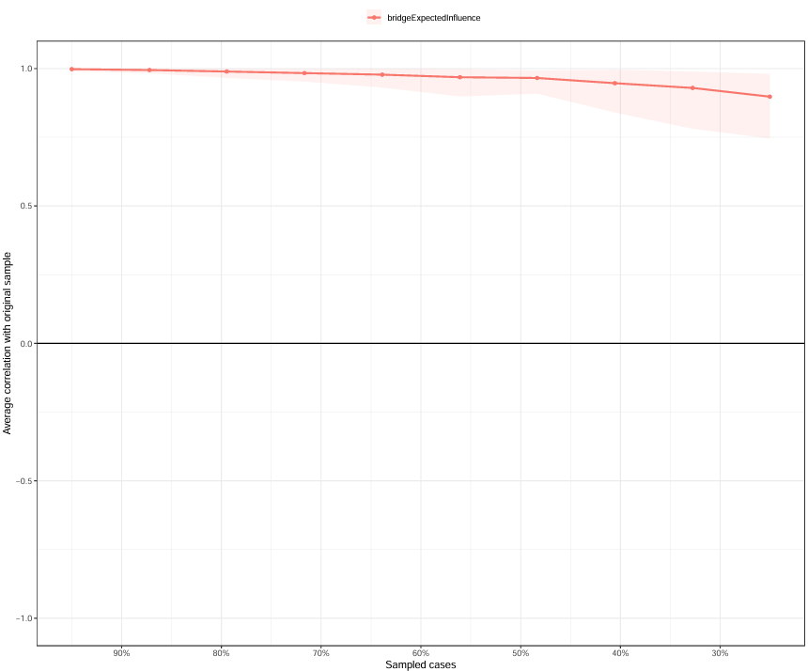
Figure.S1. Stability test of 1000 bootstrap tests for bridge centrality index in full sample.

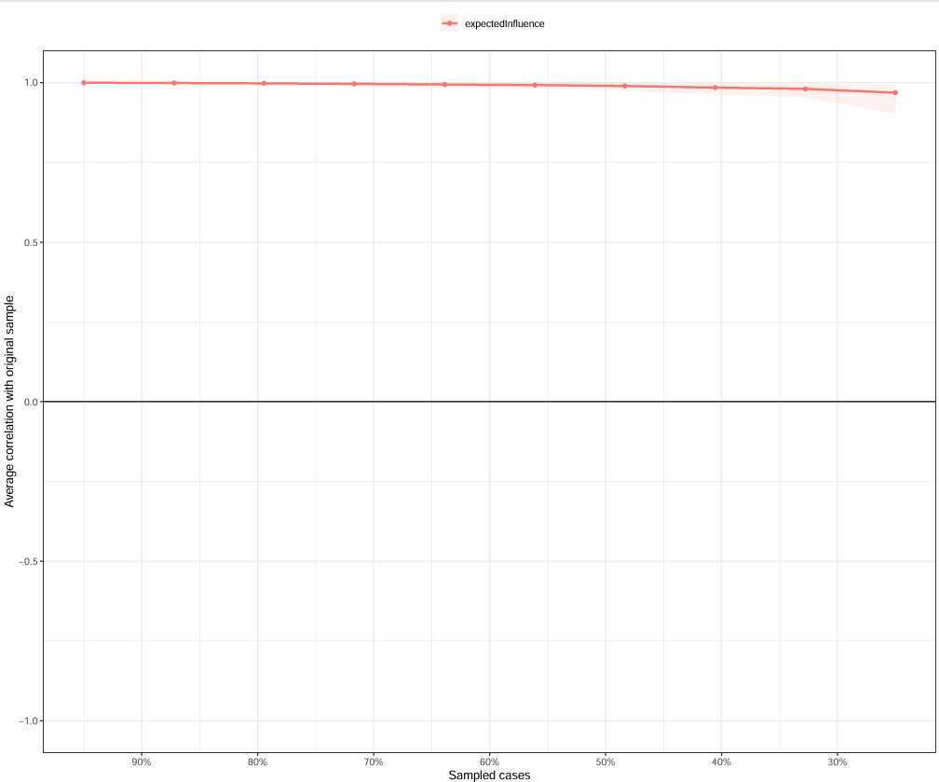
Figure S2. Stability test of 1000 bootstrap tests for expectedInfluence centrality index in full sample.
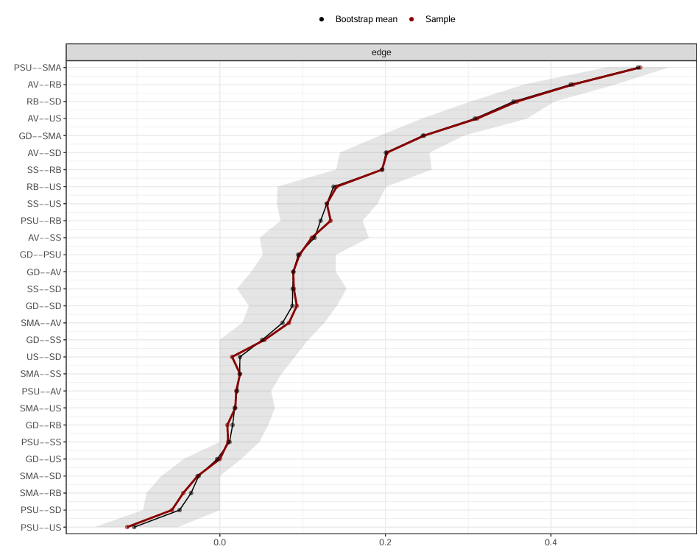
Figure S3. Accuracy of edge weights. Red dots show original edge weights; black dots and gray areas represent bootstrap estimates and 95% CIs. Narrower intervals indicate higher accuracy.

