Supplementary information for Autism-associated Shank3B deletion drives widespread dorsal cortical hyperactivity, amplified sensory responses and accelerated propagation

Supplementary Figures
Supplementary Figure S1 and S2. Sex-stratified analyses of evoked activity.
To determine whether sex modulated genotype effects on sensory-evoked responses, we performed two-way ANOVAs (factors: genotype and sex) on five whisker stimulation metrics (Figure S1 a-e). Significant main effects of genotype were found for peak amplitude (F(1,16) = 15.28, p = 0.0012), STD of peak responses (F(1,16) = 5.036, p = 0.0393), baseline STD (F(1,16) = 10.24, p = 0.0056), SNR (F(1,16) = 4.755, p = 0.0445), and ITR (F(1,16) = 11.81, p = 0.0034). Significant main effects of sex were found for the SNR (F (1,16) = 6.205, p = 0.0241). No other significant main effects of sex were observed for any variable (all p > 0.05), and no genotype x sex interactions reached significance (all p > 0.05). Post hoc comparisons using Fisher’s LSD test confirmed significantly higher peak amplitudes in Shank3B^{-/-} mice compared to Shank3B^{+/+} in both males (t = 3.421, p = 0.0035) and females (t = 2.179, p = 0.0447, Figure S1 a). For the STD of the response, genotype differences were significant only in males (t = 2.554, p = 0.0212, Figure S1 b), with no significant difference in females (t = 0.7173, p = 0.4835). For baseline STD, the genotype effect was significant in males (t = 2.414, p = 0.0281) and in females (t = 2.132, p = 0.0488, Figure S1 c). For the SNR, genotype differences were significant only in males (t = 2.534, p = 0.0221), with no significant difference in females (t = 0.6501, p = 0.5248) and significant sex difference in Shank3B^{-/-} mice (t = 2.648, p = 0.0175, Figure S1 d). For the ITR, genotype differences were significant only in females (t = 3.135, p = 0.0064), with no significant difference in males (t =1.656, p = 0.1173, Figure S1 e).
Because the genotype conclusions were unchanged in male-only and female-only analyses (no genotype x sex interaction), we report pooled-sex estimates in the main text and provide sex-stratified summaries in the Supplement. After pooling sexes, Shank3B^{-/-} mice exhibited significantly larger whisker-evoked peak amplitudes than Shank3B^{+/+} (t = 3.733, p = 0.0015). STD of peak responses was also higher in mutants (t = 2.422, p = 0.0262). Baseline STD was elevated in Shank3B^{-/-} mice (t = 3.484, p = 0.0027). SNR was trended higher but not significant (t = 1.959, p = 0.0658), and ITR showed a significant increase (t = 3.719, p = 0.0016, Figure S2 f-j).
Figure S1. Increased variability and baseline fluctuations in whisker‐evoked responses in Shank3B^{-/-} mice.
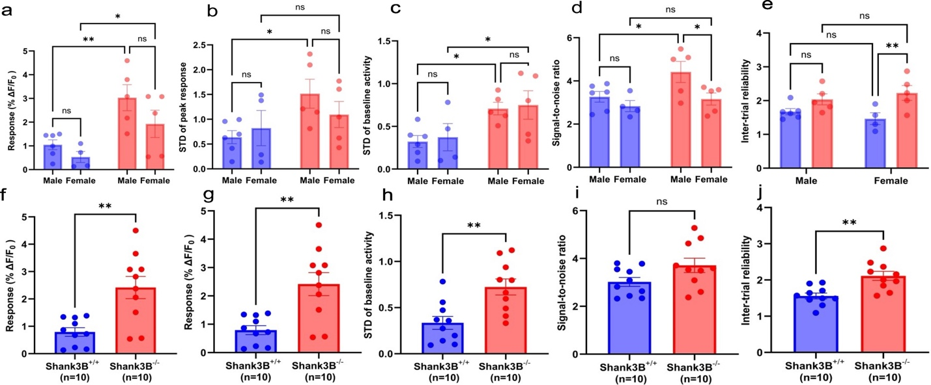
(a-e) Quantification of whisker-evoked activity, separated by genotype and sex (Shank3B^{+/+} and Shank3B^{-/-}; male and female). Metrics include: (h) peak response amplitude, (i) standard deviation (STD) of peak responses, (j) STD of baseline (pre-stimulus) activity, (k) signal-to-noise ratio (SNR; peak / baseline STD), and (l) inter-trial reliability (ITR; peak / STD of peak responses). Sample sizes were as follows: n = 4~6 per group (Shank3B^{+/+} male, Shank3B^{+/+} female, Shank3B^{-/-} male, Shank3B^{-/-} female).
(f-j) Same whisker stimulation metrics shown in (h–l), but collapsed across sex (n=10 per group).
Statistical comparisons in (a-e) were performed using two-way ANOVA (factors: genotype and sex), followed by Fisher’s LSD post hoc tests. Comparisons in (f-j) were based on unpaired two-tailed t-tests. Data represent mean ± SEM. *p < 0.05, **p < 0.01.
We next applied the same two-way ANOVA framework (factors: genotype and sex) to visual stimulation metrics (Figure S2 a-e). Significant main effects of genotype were found for peak amplitude (F(1,16) = 10.18, p = 0.0057), STD of peak responses (F(1,16) = 5.046, p = 0.0391), and baseline STD (F(1,16) = 4.521, p = 0.0494). Significant main effects of genotype were not found for the SNR (F(1,16) = 1.005, p = 0.3310) and ITR (F(1,16) = 0.5424, p = 0.4721). No significant main effects of sex were observed for any variable (all p > 0.05), and no genotype x sex interactions reached significance (all p > 0.05). Post hoc comparisons using Fisher’s LSD test confirmed significantly higher peak amplitudes in Shank3B^{-/-} mice compared to Shank3B^{+/+} in both males (t = 2.280, p = 0.0367) and females (t = 2.232, p = 0.0402, Figure S2 a). For the STD of the response, genotype differences were significant only in males (t = 2.248, p = 0.0390, Figure S2 b), with no significant difference in females (t = 0.9286, p = 0.3669). No other post hoc comparisons reached significance. Because two-way ANOVAs for the visual metrics showed no sex main effect and no genotype x sex interaction (all p>0.05), we pooled males and females for the primary genotype comparisons; sex-stratified summaries are also provided. After pooling sexes, Shank3B^{-/-} mice exhibited significantly larger visual peak amplitudes than Shank3B^{+/+} (t = 3.275, p = 0.0042). STD of peak responses was also higher in mutants (t = 2.248, p = 0.0374). Baseline STD was significantly higher (t =2.707, p = 0.0144). SNR (t =1.015, p = 0.3234) and ITR (t = 0.6842, p = 0.5026) were not significantly different between genotypes (Figure S2 h-j).

Figure S2. Increased variability and baseline fluctuations in visual‐evoked responses in Shank3B^{-/-} mice.
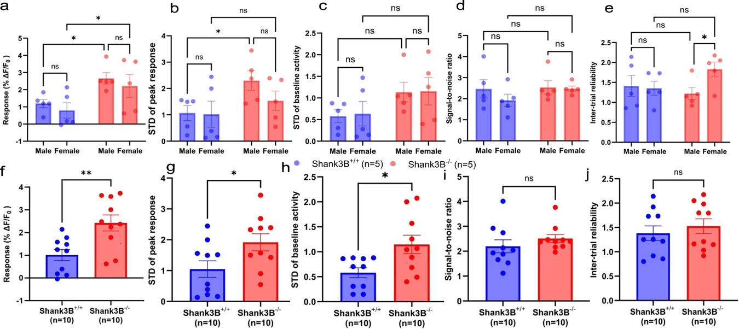
(a-e) Quantification of visually evoked activity, separated by genotype and sex (Shank3B^{+/+} and Shank3B^{-/-}; male and female). Metrics include: (h) peak response amplitude, (i) standard deviation (STD) of peak responses, (j) STD of baseline (pre-stimulus) activity, (k) signal-to-noise ratio (SNR; peak / baseline STD), and (l) inter-trial reliability (ITR; peak / STD of peak responses). Sample sizes were as follows: n = 5 per group (Shank3B^{+/+} male, Shank3B^{+/+} female, Shank3B^{-/-} male, Shank3B^{-/-} female).
(f–j) Same visual stimulation metrics shown in, but collapsed across sex (n=10 per group).
Statistical comparisons in panel a-e were performed using two-way ANOVA (factors: genotype and sex), followed by Fisher’s LSD post hoc tests. Comparisons in panel f-j were based on unpaired two-tailed t-tests. Data represent mean ± SEM. *p < 0.05, **p < 0.01.

Figure S3. Shank3B^{-/-} mice show faster cortical propagation speed and preserved direction during both visual and whisker stimulation (sex difference).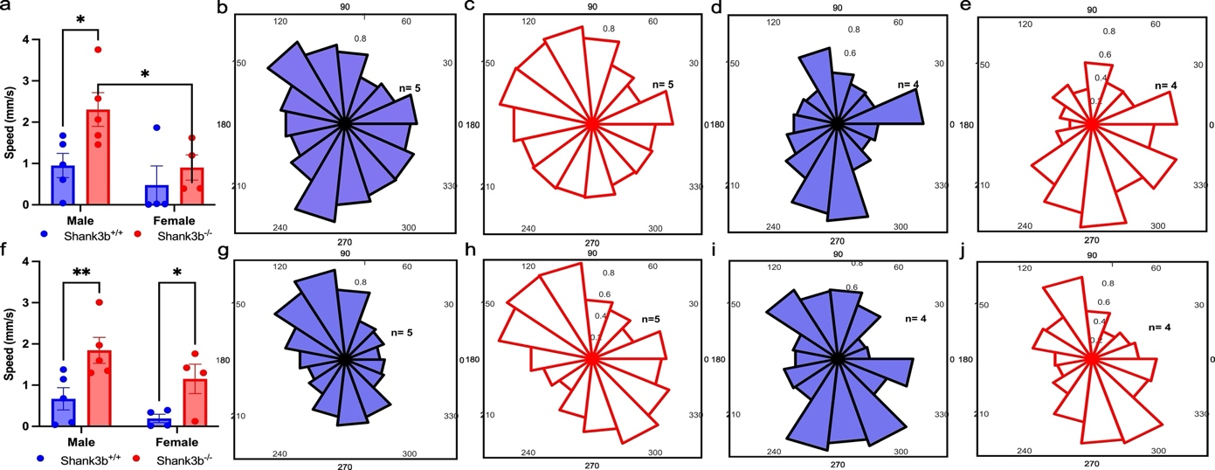
(a) Average speed (mm/s), visual: grouped bars with animal-level dots; factors: genotype (Shank3B^{+/+}, Shank3B^{-/-}) x sex (male, female).
(b-e) Visual: group-average rose histograms of flow direction for Shank3B^{+/+} and Shank3B^{-/-}, male and female; b: Shank3B^{+/+} male, c: Shank3B^{−/−} male, d: Shank3B^{+/+} female, e: Shank3B^{-/-} female. Directions were binned into 15 x 24° rose histograms over the full recording. Angle convention: 0° = medial (toward the midline), 90° = anterior, 180° = lateral, 270° = posterior. Bins: 24°. Plots show counts of unit-vector angles.
(f) Average speed (mm/s), whisker: grouped bars with animal-level dots; factors: genotype (Shank3B^{+/+}, Shank3B^{-/-}) x sex (male, female).
(g-j) Whisker: group-average rose histograms of flow direction for Shank3B^{+/+} and Shank3B^{-/-}, male and female; g: Shank3B^{+/+} male, h: Shank3B^{-/-} male, i: Shank3B^{+/+} female, j: Shank3B^{-/-} female . Directions were binned into 15 x 24° rose histograms over the full recording. Angle convention: 0° = medial (toward the midline), 90° = anterior, 180° = lateral, 270° = posterior. Bins: 24°. Plots show counts of unit-vector angles.

Supplementary Tables
Supplementary Table S1. Summary of statistical results for all inferential analyses
Analysis category | Data level | Dependent variable(s) | Independent variable(s) | Statistical test / model | Key statistics reported in main text | Notes
Sensory-evoked response amplitude | Animal-level | Peak ΔF/F₀ (V1/BC ROI) | Genotype × stimulus intensity | Two-way ANOVA | F, df, p (genotype main effect); post hoc comparisons | Trial responses averaged within animal before analysis
Sensory-evoked response amplitude (summary) | Animal-level | Mean peak ΔF/F₀ (pooled intensities) | Genotype | Unpaired t-test | t, df, p | Intensities averaged per animal
Sensory-evoked activation area | Animal-level | Area above ΔF/F₀ threshold | Genotype × threshold | Two-way ANOVA | F, df, p | Trend-level effects reported
Evoked response variability | Animal-level | SD of peak ΔF/F₀ | Genotype | Unpaired t-test | t, df, p | Highest stimulus intensity only
Baseline variability (evoked trials) | Animal-level | SD of baseline ΔF/F₀ | Genotype | Unpaired t-test | t, df, p | Highest stimulus intensity only
Signal-to-noise ratio (SNR) | Animal-level | SNR | Genotype | Unpaired t-test | t, df, p | Defined as mean peak / SD of baseline
Inter-trial reliability (ITR) | Animal-level | ITR | Genotype | Unpaired t-test | t, df, p | Defined as mean peak / SD of peak
Amplitude-variability scaling | Animal-level | SD of peak vs mean peak | Genotype | Linear regression (Shank3B^{+/+} reference) | Regression slope; residual distributions | Regression fit to Shank3B^{+/+} only
Propagation speed (visual/whisker) | Animal-level | Mean speed (mm/s) | Genotype | Unpaired t-test and Mann-Whitney U test | t, df, p and U, p | Trial-level speeds averaged within animal
Propagation direction (R) | Animal-level | Resultant vector length (R) | Genotype | Mann-Whitney U test | U, p | R computed from 15-bin angular histogram; sexes pooled
Spontaneous cortical activity (RMS) | Animal-level | RMS ΔF/F₀ (11 ROIs) | Genotype × sex × ROI | Three-way repeated-measures ANOVA | F, df, p (main effects & interactions) | Greenhouse-Geisser correction applied
Spontaneous cortical activity (pooled sex) | Animal-level | RMS ΔF/F₀ (11 ROIs) | Genotype × ROI | Two-way repeated-measures ANOVA | F, df, p; post hoc tests | Sex pooled after no interaction detected
Genotype prediction (sensory-evoked) | Animal-level | Genotype | Response_Z, STD_response_Z, Baseline_Z | Logistic regression (5-fold CV) | β (slope), p, CV-AUC, accuracy | Predictors z-scored within modality
Genotype prediction (resting-state) | Animal-level | Genotype | RMS (single ROI) | Univariate logistic regression | β, p, CV-AUC | One model per ROI
Multivariate genotype prediction | Animal-level | Genotype | RMS (all ROIs) | LASSO logistic regression | Retained predictors; CV-AUC | λ selected by cross-validation

Supplementary Table S2. Full statistical results for all inferential analyses
Full statistical results for all inferential analyses performed in this study. All analyses were conducted at the animal level. ANOVA results report F statistics, degrees of freedom, and p values for main effects and interactions. t-tests report t values, degrees of freedom, and p values. Logistic regression results include regression coefficients (β), p values, and cross-validated performance metrics (Table 1). LASSO models report retained predictors and model performance (Table S2C); p values are not provided for LASSO coefficients.

Supplementary Table S2A. ANOVA results (Figure 2, 3, S1, S3, and sex difference)
Analysis | Dependent variable | Effect | F | df (effect, error) | p value
Whisker-evoked response | Peak ΔF/F₀ | Genotype | F (1, 45) =55.51 | 1 | <0.0001
Whisker-evoked response | Peak ΔF/F₀ | Intensity | F (4, 45) = 0.7642 | 4 | 0.5542
Whisker-evoked response | Peak ΔF/F₀ | Genotype × Intensity | F (4, 45) = 0.6851 | 4 | 0.060
Whisker activation area | Area above absolute threshold | Genotype | F (1, 54) = 16.77 | 1 | 0.0001
Whisker activation area | Area above absolute threshold | Threshold | F (5, 54) = 16.76 | 5 | 0.0001
Whisker activation area | Area above absolute threshold | Genotype × Threshold | F (5, 54) = 0.2740 | 5 | 0.9254
Whisker-evoked response | Mean of the peak | Genotype | F (1, 16) = 15.28 | 1 | 0.0012
Whisker-evoked response | Mean of the peak | Sex | F (1, 16) = 3.510 | 1 | 0.0794
Whisker-evoked response | Mean of the peak | Genotype × Sex | F (1, 16) = 0.4557 | 1 | 0.5093
Whisker-evoked response | SD of peak | Genotype | F (1, 16) = 5.036 | 1 | 0.0393
Whisker-evoked response | SD of peak | Sex | F (1, 16) = 0.2137 | 1 | 0.6501
Whisker-evoked response | SD of peak | Genotype × Sex | F (1, 16) = 1.390 | 1 | 0.2556
Whisker-evoked response | SD of baseline | Genotype | F (1, 16) = 10.24 | 1 | 0.0056
Whisker-evoked response | SD of baseline | Sex | F (1, 16) = 0.1505 | 1 | 0.7032
Whisker-evoked response | SD of baseline | Genotype × Sex | F (1, 16) = 0.001205 | 1 | 0.9727
Whisker-evoked response | SNR | Genotype | F (1, 16) = 4.755 | 1 | 0.0445
Whisker-evoked response | SNR | Sex | F (1, 16) = 6.205 | 1 | 0.0241
Whisker-evoked response | SNR | Genotype × Sex | F (1, 16) = 1.477 | 1 | 0.2418
Whisker-evoked response | ITR | Genotype | F (1, 16) = 11.81 | 1 | 0.0034
Whisker-evoked response | ITR | Sex | F (1, 16) = 0.002668 | 1 | 0.9594
Whisker-evoked response | ITR | Genotype × Sex | F (1, 16) = 1.483 | 1 | 0.2410
Visual-evoked response | Peak ΔF/F₀ | Genotype | F (1, 40) = 41.73 | 1 | <0.0001
Visual-evoked response | Peak ΔF/F₀ | Intensity | F (4, 40) = 3.333 | 4 | 0.0190
Visual-evoked response | Peak ΔF/F₀ | Genotype × Intensity | F (1, 16) = 0.6544 | 1 | 0.6272
Visual activation area | Area above relative threshold | Genotype | F (1, 48) = 1.928 | 2 | 0.1713
Visual activation area | Area above relative threshold | Threshold | F (5, 48) = 6.939 | 5 | <0.0001
Visual activation area | Area above relative threshold | Genotype × Threshold | F (5, 48) = 0.01162 | 5 | >0.9999
Visual-evoked response | Mean of the peak | Genotype | F (1, 16) = 10.18 | 1 | 0.0057
Visual-evoked response | Mean of the peak | Sex | F (1, 16) = 0.8771 | 1 | 0.3629
Visual-evoked response | Mean of the peak | Genotype × Sex | F (1, 16) = 0.001124 | 1 | 0.9737
Visual-evoked response | SD of peak | Genotype | F (1, 16) = 5.046 | 1 | 0.3646
Visual-evoked response | SD of peak | Sex | F (1, 16) = 1.106 | 1 | 0.3087
Visual-evoked response | SD of peak | Genotype × Sex | F (1, 16) = 0.8708 | 1 | 0.0391
Visual-evoked response | SD of baseline | Genotype | F (1, 16) = 4.521 | 1 | 0.0494
Visual-evoked response | SD of baseline | Sex | F (1, 16) = 0.02352 | 1 | 0.8800
Visual-evoked response | SD of baseline | Genotype × Sex | F (1, 16) = 0.004890 | 1 | 0.9451
Visual-evoked response | SNR | Genotype | F (1, 16) = 1.005 | 1 | 0.3310
Visual-evoked response | SNR | Sex | F (1, 16) = 0.9494 | 1 | 0.3444
Visual-evoked response | SNR | Genotype × Sex | F (1, 16) = 0.5999 | 1 | 0.4499
Visual-evoked response | ITR | Genotype | F (1, 16) = 0.5424 | 1 | 0.4721
Visual-evoked response | ITR | Sex | F (1, 16) = 1.981 | 1 | 0.1784
Visual-evoked response | ITR | Genotype × Sex | F (1, 16) = 2.875 | 1 | 0.1094
Spontaneous activity (RMS) | RMS ΔF/F₀ (11 ROIs) | Genotype | F (1, 24) = 7.832 | 1 | <0.0001
Spontaneous activity (RMS) | RMS ΔF/F₀ (11 ROIs) | ROI | F (1.501, 36.02) = 57.49 | 10 | <0.0001
Spontaneous activity (RMS) | RMS ΔF/F₀ (11 ROIs) | Genotype × ROI | F (10, 240) = 5.074 | 10 | <0.0001
Propagation speed (visual) | Mean speed (mm/s) | Genotype | F(1,14) = 5.60 | 1 | 0.0329
Propagation speed (visual) | Mean speed (mm/s) | Sex | F(1,14) = 6.20 | 1 | 0.0255
Propagation speed (visual) | Mean speed (mm/s) | Genotype × Sex | F(1,14) = 1.50 | 1 | 0.2351
Propagation speed (whisker) | Mean speed (mm/s) | Genotype | F(1,14) = 13.96 | 1 | 0.0022
Propagation speed (whisker) | Mean speed (mm/s) | Sex | F(1,14) = 4.181 | 1 | 0.0602
Propagation speed (whisker) | Mean speed (mm/s) | Genotype × Sex | F(1,14) = 1.145 | 1 | 0.7090
Repeated-measures ANOVA with Greenhouse-Geisser correction applied where appropriate.

Supplementary Table S2B. t-test results (Figure 4)
Analysis | Dependent variable | Comparison | t | df | p value
Whisker-evoked response (summary) | Area | Shank3B^{+/+} vs Shank3B^{-/-} | 2.775 | 64 | 0.0072
Visual-evoked response (summary) | Area | Shank3B^{+/+} vs Shank3B^{-/-} | 1.163 | 58 | 0.2498
Whisker-evoked response (summary) | Mean peak ΔF/F₀ across intensities | Shank3B^{+/+} vs Shank3B^{-/-} | 7.180 | 33.07 | <0.0001
Visual-evoked response (summary) | Mean peak ΔF/F₀ across intensities | Shank3B^{+/+} vs Shank3B^{-/-} | 5.983 | 37.90 | <0.0001
Whisker-evoked response (summary) | Mean peak ΔF/F₀ | Shank3B^{+/+} vs Shank3B^{-/-} | 4.003 | 11.97 | 0.0018
Visual-evoked response (summary) | Mean peak ΔF/F₀ | Shank3B^{+/+} vs Shank3B^{-/-} | 2.031 | 17.82 | 0.0574
Evoked variability (whisker) | SD of peak ΔF/F₀ | Shank3B^{+/+} vs Shank3B^{-/-} | 3.290 | 15.20 | 0.0049
Evoked variability (visual) | SD of peak ΔF/F₀ | Shank3B^{+/+} vs Shank3B^{-/-} | 2.342 | 17.04 | 0.0316
Baseline variability (whisker) | SD of baseline ΔF/F₀ | Shank3B^{+/+} vs Shank3B^{-/-} | 4.612 | 15.76 | 0.0003
Baseline variability (visual) | SD of baseline ΔF/F₀ | Shank3B^{+/+} vs Shank3B^{-/-} | 2.559 | 15.98 | 0.0210
Signal-to-noise ratio  (whisker) | SNR | Shank3B^{+/+} vs Shank3B^{-/-} | 1.828 | 17.87 | 0.0842
Signal-to-noise ratio  (visual) | SNR | Shank3B^{+/+} vs Shank3B^{-/-} | 0.3765 | 14.57 | 0.7120
Inter-trial reliability  (whisker) | ITR | Shank3B^{+/+} vs Shank3B^{-/-} | 2.432 | 14.11 | 0.0289
Inter-trial reliability  (visual) | ITR | Shank3B^{+/+} vs Shank3B^{-/-} | 0.1239 | 14.76 | 0.9031
Propagation speed (visual, pooled) | Mean speed (mm/s) | Shank3B⁺/⁺ vs Shank3B⁻/⁻ | 2.365 | 11.49 | 0.0366
Note: † Mann-Whitney U test used due to non-normality.
Analysis | Dependent variable | Comparison | U | p value
Propagation speed (whisker, pooled) | Mean speed (mm/s) | Shank3B⁺/⁺ vs Shank3B⁻/⁻ | 16 | 0.0315
Propagation direction (visual) | Resultant vector length (R) | Shank3B⁺/⁺ vs Shank3B⁻/⁻ | 24 | 0.1552
Propagation direction (whisker) | Resultant vector length (R) | Shank3B⁺/⁺ vs Shank3B⁻/⁻ | 34 | 0.5867

Supplementary Table S2C. Retained predictors from LASSO-penalized logistic regression using resting-state RMS
Model | Predictor (ROI) | Coefficient | Retained (Yes/No)
RMS LASSO | BC | 1.2302 | Yes
RMS LASSO | S2 | 3.9381 | Yes
RMS LASSO | Other ROIs | 0.00 | No

