Supplementary materials for
“Feeding the Problem? Free-Ranging Cats and Wildlife Loss in Urban Park”
Colony management procedures
The management of the free-ranging cat colony at Américo Renné Giannetti Municipal Park (PqMARG) has historically been conducted by non-governmental organizations and independent animal welfare volunteers. In 2022, as part of the colony management strategy, the Belo Horizonte Municipal Government established an on-site veterinary outpatient facility within the park to provide minor surgical procedures, clinical treatments, routine veterinary care, and post-neutering follow-up. Since then, management activities have been carried out by a multidisciplinary team composed of veterinarians, biologists, and animal caretakers assigned exclusively to the park, in collaboration with the Municipal Health Department's Zoonosis Control Directorate and the Centro-Sul Zoonosis Control Unit. In addition, the municipality maintains a partnership with a contracted veterinary clinic to perform more complex veterinary procedures when required. Trap-Neuter-Return (TNR) has been adopted as the primary population management strategy because it is considered an ethical approach consistent with animal welfare principles. The program consists of the continuous capture of free-ranging cats for sterilization followed by their return to their original location. Cats are captured either through manual restraint of habituated individuals or by using hand nets and baited live traps. Healthy, unneutered cats are transported to the Municipal Zoonosis Control Center, where they undergo sex determination, surgical sterilization, permanent identification through implantation of a subcutaneous interscapular microchip, rabies vaccination, and permanent ear-tipping (left ear for males and right ear for females). Ear-tipping is performed under appropriate sedation and animal welfare protocols and provides a readily visible indicator that an individual has already been sterilized, thereby preventing unnecessary recapture. Animals requiring additional veterinary care are referred either to the Belo Horizonte Public Veterinary Hospital Complex or to the municipality's contracted veterinary clinic. Following capture, identification, veterinary care, and sterilization, individuals that are not adopted or placed in foster care are returned to PqMARG, where they remain under continuous monitoring as members of the managed colony. These teams are also responsible for a wide range of complementary management activities, including population characterization (updating records of colony size, sex ratio, age class, and health status); colony reduction through the continuous removal of newly abandoned, unneutered, and adoptable cats; animal health and welfare interventions (veterinary care, surgical sterilization, microchipping, and vaccination); individual registration and long-term monitoring; epidemiological surveillance of rabies and sporotrichosis; and the promotion of adoption and foster care programs, among other management activities.

Supplementary Tables and Figures
Table S1. Ethogram of predatory behaviors recorded in free-ranging cats, developed from 30 hours of pilot observations and adapted from Leyhausen (1979).
Behavior | Definition
Tracking | The cat follows trails or scent cues left by prey.
Watching posture | The cat detects the prey and remains alert and vigilant, with erect ears and its gaze fixed on the environmental stimulus. It remains motionless or subtly tracks the prey with head and eye movements while assessing the situation before initiating any approach
Ambush | The cat positions itself in cover and remains motionless with its body held low and attention focused on the prey. In this posture, it relies on concealment to avoid detection while waiting for the prey to approach within striking distance
Stealthy approach | The cat advances toward the prey with slow, deliberate steps while keeping its body low, its head aligned with the body axis, and its tail extended close to the ground.
Crouching (Stalking pause) | The cat adopts a motionless, crouched posture close to the ground, with its body elongated and head extended forward while maintaining direct visual contact with the prey. The tail may exhibit subtle serpentine movements. This behavior occurs when the prey has already been detected at close range and the cat waits for the appropriate moment to attack or resume the stealthy approach.
Chase | The cat pursues the prey by running in an attempt to capture it.
Attack | The cat lunges at the prey with its body compressed and claws extended, using both teeth and claws to capture the prey.
Restraint | The cat secures the prey with its claws while maintaining a tense body posture and firmly positioned limbs, preventing the prey from escaping.
Shake | The cat vigorously shakes the prey by moving its body from side to side, typically while holding the prey in its mouth and maintaining a firm grip with its claws.
Licking | The cat licks the prey with its head lowered and body relaxed, using its tongue to clean or inspect the prey.
Manipulation | The cat manipulates the prey with its forepaws, frequently changing body position to facilitate handling and maintain control.
Feeding/Consumption | The cat consumes the prey while maintaining a flexible body posture with its head lowered over the prey, using its claws to stabilize it during feeding.
Abandonment | The cat abandons the prey without consuming it.
Unsuccessful attack | The cat performs attack movements, such as jumping or lunging toward the prey, but fails to capture it.
Post-attack observation / Escape monitoring | The cat remains alert, maintaining a watching posture while visually tracking the prey as it retreats and keeping its head oriented toward the location where the prey disappeared.
Prey play | The cat interacts playfully with the prey by biting, sniffing, batting it with its forepaws, shaking it, tossing it into the air, or holding it with its mouth and/or forepaws while delivering rapid kicks with its hind legs.

Supplementary Tables and Figures
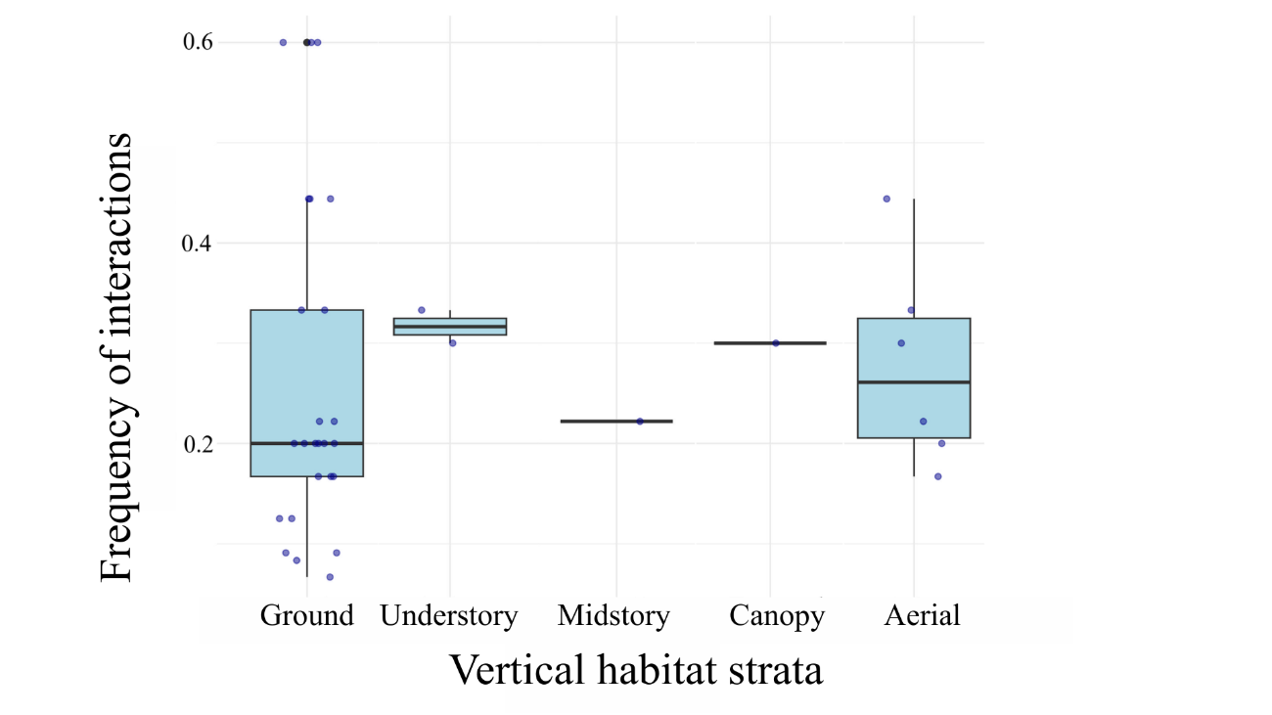
Fig. S1. Boxplot of the relative frequency of interactions between free-ranging cats and wildlife across the landscape strata where interaction events were recorded. Boxes represent the distribution of relative frequencies (interquartile range), and the horizontal line within each box indicates the median. The relative frequency of interactions did not differ significantly among landscape strata.
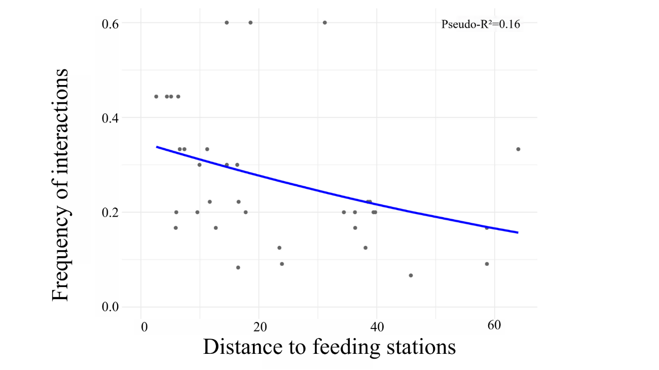
Fig. S2. Relationship between the frequency of interactions between free-ranging cats and wildlife and the distance to the nearest feeding station (m). The blue line represents the fitted beta regression model, indicating a negative relationship: the shorter the

Table S2. Undigested remains of any origin identified in scat samples collected from free-ranging cats at PqMARG, including plant material and undigested material of anthropogenic origin
Code | Class. Order. Family. Genus. Species | Photographic record
9 | Insecta. Blattodea. Blattidae.  Exoskeleton | 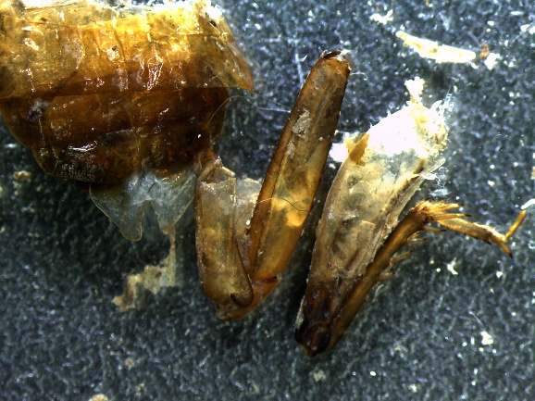
35 | Mammalia.  Bones; teeth | 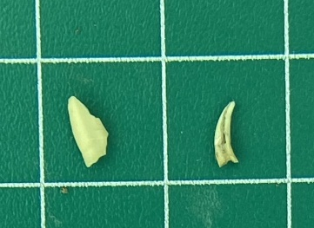
35 | Aves.  Feathers | 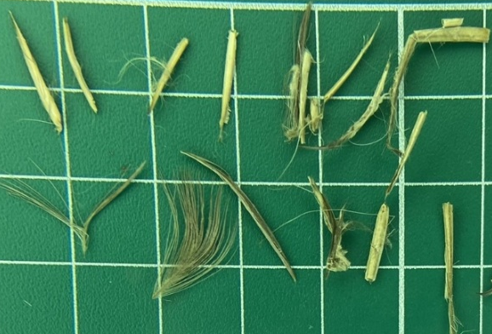
52 | Undigested anthropogenic material.  Plastic | 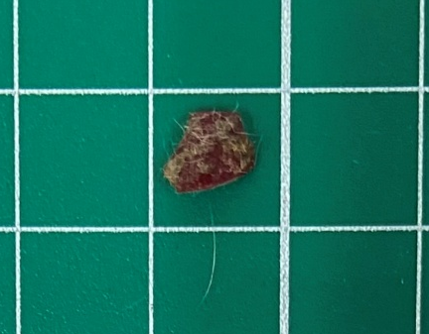
56 e 57 | Mammalia. Chiroptera. Phyllostomidae.  Teeth; bones; claws | 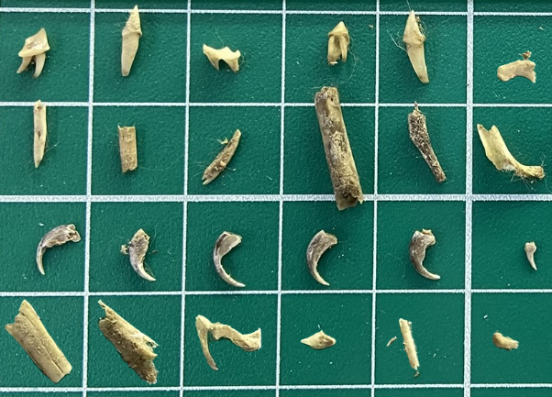
56 e 57 | Mammalia. Chiroptera. Phyllostomidae.  Hair | 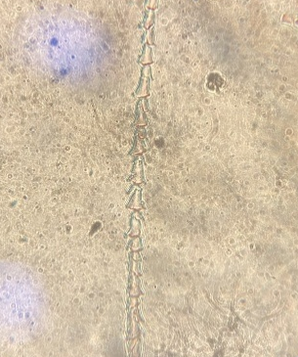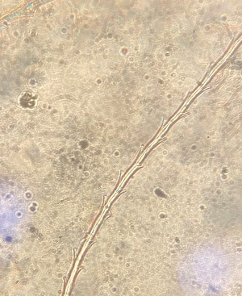  Smooth conoidal cuticular pattern with bracts and absent medulla.
79 | Mammalia. Chiroptera. Vespertilionidae.  Teeth; bones; claws | 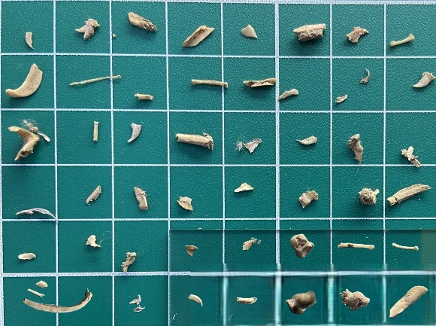
79 | Mammalia. Chiroptera. Phyllostomidae.  Hair | 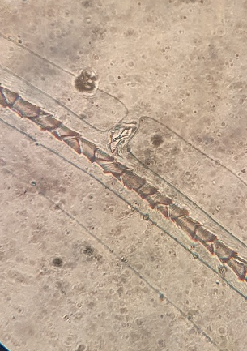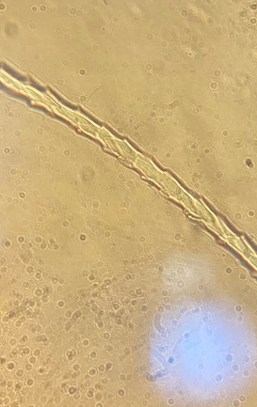  Narrow folidaceous cuticular pattern and absent medulla
81 | Insecta.  Exoskeleton | 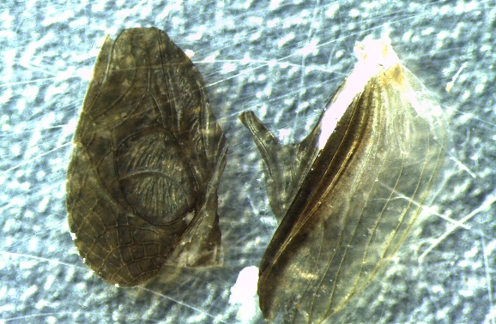
101 | Mammalia. Didelphimorphia. Didelphidae. Didelphis albiventris  Teeth; bones | 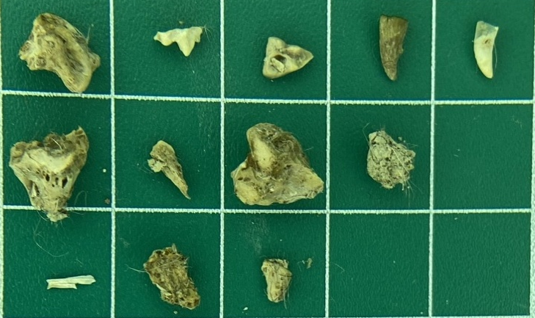
101 | Mammalia. Didelphimorphia. Didelphidae. Didelphis albiventris  Hair | 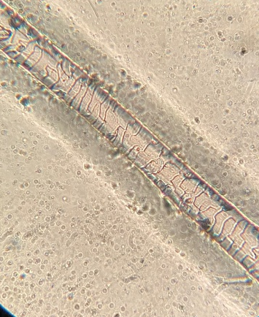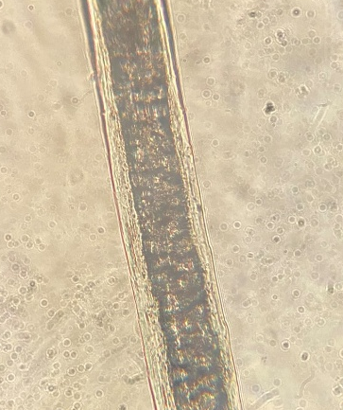  Imbricate cuticle, with undulated, smooth scales arranged transversely and discontinuous margins; medulla present, continuous, multiseriate, anastomosing, with a cribiform cellular pattern.
101 | Aves.  Feathers; bones; keratinized scales | 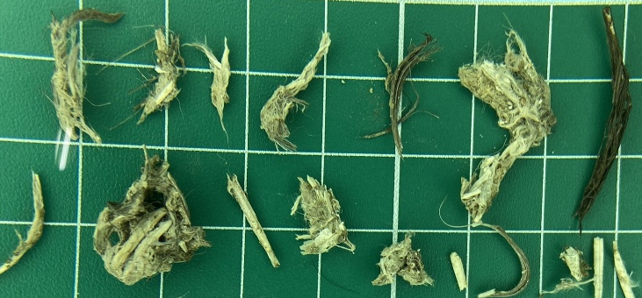
105 | Mammalia. Didelphimorphia. Didelphidae. Didelphis albiventris  Bones | 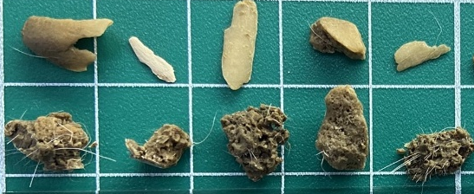
105 | Mammalia. Didelphimorphia. Didelphidae. Didelphis albiventris  Hair | 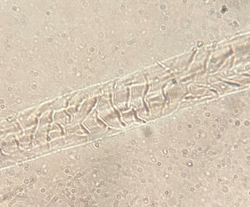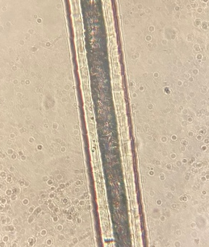  Imbricate cuticle, with undulated, smooth scales arranged transversely and discontinuous margins; medulla present, continuous, multiseriate, anastomosing, with a cribriform cellular pattern.
105 | Undigested anthropogenic material.  Aluminum foil | 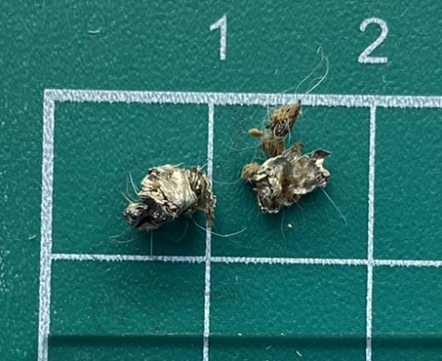
106 | Exoskeleton | 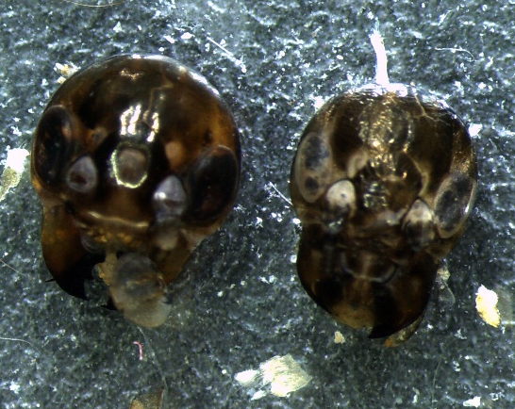
106 | Exoskeleton | 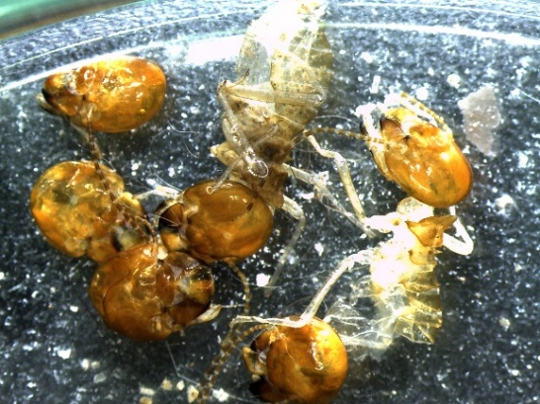
109 | Mammalia. Didelphimorphia. Didelphidae. Didelphis albiventris  Teeth; bones; claws | 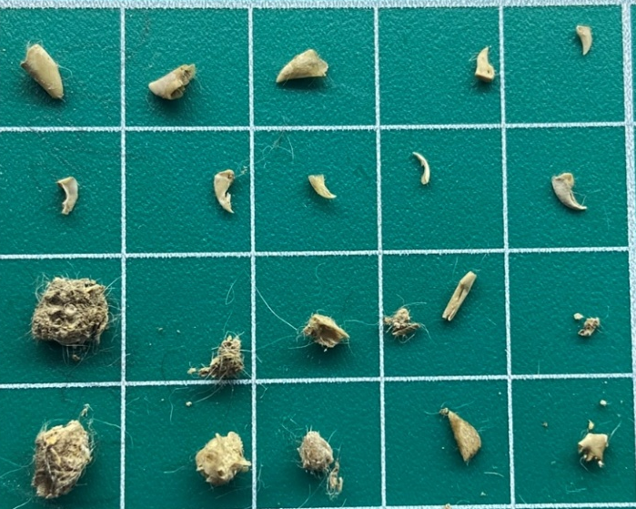
109 | Mammalia. Didelphimorphia. Didelphidae. Didelphis albiventris  Hair | 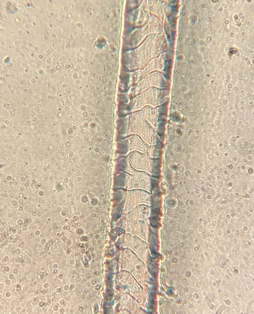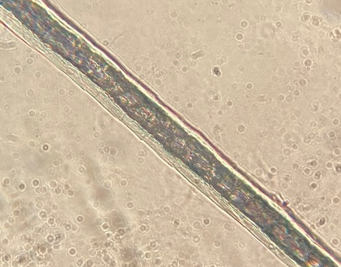  Imbricate cuticle, with undulated, smooth scales arranged transversely and discontinuous margins; medulla present, continuous, multiseriate, anastomosing, with a cribriform cellular pattern.
111 | Aves.  Feathers; bones | 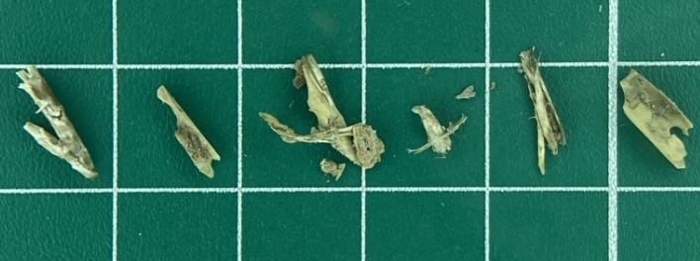
126 | Undigested anthropogenic material. Plastic | 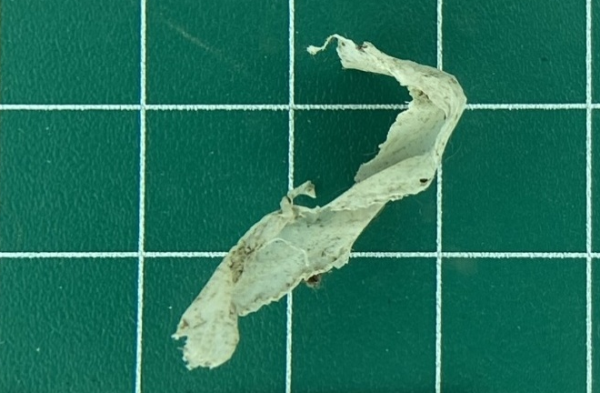
129 | Undigested anthropogenic material. Plastic | 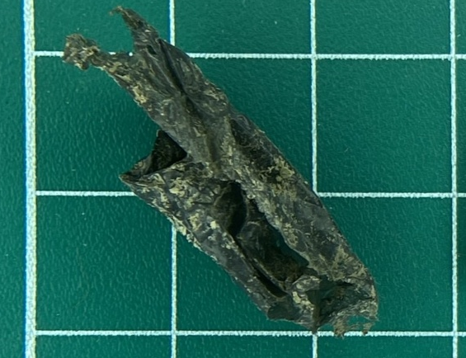
129 | Aves.  Feathers | 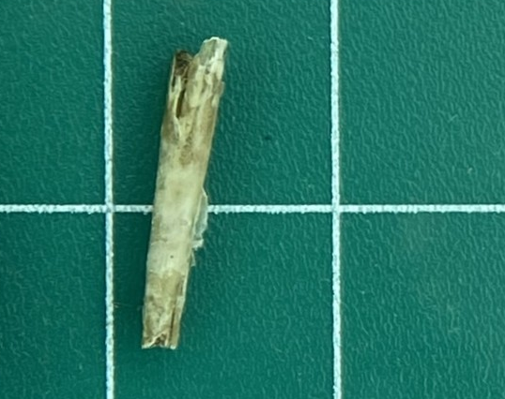
141 | Exoskeleton | 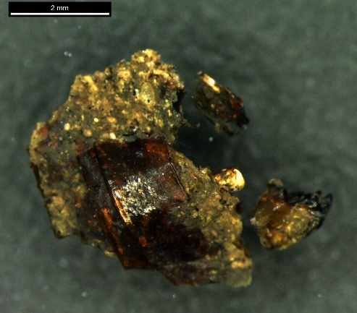
142 | Exoskeleton | 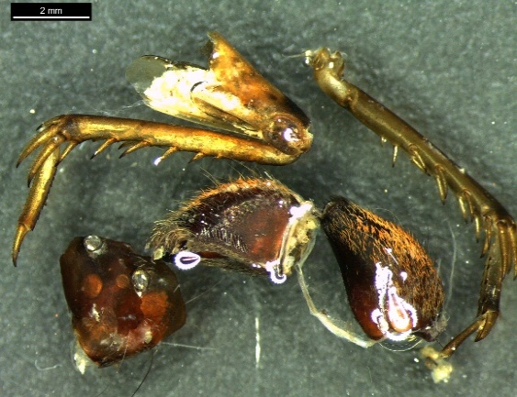
143 | Aves.  Feathers | 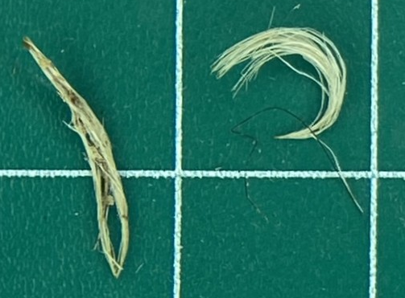
143 | Exoskeleton | 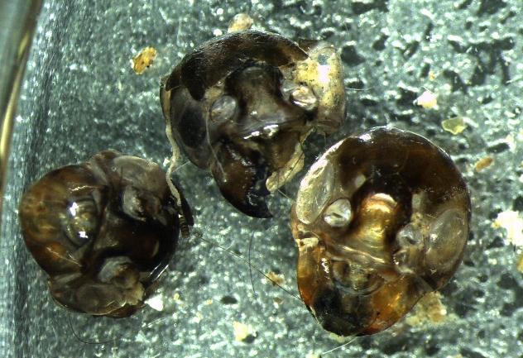
145 | Exoskeleton | 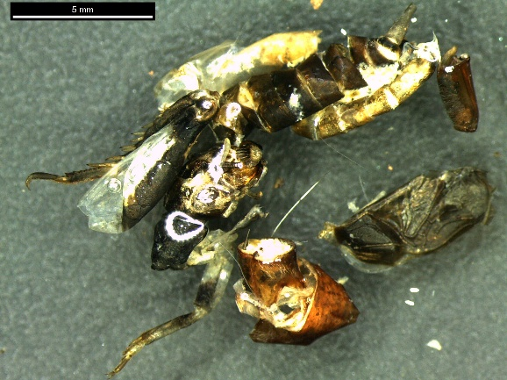
145 | Aves.  Feathers; bones | 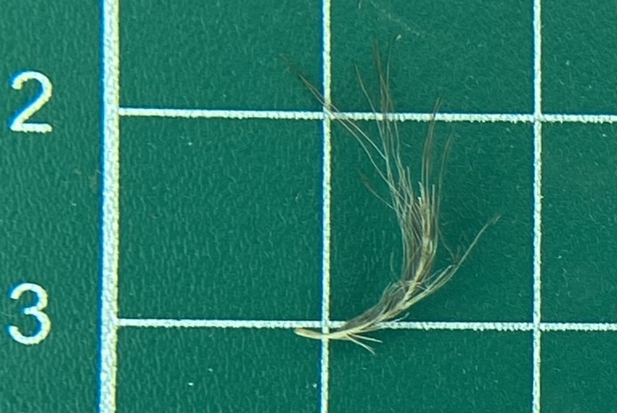
146 | Aves.  Feathers; bones; keratinized scales | 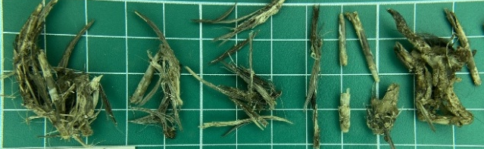
148 | Aves.  Feathers; bones; keratinized scales | 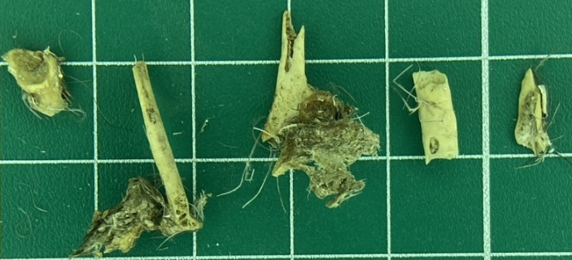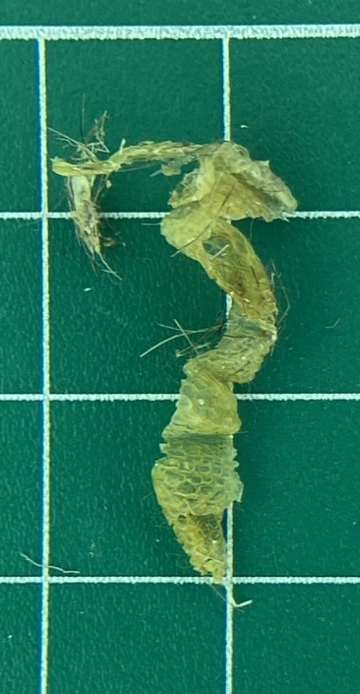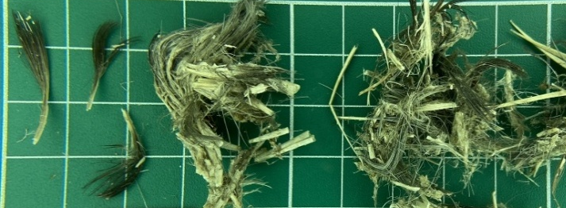
148 | Exoskeleton | 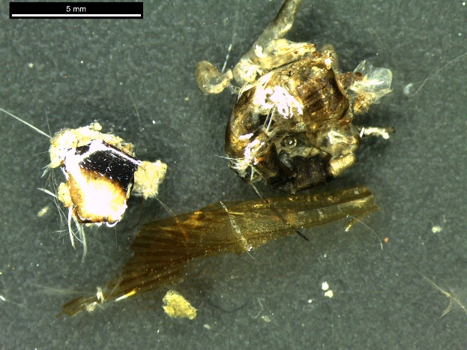
149 | Exoskeleton | 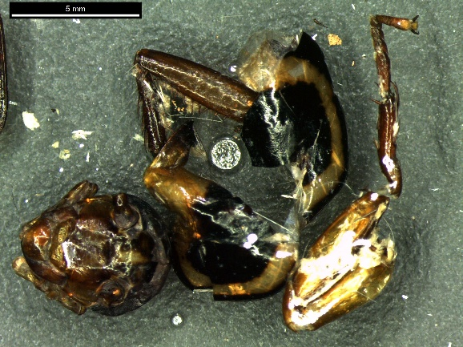
150 | Undigested anthropogenic material.  Nylon suture thread; metallic spherical projectile | 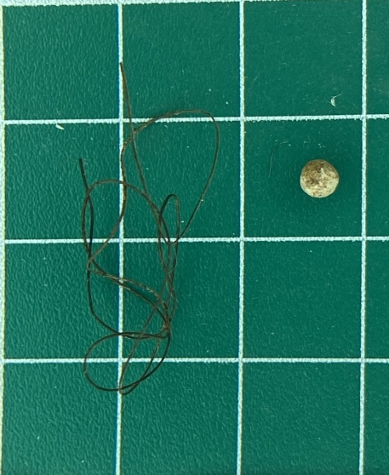
171 | Undigested anthropogenic material.  Paper | 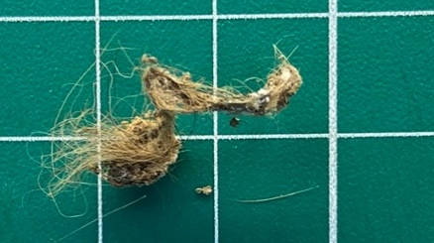
179 | Mammalia. Didelphimorphia. Didelphidae. Didelphis albiventris  Hair | 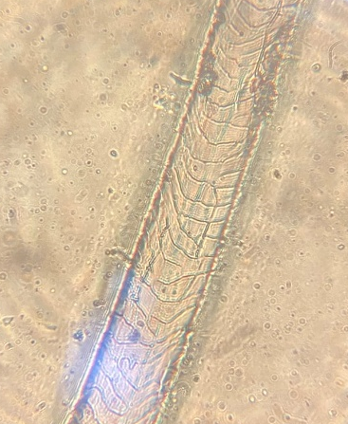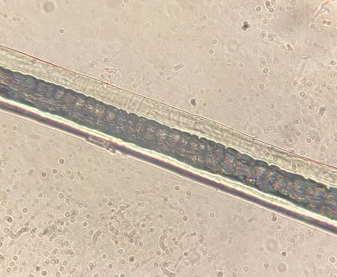  Imbricate cuticle, with undulated, smooth scales arranged transversely and discontinuous margins; medulla present, continuous, multiseriate, anastomosing, with a cribriform cellular pattern.
180 | Mammalia. Rodentia. Muridae. Mus musculus  Hair | 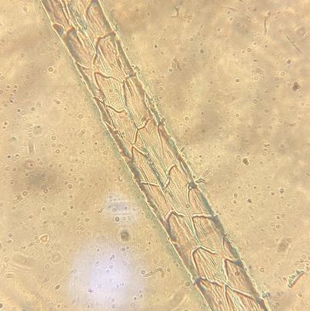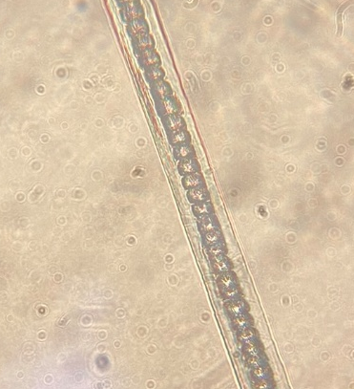  Padrão cuticular losângica larga; Padrão medular alveolar
187 | Exoskeleton | 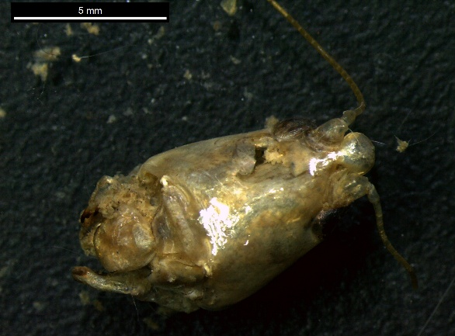
207 | Exosqueleto | 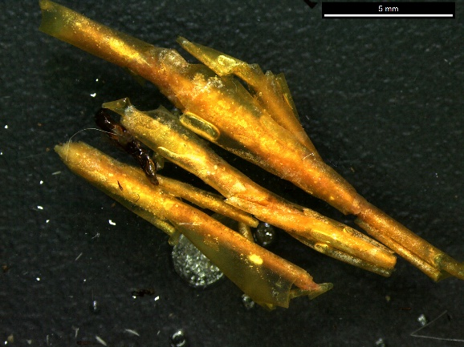
208 | Mammalia. Chiroptera. Phyllostomidae.  Teeth; claws | 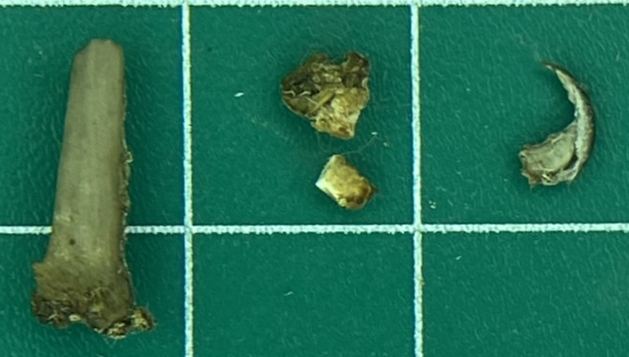
208 | Mammalia. Chiroptera. Phyllostomidae.  Hair | 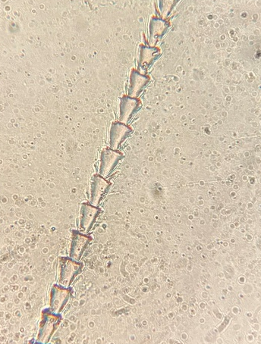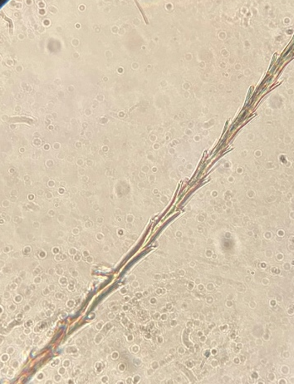  Padrão cuticular conoidal lisa com bráctea e medula ausente
209 | Exoskeleton | 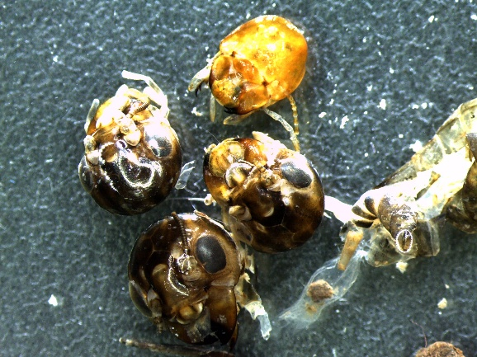
211 | Mammalia. Chiroptera. Phyllostomidae.  Hair | 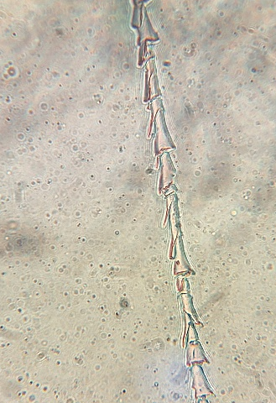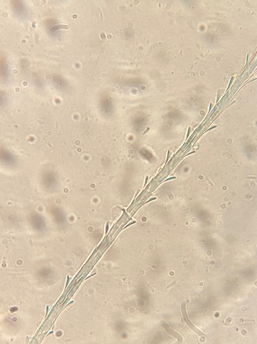  Padrão cuticular conoidal lisa com bráctea e medula ausente
213 | Exoskeleton | 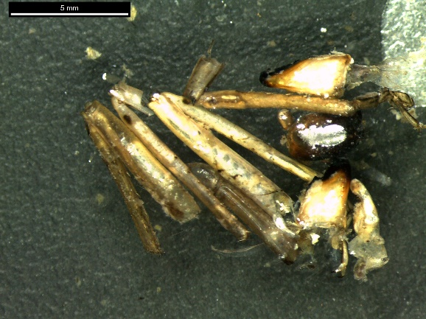
215 | Exoskeleton | 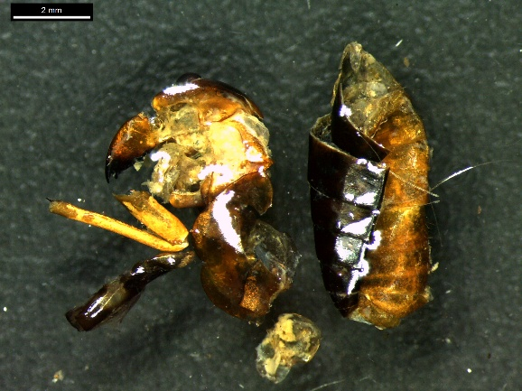
224 | Insecta. Orthoptera. Tettigoniidae.  Exoskeleton | 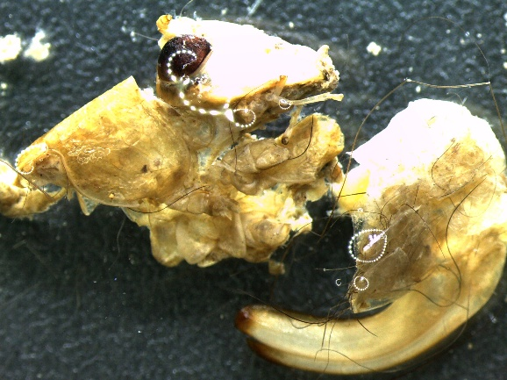
230 | Insecta. Coleoptera.  Exoskeleton | 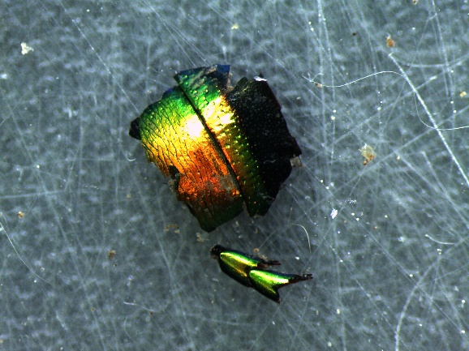
236 | Exoskeleton | 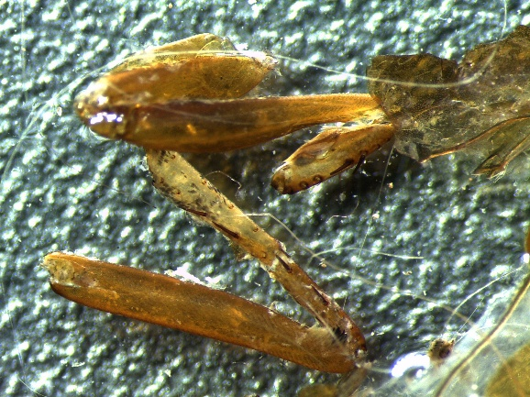
239 | Exoskeleton | 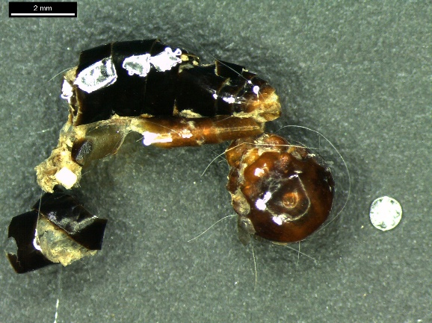
272 | Exoesquelto | 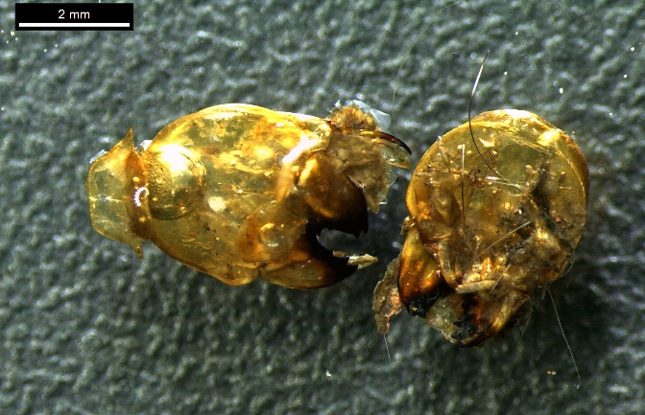
283 | Exoskeleton | 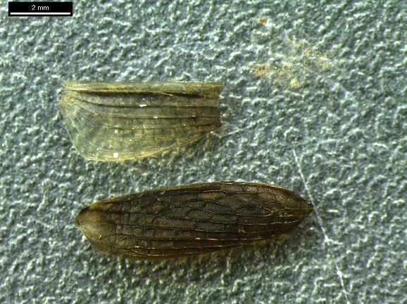
284 | Exoskeleton | 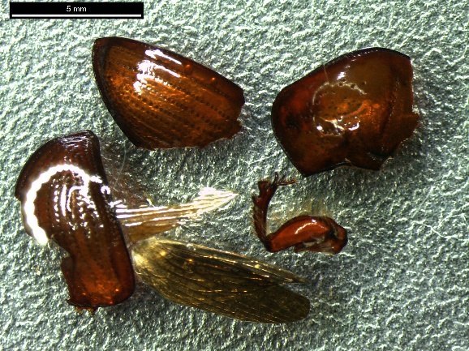
285 | Exoskeleton | 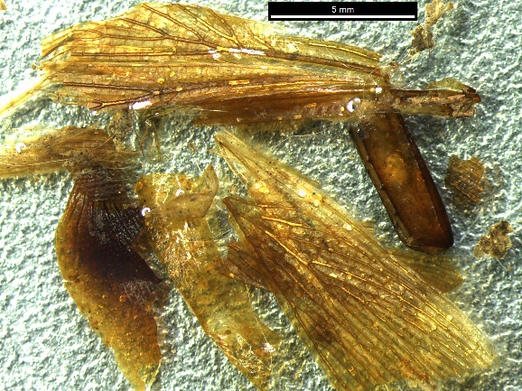
287 | Exoskeleton | 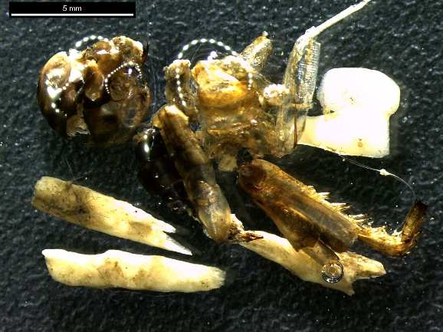
301 | Exoskeleton | 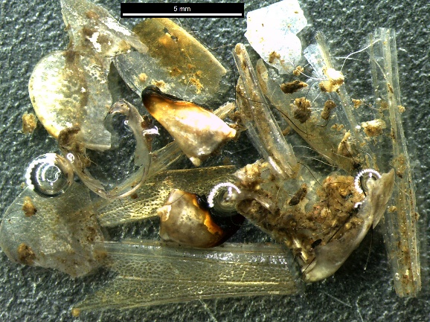
308 | Mammalia. Didelphimorphia. Didelphidae. Didelphis albiventris  Bones | 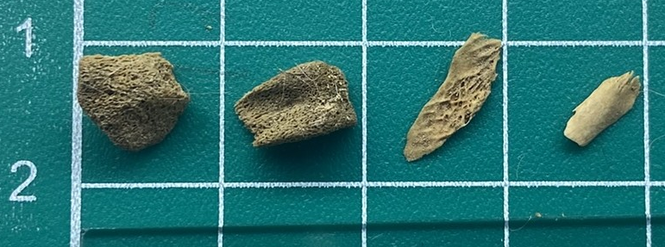
308 | Mammalia. Didelphimorphia. Didelphidae. Didelphis albiventris  Hair | 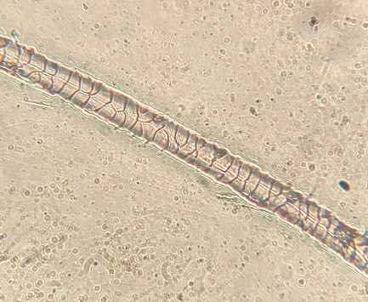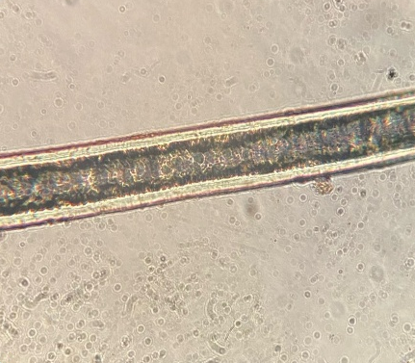  Imbricate cuticle, with undulated, smooth scales arranged transversely and discontinuous margins; medulla present, continuous, multiseriate, anastomosing, with a cribriform cellular pattern.
308 | Exoskeleton | 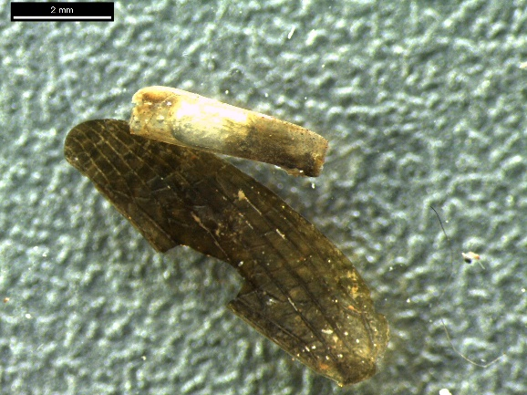
314 | Exoskeleton | 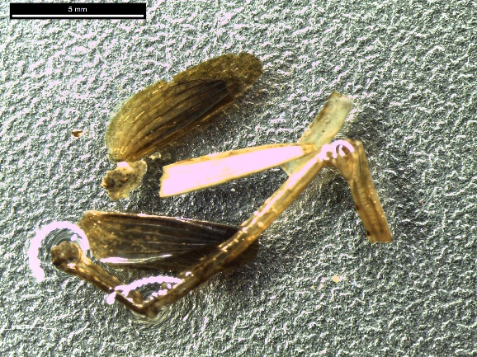
319 | Exoskeleton | 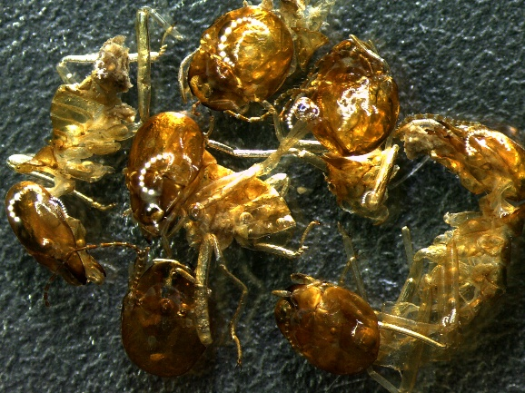
323 | Exoskeleton | 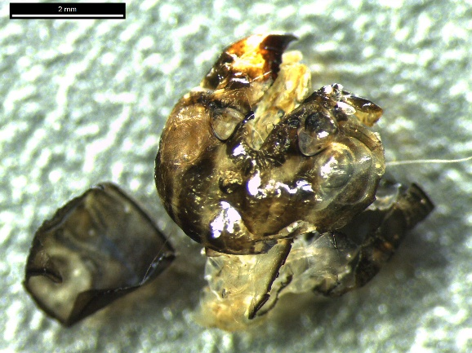
326 | Aves.  Feathers; bones; keratinized scales | 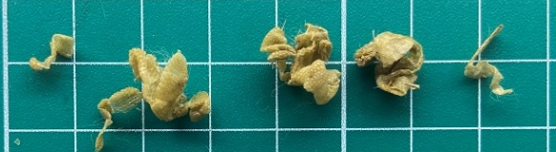  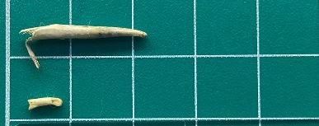
326 | Exoskeleton | 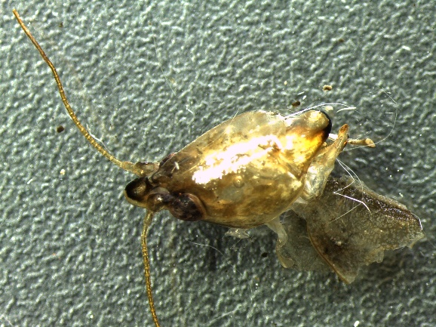
327 | Mammalia. Didelphimorphia. Didelphidae. Didelphis albiventris  Bones; teeth | 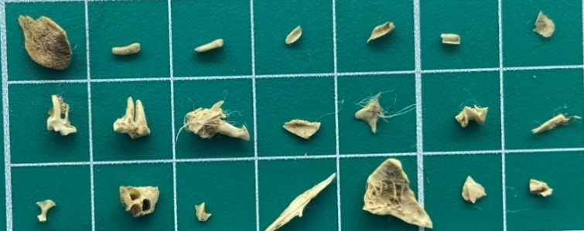
327 | Mammalia. Didelphimorphia. Didelphidae. Didelphis albiventris  Hair | 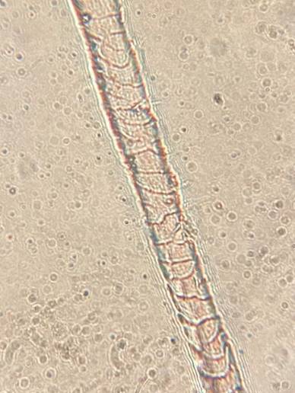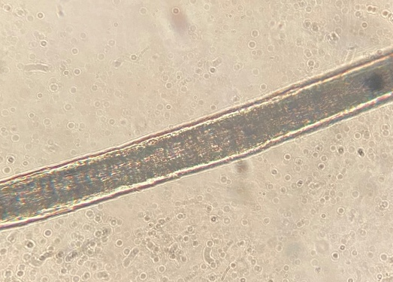  Cutícula pavimentosa, com escamas ondeadas, lisas, orientadas de forma transversal e bordas descontínuas; medula presente, contínua, multisseriada, anastomosadas, forma das células crivada
338 | Exoskeleton | 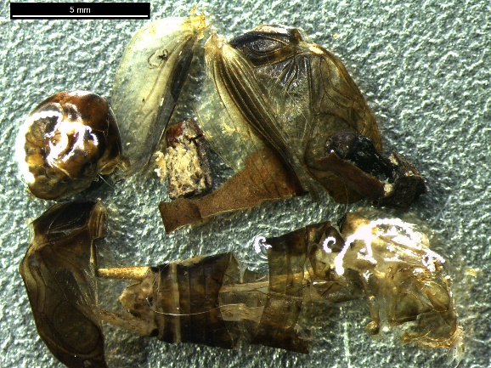
341 | Exoskeleton | 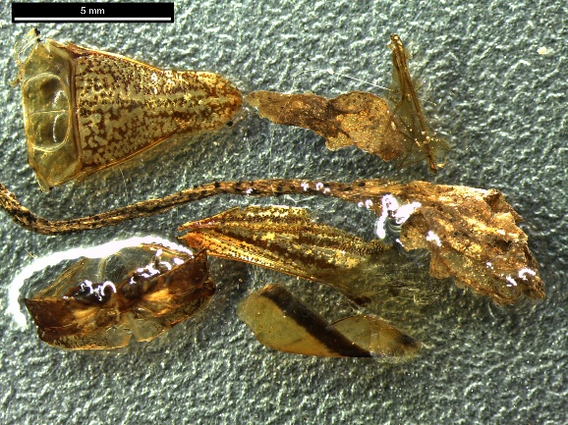
342 | Mammalia. Rodentia. Muridae. Mus musculus  Bones | 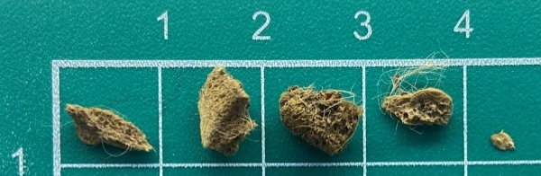
342 | Mammalia. Rodentia. Muridae. Mus musculus  Hair | 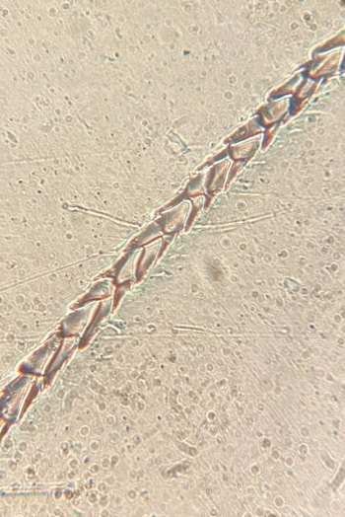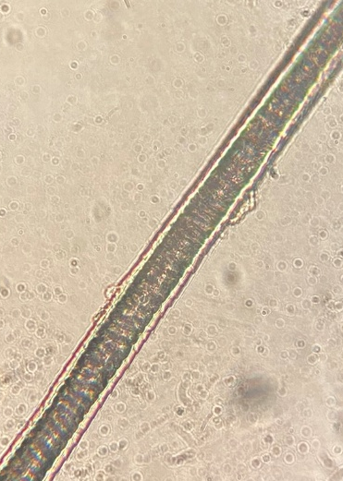  Broad rhomboidal cuticular pattern; alveolar medullary pattern
342 | Exoskeleton | 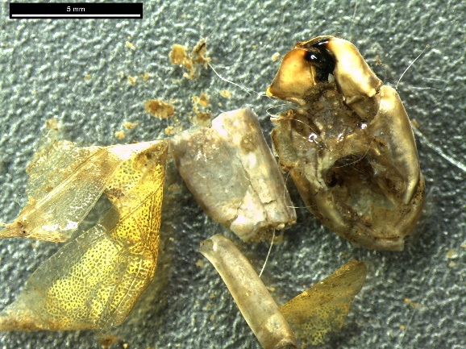
350 | Exoskeleton | 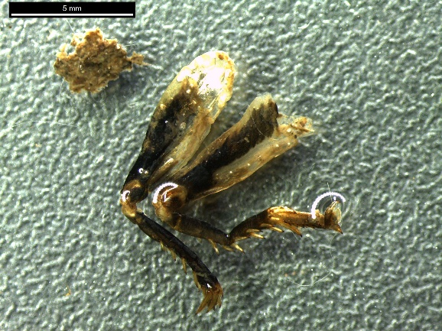
370 | Undigested anthropogenic material. Plastic; cotton thread; aluminum foil | 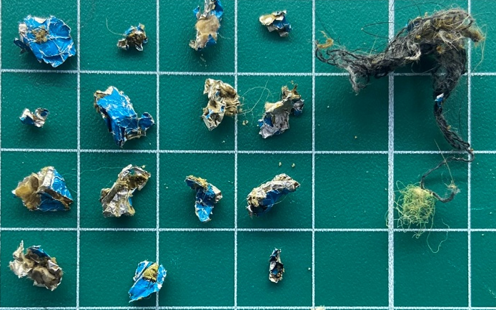

Table S3. Interactions between free-ranging cats and wildlife recorded using the behavioral observational sampling method.
Code | Class. Order. Family. Genus. Species | Photographic record
I1 | Aves. Passeriformes. Furnariidae. Furnarius. Furnarius rufus | 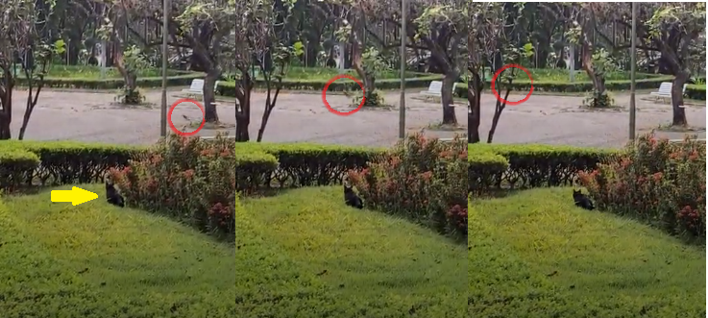
I3 | Aves. Passeriformes. Turdidae. Turdus. Turdus amaurochalinus | 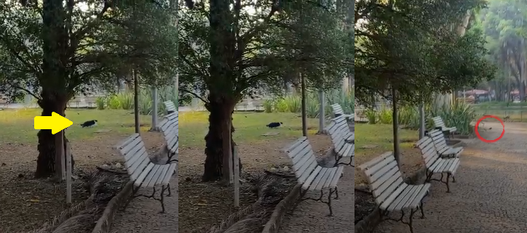
I5 | Aves. Passeriformes. Turdidae. Turdus. Turdus amaurochalinus | 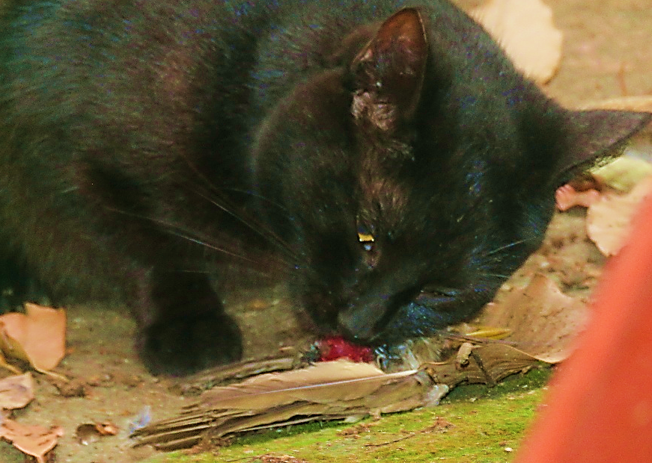
 |  | 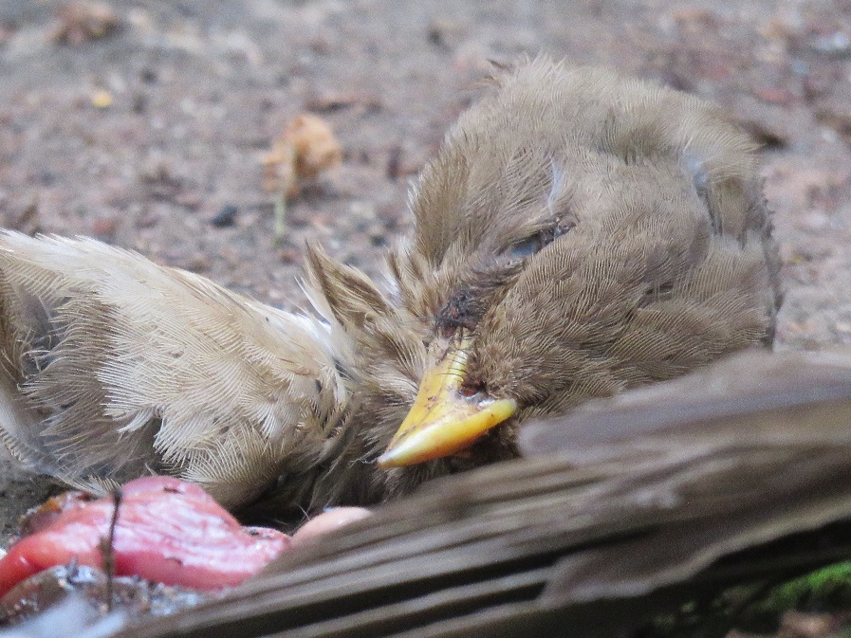
I7 | Aves. Columbiformes. Columbidae. Patagioenas. Patagioenas picazuro | 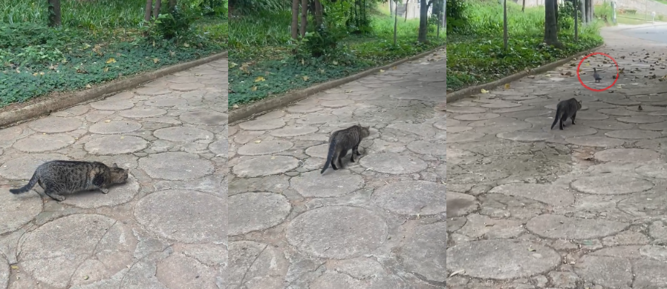
I8 | Aves. Passeriformes. Tyrannidae. Pitangus. Pitangus sulphuratus | 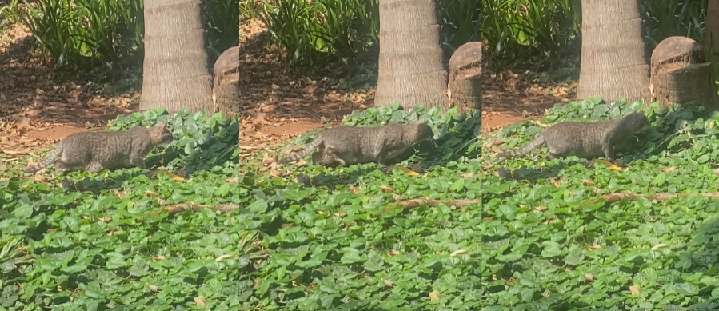
I10 | Aves. Columbiformes. Columbidae. Patagioenas. Patagioenas picazuro | 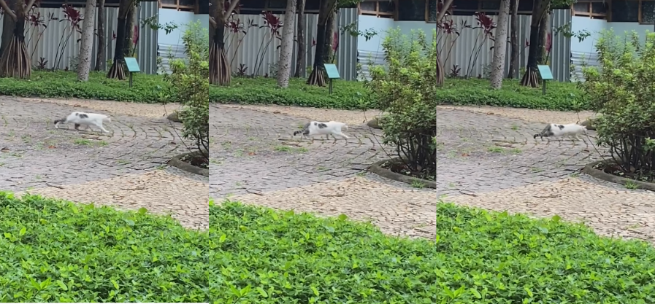
I11 | Aves. Columbiformes. Columbidae. Patagioenas. Patagioenas picazuro | 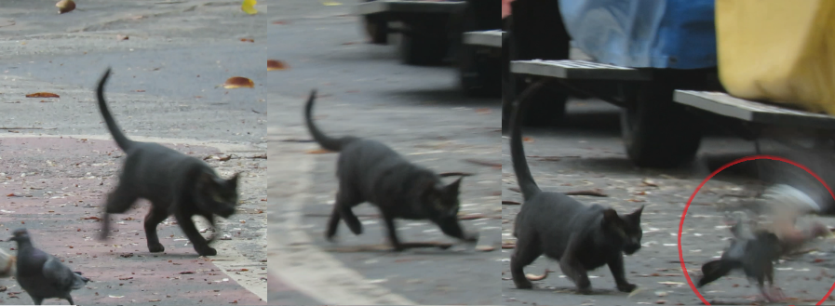
I13 | Aves. Passeriformes. Turdidae. Turdus. Turdus amaurochalinus | 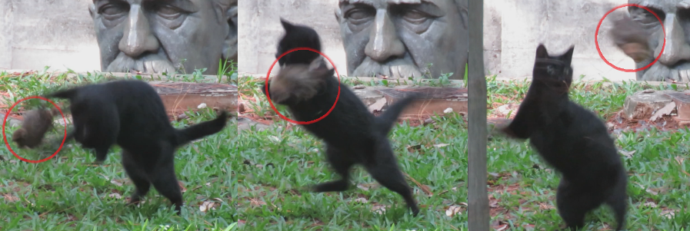
 |  | 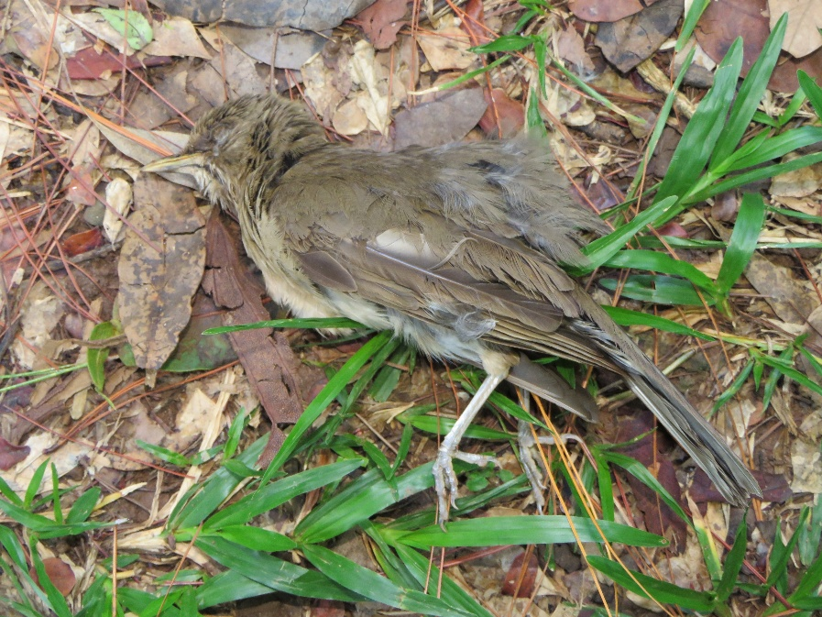
 |  | 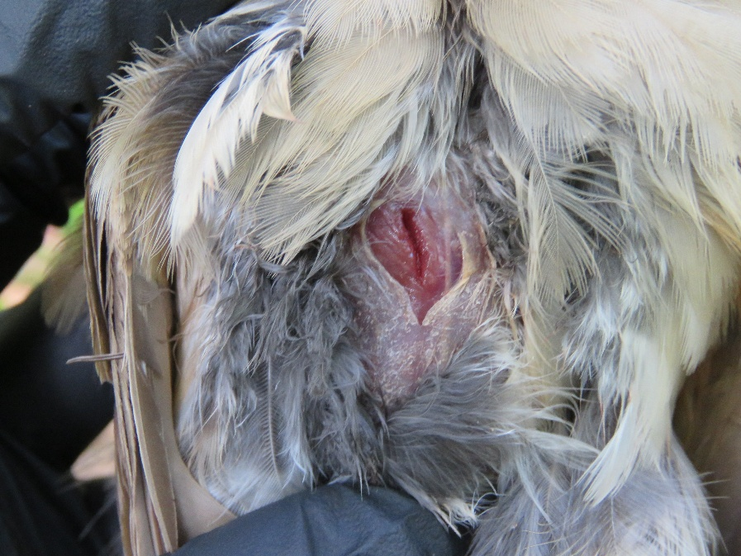
I15 | Aves. Passeriformes. Turdidae. Turdus. Turdus amaurochalinus | 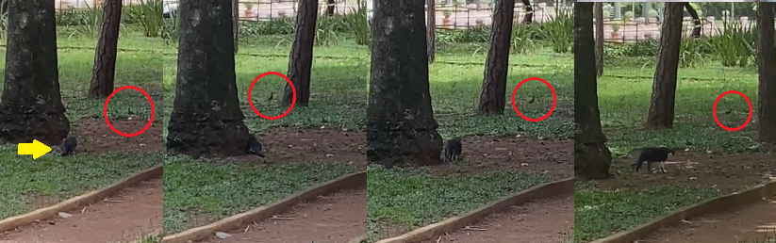
I18 | Aves. Passeriformes. Turdidae. Turdus. Turdus amaurochalinus | 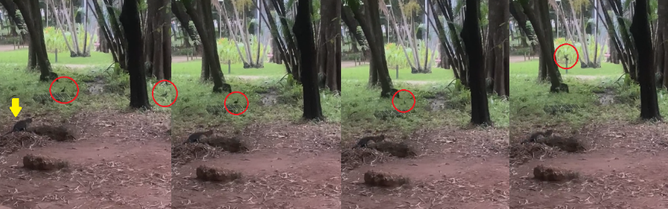
I19 | Mammalia. Primates. Callitrichidae. Callithrix. Callithrix penicillata. | 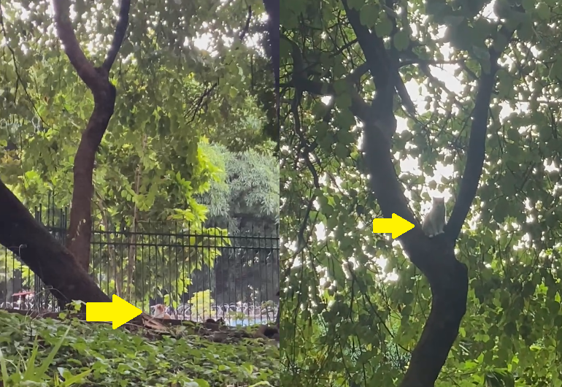
I22 | Mammalia. Chiroptera.  Unidentified species | 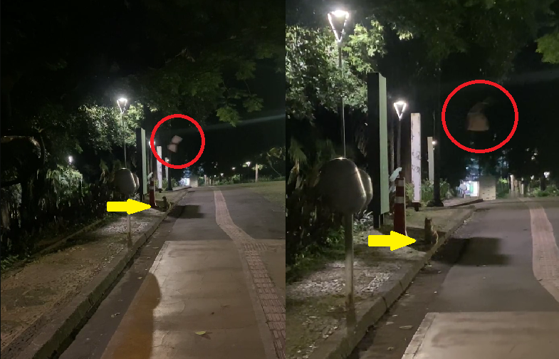
I26 | Aves. Passeriformes. Turdidae. Turdus. Turdus amaurochalinus | 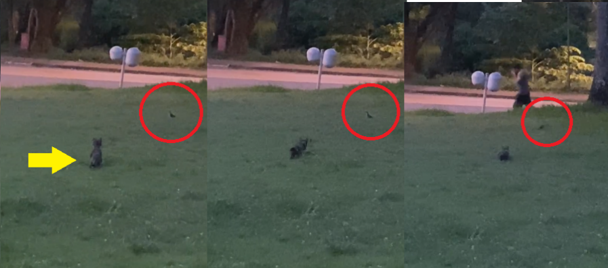
I28 | Mammalia. Chiroptera.  Unidentified species | 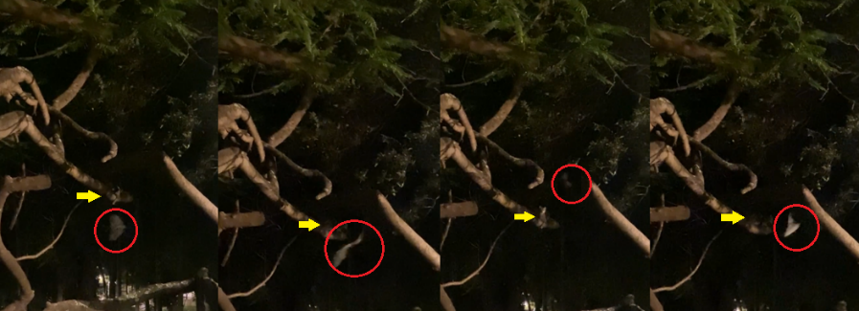
I29 | Insecta. Hymenoptera. | 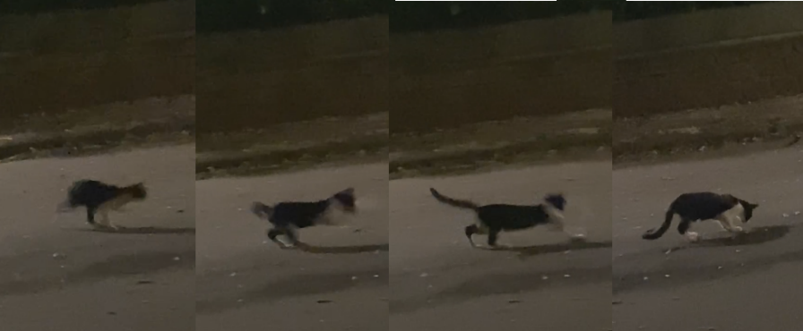
I30 | Mammalia. Chiroptera.  Unidentified species | 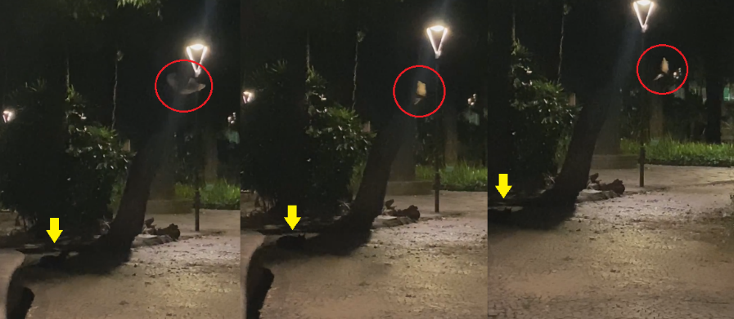
I32 | Insecta. Lepidoptera. Riodinidae. | 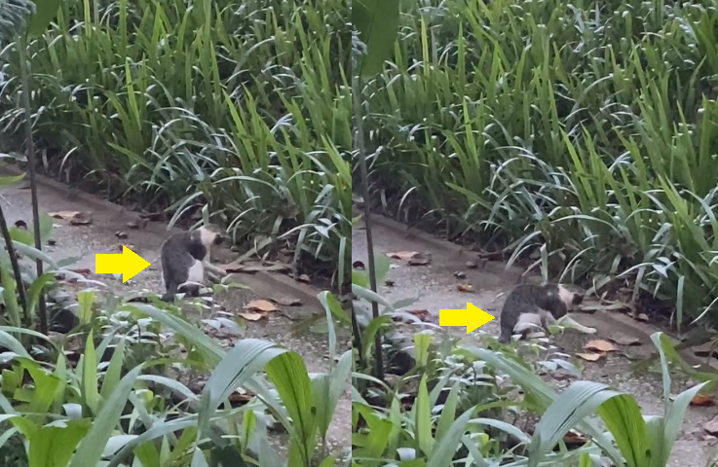
 |  | 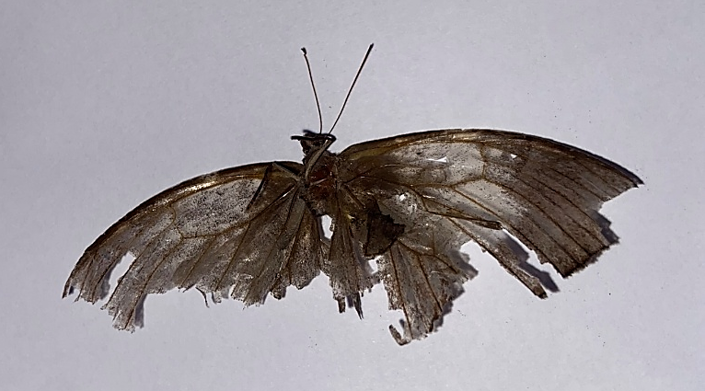
I33 | Mammalia. Rodentia. Muridae. Rattus. Rattus norvegicus | 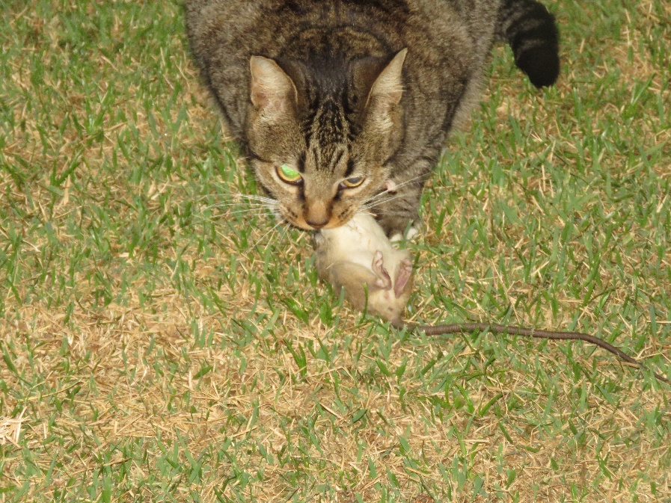
 |  | 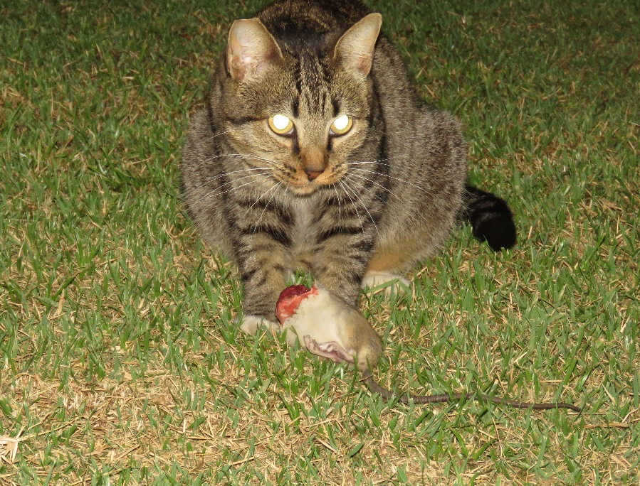
 |  | 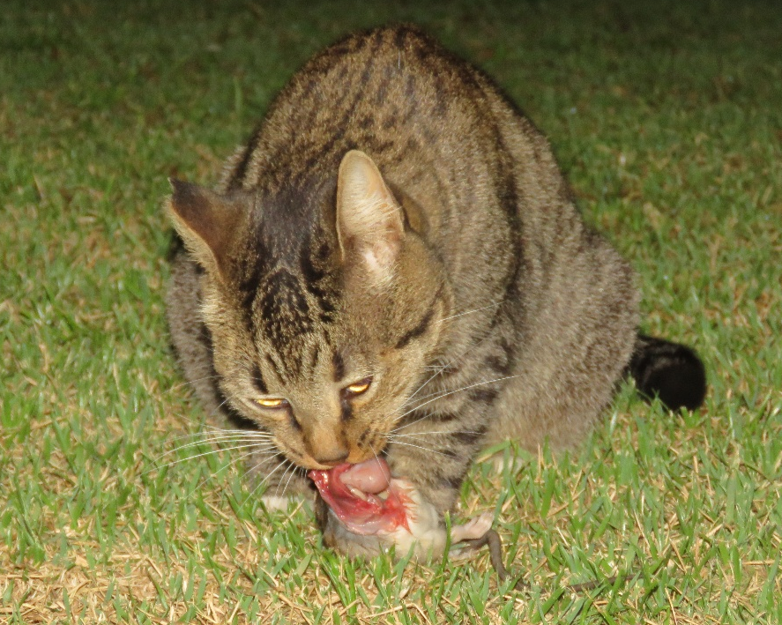
 |  | 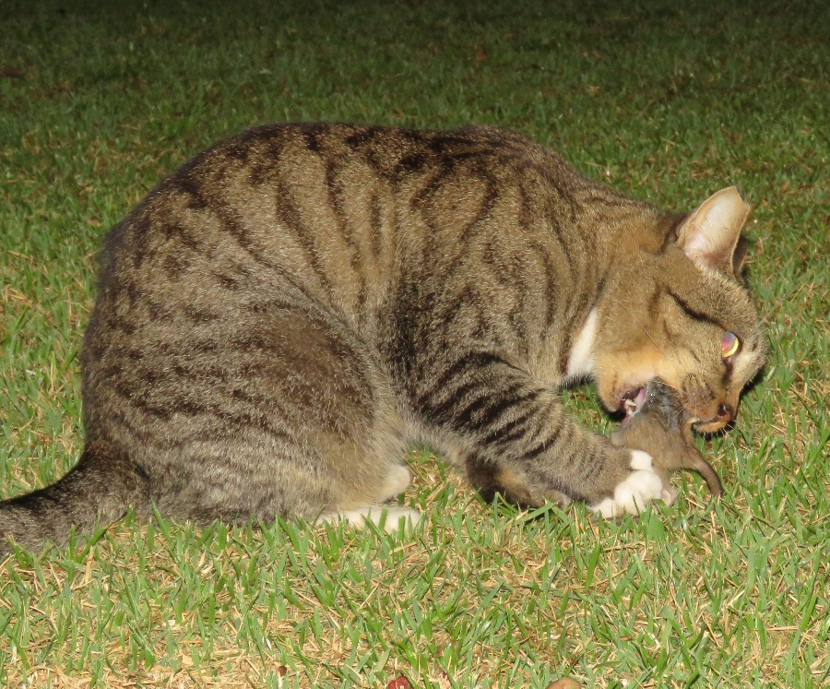
I34 | Aves. Columbiformes. Columbidae. Patagioenas. Patagioenas picazuro | 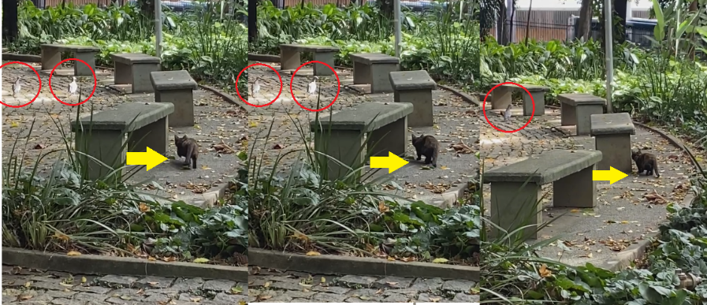

Table S4. Interactions between free-ranging cats and wildlife compiled from the Standardized animal incident records
Code | Class. Order. Family. Genus. Species | Photographic record
102.1/2024 | Aves. Passeriformes. Turdidae. Turdus. Turdus rufiventris | 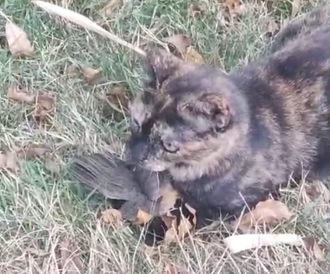
108.2/2024 | Aves. Apodiformes. Trochilidae. Eupetomena. Eupetomena macroura | 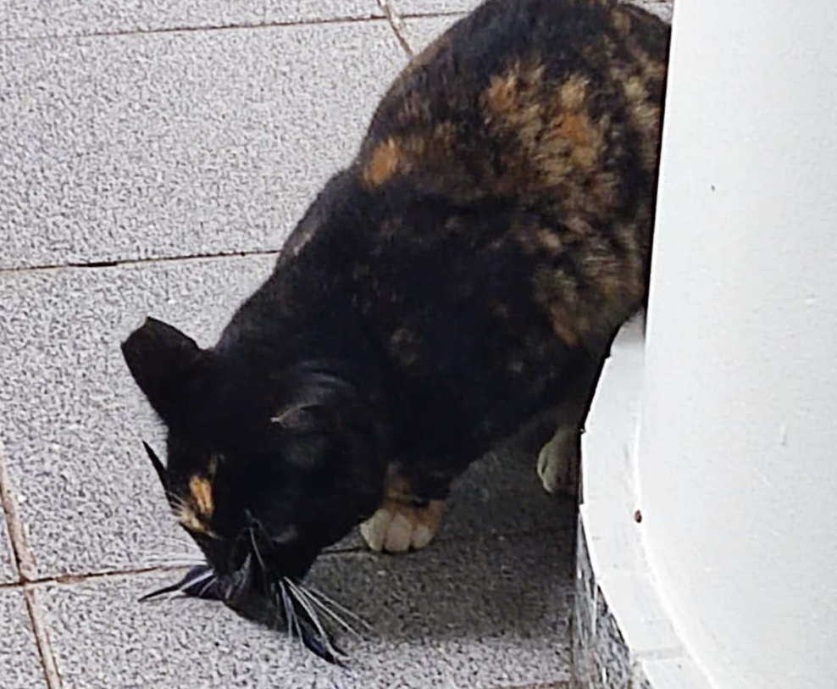
113/2024 | Aves. Passeriformes. Turdidae. Turdus. Turdus amaurochalinus | 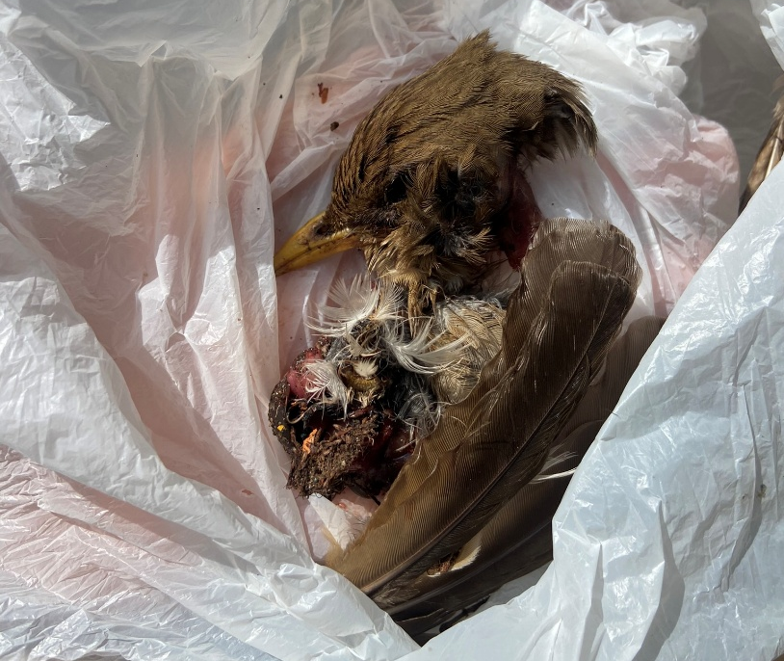
119/2024 | Mammalia. Didelphimorphia. Didelphidae. Didelphis. Didelphis albiventris | 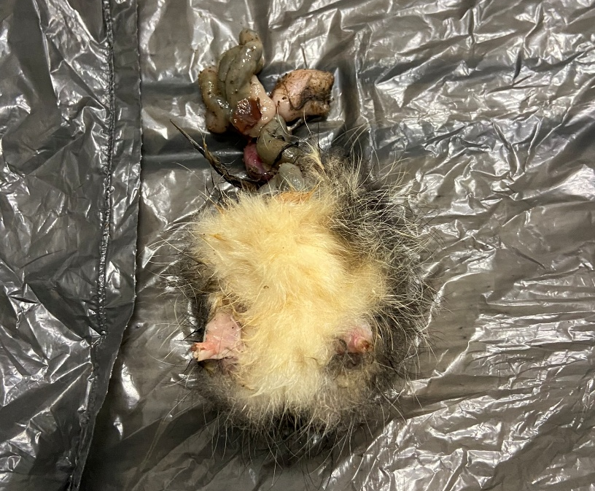
120/2024 | Aves. Columbiformes. Columbidae. Columba. Columba livia | 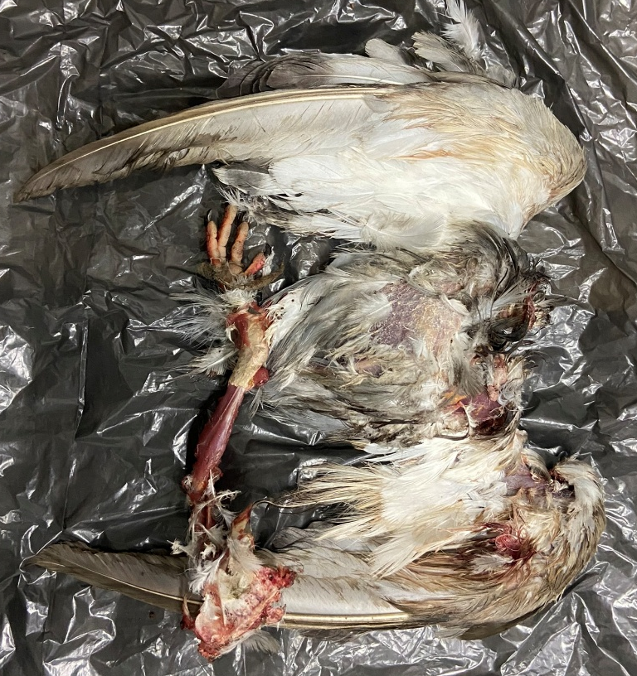
142/2024 | Aves. Passeriformes. Turdidae. Turdus. Turdus amaurochalinus | 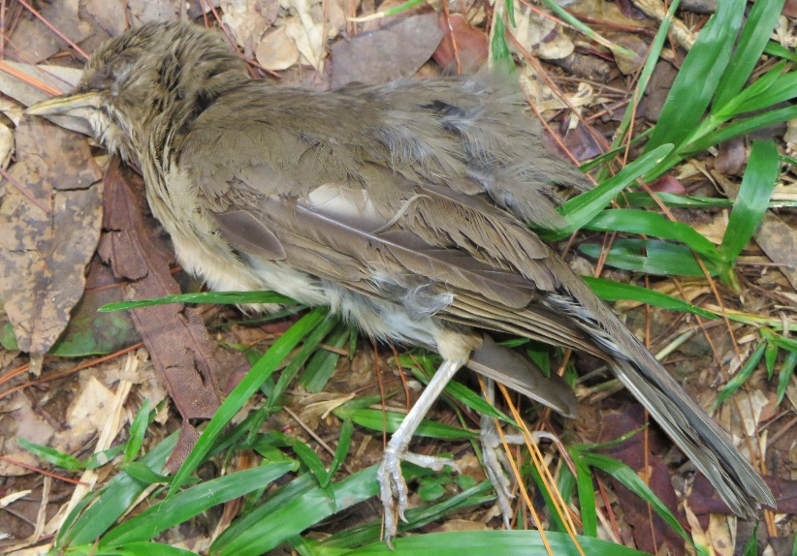
142.2/2024 | Aves. Passeriformes. Turdidae. Turdus. Turdus amaurochalinus | 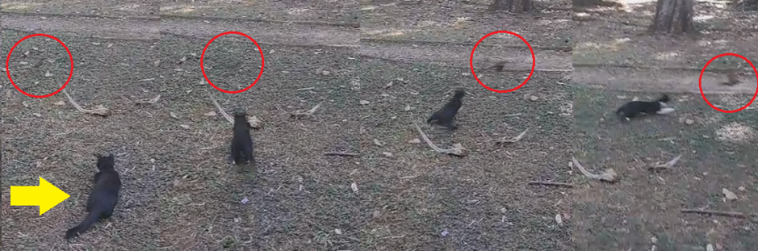
151 | Aves. Columbiformes. Columbidae. Columba. Columba livia | 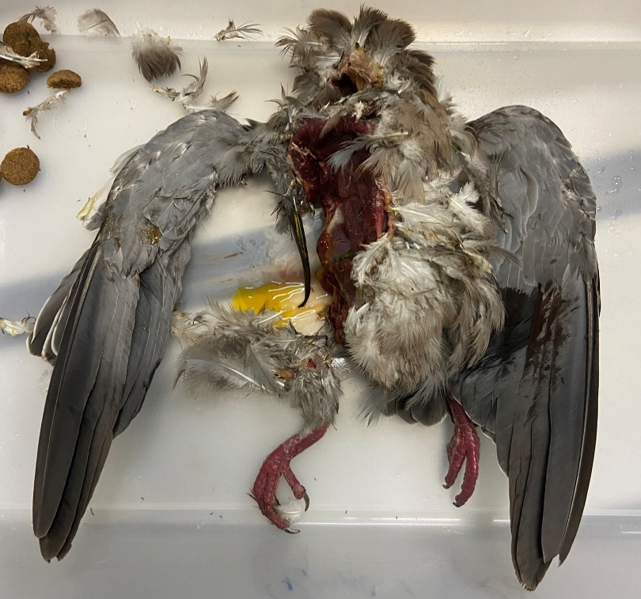
165/2024 | Aves. Passeriformes. Tyrannidae. Pitangus. Pitangus sulphuratus | 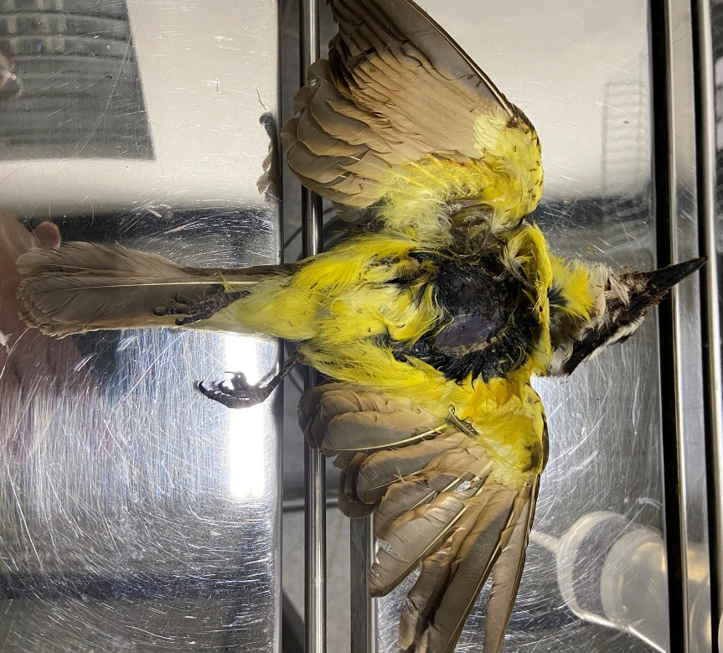
61/2025 | Mammalia. Chiroptera. Phyllostomidae. Artibeus. Artibeus sp. | 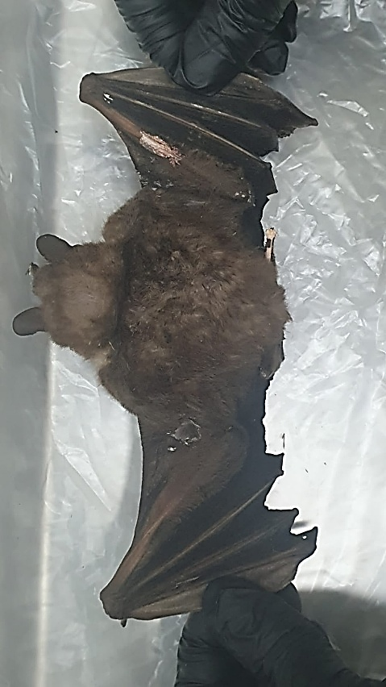
72/2025 | Aves. Passeriformes. Thraupidae. Thraupis. Thraupis palmarum | 