Table 1. Demographic and IVF treatment characteristics of participants
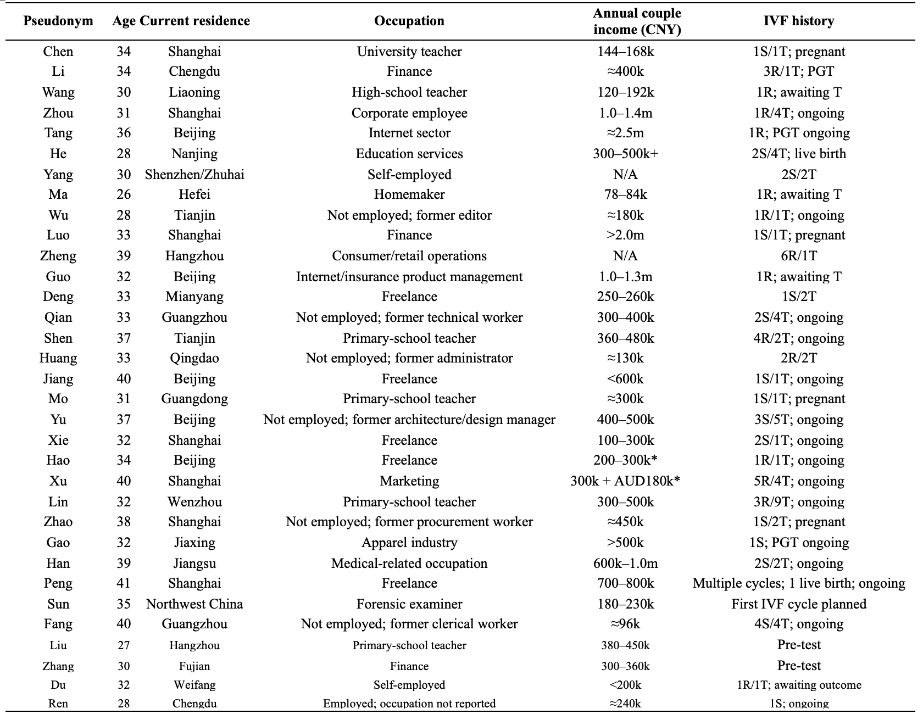
Abbreviations: S, ovarian stimulation; R, oocyte retrieval; T, embryo transfer; PGT, preimplantation genetic testing; N/A, not available.
*Income figures are approximate and based on participants’ self-reports. P26 reported previous rather than current couple income. P27’s husband’s income was reported in Australian dollars and is retained in the original currency.

