Supplementary Information
Supplementary Table 1 Details of cancer cell lines used in this study
Cell line name | Cancer type | Media | Obtained from
PC9 | Adenocarcinoma | RPMI 1640 media (Sigma Aldrich) supplemented with 2mM L-glutamine (Gibco) and 10% foetal bovine serum (Scientifix) | CellBank Australia, the European Collection of Cell Cultures
K562, | Leukemia | RPMI 1640 media (Sigma Aldrich) supplemented with 10% foetal bovine serum (Scientifix) | American Type Culture Collection
K562-OKT3 | Leukemia | RPMI 1640 media (Sigma Aldrich) supplemented with 10% foetal bovine serum (Scientifix) | Kindly provided by Prof Michale Jensen (Seattle Children’s Research Institute, Seattle).
K562-Luc | Leukemia | RPMI 1640 media (Sigma Aldrich) supplemented with 10% foetal bovine serum (Scientifix) | CellBank Australia, Japanese Collection of Research Bioresources Cell Bank
MDA-MB-231 | Breast | DMEM media (Sigma Aldrich) supplemented with 10% foetal bovine serum (Scientifix) | The human triple negative breast adenocarcinoma MDA-MB-231 cell line used in in vivo experiments was kindly provided by Prof Robin Anderson (Olivia Newton-John Cancer Research Institute, VIC).
MDA-MB-231-Luc | Breast | DMEM media (Sigma Aldrich) supplemented with 10% foetal bovine serum (Scientifix) | CellBank Australia, Japanese Collection of Research Bioresources Cell Bank
MDA-MB-231-LM2 | Breast | DMEM media (Sigma Aldrich) supplemented with 10% foetal bovine serum (Scientifix) | Gifted from J Massague, Sloan Kettering Institute
BT-549-Luc | Breast | RPMI 1640 media (Sigma Aldrich) supplemented with 10% foetal bovine serum (Scientifix) and 0.023IU Insulin (Protaphone) | CellBank Australia, Japanese Collection of Research Bioresources Cell Bank
HCT-116 | Colorectal | DMEM media (Sigma Aldrich) supplemented with 2 mM L-glutamine (Gibco) and 10% foetal bovine serum (Scientifix) | CellBank Australia, the European Collection of Cell Cultures
Lim-1215 | Colorectal | RPMI 1640 media (Sigma Aldrich) supplemented with 2mM L-glutamine (Gibco), 10% foetal bovine serum (Scientifix), 25mM Hepes, 0.6mg/mL Insulin (Protaphone), 1mg/mL Hydrocortisone (Sigma) and 10mM 1-Thioglycerol (Merck) | CellBank Australia
LOVO | Colorectal | Ham’s F12 media (Sigma Aldrich) supplemented with 10% foetal bovine serum (Scientifix) | European Collection of Cell Cultures, purchased from CellBank Australia
U87 | Glioma | EMEM (EBSS) + 2mM Glutamine + 1% Non-Essential Amino Acids (NEAA) + 1mM Sodium Pyruvate (NaP) + 10% Foetal Bovine Serum (FBS). | American Type Culture Collection
UM-SCC-1 | Head and neck squamous carcinoma | RPMI 1640 media (Sigma Aldrich) supplemented with 10% foetal bovine serum (Scientifix) | American Type Culture Collection
NCI-H460-Luc | Lung | RPMI 1640 media (Sigma Aldrich) supplemented with 10% foetal bovine serum (Scientifix) | CellBank Australia, Japanese Collection of Research Bioresources Cell Bank
Namalwa | Lymphoma | RPMI 1640 media (Sigma Aldrich) supplemented with 2mM L-glutamine (Gibco) and 10% foetal bovine serum (Scientifix) | CellBank Australia, the European Collection of Cell Cultures
Raji | Lymphoma | RPMI 1640 media (Sigma Aldrich) supplemented with 2mM L-glutamine (Gibco) and 10% foetal bovine serum (Scientifix) | CellBank Australia, the European Collection of Cell Cultures
Ramos | Lymphoma | RPMI 1640 media (Sigma Aldrich) supplemented with 2mM L-glutamine (Gibco) and 10% foetal bovine serum (Scientifix) | CellBank Australia, the European Collection of Cell Cultures
C32 | Melanoma | RPMI 1640 media (Sigma Aldrich) supplemented with 10% foetal bovine serum (Scientifix) | American Type Culture Collection
M21 | Melanoma |  | American Type Culture Collection
Skmel-5 | Melanoma | RPMI 1640 media (Sigma Aldrich) supplemented with 10% foetal bovine serum (Scientifix) | American Type Culture Collection
Skmel-28 | Melanoma | RPMI 1640 media (Sigma Aldrich) supplemented with 10% foetal bovine serum (Scientifix) | American Type Culture Collection
Be(2)-M17 | Neuroblastoma | Ham’s F12 / EMEM media (both Sigma Aldrich) supplemented with 1% NEAA (Life Technologies), 2 mM L-glutamine (Gibco) and 15% foetal bovine serum (Scientifix) | CellBank Australia, the European Collection of Cell Cultures
Kelly | Neuroblastoma | RPMI 1640 media (Sigma Aldrich) supplemented with 2mM L-glutamine (Gibco) and 10% foetal bovine serum (Scientifix) | CellBank Australia, the European Collection of Cell Cultures
SH-5Y-SY | Neuroblastoma | Ham’s F12 / EMEM (ATCC) media supplemented with 1% NEAA (Life Technologies), 2 mM L-glutamine (Gibco) and 15% foetal bovine serum (Scientifix) | CellBank Australia, the European Collection of Cell Cultures
SK-N-DZ | Neuroblastoma | DMEM media (Sigma Aldrich) supplemented with 2 mM L-glutamine (Gibco), 20% foetal bovine serum (Scientifix) and 1% NEAA (Sigma Aldrich) | CellBank Australia, the European Collection of Cell Cultures
OVCAR3-Luc | Ovarian | RPMI 1640 media (Sigma Aldrich) supplemented with 15U Insulin (Protaphone), 20% foetal bovine serum (Scientifix) | CellBank Australia, Japanese Collection of Research Bioresources Cell Bank
OVCAR5 | Ovarian | RPMI 1640 media (Sigma Aldrich) supplemented with 2 mM L-glutamine (Gibco) and 10% foetal bovine serum (Scientifix) | Dr Thomas Hamilton (Fox Chase Cancer Center, PA, USA)
AsPC-1/CMV-Luc | Pancreatic | RPMI 1640 media (Sigma Aldrich) supplemented with 10% foetal bovine serum (Scientifix) | CellBank Australia, Japanese Collection of Research Bioresources Cell Bank
PC3-Luc | Prostate | Ham’s F12 media supplemented with 7% foetal bovine serum (Scientifix) | CellBank Australia, the European Collection of Cell Cultures
DU-145-luc | Prostate | EMEM media (Sigma Aldrich) supplemented with 10% foetal bovine serum (Scientifix) | CellBank Australia, Japanese Collection of Research Bioresources Cell Bank
RPMI-8226 | Myeloma | RPMI 1640 media (Sigma Aldrich) supplemented with 10% foetal bovine serum (Scientifix) | Kindly provided by Dr Krzysztof Mrozik, University of Adeliade
RD | Rhabdomyosarcoma | DMEM media (Sigma Aldrich) supplemented with 2 mM L-glutamine (Gibco), 10% foetal bovine serum (Scientifix), 2% NEAA (Life Technologies) and 2% Vitamins (Gibco) | CellBank Australia, the European Collection of Cell Cultures

Supplementary Table 2 Monoclonal antibodies and related reagents
Primary antibodies for flow cytometry and cell culture
Antigen | Conjugate | Clone | Manufacturer | Final concentration or dilution from manufacturer’s test size | Final dilution
CD3 | BUV737  Purified (cell culture) | UCHT1  OKT3 | BD  Invitrogen | 30ng/ml  1/8 | 1:250
CD4 | BUV496 | SK3 | BD | 1/4 | 1:200
CD8 | BUV395 | RPA-T8 | BD | 1/8 | 1:250
Granzyme B | BV421 | GB11 | BD | 1/2 | 1:100
Perforin | FITC | B-D48 | Biolegend | 1/4 | 1:200
CD107a | PECy7 | H4A3 | BD | 1/6 | 1:300
IFNγ | PE | B27 | BD | Recommended | 1:12.5
TNFa | APC | MAb11 | BD | 1/2 | 1:200
IL-2 | BV711 | 5344.111 | BD | 1/4 | 1:50
CCR7 | PE | 150503  2-L1-A | BD  BD | Recommended  Recommended | 1:12.5
CD45RA | BB515 | HI100 | BD | 1/6 | 1:250
CD45RO | PECy7 | UCHL1 | BD | Recommended | 1:50
CD62L | BV421 | DREG-56 | BD | 1/2 | 1:15
EGFR | eF660 | me1B3 | BD | Recommended | 1:50
CD27 | APC | M-T271 | BD | Recommended | 1:25
CD28 | BUV737 | CD28.2 | BD | Recommended | 1:50
CD95 | PECy7 | DX2 | BD | 1/8 | 1:200
CXCR3 | BV421 | 1C6/CXCR3 | BD | Recommended | 1:50
PD-1 | PECy7 | EH12.1 | BD | Recommended | 1:50
CTLA-4 | BV421 | BNI3 | BD | Recommended | 1:50
TIM-3 | BB515 | 7D3 | BD | Recommended | 1:50
LAG-3 | APC | T47-530 | BD | Recommended | 1:50
CD39 | PE-CF594  BUV805 | TU66 | BD | Recommended | 1:50
Related flow cytometry reagents
Reagent | Conjugate | Clone | Manufacturer | Final dilution
Fixable Viability Dye | 780 | - | BD | 1/1000 | 1:1000

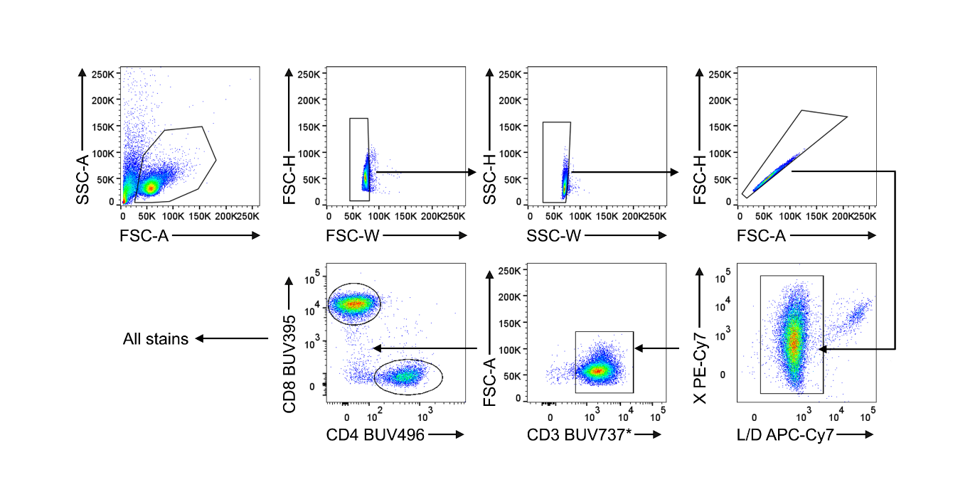

Supplementary Figure 1: Flow cytometry pre-gating strategy for all stains. Lymphocyte gating, single cell discrimination, viability gating, CD3⁺ gating, CD4⁺ or CD8⁺ gating serves as a pre-gate for all flow cytometry data, with the exception of the activation marker phenotyping. *In that panel, CD28-BUV737 was used such that the combination of fluorophores was optimised to reduce spectral spillover. As CD3 was conjugated to the same fluorophore and cells were routinely all CD3⁺, it was not included in the panel. X represents CD95, CD45RO, PD-1 or CD107a.

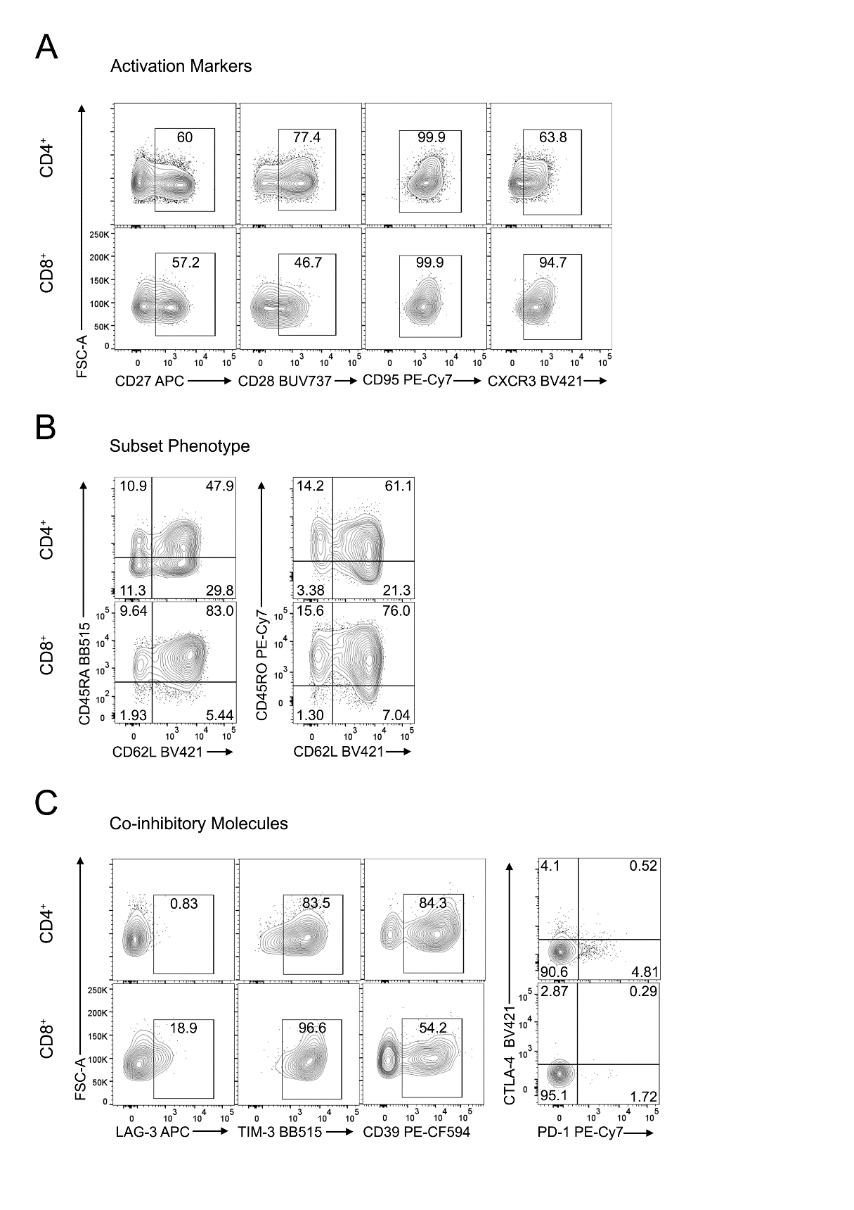
Supplementary Figure 2: Flow cytometry gating strategy for T cell phenotype. After setting pre-gates depicted in Supp. Figure 1, CD4⁺ and CD8⁺ T cells were gated for (A) activation marker expression, (B) subset phenotype and (C) co-inhibitory molecule expression. Gates were set on fluorescence minus one (FMO) controls, with the exception of CTLA-4, which was gated based on an FMO for cultured T cells or an isotype control for tumour suspensions.

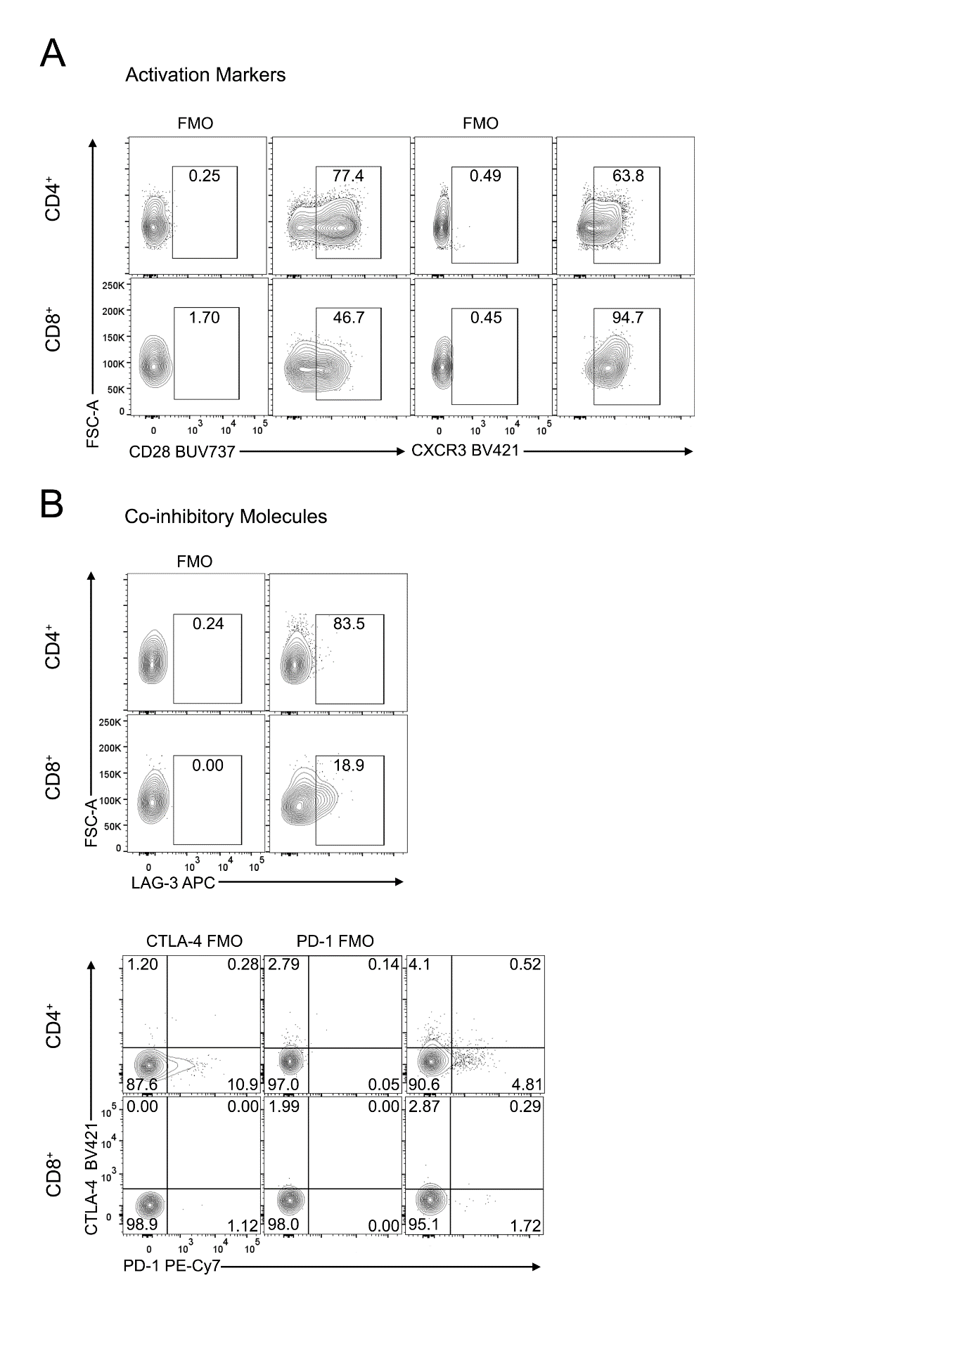
Supplementary Figure 3: Flow cytometry gating strategy for T cell phenotype (FMOs). After setting pre-gates depicted in Supp. Figure 1, CD4⁺ and CD8⁺ T cells were gated for (A) activation marker expression and (B) co-inhibitory molecule expression. FMO controls are shown alongside stained samples.

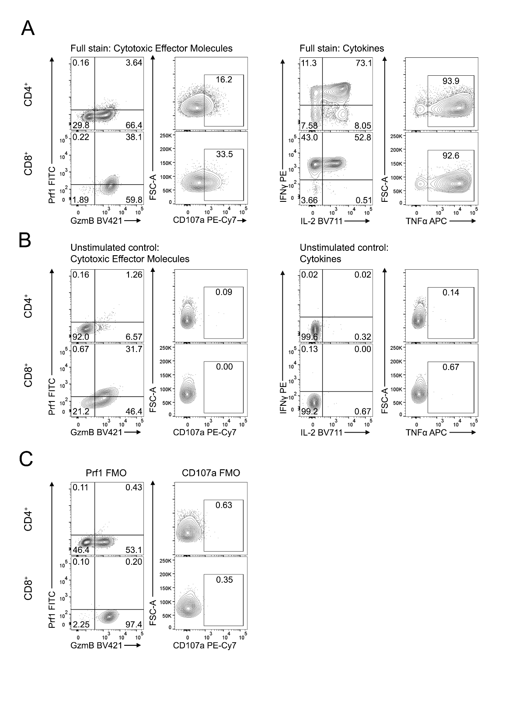
Supplementary Figure 4: Flow cytometry gating strategy for cytotoxic molecule and cytokine expression. After setting pre-gates depicted in Supp. Figure 1, (A) CD4⁺ and CD8⁺ T cells were gated for cytotoxic molecule and cytokine expression. Gates were set on a (B) unstimulated control and (C) FMO controls.

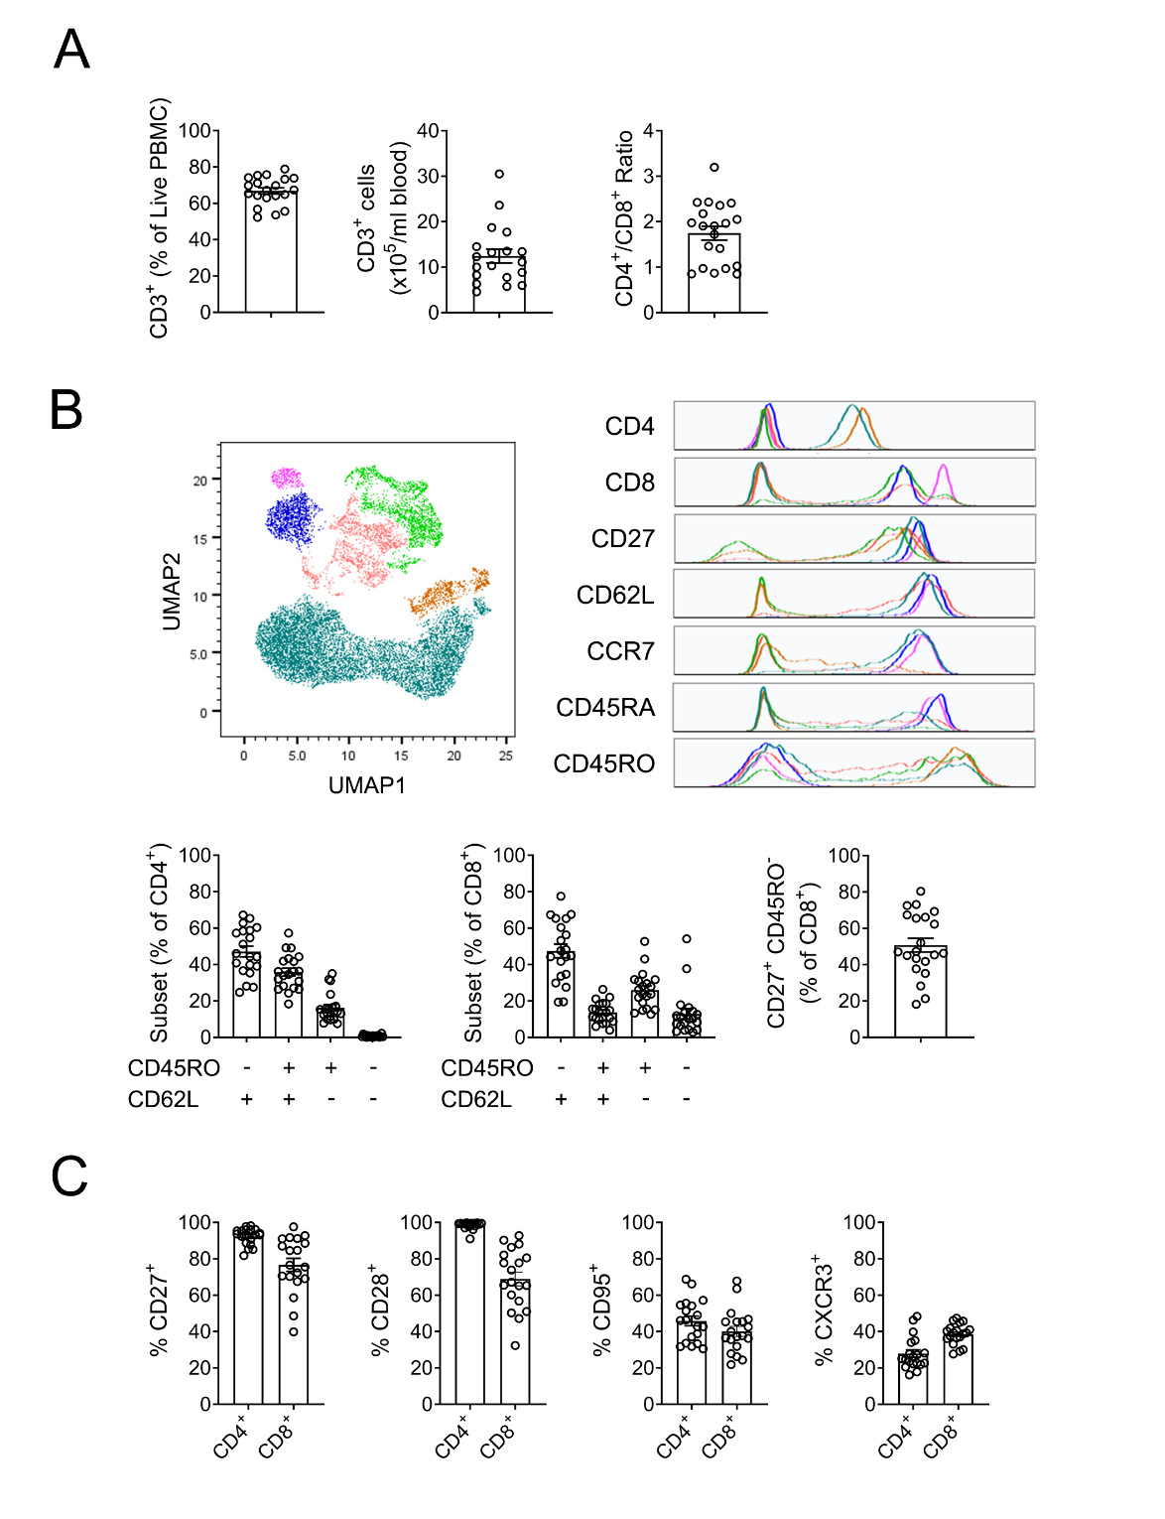
Supplementary Figure 5: Phenotyping of peripheral blood T cells isolated from healthy donors.
PBMCs were isolated from the fresh peripheral blood of healthy individuals and were assessed for differentiation and activation marker expression by flow cytometry. (A) Frequency of CD3⁺ cells of total live PBMC, number of CD3⁺ cells per ml of blood and CD4⁺/CD8⁺ ratio of CD3⁺. (B) UMAP analysis of differentiation/activation marker expression by CD3⁺ cells, represented as two-dimensional clusters and histogram overlays of individual clusters. Frequencies of T cell subset phenotypes of CD4⁺ and CD8⁺ and frequency of CD27⁺ CD45RO⁻ of CD8⁺. (C) Frequencies of activation markers, CD27, CD28, CD95 and CXCR3 of CD4⁺ and CD8⁺. Gating strategy is shown in Supp. Figure 1 and 2. Data pooled from 20 donors across three independent experiments and represented as mean ± SEM.

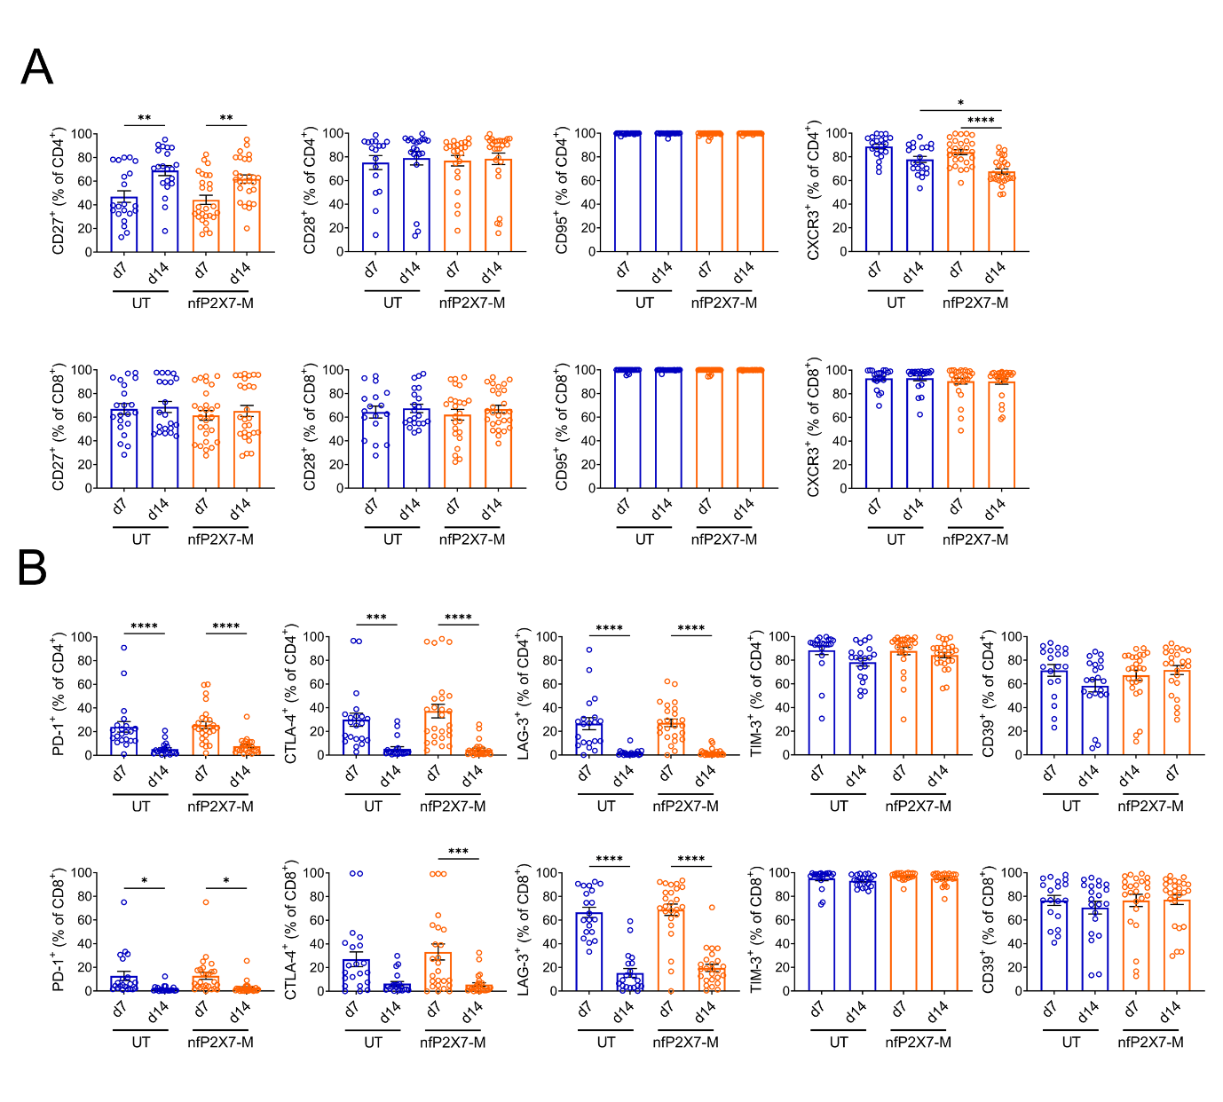
Supplementary Figure 6: NfP2X7-targeting CAR-T cells, are highly activated and display minimal co-inhibitory molecule expression. NfP2X7-targeting CAR-T cells were generated and stimulated with α-CD3, α-CD28 and irradiated PBMC. (A) Frequency of CD27, CD28, CD95 and CXCR3 of CD4⁺ and CD8⁺ on d7 post-PBMC and d14 post-PBMC. (B) Frequency of PD-1, CTLA-4, LAG-3, TIM-3 and CD39 of CD4⁺ and CD8⁺ on d7 post-PBMC and d14 post-PBMC. Gating strategy is shown in Supp. Figure 1 and 2. Data pooled from 10 independent CAR-T preparations, derived from 8 healthy donors. Data represented as mean ± SEM; Ordinary one-way ANOVA with Bonferroni’s post-test; * p≤0.05, ** p≤0.01, *** p≤0.001, **** p≤0.0001; n = 20-27.

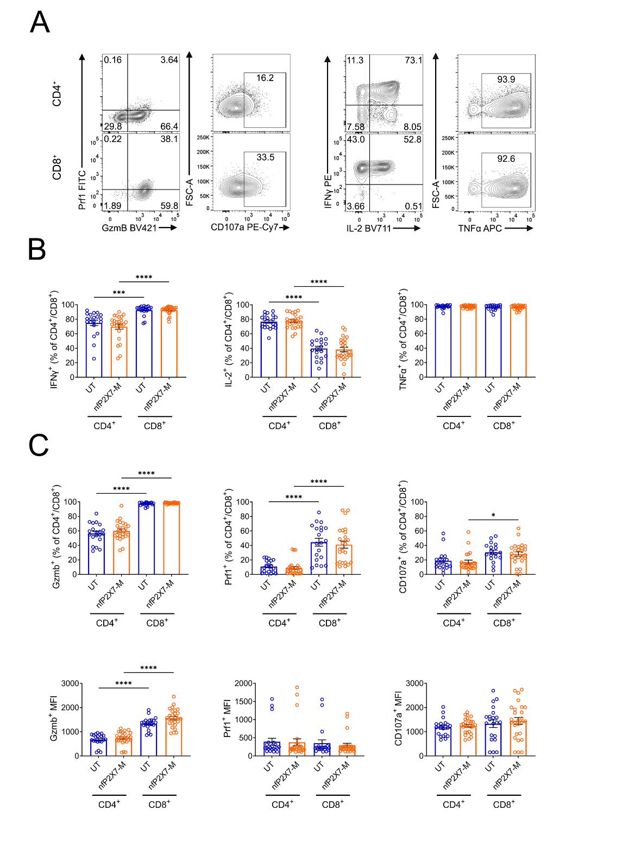
Supplementary Figure 7: NfP2X7-targeting CAR-T cells express cytotoxic molecules and T_{H}1 cytokines. NfP2X7-targeting CAR-T cells were generated and stimulated with α-CD3, α-CD28 and irradiated PBMC. On d14 post-PBMC, cells were assessed by flow cytometry following PMA stimulation. (A) Representative flow cytometry on d14 post-PBMC. (B) Frequency of cytokine expression of CD4⁺ and CD8⁺. (C) Frequency and geometric fluorescence intensity (gMFI) of granzyme B, perforin and CD107a expression of CD4⁺ and CD8⁺. Gating strategy is shown in Supp. Figure 1 and 4. Data pooled from 10 independent CAR-T preparations, derived from 8 healthy donors. Data represented as mean ± SEM; Ordinary one-way ANOVA with Bonferroni’s post-test; * p≤0.05, *** p≤0.001, **** p≤0.0001; n = 20-27.

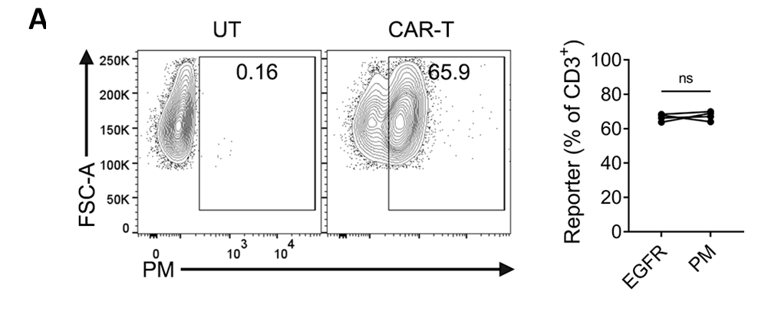
Supplementary Figure 8: EGFRt reporter expression is a reliable measure of CAR expression (A) Frozen nfP2X7-M CAR-T cells were thawed and rested in IL-2 and IL-15 for 2-3 days. Representative flow cytometry and frequency of CAR⁺ cells, based on EGFR expression and nfP2X7 peptide mimetic staining of the same cell population, pre-gated on CD3⁺; n = 4; paired t-test. Data in right panel pooled from four independent experiments. PM (peptide mimetic).

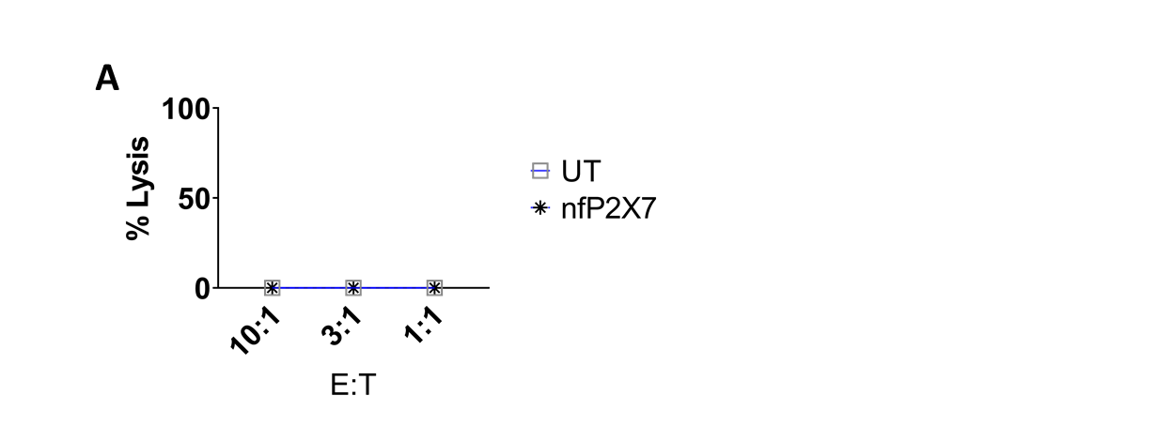
Supplementary Figure 9 NfP2X7-M CAR-T cells were not cytotoxic towards healthy donor derived normal cells. NfP2X7-M CAR-T cells were co-cultured with healthy donor-derived PBMCs at E:T ratios of 10:1, 3.3:1 and 1.1:1 for 18 h. Specific cytotoxicity was measured using a BrightGlo luciferase-based cytotoxicity assay system. Data from a single experiment.

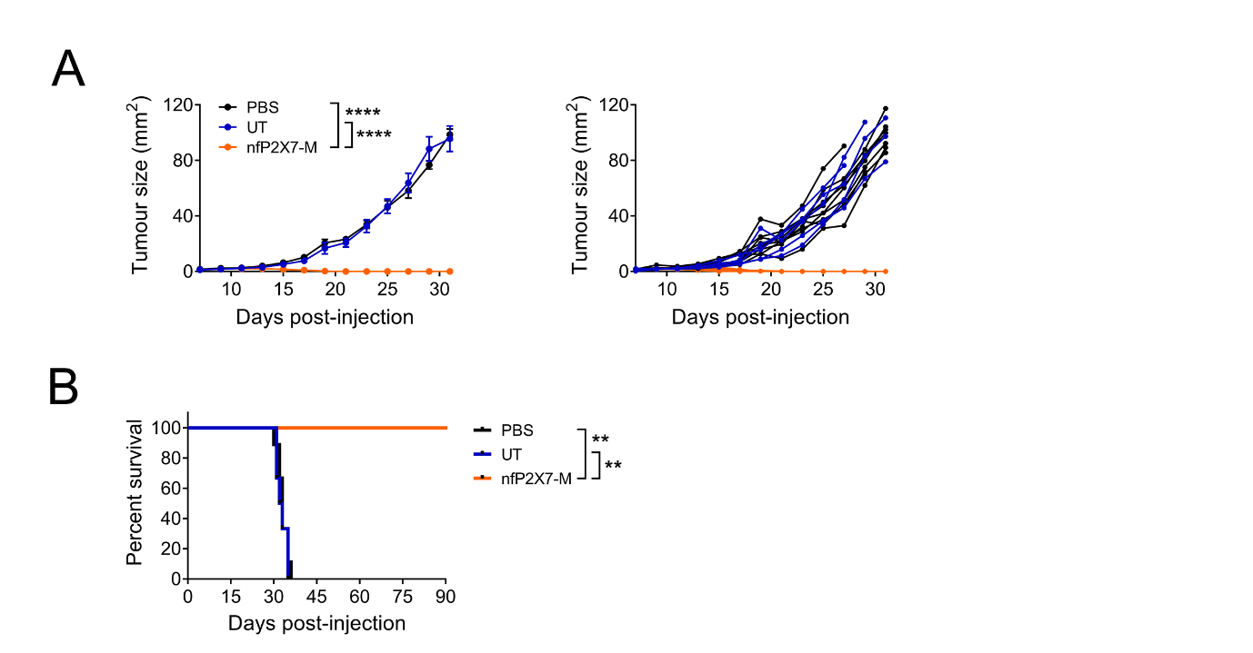
Supplementary Figure 10: NSG mice were subcutaneously injected with 1x10⁶ PC3 human prostate cancer cells into the lower abdomen and intravenously injected with 2x10⁷ nfP2X7-targeting CAR-T cells or untransduced T cells on d3 post-tumour injection. (A) Tumour growth curves as pooled and individual mice; two-way ANOVA with Bonferroni’s post-test. (B) Kaplan-Meier survival curve; Mantel-Cox test. Data from a single experiment and represented as mean ± SEM; ** p≤0.01, **** p≤0.0001; n = 5-9.

Supplementary Video 1. Real-time imaging of nfP2X7-M CAR-T cell adhesion and transmigration through blood vessels in vivo. For intravital microscopy, 2x10⁶ MDA-MB-231-LM2 cells expressing GFP was injected into the mammary fat pad of NSG mice and allowed to establish for 2 weeks. The mice then received an intravenous injection of 2x10⁷ nfP2X7-M CAR-T cells fluorescently labelled with CellTracker Orange as well as Cy5 Dextran (for visualisation of blood vessels with active blood flow). The surgically exposed tumour was then placed under a 20x objective lens and the interaction between the CAR T cells and the blood vessels were visualised in real time. Representative video showing nfP2X7-M CAR-T cells firmly adhered to a blood vessel and transmigrating across a blood vessel. Representative of two independent experiments. Scale bars = 50 µm.
Supplementary Video 2. Real-time imaging of nfP2X7-M CAR-T cells killing MDA-MB-231 breast cancer cells in vitro. MDA-MB-231 breast cancer cells were seeded into wells and allowed to grow overnight. nfP2X7-M CAR-T cells or untransduced (UT) T cells pulsed with Fluo-4 AM (green), and PI (red) were added into the wells at the same time. Images were taken at 10s intervals for at least 3 hours using a 40x objective lens on the Zeiss LSM700. Representative of three independent experiments.

