Supplementary Material
Early Proteinuria as a Predictor of Renal Dysfunction following Allogeneic Hematopoietic Stem Cell Transplantation in Acute Myeloid Leukemia
1. Cohort flow diagrams
Flow diagrams illustrating patient selection for the classification and the exploratory regression analyses. Created with pycohortflow (Schwarz F. pycohortflow: lightweight, customisable cohort-flow diagrams in Python and JavaScript. MetaArXiv preprint, 2026, doi:10.31222/osf.io/ncya2; software release archived on Zenodo, doi:10.5281/zenodo.20052730).
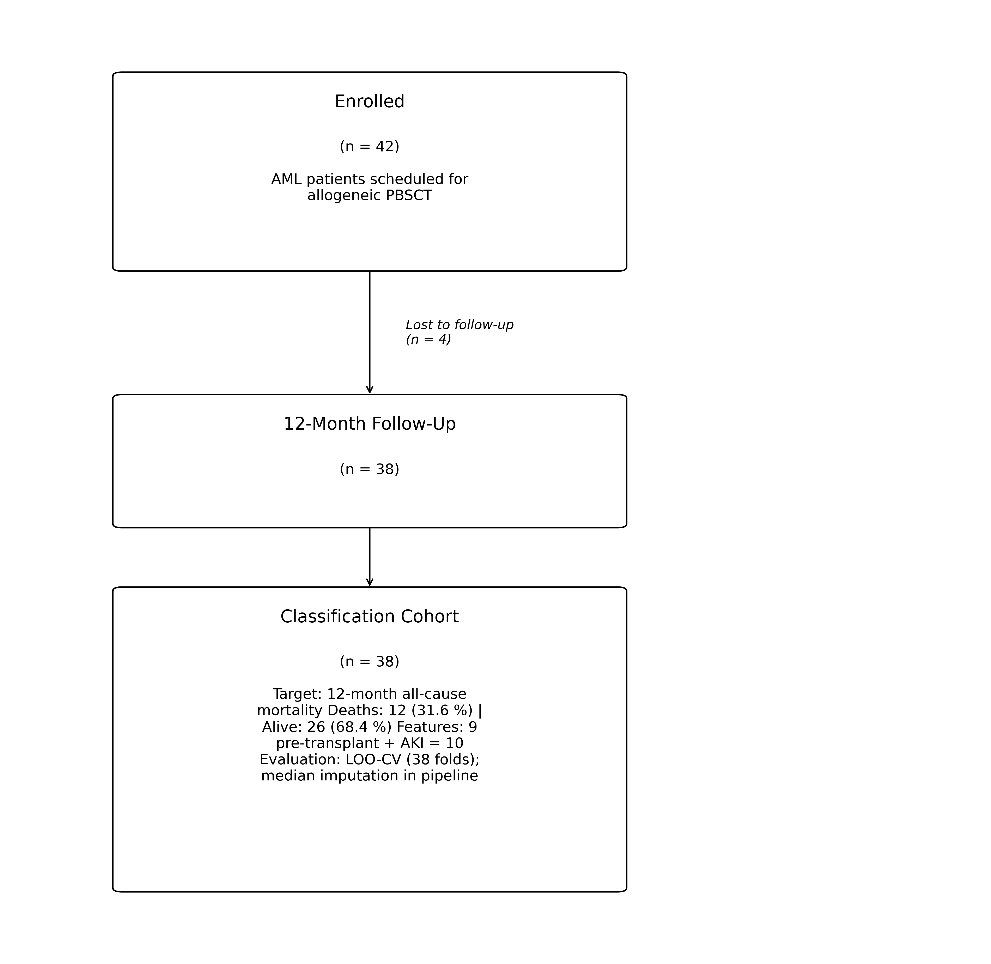
Supplementary Figure S1. Cohort flow for the classification analysis. Of 42 enrolled patients, 4 were lost to follow-up, yielding a classification cohort of 38 patients (12 deaths, 26 alive at 12 months; 31.6 % positive class). The deployable 10-feature linear-SVC model (9 pre-transplant predictors plus AKI during hospitalisation; see §5.1 and §5.2) was evaluated by leave-one-out cross-validation with median imputation inside the pipeline.
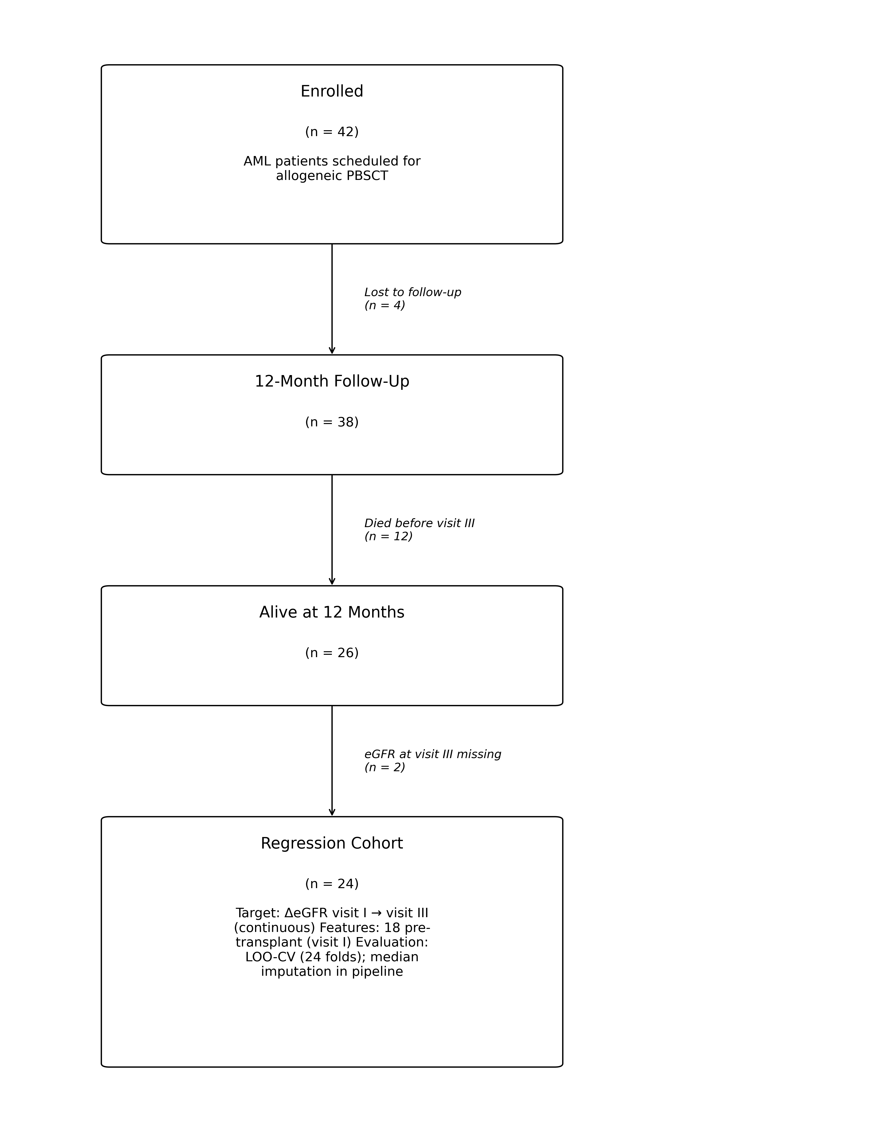
Supplementary Figure S2. Cohort flow for the exploratory regression (§6). From 42 enrolled patients, sequential exclusion of lost-to-follow-up (n = 4), deaths (n = 12) and missing eGFR at visit III (n = 2) yielded a regression cohort of 24 patients. Eighteen pre-transplant features were used to predict ΔeGFR visit I → III by leave-one-out cross-validation.

2. Creatinine-based versus cystatin C-based eGFR
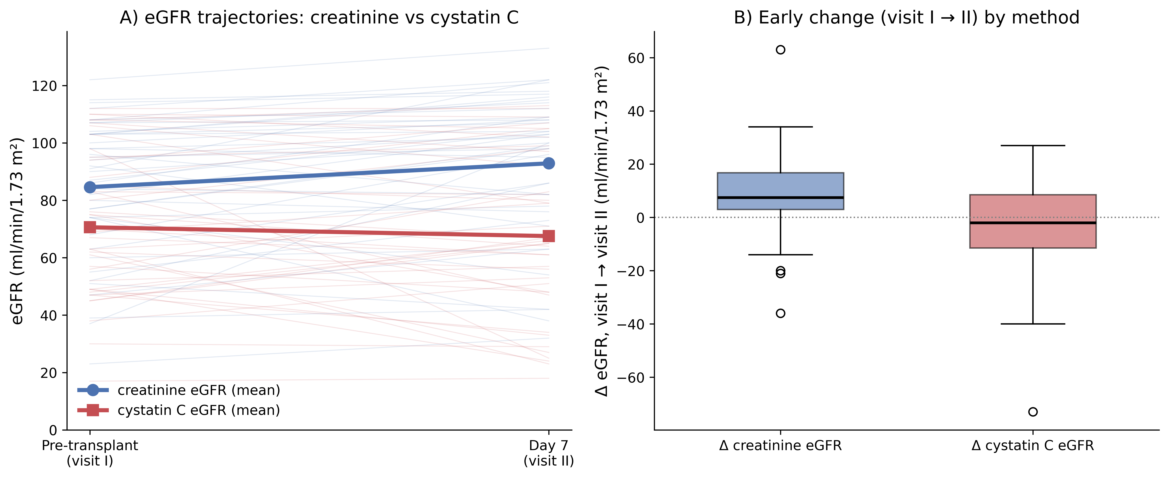
Supplementary Figure S3. Comparison of creatinine-based (CKD-EPI creatinine) and cystatin C-based (CKD-EPI cystatin C) eGFR at visit I (pre-transplant) and visit II (day 7 ± 3 days post-PBSCT). (A) Individual trajectories, showing consistently lower cystatin C-based eGFR. (B) Boxplot of the early change (ΔeGFR visit I → II) for each method.

3. eGFR course stratified by sex
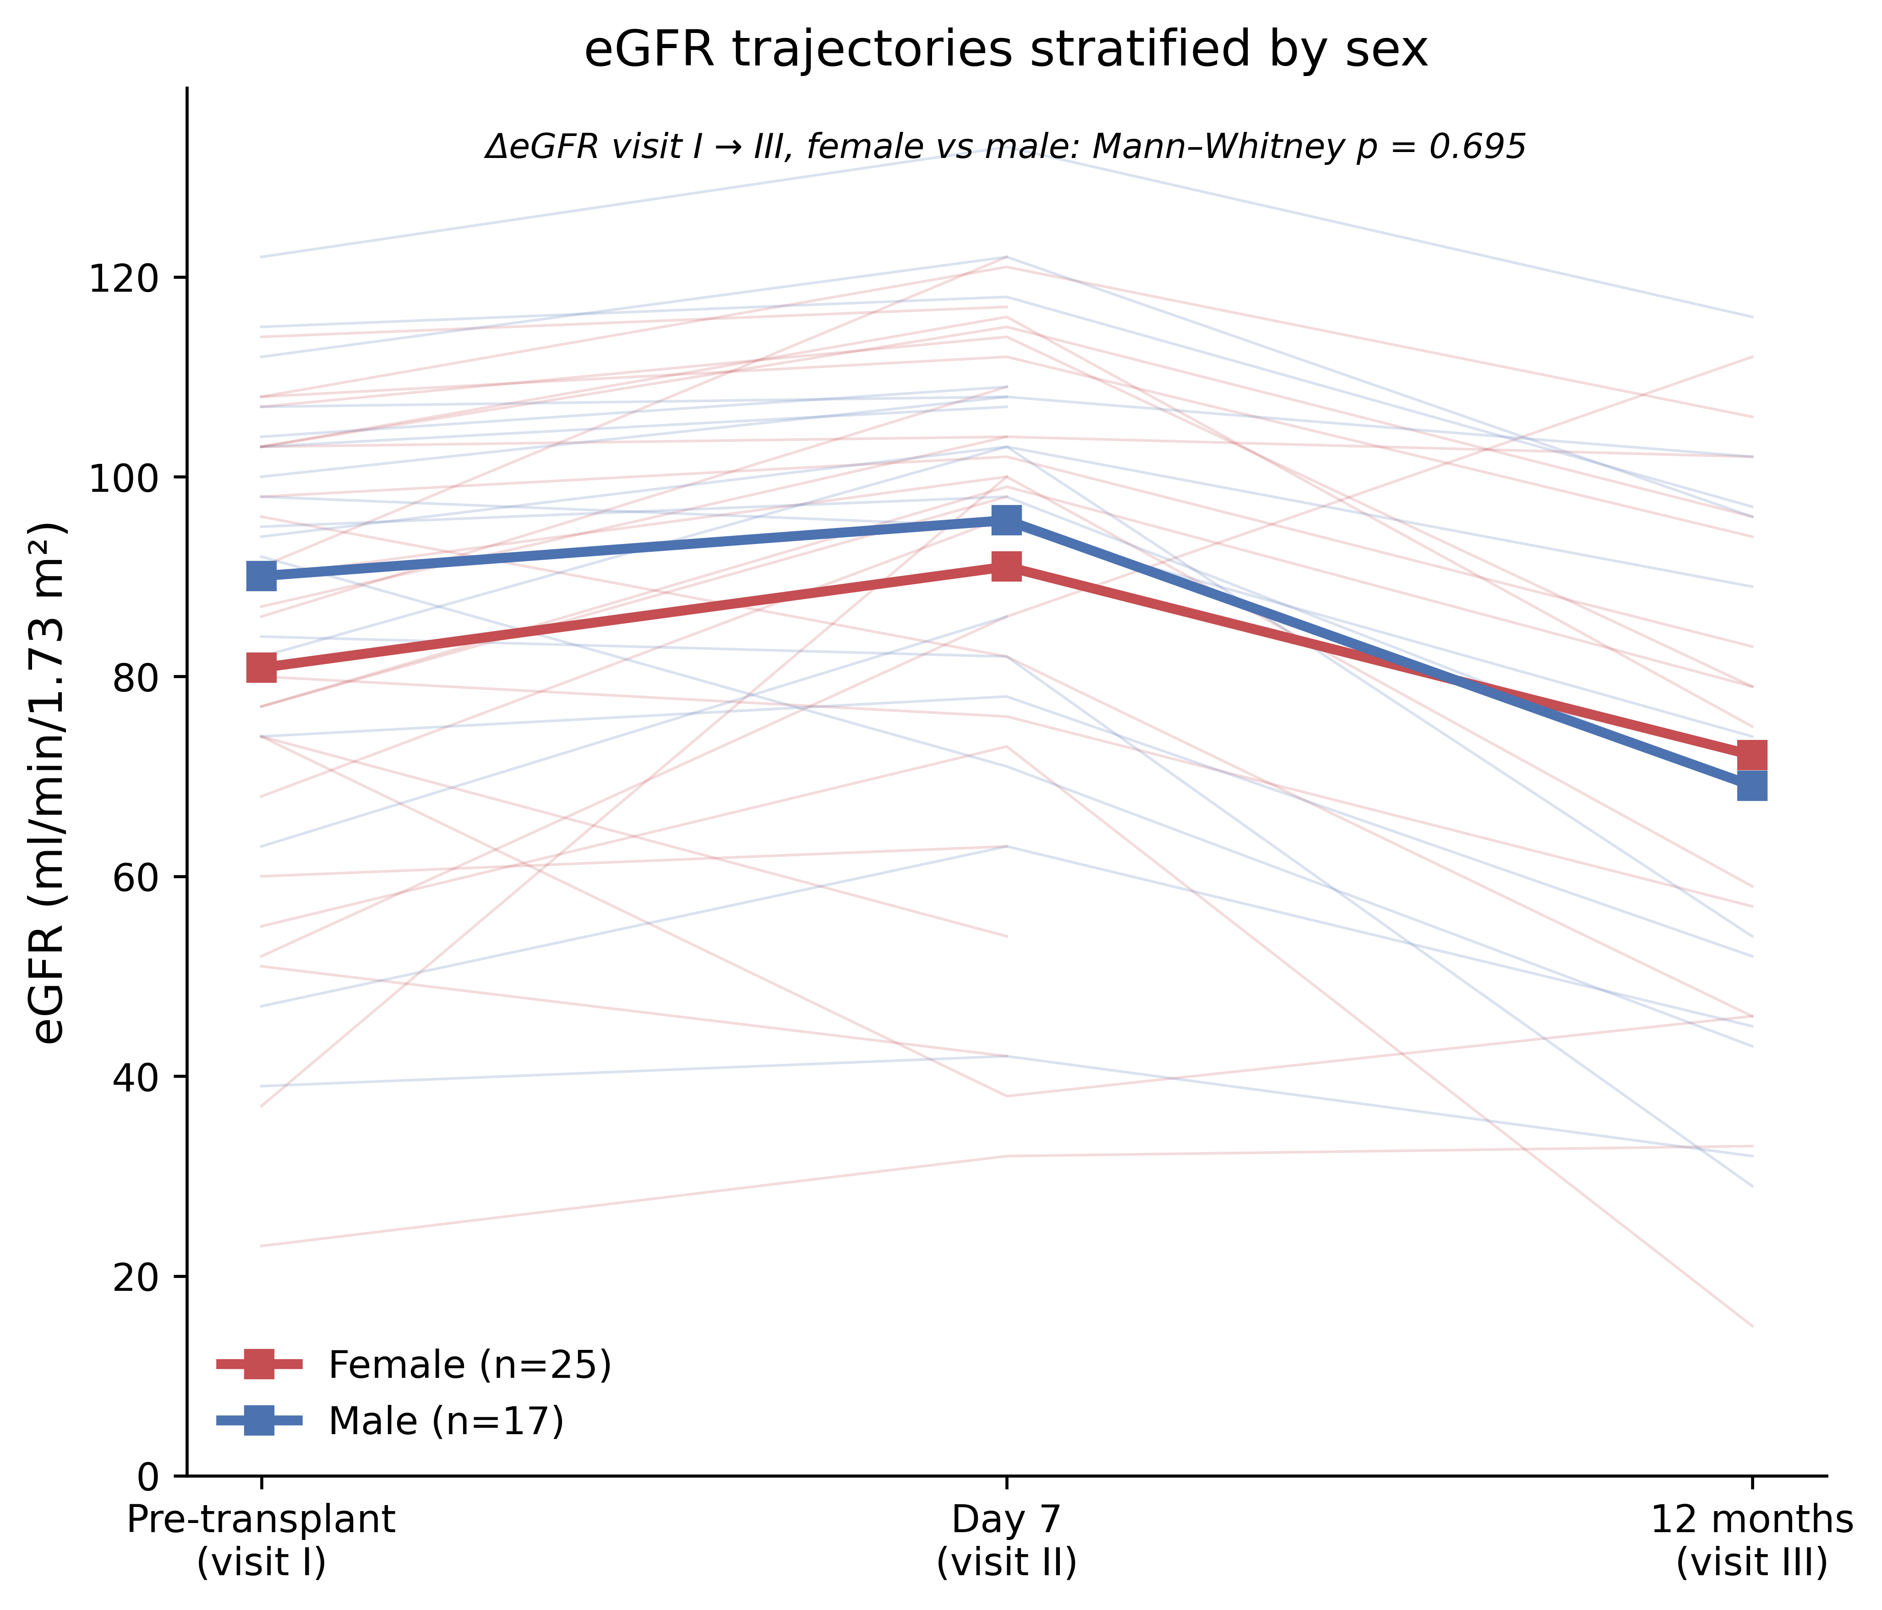
Supplementary Figure S4. Estimated GFR (CKD-EPI creatinine) trajectories across the three visits: pre-transplant (visit I), day 7 ± 3 days post-PBSCT (visit II) and 12 months (visit III); stratified by sex. Thin lines show individual patients, bold lines show group means. The between-sex difference in ΔeGFR from visit I to visit III was not statistically significant (two-sided Mann–Whitney U test, p = 0.695).

4. Correlation among input features
Before modelling we examined the pairwise correlations among the candidate input features (Figure S5), as several routinely measured renal markers are mechanistically linked and therefore strongly inter-correlated (e.g., creatinine- and cystatin C-based eGFR with their parent serum analytes, and the urinary protein-, albumin- and α1-microglobulin-to-creatinine ratios with one another). The occurrence of collinearity means the apparent importance of any single predictor must be read with caution: correlated features share information, so a model can distribute weight among them in ways that do not reflect independent causal contributions. We also used the Spearman rank correlation rather than the Pearson correlation because the laboratory values are skewed and contain outliers, several inputs are ordinal or binary, and the cohort is small (n = 38); Spearman captures any monotonic relationship without assuming linearity or normality and is robust to extreme values.
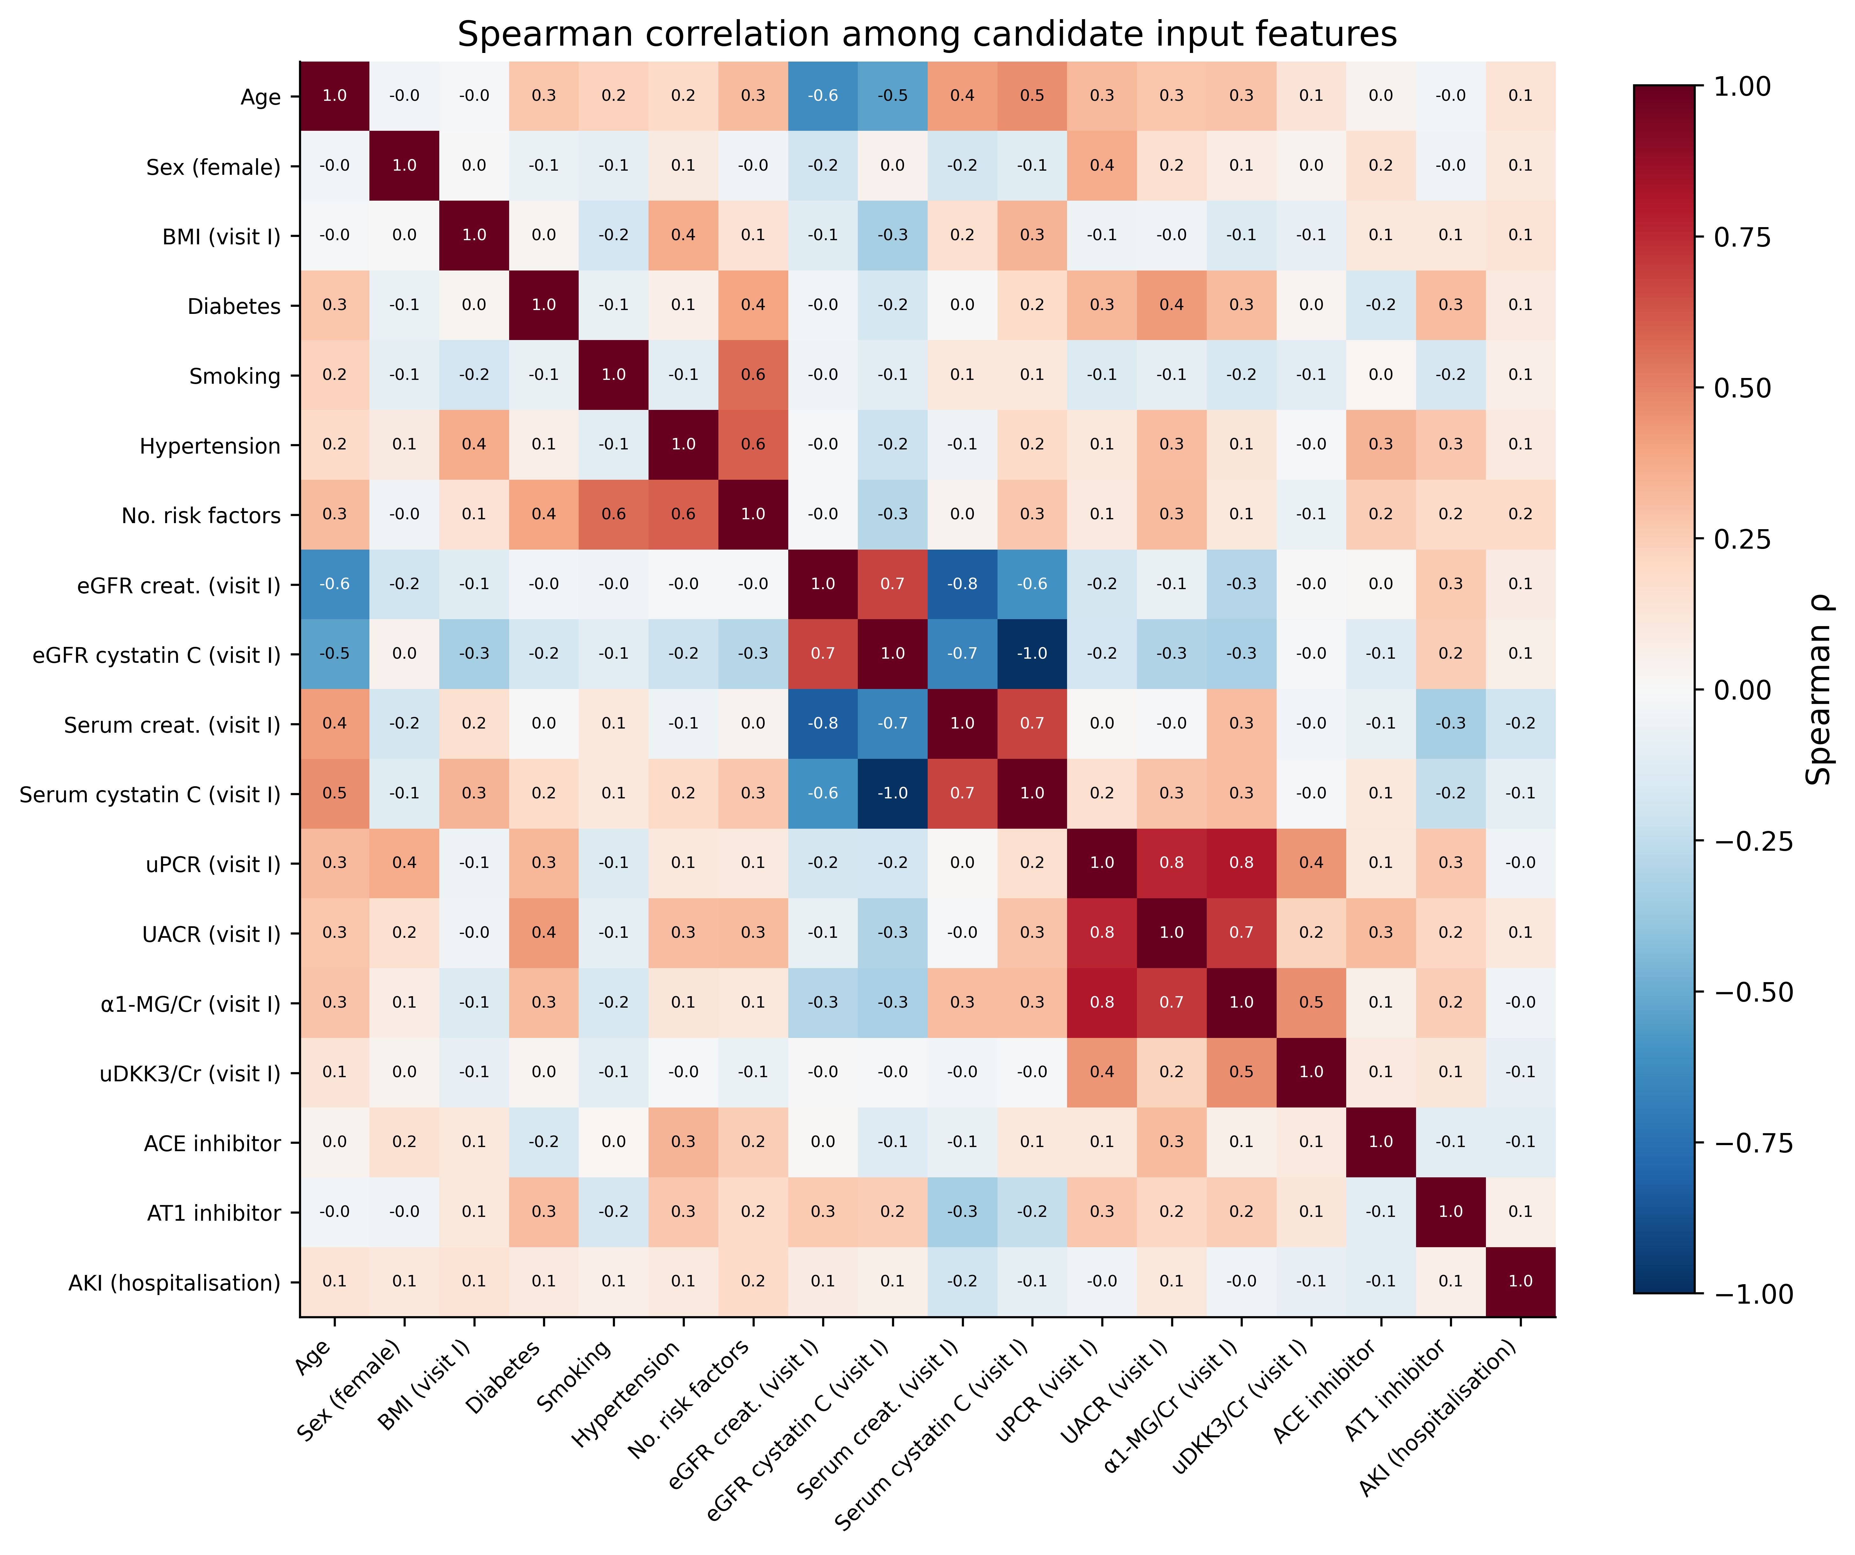
Supplementary Figure S5. Spearman rank correlation among the candidate input features at visit I (plus AKI during hospitalisation). Strong coefficients between each eGFR estimate and its parent serum analyte, and among the urinary protein/albumin/α1-microglobulin ratios indicate redundancy among predictors.

5. Mortality-classification model
5.1 Feature reduction by truly nested cross-validation
A forward-selection scheme was embedded in a truly nested leave-one-out cross-validation to test whether a clinically motivated 19-feature candidate pool could be reduced. For every outer LOO fold the linear-kernel SVC was refitted on the remaining 37 patients in an inner LOO loop; the median absolute standardised coefficient across the 37 inner fits was used as the feature ranking for that outer fold only, and the held-out outer patient was scored on the top-k features for k = 1 … 19. The procedure therefore evaluates the entire ranking-and-fit pipeline rather than only the SVC fit. The nested AUC peaked at k = 10 (AUC 0.881) and remained close to that maximum from k = 10 through k = 14; the optimistic curve obtained from a full-data ranking was 4–10 AUC points higher across the same range, quantifying the optimism contributed by the selection step (Figure S6).
The ten features selected by the SVC’s coefficient-stability ranking on all 38 patients (the “a-priori top-10”) coincided exactly with the ten most-frequently selected features across the 38 outer folds (the “nested-consensus top-10”): six features were selected in 38/38 outer folds (creatinine- and cystatin C-based eGFR, serum creatinine, ACE inhibitor, sex, AKI), three in 37/38 (serum cystatin C, uPCR, smoking) and age in 25/38. UACR (7/38), BMI (4/38), urinary α1-microglobulin/Cr (2/38) and urinary DKK3/Cr (0/38) occasionally entered the top-10 but were displaced by age on aggregate (Figure S7). This 10/10 overlap means the ten predictors carried into the deployable model are independent of whether the evaluation is the fixed-subset or the truly nested LOO-CV.
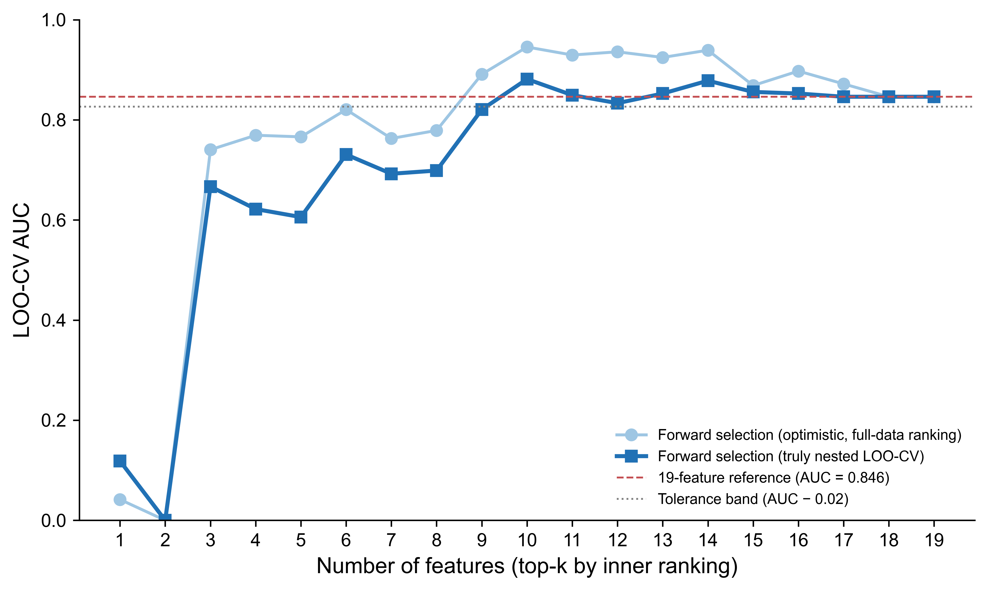
Supplementary Figure S6. Forward-selection LOO-CV AUC versus number of features for the linear-kernel SVC. Light blue: optimistic curve from a full-data feature ranking. Dark blue: truly nested curve in which the ranking is re-derived inside every outer LOO fold. The 19-feature reference (red dashed) and a 0.02 tolerance band (grey dotted) are shown.
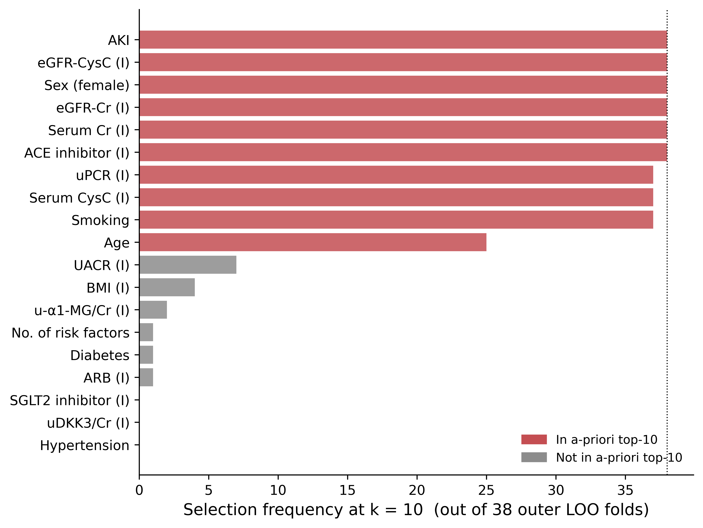
Supplementary Figure S7. Per-fold feature stability at k = 10 (across the 38 outer LOO folds). Red bars: features in the a-priori top-10 (carried into the deployable model). Grey bars: features that occasionally entered the top-10 but were not in the a-priori list. The two rankings have a 10/10 overlap. Features measured at visit I carry an “(I)” suffix; AKI refers to acute kidney injury during hospitalisation.
5.2 Deployable best-model card
The deployable model is a linear-kernel SVC (C = 1, probability = True, random_state = 2718) inside a pipeline that imputes missing values with the per-feature median and standardises features to zero mean / unit variance, fitted on all 38 patients of the classification cohort with the 10-feature subset. Standardised coefficients with non-parametric bootstrap 95 % confidence intervals (1,000 resamples) are summarised in Figure S8. Cystatin C-based eGFR carried the largest absolute coefficient (−1.76, 95 % CI −1.98 to −0.65), followed by creatinine-based eGFR (−1.49) and serum creatinine (−1.09); ACE-inhibitor use (+0.68), female sex (+0.54) and AKI (+0.52) entered as risk-increasing variables, while uPCR had a small coefficient whose 95 % CI crossed zero.
Discrimination by LOO-CV reached AUC 0.946, average precision 0.898 and Brier score 0.106. At the Youden-optimal threshold (0.36) the model achieved sensitivity 0.92, specificity 0.92, accuracy 0.92 and F1-score 0.88, correctly classifying 35 of 38 patients (Figure S9). The reliability diagram showed a Cox calibration intercept of +0.77 and slope of +2.22, indicating that the predicted probabilities discriminate well but are too sharp at the extremes; therefore, recalibration would be necessary before any real clinical deployment (Figure S10). LOO-CV AUC stratified by clinically relevant subgroups remained ≥ 0.86 throughout (overall 0.946; female 0.98, male 0.86; AKI yes 0.88, no 0.98; age ≥ 58 y 0.94, < 58 y 0.94).
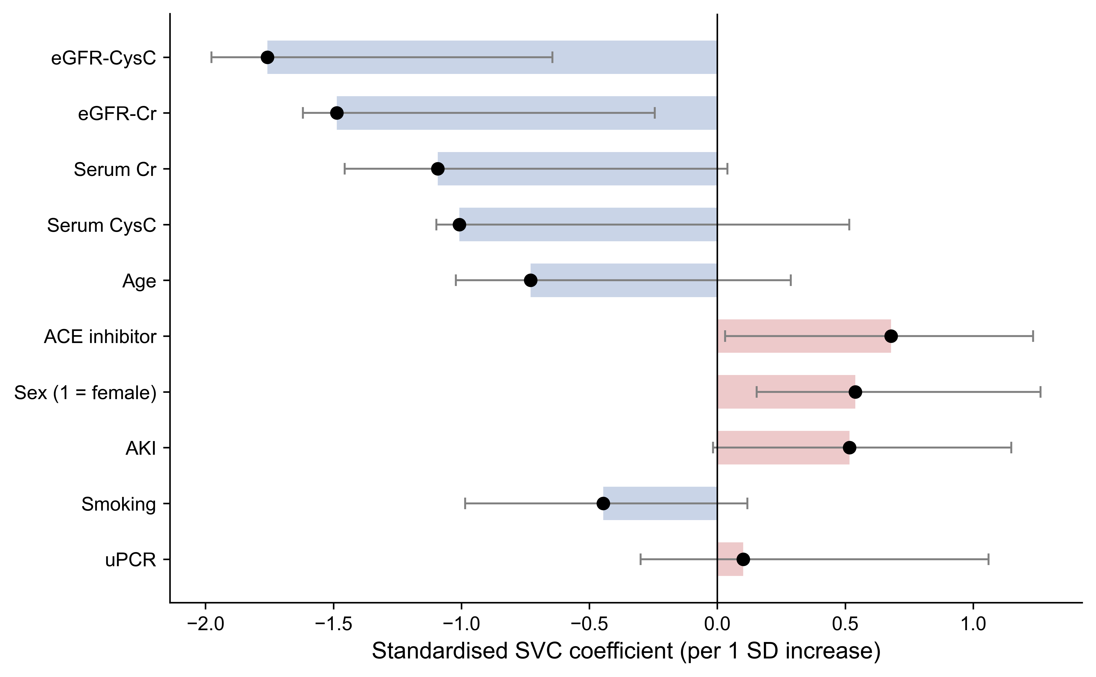
Supplementary Figure S8. Standardised SVC coefficients with bootstrap 95 % confidence intervals (1,000 resamples) for the deployable 10-feature model. Red bars indicate features that increase predicted mortality; blue bars indicate protective features.
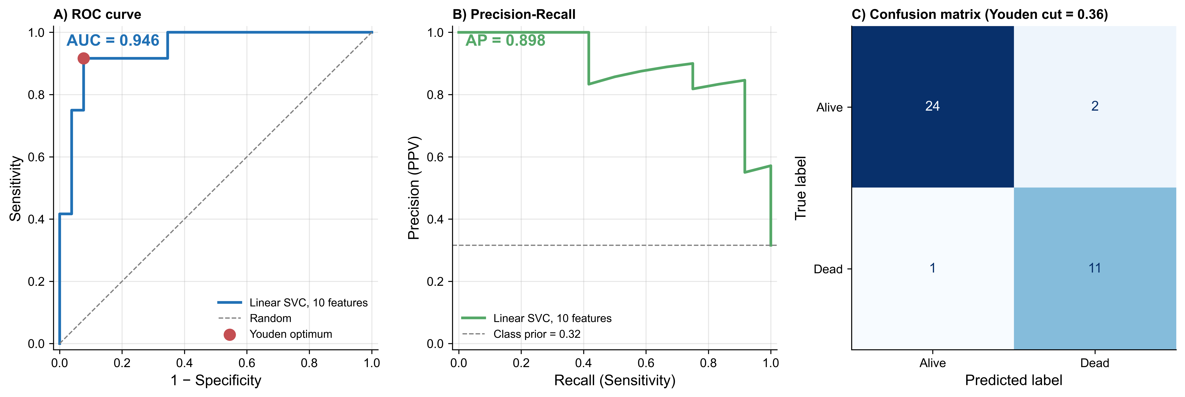
Supplementary Figure S9. ROC curve (left), precision–recall curve (centre) and confusion matrix at the Youden-optimal threshold (right) for the deployable 10-feature model under LOO-CV (n = 38).
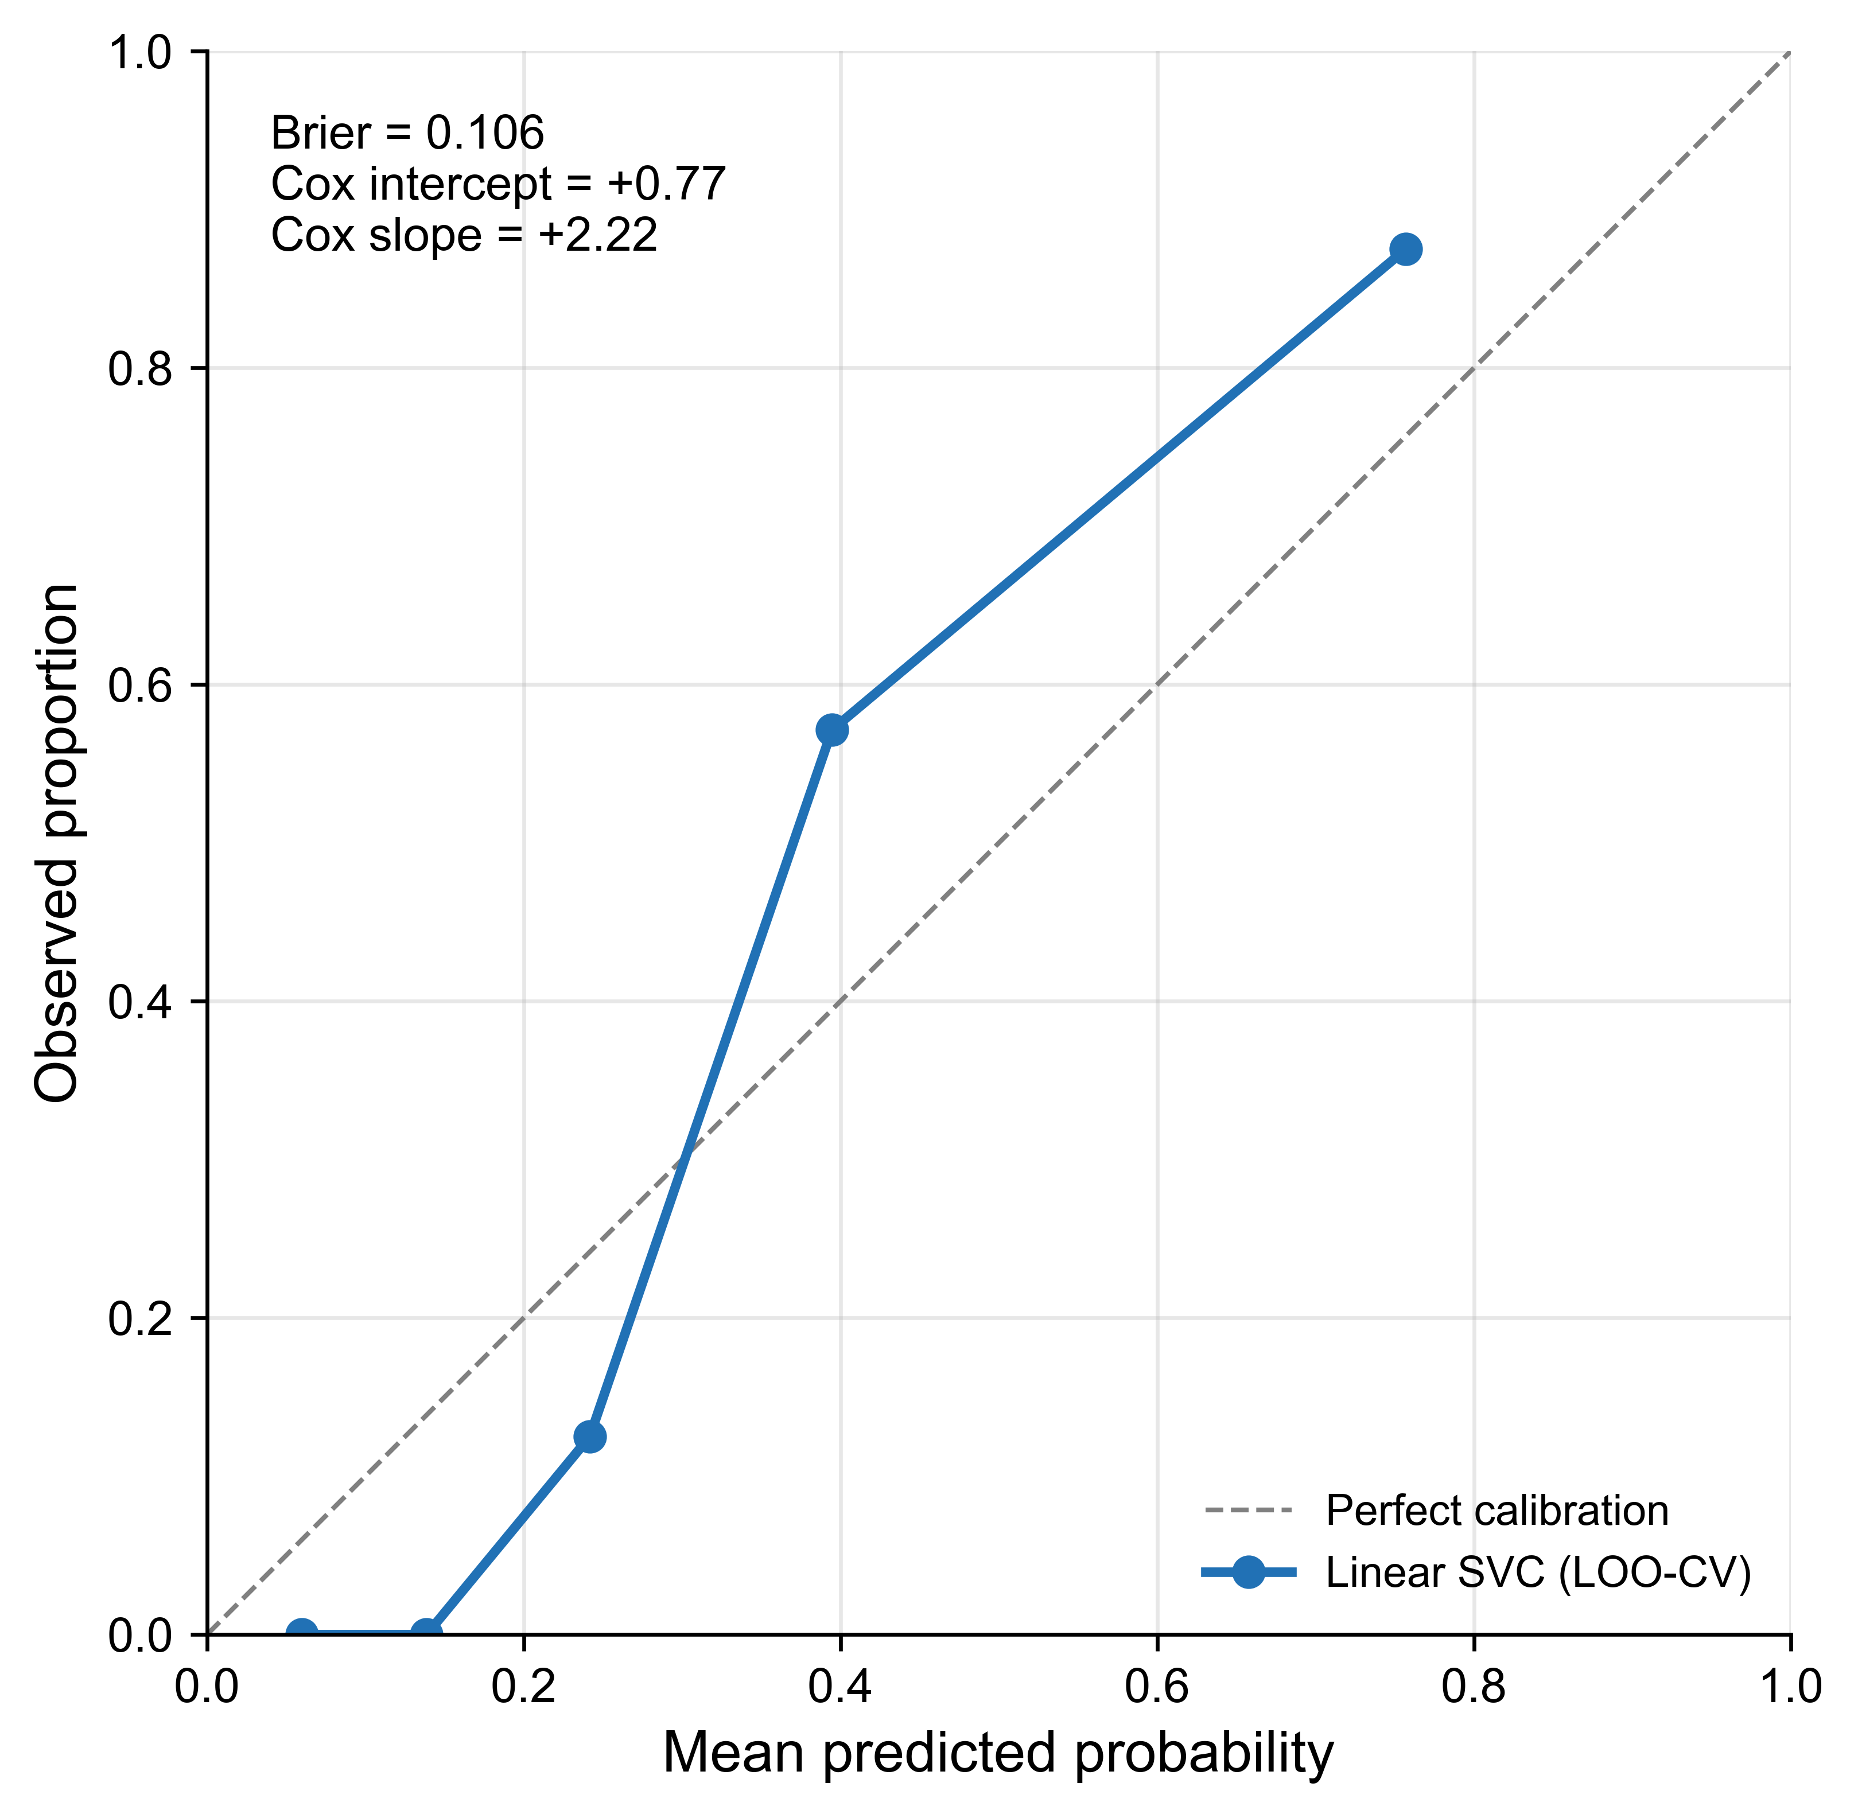
Supplementary Figure S10. Reliability diagram (5 quantile bins) for the deployable 10-feature model. Brier score 0.106; Cox calibration intercept +0.77, slope +2.22.
Note on urinary DKK3. Although DKK3 is the eponymous biomarker of this study and the early post-transplant change in urinary DKK3 is significantly correlated with 12-month eGFR (main text Figure 3), the urinary DKK3-to-creatinine ratio at visit I was selected in 0/38 outer LOO folds at k = 10 and is therefore not retained in the deployable mortality model. DKK3’s prognostic role in this cohort is confined to the eGFR-decline analysis, not to 12-month all-cause mortality. Given the reduced number of patients and events, this should be interpreted as hypothesis-generating and should be validated in a larger, ideally multicenter cohort.
5.3 Feature contributions of the deployable model (SHAP)
To interpret the deployable model at the level of individual predictions, we computed SHAP (SHapley Additive exPlanations) values for the 10-feature linear-kernel SVC (Figure S11). Consistent with the standardised coefficients, the three kidney-function variables cystatin C-based eGFR, creatinine-based eGFR and serum creatinine at visit I dominate the contributions, with lower values pushing the predicted 12-month mortality risk upward; female sex, baseline ACE-inhibitor use and AKI during hospitalisation contribute smaller, risk-increasing effects, and urinary protein-to-creatinine ratio the least. Because several of these inputs are strongly correlated (§4), the SHAP attributions should be read as the model’s internal allocation of shared information rather than as independent causal effects. Because the classifier is linear, each SHAP value equals the standardised coefficient multiplied by the centred feature value, so the contributions re-express the coefficient estimates of §5.2 at the level of individual patients rather than providing independent information; binary inputs (e.g. sex) therefore collapse to two values whose magnitudes are weighted by category prevalence.
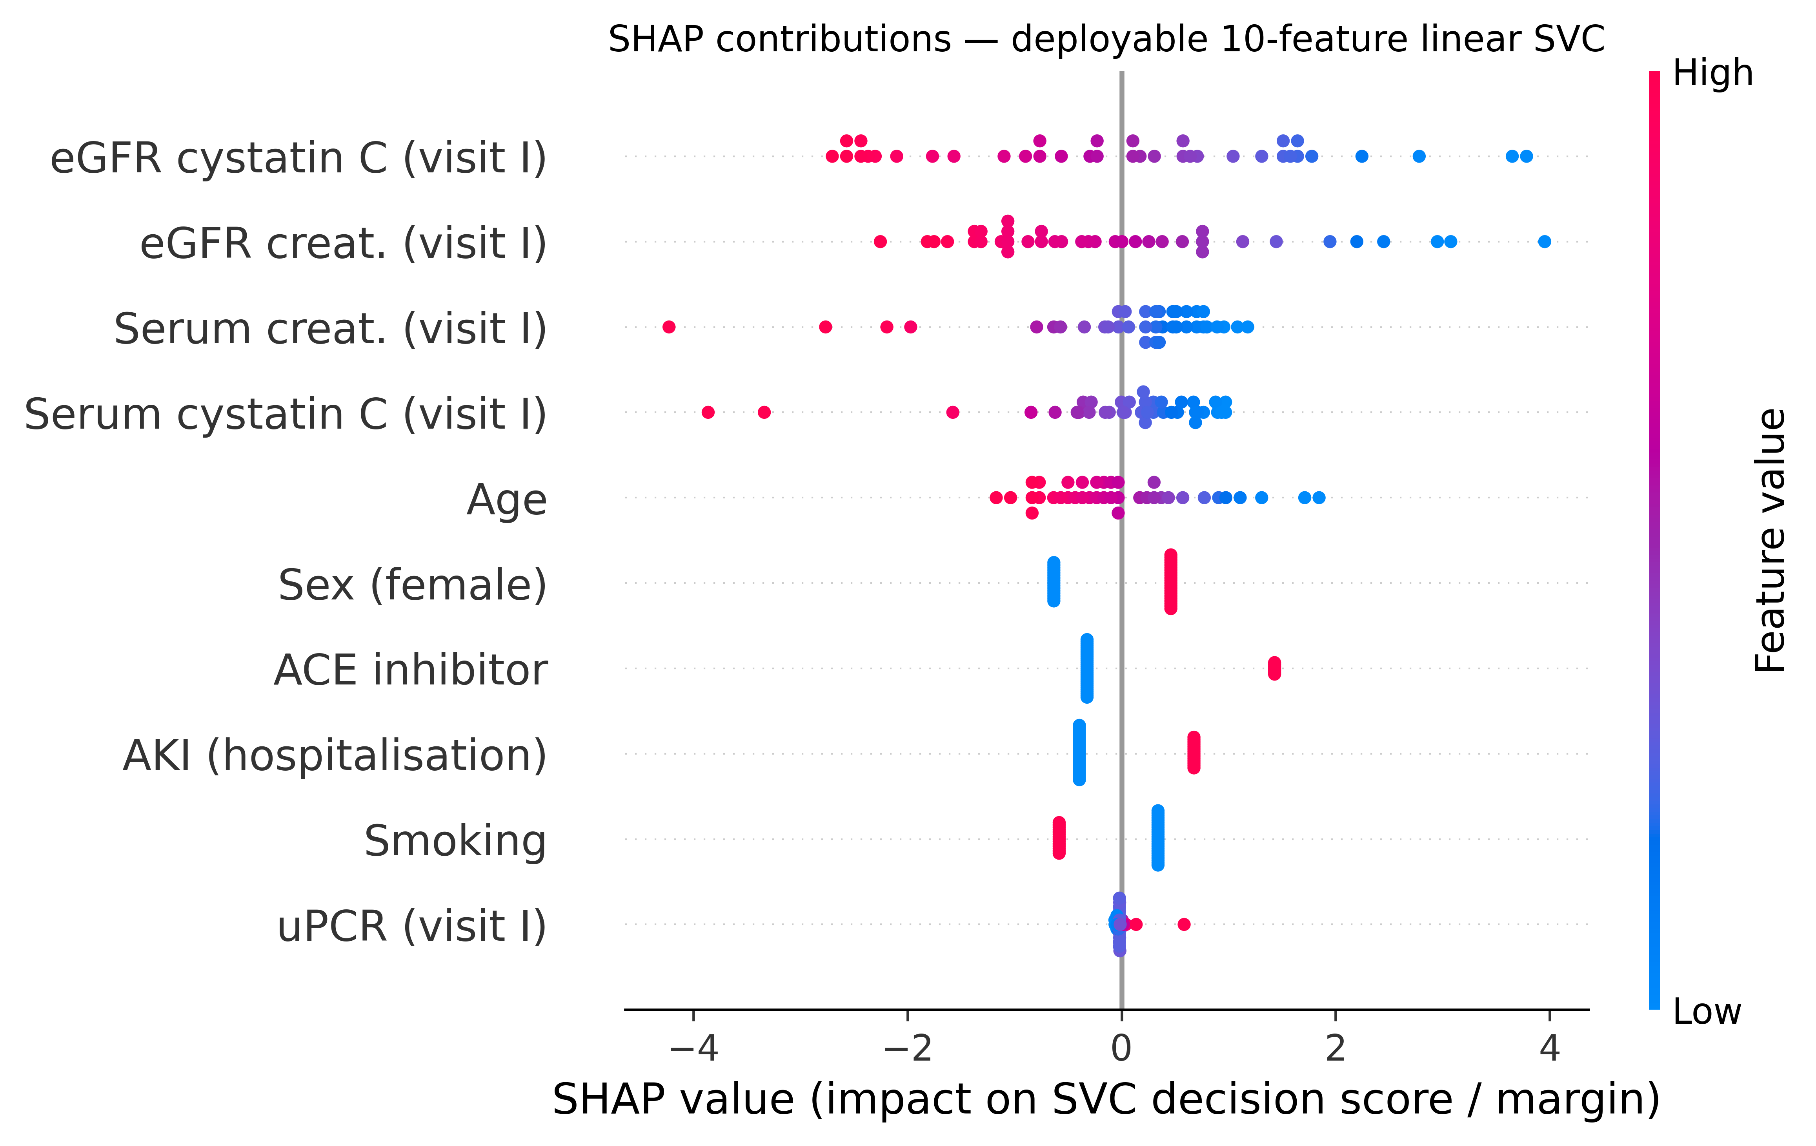
Supplementary Figure S11. SHAP contributions for the deployable 10-feature linear SVC (all 38 patients). Each point is one patient; position on the x-axis is the SHAP value, expressed in units of the SVC decision score (the signed margin to the separating hyperplane, where higher values correspond to higher predicted 12-month mortality), and colour encodes the feature value (red = high, blue = low). Features are ordered by mean absolute SHAP value.
5.4 Sensitivity analysis
An independent outlier-detection scheme (IsolationForest, contamination = 10 %, random_state = 2718, fitted on the median-imputed and z-scaled 10-feature matrix) flagged four patients as outliers. Removing them and re-evaluating the deployable model under LOO-CV reduced the AUC from 0.946 to 0.892 and increased the Brier score from 0.106 to 0.127, indicating that the classifier is reasonably robust to a different outlier-detection rule and is not driven by individual extreme observations.

6. Exploratory regression of ΔeGFR (visit I → III)
As an exploratory analysis we tested whether the 18 pre-transplant features could predict the continuous change in eGFR from visit I to visit III in the 24 survivors with paired measurements. In univariate testing, only age was significantly associated with ΔeGFR (Spearman ρ = −0.44, p = 0.031; Figure S12). The best multivariable model (linear-kernel support-vector regression, leave-one-out R² = 0.45) was not robust: its performance collapsed once three influential observations were removed (R² = 0.19; identified by a consensus of interquartile-range, z-score, IsolationForest and Cook’s-distance criteria). Given this fragility at n = 24, the regression is reported as hypothesis-generating only and is not developed further.
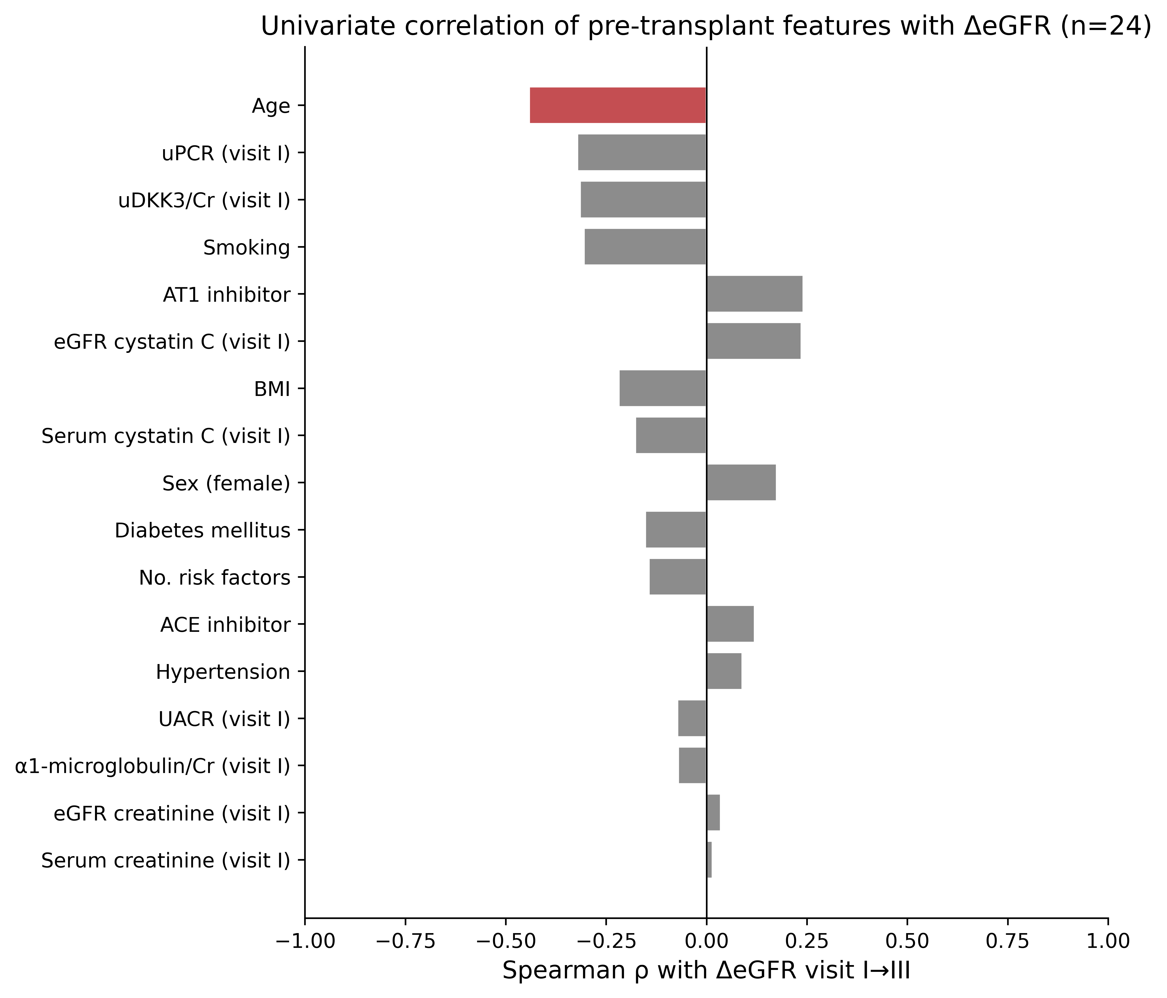
Supplementary Figure S12. Univariate Spearman correlations of the 18 pre-transplant features with ΔeGFR (visit I → III) in the regression cohort (n = 24). Only age reached statistical significance (ρ = −0.44, p = 0.031); red bars denote p < 0.05.

7. Urinary biomarker associations with 12-month eGFR
To complement the ranked correlation coefficients of main-text Figure 3, Supplementary Figure S13 shows the underlying scatter plots for the six urinary markers that reached nominal significance (uncorrected p < 0.05) against the 12-month creatinine-based eGFR. In every case a higher post-transplant urinary marker was associated with a lower 12-month eGFR. Because the cohort is small and the tests are not adjusted for multiple comparisons, these associations are hypothesis-generating and did not survive Benjamini–Hochberg control of the false-discovery rate (smallest q ≈ 0.11).
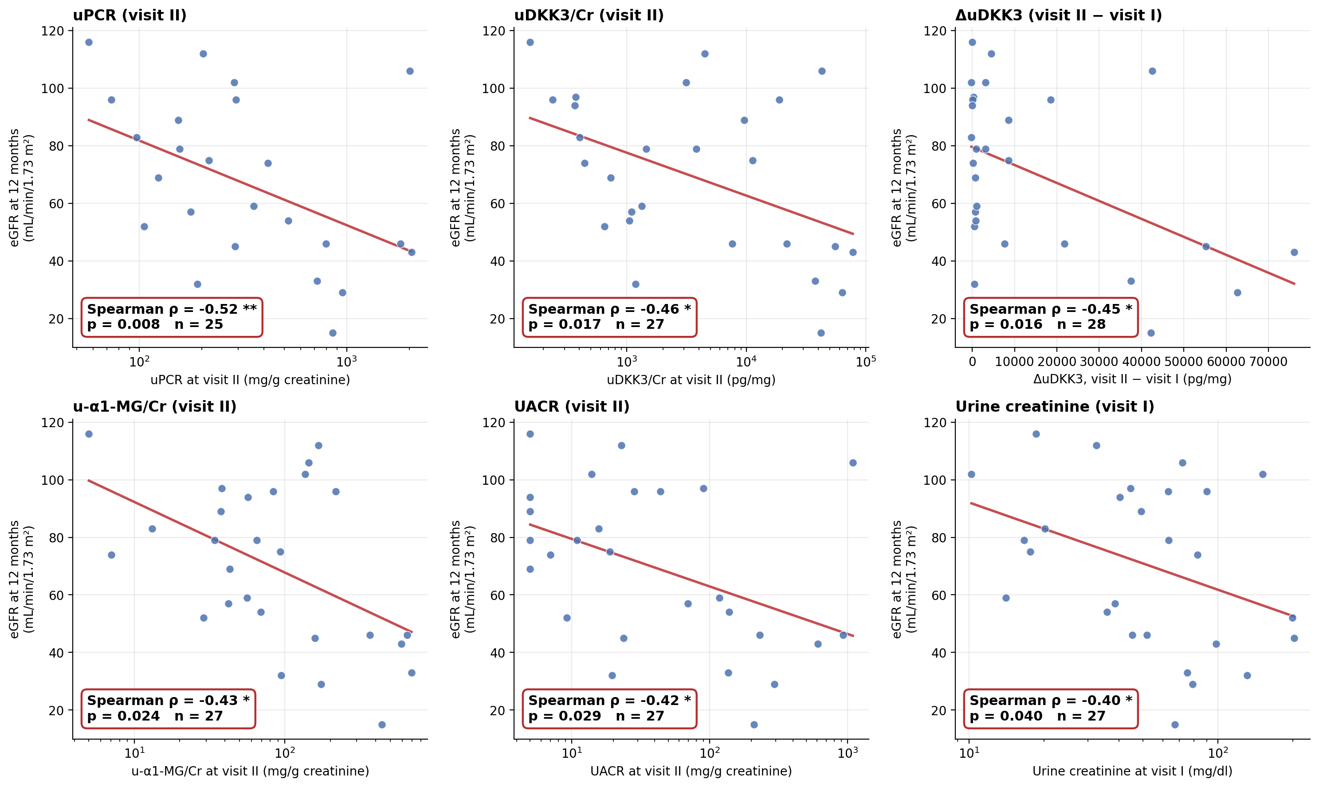
Supplementary Figure S13. Scatter plots of the six urinary biomarkers significantly associated with 12-month creatinine-based eGFR in the main-text Figure 3 analysis: urine protein-to-creatinine ratio (uPCR), uDKK3-to-creatinine ratio (uDKK3/Cr), the early change in urinary DKK3 (ΔuDKK3, visit II − visit I), α1-microglobulin-to-creatinine ratio (u-α1-MG/Cr) and albumin-to-creatinine ratio (UACR) at the indicated visits, and urine creatinine at visit I. Each panel plots one biomarker against eGFR at 12 months; the annotation gives the Spearman rank-correlation coefficient (ρ), its uncorrected p-value and the number of paired observations (n). The red line is a least-squares fit shown for visual orientation only. Right-skewed concentration and ratio markers are drawn on a logarithmic x-axis (one uPCR value of 0 is omitted from the display but retained in the correlation); the signed ΔuDKK3 uses a linear x-axis. * p < 0.05, ** p < 0.01.

8. Alignment with TRIPOD+AI (2024) reporting items
This study reports an exploratory clinical prediction model developed in a single small cohort. We summarise alignment with the 27 items of the TRIPOD+AI 2024 checklist (Collins GS et al. BMJ 2024;385:e078378) below.
Items 1–3 (title, abstract, introduction): main text. Items 4–10 (methods — sources of data, participants, outcome, predictors, sample size, missing data, statistical analysis): main text Methods plus this supplement (§5.1 nested forward selection; §5.2 deployable model card with bootstrap 95 % confidence intervals). Items 11–17 (model development, validation, evaluation, specification, performance, risk of bias): §5.1–§5.3 of this supplement; sample-size limitations are noted in §5.2 and in the limitations paragraph below. Items 18–22 (results — participants, model development and specification, performance, calibration, fairness): main text Results plus §5.2 (operating-point and nested AUCs, calibration intercept and slope, subgroup AUCs) and §5.3 (SHAP feature contributions). Items 23–27 (discussion, other information, open science): main text Discussion (limitations including events-per-predictor); data- and code-availability statements at the end of the main manuscript; the analysis scripts reproducing every figure are archived alongside the manuscript.
Limitations relevant to TRIPOD+AI compliance. The 10-feature subset was data-derived in the same cohort and no external validation has been performed. Calibration is sharper than ideal (Cox slope +2.22) and the model should be recalibrated before clinical use. The events-per-predictor ratio is 1.2. The model is therefore reported as hypothesis-generating.

