Supplementary Information
Online Resource 1 Principal component analysis (PCA) of male Halobaena caerulea calls. Arrows indicate the loadings of each acoustic parameter; colours identify the different individuals.
Online Resource 2 Principal component analysis (PCA) of female Halobaena caerulea calls. Arrows indicate the loadings of each acoustic parameter; colours identify the different females.

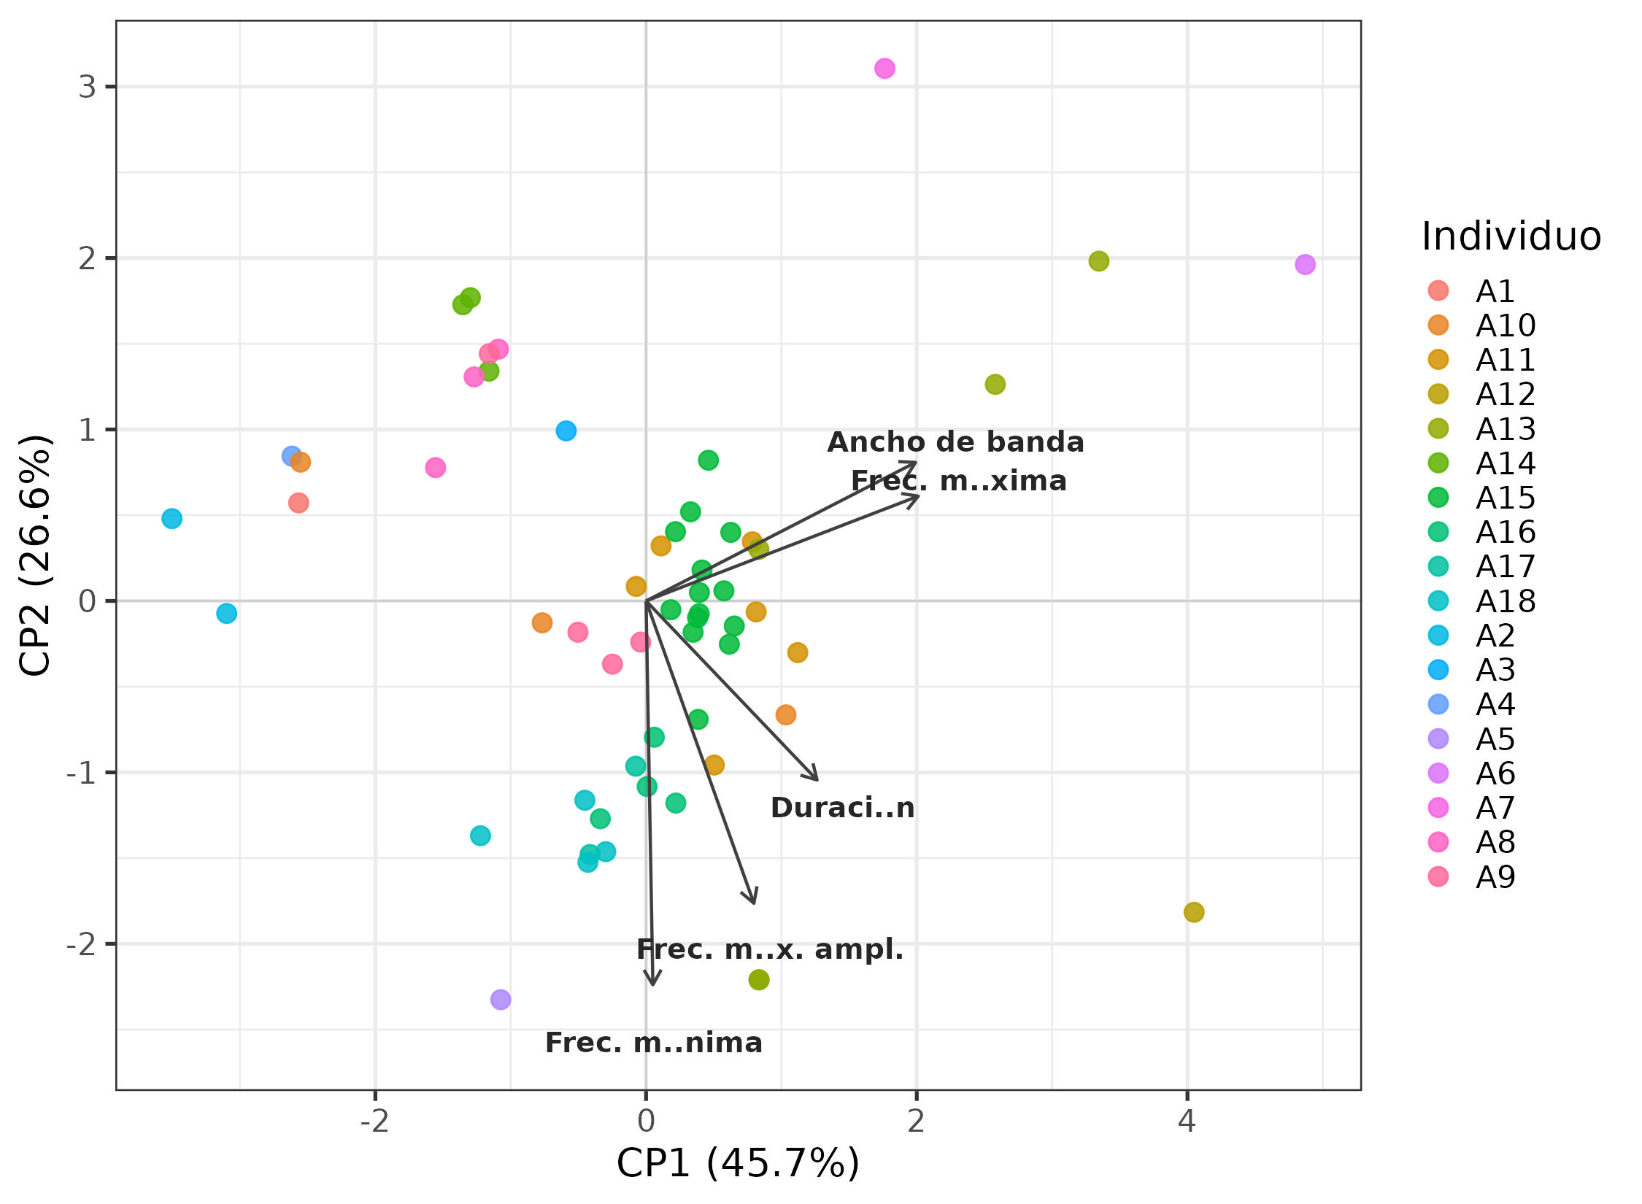
Online Resource 1

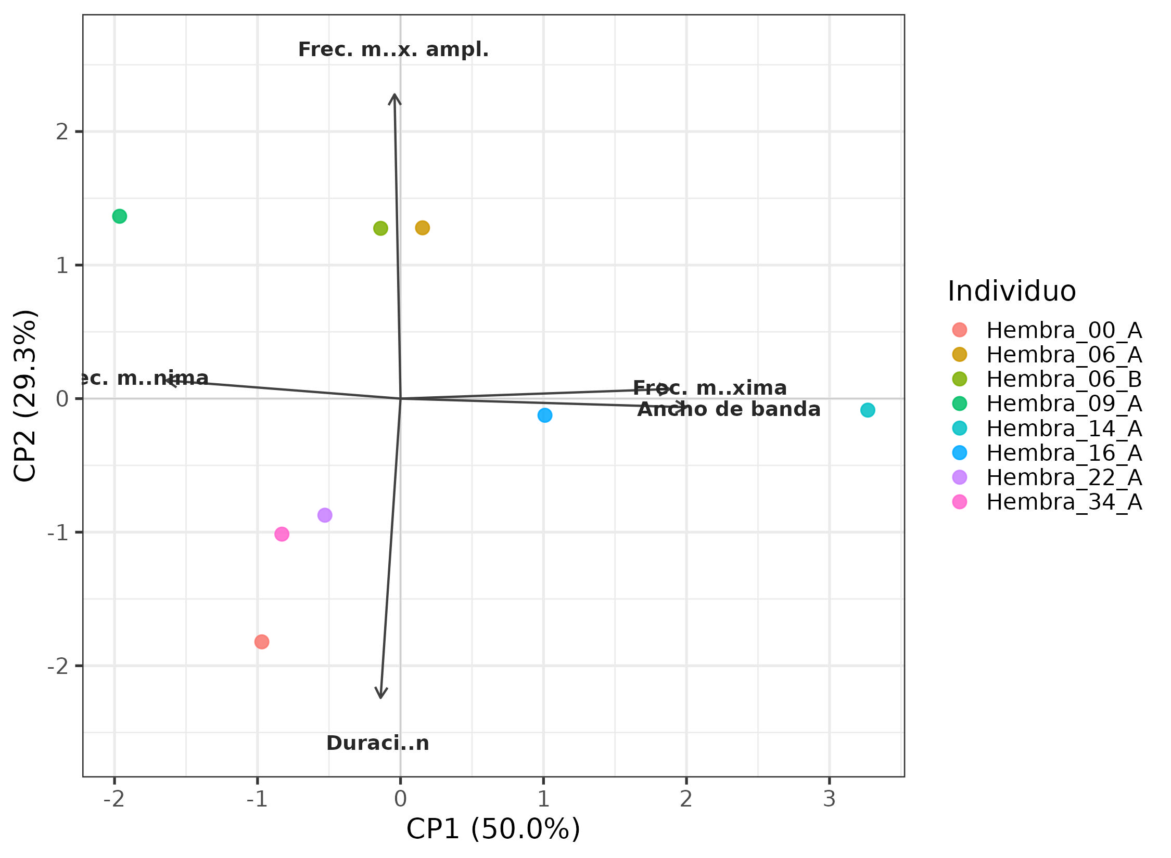
Online Resource 2

