ONLINE-ONLY SUPPLEMENTARY MATERIAL

Hypertension is associated with better brain health outcomes in older-age asymptomatic carotid disease populations - A Multi-Cohort Study
Summan Zahra, Alexander T. Hong, Juan C. Arias, Scott R. French, Haley Wiskoski, Ivan Y. Luu, Erin B. Oxnam, Elizabeth O. Orobiyi, Madeline Ally, Cris Escareno, Gavin Culwell, Emma Heitkamp, Franchell Vasquez, Paola Vidana, Xana Waughman, Madison Hillis, Kevin Johnson, Dedrick Jordan, Georg A. Hishaw, Edward J. Bedrick, Francesca Vitali, Raza Mushtaq, Maria Altbach, Jeremy Pruzin, Timothy Hughes, Gene E. Alexander, Tze-Woei Tan, Craig C. Weinkauf

Supplemental Table 1. Summary of randomized clinical trial understanding the association between blood pressure and cognitive outcomes.
Study | Participants | BP cut-off | Outcomes | Results
ACCORD-MIND ¹ | RCT  Inclusions: Age ≥55,  High CVD, type 2 diabetes  Exclusions: Cognitive impairment or dementia at baseline | <120 vs <140 | Primary:  Cognition  Secondary:  Total brain volume (TBV) | Intensive BP control did not have a measurable effect on cognitive decline at follow-up.  Intensive BP was associated with greater decline in TBV as compared to standard therapy.
SPRINT-MIND² | RCT  Inclusions: Age ≥50, CV risk factor  Exclusions: stroke, diabetes, dementia | <120 vs <140 | Primary:  Probable dementia  Secondary:  Mild cognitive impairment | Intensive BP did not result in significant reduction in probable dementia.
BPROAD³ | RCT  Inclusions: Age ≥50, elevated SBP & increased CV risk | <120 vs <140 | Primary:  All-cause dementia: decline in memory, functional impairment, irreversible cognitive deficits  MCI: change in cognition, impairment in cognitive domain, independent in functional abilities  Secondary:  Change in global cog function, brain structure, MRI characteristics, TBV, high signal lesions of WM, CSVD | No cognitive-outcome results released
STEP⁴ | Inclusions: Age 60-80 year old hypertensive patients  Exclusions: History of ischemic or hemorrhagic stroke, diagnosis of dementia, or taking medications for dementia | <110-130 vs 130- <150 | Primary:  Annual change in MMSE score  Secondary:  If CV events (stroke, acute coronary syndrome, acute heart failure, atrial fibrillation, coronary revascularization, or cardiovascular death) was associated with changes in MMSE or cognitive decline  If MMSE change differed by age, sex, education, marital status, smoking, drinking, urbanization, diabetes status, etc was affected by BP control | Compared to standard treatment, intensive SBP treatment did not result in a significant change in cognitive function test score.
SPS3⁵ | RCT  Inclusions: Age ≥30, recent symptomatic S3 confirmed  Exclusions: cortical stroke, cardioembolic stroke, large artery stenosis, intracranial hemorrhage, disabling stroke | <130 vs 130-149 | Primary:  Cognition - Cognitive Abilities Screening Instrument (CASI) | No significant difference in cognition between BP target groups.
CRHCP-3⁶ | RCT  Inclusions: Age ≥40, uncontrolled hypertension, must live in village & will not migrate  Exclusions: Pregnancy, malignant tumors, low life expectancy | <130 vs usual care | Primary:  All-cause dementia  Secondary:  Cognitive impairment without dementia, Composite endpoints | Intensive BP control can significantly reduce dementia risk  The risk of developing all-cause dementia was significantly lower in the intervention group compared to usual care & fewer serious adverse events than the usual care group
Abbreviations, BP, blood pressure; CSVD, cerebral small vessel disease; CV, cardiovascular; MRI, magnetic resonance imaging; WM, white matter RCT, randomized controlled trial; ACCORD-MIND, Action to Control Cardiovascular Risk in Diabetes – Memory in Diabetes Study; SPRINT-MIND, Systolic Blood Pressure Intervention Trial – Memory and Cognition in Decreased Hypertension; BPROAD, Blood Pressure Control Target in Diabetes; STEP, Strategy of Blood Pressure Intervention in the Elderly Hypertensive Patients; SPS3, Secondary Prevention of Small Subcortical Strokes; CRHCP, China Rural Hypertension Control Project.

Supplemental Table 2. Demographic, Diagnostic, and Laboratory Codes Used in Propensity Score Matching, TriNetX cohort.
Category | Code | Description
Demographics | AI (TriNetX curated) | Age at Index
Demographics | 2106-3 (TriNetX curated) | White
Demographics | 1002-5 (TriNetX curated) | American Indian or Alaska Native
Demographics | M (TriNetX curated) | Male
Demographics | F (TriNetX curated) | Female
Demographics | 2076-8 (TriNetX curated) | Native Hawaiian or Other Pacific Islander
Demographics | 2135-2 (TriNetX curated) | Hispanic or Latino
Demographics | 2054-5 (TriNetX curated) | Black or African-American
Demographics | 2131-1 (TriNetX curated) | Other Race
Demographics | 2028-9 (TriNetX curated) | Asian
Demographics | UNK (TriNetX curated) | Unknown Race
Diagnosis | I20-I25 | Ischemic heart diseases
Diagnosis | I48 | Atrial fibrillation and flutter
Diagnosis | Z55-Z65 | Persons with potential health hazards related to socioeconomic and psychosocial circumstances
Diagnosis | F17 | Nicotine dependence
Diagnosis | E08-E13 | Diabetes mellitus
Diagnosis | F10 | Alcohol related disorders
Diagnosis | E66 | Overweight and obesity
Diagnosis | H91 | Hearing loss
Laboratory | 9037 (TriNetX curated) | Hemoglobin A1c
Laboratory | 9083 (TriNetX curated) | Body mass index (BMI)
Laboratory | 9085 (TriNetX curated) | Blood Pressure, Systolic
Laboratory | 9001 (TriNetX curated) | HDL Cholesterol [Mass/volume] in Serum or Plasma
Laboratory | 9002 (TriNetX curated) | LDL Cholesterol [Mass/volume] in Serum or Plasma
Laboratory | 9004 (TriNetX curated) | Triglyceride [Mass/volume] in Serum, Plasma or Blood

Supplemental Table 3. Codes Used in the Definition of Diagnosis and Outcomes, TriNetX cohort
Diagnosis | Code
Carotid artery stenosis | I65.2
Primary hypertension | I10
Carotid endarterectomy or stent placement | 35301, 37215, 37216
Cognitive outcomes
Alzheimer’s disease (AD) | G30
Non-AD dementia
Vascular dementia | F01
Unspecified dementia | F03
Dementia in other diseases classified elsewhere | F02
Frontotemporal dementia | G31.0
Senile degeneration of brain, not elsewhere classified | G31.1
Other specified degenerative diseases of nervous system | G31.8
Mild cognitive impairment | G31.84
MACE outcomes
Acute myocardial infarction | I21
Stroke | I60, I61, I62, I63
Mortality | Deceased (TriNetX curated), R99
Other clinically significant outcomes
Heart failure | I50
Chronic kidney disease | N18
Blood brain barrier (BBB)-crossing medications
Telmisartan | 73494
Candesartan | 214354
Captopril | 1998
Fosinopril | 50166
Lisinopril | 29046
Perindopril | 54552
Ramipril | 35296
Trandolapril | 38454

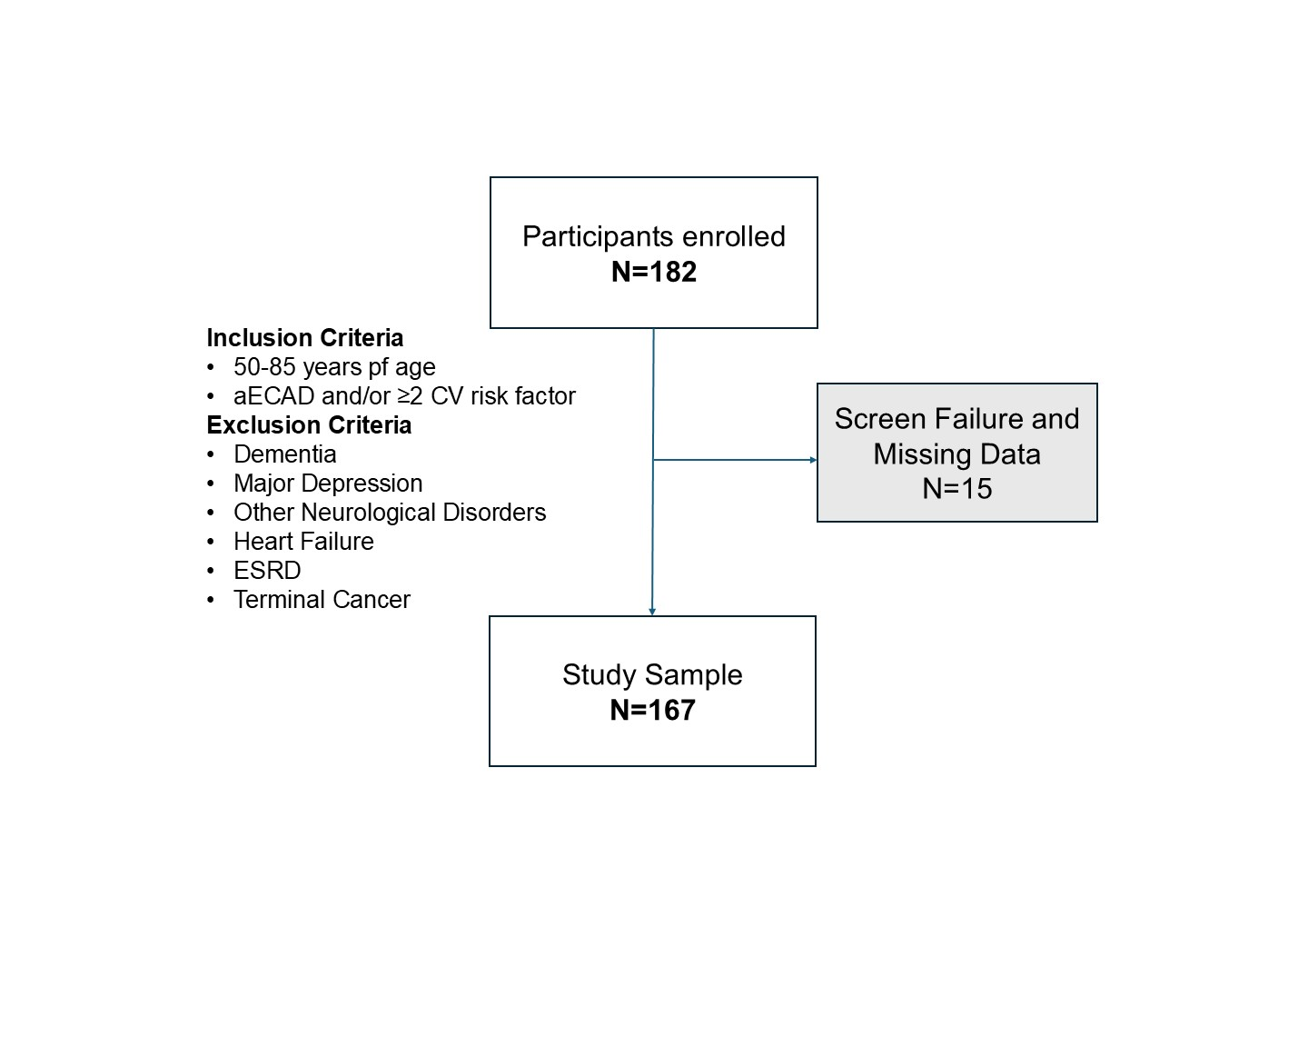
Supplemental Figure 1. Flow diagram showing study sample for the primary CAM cohort.
Inclusion and exclusion criteria are based on participants’ diseases and conditions diagnosed clinically; diagnoses are confirmed with the patient.
Abbreviations: aECAD, Asymptomatic Extracranial Carotid Atherosclerotic Disease; CAM, Carotid and Mind; CV, Cardiovascular; ESRD, End Stage Renal Disease; TIA, Transient Ischemic Attack

Supplemental Table 4. Demographic characteristics of CAM cohort

Characteristic | N=167
Age | 72 (7)
Sex
Female | 72 (43%)
Male | 95 (57%)
Race
White | 159(96%)
Asian | 5 (3.0%)
Black | 1 (0.6%)
Other | 1 (0.6%)
Not Reported | 1 (0.6%)
Ethnicity
Not Hispanic/Latino | 144(86%)
Hispanic/Latino | 18 (11%)
Not Reported | 5 (3.0%)
Education
≤12 | 49 (29%)
13-16 | 81 (49%)
≥17 | 37 (22%)
Hypertension | 110(66%)
Hyperlipidemia | 127(76%)
Diabetes | 48 (29%)
Smoking | 94 (56%)
Coronary Artery Disease | 61 (37%)
Chronic Kidney Disease | 13(7.8%)
Stroke | 28 (17%)
Transient Ischemic Attack | 9 (5.4%)
APOE ε4 allele* | 43 (26%)
Carotid Disease Group
No ECAD (<50%) | 60 (36%)
aECAD (≥50%) | 107(64%)
Continuous variables are present as Mean(SD) and categorical variables as n(%). aECAD, Asymptomatic extracranial carotid atherosclerotic disease.
*APOE ε4 allele, N=164

Supplemental Figure 2. Within individuals with No ECAD, hypertension is not significantly associated with MOCA scores and pTau217 levels, CAM cohort. Multivariable linear regression models estimating the effect of hypertension on cognition adjusting for a-d) age, sex, education and APOE ε4 allele b-e) demographics and vascular comorbidities c-f) and additional white matter lesion volumes. Abbreviations: APOE ε4 , Apolipoprotein ε4; HTN, history of hypertension; ECAD, extracranial carotid atherosclerotic disease; 𝛃, standardized beta estimates. *P<.05 **P<.01 ***P<.001

Supplemental Figure 3. Protective effect of hypertension on cognition and AD pathology in aECAD is independent of the use of anti-hypertensive medications, CAM cohort. Multivariable linear regression models estimating the effect of hypertension on cognition adjusting for a) anti-HTN medication broadly b) blood brain barrier crossing (BBB) anti-HTN medications and other relevant confounders. Hypertension is significantly associated with higher MoCA scores in both models independent of medication effect. Abbreviations: APOε4, Apolipoprotein ε4; BBB, blood brain barrier; HTN, history of hypertension; aECAD, asymptomatic extracranial carotid atherosclerotic disease; log pTau217, log transformed phosphorylated Tau 217; 𝛃, standardized beta estimates. *P<.05 **P<.01 ***P<.001

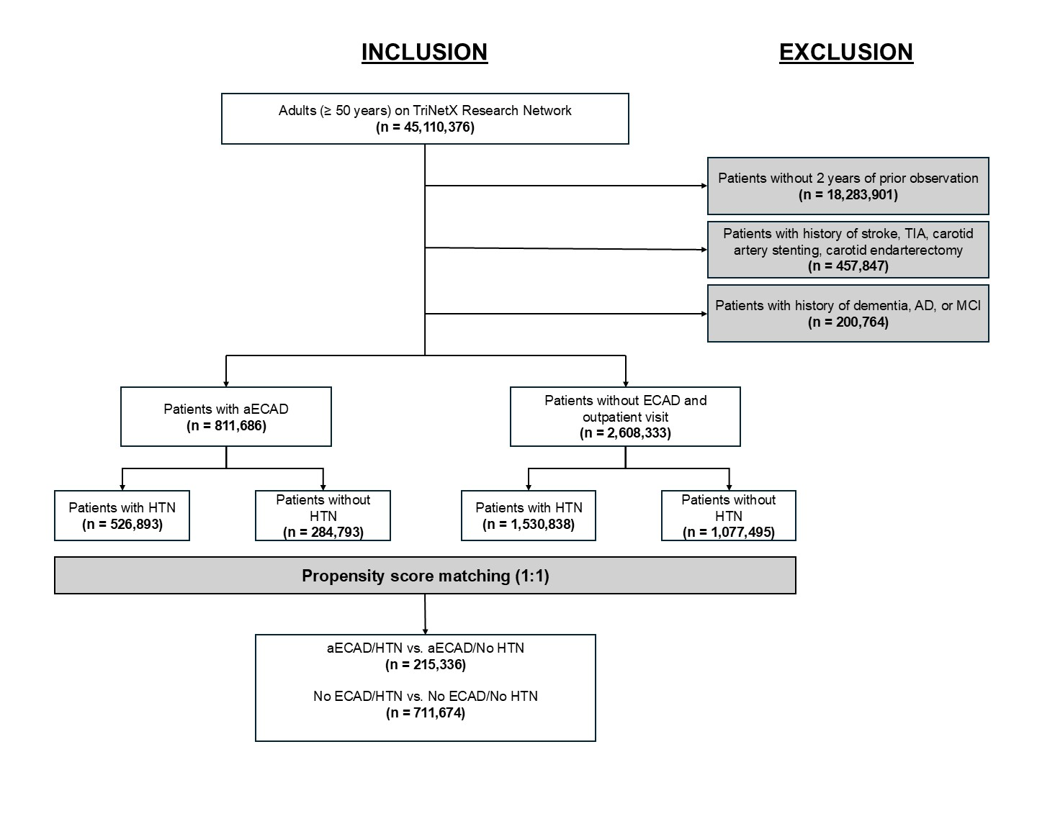
Supplemental Figure 4. Flow diagram showing study sample for TriNetX cohorts.
Inclusion and exclusion criteria are based on ICD.10 codes seen in supplemental tables 1-2 shown above.

Supplementary Table 5. Baseline Characteristics of aECAD/HTN and aECAD/No HTN Cohorts Before and After Propensity Score Matching, TriNetX cohort.
 | Before Matching, No. (%) |  |  |  | After Matching, No. (%)
Cohort | aECAD/HTN (n=526,893) | aECAD/No HTN (n=284,793) | SMD |  | aECAD/HTN (n=215,336) | aECAD/No HTN (n=215,336) | SMD
Demographics
Age at index, years | 69.8 ± 8.3 | 67.5 ± 8.7 | 0.273 |  | 68.3 ± 8.4 | 68.4 ± 8.7 | 0.020
Female | 234,735 (44.9%) | 131,801 (47.5%) | 0.051 |  | 101,013 (46.9%) | 101,156 (47.0%) | 0.001
Male | 263,885 (50.5%) | 136,252 (49.1%) | 0.029 |  | 105,974 (49.2%) | 105,797 (49.1%) | 0.002
American Indian or Alaskan Native | 1,792 (0.3%) | 816 (0.3%) | 0.009 |  | 546 (0.3%) | 710 (0.3%) | 0.014
Asian | 13,649 (2.6%) | 7,552 (2.7%) | 0.007 |  | 5,824 (2.7%) | 5,916 (2.7%) | 0.003
Black or African American | 49,944 (9.6%) | 16,450 (5.9%) | 0.136 |  | 15,393 (7.1%) | 15,024 (7.0%) | 0.007
Hispanic or Latino | 27,032 (5.2%) | 12,182 (4.4%) | 0.037 |  | 9,119 (4.2%) | 9,818 (4.6%) | 0.016
Native Hawaiian or Pacific Islander | 7,984 (1.5%) | 2,003 (0.7%) | 0.077 |  | 1,859 (0.9%) | 1,886 (0.9%) | 0.001
Other Race | 11,590 (2.2%) | 7,523 (2.7%) | 0.032 |  | 5,193 (2.4%) | 5,456 (2.5%) | 0.008
White | 397,337 (76.1%) | 214,695 (77.3%) | 0.029 |  | 167,718 (77.9%) | 167,066 (77.6%) | 0.007
Unknown Race | 39,938 (7.6%) | 28,598 (10.3%) | 0.093 |  | 18,803 (8.7%) | 19,278 (9.0%) | 0.008
Comorbidities
Ischemic Heart Diseases | 224,225 (42.9%) | 44,201 (15.9%) | 0.621 |  | 43,814 (20.3%) | 43,436 (20.2%) | 0.004
Diabetes Mellitus | 181,756 (34.8%) | 27,280 (9.8%) | 0.629 |  | 27,376 (12.7%) | 27,144 (12.6%) | 0.003
Nicotine Dependence | 90,989 (17.4%) | 23,886 (8.6%) | 0.264 |  | 23,133 (10.7%) | 22,483 (10.4%) | 0.010
Alcohol-Related Disorders | 23,705 (4.5%) | 5,640 (2.0%) | 0.141 |  | 5,237 (2.4%) | 5,410 (2.5%) | 0.005
Hyperlipidemia | 290,166 (55.6%) | 54,574 (19.7%) | 0.798 |  | 54,383 (25.3%) | 54,317 (25.2%) | 0.001
Atrial Fibrillation or flutter | 75,357 (14.4%) | 14,180 (5.1%) | 0.318 |  | 14,377 (6.7%) | 13,862 (6.4%) | 0.010
Overweight or Obesity | 124,875 (23.9%) | 18,290 (6.6%) | 0.497 |  | 18,206 (8.5%) | 18,118 (8.4%) | 0.001
Socioeconomic or Psychosocial Health Hazards | 14,093 (2.7%) | 2,935 (1.1%) | 0.121 |  | 2,537 (1.2%) | 2,776 (1.3%) | 0.010
Hearing Loss | 34,560 (6.6%) | 8,135 (2.9%) | 0.174 |  | 7,515 (3.5%) | 7,638 (3.5%) | 0.003
Laboratory values
BMI (kg/m²) | 29.5 ± 6.3 | 27.6 ± 5.9 | 0.314 |  | 27.7 ± 6.0 | 27.6 ± 5.9 | 0.053
Hemoglobin A1c (%) | 6.5 ± 1.7 | 6.3 ± 1.7 | 0.150 |  | 6.2 ± 1.6 | 6.3 ± 1.7 | 0.021
Triglycerides (mg/dL) | 140.1 ± 101.8 | 125.9 ± 95.1 | 0.144 |  | 135.2 ± 96.5 | 126.2 ± 95.9 | 0.093
HDL Cholesterol (mg/dL) | 47.5 ± 19.3 | 51.9 ± 20.8 | 0.221 |  | 50.4 ± 20.2 | 51.7 ± 20.8 | 0.065
LDL Cholesterol (mg/dL) | 92.1 ± 38.6 | 105.4 ± 40.6 | 0.336 |  | 100.0 ± 38.8 | 102.0 ± 39.7 | 0.086
aECAD, asymptomatic extracranial carotid artery disease; HTN, hypertension; SMD, standardized mean difference; BMI, body mass index; HDL, high density lipoprotein; LDL, low density lipoprotein.

Supplementary Table 6. Baseline Characteristics of No aECAD/HTN and No aECAD/No HTN Cohorts Before and After Propensity Score Matching, TriNetX cohort.
 | Before Matching, No. (%) |  |  |  | After Matching, No. (%)
Cohort | No aECAD/HTN (n=1,530,838) | No aECAD/No HTN (n=1,077,495) | SMD |  | No aECAD/HTN (n=711,674) | No aECAD/No HTN (n=711,674) | SMD
Demographics
Age at index, years | 68.1 ± 8.4 | 65.5 ± 8.6 | 0.308 |  | 66.4 +/- 8.4 | 66.8 +/- 8.6 | 0.042
Female | 807,158 (52.7%) | 633,314 (58.8%) | 0.122 |  | 403,548 (56.7%) | 403,426 (56.7%) | <0.001
Male | 722,690 (47.2%) | 443,302 (41.1%) | 0.122 |  | 307,675 (43.2%) | 307,545 (43.2%) | <0.001
American Indian or Alaskan Native | 5,505 (0.4%) | 4,409 (0.4%) | 0.008 |  | 2,481 (0.3%) | 2,764 (0.4%) | 0.007
Asian | 53,315 (3.5%) | 32,238 (3.0%) | 0.028 |  | 22,484 (3.2%) | 23,361 (3.3%) | 0.007
Black or African American | 164,673 (10.8%) | 69,096 (6.4%) | 0.156 |  | 56,305 (7.9%) | 57,968 (8.1%) | 0.009
Hispanic or Latino | 33,338 (2.2%) | 22,593 (2.1%) | 0.006 |  | 13,582 (1.9%) | 14,720 (2.1%) | 0.007
Native Hawaiian or Pacific Islander | 11,746 (0.8%) | 4,220 (0.4%) | 0.050 |  | 3,109 (0.4%) | 3,392 (0.5%) | 0.006
Other Race | 13,947 (0.9%) | 65,721 (0.9%) | 0.003 |  | 5,754 (0.8%) | 6,165 (0.9%) | 0.004
White | 1,254,598 (82.0%) | 927,262 (86.1%) | 0.112 |  | 606,494 (85.2%) | 602,674 (84.7%) | 0.015
Unknown Race | 29,597 (1.6%) | 33,186 (2.6%) | 0.072 |  | 15,047 (2.1%) | 15,350 (2.2%) | 0.002
Comorbidities |  |  |  |  |  |  | 0.006
Ischemic Heart Diseases | 400,974 (26.2%) | 79,378 (6.1%) | 0.568 |  | 65,882 (9.3%) | 64,614 (9.1%) | 0.006
Diabetes Mellitus | 473,192 (30.9%) | 81,107 (7.5%) | 0.621 |  | 80,022 (11.2%) | 79,558 (11.2%) | 0.002
Nicotine Dependence | 263,087 (17.2) | 102,632 (9.5%) | 0.227 |  | 91,197 (12.8%) | 86,921 (12.2%) | 0.018
Alcohol-Related Disorders | 84,456 (5.5%) | 28,972 (2.7%) | 0.143 |  | 25,697 (3.6%) | 25,619 (3.6%) | 0.001
Hyperlipidemia | 808,108 (52.8%) | 197,581 (18.3%) | 0.771 |  | 196,497 (27.6%) | 193,998 (27.3%) | 0.008
Atrial Fibrillation or flutter | 188,960 (12.3%) | 36,620 (3.4%) | 0.337 |  | 37,247 (5.2%) | 35,397 (5.0%) | 0.012
Overweight or Obesity | 431,822 (28.2%) | 100,627 (9.3%) | 0.498 |  | 99,106 (13.9%) | 96,125 (13.5%) | 0.012
Socioeconomic or Psychosocial Health Hazards | 61,935 (4.0%) | 21,143 (2.0%) | 0.122 |  | 18,228 (2.6%) | 18,229 (2.6%) | <0.001
Hearing Loss | 111,368 (7.3%) | 41,550 (3.9%) | 0.150 |  | 35,901 (5.0%) | 35,291 (5.0%) | 0.004
Laboratory values
BMI (kg/m²) | 30.8±7.2 | 28.6 ± 6.5 | 0.333 |  | 30.2 ± 6.9 | 28.6 ± 6.6 | 0.225
Hemoglobin A1c (%) | 6.4 ± 1.4 | 6.0 ± 1.2 | 0.296 |  | 6.0 ± 1.2 | 6.0 ± 1.3 | 0.017
Triglycerides (mg/dL) | 139.5±106.3 | 122.6±84.9 | 0.176 |  | 133.9 ± 103.9 | 123.8 ± 85.6 | 0.107
HDL Cholesterol (mg/dL) | 51.5±17.2 | 57.2 ±18.5 | 0.315 |  | 54.6 ± 18.0 | 54.8 ± 18.4 | 0.121
LDL Cholesterol (mg/dL) | 97.5±37.6 | 112.5±36.1 | 0.406 |  | 106.2 ± 36.2 | 111.8 ± 36.6 | 0.155
aECAD, asymptomatic extracranial carotid artery disease; HTN, hypertension; SMD, standardized mean difference; BMI, body mass index; HDL, high density lipoprotein; LDL, low density lipoprotein.

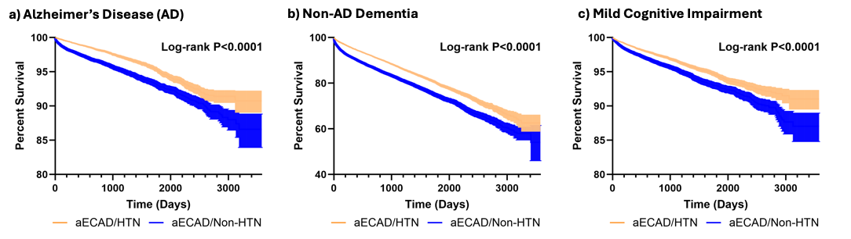

Supplemental Figure 5. Cognitive Outcomes Survival Analysis in aECAD Patients Aged 81+ Stratified by Hypertension Status, TriNetX cohort. Kaplan-Meier survival curves showing Alzheimer’s disease (a), non-AD dementia (b), and mild cognitive impairment (c)–free survival among patients aged 81+ with asymptomatic extracranial carotid artery disease (aECAD), stratified by hypertension status. Each eligible individual was followed up from the index event until the occurrence of the outcomes, death, loss to follow-up, or 10 years after the index event, whichever occurred first.

Supplemental Table 7. Unilateral aECAD had lower risk of dementia outcomes as compared to bilateral aECAD, TriNetX cohort.

Cohort | Outcomes | Unilateral aECAD n(%) | Bilateral aECAD  n(%) | HR (95% CI)
HTN patients  (n=80008) | AD | 791 (1.0) | 965 (1.2) | 0.82 (0.75-0.90)
HTN patients  (n=80008) | Non-AD dementia | 4195 (5.2) | 4881 (6.1) | 0.86(0.83-0.90)
HTN patients  (n=80008) | MCI | 1413 (1.8) | 1766 (2.2) | 0.91(0.85-0.98)
These data evaluate whether bilateral aECAD is associated with worse dementia outcomes as compared to unilateral aECAD. Groups were propensity score matched. Data demonstrate among patients with aECAD unilateral aECAD is associated with lower risk of dementia outcomes.
CI, confidence interval; HR, hazard ratio; aECAD, asymptomatic extracranial carotid artery disease; HTN, hypertension; AD, Alzheimer’s disease; MCI, mild cognitive impairment.

Supplemental Table 8. Blood brain barrier (BBB)-crossing medications have minimal effects on dementia outcomes in aECAD patients with HTN, TriNetX cohort.
Cohort | Outcomes |  |  | HR (95% CI)
 |  | BBB-crossing  n (%) | non-BBB crossing  n (%)
HTN patients aged 81+  (n=5,111) | AD | 120 (2.3%) | 114 (2.2%) | 1.02 (0.79-1.32)
HTN patients aged 81+  (n=5,111) | Non-AD dementia | 566 (11.1%) | 486 (9.5%) | 1.15 (1.02-1.30)
HTN patients aged 81+  (n=5,111) | MCI | 143 (2.8%) | 147 (2.9%) | 0.95 (0.75-1.20)
 |  | BBB-crossing  n (%) | No antihypertensive therapy  n (%)
HTN patients aged 81+  (n=5,532) | AD | 135 (2.4%) | 118 (2.1%) | 1.13 (0.88-1.44)
HTN patients aged 81+  (n=5,532) | Non-AD dementia | 639 (11.6%) | 577 (10.4%) | 1.10 (0.98-1.23)
HTN patients aged 81+  (n=5,532) | MCI | 157 (2.8%) | 146 (2.6%) | 1.06 (0.85-1.33)
These data evaluate whether hypertension medications could be related to changes in dementia outcomes in the highest risk cohort (aECAD/HTN, 81+). Groups were propensity score matched and had mean follow-up of 2.5±2.0 years. Data demonstrate that hypertension medications that cross the blood brain barrier do not have a protective effect in this cohort.

BBB, blood brain barrier; CI, confidence interval; HR, hazard ratio; aECAD, asymptomatic extracranial carotid artery disease; HTN, hypertension; CEA, carotid endarterectomy; AD, Alzheimer’s disease; MCI, mild cognitive impairment.

Supplemental Table 9. Permissive hypertension of 140-159 mmHg systolic BP does not significantly increase major cardiovascular events, TriNetX cohort.
Cohort | Outcome | aECAD/HTN  n (%) | aECAD/HTN 130-139, n (%) | HR (95% CI)
SBP 140-159  (n=22,606) | MACE | 9,085 (40.1%) | 9,095 (40.2%) | 1.01 (0.99-1.04)
SBP 140-159  (n=22,606) | MI | 3,614 (16.0%) | 3,709 (16.4%) | 0.99 (0.94-1.03)
SBP 140-159  (n=22,606) | Heart failure | 11,478 (50.8%) | 11,779 (52.1%) | 0.98 (0.95-1.00)
SBP 140-159  (n=22,606) | CKD | 12,363 (54.7%) | 12,550 (55.5%) | 0.99 (0.97-1.02)
 | Stroke | 2,885 (12.8%) | 2,820 (12.5%) | 1.04 (0.99-1.10)
 | Mortality | 5,273 (23.3%) | 5,290 (23.4%) | 1.02 (0.98-1.06)
SBP 160-179  (n=11,964) | MACE | 5,380 (45.0%) | 5,019 (42.0%) | 1.06 (1.02-1.10)
SBP 160-179  (n=11,964) | MI | 2,268 (19.0%) | 2,106 (17.6%) | 1.08 (1.02-1.14)
SBP 160-179  (n=11,964) | Heart failure | 7,526 (62.9%) | 7,352 (61.5%) | 1.00 (0.97-1.03)
SBP 160-179  (n=11,964) | CKD | 8,333 (69.7%) | 7,917 (66.2%) | 1.05 (1.02-1.08)
 | Stroke | 1,801 (15.1%) | 1,612 (13.5%) | 1.10 (1.03-1.18)
 | Mortality | 3,034 (25.4%) | 2,849 (23.8%) | 1.07 (1.02-1.11)
SBP ≥180  (n=7,537) | MACE | 3,403 (45.2%) | 3,057 (40.6%) | 1.11 (1.07-1.16)
SBP ≥180  (n=7,537) | MI | 1,438 (19.1%) | 1,274 (16.9%) | 1.13 (1.05-1.21)
SBP ≥180  (n=7,537) | Heart failure | 3,288 (43.6%) | 2,952 (39.2%) | 1.08 (1.03-1.14)
SBP ≥180  (n=7,537) | CKD | 3,611 (47.9%) | 3,214 (42.7%) | 1.11 (1.06-1.16)
 | Stroke | 1,189 (15.8%) | 949 (12.6%) | 1.19 (1.09-1.30)
 | Mortality | 1,919 (25.5%) | 1,769 (23.5%) | 1.09 (1.03-1.15)
These data compared patients who were 81 or older with aECAD/HTN and various systolic blood pressure ranges to aECAD/HTN patients with SBP 130-139 mmHg. Each blood pressure group was propensity score matched separately, and cardiovascular outcomes were compared with mean follow-up of 3.3±2.2 years. These data demonstrate that the highest SBP ranges had significantly higher cardiovascular events, yet in the SBP 140-159 range, these differences were no longer significant. This suggests that cardiovascular risk may be tolerable with permissive HTN in the SBP 140-159 range.CI, confidence interval; HR, hazard ratio; aECAD, asymptomatic extracranial carotid artery disease; HTN, hypertension; SBP, systolic blood pressure; MACE, major adverse cardiac event; MI, myocardial infarction; CKD, chronic kidney disease.

References
1. Williamson, J. D. et al. Cognitive Function and Brain Structure in Persons With Type 2 Diabetes Mellitus After Intensive Lowering of Blood Pressure and Lipid Levels: A Randomized Clinical Trial. JAMA Intern. Med. 174, 324–333 (2014).
2. Williamson, J. D. et al. Effect of Intensive vs Standard Blood Pressure Control on Probable Dementia: A Randomized Clinical Trial. JAMA 321, 553–561 (2019).
3. Ning, G. et al. Blood pressure targets for prevention of cognitive decline in patients with diabetes and hypertension: Design of the Blood Pressure Control Target in Diabetes (BPROAD) Cognitive Study. J. Diabetes 15, 1041–1047 (2023).
4. Fan, J., Bai, J., Liu, W. & Cai, J. Effects of intensive vs. standard blood pressure control on cognitive function: Post-hoc analysis of the STEP randomized controlled trial. Front. Neurol. 14, (2023).
5. Pearce, L. A. et al. Effects of long-term blood pressure lowering and dual antiplatelet treatment on cognitive function in patients with recent lacunar stroke: A secondary analysis from the SPS3 randomised trial. Lancet Neurol. 13, 1177–1185 (2014).
6. He, J. et al. Blood pressure reduction and all-cause dementia in people with uncontrolled hypertension: an open-label, blinded-endpoint, cluster-randomized trial. Nat. Med. 31, 2054–2061 (2025).

