Table S1. Changes in volatile compounds of fresh and stored mushrooms (day 12) under different coating treatments determined by GC–MS/MS
No. | Components | Retention time (min) | Relative content (μg/g)
 |  |  | Control | CGR3
Alcohols
1 | 1-Pentanol | 22.779 | 0.059^{b}±0.001 | 0.063ª±0.010
2 | 1-Octanol | 36.628 | 0.008^{b}±0.000 | 0.026ª±0.010
3 | 1-Octen-3-ol | 32.041 | 0.100ª±0.010 | 0.043^{b}±0.001
4 | Furfuryl alcohol | 41.039 | 0.249ª±0.050 | 0.209ª±0.010
5 | Benzyl alcohol | 49.238 | 0.723ª±0.100 | 0.593ª±0.010
6 | (E)-carveol | 47.569 | - | 0.032ª±0.001
7 | o-Cresol | 53.599 | 0.262ª±0.010 | 0.234+±0.010
8 | Phenol | 53.734 | 0.125ª±0.010 | 0.091^{b}±0.000
9 | 1-Hexadecanol | 64.884 | 0.017^{b}±0.010 | 0.035ª±0.010
10 | p-Cresol | 56.227 | 0.028ª±0.001 | 0.026ª±0.001
11 | Sulfurol | 63.239 | 0.093ª±0.010 | 0.081ª±0.060
12 | Maltol | 52.494 | 0.596ª±0.060 | 0.388^{b}±0.000
13 | 2,3-Butanediol isomer-1 | 36.108 | 2.342ª±0.870 | 1.624^{b}±0.110
14 | Farnesol isomer-1 | 62.866 | 0.093ª±0.010 | 0.091ª±0.050
Aldehydes
1 | Propanal | 5.506 | 1.539ª±0.310 | 0.705^{b}±0.380
2 | 2-Methylbutanal | 8.029 | 0.128ª±0.020 | 0.140ª±0.010
3 | 3-Methylbutanal | 8.000 | 0.183^{b}±0.180 | 0.218ª±0.250
4 | Valeraldehyde | 10.320 | 0.010ª±0.010 | 0.021ª±0.001
5 | Benzaldehyde | 35.714 | 0.984ª±0.090 | 0.746^{b}±0.020
6 | 5-Methyl furfural | 37.790 | 0.037ª±0.010 | 0.030ª±0.001
7 | 2,4-Decadienal | 46.902 | 0.007ª±0.001 | 0.010ª±0.001
8 | Furfural | 33.098 | 0.086ª±0.010 | 0.067^{b}±0.001
9 | 2-Formylthiophene | 42.691 | 0.004ª±0.001 | 0.001ª±0.001
Ketones
1 | Mesityl oxide | 17.062 | 0.037ª±0.030 | 0.021ª±0.030
2 | 2-Butanone | 7.702 | 0.067ª±0.010 | 0.036^{b}±0.010
3 | 3-Methyl-2-butanone | 8.172 | 0.049ª±0.001 | 0.028^{b}±0.020
4 | 2-Heptanone | 19.569 | 0.031^{b}±0.001 | 0.051ª±0.001
5 | 2-Octanone | 24.589 | 0.005ª±0.001 | 0.006ª±0.001
6 | 2-Undecanone | 38.474 | 0.110ª±0.001 | 0.083^{b}±0.001
7 | gamma-Butyrolactone | 40.247 | 2.432ª±0.560 | 2.060ª±0.330
8 | 2-Acetylfuran | 34.862 | 0.072ª±0.010 | 0.064^{b}±0.000
9 | Acetophenone | 40.936 | 0.010ª±0.010 | 0.018ª±0.001
10 | (-)-Carvone | 44.081 | - | 0.026ª±0.001
11 | d-Carvone | 44.081 | - | 0.026ª±0.001
12 | p-Acetyltoluene | 45.716 | - | 0.014ª±0.001
Lactones
1 | gamma-Caprolactone | 43.045 | 0.107ª±0.020 | 0.123ª±0.020
2 | gamma-Octalactone | 50.796 | 0.112ª±0.010 | 0.060^{b}±0.001
3 | Pantolactone | 54.752 | 13.100^{b}±9.670 | 21.060ª±1.170
4 | 3-Methyl-2(5H)-furanone | 43.660 | 0.437ª±0.070 | 0.319^{b}±0.010
Esters
1 | alpha-Terpinyl acetate | 42.555 | 0.029^{b}±0.020 | 0.040ª±0.001
2 | Ethyl lactate | 27.261 | 0.004ª±0.001 | 0.003ª±0.001
3 | Methyl stearate | 66.239 | 0.022ª±0.001 | 0.022ª±0.001
4 | Methyl palmitate | 60.137 | 0.016^{b}±0.001 | 0.027ª±0.001
5 | Ethyl palmitate | 61.258 | 0.068ª±0.001 | 0.015^{b}±0.001
Acids
1 | Nonanoic acid | 58.593 | 0.064^{b}±0.010 | 0.751ª±0.240
2 | Capronic acid | 47.907 | 0.202^{b}±0.030 | 0.258ª±0.040
3 | Isovaleric acid | 41.334 | 0.474ª±0150 | 0.220^{b}±0.020
4 | 2-Methyl butyric acid | 41.359 | 0.104ª±0.040 | 0.041^{b}±0.000
5 | Propanoic acid | 36.106 | 3.228ª±1.200 | 2.421^{b}±0.200
6 | Isobutyric acid | 37.268 | 0.301ª±0.100 | 0.160^{b}±0.020
7 | Benzoic acid | 66.792 | 45.447ª±2.890 | 18.742^{b}±13.170
8 | Valeric acid | 41.334 | 0.057ª±0.010 | 0.057ª±0.010
9 | Butyric acid | 37.268 | 0.199ª±0.060 | 0.147ª±0.001
Sulfur compounds
1 | Dimethyl disulfide | 14.278 | 0.096ª±0.020 | 0.070^{b}±0.001
2 | Dimethyl trisulfide | 29.185 | 0.473ª±0.050 | 0.364^{b}±0.020
3 | Methyl furfuryl disulfide | 46.902 | 0.011ª±0.001 | 0.007ª±0.010
4 | Benzyl mercaptan | 39.650 | 0.011ª±0.001 | 0.011ª±0.001
Others
1 | 2-Methylpyridine | 21.309 | 0.034ª±0.010 | 0.027ª±0.001
2 | 2-Pentylfuran | 21.886 | 0.069^{b}±0.001 | 0.093ª±0.001
3 | 2-Methylanisole | 30.186 | 0.192ª±0.030 | 0.107^{b}±0.001
4 | alpha,p-Dimethylstyrene | 31.708 | 0.004^{b}±0.001 | 0.028ª±0.001
5 | 2-Pentylpyridine | 37.500 | 0.047ª±0.001 | 0.043ª±0.001
6 | Benzonitrile | 39.015 | 0.008ª±0.010 | 0.015ª±0.010
7 | 2-Acetylpyrrole | 52.632 | 1.345ª±0.110 | 1.161ª±0.040
8 | Skatole | 68.697 | 0.015ª±0.001 | 0.017ª±0.001
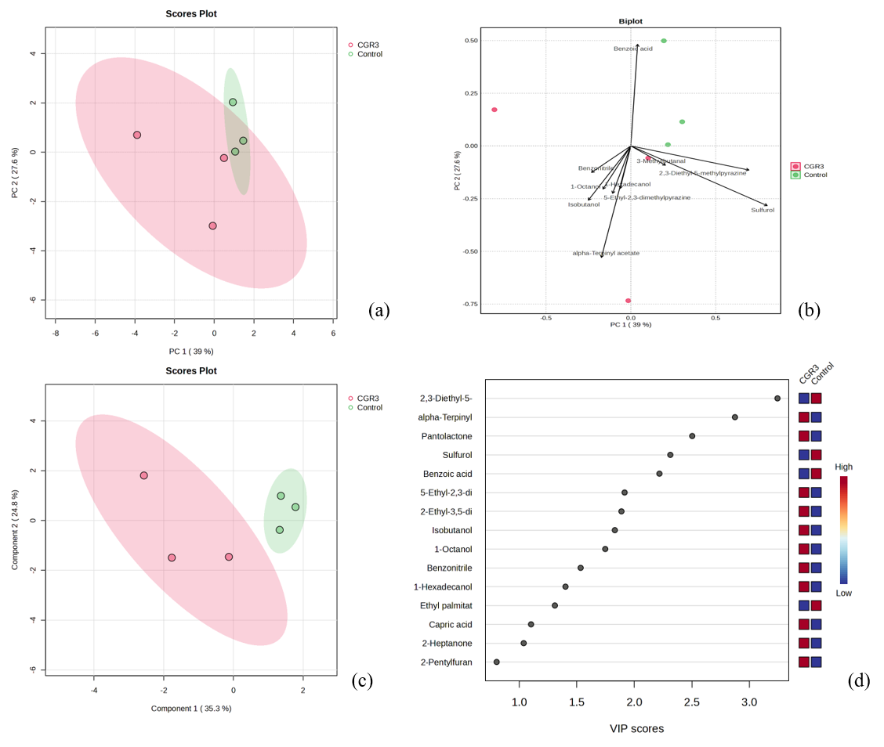
Fig. S1. Multivariate analysis of volatile metabolites in mushrooms: (a) PCA 2D score plot, (b) PCA biplot, (c) PLS-DA 2D score plot, and (d) PLS-DA important features
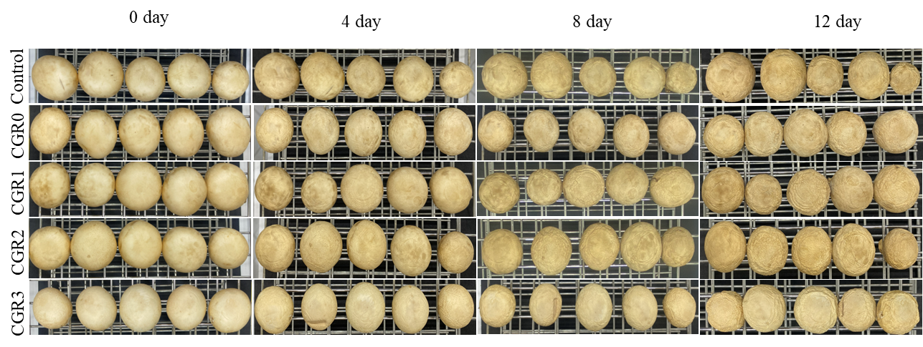
Fig. S2. Visual appearance of control and coated mushrooms during storage at 5 °C over 12 days

