Table S1. Specification of the target trial and emulation
Target trial component | Target trial specification | Emulation in this study
Research question | Efficacy of neoadjuvant pembrolizumab plus chemotherapy versus chemotherapy alone on pCR in early-stage TNBC. | Similar to the KEYNOTE-522 trial, estimated using real-world electronic health record data from Vietnam National Cancer Hospital.
Crucial eligibility criteria | Women aged ≥18 years with non-metastatic TNBC eligible for neoadjuvant therapy. | Women aged ≥18 years with stage II–III TNBC who received neoadjuvant pembrolizumab-based therapy or chemotherapy.
Treatment strategies | Pembrolizumab plus chemotherapy versus chemotherapy alone.  Patients received 4 cycles of IV pembrolizumab or placebo once every 3 weeks + paclitaxel + carboplatin, followed by 4 cycles of pembrolizumab or placebo plus doxorubicin/epirubicin + cyclophosphamide every 3 weeks in the subsequent 12 weeks. | Pembrolizumab plus chemotherapy versus chemotherapy alone.  For pembrolizumab arm: patients received 4 cycles of IV pembrolizumab + paclitaxel + carboplatin every 3 weeks, followed by 4 cycles of pembrolizumab + doxorubicin+ cyclophosphamide every 3 weeks in the subsequent 12 weeks  For chemotherapy arm: patients received anthracycline-based therapy: dominantly 4AC (in 12 weeks)-4T (in 12 weeks), or dose-dense 4AC (in 8 weeks)-4T (in 8 weeks).
Treatment assignment | Randomized allocation. | Non-randomized treatment selection in routine clinical practice.
Time zero | Initiation of neoadjuvant treatment. | Initiation of neoadjuvant treatment.
Follow-up | Treatment initiation to surgery for pCR. | Treatment initiation to surgery for pCR.
Outcome | Pathological complete response (pCR), defined as ypT0/Tis ypN0. | pCR defined as ypT0/Tis ypN0.
Causal contrast | Intention-to-treat effect. | Intention-to-treat analysis.
Confounding control | Randomization. | Adjustment for prespecified baseline confounders identified using a DAG.
Statistical analysis | Comparison between randomized groups. | IPTW combined with doubly robust g-computation.
Estimand | The difference in the probability of pCR if all eligible patients were assigned to pembrolizumab plus chemotherapy versus placebo plus chemotherapy. | Average treatment effect (ATE): the expected difference in pCR if all eligible patients received pembrolizumab-based therapy versus chemotherapy alone.
Exploratory analyses | Subgroup analysis for: PD-L1 status (≥1 and <1),  nodal status (N+ and N−),  tumor size (T1/T2 and T3/T4),  stage (II and III), age (<65 and ≥65), ECOG (0 and 1), carboplatin schedule (weekly and q3w) | Subgroup analysis for: nodal status (N+ and N−),  tumor size (T1/T2 and T3/T4),  stage (II and III), age (<50 and ≥50), menopausal status (pre- and post-menopause), Ki67 (<70% and ≥70%), HER2 status (zero and low)  Sensitivity analysis: ATT weighting, exclusion of treatment discontinuation, and treatment-year adjustment.
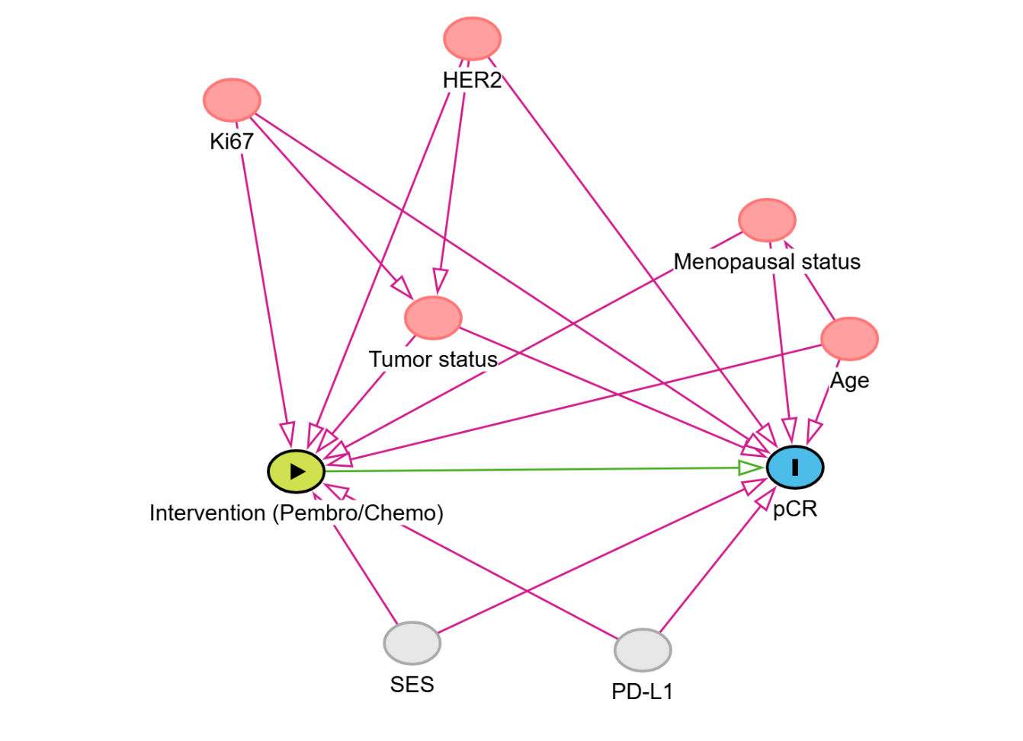
Figure S1. Directed acyclic graph used for confounder selection.
Socioeconomic status (SES) and PD-L1 were unmeasured covariates

Comment: Socioeconomic status was not available for adjustment and may have influenced treatment selection. However, compared with biological factors such as PD-L1 expression, socioeconomic status is unlikely to be a strong determinant of pCR. Together with the robustness of the sensitivity analyses and quantitative bias analysis, this suggests that residual confounding from socioeconomic differences alone is unlikely to fully explain the observed treatment benefit.

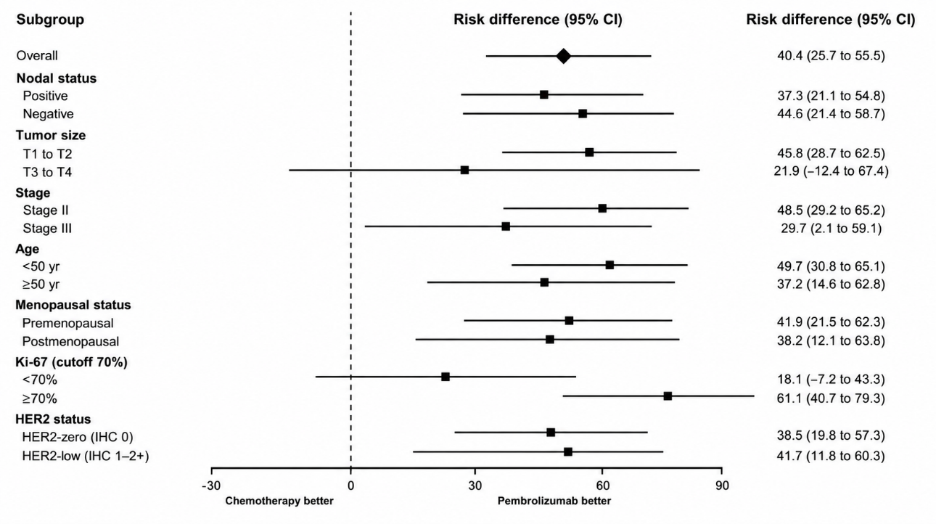
Figure S2. Subgroup analysis results

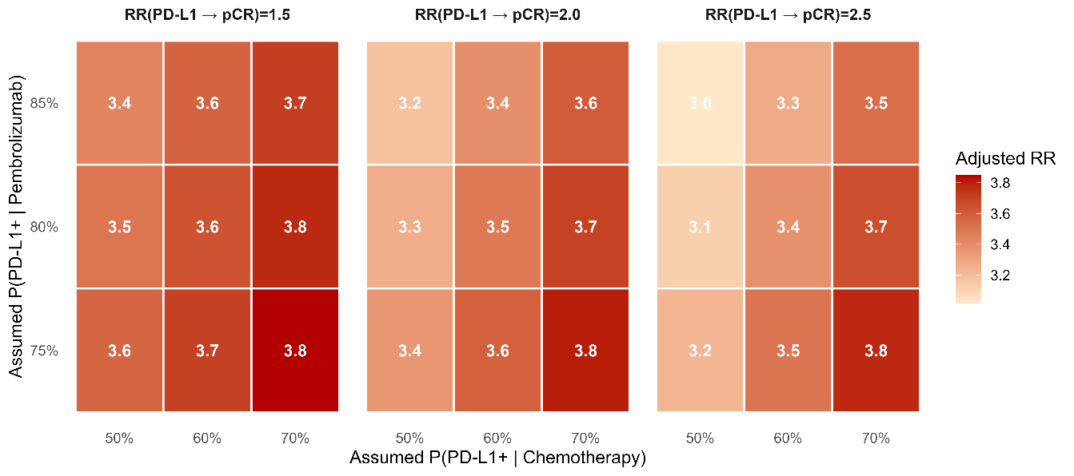
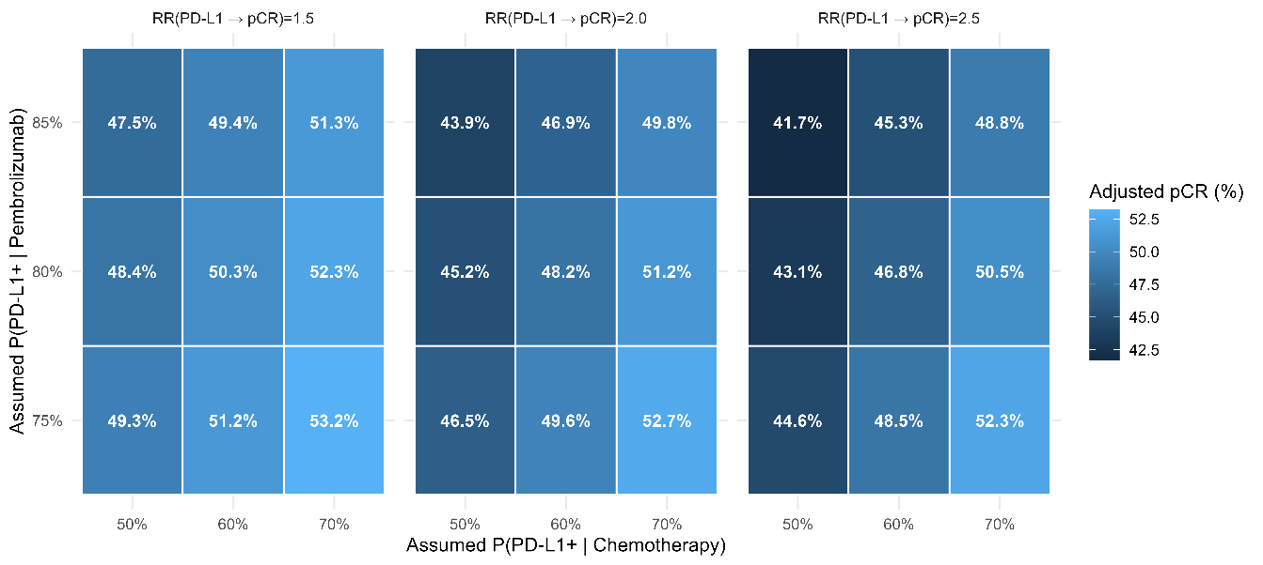
Figure S3. Quantitative bias analysis for potential unmeasured confounding by PD-L1 status (upper: risk ratio, lower: risk difference)

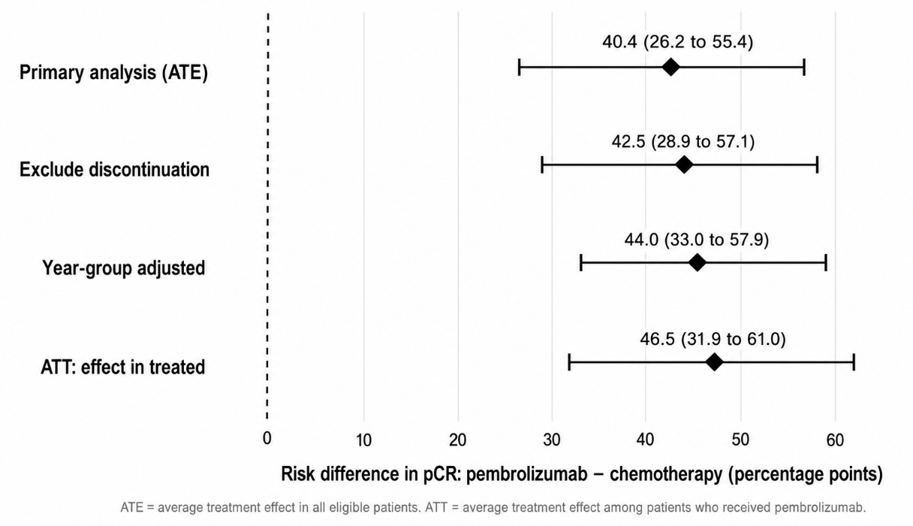
Figure S4. Sensitivity analysis for pCR

