Supplementary information
A Toolkit for Manipulating Cellular Behavior: Peptide with Tryptophan-Selective Ru-TAP Complex Regioselectively Photolabeling Specific Protein in Live Cell

Tzu-Ho Chen^{1,2,6}, Kevin Garnir⁵, Chong-Yen Chen⁶, Cheng-Bang Jian^{2,3,6}, Hua-De Gao^{2,6}, Bill Cheng⁴, Mei-Chun Tseng⁶, Cécile Moucheron⁵, Andrée Kirsch-De Mesmaeker*⁵, and Hsien-Ming-Lee*⁶
¹Chemical Biology and Molecular Biophysics Program, Taiwan International Graduate Program, Academia Sinica, Taipei 11529, Taiwan
²Department of Chemistry, National Taiwan University, Taipei 10617, Taiwan
³Nano Science and Technology Program, Taiwan International Graduate Program, Academia Sinica, Taipei 11529, Taiwan
⁴Graudate Institite of Biomedical Engineering, National Chung Hsing University, Taichung 40227, Taiwan
⁵Laboratoire de Chimie Organique et Photochimie CP160/08, Université libre de Bruxelles, 50 Av. Franklin D. Roosevelt, 1050 Brussels, Belgium.
⁶Institute of Chemistry, Academia Sinica, Taipei 11529, Taiwan.

Materials and Methods
Recombinant PKA preparation
For intact protein and proteolytic digested fragment mass analysis, commercially available bovine recombinant PKA catalytic subunit (Promega, V5161) was used. The homogeneous phosphorylation status of this PKA is suitable for better clarity for the interpretation of HPLC-MS results. The other experiments throughout this study, including kinase activity studies, SDS-PAGE, Western blot analysis, and cell experiments, involved the use of bacteria expressing recombinant His-tagged murine PKA catalytic subunit (rPKA) prepared as reported previously.⁴⁹ In brief, rPKA (Addgene, Plasmid #14921) was expressed in E.coli BL21 (DE3) strain. E.coli cells were lysed via sonication, and the subsequent lysate supernatant was subjected to FPLC (AKTA, GE Healthcare) purification using HisTrap affinity chromatography to isolate the rPKA. The purified rPKA was dialyzed into PBS prior to use.
In vitro PAL and photolysis
Blue light-driven PAL and UV photolysis were conducted in a PBS solution containing 5–10 μM rPKA and 5–10 μM PAL probe (exact concentrations are noted in the main text) along with 1 mM ATP, 1 mM MgCl₂, 5 mM GSH, 25 mM NaN₃, and 0.1% Prionex, with or without the presence of cell lysates. A glass sample vial loaded with the solution mixtures was aligned with the light source at the bottom. The photoreactions were triggered at the intended time and duration by a LED light system (UVATA) equipped with 450 nm and 360 nm torch heads at 0.4 W/cm² and 3 W/cm² output power densities.
HPLC-MS analysis of intact proteins and trypsin-digested peptide fragments
A 100 μL solution mixture composed of 10 μM PKA with 10 μM Probe-1 was illuminated with blue light for 10 min. The intact rPKA and subsequent photoadduct were then isolated using an HPLC C-5 column (Supelco) with a linear elution gradient of 12.5–62.5% acetonitrile/water (containing 0.1% TFA) over 40 min. The fractions were collected, followed by ESI-Q-TOF mass analysis (timsTOF Pro, Bruker Dalton, Bremen, Germany). The acquired MS spectra were then deconvoluted to obtain the full molecular sizes of the proteins of interest.
To map the probe modification site on POI, solutions containing rPKA and PAL probe with or without 20 min of blue light illumination were subjected to in-solution digestion using trypsin (Sigma). The proteolytic solution mixture consisting of 8 μg (0.2 μg/μL, 4.5 μM) rPKA/photoadduct, 0.8 μg trypsin (20 ng/μL), 5 mM DTT, and 50 mM MOPS buffer, pH 8.0, was incubated at 37°C for 16 h. TFA solution was added at 15% v/v to quench the trypsin digestion, followed by HPLC analysis using a C18 column. The isolated fractions were then subjected to MALDI-TOF (New ultrafleXtreme, Bruker Dalton, Bremen, Germany) mass peptide fingerprinting.
Cell culture and cell lysate preparation
MCF7 and REF52 cells were cultured in DMEM containing 10% FBS in a 37°C incubator supplied with 5% CO₂, and they were subcultured every 2-3 days when the cells reached 70-80% confluency. To harvest the cell lysate, MCF7 cells were grown on a 15-cm petri dish to 80% confluency and then suspended in a PBS solution containing 200 μM PMSF with or without 200 μM CPT-cAMP for 15 min on ice. The cells were then lysed via sonication by ~2 kHz pulses for 2 min, followed by centrifugation at 17,000 xg 4°C for 10 min to separate the total cytosolic protein supernatant and the cell debris. The total protein in the cell lysate was quantified using the Bradford assay.
SDS-PAGE and Western blot analysis
His-tagged murine recombinant PKA expressed by E. coli was used in the SDS-PAGE and Western blot experiments. Two hundred nanograms of the purified rPKA or subsequent photoadduct containing mixture were resolved by 12% SDS-PAGE followed by Coomassie blue staining. For the rPKA spiked experiment and lysate endogenous PKA detection, 15 μg total lysate protein was first resolved by SDS-PAGE and then transferred to a PVDF membrane for Western blot analysis. Anti-FLAG (1:10000 dilution, Sigma-Aldrich) and anti-PKAcat (1:2000 dilution) antibodies were used for immuno-chemiluminescent detection of PKA and the photoadduct on the UVP gel imaging system (Analytik Jena).
Kinase assay
PKA activity was determined using the pyruvate kinase (PK) and lactate dehydrogenase (LDH)-coupled enzyme assay system. The phosphorylation kinetics were measured by the hypochromic effect as a result of NADH oxidation in the enzymatic chain reactions. The kinase assay mixture consisted of 100 mM MOPS buffer, pH 7.5, 100 mM KCl, 1 mM MgCl₂, 1 mM PEP, 1 mM ATP, 0.8 mM NADH, 0.4 mM kemptide, and 30/40 units of PK/LDH. A 2 μL volume of PKA-containing solution was added to 50 μL of the kinase assay mixture, and the decrease in absorbance at 340 nm was recorded over time. The slope of line refers to the activity of PKA being measured.
Microinjection of rPKA/PAL probe and ex vivo PAL/photolysis
REF52 cells were seeded on an 8-well plate (ibidi) at a density of 5,000 cells/well and incubated for 16 hr. The medium was then replaced with phenol red-free Leibovitz's L-15 medium prior to microinjection. A solution containing 30 μM rPKA, 30 μM Probe-1 along with 10 μM TAMRA-dextran as a fluorescent indicator was loaded into a needle with a tip opening diameter of 1.5 μm. Compensate pressure under 15 hPa was constantly applied, and injections were performed under 70 hPa pressure for a 200-ms duration. The concentrations of rPKA and Probe-1 being microinjected into living cells were estimated within the single digit micromolar range representing the optimal concentration for inducing physiological enzymatic responses.
Microinjected REF52 cells were either kept in the dark or exposed to light on the sample stage of the fluorescence microscope (IX-71, Olympus). Band pass filters of 400–450 nm (Edmund) and 330–380 nm (Olympus) were used for triggering blue light PAL (caging) and UV photolysis (uncaging), respectively, under a metal halide light source. Intracellular PKA caging was performed by exposing microinjected cells to a beam of light passed through a 4x objective lens and 15 mW/cm² blue light for 20 min. PKA uncaging was accomplished by UV light exposure at 15 mW/cm² for 2 min after blue light illumination. The cells were further incubated at 37°C for 60 min to allow the development of cellular responses to PKA.
To visualize actin stress fibers, the cells were fixed with 4% paraformaldehyde containing PBS for 10 min, followed by cell membrane permeabilization with 0.1% Triton X-100. Fixed cells were then stained with Alexa 488-phalloidin (Invitrogen) for 15 min, followed by two washes with PBS. Intact stress fibers or a disassembled morphology could thus be observed in the green channel using bandpass filter sets (Ex 460–490 nm/Em 510–550 nm), as well as TAMRA-dextran fluorescence (Ex 505–545 nm/Em 600–650 nm) indicating positive microinjected cells. Images were acquired using a monochrome sCMOS camera (SPOT).

Chemical syntheses:
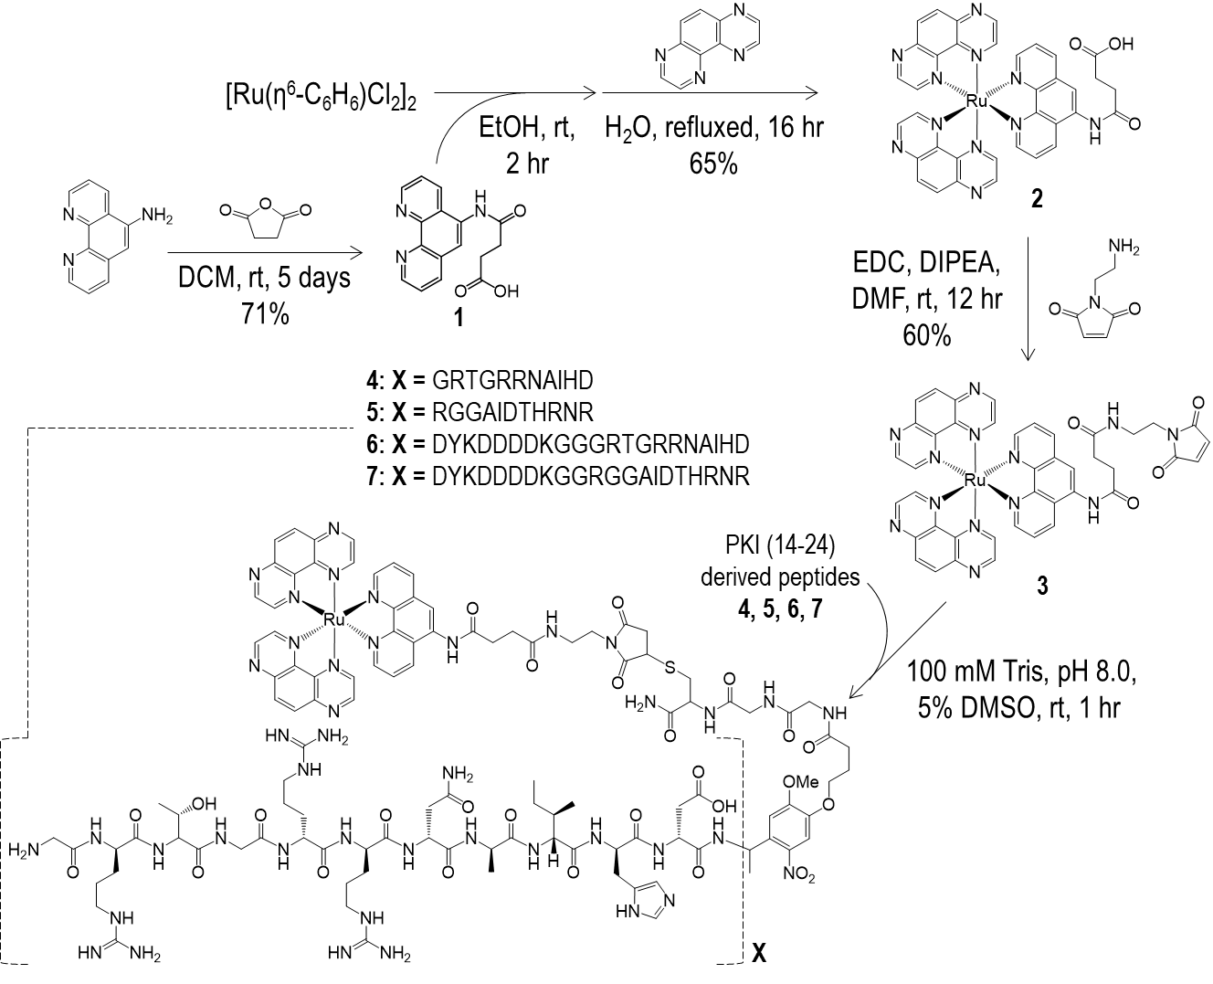
Supplementary Scheme 1. Synthetic pathway of Ru-TAP complex derived PAL probes.

Synthesis of 1
The desired polyazaaromatic ligand 1 (Supplementary Scheme 1) was obtained by reacting 5-amino-1,10-phenanthroline (2.05 mmol) dissolved in dichloromethane (DCM) (100 mL) with succinic anhydride (10.20 mmol) previously dissolved in DCM (50 mL) and slowly added to the first solution. After 5 days of reaction, a pale yellow precipitate was collected by vacuum filtration, washed with DCM, and air-dried. The crude product with an average yield of 70% was recrystallized in methanol to afford a white solid.
¹H NMR (300 MHz, δ-DMSO-d₆/ppm) 12.18 (bs, 1H, -COOH), 10.19 (s, 1H, -NH-), 9.12 (dd, 1H, ³J=4.0 Hz, ⁴J=1.6 Hz, H₂), 9.03 (dd, 1H, ³J=4.4 Hz, ⁴J=2.0 Hz, H₉), 8.64 (dd, 1H, ³J=8.4 Hz, ⁴J=1.6 Hz, H₄), 8.44 (dd, 1H, ³J=8.0 Hz, ⁴J=2.0 Hz, H₇), 8.14 (s, 1H, H₆), 7.80 (dd, 1H, ³J=4.0 Hz, ³J=8.4 Hz, H₃), 7.73 (dd, 1H, ³J=4.4 Hz, ³J=8.0 Hz, H₈), 2.78 (t, 2H, ³J=6.4 Hz, H_{α}), 2.62 (t, 2H, ³J =6.4 Hz, H_{β}).
¹³C NMR (75 MHz, δ-DMSO-d₆/ppm) 173.67, 171.17, 149.62, 149.07, 145.64, 142.62, 135.60, 131.70, 131.64, 127.93, 124.60, 123.41, 122.63, 119.83, 30.81, 29.09.
ESI-MS m/z observed for C₁₆H₁₄N₃O₃ [M+H]⁺: 296.10 (100%), [2M+Na]⁺: 613.18 (15%)

Synthesis of 2
A precursor benzeneruthenium (II) chloride dimer [Ru(η⁶-C₆H₆)Cl₂]₂ (0.13 mmol) was suspended in ethanol in the presence of 1 (0.26 mmol), and stirred for 2 hours at 25°C. A 16 mL aqueous solution containing 1,4,5,8-tetraazaphenanthrene (TAP) (0.52 mmol) was subsequently added, the resulting mixture was heated under reflux and further stirred overnight under argon. Saturated KPF₆ aqueous solution was then added to the reaction mixture to facilitate precipitation of the desired product. The precipitate was washed twice with cold water and then dried under vacuum. Further purification is realized by aluminum oxide column chromatography using an acetonitrile/water (8:2) mixture as eluent to give rise to the red-orange crystal of 2 (Supplementary Scheme 1) with a 65% yield. HR-ESI-MS (m/z) of 2 (C₃₆H₂₅N₁₁O₃Ru): [M]²⁺ calcd 380.5598, found 380.5590 (Supplementary Fig. 1).
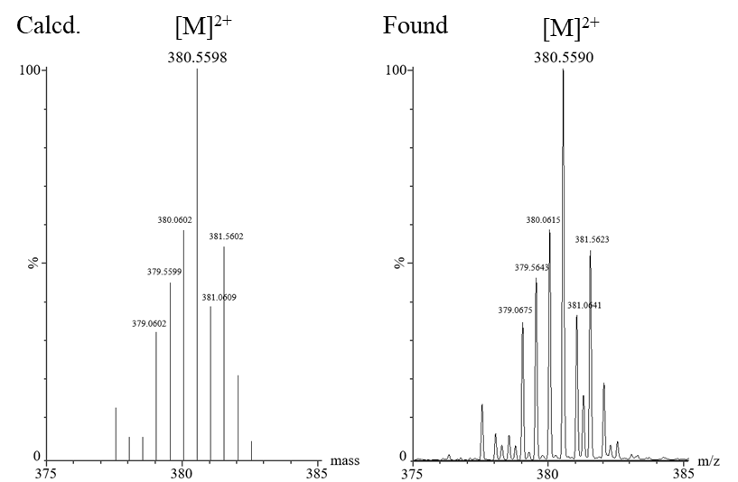
Supplementary Figure 1. Calculated (left) and found (right) ESI-MS spectra of compound 1.
Synthesis of 3
The solid crystal of 2 (1 mmol) was dissolved in 0.2 mL of N,N-dimethylformamide (DMF) and incubated 5 minutes with 0.2 mL DMF containing 1-Ethyl-3-(3-dimethylaminopropyl)carbodiimide (EDC) (5 mmol) and N,N-Diisopropylethylamine (DIPEA) (2 mmol) allowing formation of active ester. N-(2-aminoethyl)maleimide (10 mmol) in 0.1 mL DMF was then added to the former mixture and stirred for 12 hours to afford the desired maleimide functionalized Ru-TAP complex 3 (Supplementary Scheme 1) with 60% yield. Purification of the product was achieved through reverse phase high-performance liquid chromatography (RP-HPLC) on C-18 column under linear elution gradient from 0 – 50% acetonitrile/H₂O (containing 0.1% trifluoroacetic acid, TFA). HR-ESI-MS m/z of 3 (C₄₂H₃₁N₁₃O₄Ru): [M]²⁺ calcd 441.5838, found 441.5823. (Supplementary Fig. 2).
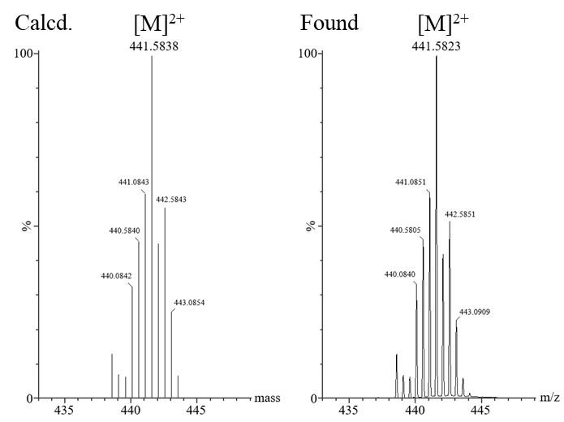
Supplementary Figure 2. Calculated (left) and found (right) ESI-MS spectra of compound 2.
Solid-phase peptide synthesis of 4 – 7
Four peptides derived from PKA inhibitor peptide, PKI (14-24), with common photolabile-linker and spacer moiety as shown in Fig. 1 in main text were synthesized on Liberty Blue automated microwave peptide synthesizer (CEM) to afford 4, 5, 6, and 7. Rink amide ProTide resin (low loading 0.18 mmol/g, CEM) was used as solid support under 0.1 mmol scale. Coupling was carried out by mixing resin with Fmoc-amino acids (0.5 mmol), HCTU (0.5 mmol), and DIPEA (1 mmol) under 50°C, except for Fmoc-photolabile linker (Advanced Chemtech) 0.4 mmol (4 equiv/equiv resin) coupling, which was under room temperature. Deprotection of Fmoc was done by using 20% v/v piperidine in DMF under 50°C. Peptides were then cleaved from solid-support in a solution containing 95% TFA, 2.5% H₂O, 2.5% triisopropylsilane for 1 hour, and precipitated in cold ether. Crude peptides were dried and then purified by semi-preparative C-18 column (Supelco) using HPLC (Agilent) with a linear binary elution gradient in 60 minutes (solvent A: 95% H₂O 5% acetonitrile with 0.1% TFA; solvent B: 95% acetonitrile 5% H₂O with 0.08% TFA). The molecular ion determined from the deconvolution of the ESI spectra of compound 4 (C₆₉H₁₁₃N₂₉O₂₃S₁): calcd 1748.91, found 1748.64. 5 (C₆₉H₁₁₃N₂₉O₂₃S₁): calcd 1748.91, found 1748.59. 6 (C₁₁₄H₁₇₇N₄₁O₄₄S₁): calcd 2857.98, found 2857.32. 7 (C₁₁₄H₁₇₇N₄₁O₄₄S₁): calcd 2857.98, found 2857.22.

General procedure for PAL probes synthesis
Probe-1, Probe-2, FLAG-Probe-1, and FLAG-Probe-2 were obtained by conjugation purified peptides 4, 5, 6, and 7, respectively to the functionalized Ru-TAP complex 3 via thiol-maleimide Michael addition in 100 mM Tris buffer (containing 5% DMSO) at pH 8.0 for 1 hour. The reaction mixtures were then quenched by 0.1% TFA and isolated by RP-HPLC. The four purified PAL probes were then characterized by ESI-MS and the corresponding mass spectra are shown in Supplementary Fig. 3. The molecular ion determined from the deconvolution of the ESI spectra of Probe-1, Probe-2 (C₁₁₁H₁₄₄N₄₂O₂₇RuS): 2631.0, and FLAG-Probe-1, FLAG-Probe-2 (C₁₅₆H₂₀₈N₅₄O₄₈RuS₁): 3739.4.

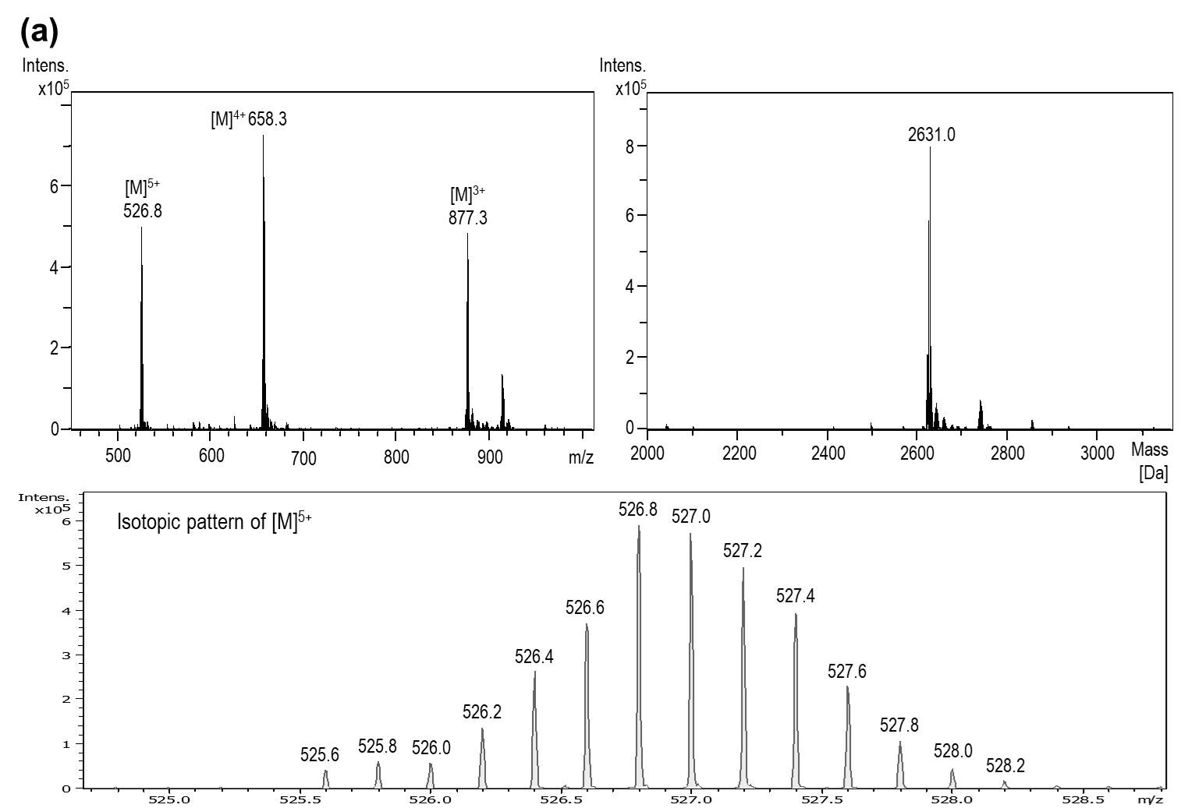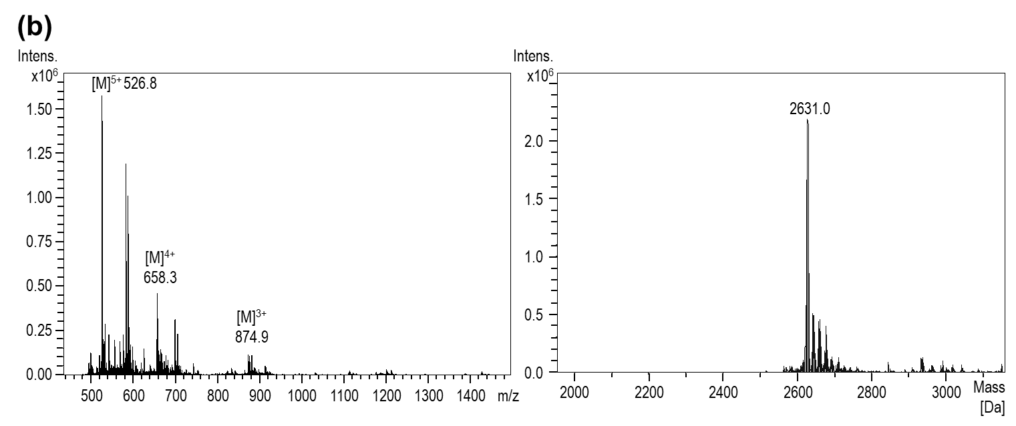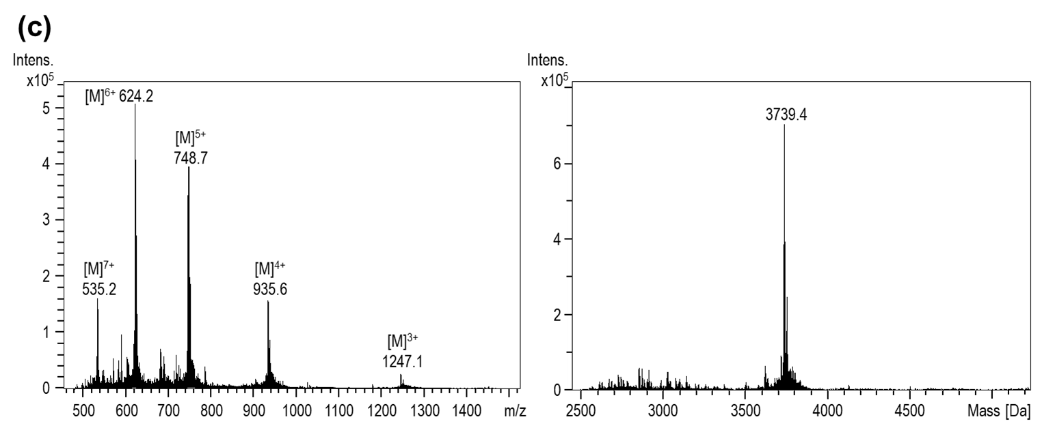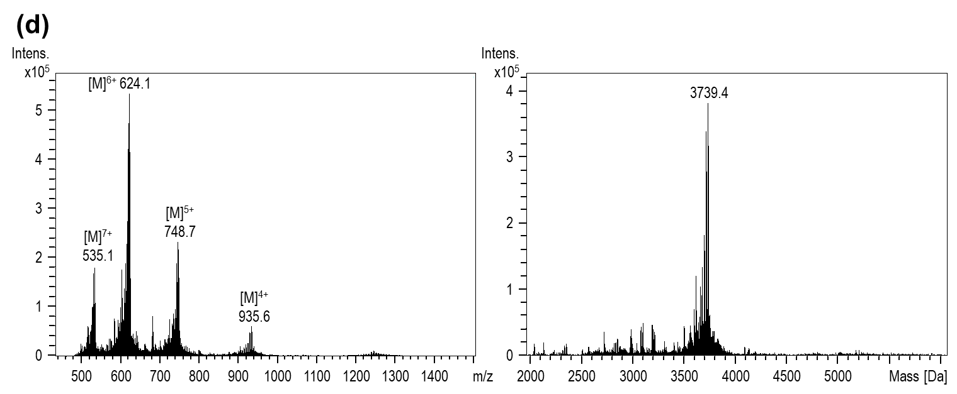
Supplementary Figure 3. ESI-MS spectra of four PAL Probes. (a) Probe-1, (b) Probe-2, (c) FLAG-Probe-1, and (d) FLAG-Probe-2 before (left) and after deconvolution (right), respectively. A spectrum focused around m/z = 526.8 of Probe-1 displays the isotopic distribution of the [M]⁺⁵ species, which is shown in the bottom of (a).
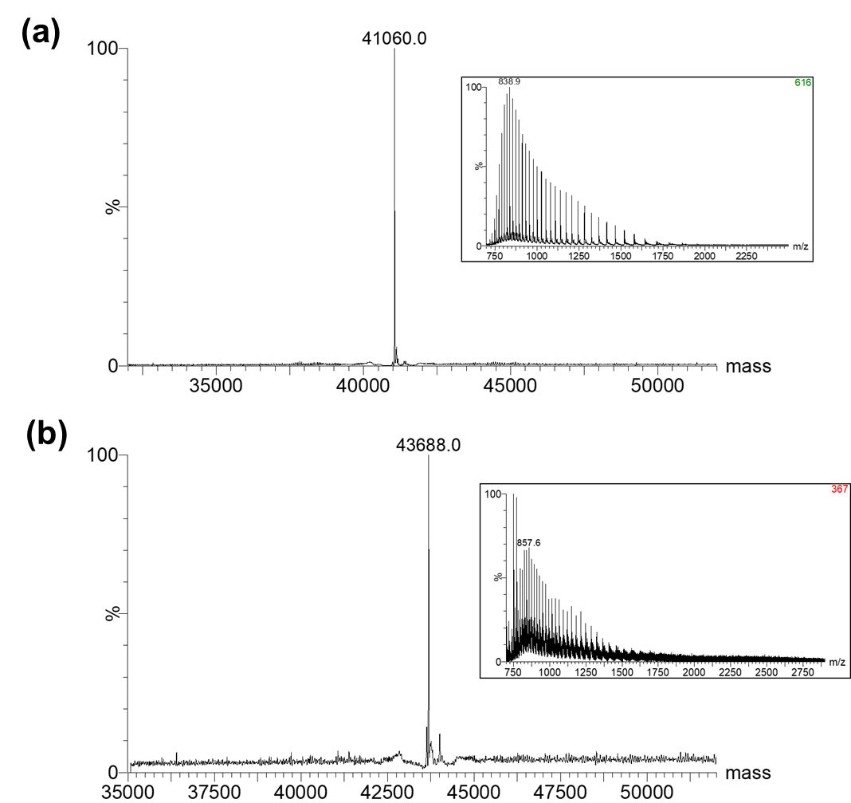
Supplementary Figure 4. Deconvoluted ESI mass spectra of (a) PKA and (b) photoadduct correspond to HPLC peak 2 and peak 2* (main text Figure 2b), respectively. Inset: The multiple-charge mass spectra before deconvolution are shown.

Identification of Probe-1 labeling site on PKA via trypsin-digestion followed by HPLC and MALDI-TOF mass analysis
A mixture containing PKA and Probe-1 was trypsin digested before light illumination. The subsequent peptide fragments were isolated by HPLC with C-5 analytical column and followed by mass analysis. MALDI-TOF mass spectra of fully and partially digested free Probe-1 fragments containing Ru-TAP complex portion are shown in Supplementary Fig. 5, 6, and all the other obtained Trp-containing peptides of native PKA are shown in Supplementary Fig. 7 – 10. Tandem MS analysis was used to further confirm the peptide fragment that should diminish upon blue light illumination in native W196 peptide (peak 3) (Supplementary Fig. 11). After blue light illumination, the expected mass of Probe-1 modified W196 fragment is at m/z 4317.76 while the observed mass corresponds to m/z 4435.75 (Supplementary Fig. 12a). The mass difference is about 118. This might be explained by two contributions: (i) Association with trifluoroacetate anion, which is due to the HPLC treatment with 0.1% TFA eluent as also observed for Ru[(TAP)₂phen]²⁺ before and after maleimide functionalization. Such an adduct ion is about 114. (ii) In addition, the oxidation of tryptophan into kynurenine (Kyn) species during sample handling gives rise to an additional four mass. Thus these two factors would lead to the chemical structure of the peptide fragment depicted in Supplementary Fig. 12b.
The oxidation of peptide fragment is not likely caused by photo-generated reactive oxygen species upon light exposure because the intact molecular mass of the rPKA– Probe-1 photoadduct (Supplementary Fig. 4) was found in native state instead of an oxidized product. Hence, the occurrence of kynurenine (Kyn) species is likely due to further sample handling processes including trypsin digestion and the following HPLC manipulation which have been reported in other studies ¹⁻³. The modified W196 indole group possibly becomes more susceptible to oxidation than its native counterpart due to surrounding chemical environment, of the trypsin treatment. This leads to the expected Ru-TAP complex adduct with Trp, eventually further oxidized into Kyn. This oxidized product can be further confirmed by tandem MS analysis as shown in Supplementary Fig. 12b.

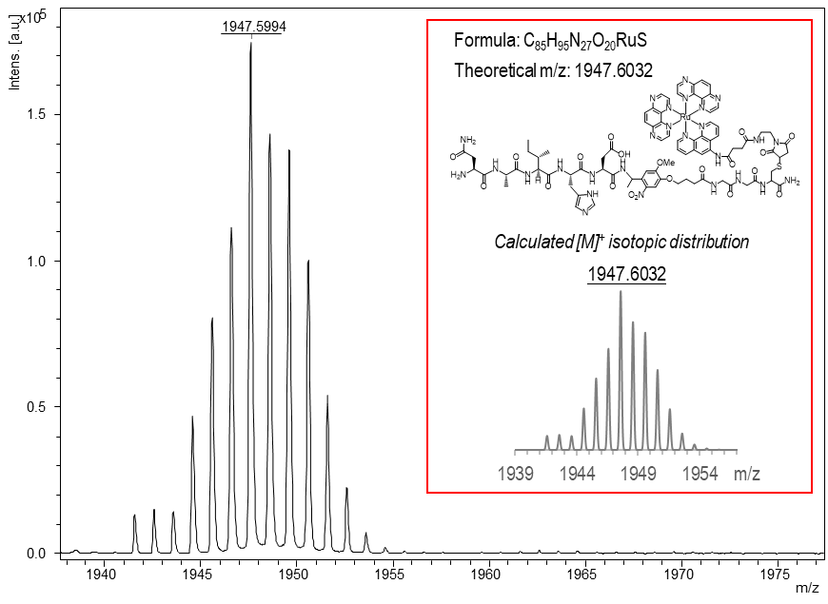
Supplementary Figure 5. MALDI-TOF mass spectrum of HPLC peak a. (t_{R} = 30.5 min, Figure 2c) containing trypsin-digested Probe-1 fragment. Inset: structure and theoretical isotopic mass distribution of Probe-1 after digestion.

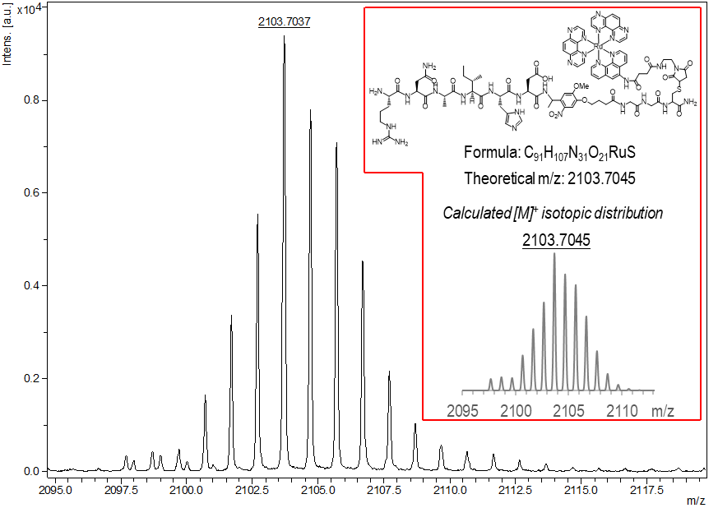
Supplementary Figure 6. MALDI-TOF mass spectrum of HPLC peak a. (t_{R} = 31.1 min, main text Figure 2c) containing trypsin digested Probe-1 fragment with one Arg miscleaved site. Inset: structure and theoretical isotopic mass distribution of the miscleaved Probe-1.

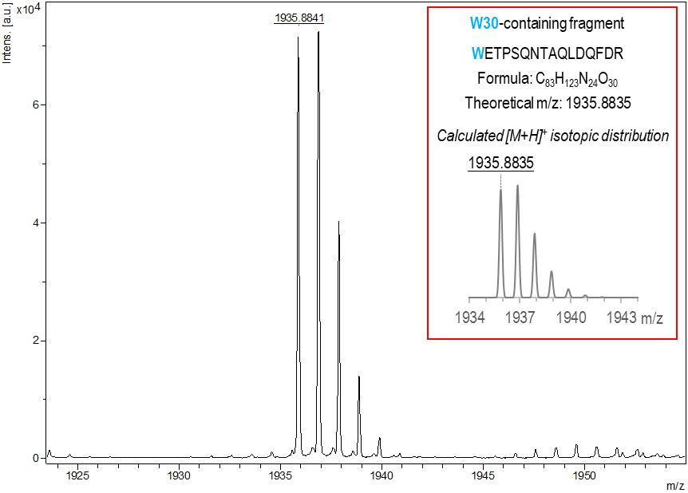
Supplementary Figure 7. MALDI-TOF mass spectrum of HPLC peak 1 (t_{R} = 29.7 min, main text Figure 2c) containing trypsin-digested W30 fragment. Inset: peptide sequence and theoretical isotopic mass distribution.

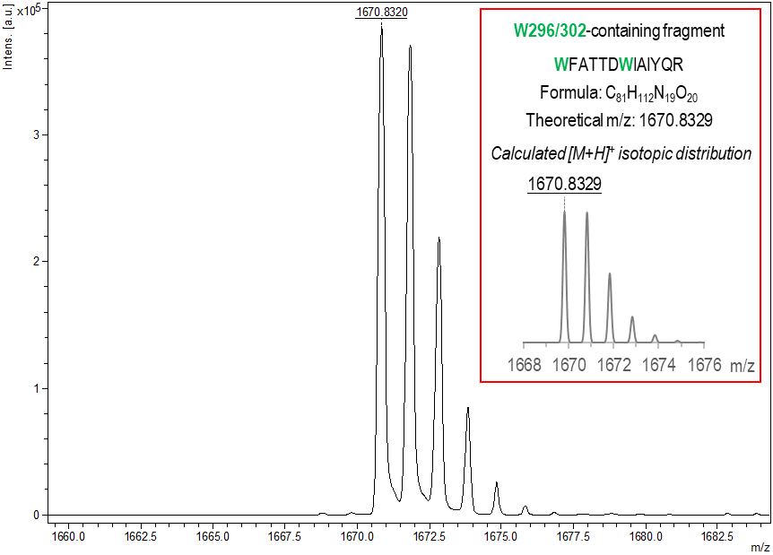
Supplementary Figure 8. MALDI-TOF mass spectrum of HPLC peak 2 (t_{R} = 41.7 min, main text Figure 2c) containing trypsin-digested W296/302 fragment. Inset: peptide sequence and theoretical mass isotopic distribution.
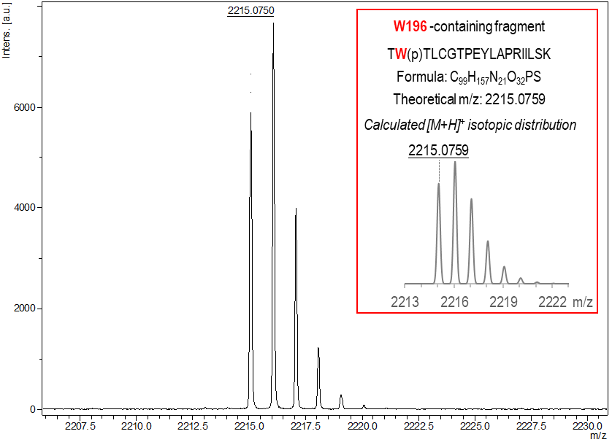
Supplementary Figure 9. MALDI-TOF mass spectrum of HPLC peak 3 (t_{R} = 42.7 min, main text Figure 2c) containing trypsin-digested W196 fragment. Inset: peptide sequence and theoretical mass isotopic distribution.
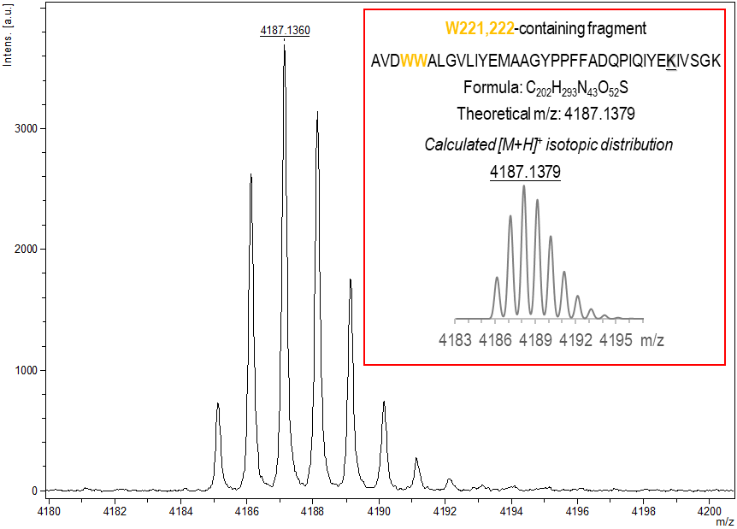
Supplementary Figure 10. MALDI-TOF mass spectrum of HPLC peak 4 (t_{R} = 52.0 min, main text Figure 2c) containing trypsin-digested W221, 222 fragment. Inset: peptide sequence and theoretical mass isotopic distribution.

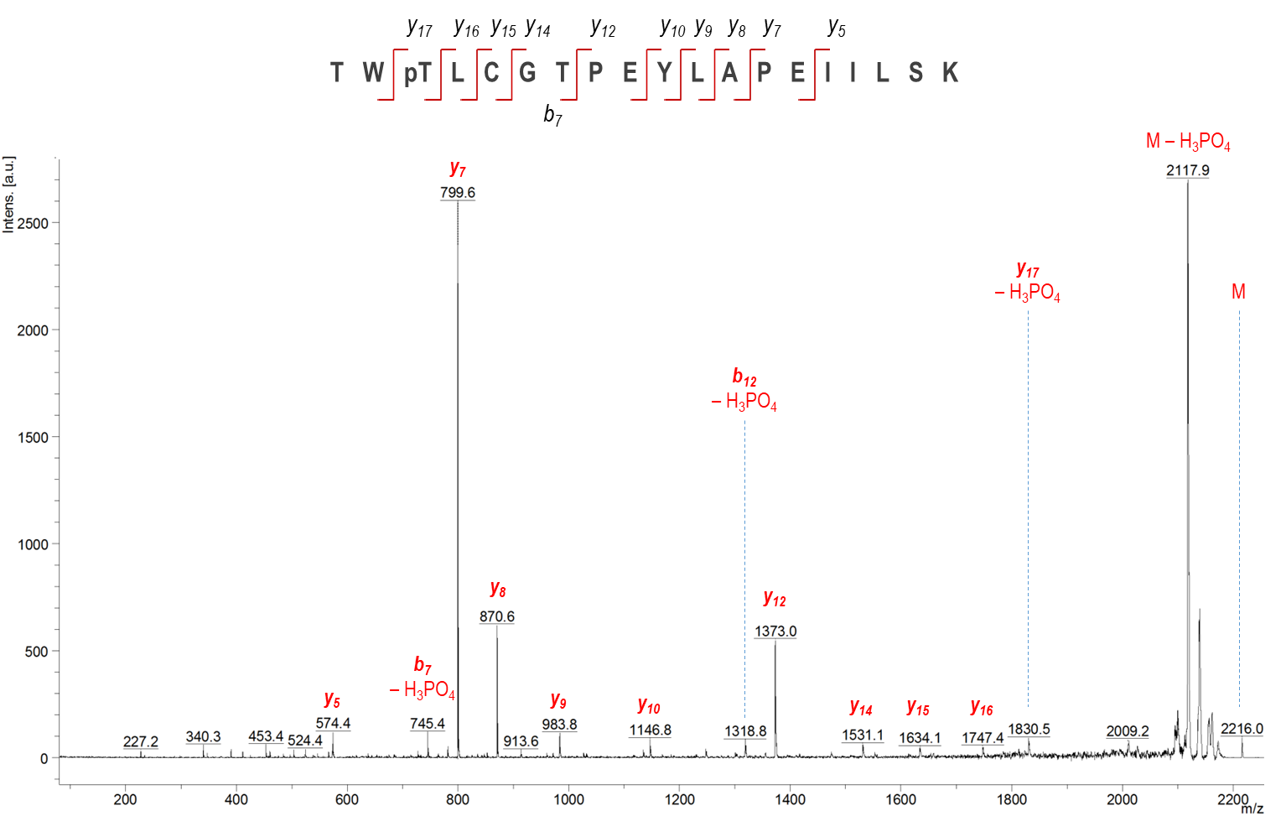
Supplementary Figure 11. Tandem MS sequencing of HPLC peak 3 (t_{R} = 42.7 min, main text Figure 2c) containing trypsin-digested native W196 fragment before 450 nm illumination.
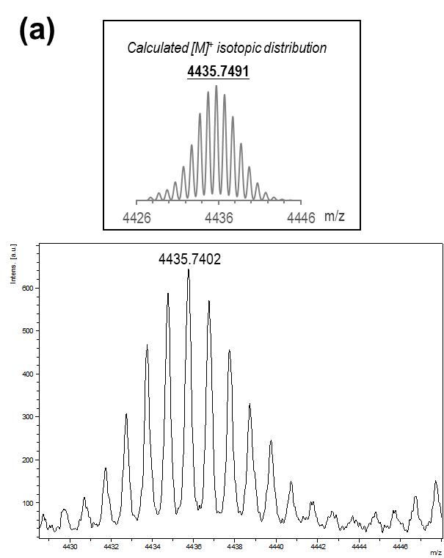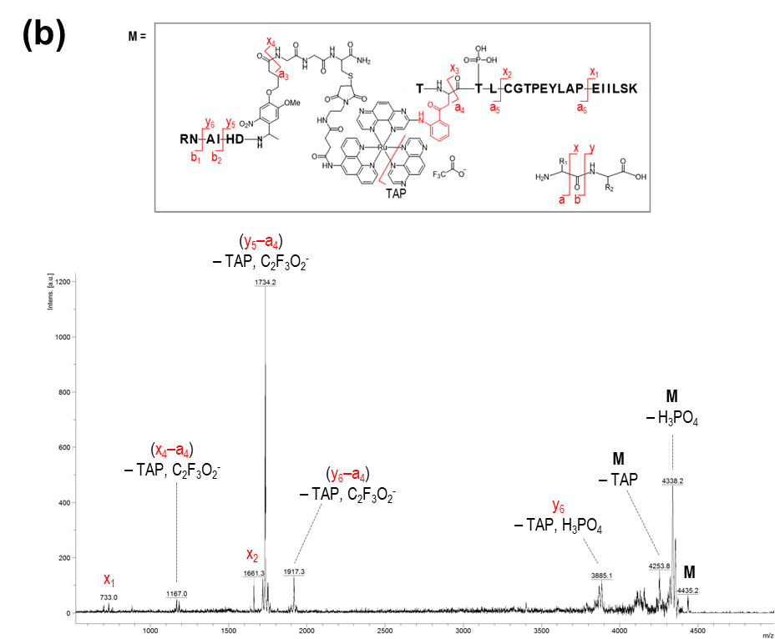
Supplementary Figure 12. Tandem-MS determination of Probe-1 labeling site. Only calculated mass with oxidized Trp, i.e. kynurenine, fits with the observed mass. (a) Theoretical (inset) and observed MALDI-MS spectrum with isotopic distribution of Probe-1 labeled W196 peptide fragment isolated from HPLC peak 3* (t_{R} = 42.7 min, main text Figure 2c). The labeled fragment is associated with trifluoroacetate counter anion, and Trp is oxidized into Kynurenine. (b) Tandem MS sequencing of the labeled W196 fragment. Inset: chemical structure of the labeled peptide and interpreted fragmentation from the primary ion.

Determination of PAL probes in caging and uncaging of PKA activity
PAL probes and PKA containing solutions were either kept in dark or subjected to light illumination (caging and uncaging), and followed by kinase activity measurement. The slope of line refers to the activity of PKA being measured and is shown in Supplementary Fig. 13. FLAG-tagged PAL probes mediated PKA caging and uncaging were also evaluated to examine whether the extra peptide sequence of FLAG-tag would interfere with the affinity between PKA and PKI (14-24). The kinase assay results showed identical PKA activity caging/uncaging efficacy between Probe-1 and FLAG-Probe-1 as shown in Supplementary Fig. 14a, b. Probe-2 and FLAG-Probe-2 showed similar negative behavior in manipulating PKA activity (Supplementary Fig. 14c, d).

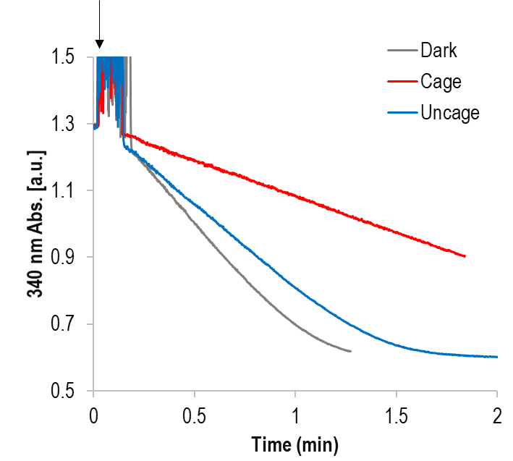
Supplementary Figure 13. In response to kinase activity, coupled-enzyme assays in a series of biochemical reactions eventually lead to NADH oxidation, which can be monitored via decreasing absorbance at 340 nm over time. After PKA addition, initial rate (linear slope) can be obtained which corresponds to PKA kinase activities under dark (grey line), blue light caged (red line), and UV uncaged (blue line). Black arrow indicates the time point when PKA containing solution was added to the assay mixture.

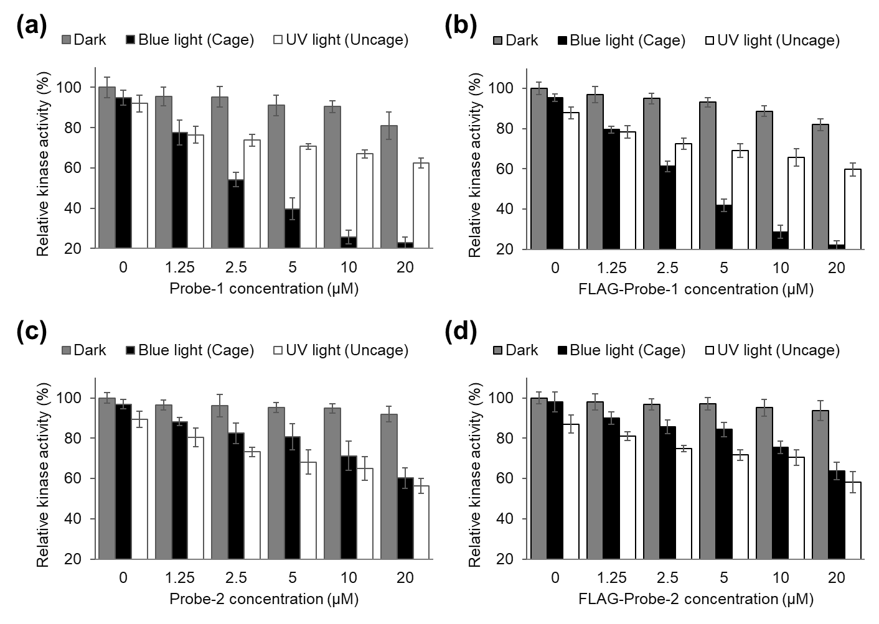
Supplementary Figure 14. Results showing that non-Flag-tagged and Flag-tagged PAL probes have the same activity influence against PKA. Solutions containing 5 μM rPKA and different concentration of (a) Probe-1, (b) FLAG-Probe-1, (c) Probe-2, and (d) FLAG-Probe-2 were kept in dark, or exposed to 450 nm light for 10 min, or further illuminated under 360 nm light for 2 min. The relative PKA activities were obtained as described in Supplementary Figure 13.

Photoadduct formation suppressing PAL probes singlet oxygen generation
Similar to that of Probe-2, the free Ru-TAP complex showed no effective PKA activity suppression and reactivation upon 450 and 360 nm light irradiation (Supplementary Fig. 15). This indicated that the decreased PKA activity was not a result of PAL caging, suggesting that another non-PeT photoreaction might have contributed to this irreversible activity loss. We believe singlet oxygen production by the excited Ru-TAP complex is responsible for the reduction of PKA activity.
According to previously reported pathways of excited Ru-TAP complex, PeT bond formation and photo-sensitization occur in a competing fashion ⁴. We hypothesized that Probe-1 in interaction with PKA has higher PeT yield and hence lower ¹O₂ generation because of affinity-induced proximity between W196 and Ru-TAP complex. ¹O₂ generation of Probe-1, Probe-2 and free Ru-TAP complex in the presence or absence of PKA were assayed by p-nitrosodimethylaniline (RNO) bleaching assay to prove this hypothesis. Solution mixtures composed of 1.5 μM PAL probe, 60 μM RNO, 2 mM L-Histidine in pH 7.4 PBS with or without 3 μM PKA were subjected to time-dependent blue light illumination followed by monitoring RNO absorbance at 440 nm. In the absence of PKA, free Ru-TAP complex generates the highest ¹O₂ while Probe-1 and Probe-2 produce ¹O₂ at similar level (Supplementary Fig. 16a), which represents the intrinsic ¹O₂ generation capacity of each probe. In the presence of PKA, much lower ¹O₂ was generated by Probe-1 as shown in Supplementary Fig. 16b due to the close proximity driven PeT bond formation between W196 and Ru-TAP complex of Probe-1. Conversely, when Probe-2 or free Ru-TAP complex was incubated with PKA in RNO assay, still significant amount of ¹O₂ was produced due to the lack of effective PeT bond forming reaction.

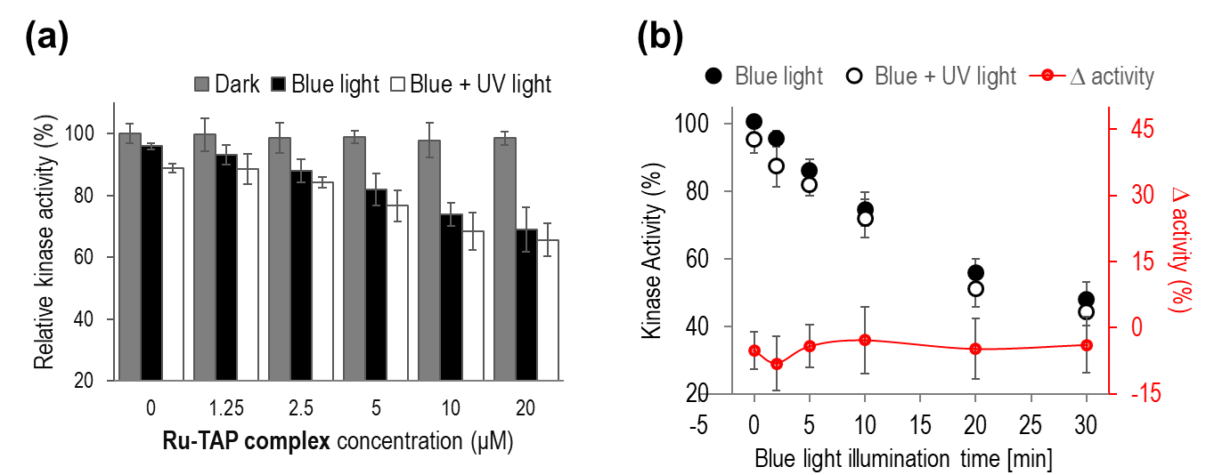
Supplementary Figure15. Effect of free Ru-TAP complex toward PKA kinase activity under different conditions. (a) Concentration titration of Ru-TAP complex against 5 μM rPKA and kept in the dark or exposed to 450 nm light for 10 min (caging), or further illuminated under 360 nm light for 2 min (uncaging). (b) Ru-TAP complex illuminated with 450 nm light at different time intervals (closed circle) and further exposed to 360 nm light for 2 min (open circle). The activity difference (delta activity) between caged and uncaged PKA at different 450 nm illumination times were calculated and plotted as function of the illumination time (red line).
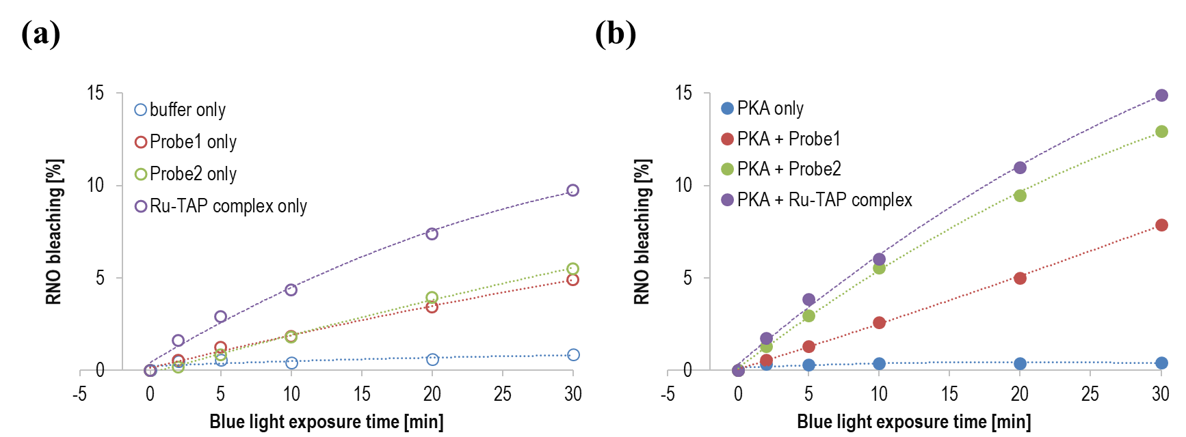
Supplementary Figure 16. ¹O₂ production with 1.5 μM of Probe-1, Probe-2, and free Ru-TAP complex assayed by the p-nitrosodimethylaniline (RNO) bleaching experiment. The solution mixtures were exposed to blue light for different periods of time (a) in the absence of PKA, or (b) under the presence of 3 μM PKA. The bleaching percentages were calculated by measuring the RNO maximum absorbance change at 440 nm.

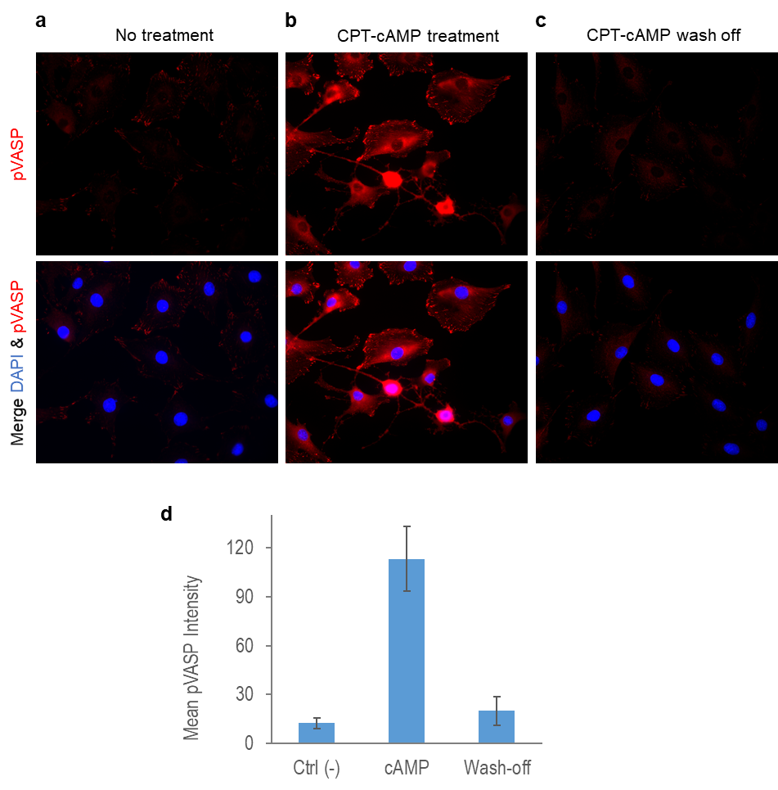
Supplementary Figure 17. Effects of cAMP on VASP phosphorylation.
REF52 cells were cultured in complete medium with different treatments. (a) Control cells without treatment. (b) Treated with 250 μM CPT-cAMP for 10 min. (c) After 10 min CPT-cAMP treatment, wash-off, and further incubated in fresh medium for 10 min. The cells were then incubated for 1 h and fixed with 4% paraformaldehyde followed by anti-pVASP immunostaining and DAPI staining. (d) Quantification of mean pVASP intensity of the three groups.

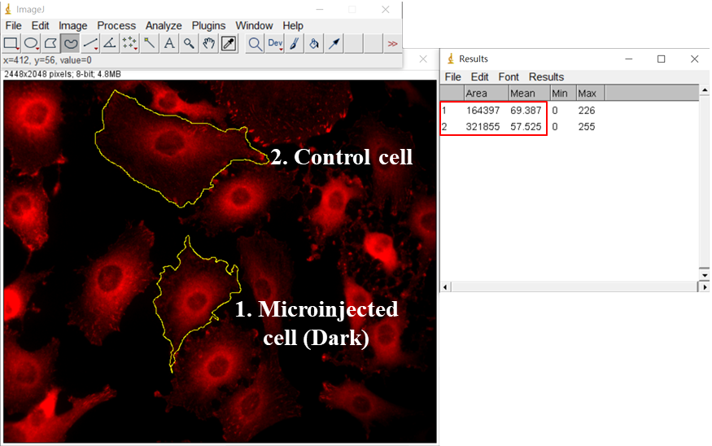
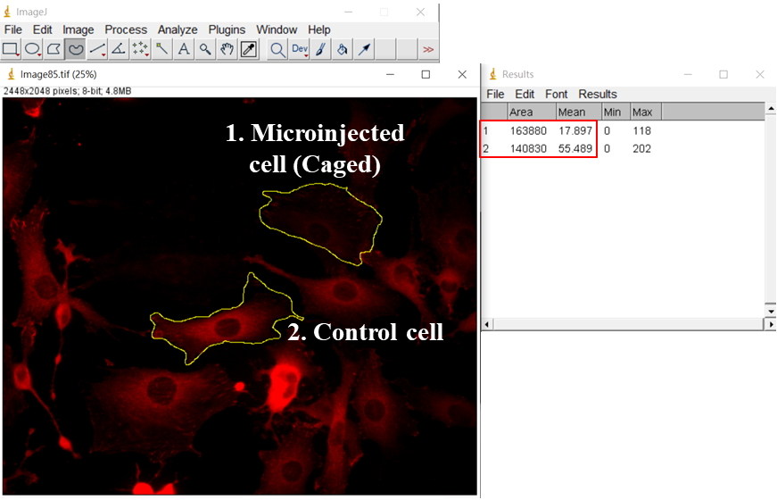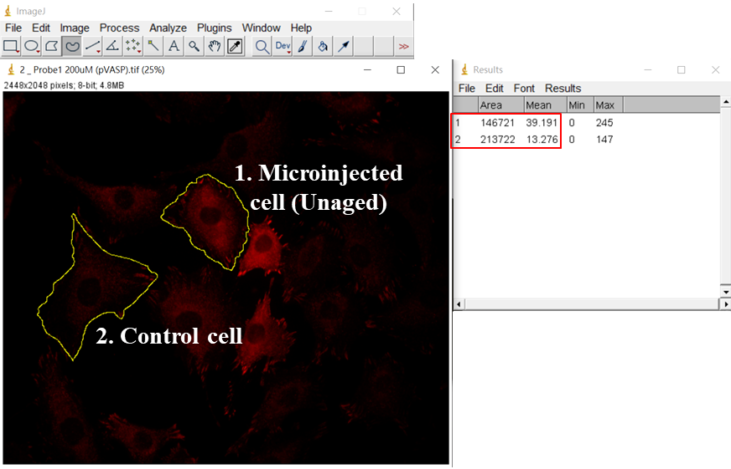
Supplementary Figure 18. Quantification of pVASP intensity of microinjected cells using ImageJ.
References
1. Thiede, B.; Lamer, S.; Mattow, J.; Siejak, F.; Dimmler, C.; Rudel, T.; Jungblut, P. R., Analysis of missed cleavage sites, tryptophan oxidation and N-terminal pyroglutamylation after in-gel tryptic digestion. Rapid Communications in Mass Spectrometry 2000, 14 (6), 496-502.
2. Perdivara, I.; Deterding, L. J.; Przybylski, M.; Tomer, K. B., Mass Spectrometric Identification of Oxidative Modifications of Tryptophan Residues in Proteins: Chemical Artifact or Post-Translational Modification? Journal of the American Society for Mass Spectrometry 2010, 21 (7), 1114-1117.
3. folzer, E.; diepold, K.; bomans, K.; finkler, C.; schmidt, R.; bulau, P.; huwyler, J.; mahler, H.-c.; koulov, A. V., Selective Oxidation of Methionine and Tryptophan Residues in a Therapeutic IgG1 Molecule. Journal of Pharmaceutical Sciences 2015, 104 (9), 2824-2831.
4. Gicquel, E.; Boisdenghien, A.; Defrancq, E.; Moucheron, C.; Kirsch - De Mesmaeker, A., Adduct formation by photo-induced electron transfer between photo-oxidising Ru(ii) complexes and tryptophan. Chemical Communications 2004, (23), 2764-2765.

