Development of A Novel Anti-Liver Fibrosis Formula with luteolin, licochalcone A, aloe-emodin and acacetin by network pharmacology and transcriptomics analysis
Author names
Yuan Zhou^{1a}, Rong Wu^{1a}, Fei-Fei Caiª, Wen-Jun Zhouª, Yi-Yu Luª, Hui Zhangª, Qi-Long Chenª, Mingyu Sun^{b}*, Shi-Bing Suª*

Supplementary Figures

Supplementary Figure S1
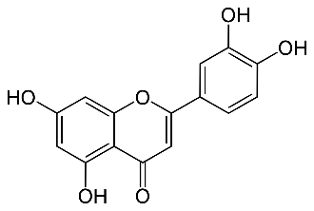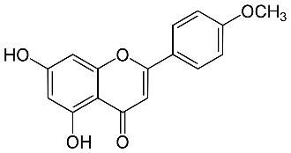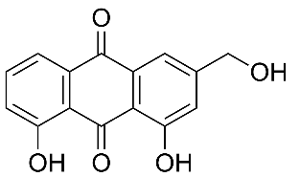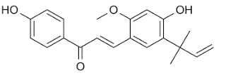

A B C D

Supplementary Figure 1. Chemical structure of Luteolin, licochalcone A, aloe-emodin, acacetin. (A) Luteolin (B) acacetin (C) aloe-emodin (D) licochalcone A

Supplementary Figure S2
A
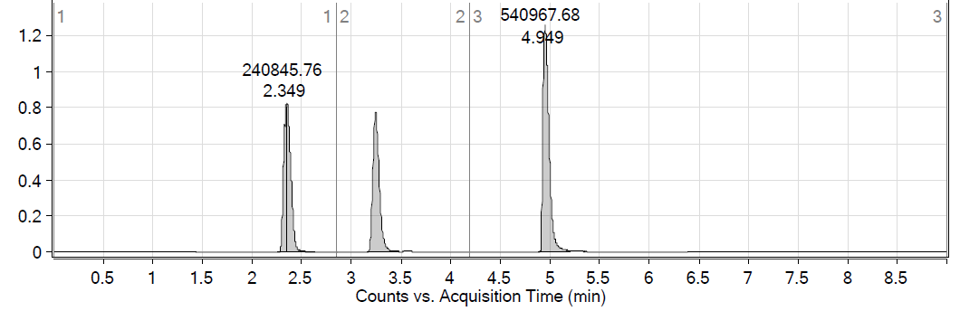
B
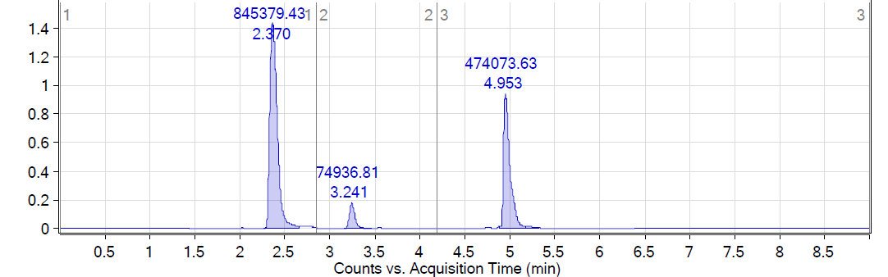
C
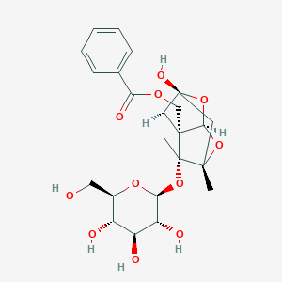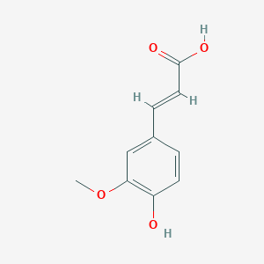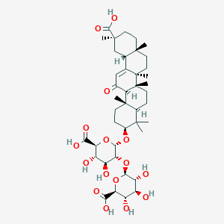
1 2 3
Supplementary Figure 2. Determination of Paeoniflorin, ferulic Acid and glycyrrhizic Acid in XYS extract by HPLC-MS. (A) Control of paeoniflorin, ferulic acid and glycyrrhizic acid. (B) XYS extract. (C) The structure of paeoniflorin, ferulic acid and glycyrrhizic acid. 1, paeoniflorin; 2, ferulic acid; 3, glycyrrhizic acid. XYS, xiaoyaosan.

