Supplementary Figure 1: Overview of the themes and subthemes derived from reflexive thematic analysis.

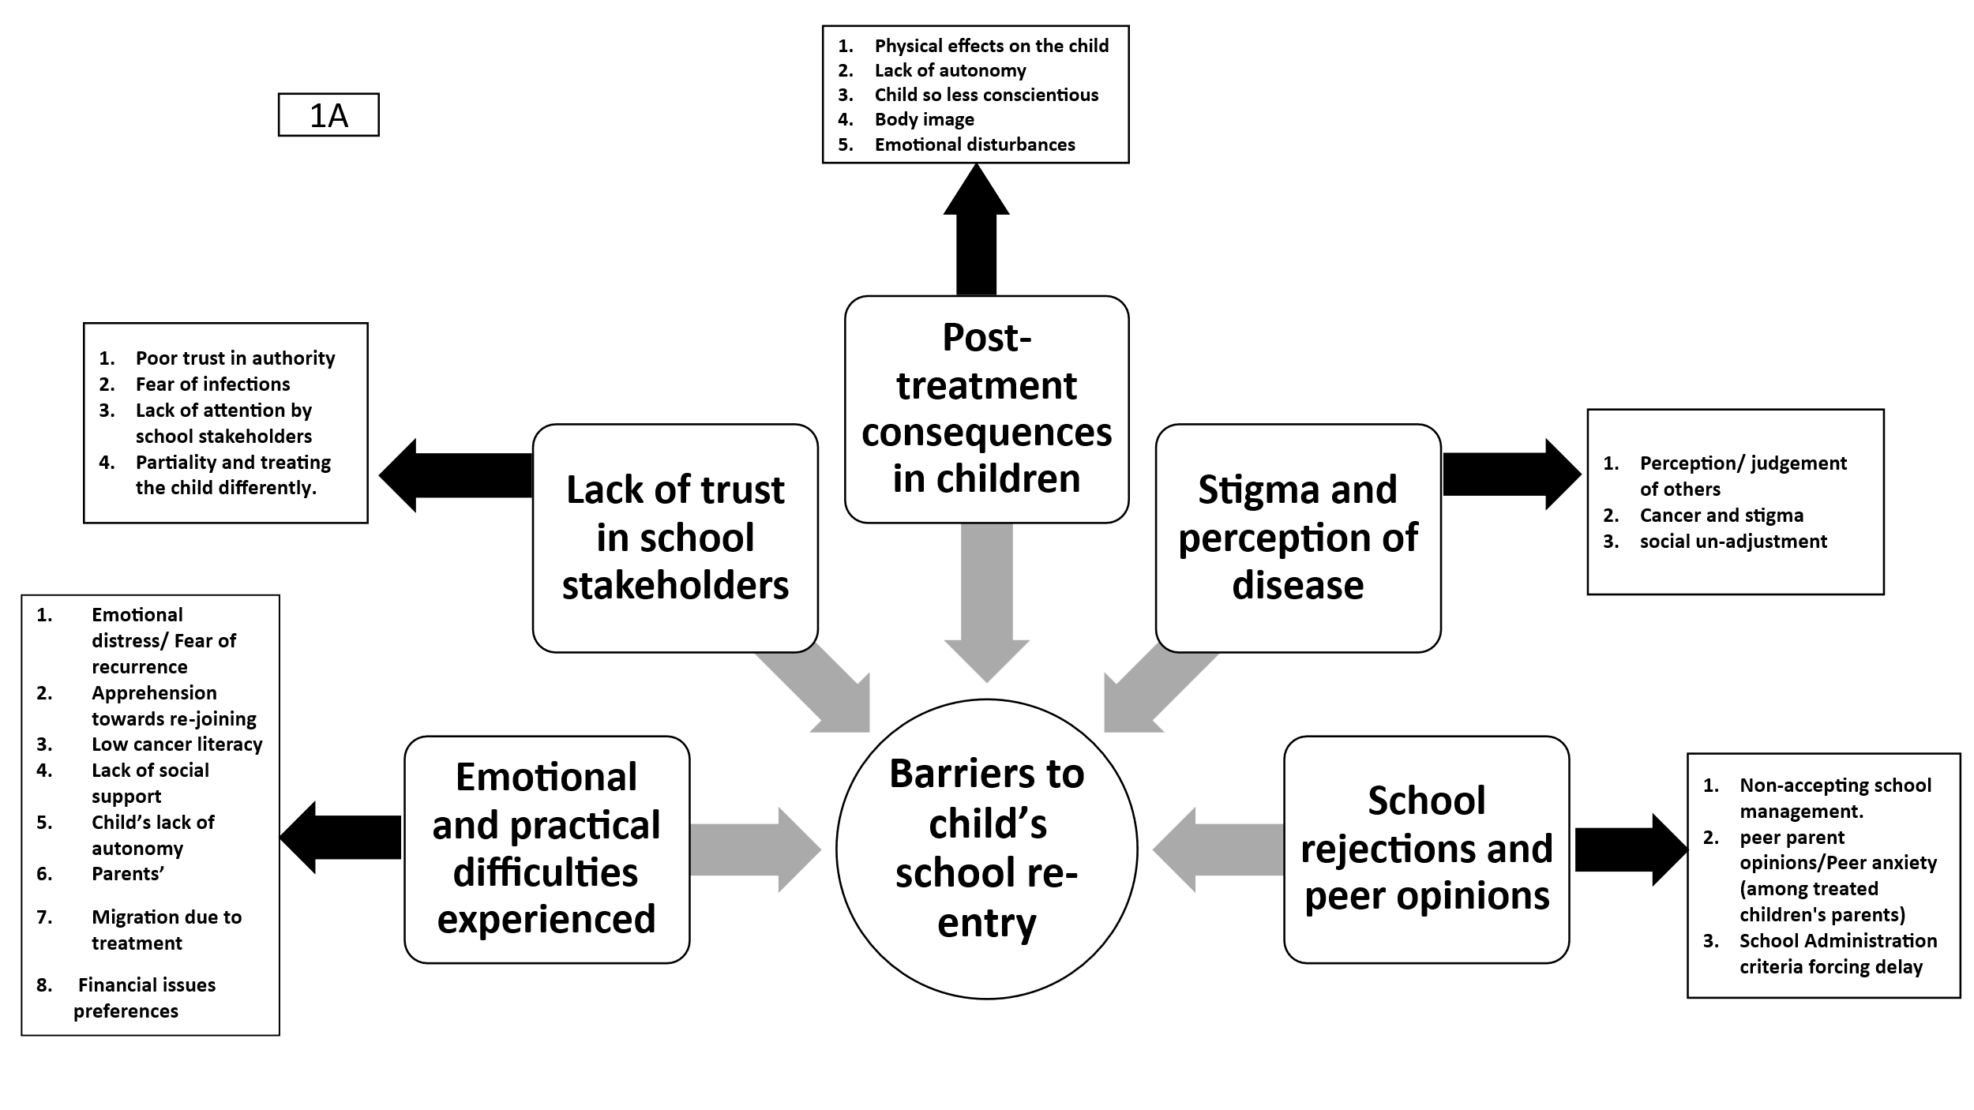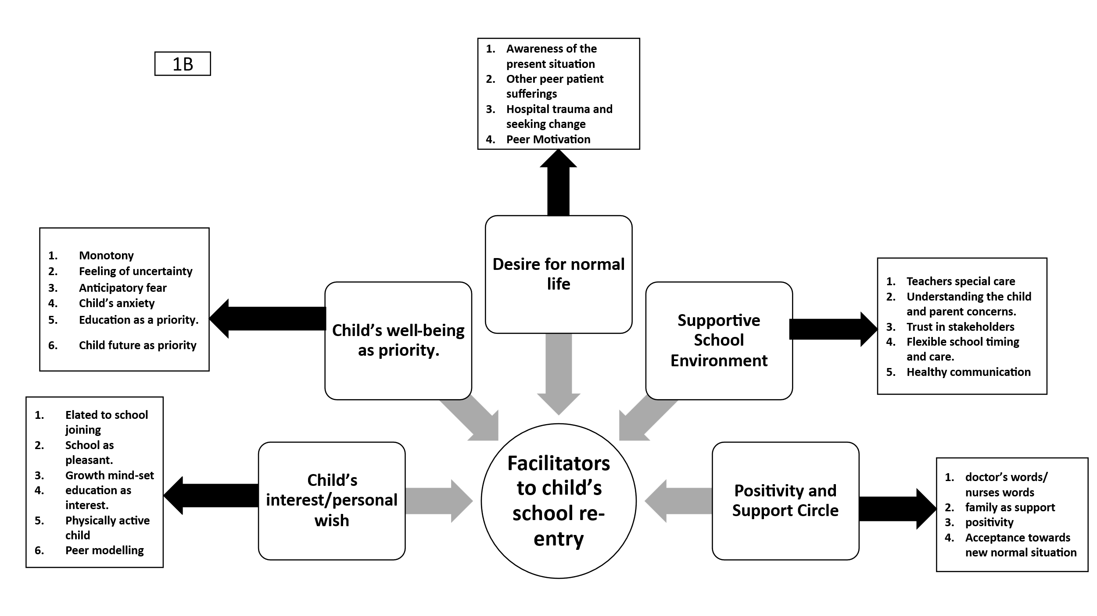
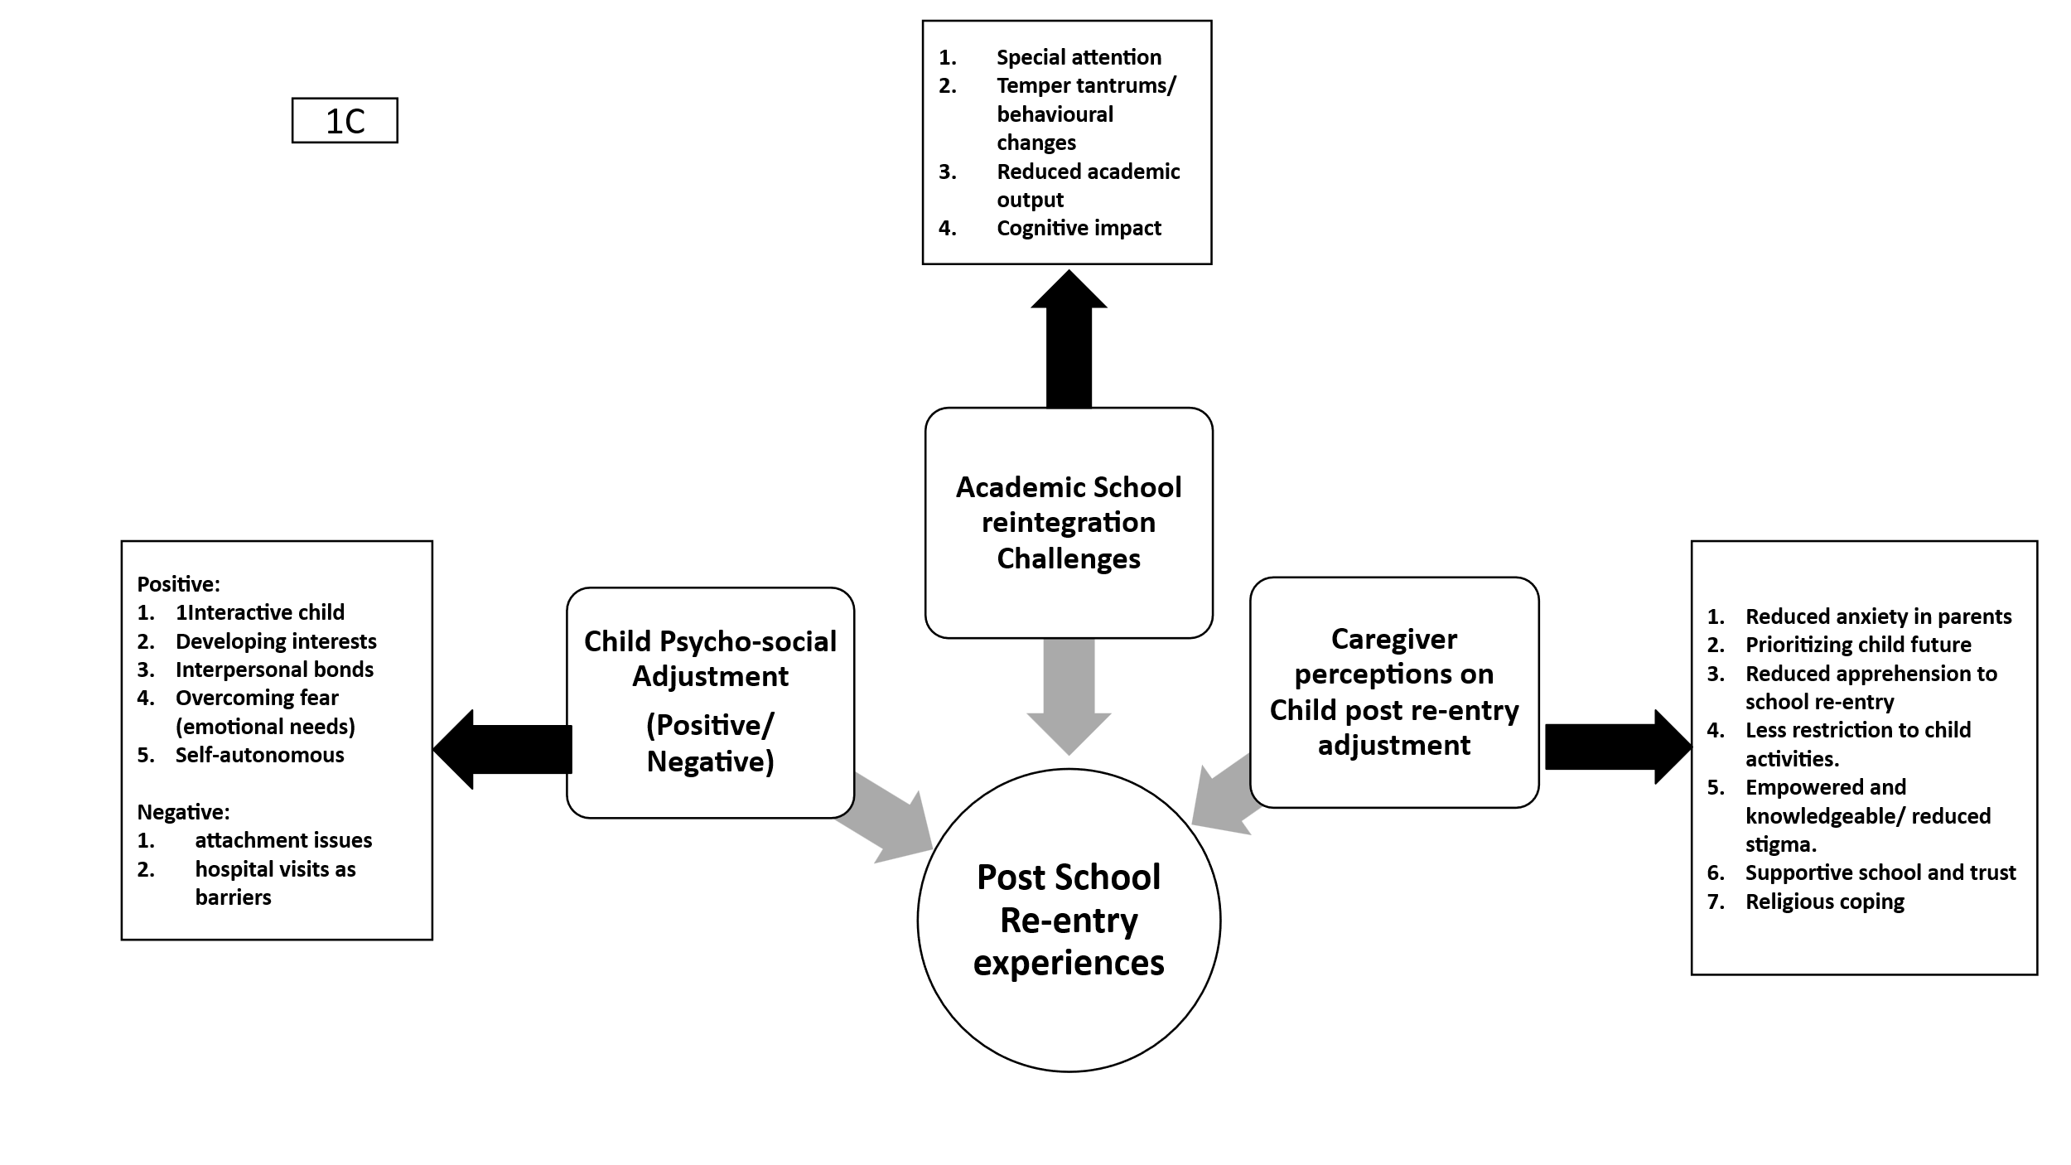
Semi-structured interview guides mapped to the three study objectives: (1A) exploration of barriers contributing to delayed school re-entry; (1B) identification of perceived facilitators of successful school re-entry; and (1C) exploration of children's post–school re-entry experiences, including psychosocial well-being.

