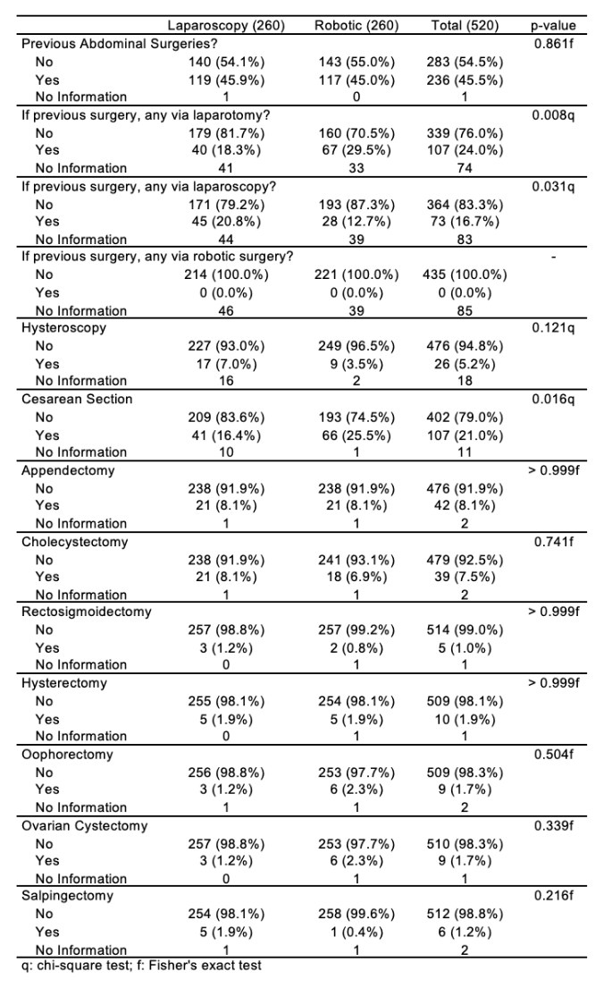
Table 1. Personal history: surgeries (N = 520).

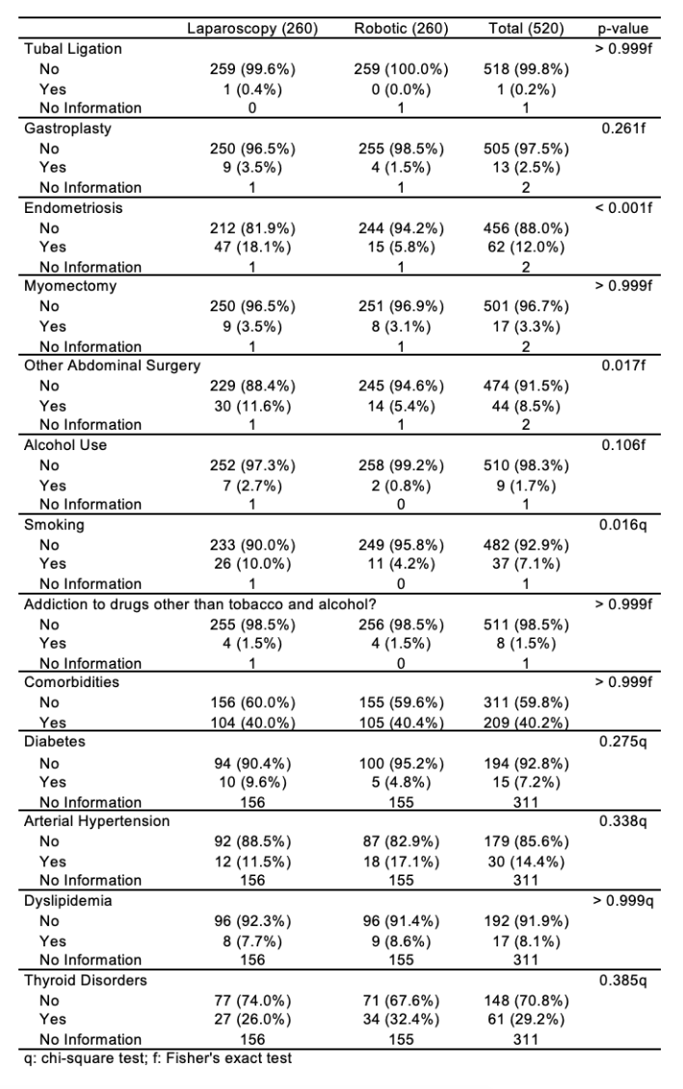
Table 2. Personal history: habits and comorbidities (N = 520).

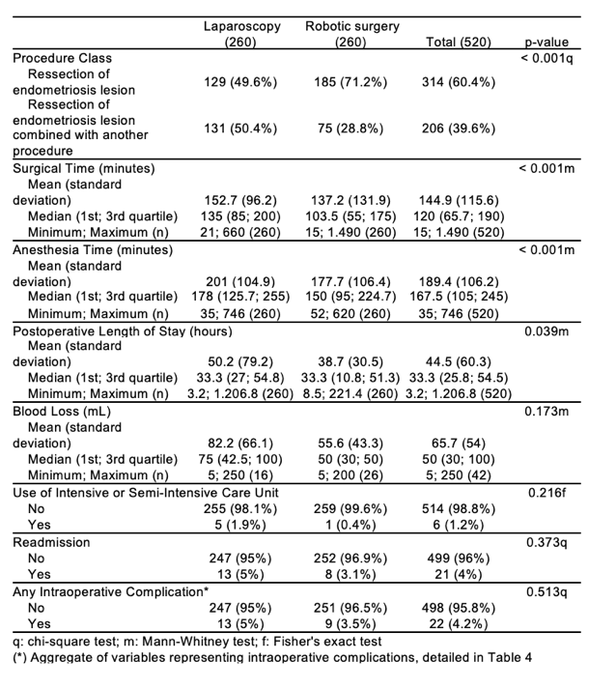
Table 3. Data, characteristics, and consequences of surgery by technique (N = 520).

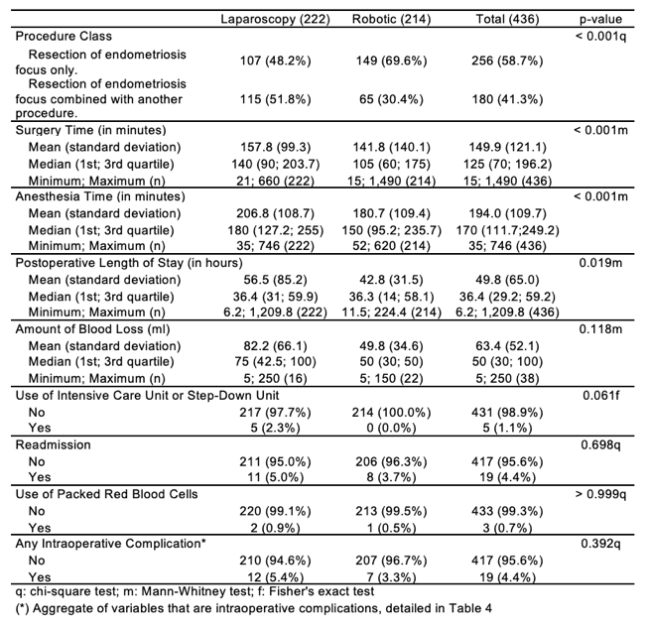
Table 4. Data, characteristics and consequences of surgery by technique in patients with endometriosis (N = 436).
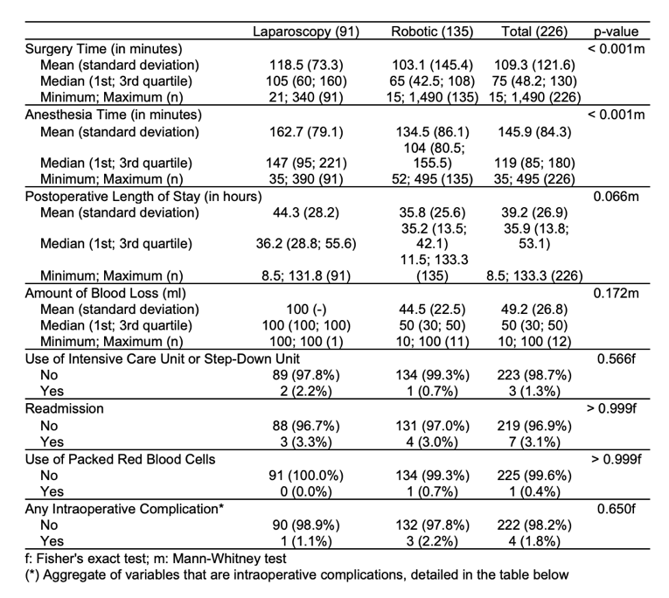
Table 5. Data, characteristics and consequences of surgery by technique in patients with endometriosis (N = 226)
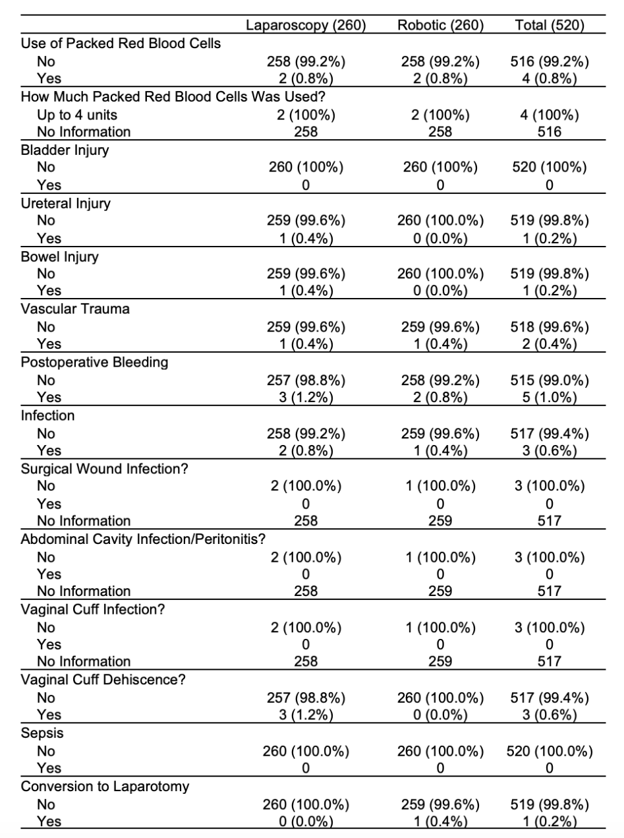
Table 6. Intraoperative complications by technique (N = 520).

