Supplementary Information:
Mapping gender measurement approaches through semantic embedding and intersectionality framework reveals hidden trends

Inter-rater reliability
Variable-level coding involved two recurring decisions. First, 19 of the 28 instruments do not publish full variable lists in English; for these, variable terms were taken from English-language text by the original authors. Second, attitudinal items sometimes encoded values across multiple dimensions simultaneously: for example, items in Wandschneider [1] such as “It would be good for society if transgender people were recognised as normal” express gender-related social norms while simultaneously touching world view. Such items were assigned to all dimensions which were assigned by at least three out of the five raters, with no distinction between human and LLM raters. If no dimension reached three out of five ratings, we assigned all dimensions assigned by every rater.
Figure 1 shows the fraction of raters who assigned each dimension to each instrument; Figure 2 shows pairwise Jaccard agreement between rater pairs per instrument and per dimension.
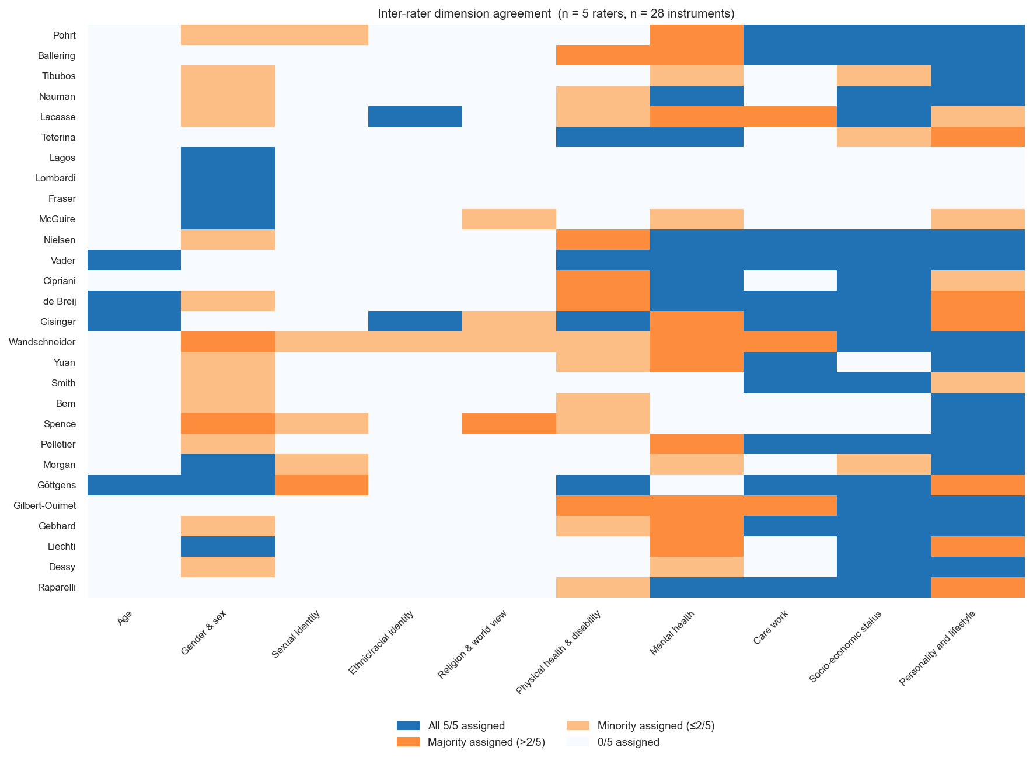
Figure 1: Inter-rater agreement on dimension-presence per instrument (28 instruments × 10 dimensions). Colour encodes the fraction of raters who assigned the dimension to that instrument (0 = no rater assigned, 1 = all raters assigned).
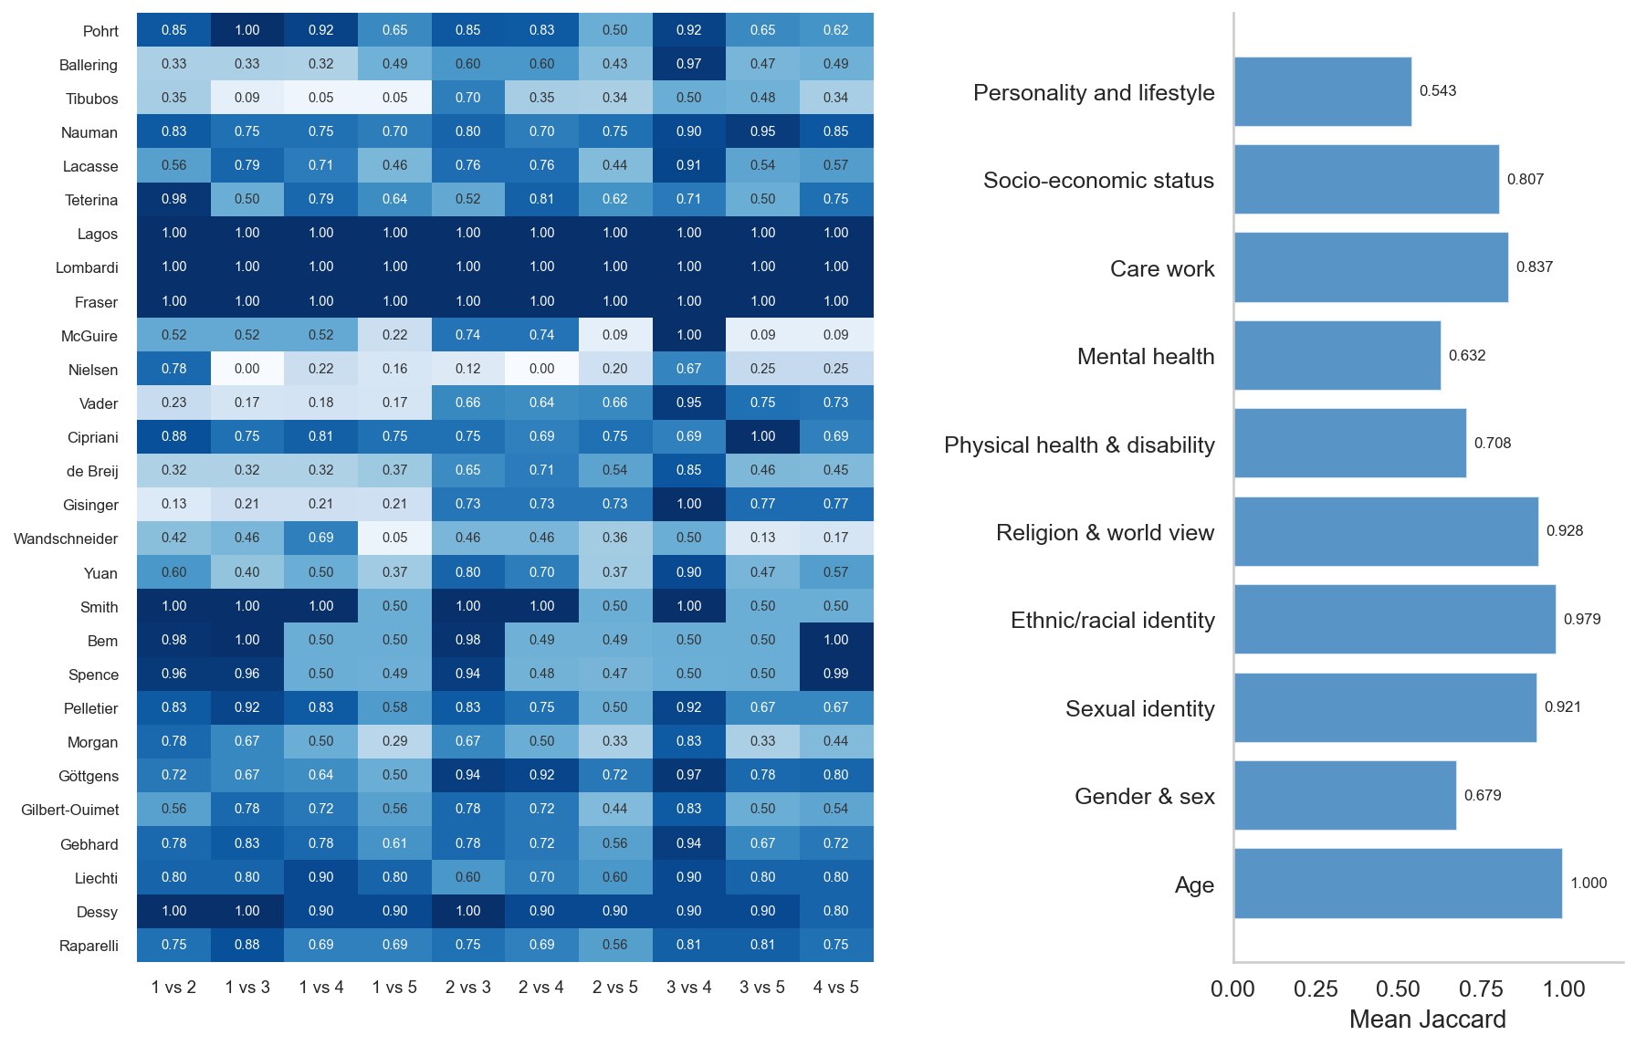
Figure 2: Variable-level Jaccard agreement. Left: mean per-variable Jaccard between dimension sets assigned by each rater pair, per instrument (0 = no agreement, 1 = identical assignments; overall mean shown in title). Right: mean per-dimension Jaccard averaged across instruments and rater pairs.

Corpus overview through visualisation
We show here the temporal, geographic, and open-science characteristics of the considered paper corpus (Figure 3, Figure 4, Figure 5).
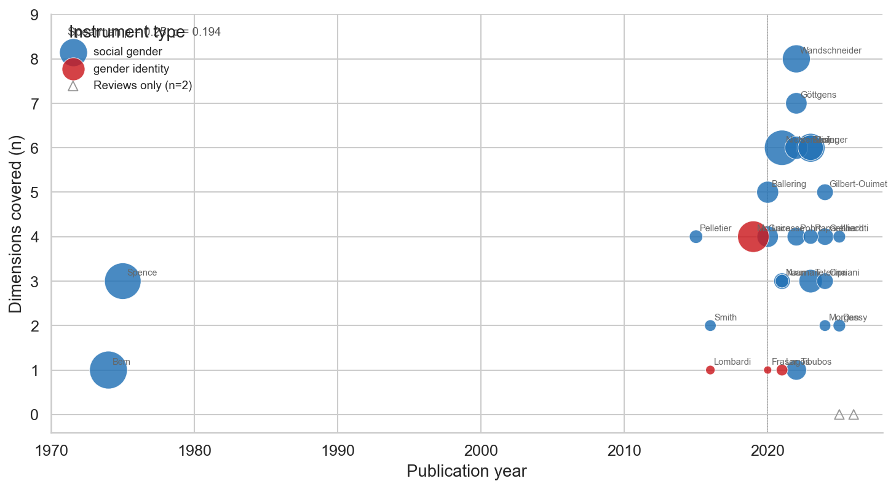
Figure 3: Publication year versus number of dimensions covered for the 28 variable-coded instruments. Point size is proportional to total variable count; colour indicates instrument type. Open triangles show the two review papers without variable-level coding, plotted at y = 0 for temporal reference only. Spearman ρ and two-sided p-value are annotated.
Most papers originated from Europe and North America (Figure 4). No instruments from Asia, Africa, or South America were identified for the considered years of publications.
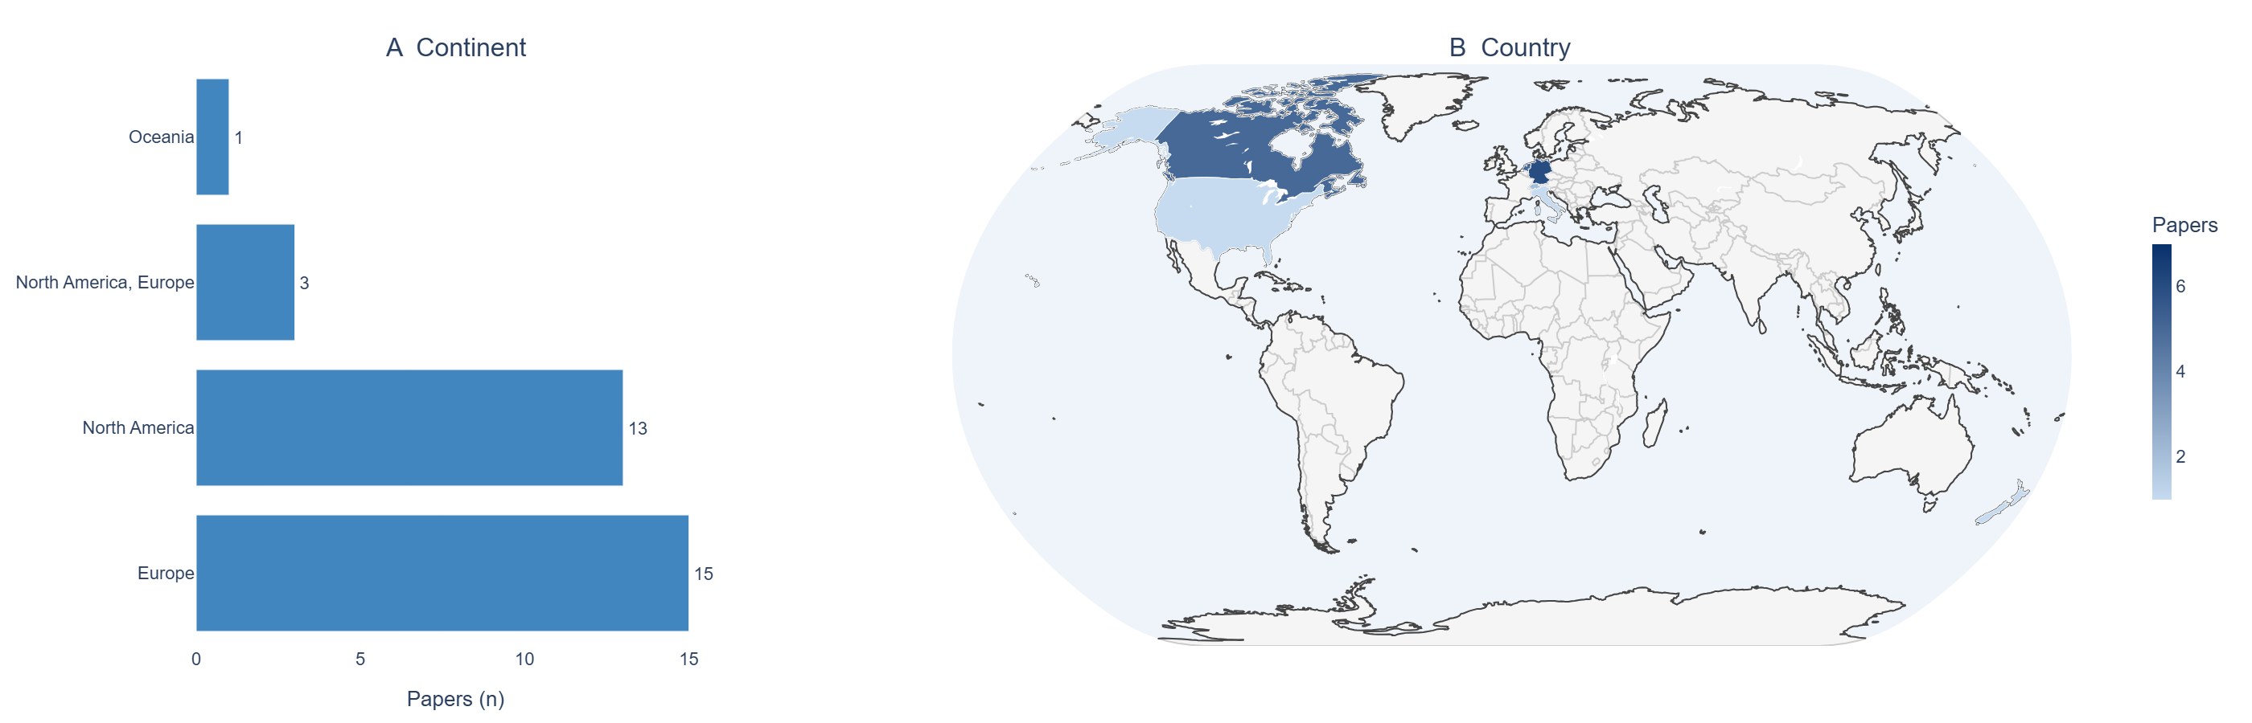
Figure 4: Geographic distribution of the corpus. (A) Papers by continent; (B) papers by country on an outline map. Western Europe and North America dominate; no instruments from low- or middle-income countries were identified. Instruments not based on a single country or continent are omitted from both panels.
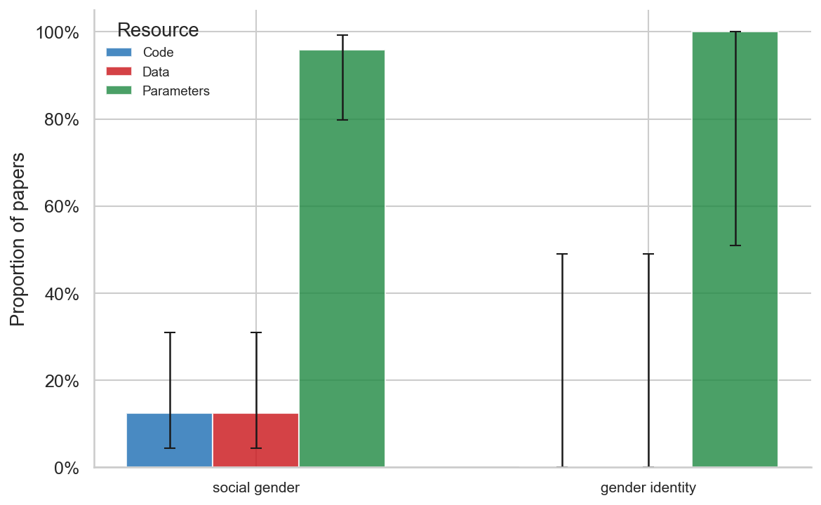
Figure 5: Open science availability by instrument type (28 coded papers). Bars show the proportion of papers within each instrument type that published analysis code, participant data, and statistical model parameters. Error bars show 95% Wilson confidence intervals.

Dimension coverage by output type and gender conceptualisation
For the sake of brevity, in the main manuscript we have only shown our dimension coverage grouped by the classification used by Schindler et al. [2]), a choice which was arbitrary. We have classified each gender score also according to the grouping introduced by Horstmann et al. [3], and we show here the alternative figures Figure 6 and Figure 7. These further classifications regard the instrument’s output (continuous/composite score, categorical/typological assignment, both), and whether the instrument conceptualises gender as binary or as non-binary/multidimensional, where here we intend independent dimensions, or explicit categories beyond male/female. The applied classifications are present in tabular form in Table 1.
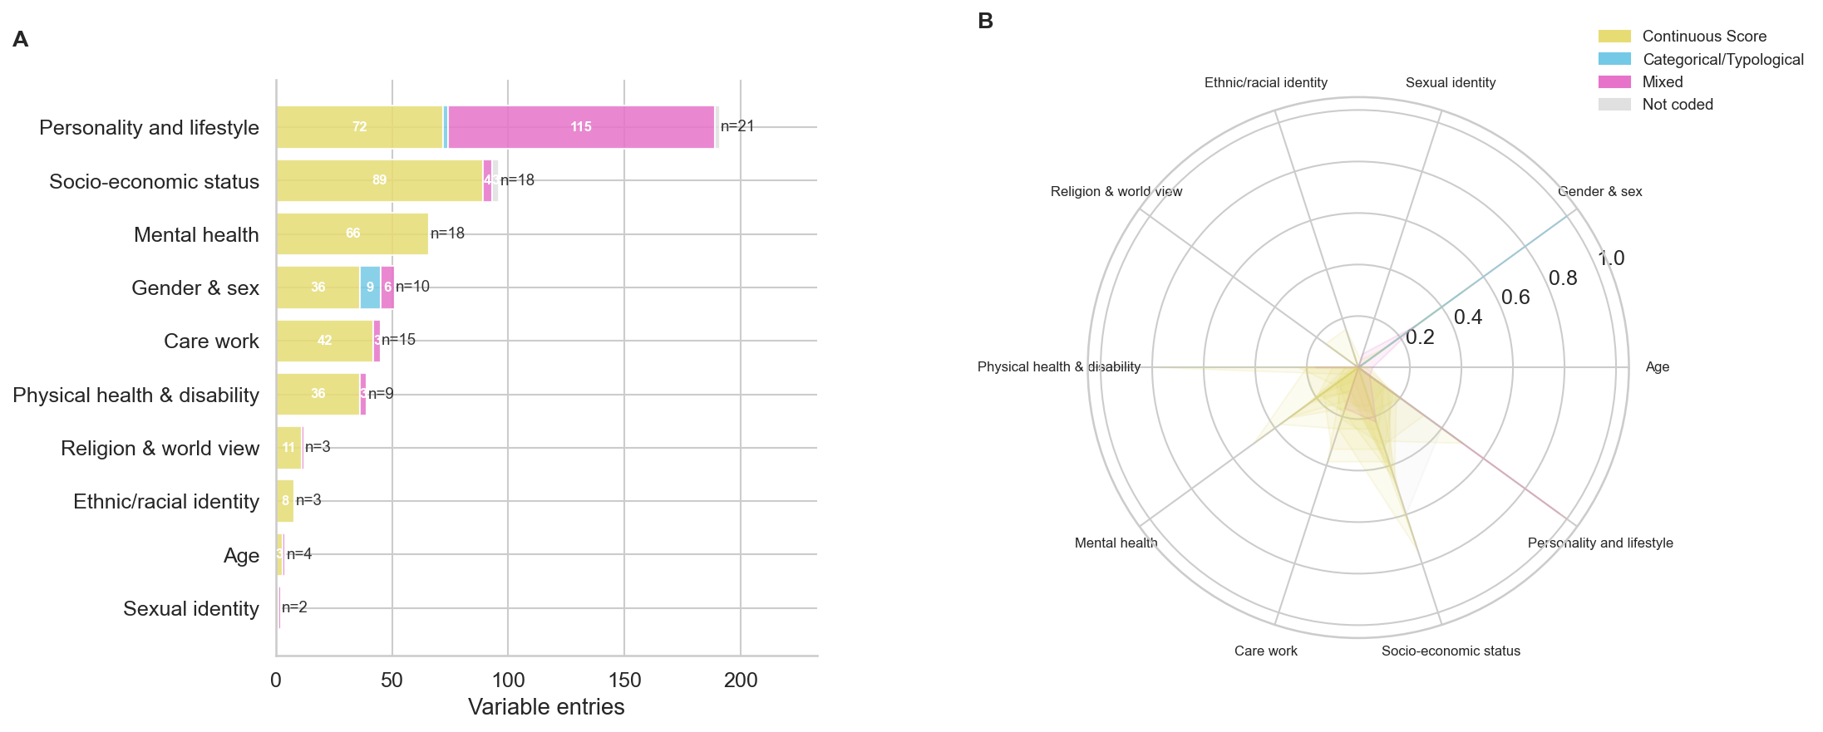
Figure 6: Dimension coverage across the 28 coded instruments, grouped by output type instead of instrument type. The colour legend indicates whether the instrument produces a continuous/composite score, a categorical/typological classification, or both. (A) Variable entries per dimension, stacked by output type. (B) Normalised dimension profile per instrument.
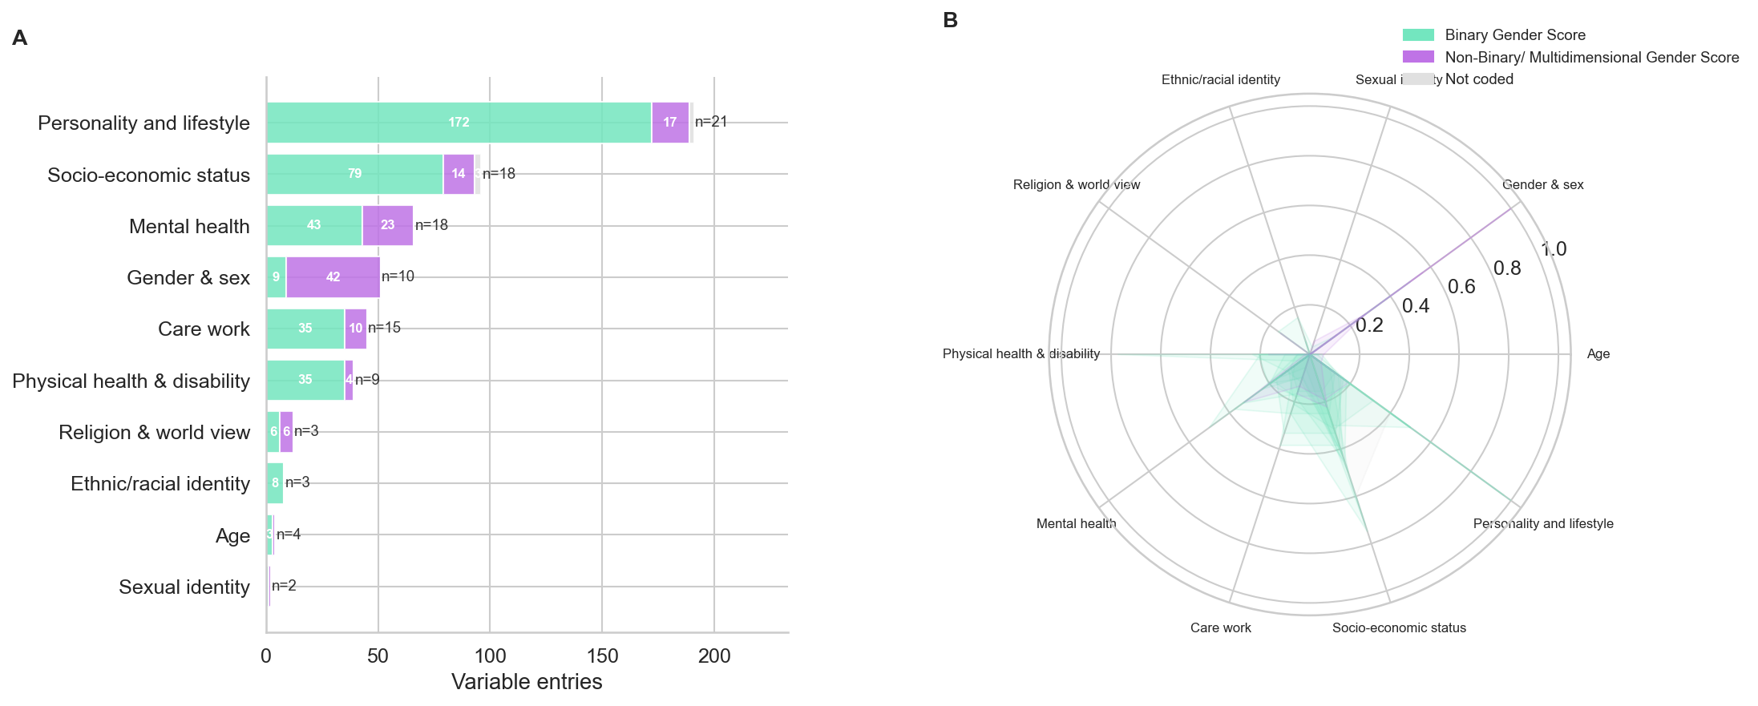
Figure 7: Dimension coverage across the 28 coded instruments, grouped by gender conceptualisation instead of instrument type. The colour legend indicates whether the instrument conceptualises gender as binary (a single masculine-feminine continuum or male/female category) or as non-binary/multidimensional. (A) Variable entries per dimension, stacked by gender conceptualisation. (B) Normalised dimension profile per instrument.
Table 1: Instrument type (main manuscript, following Schindler et al.), output type, and gender conceptualisation for each of the 28 coded instruments.
Instrument | Instrument type | Output type | Gender conceptualisation
Pohrt (2022) | Social gender | Continuous Score | Binary
Ballering (2020) | Social gender | Continuous Score | Binary
Tibubos (2022) | Social gender | Continuous Score | Binary
Nauman (2021) | Social gender | Continuous Score | Binary
Lacasse (2020) | Social gender | Continuous Score | Binary
Teterina (2023) | Social gender | Continuous Score | Binary
Lagos (2021) | Gender identity | Categorical/Typological | Non-binary / multidimensional
Lombardi (2016) | Gender identity | Categorical/Typological | Non-binary / multidimensional
Fraser (2020) | Gender identity | Categorical/Typological | Non-binary / multidimensional
McGuire (2019) | Gender identity | Continuous Score | Non-binary / multidimensional
Nielsen (2021) | Social gender | Continuous Score | Non-binary / multidimensional
Vader (2023) | Social gender | Continuous Score | Binary
Cipriani (2024) | Social gender | Continuous Score | Binary
de Breij (2022) | Social gender | Continuous Score | Binary
Gisinger (2023) | Social gender | Continuous Score | Binary
Wandschneider (2022) | Social gender | Continuous Score | Binary
Yuan (2021) | Social gender | Continuous Score | Binary
Smith (2016) | Social gender | Continuous Score | Binary
Bem (1974) | Social gender | Mixed | Binary
Spence (1975) | Social gender | Mixed | Binary
Pelletier (2015) | Social gender | Continuous Score | Binary
Morgan (2024) | Social gender | Categorical/Typological | Binary
Göttgens (2022) | Social gender | Mixed | Non-binary / multidimensional
Gilbert-Ouimet (2024) | Social gender | Continuous Score | Binary
Gebhard (2024) | Social gender | Continuous Score | Binary
Liechti (2025) | Social gender | Continuous Score | Binary
Dessy (2025) | Social gender | Not coded | Not coded
Raparelli (2023) | Social gender | Continuous Score | Binary

Statistical comparisons
In Figure 8 we present, for completeness, a short statistical comparison between the six semantic clusters. Panel A shows how many dimensions are covered per cluster; panels B and C test whether within-cluster pairs are more similar than cross-cluster pairs, for $J_{w}$ and ${\hat{J}}_{\text{sem}}$ respectively; panel D shows the joint distribution of both metrics across all pairs. The significant differences found in panels B and C support the notion that the semantic clusters are meaningful, and that instruments within the same cluster tend to be more similar to each other than to instruments from other clusters. We note, however, that the pairwise obserevations here are not independent, and that no formal multiple-comparison correction was applied.
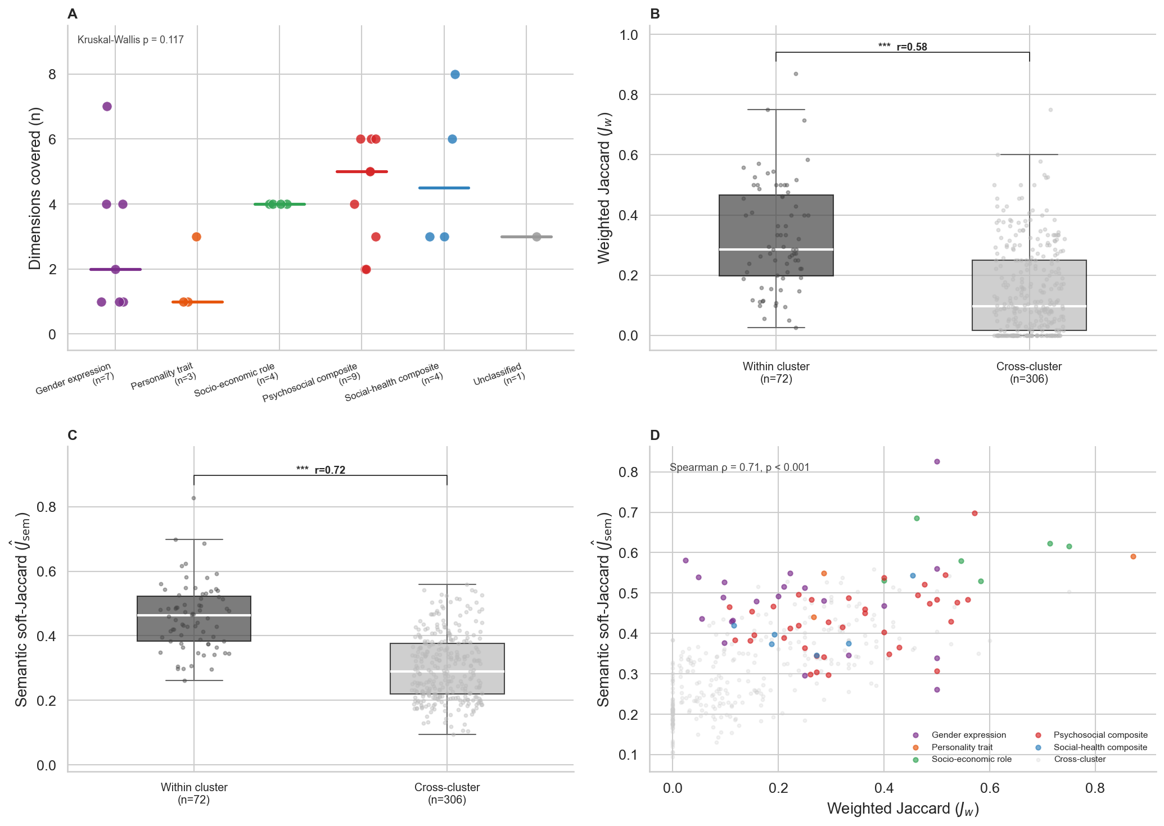
Figure 8: Statistical comparisons using the six semantic clusters. (A) Number of dimensions covered per instrument by cluster; horizontal bars show medians. (B) Pairwise weighted Jaccard similarity ($J_{w}$): within-cluster vs cross-cluster. (C) Pairwise semantic soft-Jaccard (${\hat{J}}_{\text{sem}}$): within-cluster vs cross-cluster. (D) Scatter of $J_{w}$ vs ${\hat{J}}_{\text{sem}}$ for all pairs; within-cluster pairs coloured by cluster, cross-cluster pairs in grey; Spearman ρ annotated. Boxes show IQR; whiskers 1.5×IQR. Significance from two-sided Mann-Whitney U: ns p ≥ 0.05, * p < 0.05, ** p < 0.01, *** p < 0.001; effect sizes are rank-biserial correlations (r). Kruskal-Wallis used for overall cluster comparison in A.

Semantic similarity by instrument classification
We here conduct a statistical test based on the manual classifications of output type gender conceptualisation for each instrument.
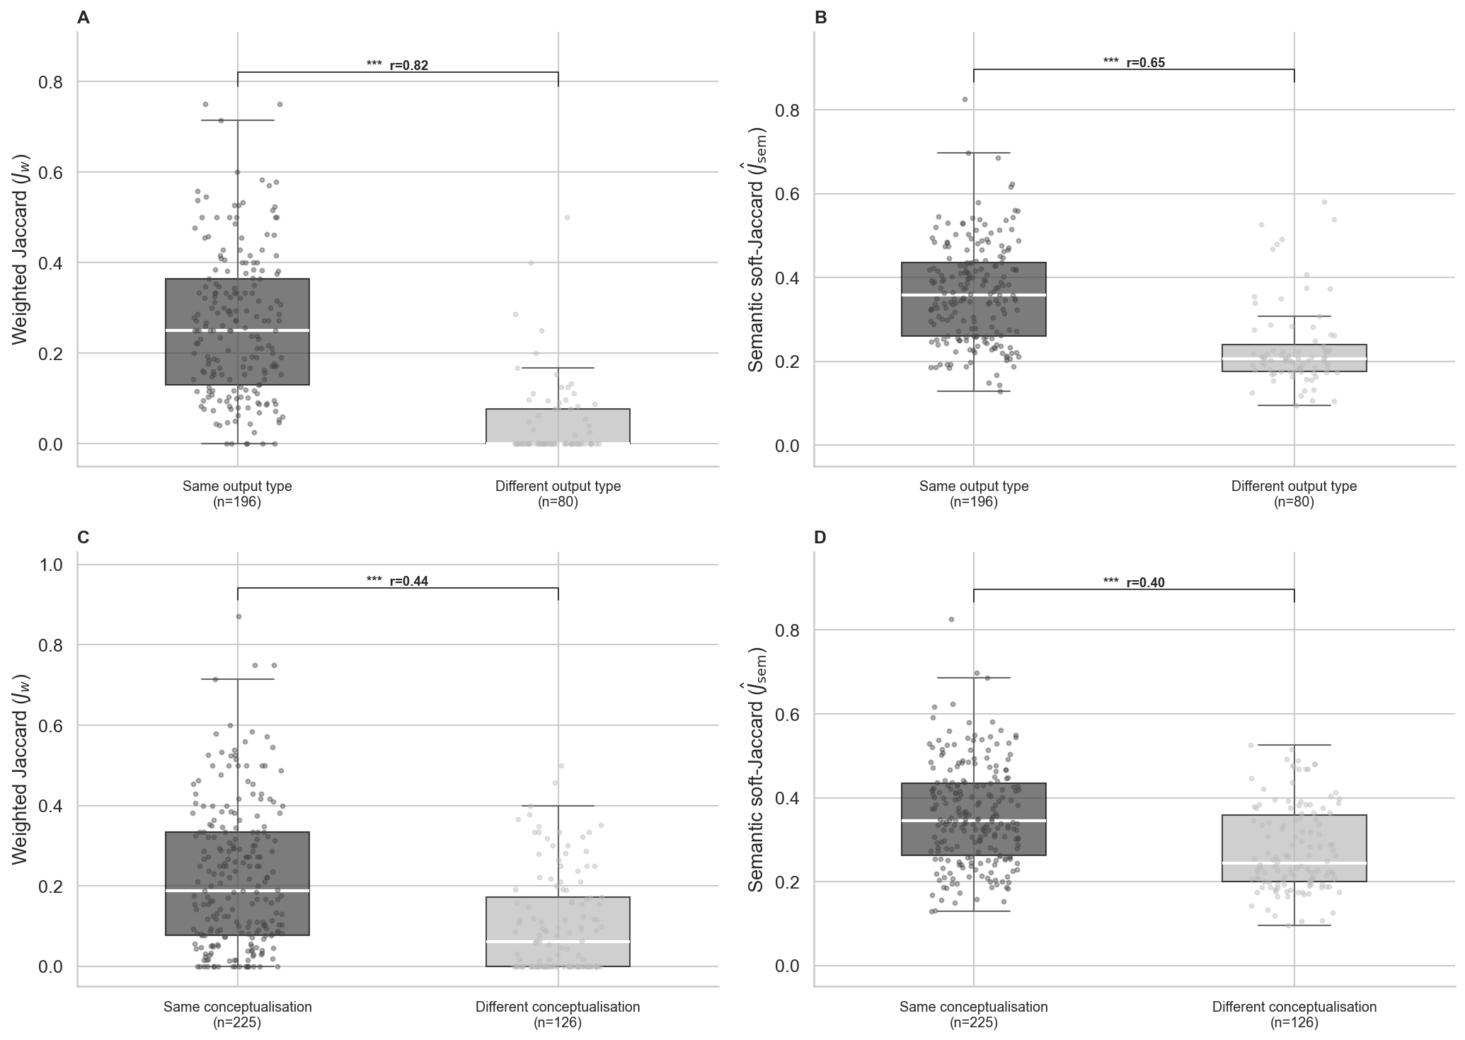
Figure 9: Pairwise similarity grouped by instrument classification. (A, B) Weighted Jaccard ($J_{w}$) and semantic soft-Jaccard (${\hat{J}}_{\text{sem}}$) for instrument pairs sharing the same output type (Continuous/categorical) versus pairs with different output type. (C, D) Weighted Jaccard ($J_{w}$) and semantic soft-Jaccard (${\hat{J}}_{\text{sem}}$) for instruments pairs sharing the same gender conceptualisation (Binary vs Non-binary/Multidimensional). Boxes show IQR; whiskers 1.5×IQR. Significance from two-sided Mann-Whitney U: ns p ≥ 0.05, * p < 0.05, ** p < 0.01, *** p < 0.001; effect sizes are rank-biserial correlations (r).
Instrument pairs sharing an output type were significantly more semantically similar than pairs with different output type (Figure 9 B: $\overline{{\hat{J}}_{\text{sem}}}=0.363$ within vs $\overline{{\hat{J}}_{\text{sem}}}=0.234$ across, Mann-Whitney $U$ with a significance of $p<0.001$) and more structurally similar (panel A). The same held for gender conceptualisation (panels C, D: $\overline{{\hat{J}}_{\text{sem}}}=0.360$ within vs $\overline{{\hat{J}}_{\text{sem}}}=0.277$ across, $p<0.001$).

Concept-network group separation: permutation test
We investigated if the separation between concepts regarding personality and lifestyle items, and the ones regarding socio-economic status and care work, identified in the concept network presented in the main manuscript, was significant. To do so, we have run a permutation test. The observed within-group/between-group edge-weight gap ($Δ=1.15$) falls at the extreme tail of the permutation null distribution (one-sided $p_{empirical}≃0.001$, Figure 10), so the identified separation is unlikely to be a spring-layout artefact.
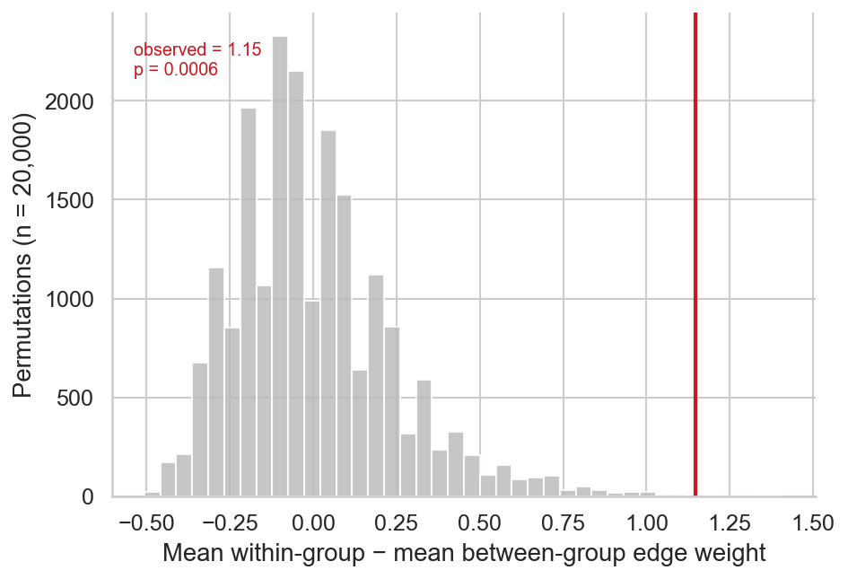
Figure 10: Permutation test for the separation between personality/lifestyle and socio-economic/care-work concept nodes in the concept co-occurrence network figure. The histogram shows the null distribution of (mean within-group edge weight − mean between-group edge weight) over 20,000 random relabellings of the 17 nodes into two groups of the same sizes (8 and 9). The observed value is marked in red.

Semantic heatmap with ordering determined by structural similarity
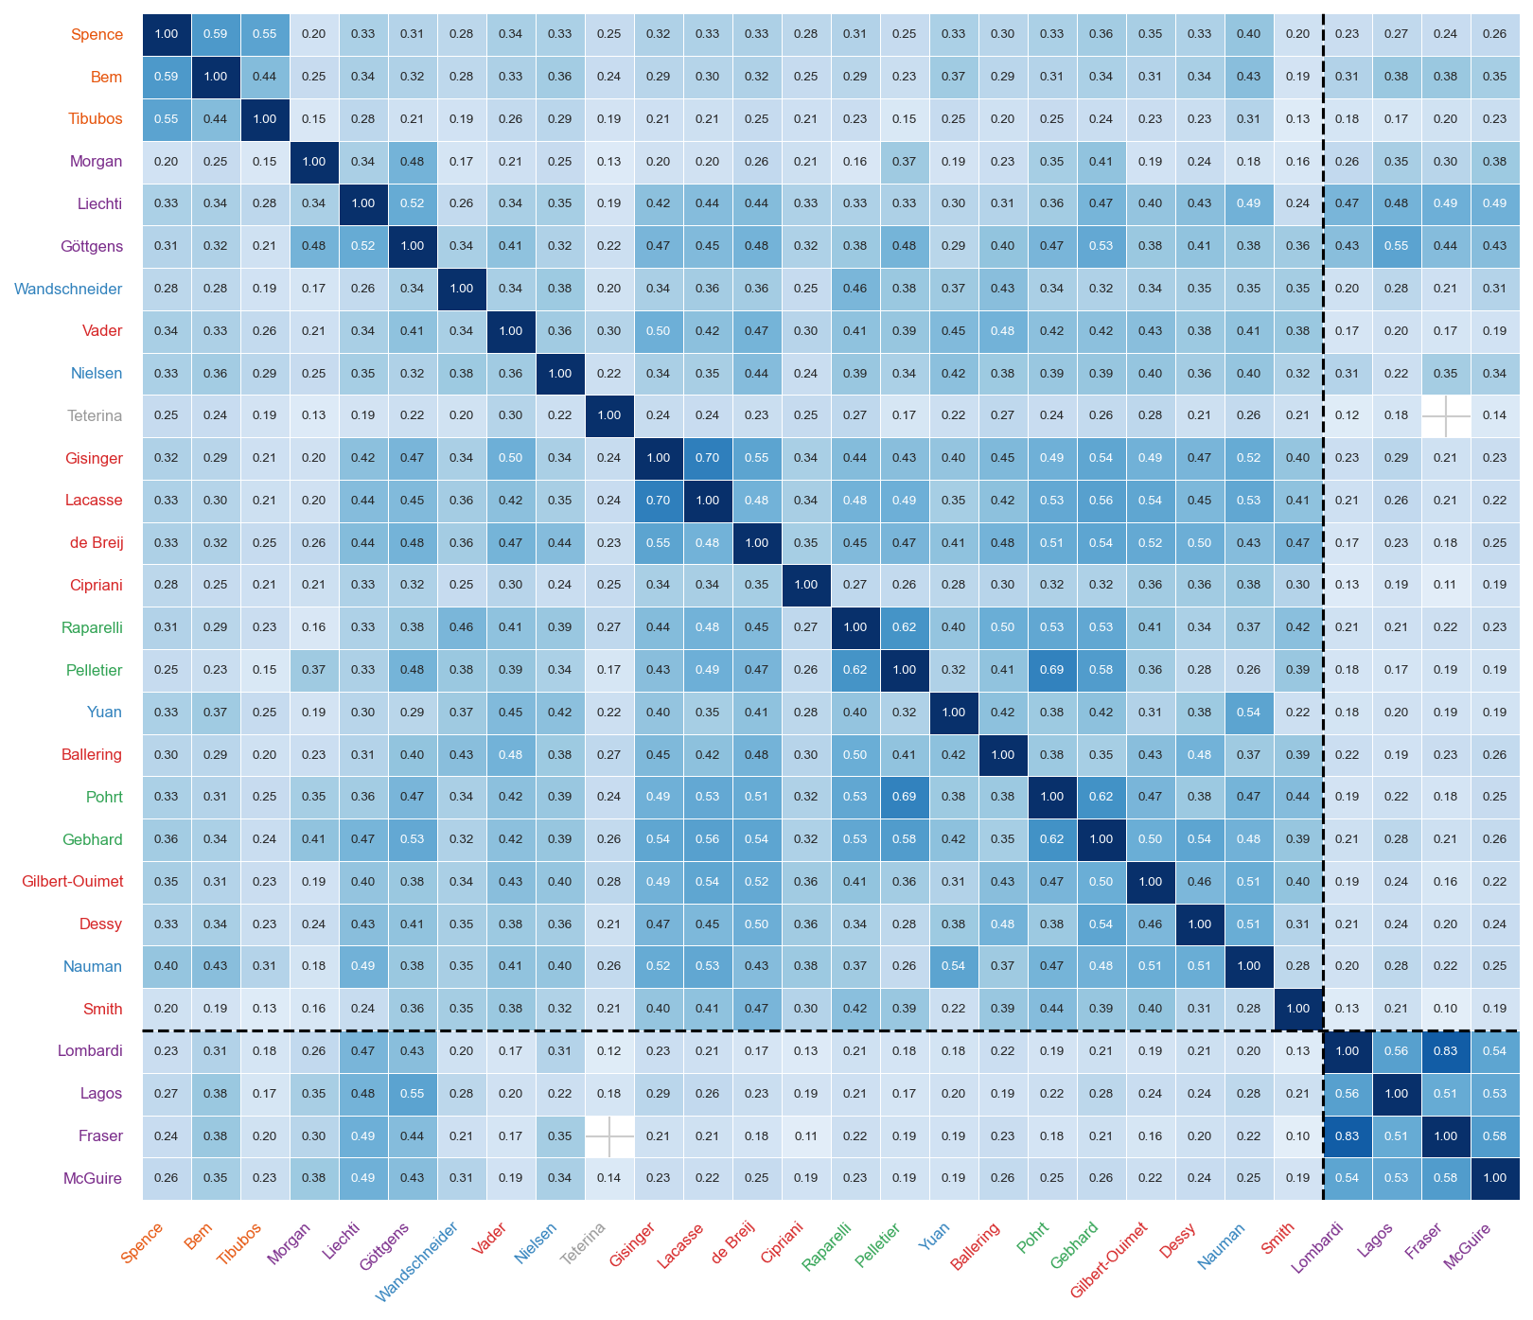
Figure 11: Semantic soft-Jaccard (${\hat{J}}_{\text{sem}}$) similarity matrix for all 28 coded instruments. The order of entries is given by the Ward D2’s linkage method on the dimension similarity, $J_{w}$.

Semantic heatmap grouped by output type and gender conceptualisation
Figure 12 and Figure 13 show the same semantic soft-Jaccard matrix as Figure 11, blocked instead by output type and by gender conceptualisation respectively. Within each block, instruments keep the same Ward’s D2 structural ordering ($J_{w}$) as Figure 11; only the block membership and boundary lines change.
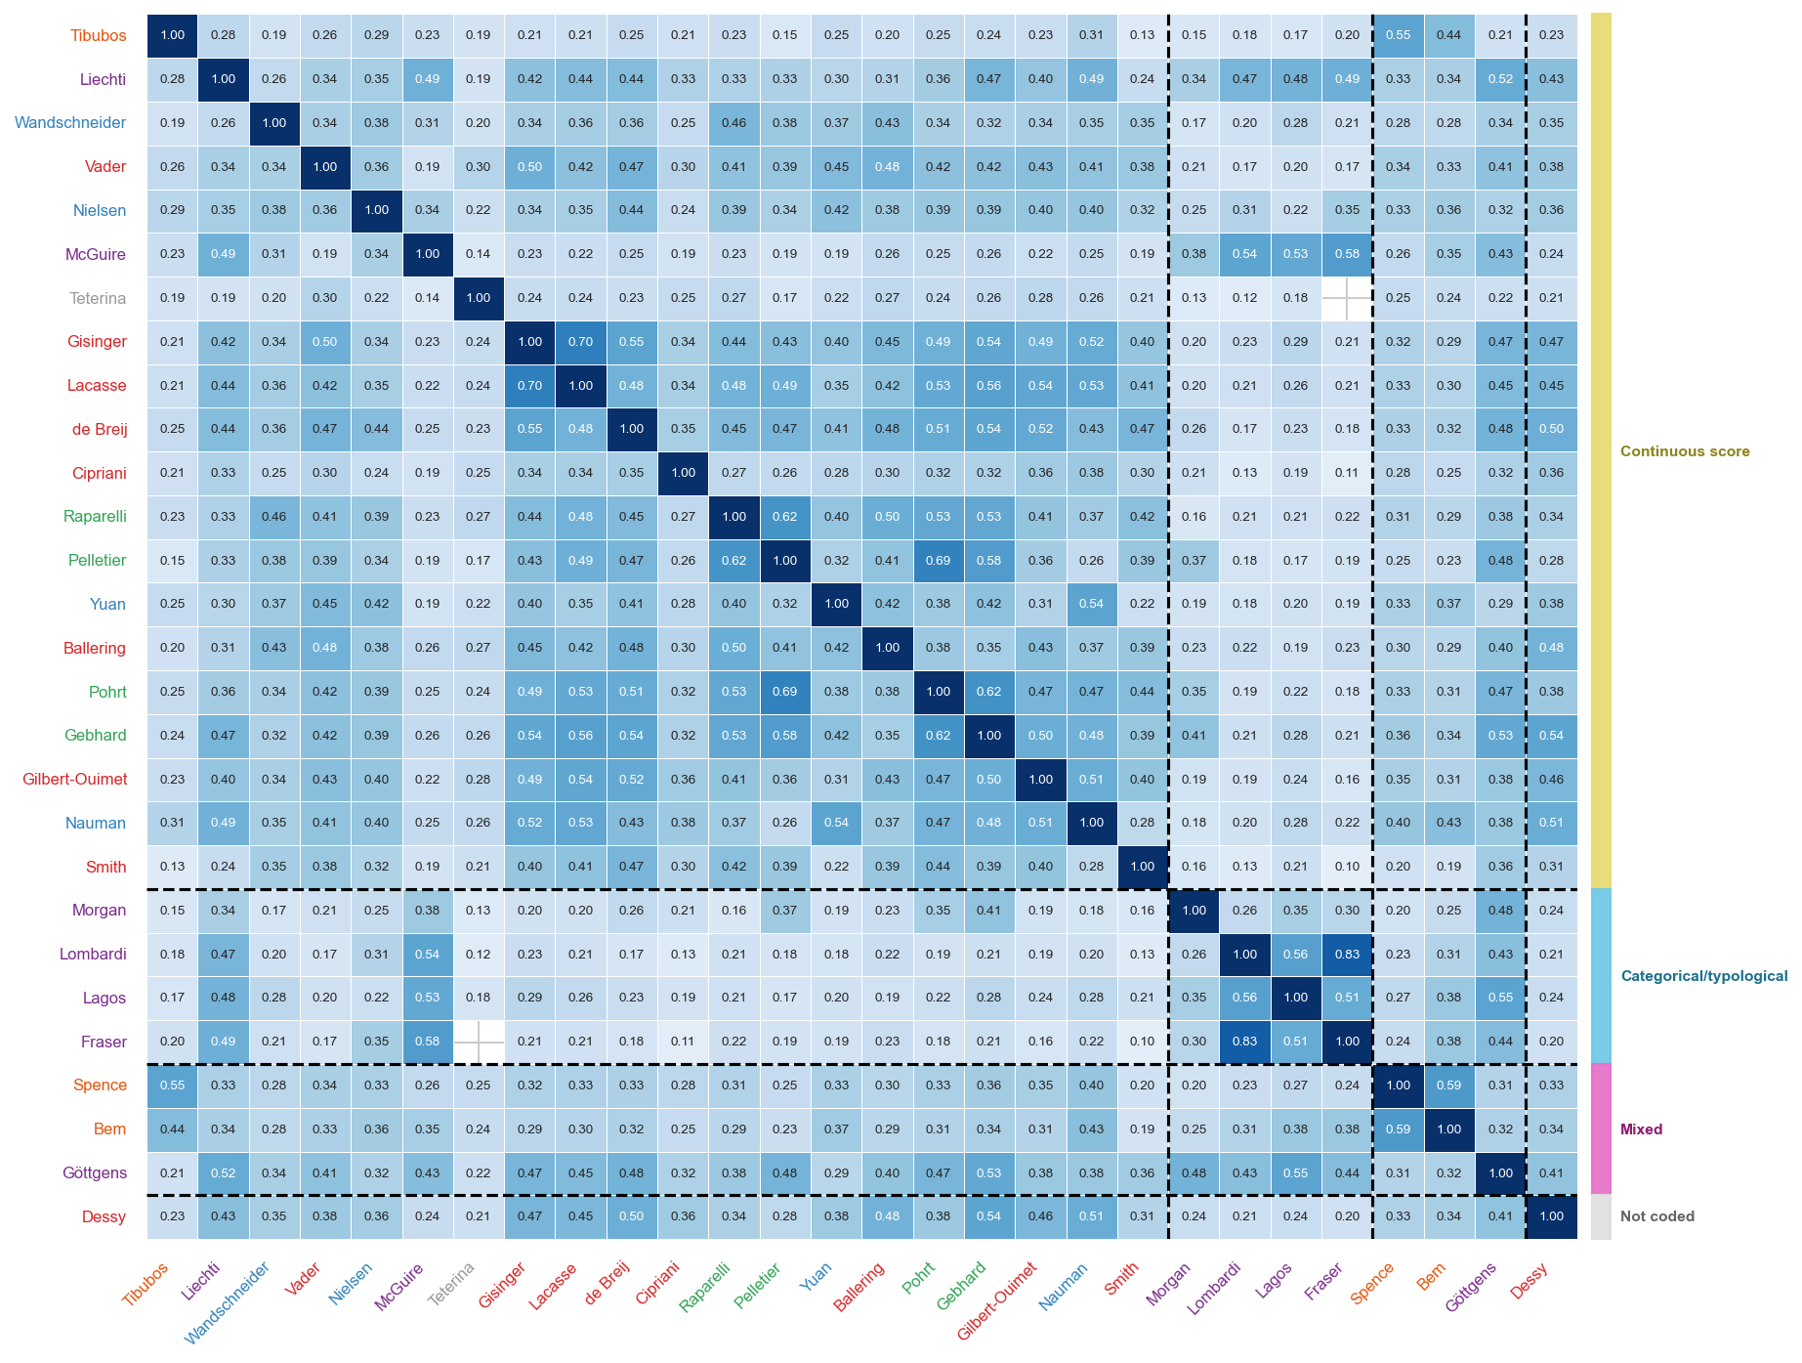
Figure 12: Semantic soft-Jaccard (${\hat{J}}_{\text{sem}}$) similarity matrix for all 28 coded instruments, blocked by output type (continuous score / categorical-typological / mixed / not coded). Within each block, entries are ordered by Ward D2’s linkage method on the dimension similarity, $J_{w}$. Output type of each block is reported on the right.
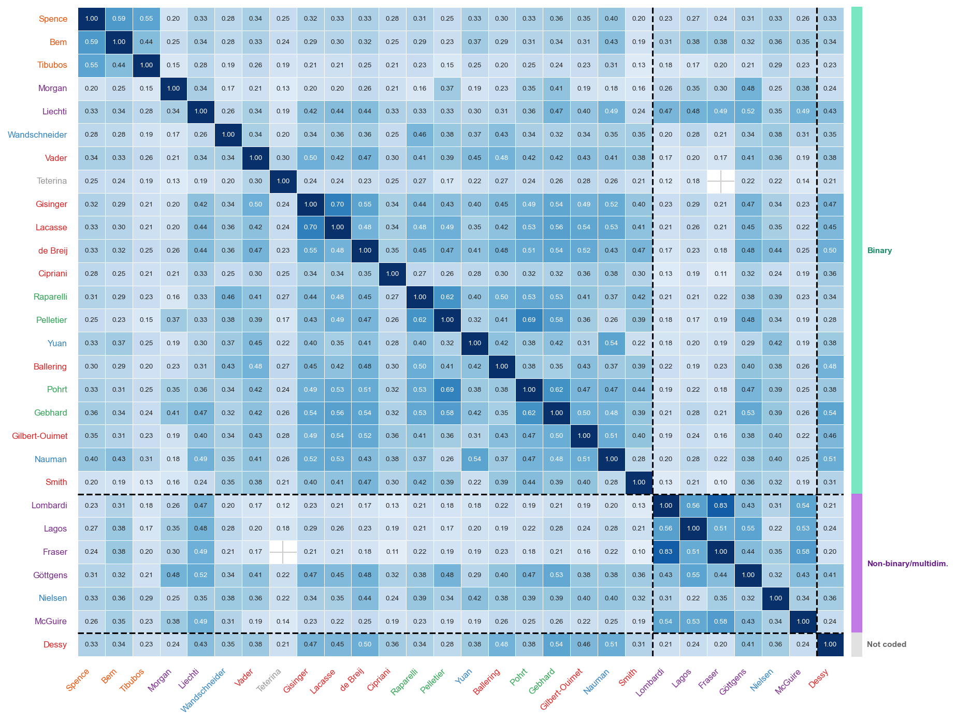
Figure 13: Semantic soft-Jaccard (${\hat{J}}_{\text{sem}}$) similarity matrix for all 28 coded instruments, blocked by gender conceptualisation (binary / non-binary-multidimensional). Within each block, entries are ordered by Ward D2’s linkage method on the dimension similarity, $J_{w}$. Gender conceptualisation of each block is reported on the right.

Concept network sensitivity: c = 15, 20, 25
Figure 14 shows the concept co-occurrence network from the main manuscript repeated at three cluster granularities ($c=15,20,25$).
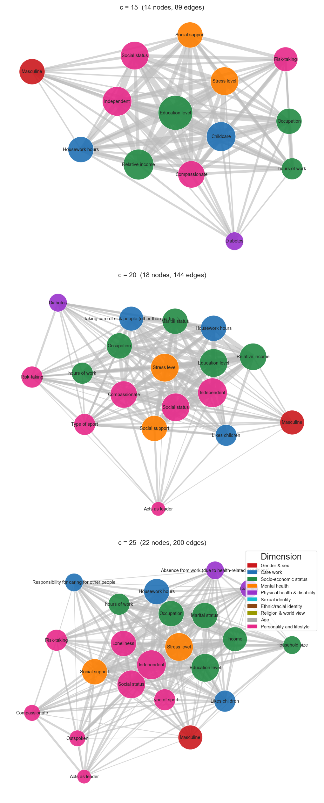
Figure 14: Concept co-occurrence networks at three cluster granularities ($c=15,20,25$), using the same embedding model and Ward’s D2 linkage as the main figure. Node size proportional to instrument count; edges connect clusters co-occurring in the same instrument; edge width proportional to co-occurrence count. Node colour indicates dominant dimension. Nodes appearing in only one instrument are omitted.

Concept network sensitivity: embedding model choice
In this study, we use an embedding model as a means to extract a numerical value to represent the meaning of relatively short text items. This is known to be sensitive to the embedding model used, and the length of the variables themselves. To observe the extent of this dependence, we compared our primary model, all-mpnet-base-v2 [4,5], against three alternative sentence-transformer models: all-MiniLM-L6-v2 [6]; BioLORD-2023;[7] and MedEmbed-base-v0.1 [8]. Ward’s D2 linkage and cluster extraction at $c=25$ were applied identically to each model’s embedding matrix. Figure 15 reports pairwise Adjusted Rand Index (ARI) and Normalized Mutual Information (NMI) between the four resulting partitions. Table 2 reports, for each of the baseline’s 25 clusters, the Jaccard overlap with its best-matching cluster under each alternative model. Figure 16 and Table 3 report a per-variable stability score: the Jaccard overlap between each variable’s co-cluster members under the baseline model and its co-cluster members under each alternative model, averaged over the three alternative models.
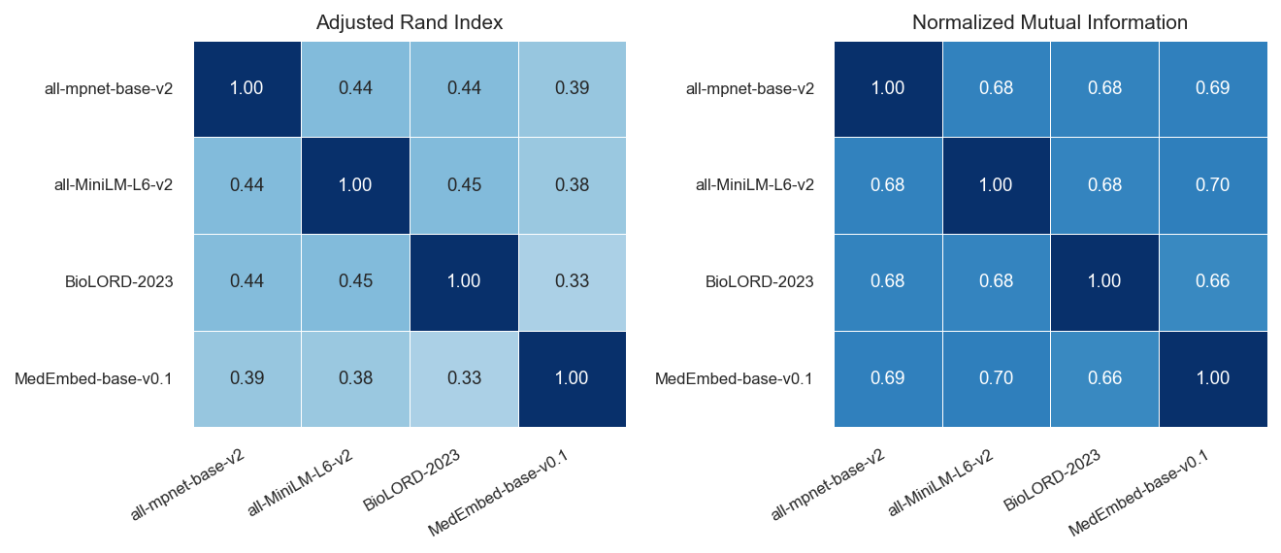
Figure 15: Pairwise agreement between the $c=25$ concept-node clusterings produced by four embedding models (Adjusted Rand Index, left; Normalized Mutual Information, right). Both metrics range from 0 (no agreement beyond chance grouping) to 1 (identical partitions).
Table 2: Best-match Jaccard overlap between each of the concept-node clusters according to the selected sentence-transformer (all-mpnet-base-v2) and its closest-matching cluster under each alternative embedding model.
Cluster label | all-MiniLM-L6-v2 | BioLORD-2023 | MedEmbed-base-v0.1
Absence from work (due to health-related conditions) | 0.210000 | 0.220000 | 0.190000
Acts as leader | 0.250000 | 0.430000 | 0.210000
Because of your gender, how often have you felt discriminated against? | 0.120000 | 1.000000 | 1.000000
Compassionate | 0.200000 | 0.210000 | 0.340000
Diabetes | 0.530000 | 0.470000 | 0.530000
Education level | 0.750000 | 0.500000 | 0.750000
Household size | 0.270000 | 0.410000 | 0.290000
Housework hours | 0.500000 | 0.350000 | 0.550000
In the past year, how often did you feel physically exhausted because of your caretaking responsibilities? | 0.360000 | 0.310000 | 0.820000
Income | 0.920000 | 0.920000 | 0.920000
Independent | 0.260000 | 0.170000 | 0.230000
Likes children | 0.300000 | 0.430000 | 0.260000
Loneliness | 0.160000 | 0.130000 | 0.140000
Marital status | 0.620000 | 0.500000 | 0.360000
Masculine | 0.840000 | 0.910000 | 0.540000
Motorcycle rider injured in noncollision transport accident, driver, nontraffic accident | 0.570000 | 0.930000 | 0.710000
Occupation | 0.890000 | 0.770000 | 0.330000
Outspoken | 0.260000 | 0.250000 | 0.230000
Responsibility for caring for other people | 0.440000 | 0.270000 | 0.600000
Risk-taking | 0.530000 | 0.920000 | 0.690000
Social status | 0.410000 | 0.470000 | 0.120000
Stress level | 0.370000 | 0.150000 | 0.690000
Traffic injury | 0.120000 | 0.200000 | 0.270000
Type of sport | 0.560000 | 0.500000 | 0.530000
hours of work | 0.580000 | 0.390000 | 0.370000

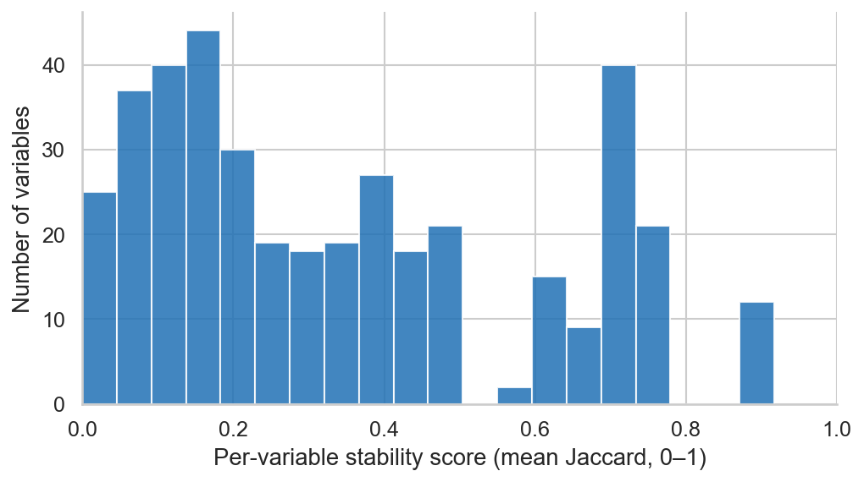
Figure 16: Distribution of per-variable cluster-stability scores across the 397 unique variable strings. Higher values of the stability score (mean Jaccard overlap with co-cluster members under the three alternative embedding models)indicate that a variable keeps the same cluster-mates regardless of which embedding model produced the $c=25$ clustering.
Table 3: The 20 variable strings with the lowest cluster-stability score across the four embedding models, i.e. whose $c=25$ concept-node membership changes the most depending on which model produced the embeddings.
Variable | Baseline cluster | Stability
Year-to-year comparison | Social status | 0.000000
Children below the age of 6 suffer if their mother works | Income | 0.000000
Trust and confidence (someone available to trust and confide in) | Traffic injury | 0.000000
Affirmative rule (behavioral/social trait) | Social status | 0.000000
Skilled in business | Education level | 0.010000
Mechanical aptitude | Education level | 0.010000
Home-oriented | Type of sport | 0.020000
Not timid | Acts as leader | 0.020000
Jealous | Independent | 0.020000
Worked in the last week | Independent | 0.020000
Worked last 12 months | Independent | 0.020000
Problems in relationship with spouse or partner | Absence from work (due to health-related conditions) | 0.020000
BMI (mean, SD) | Stress level | 0.030000
Age | Loneliness | 0.030000
Physical intensity of sport (excl. work) | Stress level | 0.030000
Likes math and science | Type of sport | 0.030000
Enjoys art and music | Type of sport | 0.030000
Needs for security | Traffic injury | 0.030000
Strong conscience | Loneliness | 0.030000
Competitive | Social status | 0.040000

Table 4: Agreement between the primary model (all-mpnet-base-v2) and each alternative model at the coarser six-cluster instrument level ($c=6$), Adjusted Rand Index.
Alternative model | Instrument-level ARI (c=6)
all-MiniLM-L6-v2 | 0.680000
BioLORD-2023 | 0.430000
MedEmbed-base-v0.1 | 0.540000

Clustering of the instruments based on their dimension profiles
Figure 17 shows Ward’s D2 clustering on the weighted Jaccard distance, complementing the semantic dendrogram in the main manuscript, which uses semantic soft-Jaccard distance. The two clusterings largely agree on the main groupings; differences highlight instruments whose dimensional profile and variable vocabulary point in different directions.
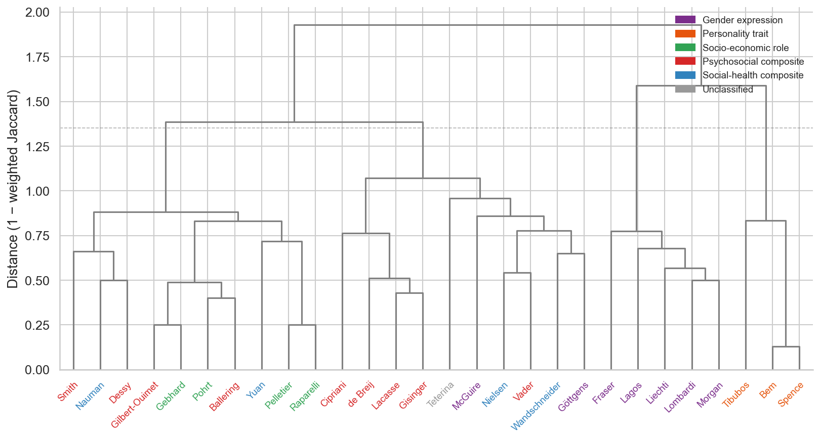
Figure 17: Ward’s D2 hierarchical clustering of weighted Jaccard distance matrix ($1-J_{w}$, n = 28 coded instruments). Leaf labels are coloured by instrument semantic cluster (same colour scheme as the semantic dendrogram in the main manuscript). The dashed line is placed at 70% of the maximum linkage height as a visual reference.

Cluster number selection for semantic clusters
Silhouette coefficients ($k$) were computed for $2≤m≤10$ on the Ward’s D2 solution of the semantic soft-Jaccard distance matrix (Figure 18). Values stayed low throughout ($0.126≤k≤0.201$), indicating weak global cluster structure; the highest score was at $m=4$ ($k=0.201$), where the only change relative to $m=3$ is Teterina splitting off into its own singleton cluster, consistent with it being identified elsewhere as a structural and semantic outlier with no close match to any other instrument in the corpus. The $m=3$ partition itself ($k=0.195$) already separates personality-trait, gender-identity, and composite social gender instruments, and the profile was flat from $m=6$ onward ($0.133≤k≤0.137$). Because the metric did not identify a clear optimal partition, $m=6$ was chosen on interpretability grounds as the largest number of clusters with distinct and labelable content, consistent with the visible branch structure in the semantic dendrogram in the main manuscript.
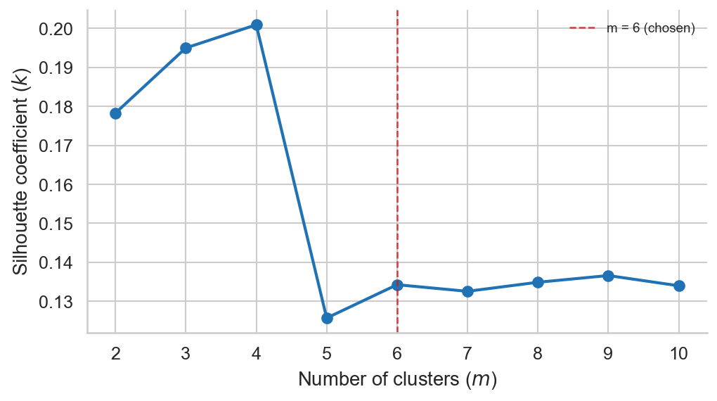
Figure 18: Silhouette coefficients ($k$) for $2≤m≤10$ semantic clusters, derived from Ward’s D2 hierarchical clustering of the semantic soft-Jaccard distance matrix. Higher values indicate better-separated clusters. The dashed line marks $m=6$, the value used in the analysis.

Concept node membership
Table 5 lists the full membership of the 25 concept nodes used to build the concept co-occurrence network in the main manuscript. Each row is one node; the label is the variable string closest to the node centroid; members are sorted alphabetically.
Table 5: Variable strings assigned to each of the 25 concept nodes (Ward’s D2, all-mpnet-base-v2). Node label is the member string closest to the centroid. Members are sorted alphabetically.
Cluster label | Member variable strings
Absence from work (due to health-related conditions) | Absence from work (due to health-related conditions); Absence from work (due to taking care of someone); Asymptomatic human immunodeficiency virus [HIV] infection status; Clinical disease duration; Disease duration; Emotional problems; Experiencing long-term difficulties or negative life events; Limited in work/activities due to emotional problems; Problems in relationship with spouse or partner; Years living with symptoms
Acts as leader | Acts as a leader; Acts as leader; Goes to pieces under pressure - stands up well under pressure; Has leadership abilities; Makes decisions easily; Not easily influenced; Not give up easily; Not timid; Stands up under pressure; Takes a stand; Willing to take a stand; Yielding; can make decisions easily—has difficulty making decisions; never gives up easily—gives up very easily
Because of your gender, how often have you felt discriminated against? | Because of your gender, how often have you felt discriminated against in public settings?; Because of your gender, how often have you felt discriminated against in your family?; Because of your gender, how often have you felt discriminated against when at school?; Because of your gender, how often have you felt discriminated against when getting hired?; Because of your gender, how often have you felt discriminated against when receiving medical care?; Because of your gender, how often have you felt discriminated against?
Compassionate | Affectionate; Agreeableness; Aware of others feelings; Compassionate; Considerate; Friendly; Kind; Likable; Sensitive to the needs of others; Sincere; Sympathetic; Truthful; Warm; Warm to others; not at all aware of feelings of others—very aware of feelings of others; not at all kind—very kind; not at all understanding of others—very understanding of others; very warm in relations with others—very cold in relations with others
Diabetes | Alcohol; Alcohol intake; Arthritis; Chronic pain; Chronic stress; Coronary Heart Disease; Diabetes; Lifestyle (e.g. dieting, alcohol, smoking); Migraine; Regular drinking; Smoking; Smoking cigars or pipe; Type of alcoholic beverage; diabetes; hypertension; lifestyle (e.g. alcoholic uptake); smoking
Education level | Bachelor's degree; Education; Education level; Educational level; Level of education; Mechanical aptitude; Secondary diploma; Skilled in business
Household size | Family load; House ownership; Household food insecurity; Household size; Household size and composition; Household with children; Living Situation; Owner or tenant of household; Private housing
Housework hours | Average hours spent weekly on household chores; Being mainly responsible for housework; Division of household labor; Hours per week spent on housework; Hours/weekday housework; Household chores; Household responsibility; Housework hours; Less participation in household tasks; Number of hours per week doing housework; Primary responsibility for doing housework; Responsibility for housework; Satisfaction with housework; Time spend on household tasks; Time spent on household chores; hours of household activities including cooking dinner; tasks at home (e.g. cooking and household activities)
In the past year, how often did you feel physically exhausted because of your caretaking responsibilities? | How often do you feel emotionally exhausted from your work activities?; How often do you feel physically exhausted from your work activities?; How often does your job involve repetitive tasks?; How often does your job require working fast?; In the past year, how often did you feel emotionally exhausted because of your caretaking responsibilities?; In the past year, how often did you feel physically exhausted because of your caretaking responsibilities?; In the past year, how often did you have someone to help you with daily chores?; In the past year, how often did you have someone to show you love and affection?; In the past year, how often have your caretaking responsibilities caused you to worry about the future?
Income | Being the primary earner of the household; Child support as main source of household income; Children below the age of 6 suffer if their mother works; Household Income; Household income; Households primary earner status; Income; Income (quartiles); Income / Economic role; Personal income; Personal net income; Primary earner status; Relative income
Independent | Adaptable; Adventurous; Ambitious; Analytical; BSRI; CVA; Conventional; Creative; Flatterable; Forward; Grateful; Gullible; High autonomy; Independence; Independent; Individualistic; Inefficient; Jealous; Loyal; Neat; Needs approval; PAQ; Reliable; Self-reliant; Self-sufficient; Theatrical; Unpredictable; Unsystematic; Worked in the last week; Worked last 12 months; not at all independent—very independent
Likes children | Assault by spouse or partner; Childcare; Childlike; Having child; Hostile behaviour during adulthood; Hostile behaviour during childhood; Likes children; Loves children; Parent with child in the house; Physical abuse; Sexual violence during childhood
Loneliness | Age; Anger; Conscientious; Conscientiousness; Cynicism and hostility; Defends own beliefs; Depression; Devotes self to others; Eager to soothe hurt feelings; Emotional intelligence; Extraversion; Feelings hurt; Intellectual; Interested in sex; Knows ways of world; Loneliness; Neuroticism; Outgoing; Religious; Sees self running show; Sexual orientation; Strong conscience; Understanding
Marital status | A person who is living with their partner for the long term should get married.; Being married or living with a partner; Civil status; Division of paid work compared with partner; Education level compared with partner; Education relative to partner/spouse; Hours of work relative to partner/spouse; Marital status; Relationship status; Work and education (compared with partner)
Masculine | A same-sex couple can raise a child just as well as a man and woman.; Another gender identity; Around me, I make sure people are free to express whatever gender roles they want; Auto-identification of sex; Current gender; Feminine; Gender Expression; Gender category changes over time; Gender identity of the attending healthcare provider; Gender identity of the primary healthcare provider; I am non binary, genderqueer, or an identity other than male or female; I dont want to be seen in the gender binary (as either male or female); I encourage others to be more open minded about gender and gender roles; I enjoy it when people are not sure if I am male or female; I have done research about gender theory and gender roles; I try to convince others that society expects people to be too gender conforming; I try to convince others that society should not insist on a gender binary; I try to deliberately confuse people about whether I am male or female; I try to do things that are masculine and feminine at the same time; I will have a non-traditional gender role (be gender non-conforming); In the future, I expect that people will rarely question my gender; In the future, I think my gender will be fluid or change over time; In the future, it will upset me if people misgender me; In the future, my gender expression will be traditional; It would be good for society if transgender people were recognised as normal.; Masculine; My gender comes naturally from within me; My gender is something I have spent a lot of time figuring out; Self-defined gender identity; Self-identification of gender; Sex assigned at birth; The way I show my gender changes depending on who I am with; The way I show my gender is important because I push society to question traditional gender roles; The way I show my gender will probably be mostly the same from day to day; The way I think about my gender has always been the same; The way I think about my gender has been influenced by experiences in my life; The way I think about my gender will probably continue to change further as I age; Transgender identity; What is your gender? (Open-ended item); What is your sex or gender? (Check ALL that apply) - male, female, other: please specify (space for answers); What sex were you assigned at birth? (Check one) - male, female, unknown or question not asked, decline to state
Motorcycle rider injured in noncollision transport accident, driver, nontraffic accident | Animal-rider or occupant of animal-drawn vehicle injured by fall or being thrown from animal in noncollision accident; Animal-rider or occupant of animal-drawn vehicle injured in other and unspecified transport accidents; Bitten or struck by dog; Contact with nonpowered hand tool; Driver of other all-terrain or other off road motor vehicle injured in traffic accident; Fall on and from scaffolding; Fall while being carried or supported by other persons; Fracture of malar and maxillary bones, LeFort 2, closed; Motorcycle rider [any] injured in unspecified nontraffic accident; Motorcycle rider injured in collision with car, pick-up truck or van, driver, traffic accident; Motorcycle rider injured in collision with fixed or stationary object, driver, traffic accident; Motorcycle rider injured in noncollision transport accident, driver, nontraffic accident; Occupant of heavy transport vehicle injured in noncollision transport accident; Traumatic brain injury
Occupation | Employment; Hours spent weekly doing odd jobs; Occupation; Occupation segregation; Occupation segregation (female workers); Occupation type; Occupation-related components (e.g. profession, housewife/-husband); Occupational position; Occupational segregation; Odd jobs; Paid work; Self-employment; Time spend on odd jobs; Unpaid work; Working experience part-time employment; spending leisure time by performing odd jobs; work-related variables (e.g. profession)
Outspoken | Active; Aggressive; Assertive; Cheerful; Conceited; Cries easily; Does not use harsh language; Dominant; Emotional; Expresses tender feelings; Forceful; Gentle; Happy; How easy is it for you to express what you are feeling to others?; Loud; Moody; Not hide emotions; Outspoken; Secretive; Self confident; Shy; Soft spoken; Solemn; Tactful; Tender; not at all emotional—very emotional; not at all self-confident—very self-confident; very passive—very active; very rough—very gentle
Responsibility for caring for other people | Caregiver strain; Informal caregiving; Responsibility educating and upbringing people; Responsibility for caring for children; Responsibility for caring for other people; Responsibility for picking up people when they become ill; Taking care of sick people; Taking care of sick people (other than partner)
Risk-taking | Behavioral traits (e.g. risk-taking); How prepared are you to take risks when it comes to recreational activities?; How prepared are you to take risks when making financial decisions?; In general, how prepared are you to take risks?; Psychological traits (e.g. mood, neuroticism); Risk willingness; Risk-taking; Risk-taking behaviour; Strong personality; Willing to take risks; Willingness to take risks; personality and lifestyle and emotions (e.g. discipline, impulsiveness, self-conscoiusness, vulnerability); personality characteristics
Social status | Affirmative rule (behavioral/social trait); Competitive; Discrimination; Feels superior; Feels superior - feels very inferior; Immigrant; Perceived social standing; Racial group; Racial/cultural group; Sense of belonging to a community; Sense of belonging to the local community; Social status; Socioeconomic status; Socioeconomic status (SES); Year-to-year comparison; feels superior—feels very inferior; not at all competitive—very competitive
Stress level | Amount of stress; BMI (mean, SD); Depressive symptoms, M(SD); Energetic and vibrant; Excitable, major crisis; Exhausted and tired; Feeling energetic and vibrant; Feeling exhausted and tired; Feeling of nervousness; High cognitive demands; High physical demands; High psychological demands; High variation in tasks; Level of stress at home; Nervousness; Not excitable, minor crisis; Perceived life stress; Perceived life stress: stress during the day; Physical intensity; Physical intensity of sport (excl. work); Physical job demands; Sleep efficacy; Sleep satisfaction; Stress at work; Stress level; Work strain
Traffic injury | Emotional support received; Helpful; Helpful to others; High social support; How important is it for you to be independent?; How important is it for you to solve your problems on your own?; How often do friends talk to you about their problems?; How often do you talk to your friends about your problems?; Needs for security; Social support; Social support outside from work; Trust and confidence (someone available to trust and confide in); Worried about crime in Germany; Worried about global terrorism; Worried about own retirement pension; not at all helpful to others—very helpful to others
Type of sport | Aesthetic sports; Athletic; Engagement in social leisure activities (including sports of moderate/strenuous intensity, dancing); Enjoys art and music; Good at sports; Home-oriented; Horse riding sports; Hours/weekday leisure, hobbies; Leisure activities (e.g. type of sport); Likes math and science; Other specified gymnastic and aesthetic sports and recreational activity; Type of sport; physical activity-related variables (e.g. type of sport activities)
hours of work | Hours/weekday repairs; Number of working hours per week; On average, how many hours per weekday do you spend on taking care of someone in need (caring for children, elders, partners in need, etc.)?; On average, how many hours per weekday do you spend on the following: Work (paid work, studying, internships, etc.)?; Work time (per week); Working hours; hours of work

Supplementary analysis of the results concerning similarity metrics
We here aim to clarify the role of $J_{w}$ and ${\hat{J}}_{sem}$. $J_{w}$ shows whether two instruments invest in the same dimensions; ${\hat{J}}_{sem}$ shows whether they use similar variable language within those dimensions. High $J_{w}$ with lower ${\hat{J}}_{sem}$ indicates similar dimensional targets reached through different variables; low $J_{w}$ with high ${\hat{J}}_{sem}$ indicates related vocabulary distributed across different structures. In such cases, the mismatch can arise for at least two reasons: similar terms may be used for different constructs, or closely related variables may have been assigned to different dimensions by the raters involved in this manuscript.
We now go through some comparison in detail, discussing the contained items for each instruments. We do this for the readers interested in better understanding how to read the presented heatmaps, or to enhance them in future studies.
Raparelli and Pelletier are the pair with the highest values on both metrics ($J_{w}=0.75$, ${\hat{J}}_{sem}=0.62$) [9,10]; both instruments were built from socio-economic role items through logistic regression against biological sex, and their shared vocabulary of housework hours, earner status, and emotional support is reflected in the high semantic score. Pohrt and Ballering illustrate the case where dimensional structure is moderately similar but variable language diverges ($J_{w}=0.60$, ${\hat{J}}_{sem}=0.38$) [11,12]. Both instruments invest in care work, socio-economic status, mental health, and personality and lifestyle; Ballering additionally includes a physical health component. However, Pohrt uses specific social role items (“Personal net income”, “BSRI”, “Hours per week spent on housework”) while Ballering uses broad behavioural block labels (“personality and lifestyle and emotions”, “Lifestyle (e.g. dieting, alcohol, smoking)”, “Occupation-related components”). Thus, the two instruments ask questions along the same areas, but the questions themselves do not appear similar.
Fraser and McGuire have high semantic similarity alongside very different dimensional structures ($J_{w}=0.02$, ${\hat{J}}_{sem}=0.58$) [13,14]. Fraser is a single open-ended item (“What is your gender?”) assigned entirely to the gender-and-sex dimension; McGuire’s Genderqueer Identity Scale contains 23 items spread across gender and sex, mental health, religion and world view, and personality and lifestyle. For the embedding model, the average of the 23 items is semantically close to Fraser’s single item, producing a high ${\hat{J}}_{sem}$.
The Pohrt/Gebhard/Gilbert-Ouimet sub-cluster (pairwise $J_{w}$ 0.53–0.75) [11,15,16] illustrates convergence driven by a single shared dimension: all three invest heavily in socio-economic status, and that alignment alone produces moderate-to-high $J_{w}$. Secondary components diverge: Pohrt and Gebhard additionally share BSRI adjectives and social support items, while Gilbert-Ouimet substitutes attitudinal personality constructs (cynicism, hostility) and physical job demands.

References
[1] Wandschneider L, Sauzet O, Razum O, Miani C. Development of a gender score in a representative German population sample and its association with diverse social positions. Frontiers in Epidemiology 2022;2. https://doi.org/10.3389/fepid.2022.914819.
[2] Schindler L, Beelich H, Katsari E, Liprandi D, Stracke S, Waltemath D. Applicability of Existing Gender Scores for German Clinical Research Data: Scoping Review and Data Mapping. JMIR Medical Informatics 2026;14:e74162. https://doi.org/10.2196/74162.
[3] Horstmann S, Schmechel C, Palm K, Oertelt-Prigione S, Bolte G. The Operationalisation of Sex and Gender in Quantitative Health-Related Research: A Scoping Review. International Journal of Environmental Research and Public Health 2022;19:7493. https://doi.org/10.3390/ijerph19127493.
[4] Song K, Tan X, Qin T, Lu J, Liu T-Y. MPNet: Masked and Permuted Pre-Training for Language Understanding. Advances in Neural Information Processing Systems, vol. 33, Curran Associates, Inc.; 2020, p. 16857–67.
[5] Reimers N, Gurevych I. Sentence-BERT: Sentence Embeddings using Siamese BERT-Networks. Proceedings of the 2019 Conference on Empirical Methods in Natural Language Processing and the 9th International Joint Conference on Natural Language Processing (EMNLP-IJCNLP), Hong Kong, China: Association for Computational Linguistics; 2019, p. 3980–90. https://doi.org/10.18653/v1/D19-1410.
[6] Wang W, Wei F, Dong L, Bao H, Yang N, Zhou M. MiniLM: Deep Self-Attention Distillation for Task-Agnostic Compression of Pre-Trained Transformers. Advances in Neural Information Processing Systems, vol. 33, Curran Associates, Inc.; 2020, p. 5776–88.
[7] Remy F, Demuynck K, Demeester T. BioLORD-2023: Semantic textual representations fusing large language models and clinical knowledge graph insights. Journal of the American Medical Informatics Association 2024;31:1844–55. https://doi.org/10.1093/jamia/ocae029.
[8] Balachandran A. MedEmbed: Fine-Tuned Embedding Models for Medical/Clinical IR 2024.
[9] Raparelli V, Romiti GF, Di Teodoro G, Seccia R, Tanzilli G, Viceconte N, et al. A machine-learning based bio-psycho-social model for the prediction of non-obstructive and obstructive coronary artery disease. Clinical Research in Cardiology 2023;112:1263–77. https://doi.org/10.1007/s00392-023-02193-5.
[10] Pelletier R, Ditto B, Pilote L. A Composite Measure of Gender and Its Association With Risk Factors in Patients With Premature Acute Coronary Syndrome. Biopsychosocial Science and Medicine 2015;77:517. https://doi.org/10.1097/PSY.0000000000000186.
[11] Pohrt A, Kendel F, Demuth I, Drewelies J, Nauman T, Behlouli H, et al. Differentiating Sex and Gender Among Older Men and Women. Psychosomatic Medicine 2022;84:339–46. https://doi.org/10.1097/PSY.0000000000001056.
[12] Ballering AV, Bonvanie IJ, Olde Hartman TC, Monden R, Rosmalen JGM. Gender and sex independently associate with common somatic symptoms and lifetime prevalence of chronic disease. Social Science &Amp; Medicine 2020;253:112968. https://doi.org/10.1016/j.socscimed.2020.112968.
[13] Fraser G, Bulbulia J, Greaves LM, Wilson MS, Sibley CG. Coding Responses to an Open-ended Gender Measure in a New Zealand National Sample. The Journal of Sex Research 2020;57:979–86. https://doi.org/10.1080/00224499.2019.1687640.
[14] McGuire JK, Beek TF, Catalpa JM, Steensma TD. The Genderqueer Identity (GQI) Scale: Measurement and validation of four distinct subscales with trans and LGBQ clinical and community samples in two countries. International Journal of Transgenderism 2018;20:289–304. https://doi.org/10.1080/15532739.2018.1460735.
[15] Gebhard CE, Sütsch C, Gebert P, Gysi B, Bengs S, Todorov A, et al. Impact of sex and gender on post-COVID-19 syndrome, Switzerland, 2020. Eurosurveillance 2024;29. https://doi.org/10.2807/1560-7917.ES.2024.29.2.2300200.
[16] Gilbert-Ouimet M, Zahiriharsini A, Blanchette C, Talbot D, Trudel X, Milot A, et al. Developing a gender measure and examining its association with cardiovascular diseases incidence: A 28-year prospective cohort study. BMC Medicine 2024;22. https://doi.org/10.1186/s12916-024-03706-3.

