Synthesis, Characterisation and Biological Evaluation of Some 5-Trifluoromethylisoxazole Derivatives

Kamalneet Kaur¹, Aman Kumar², Nisha², Ekta², Chetan Sharma³, Vishal Sharma⁴, Sundeep Jaglan⁴, Rakesh Kumar Bhardwaj², Ramesh Kataria⁵, Vikas Beniwal⁶, Vinod Kumar*²

¹Department of Chemistry, M. M. Deemed to be University, Mullana-Ambala, 133207, India
²Department of Chemistry, Central University of Haryana, Mahendergarh, 123031, India
³Department of Biotechnology, M. M. Deemed to be University, Mullana-Ambala, 133207, India
⁴Fermentation & Microbial Biotechnology Division, CSIR-Indian Institute of Integrative Medicine, Jammu and Kashmir, 180001, India
⁵Department of Chemistry & Centre for Advanced Studies in Chemistry, Panjab University, Chandigarh-160014, India
⁶Department of Microbiology, Central University of Haryana, Mahendergarh, 123031, India
*Corresponding author: vinodbatan@gmail.com, vinodkumar@cuh.ac.in

S. No. | Contents | Pages
1. | ¹H, ¹³C NMR, FT-IR, HRMS and ¹⁹F NMR spectra of compound 3a | 4–7
2. | ¹H, ¹³C NMR, FT-IR and HRMS spectra of compound 3b | 8–10
3. | ¹H, ¹³C NMR, FT-IR and HRMS spectra of compound 3c | 11–13
4. | ¹H, ¹³C NMR, FT-IR and HRMS spectra of compound 3d | 14–16
5. | ¹H, ¹³C NMR, FT-IR and HRMS spectra of compound 3e | 17–19
6. | ¹H, ¹³C NMR, FT-IR and HRMS spectra of compound 3f | 20–23
7. | ¹H, ¹³C NMR, FT-IR and HRMS spectra of compound 3g | 24–26
8. | ¹H, ¹³C NMR, FT-IR and HRMS spectra of compound 3h | 27-29
9. | ¹H, ¹³C NMR, FT-IR and HRMS spectra of compound 3i | 30–32
10. | ¹H, ¹³C NMR, FT-IR and HRMS spectra of compound 3j | 33–35
11. | ¹H, ¹³C NMR, FT-IR and HRMS spectra of compound 3k | 36–37
12. | ¹H, ¹³C NMR, FT-IR and HRMS spectra of compound 3l | 38–41
13. | ¹H, ¹³C NMR, FT-IR and HRMS spectra of compound 3m | 42–44
14. | ¹H, ¹³C NMR, FT-IR and HRMS spectra of compound 3n | 45–46
15. | ¹H, ¹³C NMR, FT-IR and HRMS spectra of compound 3aa | 47–49
16. | ¹H, ¹³C NMR, FT-IR and HRMS spectra of compound 3ab | 50–52
17. | ¹H, ¹³C NMR, FT-IR and HRMS spectra of compound 3ac | 53–55
18. | ¹H, ¹³C NMR, FT-IR and HRMS spectra of compound 3ad | 56–58
19. | ¹H, ¹³C NMR, FT-IR and HRMS spectra of compound 3ae | 59-61
20. | ¹H, ¹³C NMR, FT-IR and HRMS spectra of compound 3af | 62–64
21. | ¹H, ¹³C NMR, FT-IR and HRMS spectra of compound 3ag | 65–66
22. | ¹H, ¹³C NMR, FT-IR and HRMS spectra of compound 3ah | 67
23. | ¹H, ¹³C NMR, FT-IR and HRMS spectra of compound 3ai | 68–69
24. | ¹H, ¹³C NMR, FT-IR and HRMS spectra of compound 3aj | 70–72
25. | ¹H, ¹³C NMR, FT-IR and HRMS spectra of compound 3ak | 73
26. | ¹H, ¹³C NMR, FT-IR and HRMS spectra of compound 3al | 74–75
27. | ¹H, ¹³C NMR, FT-IR and HRMS spectra of compound 3am | 76–78
28. | ¹H, HRMS spectra of compound 3an | 79
29. | Table 1. Physical properties of the synthesized 4-(aryldiazenyl)-3-aryl-5-hydroxy-5-(trifluoromethyl)-4,5-dihydroisoxazole derivatives 3a–3n and 3aa–3an | 80-81
30. | Table 2. Zones of inhibition of compounds 3a–3an against selected microbial strains determined by the agar well diffusion method at 400 µg/100 µL | 81-82
31. | Table 3. Antimicrobial activity of compounds 3a–3an expressed as minimum inhibitory concentration (MIC, µg/100 µL) | 82-83
32. | Table 4. In vitro free-radical-scavenging activity of the synthesized compounds 3a–3an determined by the DPPH assay | 84
33. | Effect of compounds on plasmid DNA under UV-irradiation | 85

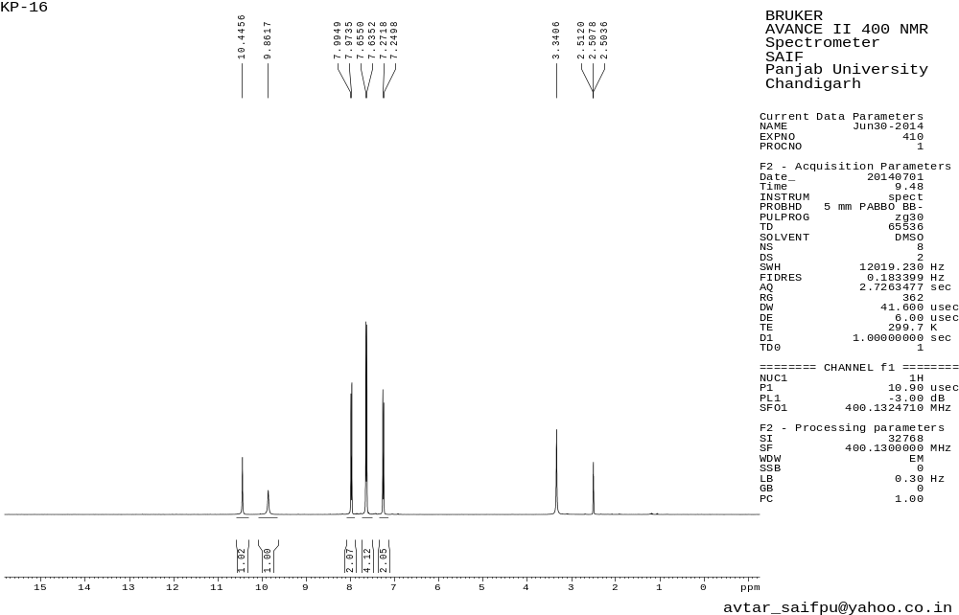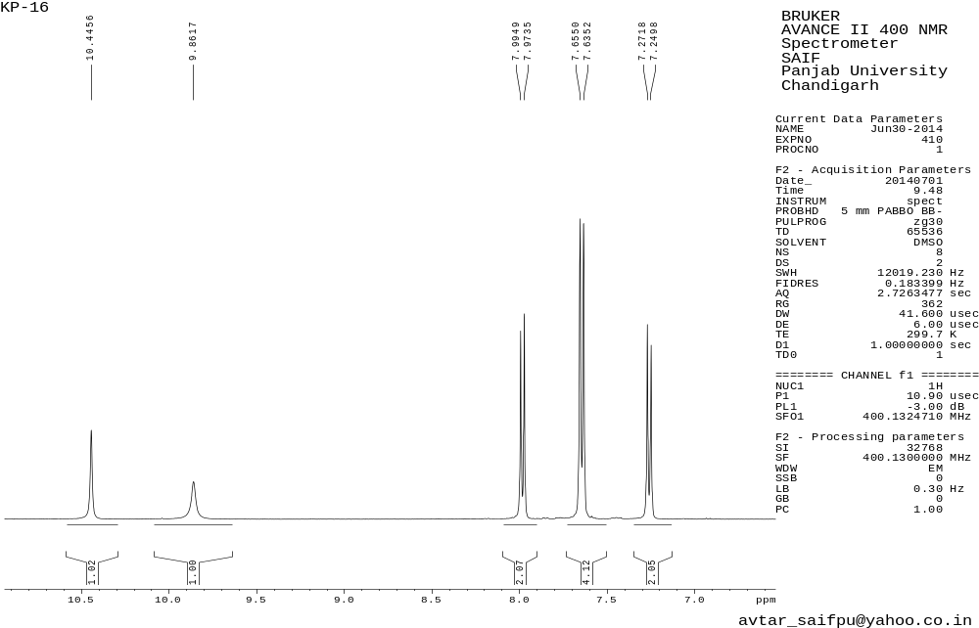Figure 1.1 ¹H NMR spectrum of 3a
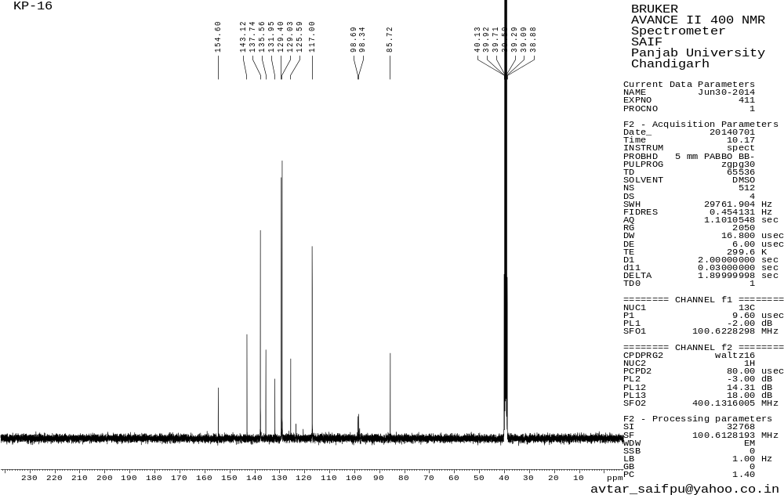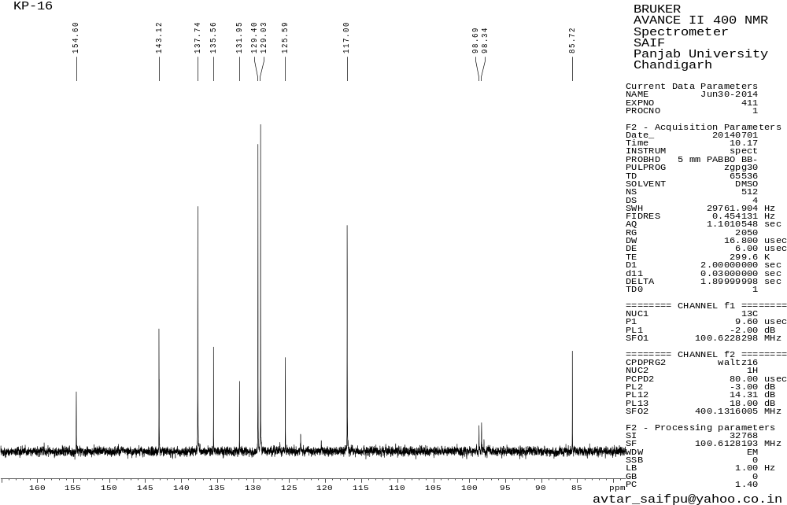Figure 1.2 ¹³C NMR spectrum of 3a

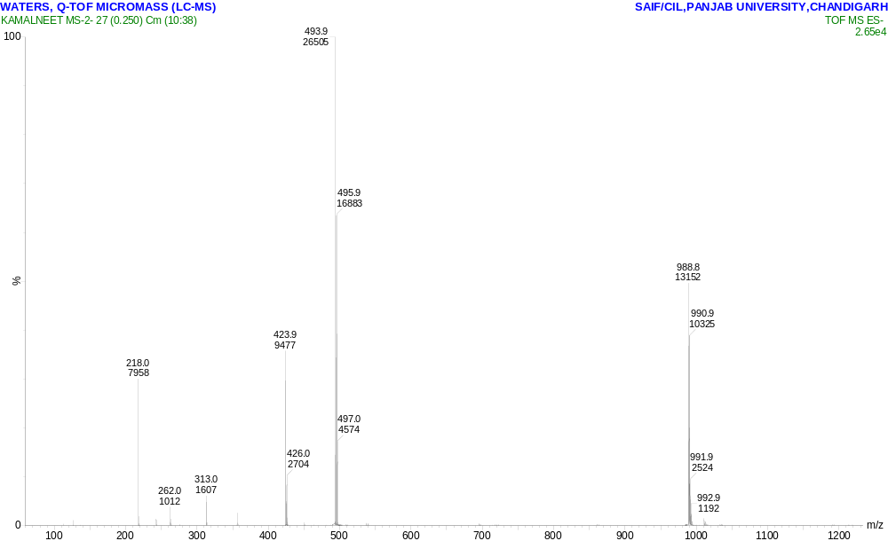
Figure 1.3 HRMS spectrum of 3a
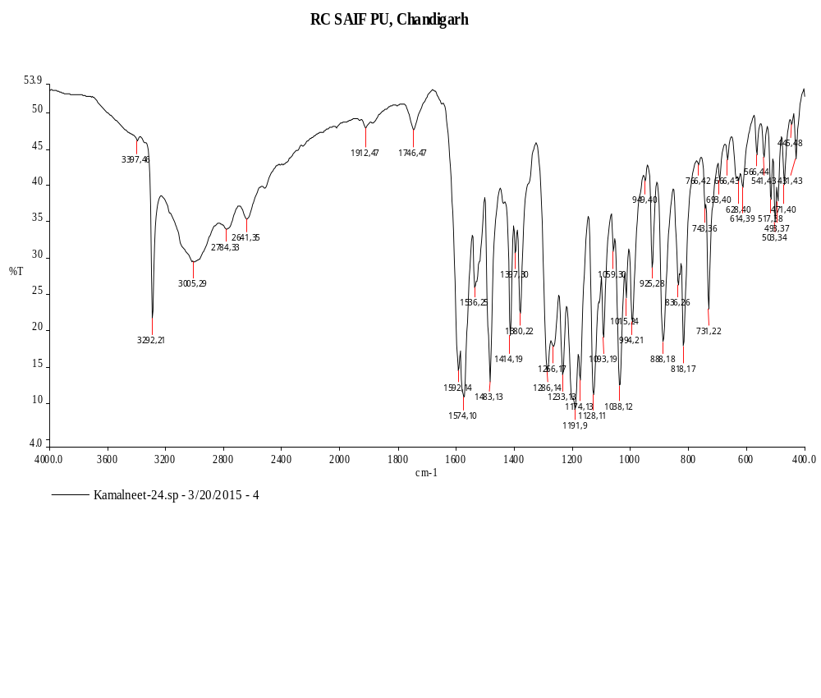Figure 1.4 FT-IR spectrum of 3a

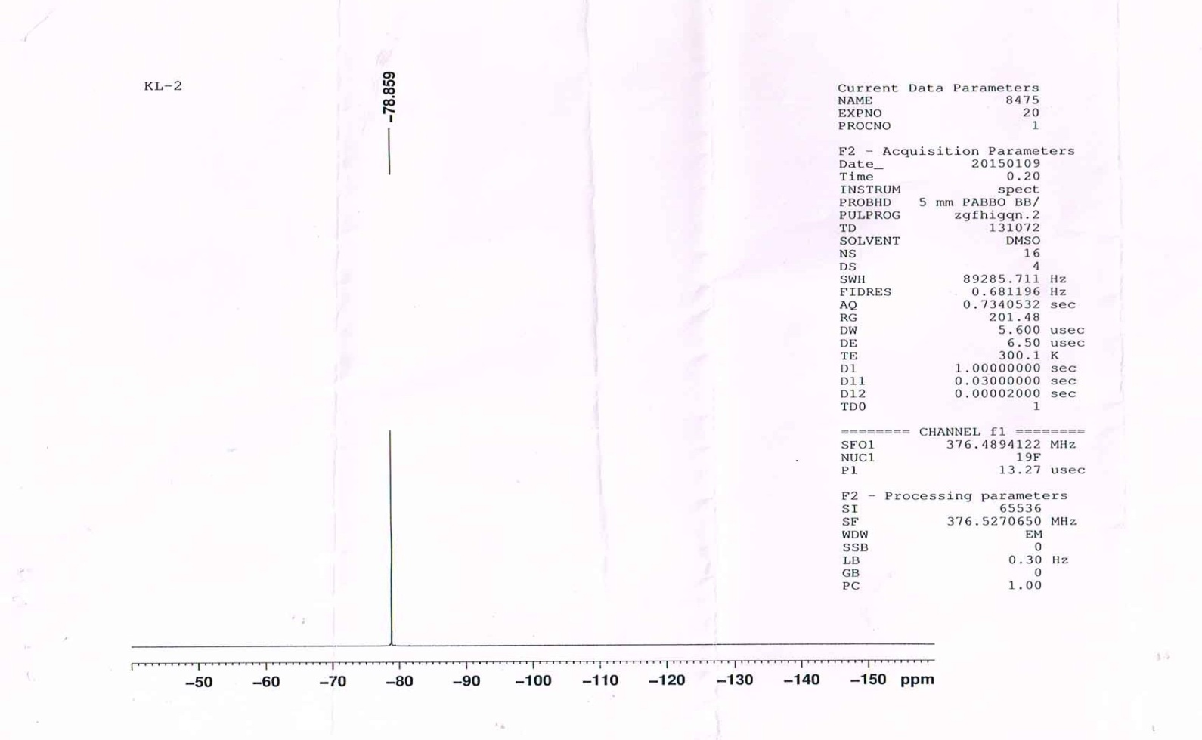
Figure 1.5 ¹⁹F NMR spectrum of 3a

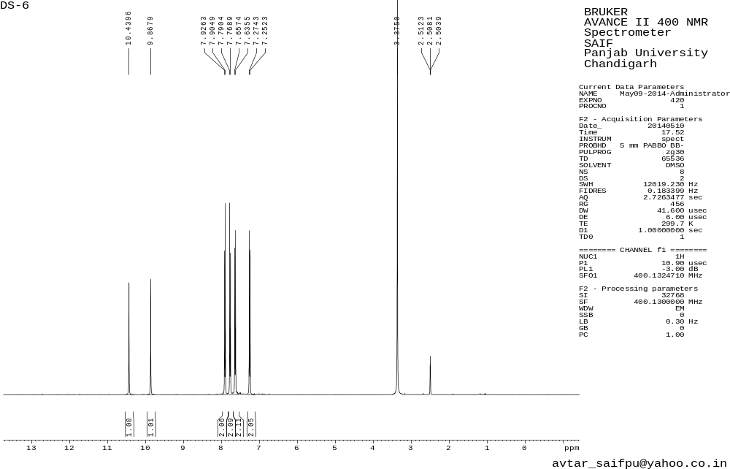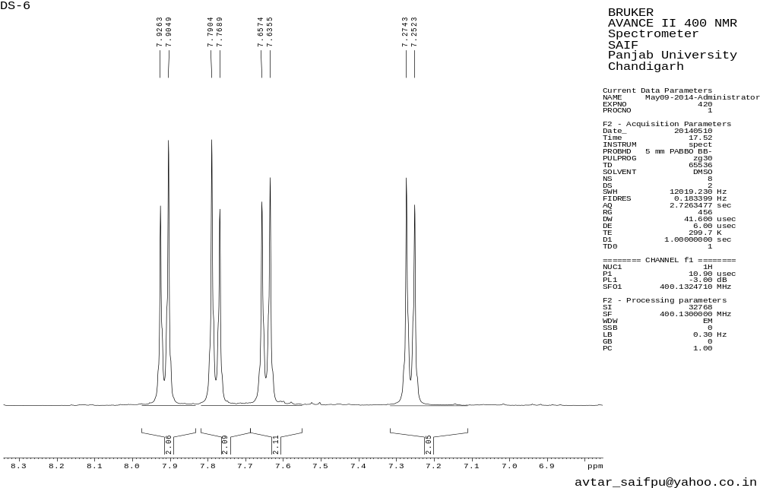
Figure 2.1 ¹H NMR spectrum of 3b
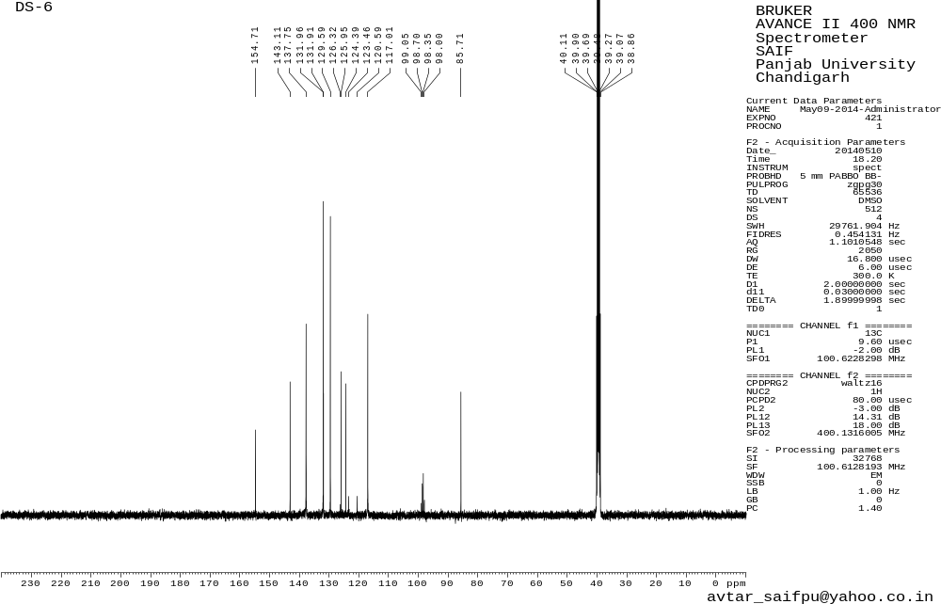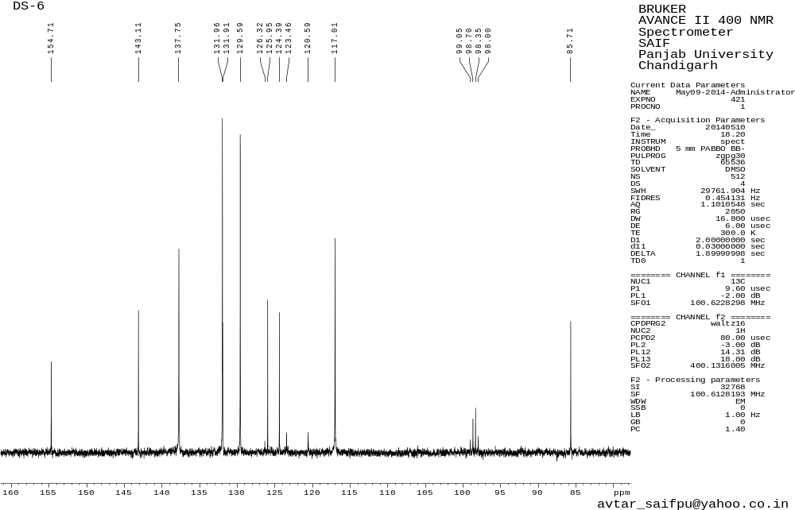
Figure 2.2 ¹³C NMR spectrum of 3b
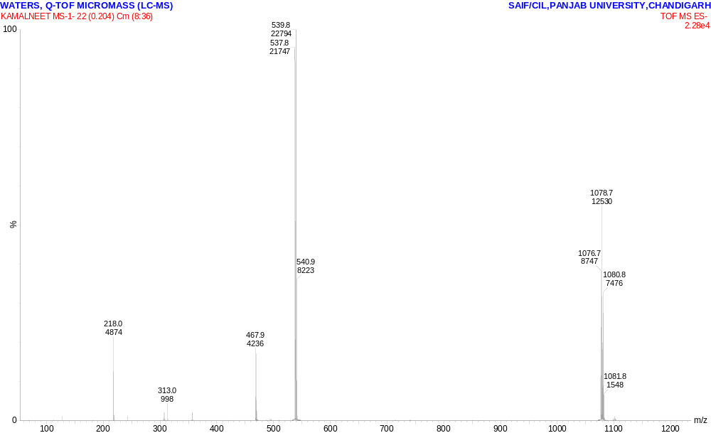
Figure 2.3 HRMS spectrum of 3b
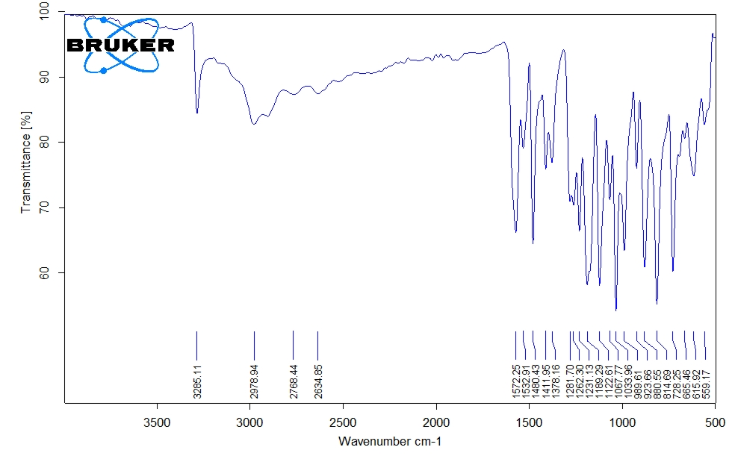

Figure 2.4 FT-IR spectrum of 3b
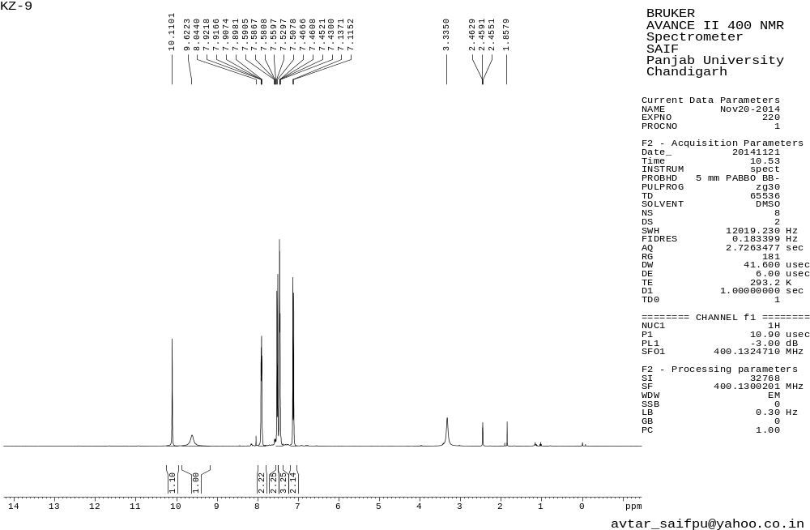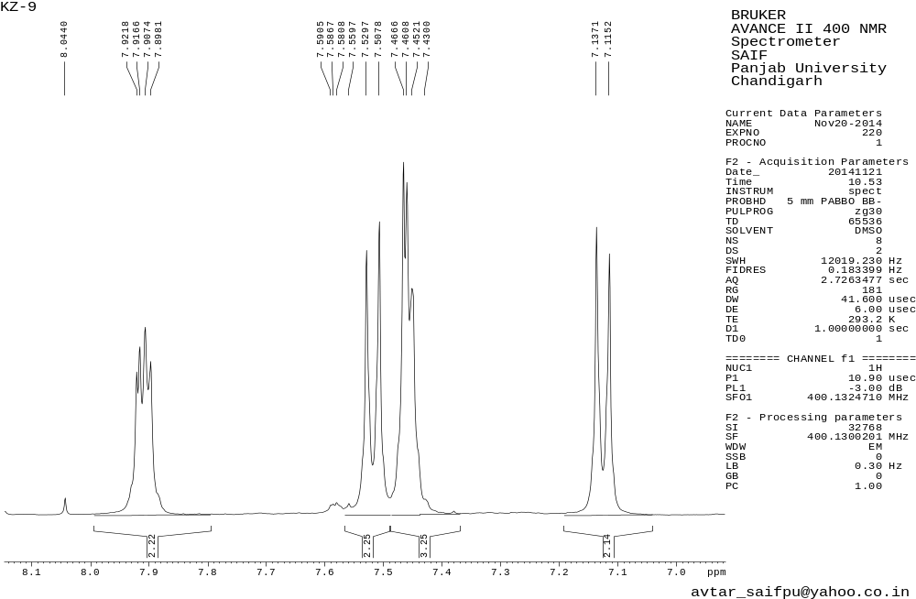
Figure 3.1 ¹H NMR spectrum of 3c
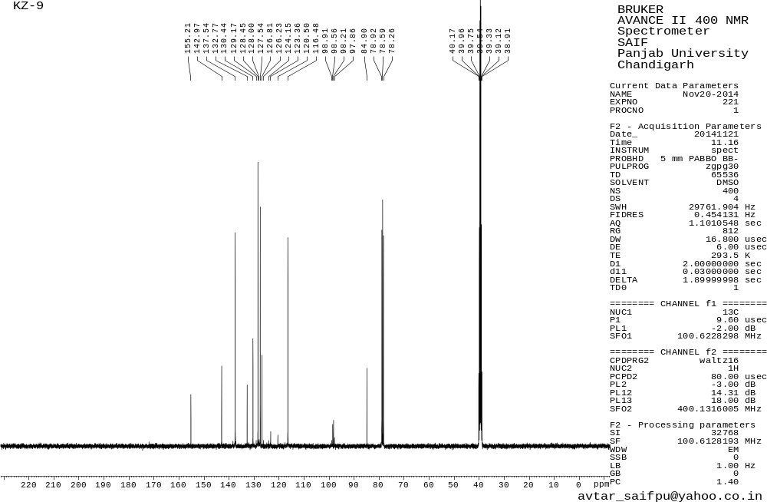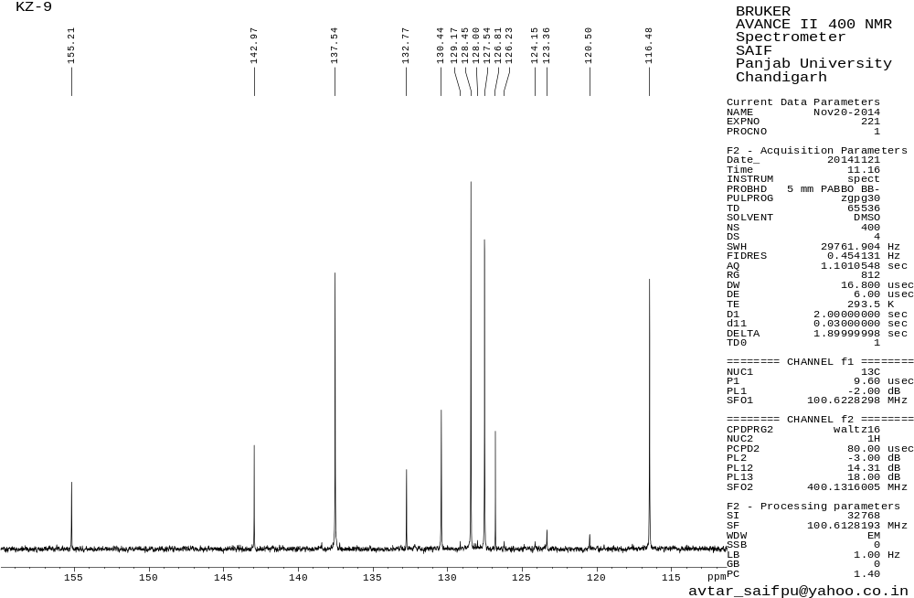
Figure 3.2 ¹³C NMR spectrum of 3c
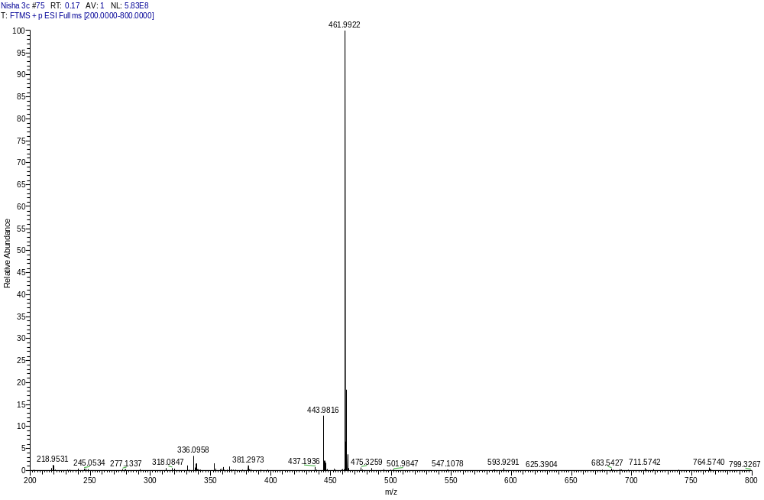

Figure 3.3 HRMS spectrum of 3c

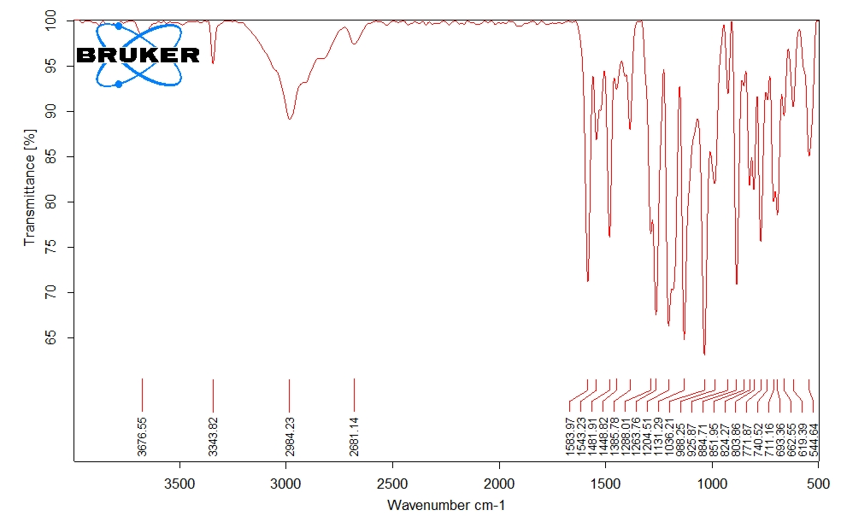Figure 2.4 FT-IR spectrum of 3c
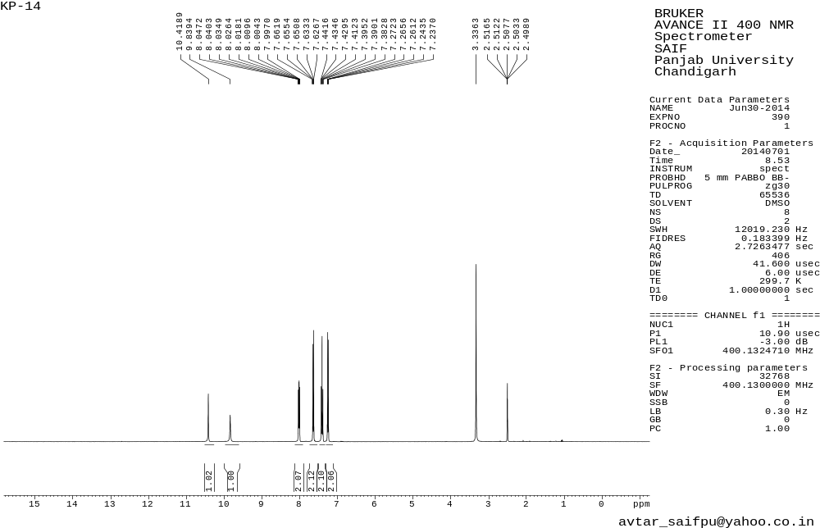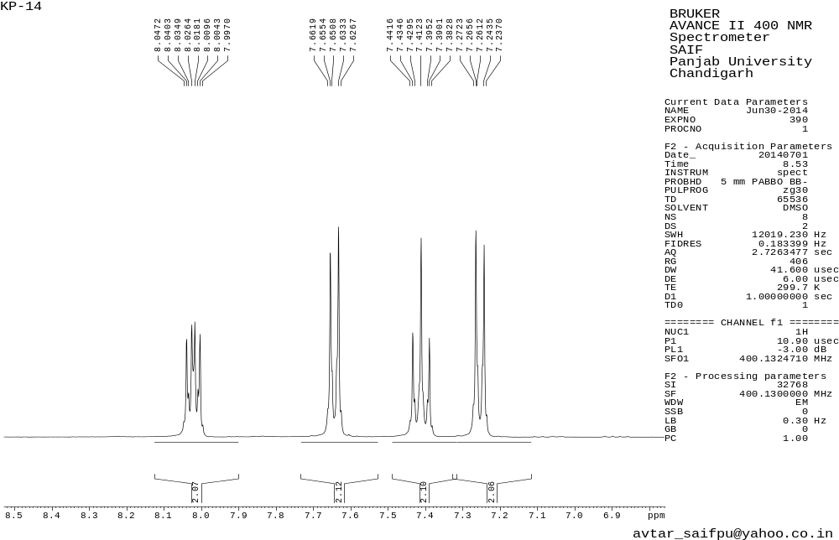
Figure 4.1 ¹H NMR spectrum of 3d
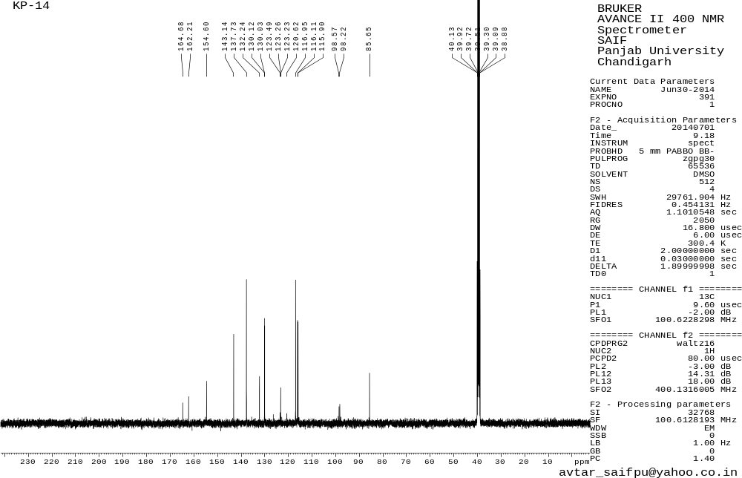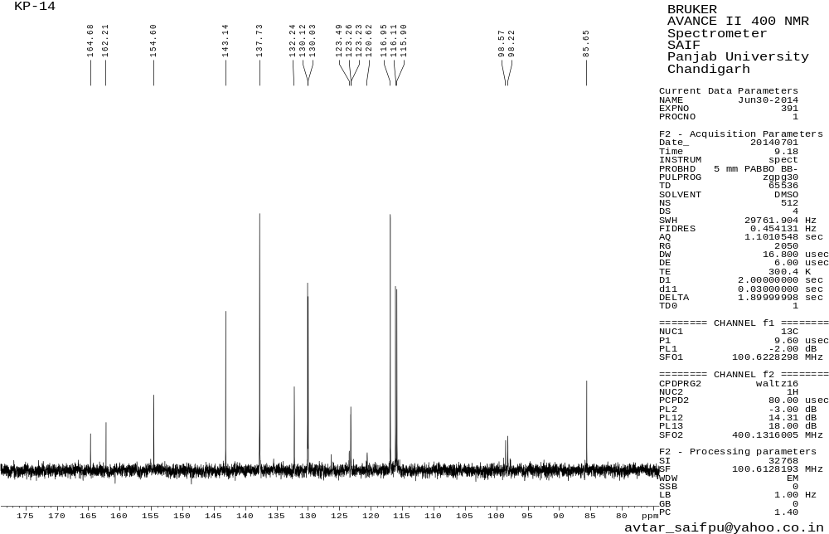
Figure 4.2 ¹³C NMR spectrum of 3d
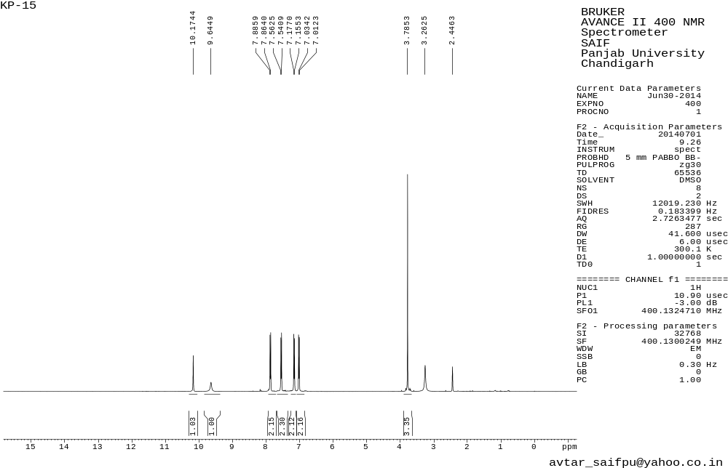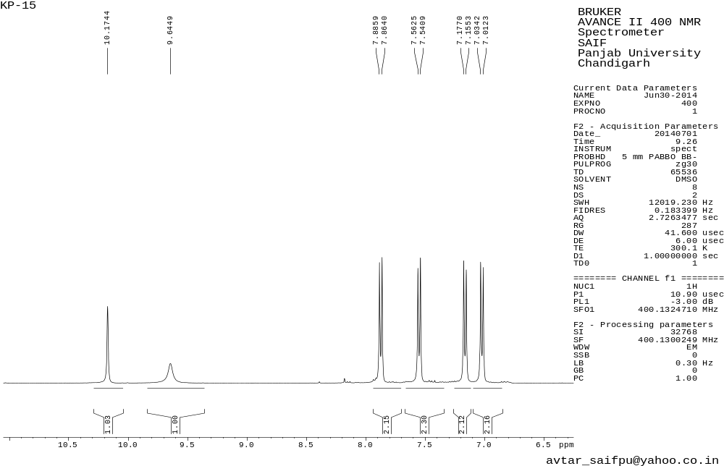
Figure 5.1 ¹H NMR spectrum of 3e
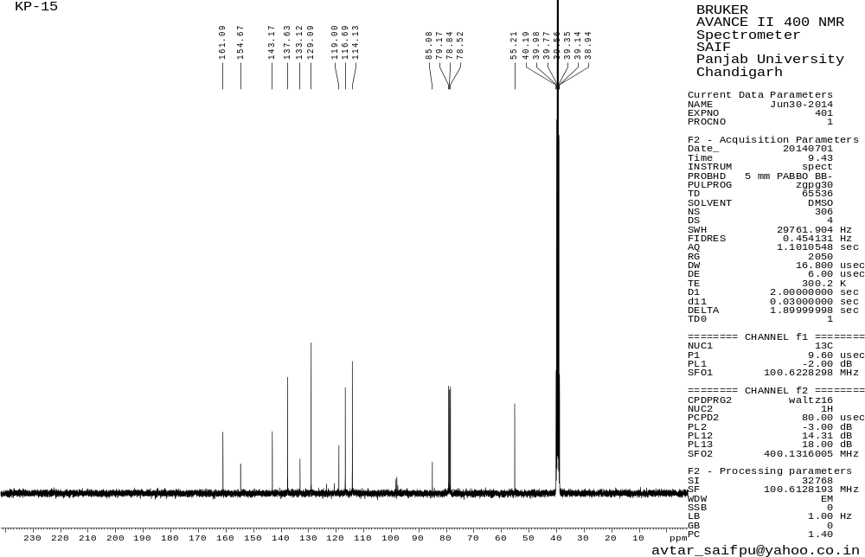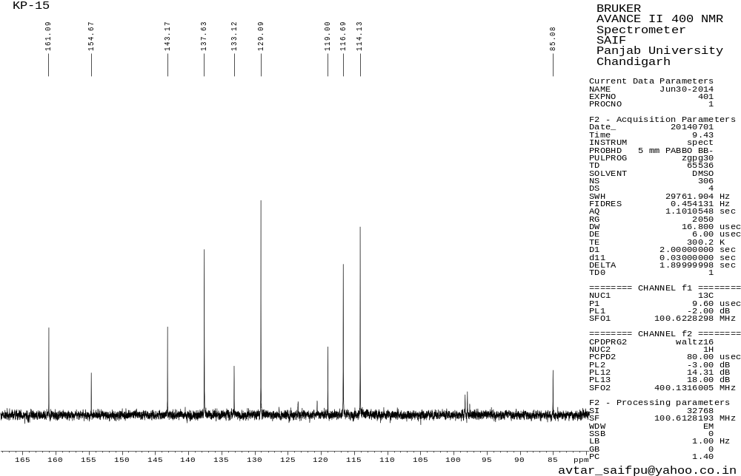
Figure 5.2 ¹³C NMR spectrum of 3e
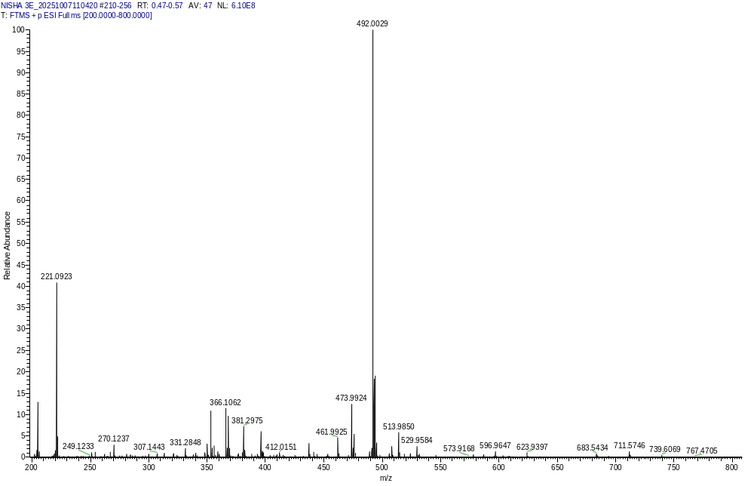
Figure 5.3 HRMS spectrum of 3e
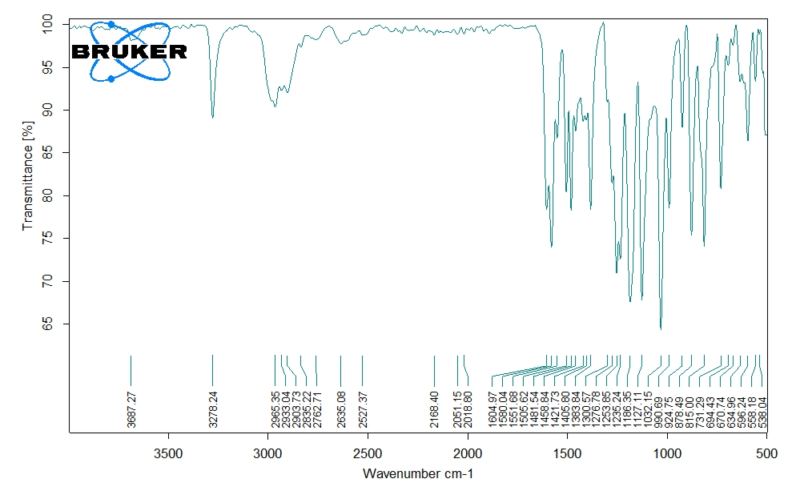
Figure 5.4 FT-IR spectrum of 3e
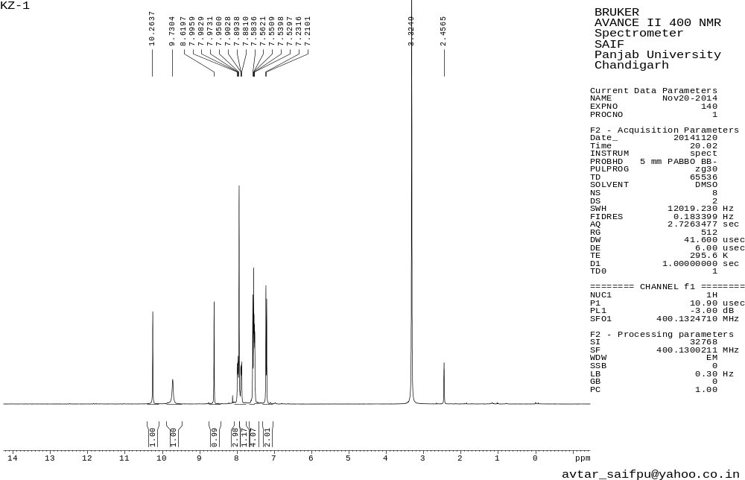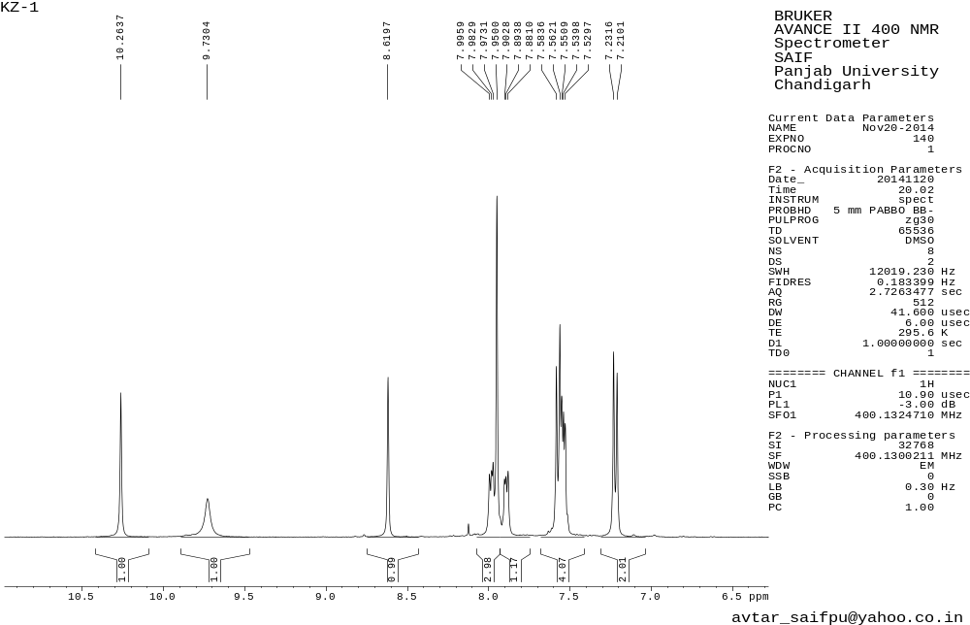Figure 6.1 ¹H NMR spectrum of 3f
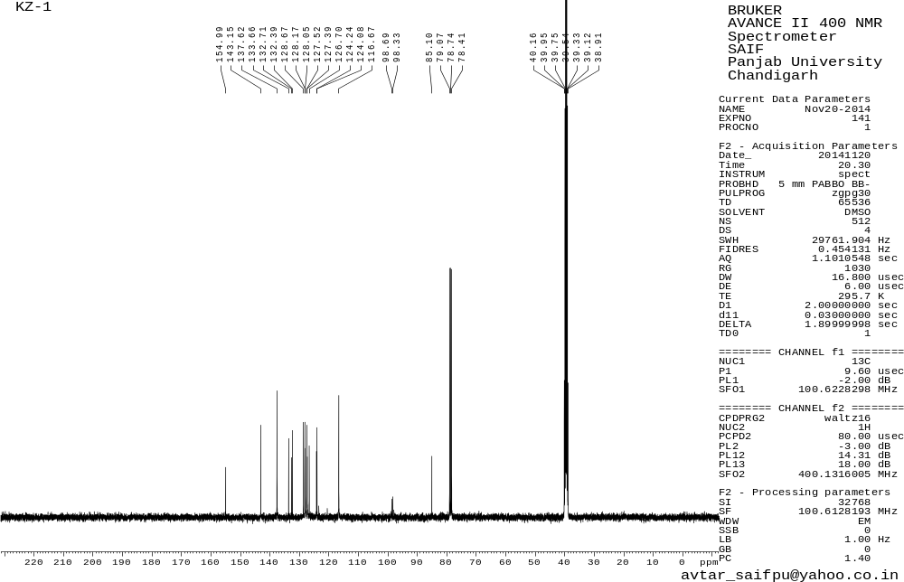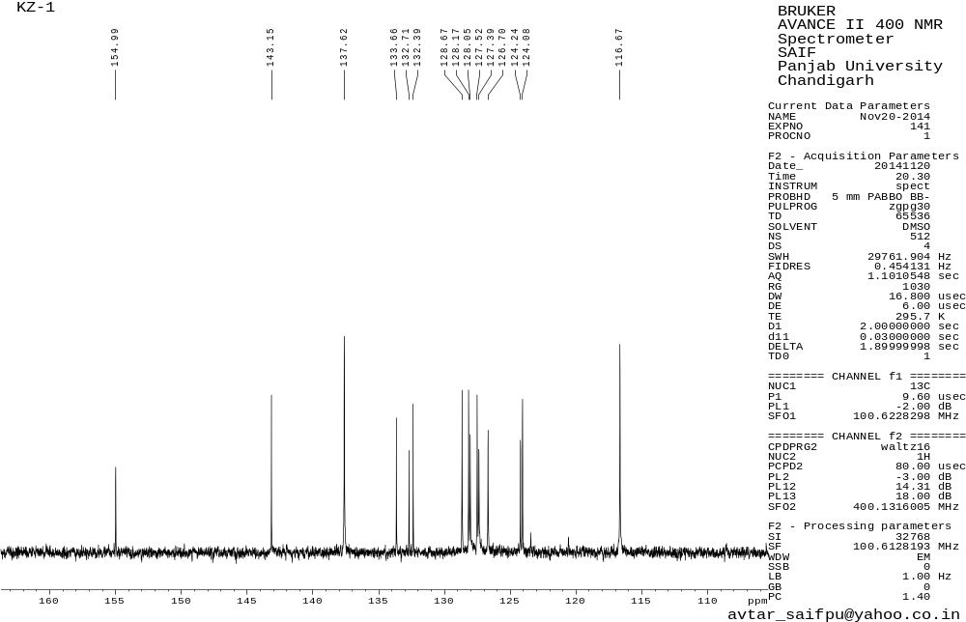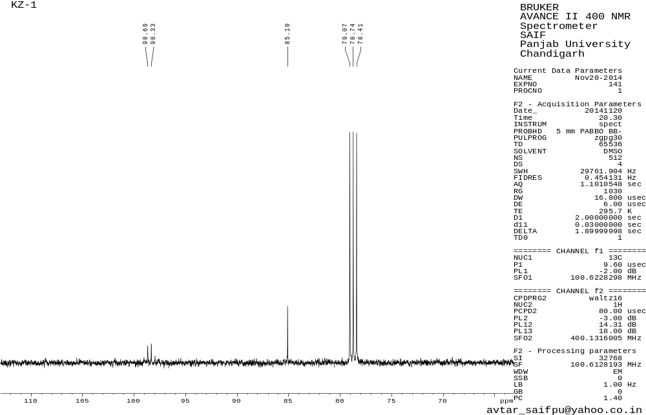
Figure 6.2 ¹³C NMR spectrum of 3f
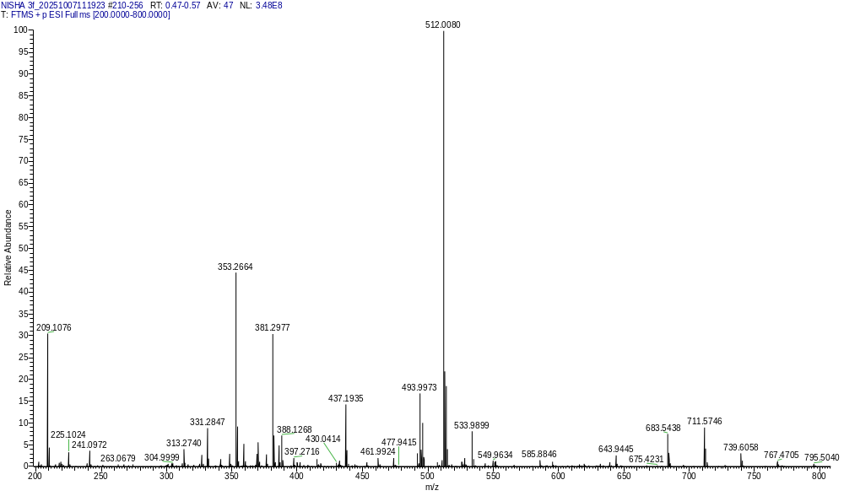
Figure 6.3 HRMS spectrum of 3f

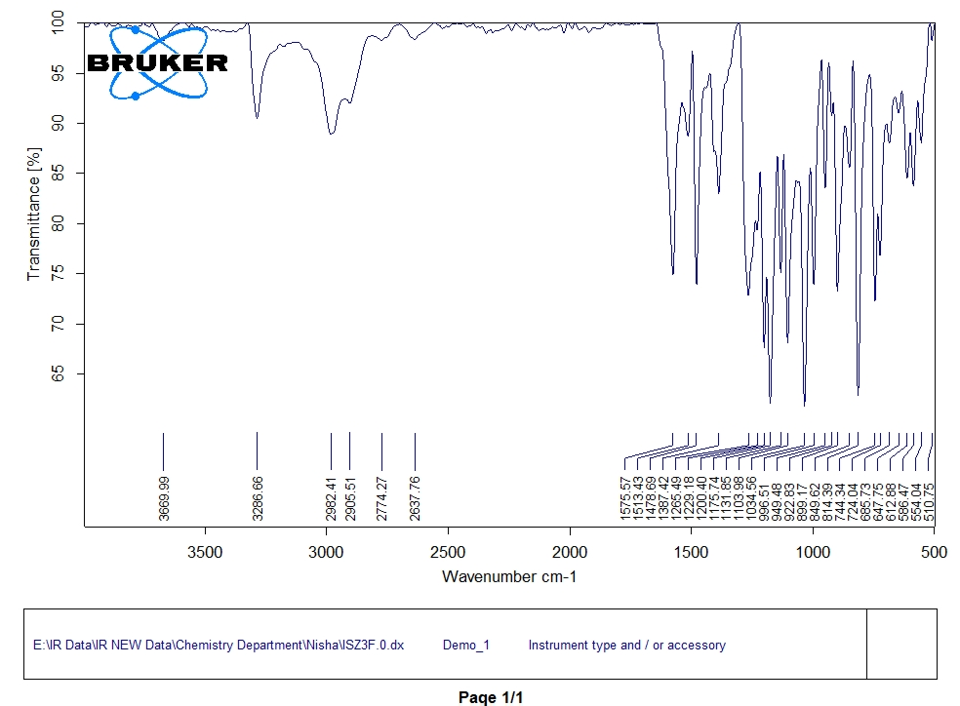Figure 6.4 FT-IR spectrum of 3f

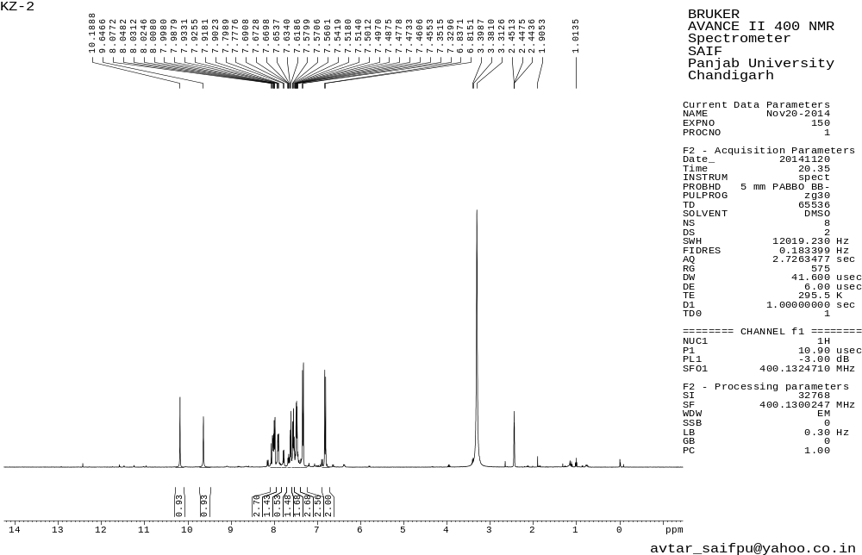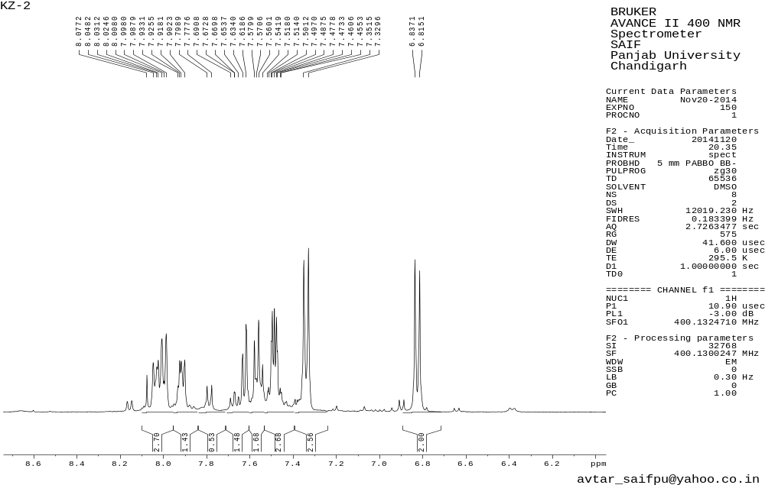
Figure 7.1 ¹H NMR spectrum of 3g
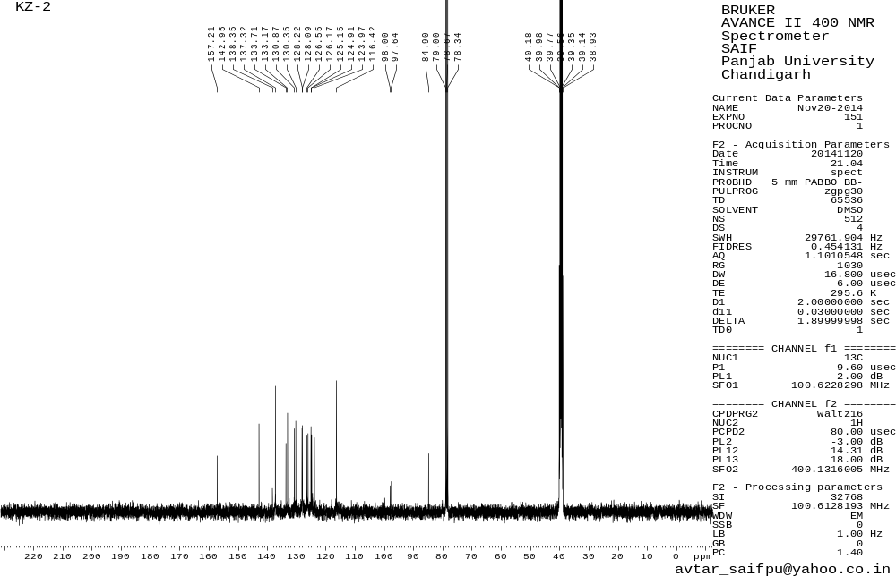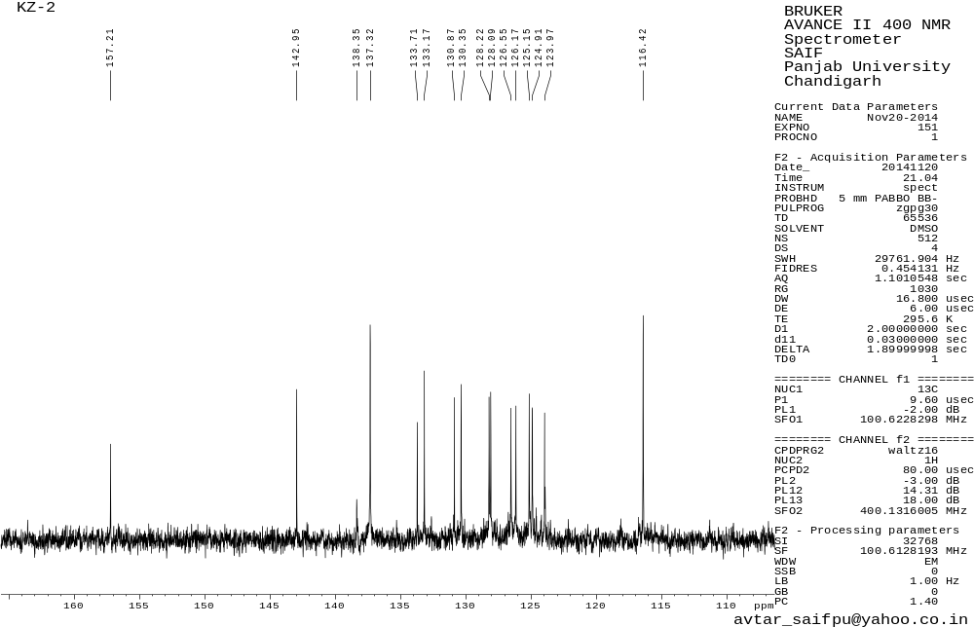
Figure 7.2 ¹³C NMR spectrum of 3g

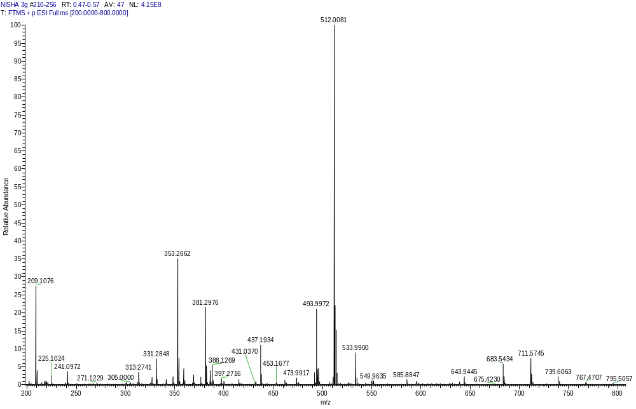

Figure 7.3 HRMS spectrum of 3g

Figure 7.4 FT-IR spectrum of 3g
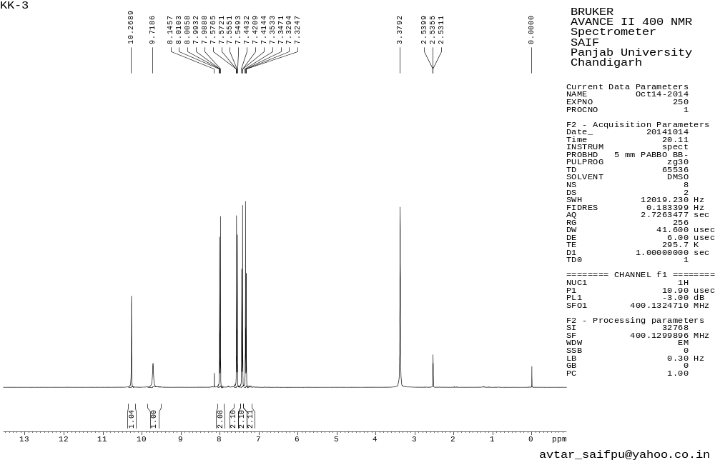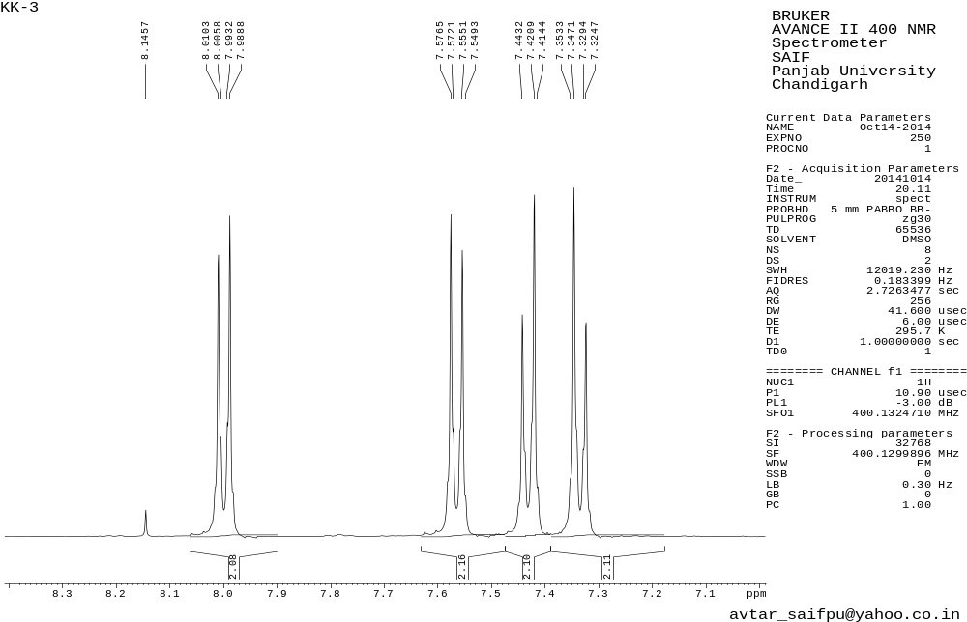
Figure 8.1 ¹H NMR spectrum of 3h
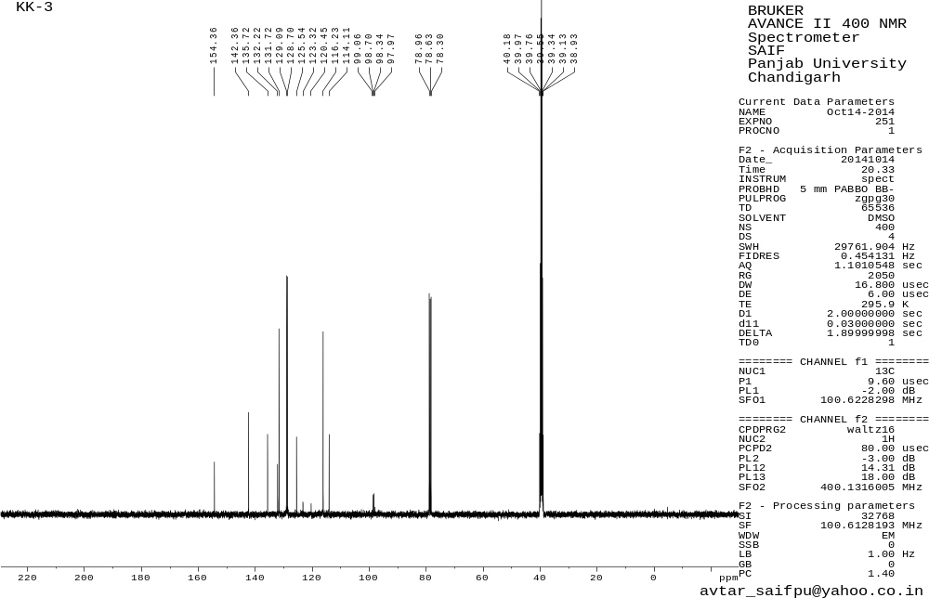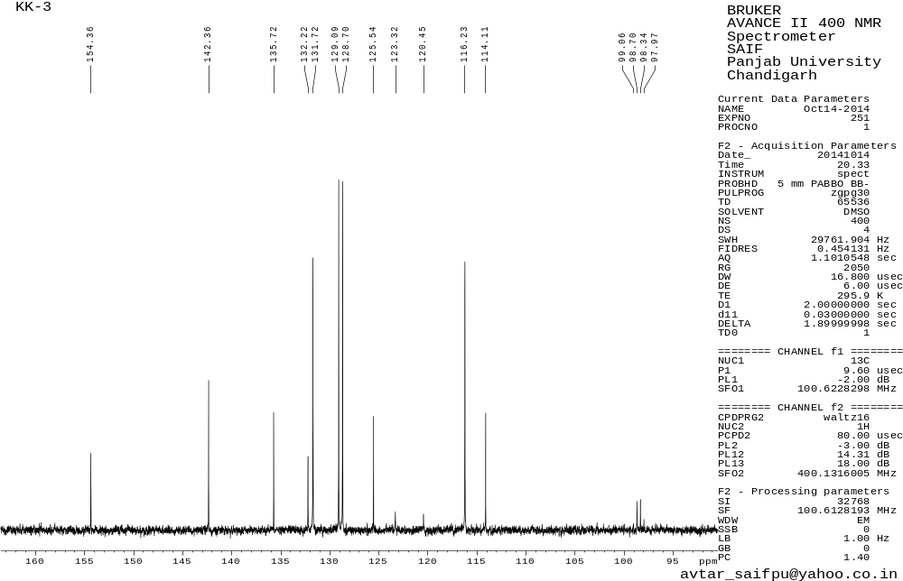
Figure 8.2 ¹³C NMR spectrum of 3h
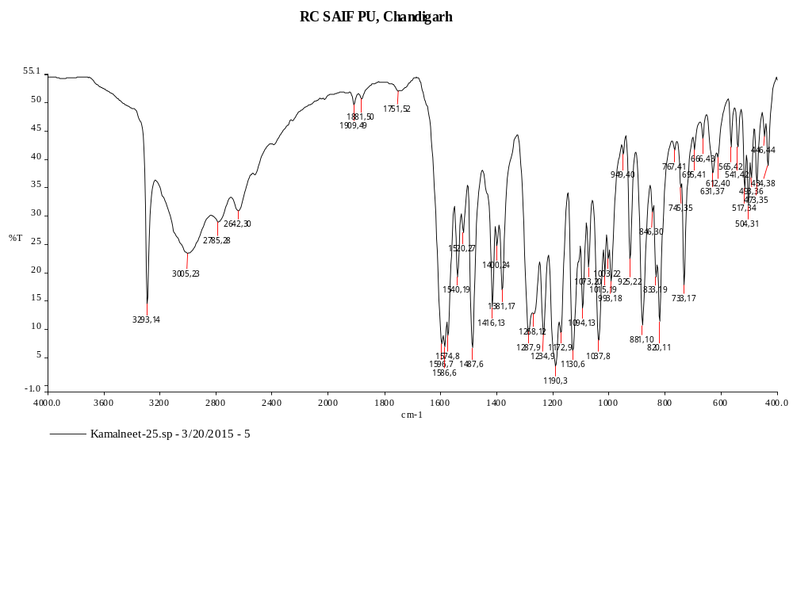
Figure 8.4 FT-IR spectrum of 3h

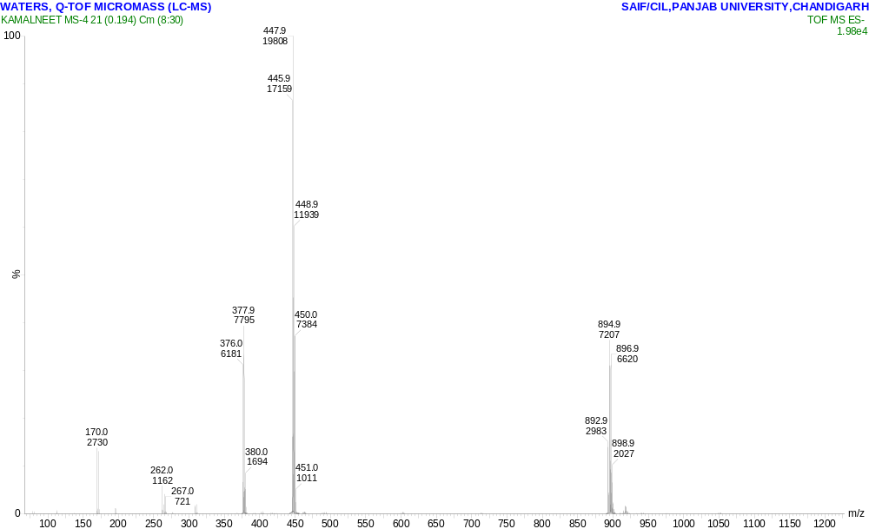

Figure 8.3 HRMS spectrum of 3h

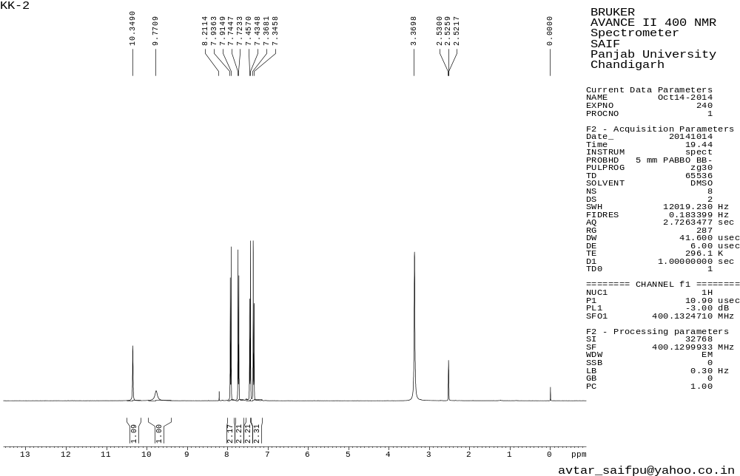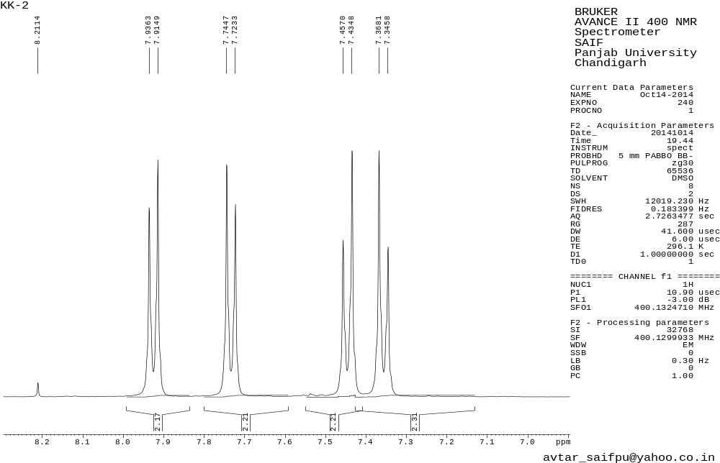
Figure 9.1 ¹H NMR spectrum of 3i
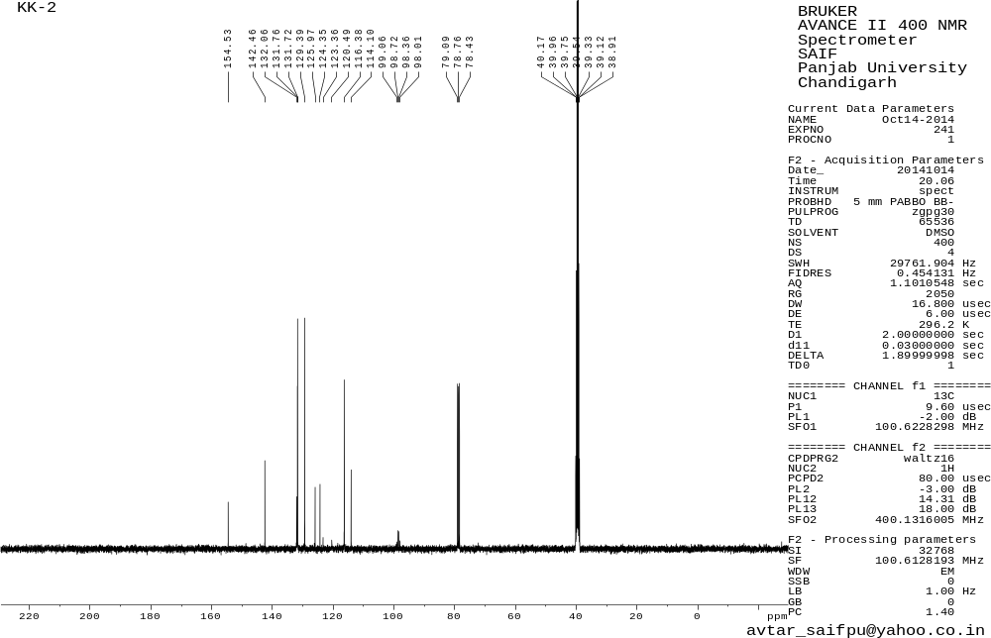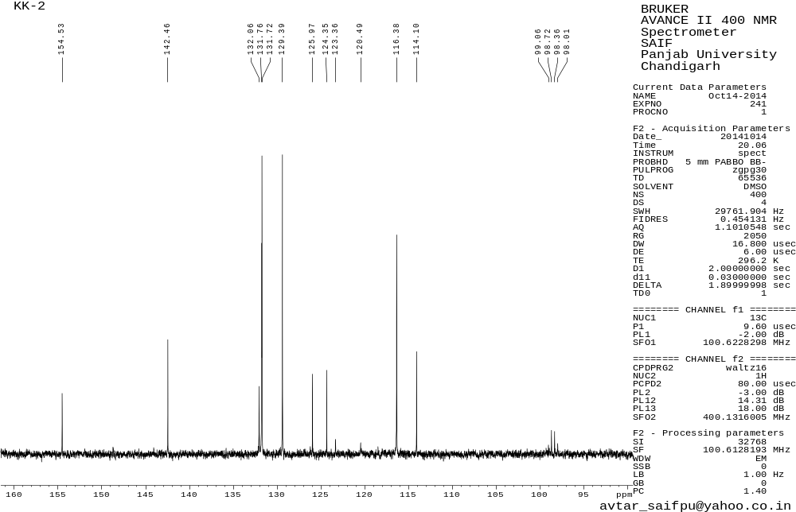
Figure 9.2 ¹³C NMR spectrum of 3i
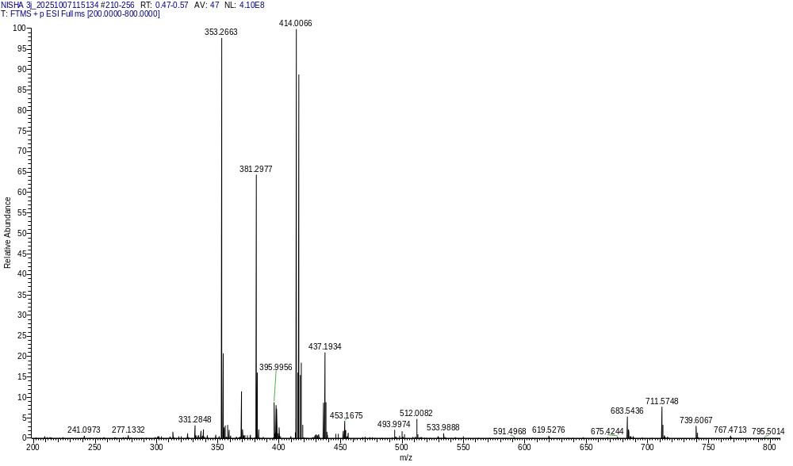

Figure 9.3 HRMS spectrum of 3i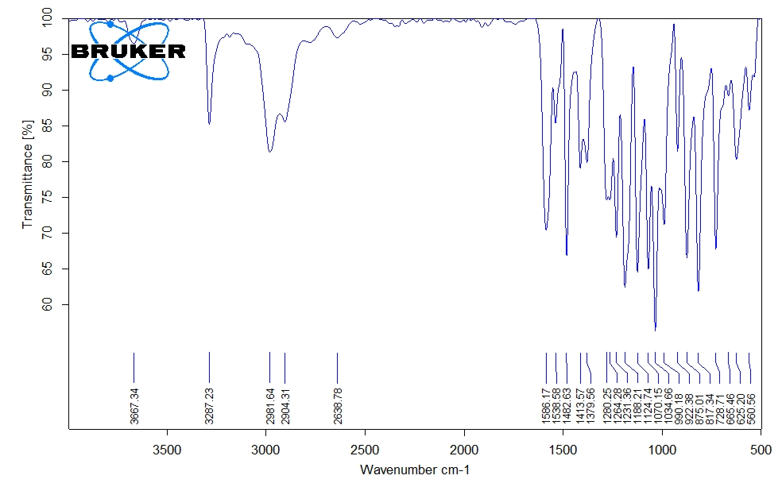
Figure 9.4 FT-IR spectrum of 3i

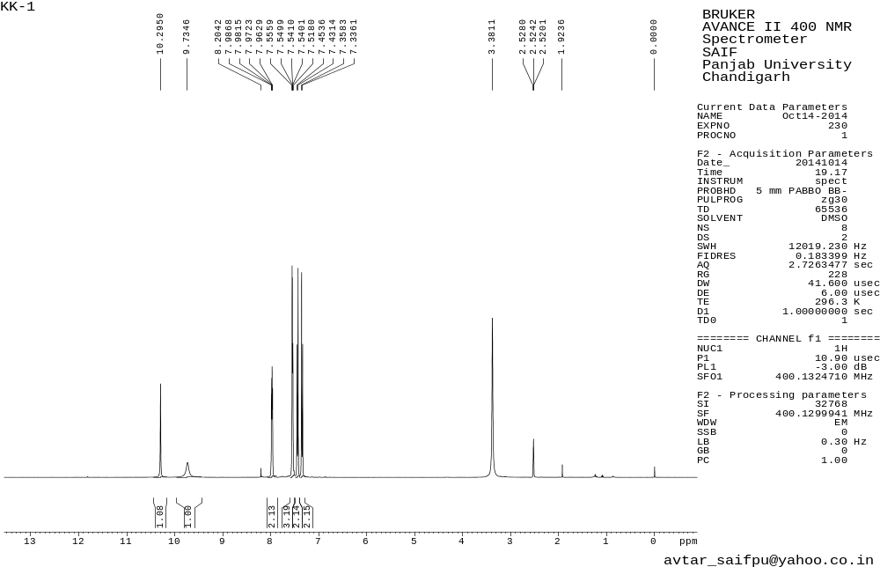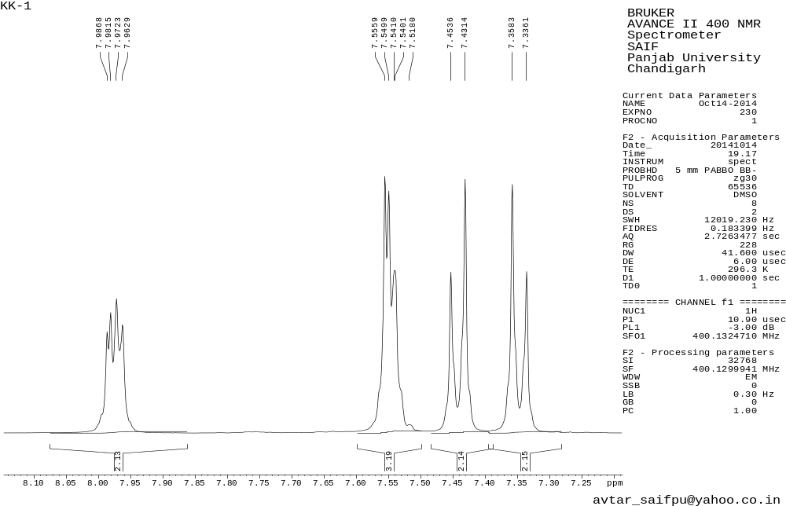
Figure 10.1 ¹H NMR spectrum of 3j
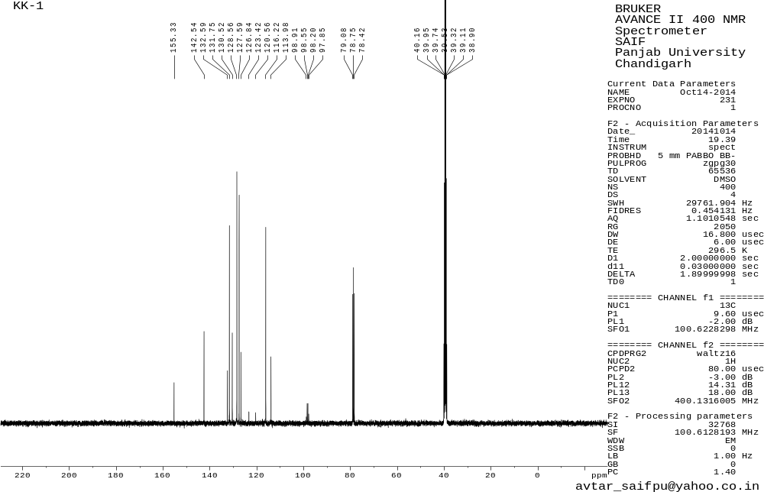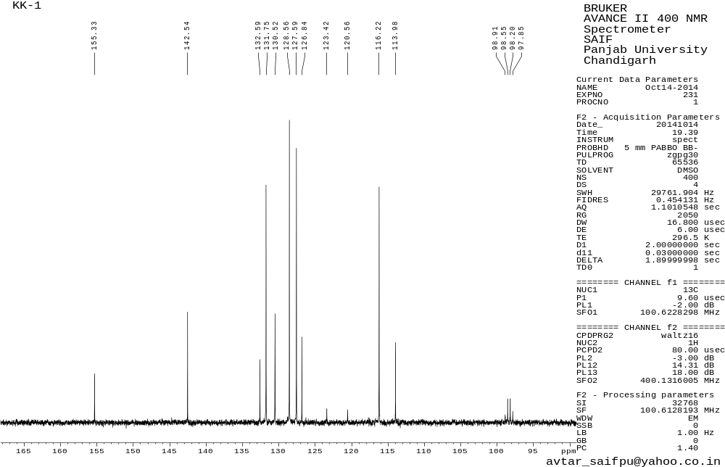
Figure 10.2 ¹³C NMR spectrum of 3j
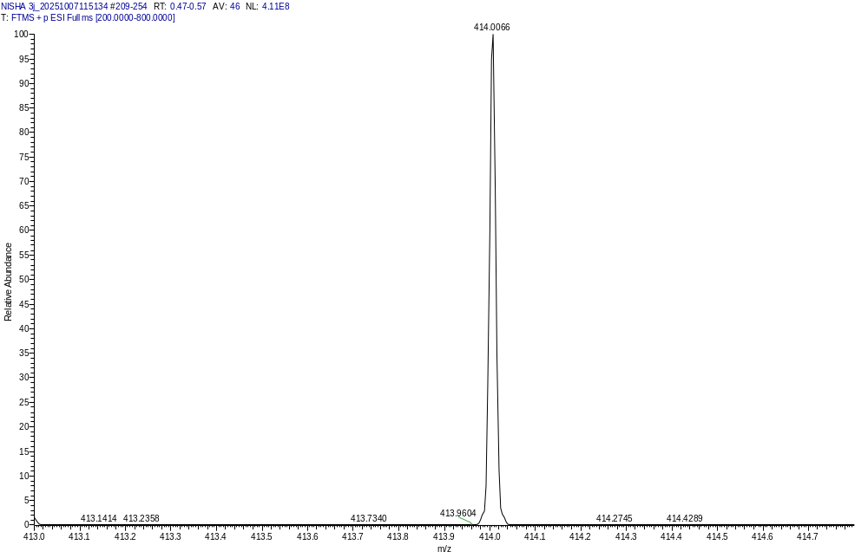
Figure 10.3 HRMS spectrum of 3j

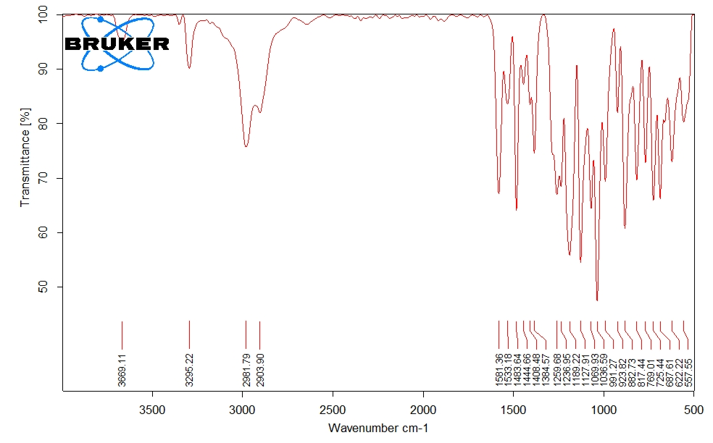Figure 10.4 FT-IR spectrum of 3j
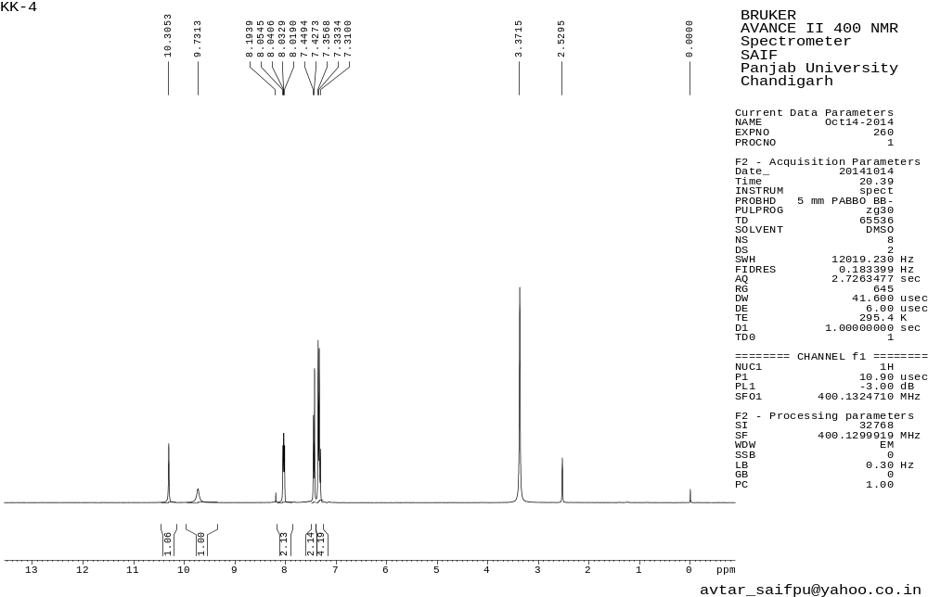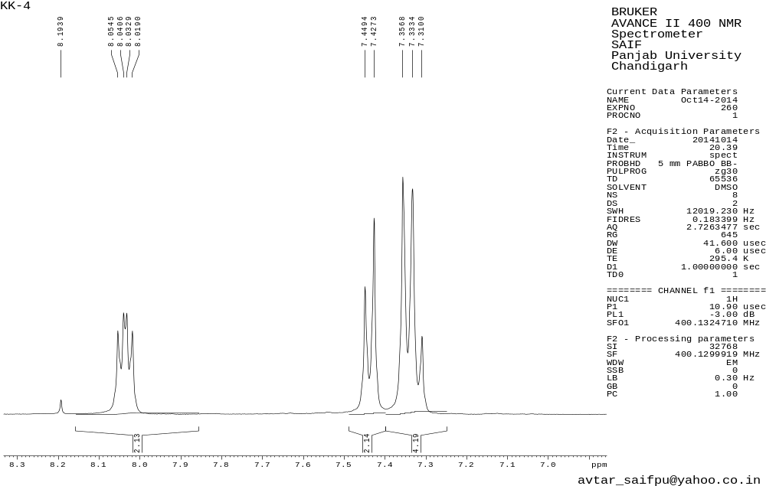Figure 11.1 ¹H NMR spectrum of 3k
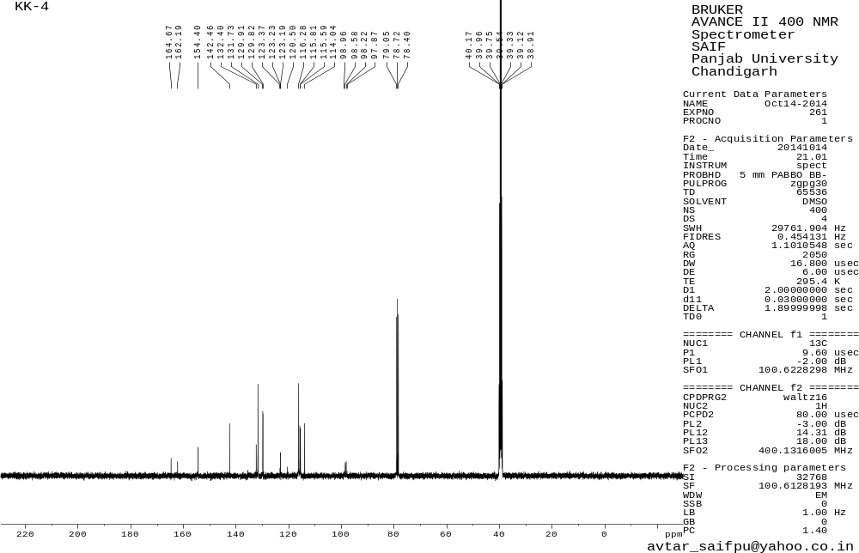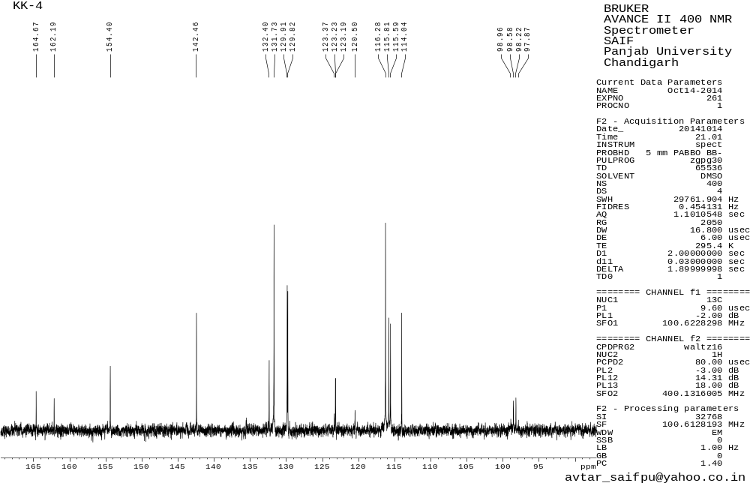
Figure 11.2 ¹³C NMR spectrum of 3k
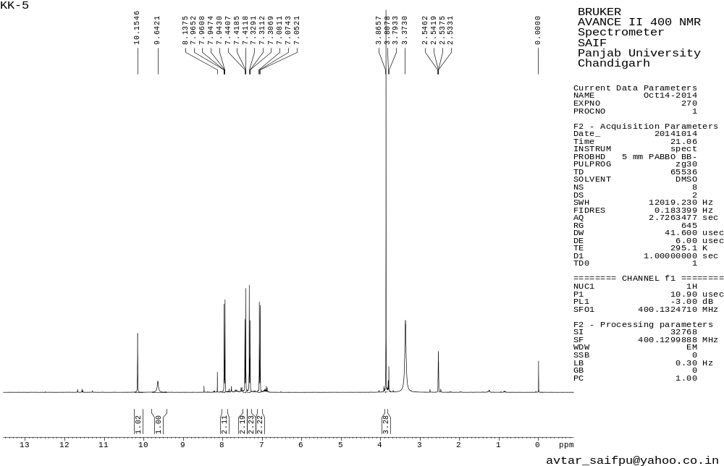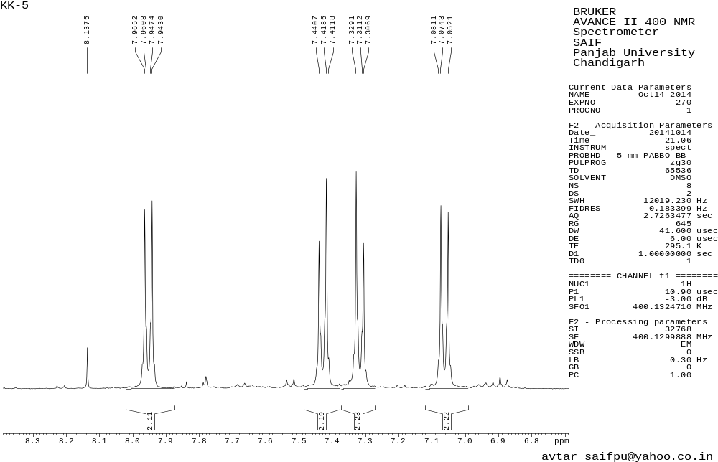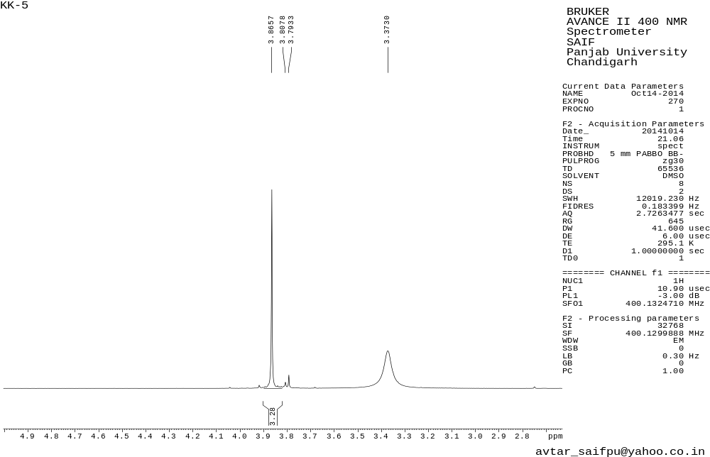
Figure 12.1 ¹H NMR spectrum of 3l
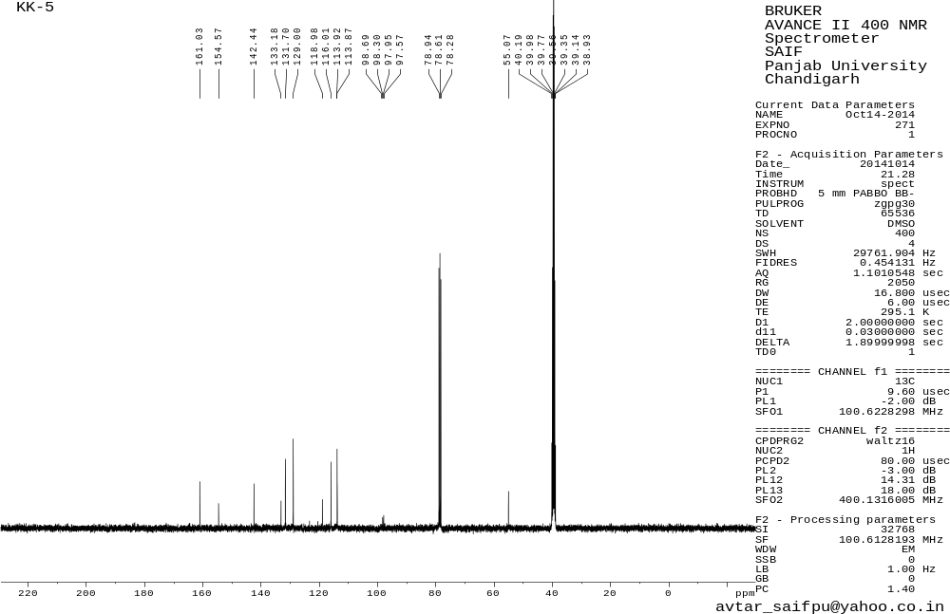
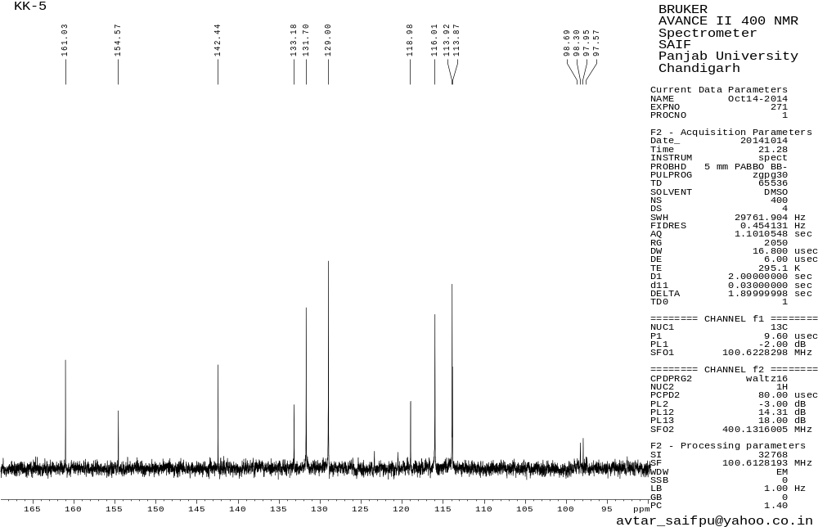
Figure 12.2 ¹³C NMR spectrum of 3l
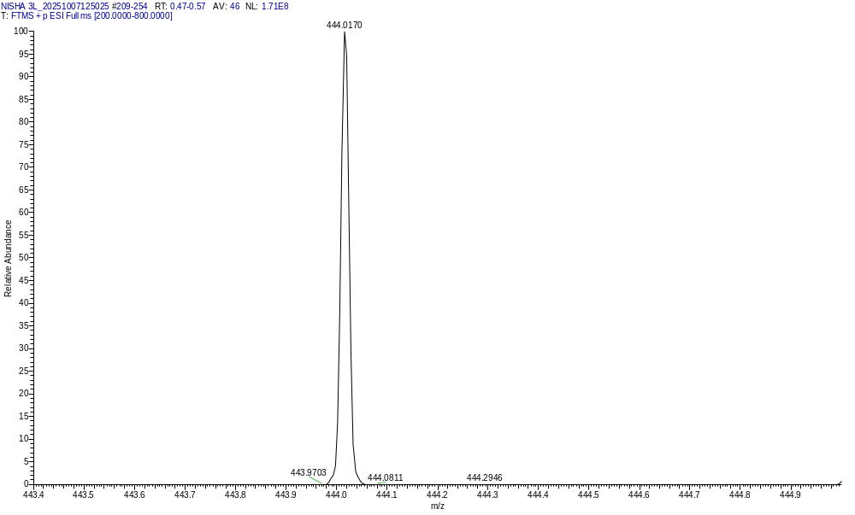
Figure 12.3 HRMS spectrum of 3l
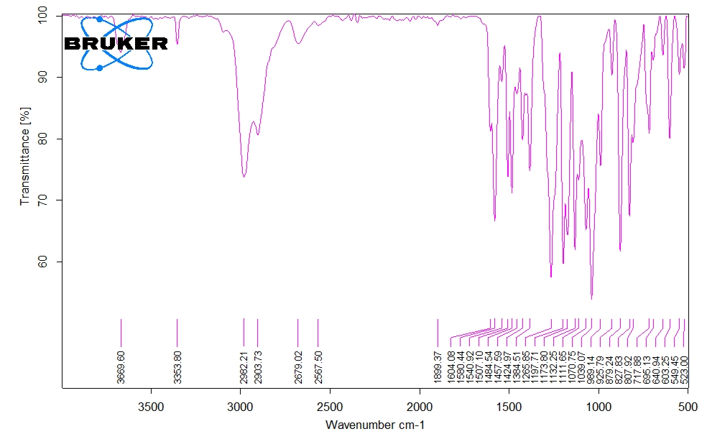Figure 12.4 FT-IR spectrum of 3l

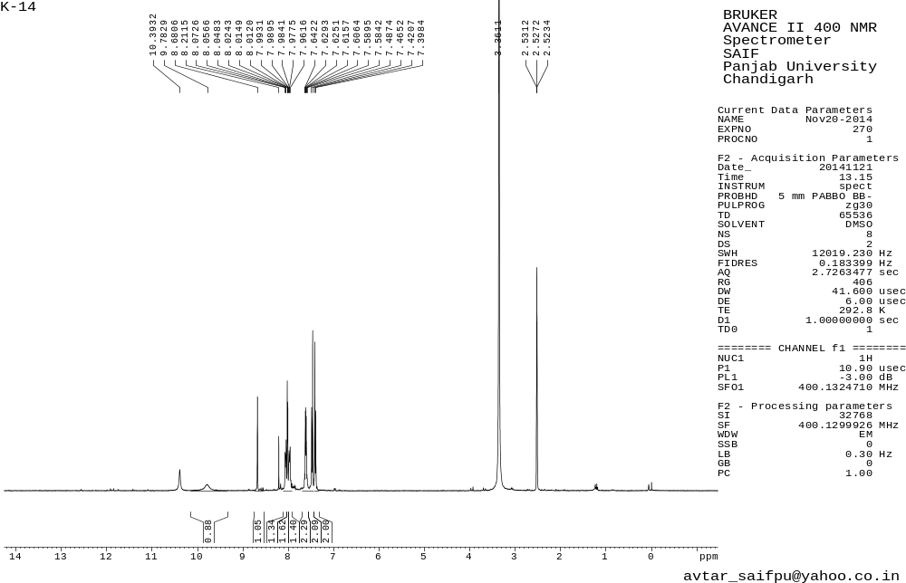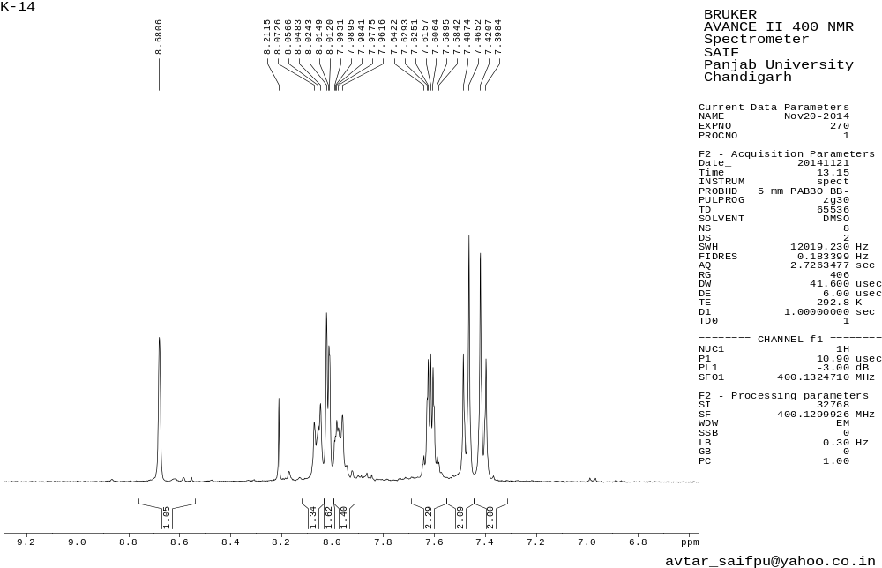
Figure 13.1 ¹H NMR spectrum of 3m
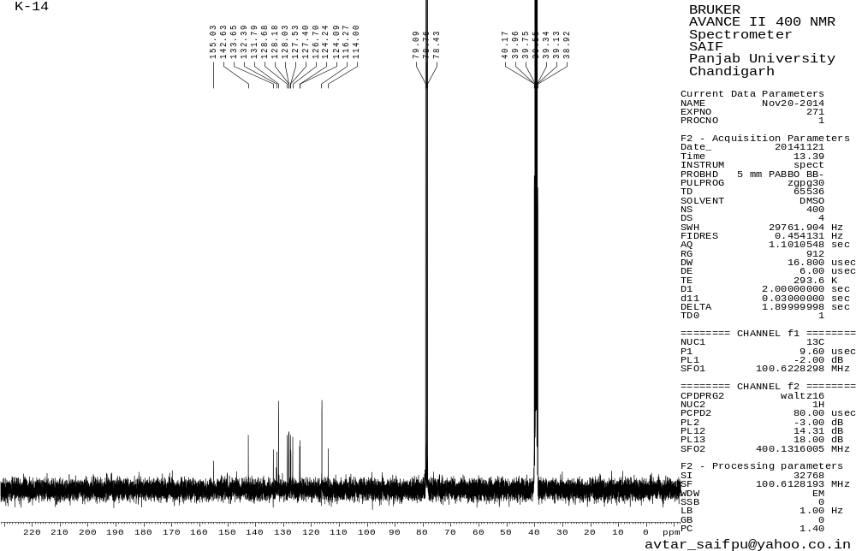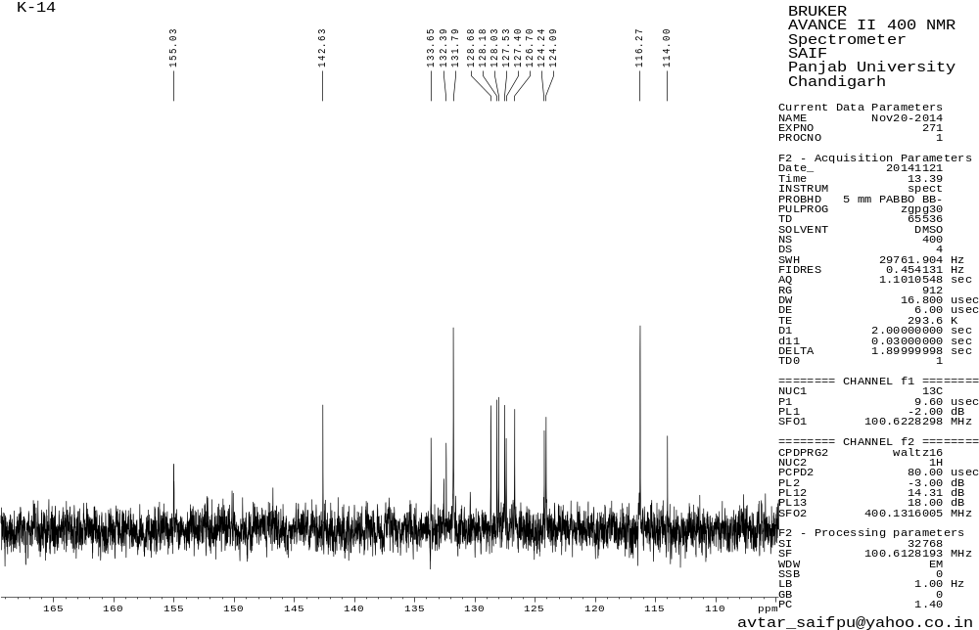
Figure 13.2 ¹³C NMR spectrum of 3m
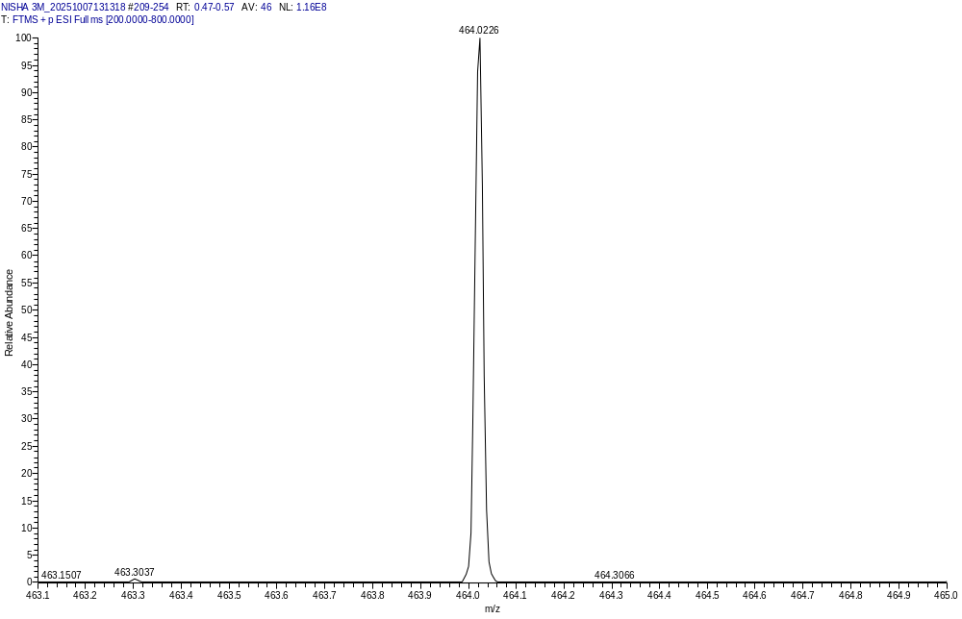

Figure 13.3 HRMS spectrum of 3m
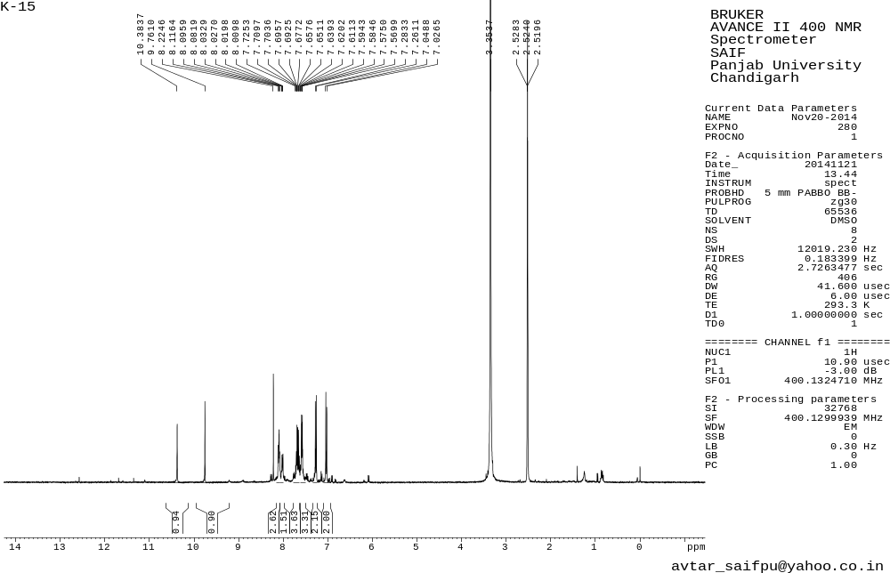
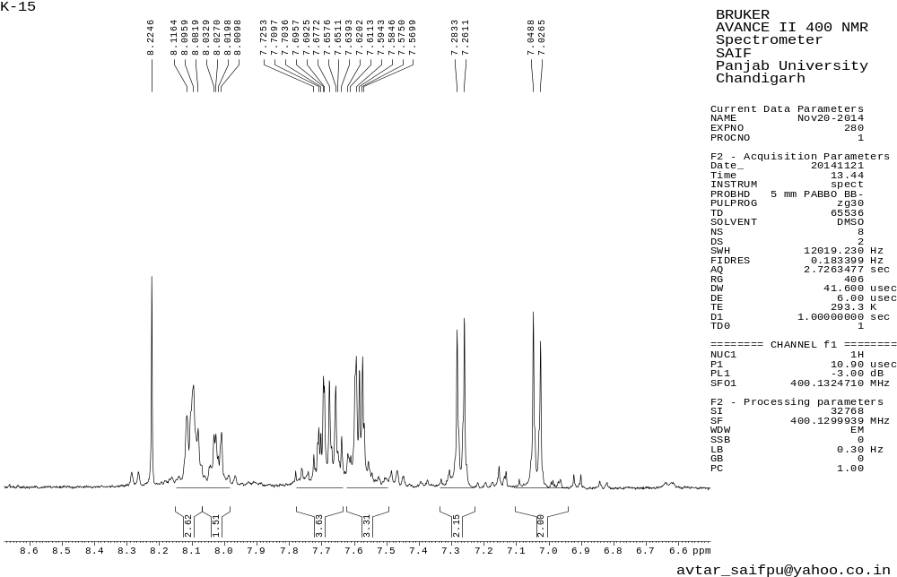
Figure 14.1 ¹H NMR spectrum of 3n
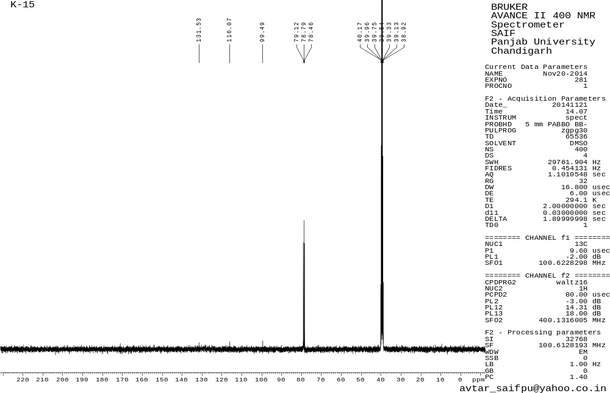

Figure 14.2 ¹³C NMR spectrum of 3n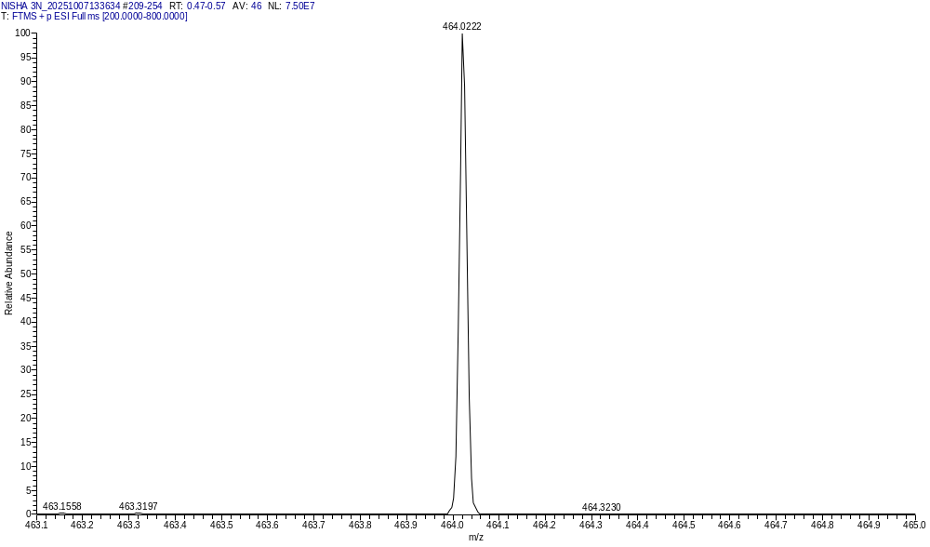

Figure 14.3 HRMS spectrum of 3n
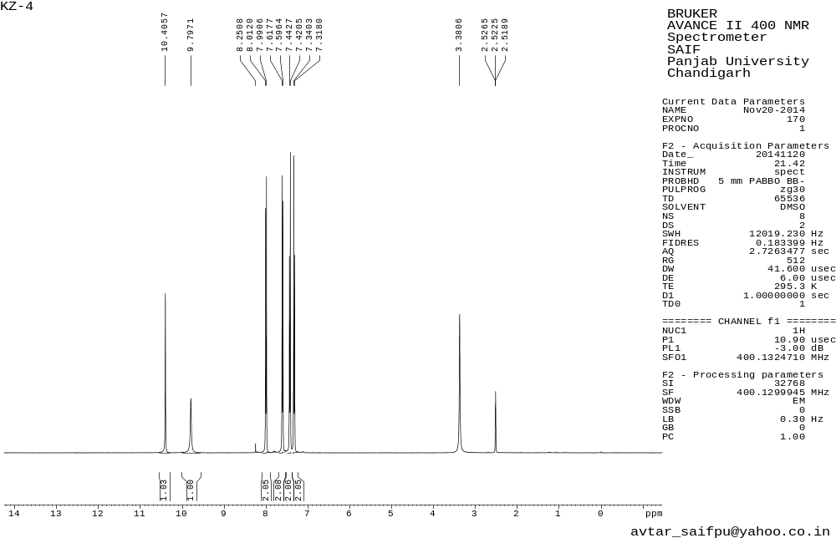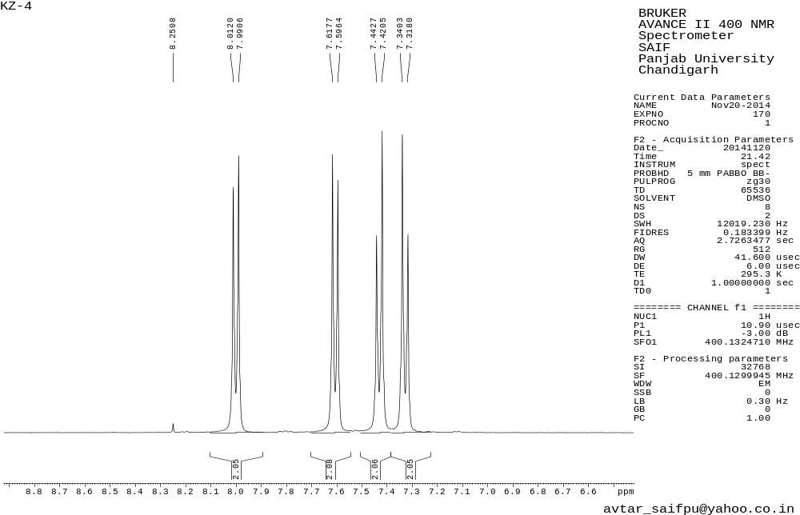
Figure 15.1 ¹H NMR spectrum of 3aa
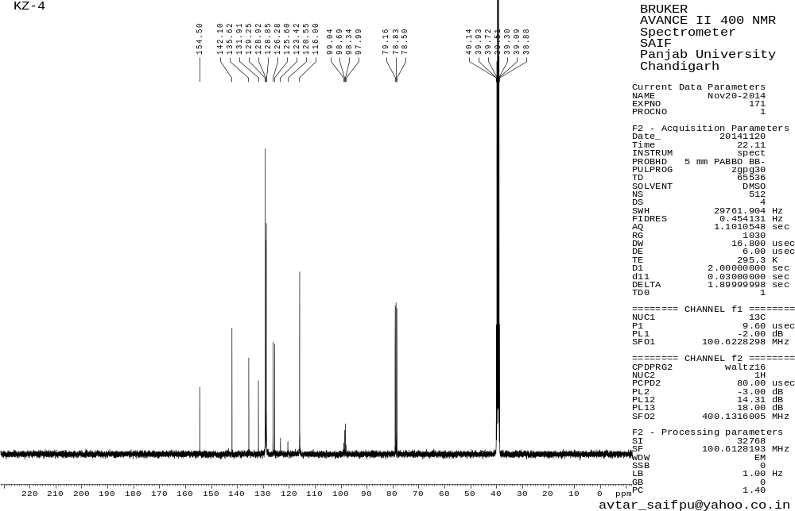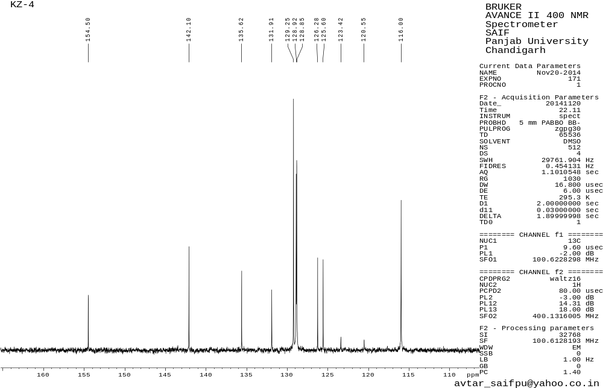
Figure 15.2 ¹³C NMR spectrum of 3aa
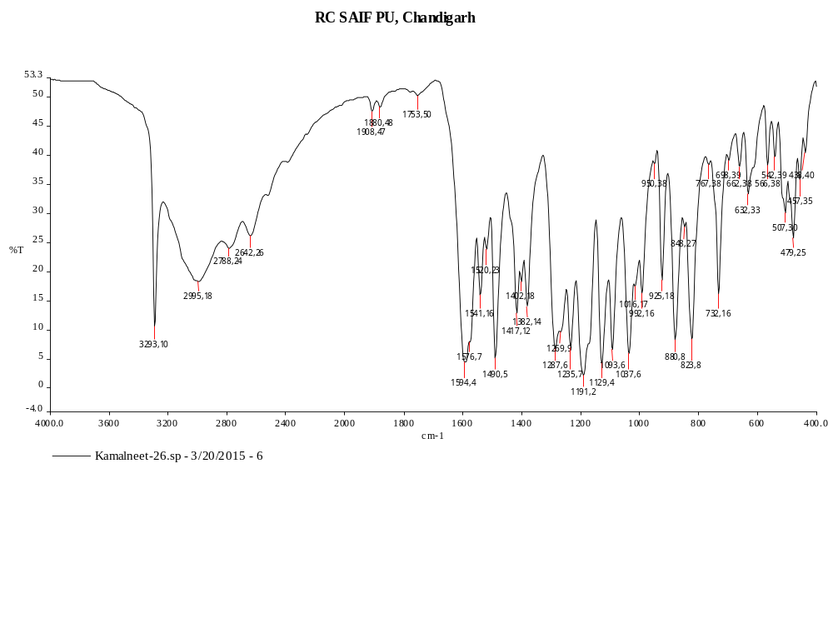
Figure 15.3 FT-IR spectrum of 3aa

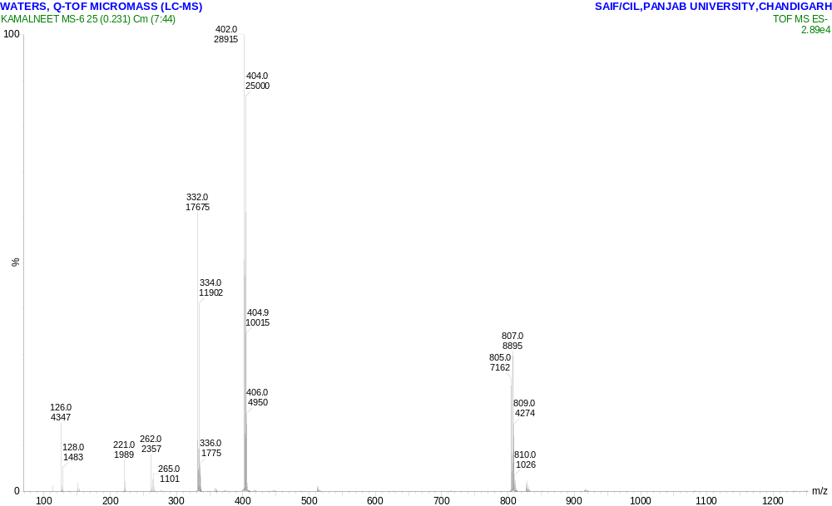

Figure 15.4 HRMS spectrum of 3aa
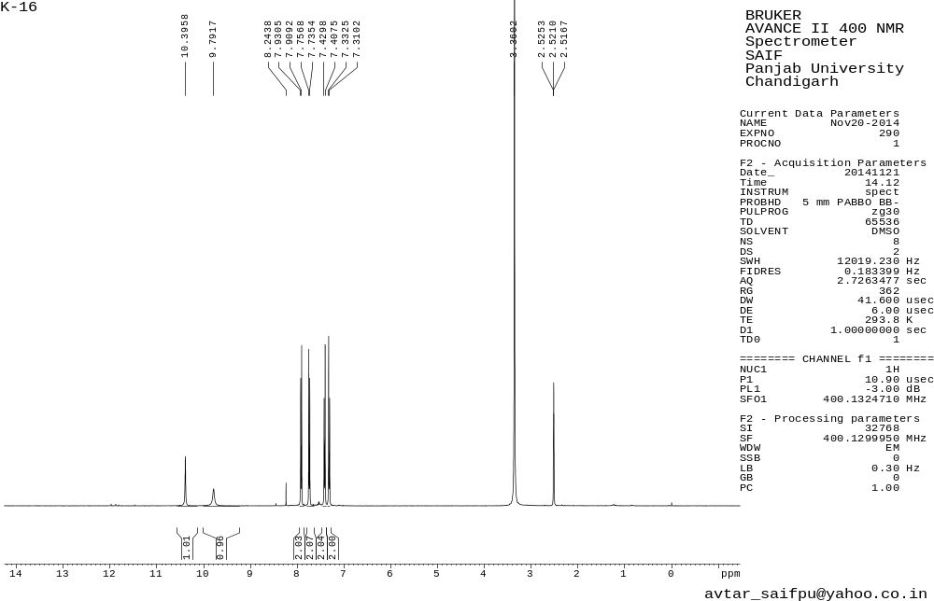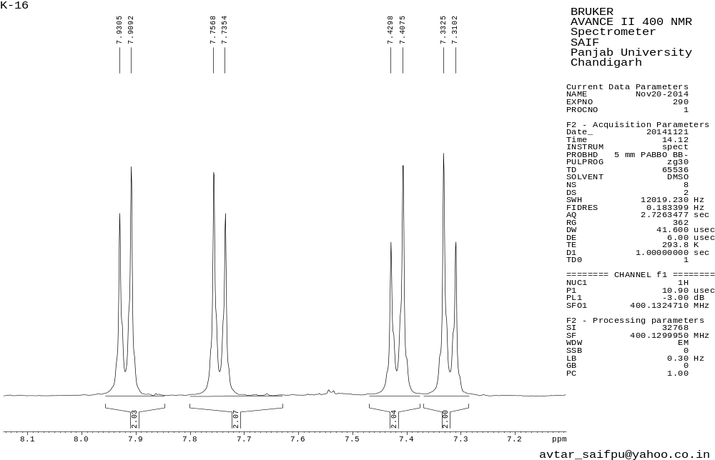
Figure 16.1 ¹H NMR spectrum of 3ab
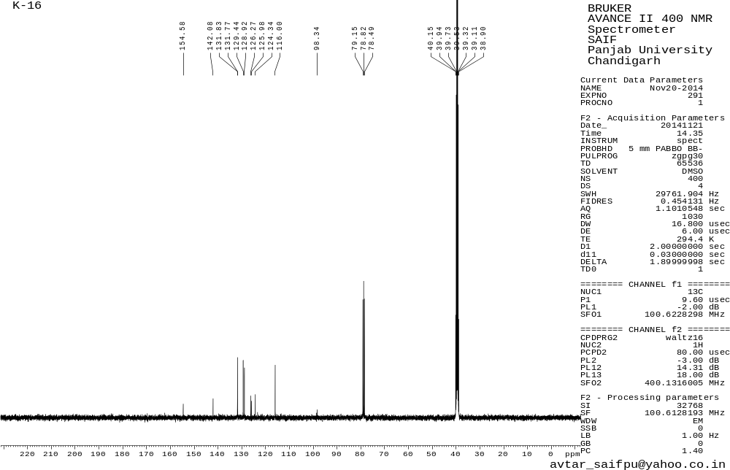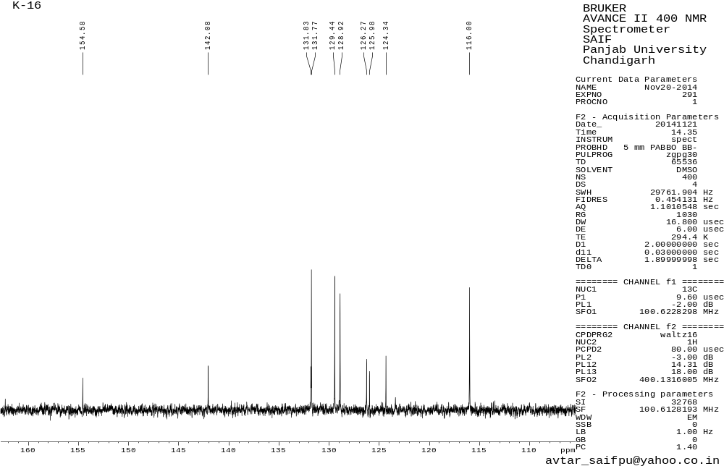
Figure 16.2 ¹³C NMR spectrum of 3ab
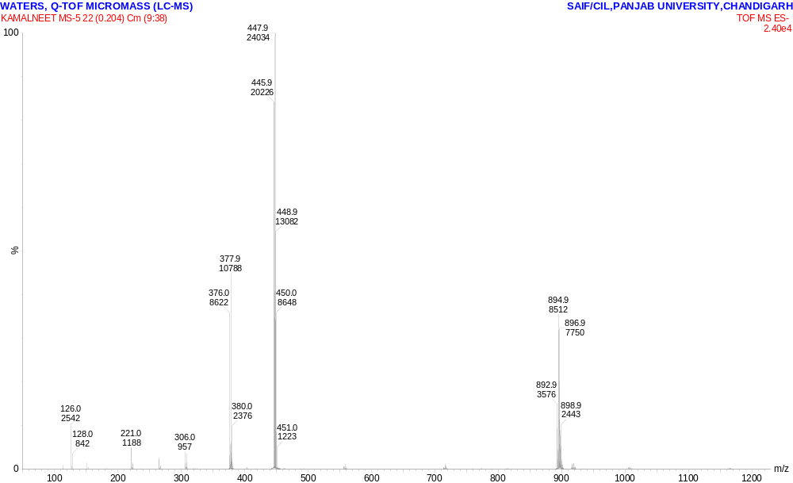

Figure 16.3 HRMS spectrum of 3ab

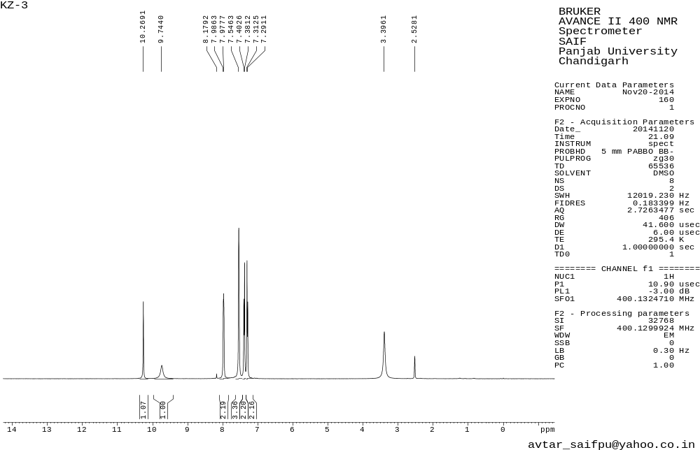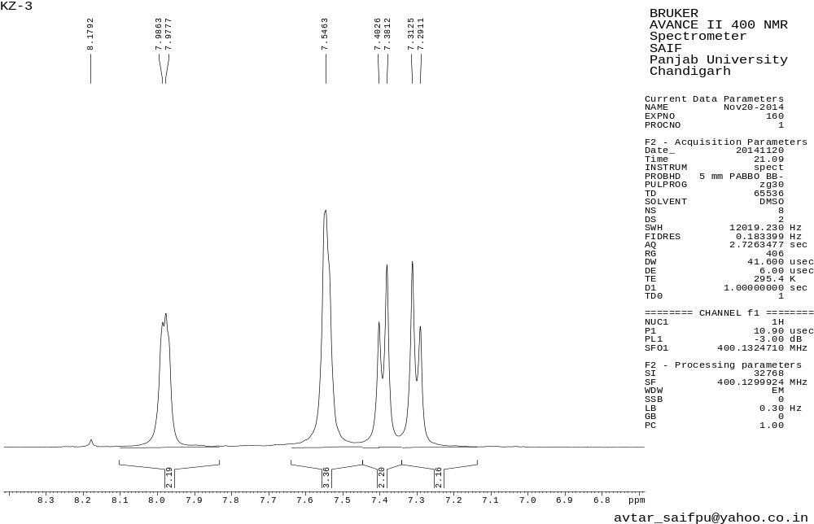
Figure 17.1 ¹H NMR spectrum of 3ac
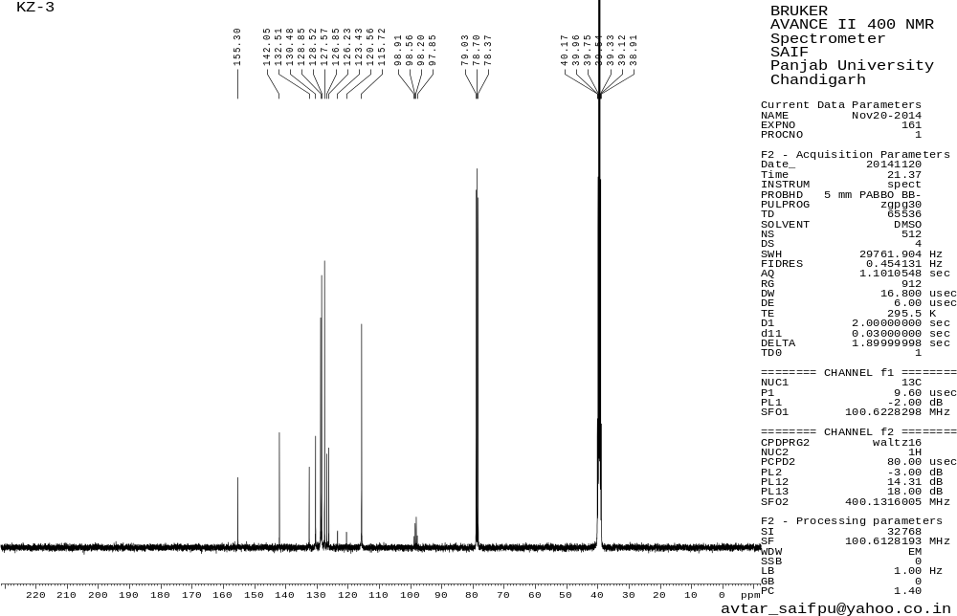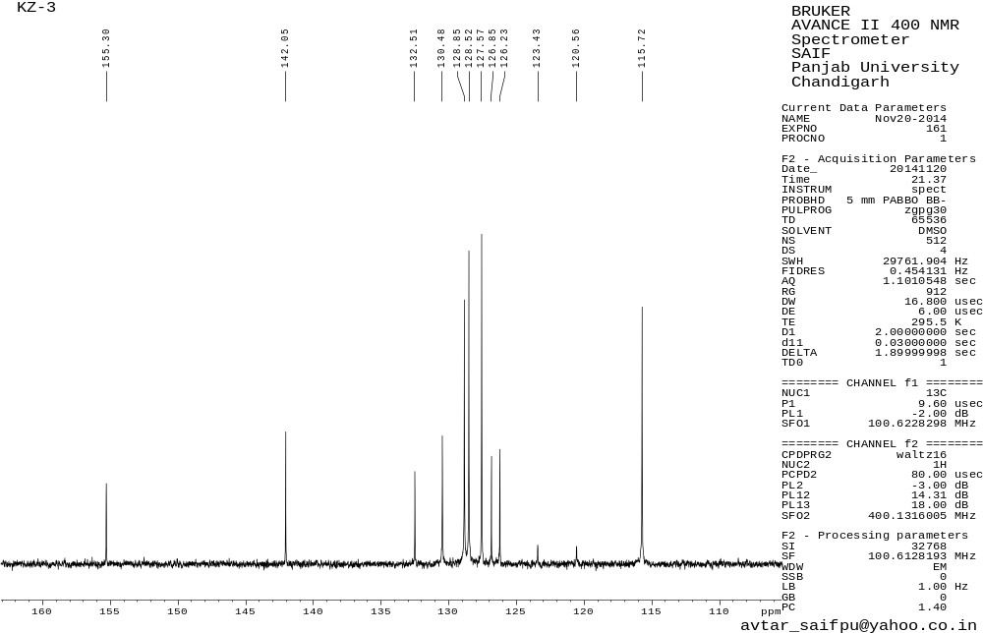
Figure 17.2 ¹³C NMR spectrum of 3ac

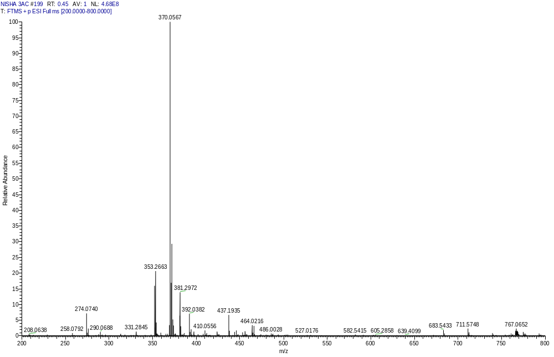
Figure 17.3 HRMS spectrum of 3ac
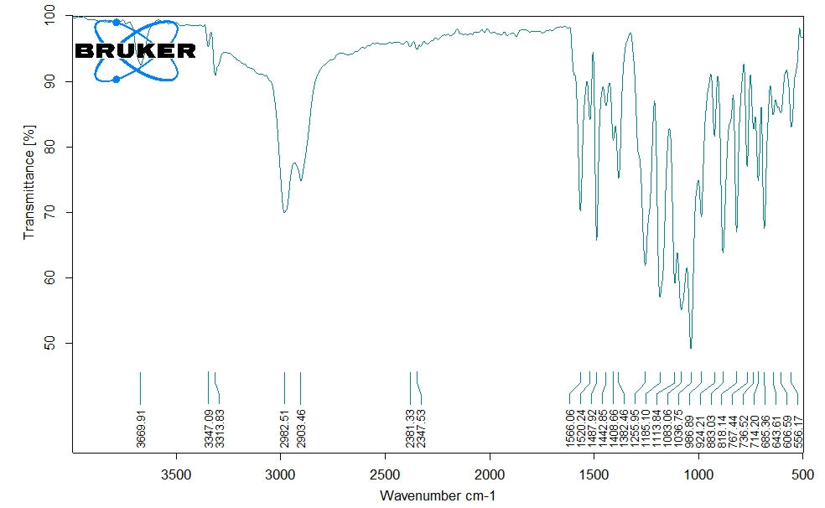Figure 17.4 FT-IR spectrum of 3ac

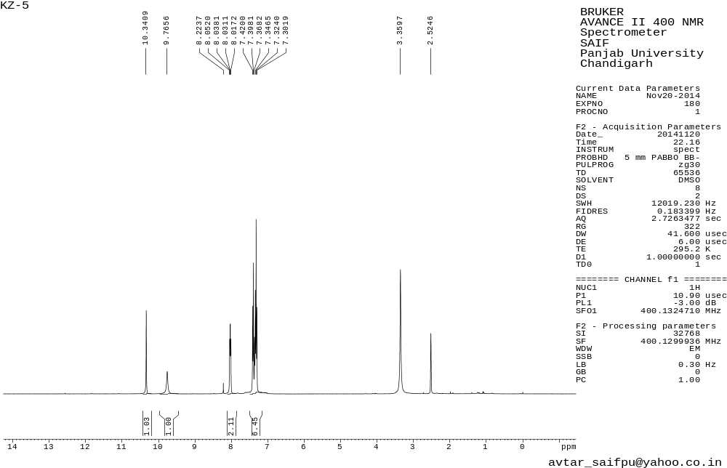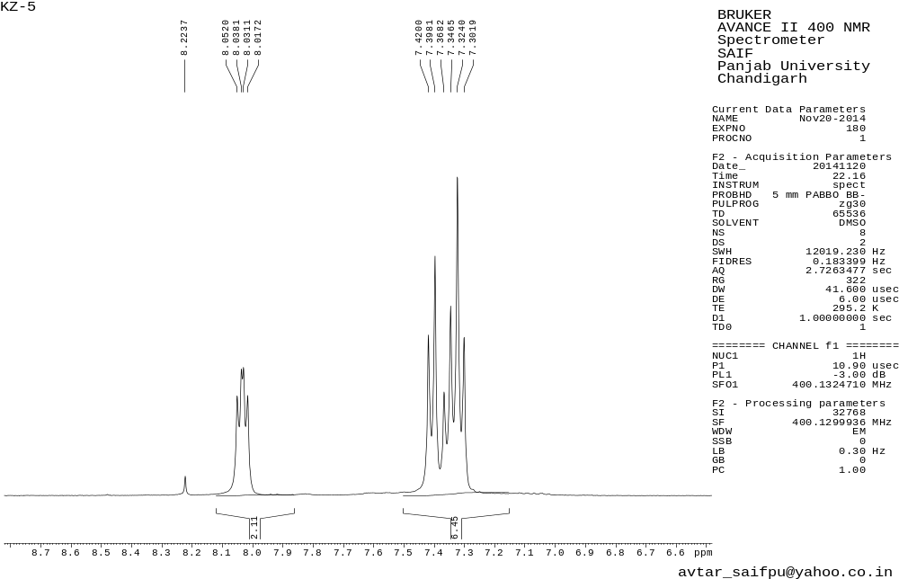
Figure 18.1 ¹H NMR spectrum of 3ad
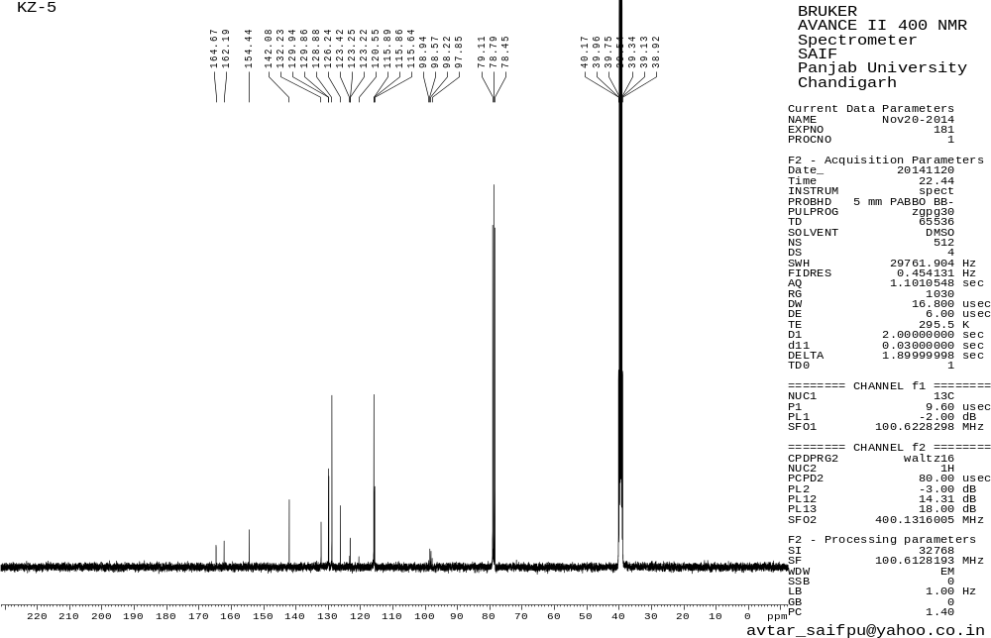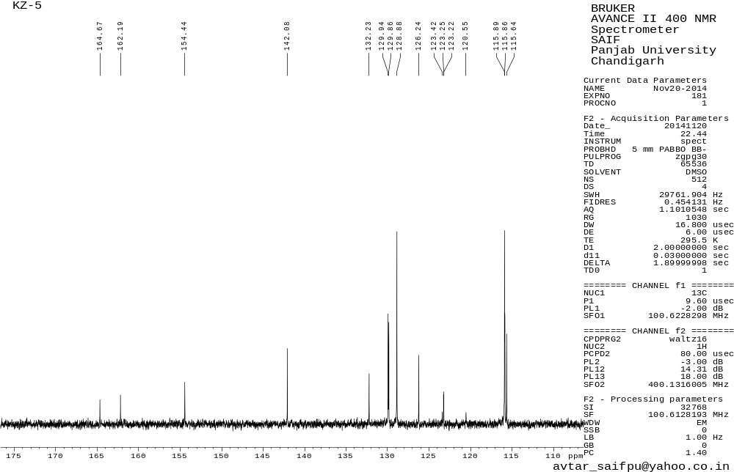
Figure 18.2 ¹³C NMR spectrum of 3ad
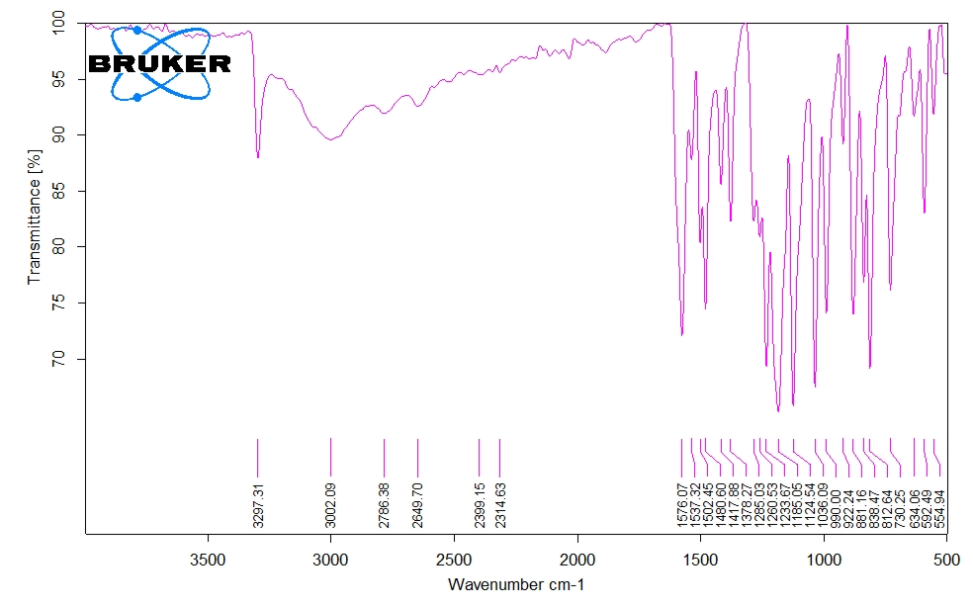Figure 18.3 FT-IR spectrum of 3ad

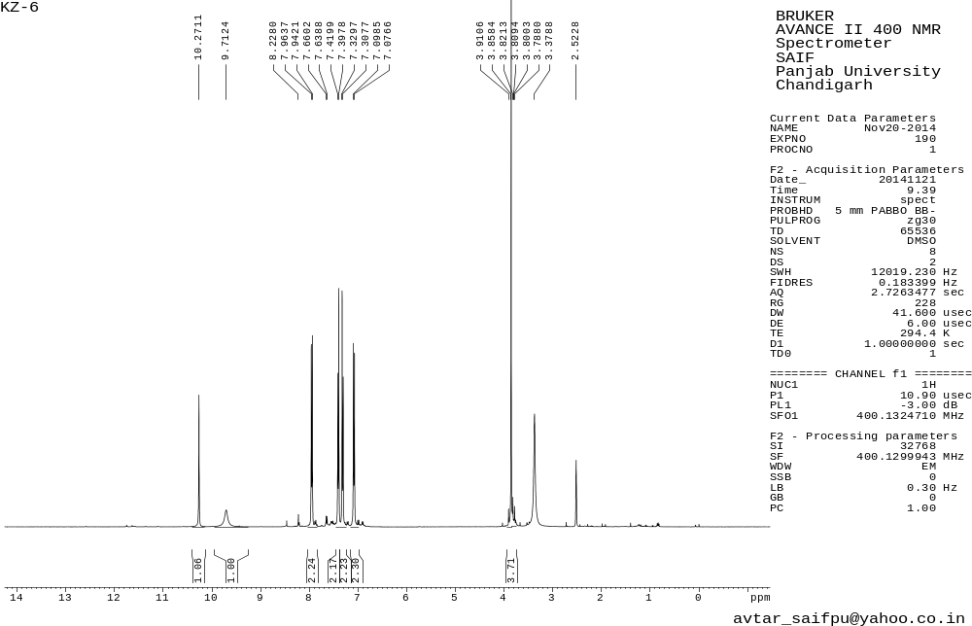
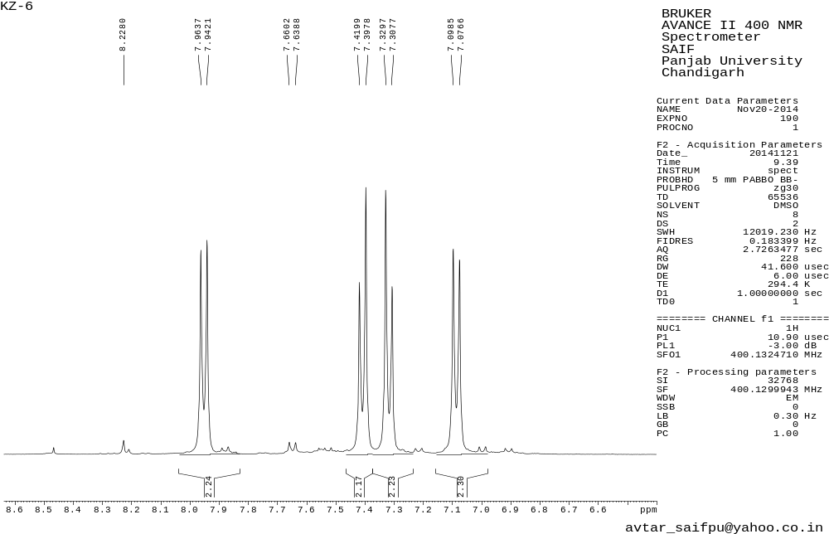
Figure 19.1 ¹H NMR spectrum of 3ae
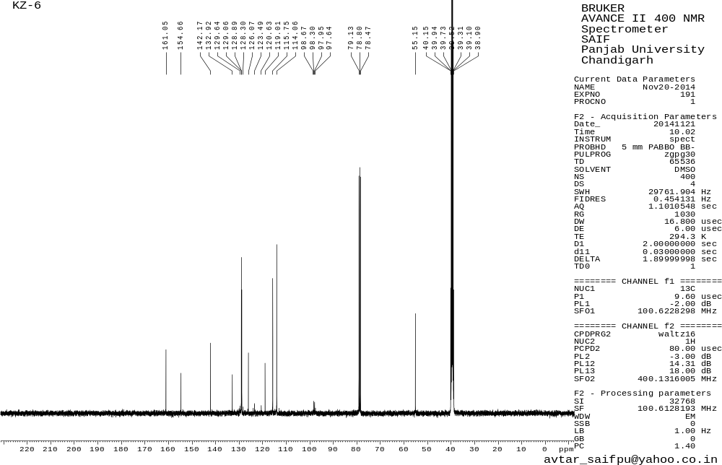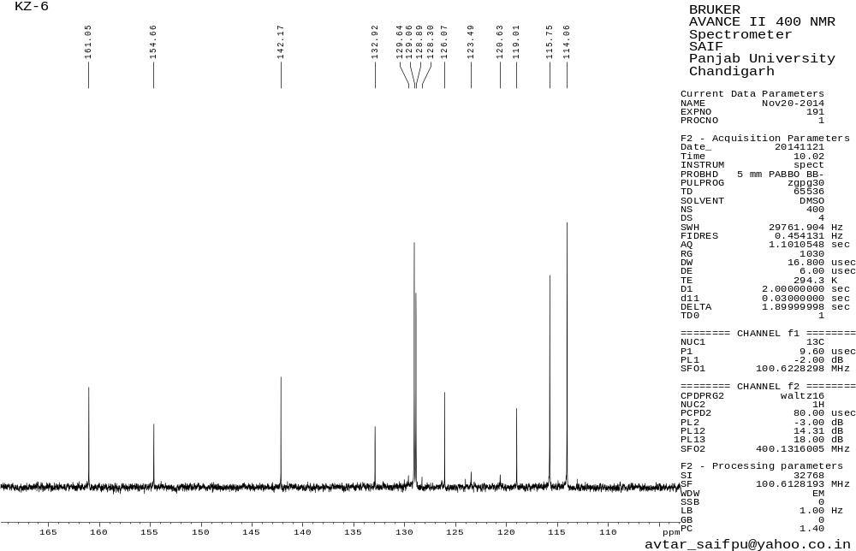
Figure 19.2 ¹³C NMR spectrum of 3ae
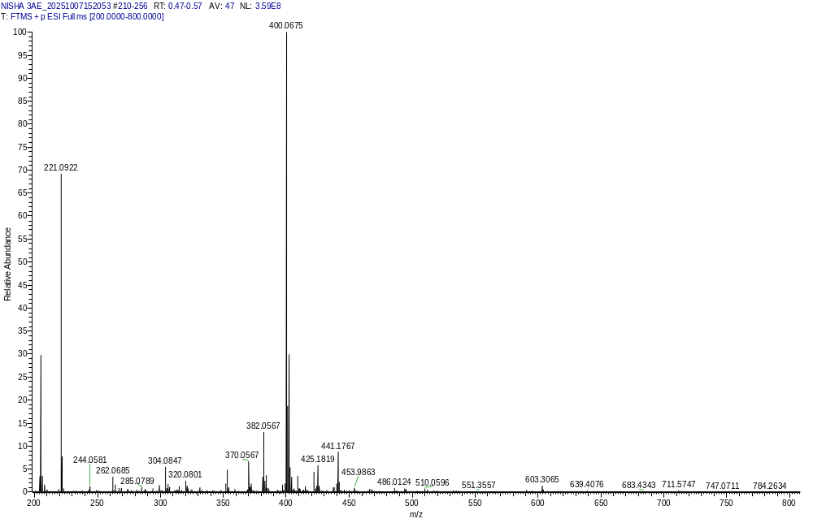

Figure 19.3 HRMS spectrum of 3ae

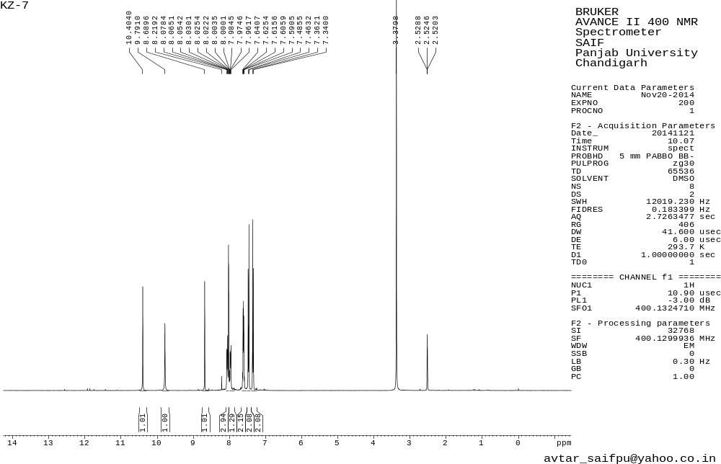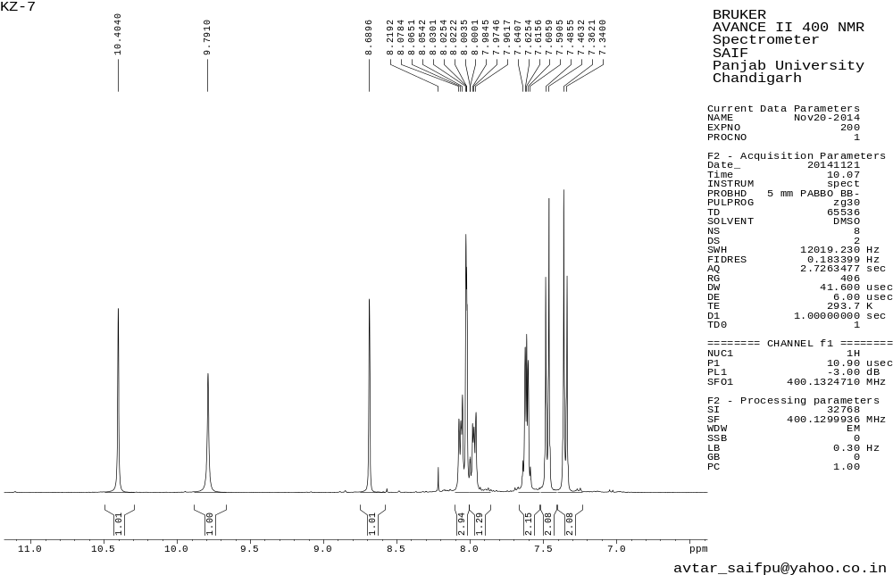
Figure 20.1 ¹H NMR spectrum of 3af
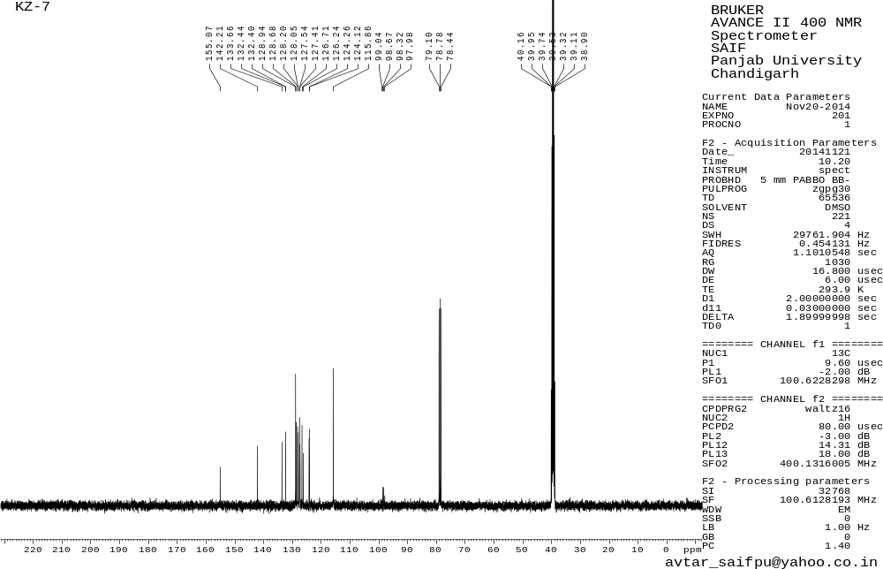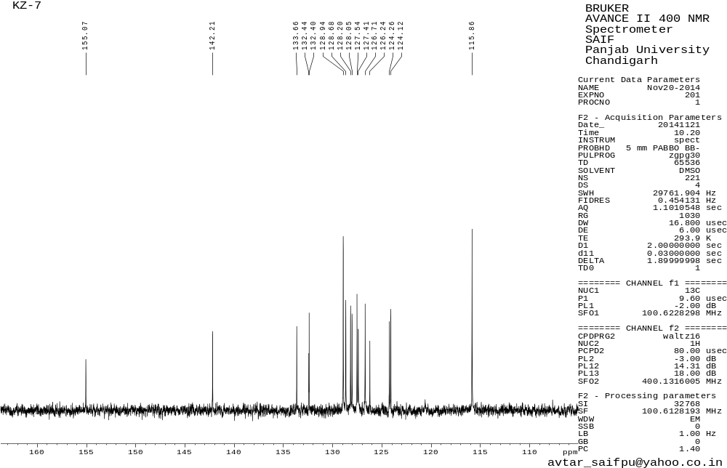
Figure 20.2 ¹³C NMR spectrum of 3af
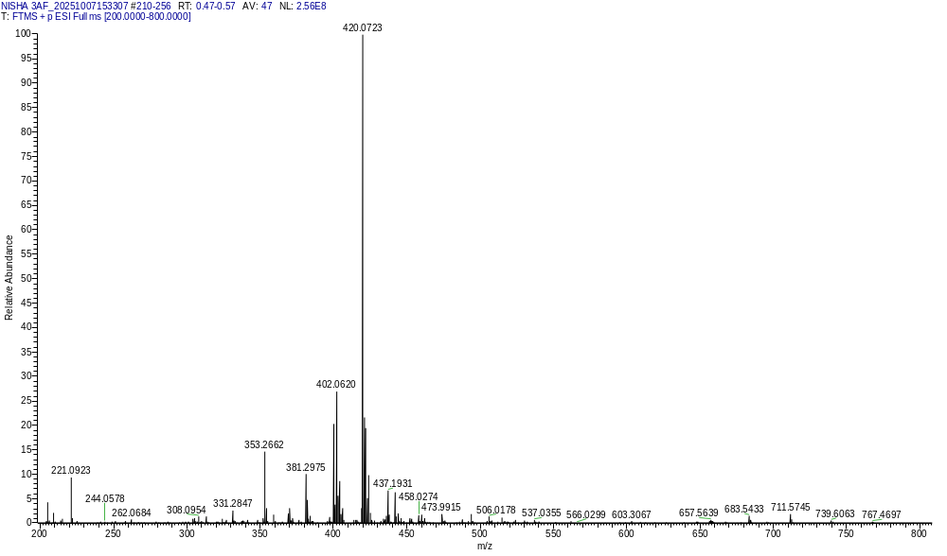
Figure 20.3 HRMS spectrum of 3af
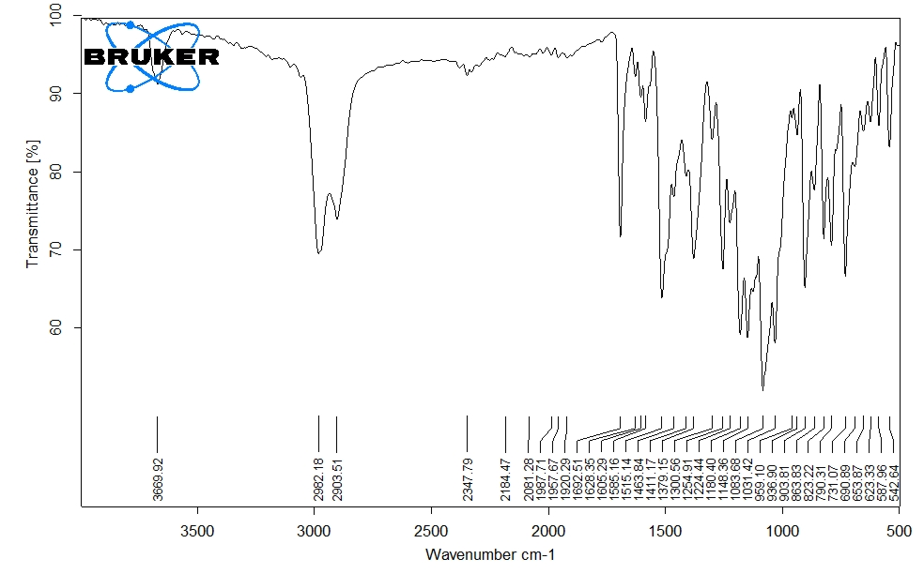
Figure 20.4 FT-IR spectrum of 3af

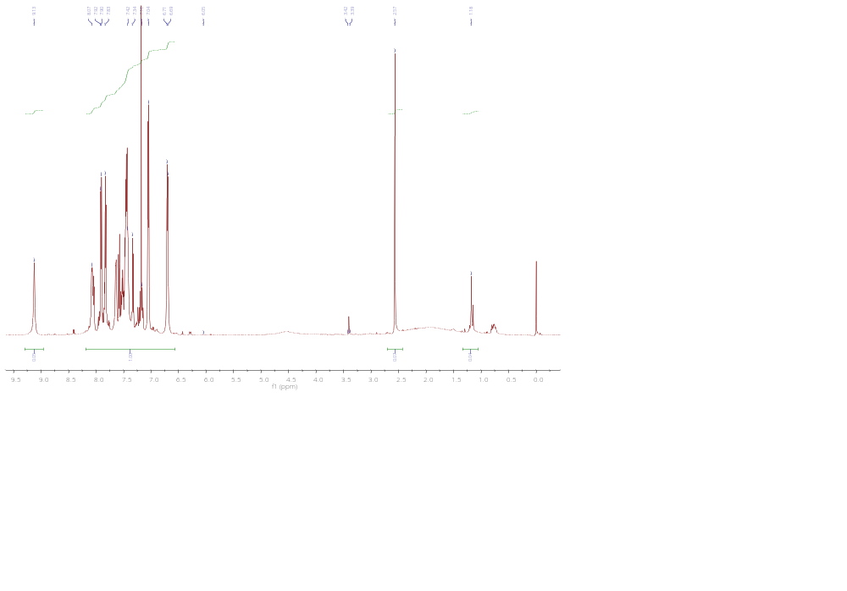
Figure 21.1 ¹H NMR spectrum of 3ag

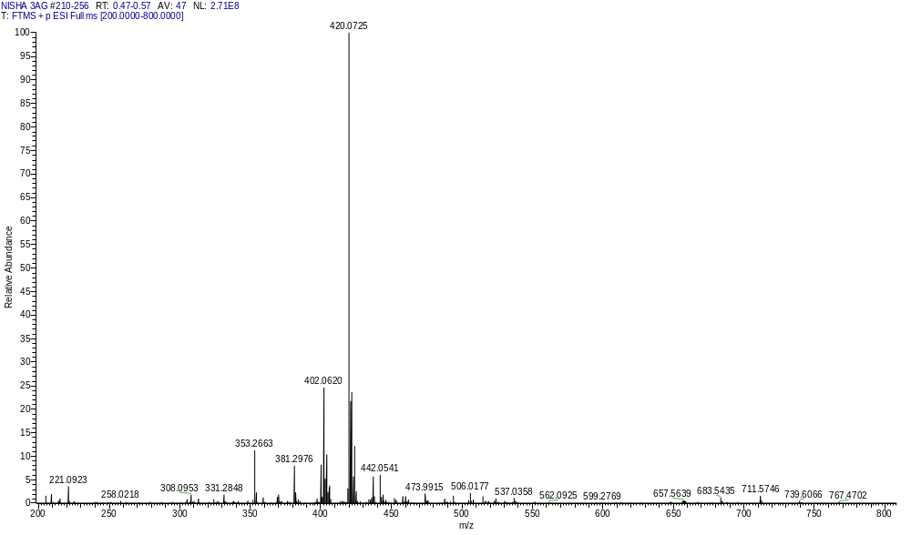Figure 21.2 HRMS spectrum of 3ag

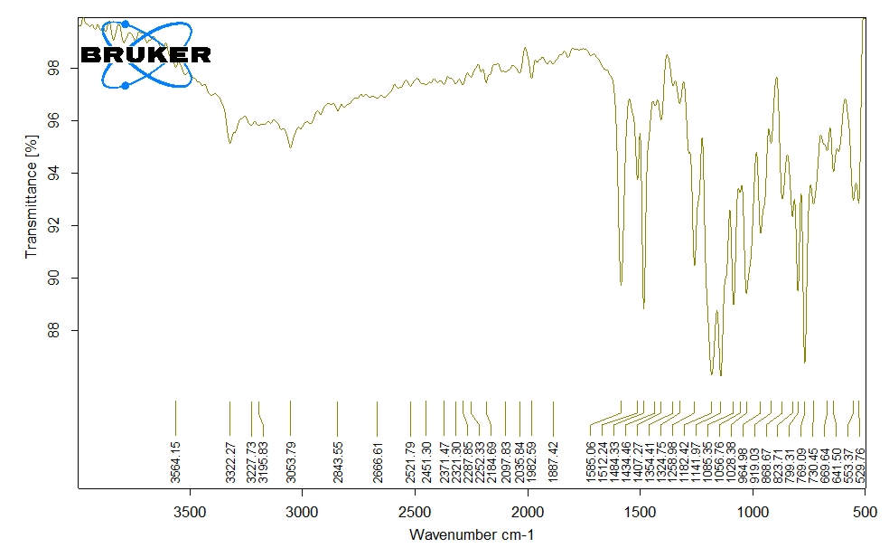
Figure 21.3 FT-IR spectrum of 3ag
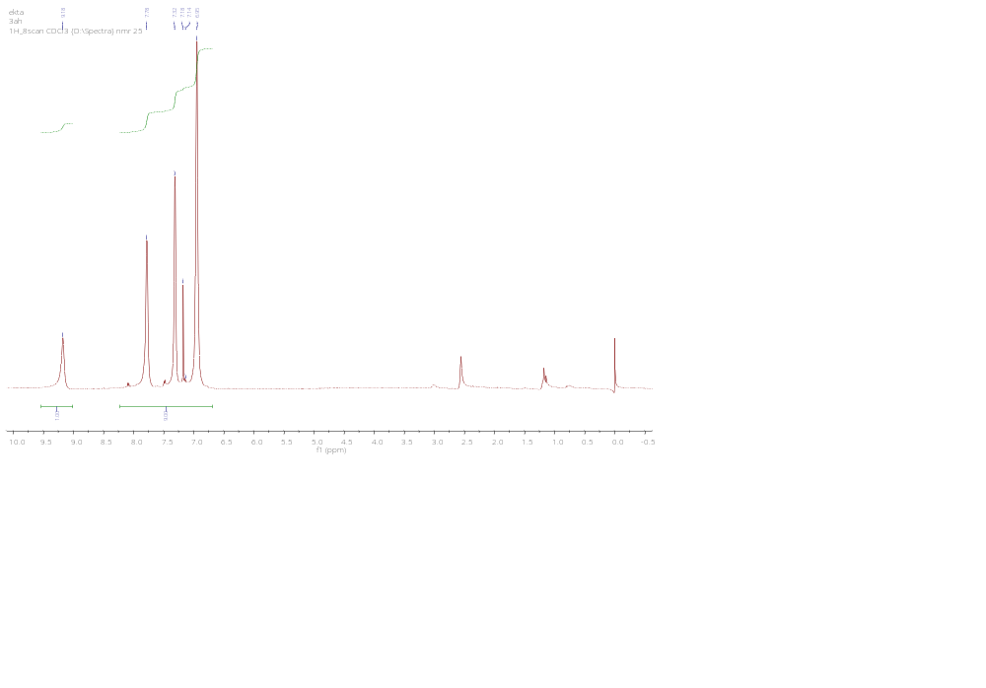
Figure 22.1 ¹H NMR spectrum of 3ah
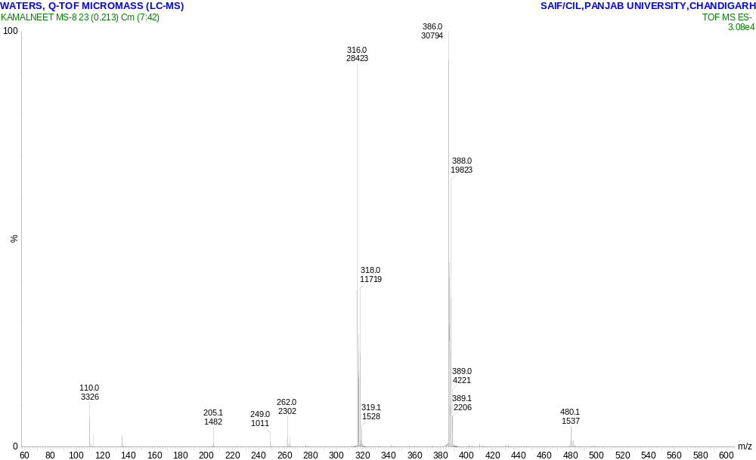Figure 22.2 HRMS spectrum of 3ah
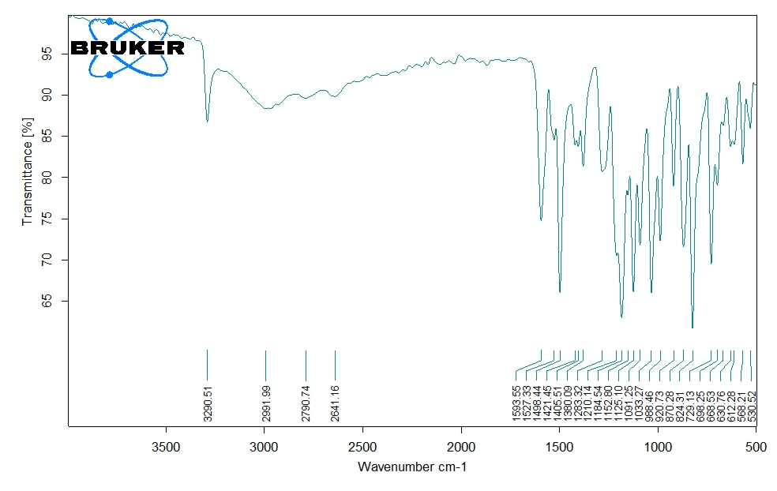Figure 22.3 FT-IR spectrum of 3ah

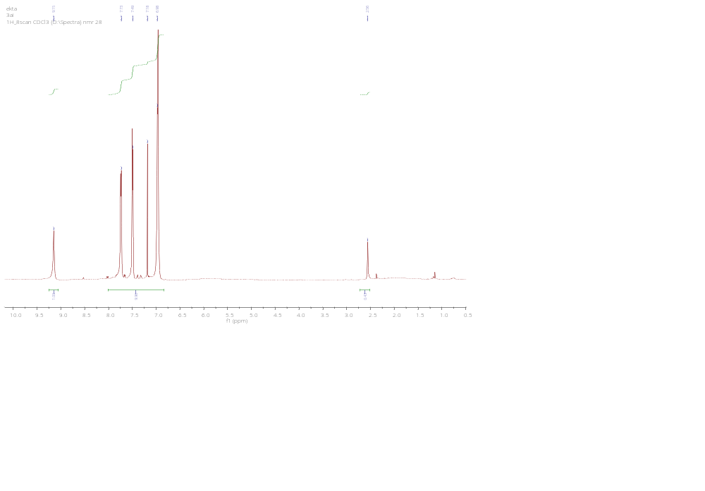
Figure 23.1 ¹H NMR spectrum of 3ai

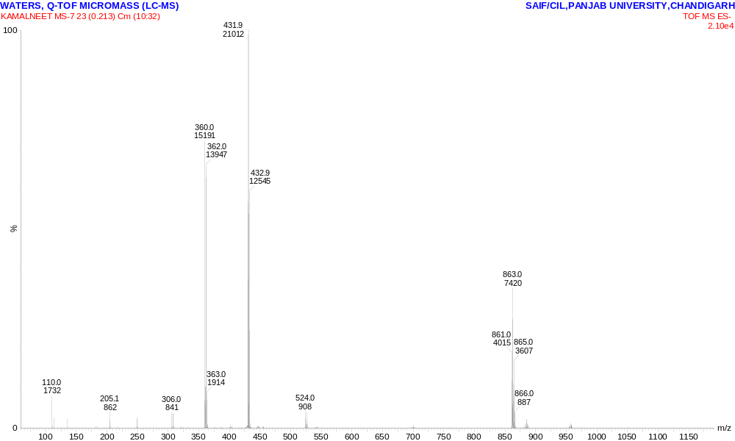Figure 23.2 HRMS spectrum of 3ai
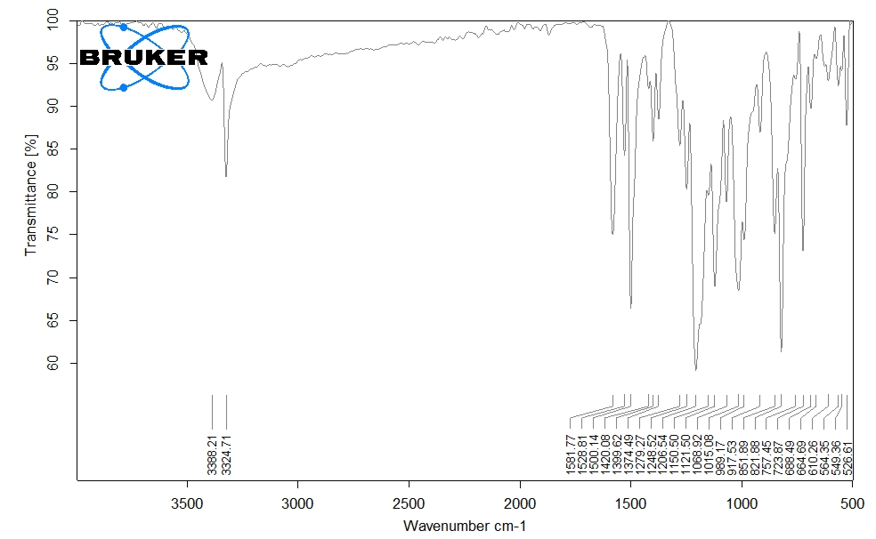Figure 22.3 FT-IR spectrum of 3ai

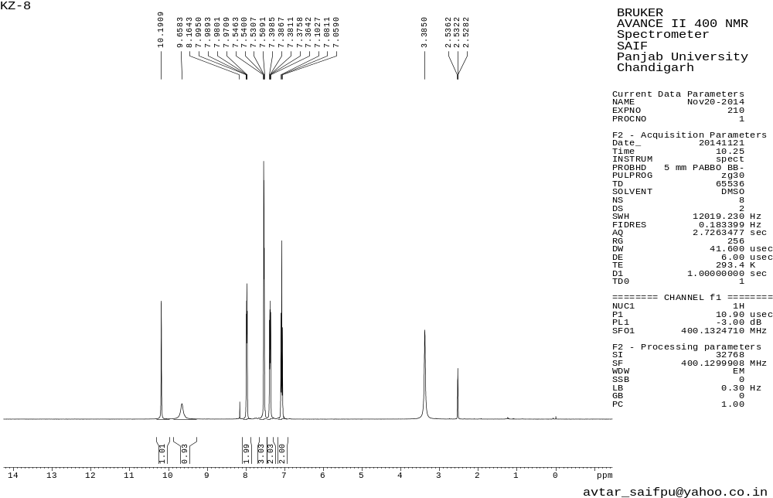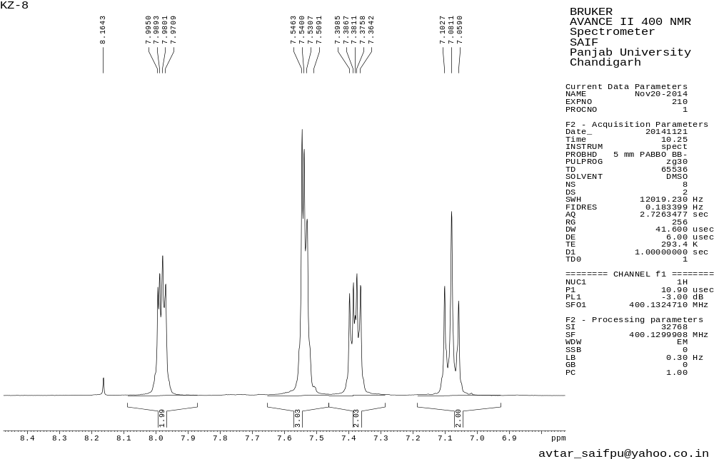Figure 24.1 ¹H NMR spectrum of 3aj
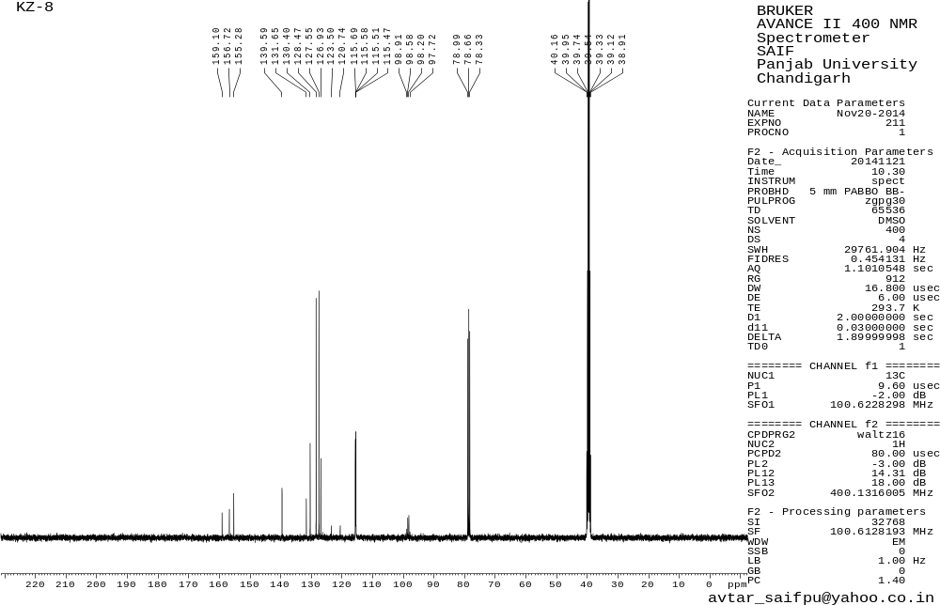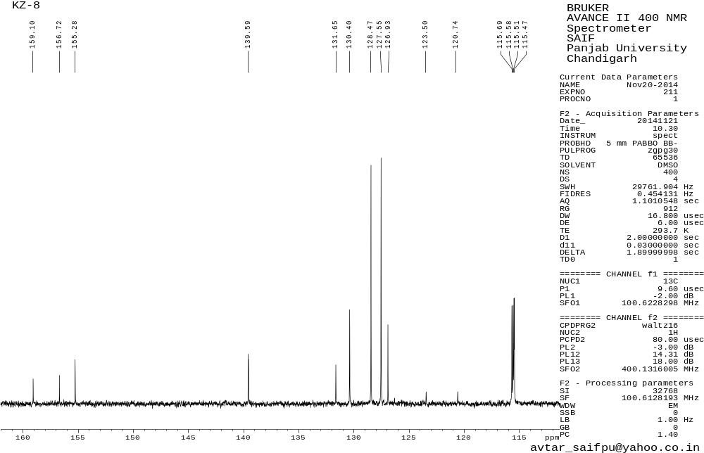Figure 24.2 ¹³C NMR spectrum of 3aj
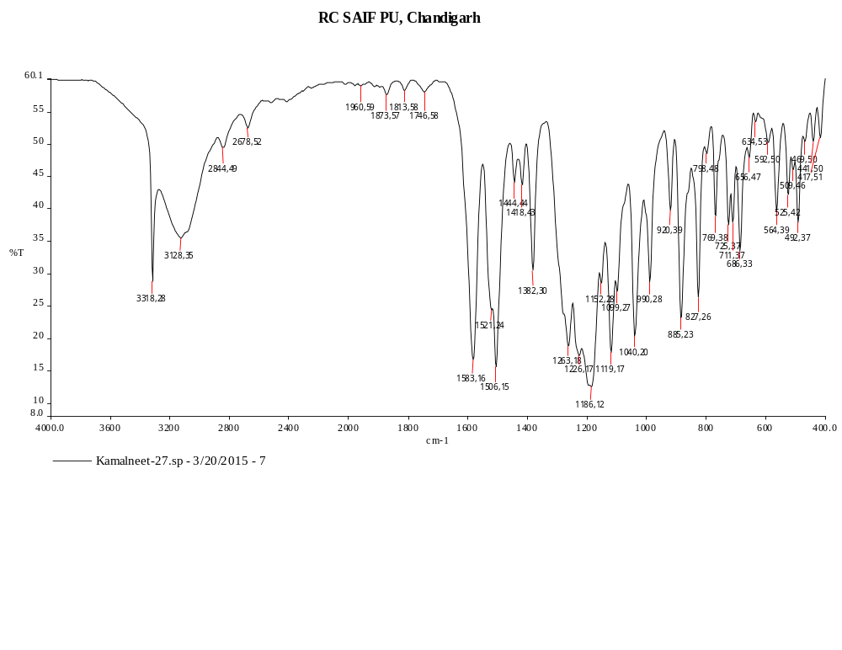
Figure 24.3 FT-IR spectrum of 3aj

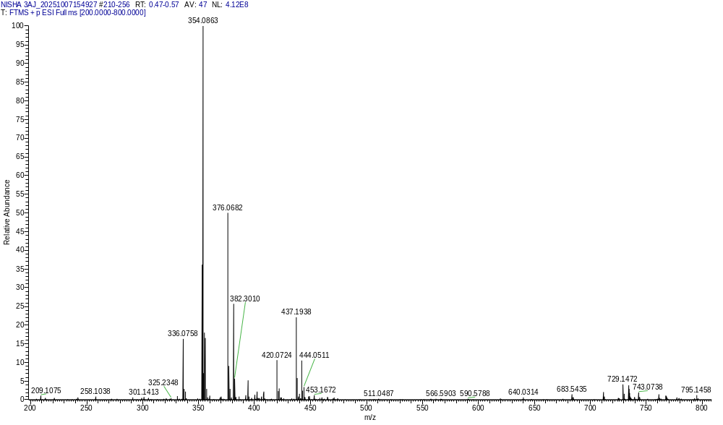
Figure 24.4 HRMS spectrum of 3aj

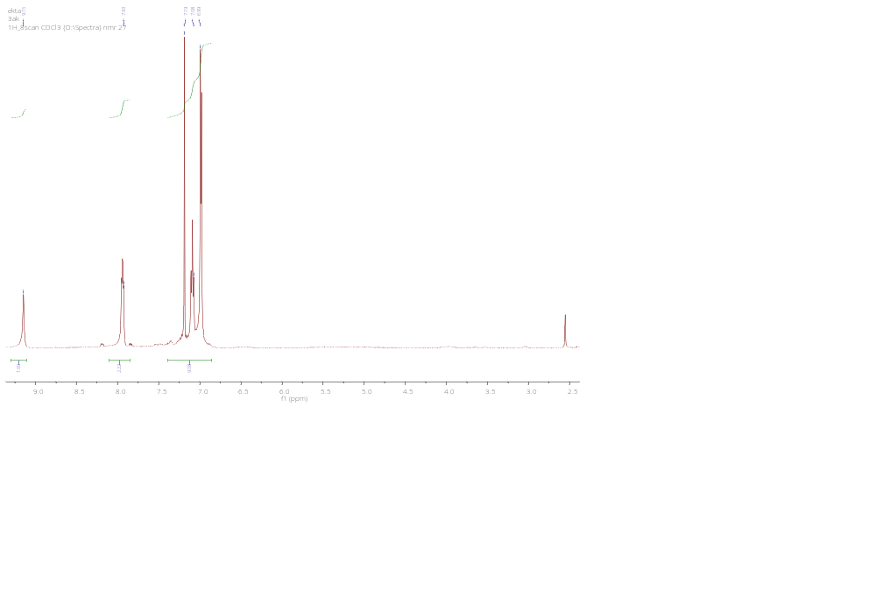
Figure 25.1 ¹H NMR spectrum of 3ak

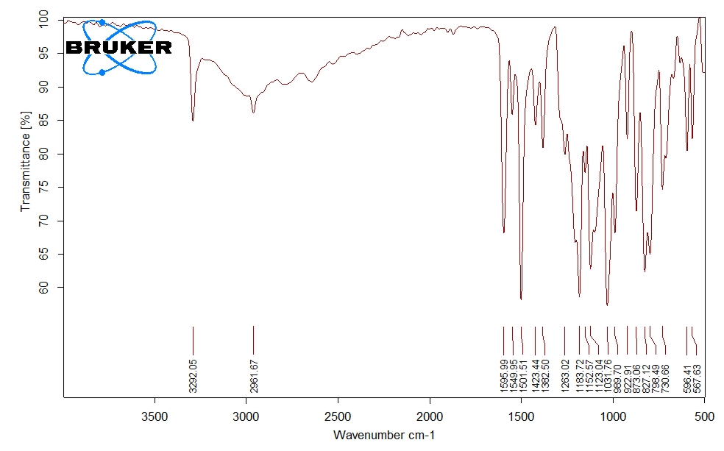Figure 25.2 FT-IR spectrum of 3ak

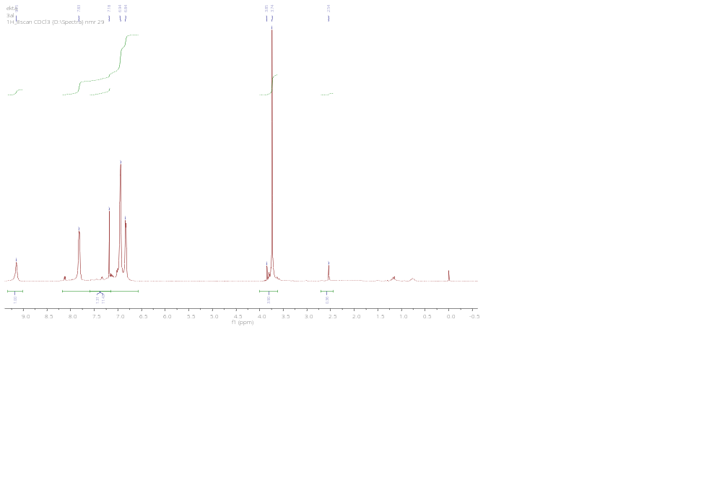
Figure 26.1 ¹H NMR spectrum of 3al
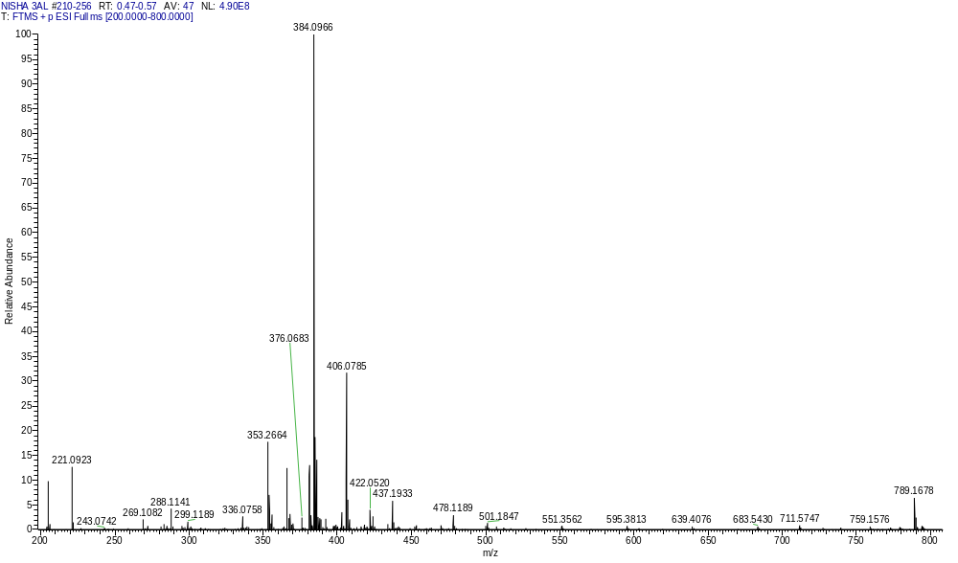

Figure 26.2 HRMS spectrum of 3al
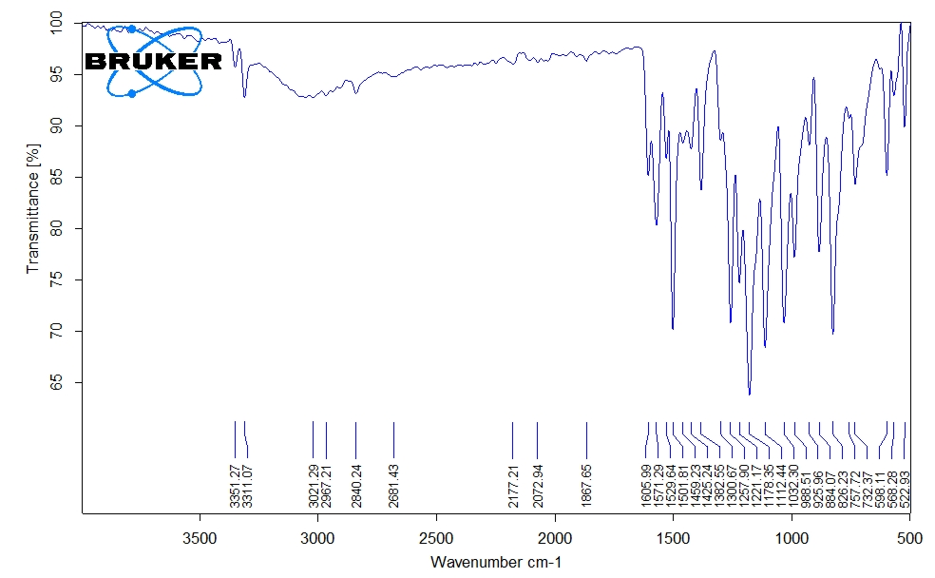
Figure 26.3 FT-IR spectrum of 3al

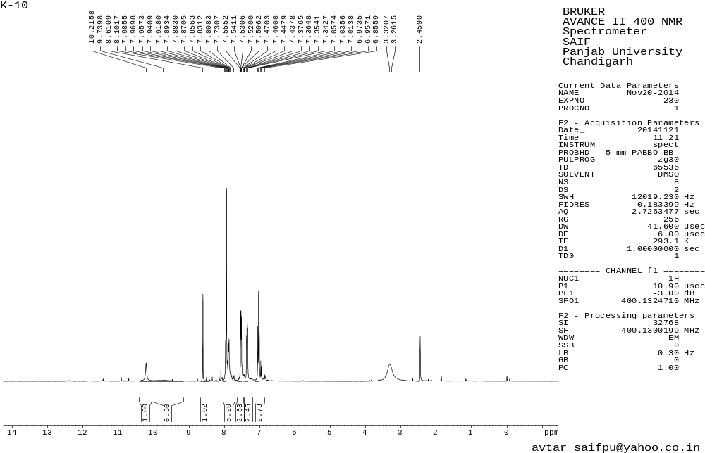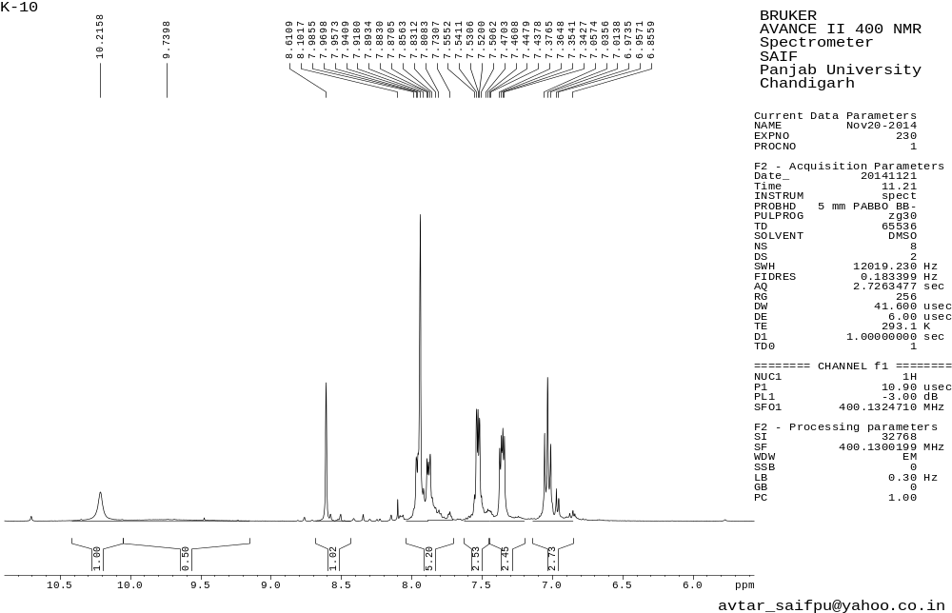Figure 27.1 ¹H NMR spectrum of 3am
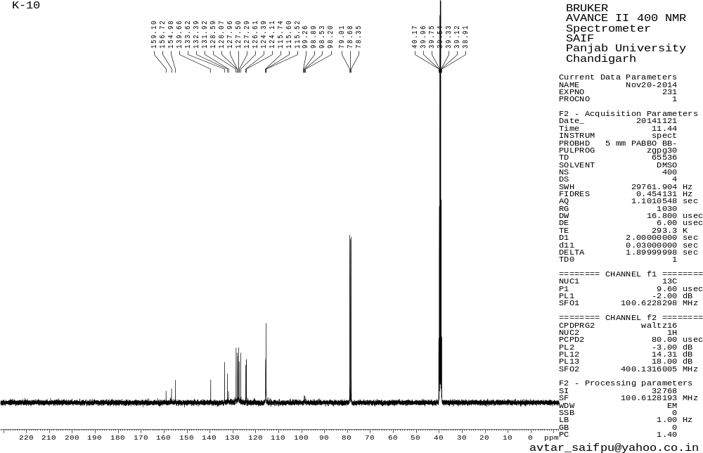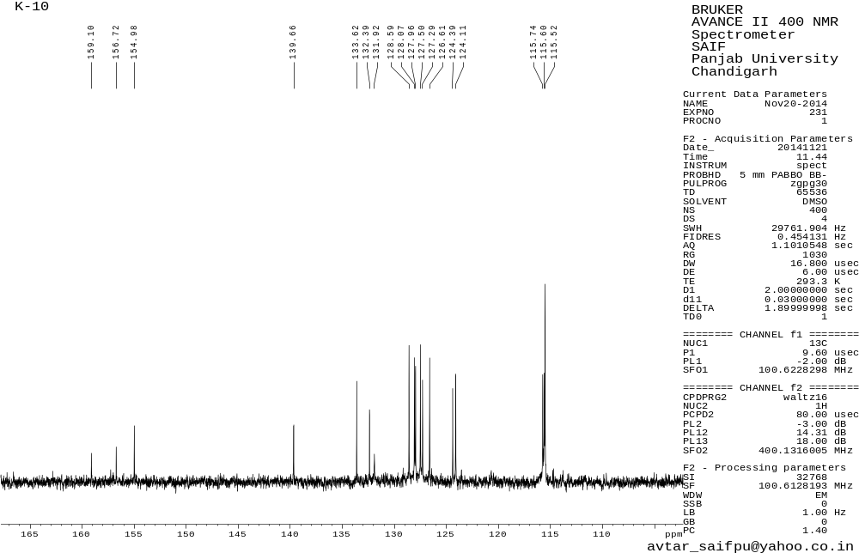
Figure 27.2 ¹³C NMR spectrum of 3am
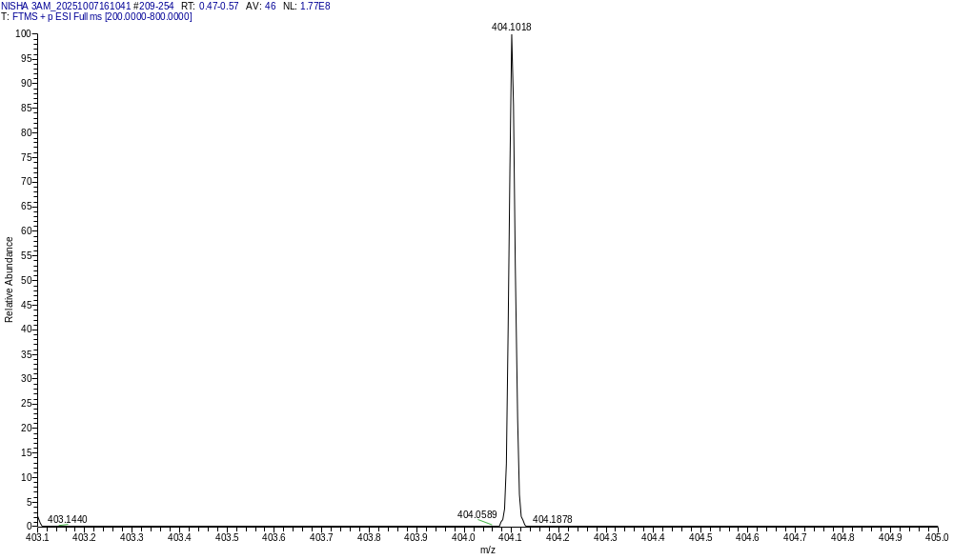

Figure 27.3 HRMS spectrum of 3am

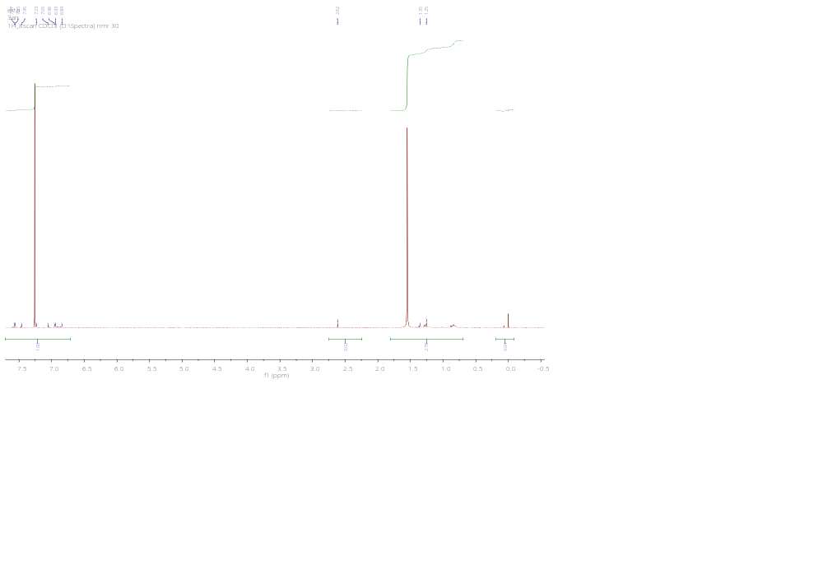
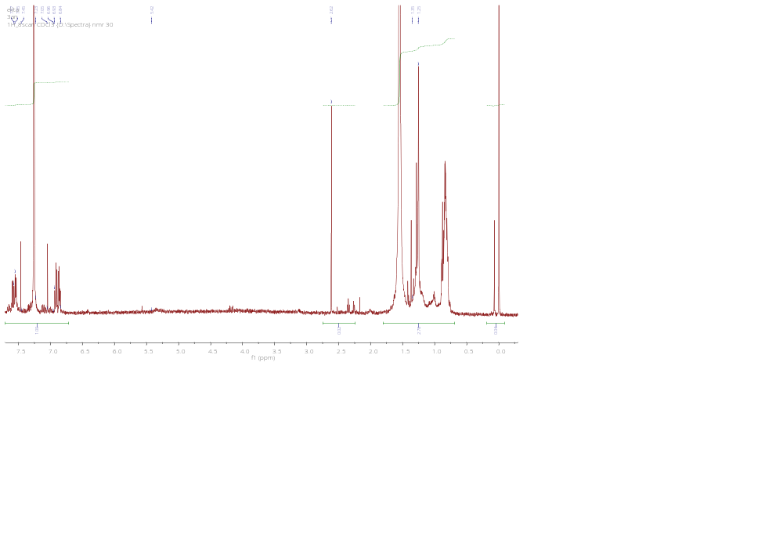Figure 28.1 ¹H NMR spectrum of 3an

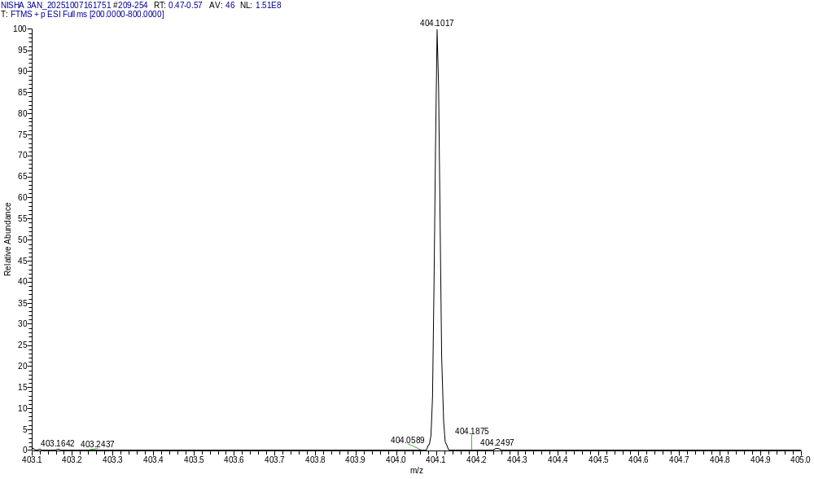
Figure 28.1 HRMS spectrum of 3an

Table 1: Physical properties of the synthesized 4-(aryldiazenyl)-3-aryl-5-hydroxy-5-(trifluoromethyl)-4,5-dihydroisoxazole derivatives (3a-3n and 3aa-3an).

Compound | 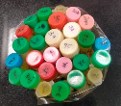  Colour | Measured m.p. (°C) | Reported m.p. (°C) | Yield (g, %)
3a | Yellow | 200–201 | — | 2.14g, 87
3b | Bright yellow | 202 | — | 2.37g, 88
3c | Dark yellow | 187 | — | 1.91g, 83
3d | Dusky yellow | 190-191 | 185-190 (Kumar et al., 2006) | 1.96g, 83
3e | Creamish white | 182 | — | 1.98g, 81
3f | Sandy yellow | 201 | — | 2g, 78
3g | Greyish-green | 170 | — | 2g, 78
3h | Lemon yellow | 178 | — | 1.95g, 87
3i | Creamish yellow | 174 | — | 2.19g, 89
3j | Pale yellow | 172 | — | 1.78g, 86
3k | Light yellow | 176 | 150-154 (Kumar et al., 2006) | 1.83g, 85
3l | Brownish yellow | 172-173 | — | 1.86g, 84
3m | Brown | 179 | — | 1.82g, 79
3n | Dark brown | 170 | — | 1.68g, 73
3aa | Yellow | 169 | — | 1.80g, 89
3ab | Pale yellow | 170 | — | 2g, 90
3ac | Citron yellow | 165 | — | 1.47g, 80
3ad | Amber yellow | 110-113 | 108-112 (Kumar et al., 2006) | 1.56g, 81
3ae | Brown | 165 | — | 1.65g, 81
3af | Turmeric yellow | 162 | — | 1.65g, 83
3ag | Greenish yellow | 160 | — | 7.15g, 76
3ah | Greyish yellow | 160 |  | 1.52g, 73
3ai | Sunny yellow | 165 | — | 1.92g, 89
3aj | Pale yellow | 164 | — | 1.50g, 80
3ak | Sandy yellow | 169-170 | 170(Kumar et al., 2006) | 1.54g, 78
3al | Brownish yellow | 143 | — | 1.63g, 80
3am | Dark yellow | 159 | — | 1.68g, 78
3an | Greenish yellow | 149 | — | 1.55g, 72

Table-2 Inhibition zone diameter of 3a-an using agar well diffusion method at 400 µg/100 µL
ªValues, including the diameter of the well (8 mm), are means of three replicates ± SD
Compounds | Diameter of growth of inhibition zone (mm)ª
Compounds | Gram-positive bacteria |  | Gram-negative bacteria |  | Fungus
Compounds | S. aureus | B. subtilis | E. coli | P. aeruginosa | C. albicans
3a | 18.6 | 20.6 | 15.3 | 14.3 | 12.0
3b | 17.3 | 18.6 | 14.3 | 12.6 | 13.6
3c | 23.6 | 24.6 | 17.6 | 15.3 | 12.6
3d | 21.6 | 24.3 | 16.6 | 15.0 | 14.3
3e | 18.3 | 21.0 | 16.3 | 15.6 | 12.6
3f | 13.6 | 15.6 | - | - | -
3g | 15.6 | 16.3 | - | - | -
3h | 18.3 | 19.3 | 14.3 | 13.6 | 12.3
3i | 19.0 | 21.6 | 15.6 | 14.3 | 12.6
3j | 23.6 | 25.3 | 16.3 | 14.6 | 13.3
3k | 21.6 | 24.3 | 14.3 | 13.6 | 12.0
3l | 20.3 | 21.6 | 15.0 | 15.3 | 12.6
3m | 14.3 | 15.6 | - | - | -
3n | 15.3 | 17.3 | - | - | -
3aa | 22.6 | 24.3 | 15.3 | 13.6 | 12.6
3ab | 22.9 | 24.5 | 15.7 | 13.9 | 12.9
3ac | 23.0 | 24.6 | 16.0 | 14.3 | 12.3
3ad | 24.3 | 26.3 | 18.6 | 17.3 | 16.3
3ae | 23.6 | 25.6 | 17.3 | 16.6 | 15.3
3af | 18.6 | 20.3 | 14.6 | 12.6 | 12.0
3ag | 21.3 | 23.6 | 15.6 | 13.3 | 12.6
3ah | 24.0 | 25.6 | 15.6 | 14.3 | 14.6
3ai | 24.6 | 26.0 | 17.6 | 16.6 | 15.0
3aj | 23.3 | 25.3 | 16.3 | 15.6 | 12.6
3ak | 25.3 | 26.3 | 18.3 | 17.6 | 16.3
3al | 21.6 | 23.6 | 15.3 | 14.6 | 13.6
3am | 18.6 | 20.3 | 14.0 | 12.6 | 13.6
3an | 20.6 | 21.2 | 15.0 | 13.7 | 14.2
Ciprofloxacin | 26.6 | 26.0 | 25.0 | 22.0 | -
Amphotericin-B | Nt | Nt | Nt | Nt | 17.6
Note: Nt means not tested, - means no activity.

Table-3 Antimicrobial activity of compounds 3a-an expressed in MIC (µg/100 µL)

Compounds | MIC in µg/ 100 µL
Compounds | Gram-positive bacteria |  | Gram-negative bacteria |  | Fungus
Compounds | S. aureus | B.subtilis | E. coli | P. aeruginosa | C. albicans
3a | 64 | 64 | 128 | 256 | 512
3b | 64 | 64 | 256 | 256 | 256
3c | 16 | 16 | 128 | 128 | 512
3d | 32 | 16 | 128 | 128 | 128
3e | 64 | 32 | 128 | 128 | 512
3f | 256 | 128 | Nt | Nt | Nt
3g | 128 | 128 | Nt | Nt | Nt
3h | 64 | 64 | 256 | 256 | 512
3i | 64 | 32 | 128 | 128 | 256
3j | 16 | 8 | 128 | 128 | 256
3k | 32 | 16 | 256 | 256 | 512
3l | 32 | 32 | 128 | 128 | 512
3m | 128 | 128 | Nt | Nt | Nt
3n | 128 | 128 | Nt | Nt | Nt
3aa | 32 | 16 | 128 | 256 | 512
3ab | 64 | 64 | 256 | 256 | 256
3ac | 16 | 16 | 128 | 128 | 512
3ad | 16 | 8 | 64 | 128 | 64
3ae | 16 | 8 | 128 | 128 | 64
3af | 64 | 64 | 256 | 256 | 512
3ag | 32 | 16 | 128 | 256 | 512
3ah | 16 | 8 | 128 | 128 | 128
3ai | 16 | 8 | 128 | 128 | 128
3aj | 16 | 8 | 128 | 128 | 512
3ak | 8 | 8 | 64 | 64 | 32
3al | 32 | 16 | 128 | 128 | 256
3am | 64 | 32 | 126 | 256 | 256
3an | 32 | 16 | 128 | 128 | 256
Ciprofloxacin | 6.25 | 6.25 | 6.25 | 6.25 | Nt
Amphotericin-B | Nt | Nt | Nt | Nt | 128
Note: Nt means not tested, - means no activity.

Table-4 The in vitro free radical-scavenging activity of the synthesized compounds, measured using the DPPH assay

Compounds | Concentration (µg/mL) |  |  |  |  | EC₅₀ Value  (µg/mL)
Compounds | 100 | 50 | 25 | 12.5 | 6.25 | EC₅₀ Value  (µg/mL)
3a | NA | NA | NA | NA | NA | NA
3b | 55.04±0.34 | 50.15±0.41 | 45.11±0.52 | 44.47±0.51 | 40.10±0.12 | ~50
3c | 38.80±0.13 | 36.43±0.14 | 36.1±0.15 | 35.80±0.26 | NA | >100
3d | 52.83±0.54 | 49.84±0.34 | 45.42±0.26 | 40.69±0.72 | 35.41±0.53 | 50-100
3e | 89.11±0.61 | 88.80±0.66 | 86.75±0.72 | 63.24±0.84 | 60.20±0.63 | >50
3f | 57.09±0.42 | 51.89±0.21 | 47.31±0.61 | 44.79±0.49 | 40.01±0.23 | 25-50
3g | 57.88±0.44 | 49.21±0.13 | 41.79±0.81 | 39.43±0.21 | 36.09±0.16 | 50-100
3h | NA | NA | NA | NA | NA | NA
3i | NA | NA | NA | NA | NA | NA
3j | 77.91±0.29 | 68.61±0.99 | 59.14±0.26 | 59.14±0.26 | 50.21±0.12 | 6.25
3k | NA | NA | NA | NA | NA | NA
3l | 68.61±0.11 | 59.77±0.19 | 51.10±0.04 | 45.89±0.29 | 39.01±0.22 | 12.5-25
3m | 59.46±0.12 | 52.05±0.47 | 44.47±0.95 | 41.48±0.65 | 38.20±0.12 | 25-50
3n | NA | NA | NA | NA | NA | NA
3aa | 62.14±0.10 | 53.94±0.33 | 51.73±0.05 | 47.79±0.01 | 45.20±0.11 | 12.5-25
3ab | 62.10±0.13 | 52.94±0.22 | 45.70±0.81 | 44.81±0.01 | 38.20±0.11 | 25-50
3ac | 66.87±0.6 | 59.93±0.26 | 49.36±0.39 | 46.84±0.15 | 40.01±0.13 | 25-50
3ad | 67.50±0.76 | 56.7±0.34 | 50±0.11 | 47.16±0.22 | 44.51±0.02 | ~25
3ae | 72.87±0.01 | 61.82±0.19 | 51.89±0.12 | 47.63±0.14 | 43.20±0.12 | 12.5-25
3af | 61.04±0.11 | 54.10±0.21 | 47.94±0.39 | 45.11±0.04 | 43.23±0.23 | 25-50
3ag | 64.98±0.14 | 56.62±0.34 | 49.84±0.42 | 47.31±0.81 | 45.33±0.21 | 25-50
3ah | 76.65±0.61 | 66.71±0.92 | 60.41±0.09 | 52.36±0.93 | 42.44±0.11 | 6.25-12.5
3ai | 76.81±0.13 | 69.24±0.02 | 55.67±0.81 | 52.52±0.31 | 49.302 | 6.25-12.5
3aj | 72.55±0.15 | 65.93±0.12 | 58.99±0.11 | 51.57±0.7 | 44.45±0.16 | 6.25-12.5
3ak | 70.50±14 | 60.09±0.14 | 53.31±0.2 | 45.58±0.3 | 38.43±0.31 | 12.5-25
3al | 78.54±0.10 | 65.93±0.11 | 63.24±0.19 | 53.94±0.3 | 43.20±0.3 | 6.25-12.5
3am | 86.90±0.18 | 78.70±0.6 | 69.71±0.16 | 57.57±0.01 | 46.11±0.12 | 6.25-12.5
3an | 82.90±0.11 | 71.70±0.3 | 63.71±0.16 | 51.62±0.3 | 43.11±0.18 | 6.25-12.5
Ascorbic acid | 87.83±0.03 | 85.83±0.03 | 76.48±1.54 | 40.94±0.67 | 20.66±0.89 | 13.27±1.10
Note: NA means---- No Activity

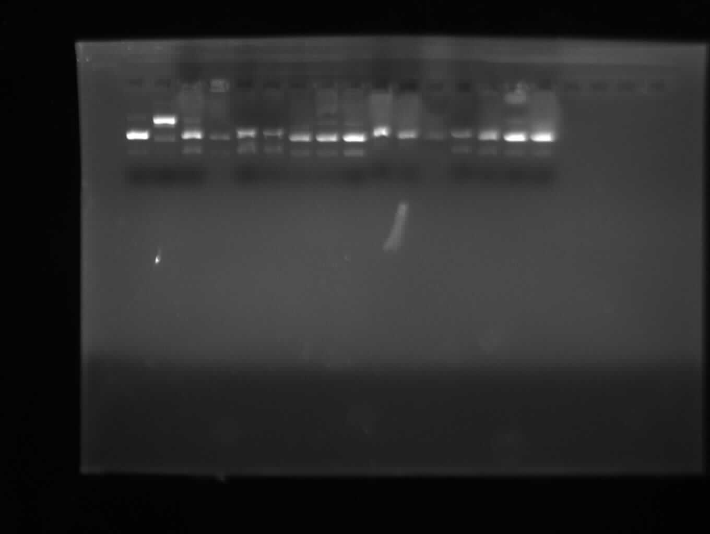
Figure 29: DNA Photocleavage Study of Isoxazoles (3a-3n) Using pBR322 Plasmid DNA at 60 µg/mL. (Original, Unprocessed, Unedited)

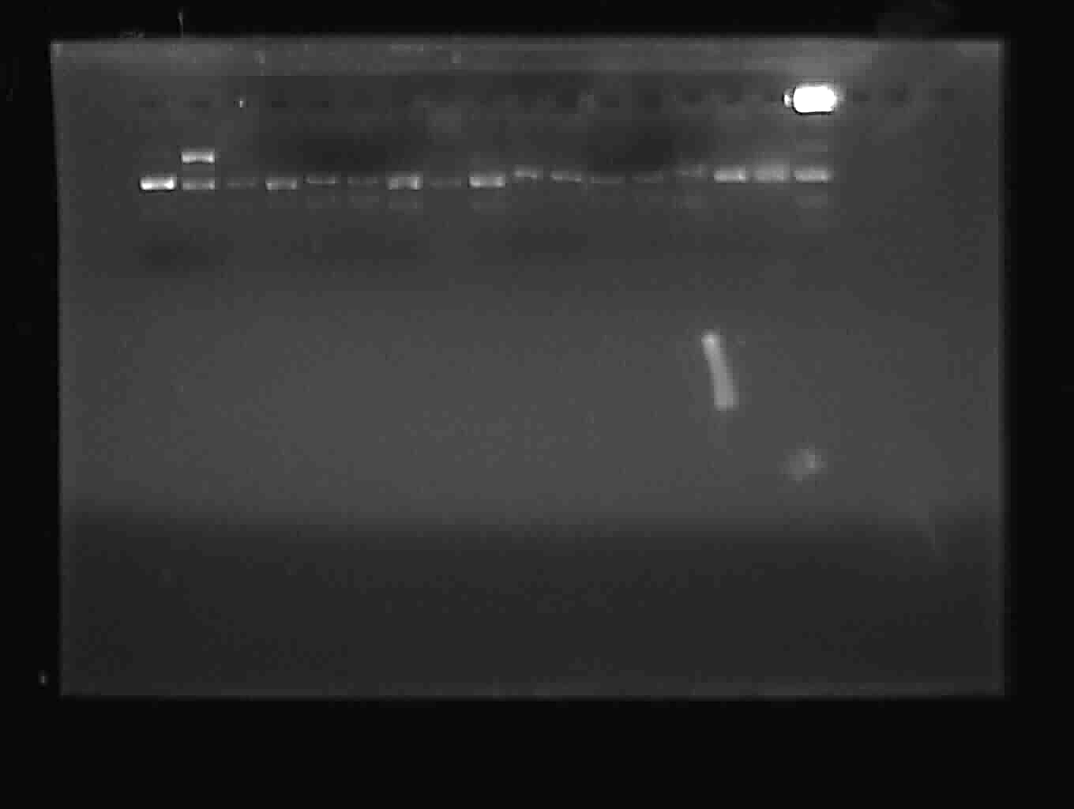
Figure 30: DNA Photocleavage Study of Isoxazoles (3aa-3an) Using pBR322 Plasmid DNA at 60 µg/mL (Original, Unprocessed, Unedited)

