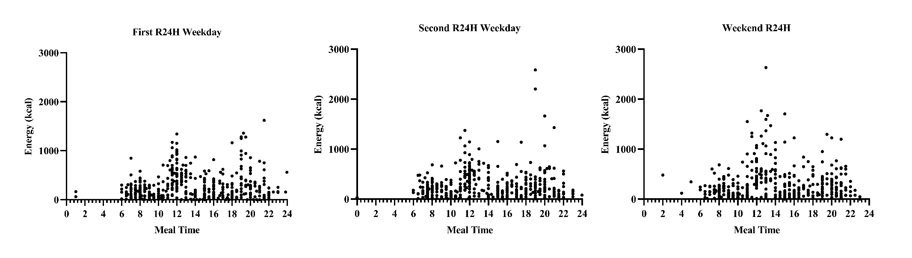
Supplementary Figure 1. Distribution of energy per hour in each of the three 24-hour dietary recalls (R24H) (n=89).

Note: Each point on the graph represents the timing and calories of a meal consumed by the participants in each of the three 24-hour recalls, with two on weekdays and one on a weekend day, applied on non-consecutive days. There is no statistically significant difference between the three recalls applied. Therefore, the average obtained from the three applied recalls was used to calculate the chrononutritional variables.

