Supplementary Information

Growth Performance and Estimated CO₂ Fixation of Chlorella sp. in Flat Panel and Tubular Photobioreactors under Tropical Outdoor Conditions in Thailand

Bernadetha Grace Wisdayanti¹, Napassawan Wongmongkol^{1*}, Muhammad Allam Daffa Alhaqi¹, Chatchawan Chaichana¹, Jeeraporn Pekkoh², Yuttana Mona¹, Kritsana Duangjan^{2,3}

¹ Department of Mechanical Engineering, Faculty of Engineering, Chiang Mai University, Chiang Mai 50200, Thailand
² Algal and Cyanobacterial Research Laboratory, Department of Biology, Faculty of Science, Chiang Mai University, Chiang Mai, 50200, Thailand
³ Office of Research Administration, Chiang Mai University, Chiang Mai, 50200, Thailand
*Corresponding author email: napassawan.k@cmu.ac.th

Contents:
Table S1. Jaworski’s Medium as the growth medium for Chlorella sp. AARL G049 2
Table S2. Meteorological conditions during the three outdoor cultivation periods in Chiang Mai, Thailand 2
Table S3. Period-specific growth performance, organic carbon content, and biomass-based estimated CO2 fixation rate. 2
Table S4. Replicate organic carbon measurements used to calculate treatment-period means. 3
Table S5. Observed mean ± SD for each cultivation condition × PBR type group across three temporal blocks (n = 3). 4
Table S6. Factorial UNIANOVA results for cultivation condition, PBR type, temporal block, and Condition × PBR type interaction. 4
Table S7. Bonferroni-adjusted estimated marginal mean comparisons between FPPBR and TPBR within each cultivation condition. 5
Table S8. Bonferroni-adjusted estimated marginal mean comparisons between controlled-room and outdoor conditions within each PBR type. 5
Table S9. Tukey HSD comparisons among cultivation periods. 6
Table S10. Shapiro-Wilk tests of residual normality for the four UNIANOVA models. 7

Figure S1. Normal Q-Q plot of residuals for specific growth rate. 7
Figure S2. Normal Q-Q plot of residuals for biomass productivity. 8
Figure S3. Normal Q-Q plot of residuals for organic carbon content. 9
Figure S4. Normal Q-Q plot of residuals for biomass-based estimated CO2 fixation rate. 10
Table S1. Jaworski’s Medium as the growth medium for Chlorella sp. AARL G049
Component | Amount (mg·L⁻¹)
Ca(NO₃)₂⋅4H₂O | 20
KH₂PO₄ | 12.4
MgSO₄⋅7H₂O | 50
NaHCO₃ | 15.9
EDTAFeNa | 2.25
EDTANa₂ | 2.25
H₃BO₃ | 2.48
MnCl₂⋅4H₂O | 1.39
(NH₄)₆Mo₇O₂₄⋅4H₂O | 1
Cyanocobalamin (Vitamin B12) | 0.04
Thiamine HCl (Vitamin B1) | 0.04
Biotin | 0.04
NaNO₃ | 80
Na₂HPO₄⋅12H₂O | 36

Table S2. Meteorological conditions during the three outdoor cultivation periods in Chiang Mai, Thailand
Period | Date | Avg. air temperature (°C) | Daily max temperature (°C) | Daily min temperature (°C) | Avg. RH (%) | Rainfall | Avg. evaporation (mm/day) | Avg. max wind speed (km/h) | Weather condition
1 | 31 Oct–8 Nov 2025 | 25.98 ± 0.81 | 27.0–33.6 | 21.9–24.0 | 86.78 ± 4.89 | 163.0 mm | 3.39 ± 1.12 | 19.67 ± 4.47 | Humid and rainy
2 | 12–20 Dec 2025 | 24.18 ± 0.63 | 27.7–31.8 | 17.2–21.0 | 77.44 ± 2.83 | 0.2 mm, with one trace day | 3.02 ± 1.49 | 16.56 ± 2.19 | Cooler and mostly dry
3 | 15–23 Jan 2026 | 22.97 ± 0.38 | 30.4–32.4 | 15.2–18.0 | 70.67 ± 1.73 | 0.0 mm | 3.23 ± 0.26 | 15.67 ± 2.65 | Coolest and dry
Source: Northern Meteorological Center, Mueang District, Chiang Mai Province
Table S3. Period-specific growth performance, organic carbon content, and biomass-based estimated CO2 fixation rate.
Period | Start date | Condition | PBR | Specific growth rate (day⁻¹) | Biomass productivity (g L⁻¹ day⁻¹) | Organic carbon (%) | Estimated CO2 fixation rate (g CO2 L⁻¹ day⁻¹)
1 | 31 Oct 2025 | Controlled room | FPPBR | 0.251 | 0.072 | 53.07 | 0.141
1 | 31 Oct 2025 | Controlled room | TPBR | 0.333 | 0.084 | 53.49 | 0.164
1 | 31 Oct 2025 | Outdoor environmental | FPPBR | 0.275 | 0.020 | 43.53 | 0.032
1 | 31 Oct 2025 | Outdoor environmental | TPBR | 0.080 | 0.010 | 42.55 | 0.016
2 | 12 Dec 2025 | Controlled room | FPPBR | 0.348 | 0.095 | 51.61 | 0.180
2 | 12 Dec 2025 | Controlled room | TPBR | 0.340 | 0.089 | 54.35 | 0.177
2 | 12 Dec 2025 | Outdoor environmental | FPPBR | 0.207 | 0.021 | 38.57 | 0.030
2 | 12 Dec 2025 | Outdoor environmental | TPBR | 0.207 | 0.021 | 37.01 | 0.029
3 | 15 Jan 2026 | Controlled room | FPPBR | 0.268 | 0.056 | 56.99 | 0.118
3 | 15 Jan 2026 | Controlled room | TPBR | 0.330 | 0.065 | 54.37 | 0.130
3 | 15 Jan 2026 | Outdoor environmental | FPPBR | 0.211 | 0.028 | 47.23 | 0.048
3 | 15 Jan 2026 | Outdoor environmental | TPBR | 0.188 | 0.026 | 42.98 | 0.041

Table S4. Replicate organic carbon measurements used to calculate treatment-period means.
Period |  | Condition | PBR | Replicate | Organic carbon (%)
1 |  | Controlled room | FPPBR | 1 | 52.91
1 |  | Controlled room | FPPBR | 2 | 53.23
1 |  | Controlled room | TPBR | 1 | 53.52
1 |  | Controlled room | TPBR | 2 | 53.46
1 |  | Outdoor environmental | FPPBR | 1 | 43.74
1 |  | Outdoor environmental | FPPBR | 2 | 43.32
1 |  | Outdoor environmental | TPBR | 1 | 42.62
1 |  | Outdoor environmental | TPBR | 2 | 42.47
2 |  | Controlled room | FPPBR | 1 | 51.99
2 |  | Controlled room | FPPBR | 2 | 51.23
2 |  | Controlled room | TPBR | 1 | 54.75
2 |  | Controlled room | TPBR | 2 | 53.96
2 |  | Outdoor environmental | FPPBR | 1 | 38.37
2 |  | Outdoor environmental | FPPBR | 2 | 38.77
2 |  | Outdoor environmental | TPBR | 1 | 37.53
2 |  | Outdoor environmental | TPBR | 2 | 36.48
3 |  | Controlled room | FPPBR | 1 | 56.76
3 |  | Controlled room | FPPBR | 2 | 57.23
3 |  | Controlled room | TPBR | 1 | 54.68
3 |  | Controlled room | TPBR | 2 | 54.06
3 |  | Outdoor environmental | FPPBR | 1 | 46.83
3 |  | Outdoor environmental | FPPBR | 2 | 47.64
3 |  | Outdoor environmental | TPBR | 1 | 41.92
3 |  | Outdoor environmental | TPBR | 2 | 44.04
Organic carbon measurements were performed in duplicate for each treatment-period sample. The two analytical replicates were averaged to obtain one treatment-period value, which was subsequently used in UNIANOVA.
Table S5. Observed mean ± SD for each cultivation condition × PBR type group across three temporal blocks (n = 3).
Condition | PBR | Specific growth rate (day⁻¹) | Biomass productivity (g L⁻¹ day⁻¹) | Organic carbon (%) | Estimated CO2 fixation rate (g CO2 L⁻¹ day⁻¹)
Controlled room | FPPBR | 0.289 ± 0.052 | 0.075 ± 0.019 | 53.89 ± 2.78 | 0.146 ± 0.031
Controlled room | TPBR | 0.334 ± 0.005 | 0.079 ± 0.013 | 54.07 ± 0.50 | 0.157 ± 0.024
Outdoor environmental | FPPBR | 0.231 ± 0.038 | 0.023 ± 0.004 | 43.11 ± 4.35 | 0.037 ± 0.010
Outdoor environmental | TPBR | 0.158 ± 0.069 | 0.019 ± 0.008 | 40.84 ± 3.33 | 0.029 ± 0.013

Table S6. Factorial UNIANOVA results for cultivation condition, PBR type, temporal block, and Condition × PBR type interaction.
Response | Effect | df1 | df2 | F | p | ηp² | Interpretation
Specific growth rate | Cultivation condition | 1 | 6 | 17.192 | 0.006 | 0.741 | Significant
Specific growth rate | PBR type | 1 | 6 | 0.229 | 0.649 | 0.037 | Not significant
Specific growth rate | Condition × PBR type | 1 | 6 | 4.386 | 0.081 | 0.422 | Not significant
Specific growth rate | Period | 2 | 6 | 0.727 | 0.522 | 0.195 | Not significant
Biomass productivity | Cultivation condition | 1 | 6 | 63.844 | <0.001 | 0.914 | Significant
Biomass productivity | PBR type | 1 | 6 | 0.004 | 0.954 | 0.001 | Not significant
Biomass productivity | Condition × PBR type | 1 | 6 | 0.356 | 0.573 | 0.056 | Not significant
Biomass productivity | Period | 2 | 6 | 1.238 | 0.355 | 0.292 | Not significant
Organic carbon | Cultivation condition | 1 | 6 | 101.225 | <0.001 | 0.944 | Significant
Organic carbon | PBR type | 1 | 6 | 0.766 | 0.415 | 0.113 | Not significant
Organic carbon | Condition × PBR type | 1 | 6 | 1.053 | 0.344 | 0.149 | Not significant
Organic carbon | Period | 2 | 6 | 5.900 | 0.038 | 0.663 | Significant
Estimated CO2 fixation rate | Cultivation condition | 1 | 6 | 90.445 | <0.001 | 0.938 | Significant
Estimated CO2 fixation rate | PBR type | 1 | 6 | 0.013 | 0.913 | 0.002 | Not significant
Estimated CO2 fixation rate | Condition × PBR type | 1 | 6 | 0.559 | 0.483 | 0.085 | Not significant
Estimated CO2 fixation rate | Period | 2 | 6 | 0.933 | 0.444 | 0.237 | Not significant

Table S7. Bonferroni-adjusted estimated marginal mean comparisons between FPPBR and TPBR within each cultivation condition.
Response | Condition | Comparison | Mean difference | p | 95% CI lower | 95% CI upper | Interpretation
Specific growth rate | Controlled room | FPPBR − TPBR | -0.046 | 0.297 | -0.143 | 0.052 | Not significant
Specific growth rate | Outdoor environmental | FPPBR − TPBR | 0.073 | 0.119 | -0.025 | 0.170 | Not significant
Biomass productivity | Controlled room | FPPBR − TPBR | -0.005 | 0.659 | -0.029 | 0.020 | Not significant
Biomass productivity | Outdoor environmental | FPPBR − TPBR | 0.004 | 0.717 | -0.020 | 0.028 | Not significant
Organic carbon | Controlled room | FPPBR − TPBR | -0.180 | 0.919 | -4.309 | 3.949 | Not significant
Organic carbon | Outdoor environmental | FPPBR − TPBR | 2.268 | 0.227 | -1.860 | 6.397 | Not significant
Estimated CO2 fixation rate | Controlled room | FPPBR − TPBR | -0.011 | 0.565 | -0.054 | 0.033 | Not significant
Estimated CO2 fixation rate | Outdoor environmental | FPPBR − TPBR | 0.008 | 0.670 | -0.035 | 0.051 | Not significant

Table S8. Bonferroni-adjusted estimated marginal mean comparisons between controlled-room and outdoor conditions within each PBR type.
Response | PBR | Comparison | Mean difference | p | 95% CI lower | 95% CI upper | Interpretation
Specific growth rate | FPPBR | Controlled room − Outdoor | 0.058 | 0.197 | -0.040 | 0.156 | Not significant
Specific growth rate | TPBR | Controlled room − Outdoor | 0.176 | 0.005 | 0.079 | 0.274 | Significant
Biomass productivity | FPPBR | Controlled room − Outdoor | 0.052 | 0.002 | 0.027 | 0.076 | Significant
Biomass productivity | TPBR | Controlled room − Outdoor | 0.060 | 0.001 | 0.036 | 0.084 | Significant
Organic carbon | FPPBR | Controlled room − Outdoor | 10.780 | 0.001 | 6.651 | 14.909 | Significant
Organic carbon | TPBR | Controlled room − Outdoor | 13.228 | <0.001 | 9.100 | 17.357 | Significant
Estimated CO2 fixation rate | FPPBR | Controlled room − Outdoor | 0.110 | 0.001 | 0.066 | 0.153 | Significant
Estimated CO2 fixation rate | TPBR | Controlled room − Outdoor | 0.128 | <0.001 | 0.085 | 0.172 | Significant

Table S9. Tukey HSD comparisons among cultivation periods.
Response | Period comparison | Mean difference | p | 95% CI lower | 95% CI upper | Interpretation
Specific growth rate | Period 1 − Period 2 | -0.0411 | 0.502 | -0.1472 | 0.0650 | Not significant
Specific growth rate | Period 1 − Period 3 | -0.0144 | 0.910 | -0.1205 | 0.0917 | Not significant
Specific growth rate | Period 2 − Period 3 | 0.0267 | 0.733 | -0.0794 | 0.1328 | Not significant
Biomass productivity | Period 1 − Period 2 | -0.0100 | 0.512 | -0.0363 | 0.0163 | Not significant
Biomass productivity | Period 1 − Period 3 | 0.0028 | 0.943 | -0.0234 | 0.0291 | Not significant
Biomass productivity | Period 2 − Period 3 | 0.0128 | 0.357 | -0.0134 | 0.0391 | Not significant
Organic carbon | Period 1 − Period 2 | 2.7738 | 0.219 | -1.7099 | 7.2574 | Not significant
Organic carbon | Period 1 − Period 3 | -2.2363 | 0.343 | -6.7199 | 2.2474 | Not significant
Organic carbon | Period 2 − Period 3 | -5.0100 | 0.032 | -9.4936 | -0.5264 | Significant
Estimated CO2 fixation rate | Period 1 − Period 2 | -0.0157 | 0.591 | -0.0627 | 0.0313 | Not significant
Estimated CO2 fixation rate | Period 1 − Period 3 | 0.0042 | 0.960 | -0.0428 | 0.0512 | Not significant
Estimated CO2 fixation rate | Period 2 − Period 3 | 0.0199 | 0.447 | -0.0272 | 0.0669 | Not significant

Table S10. Shapiro-Wilk tests of residual normality for the four UNIANOVA models.
Response | Shapiro-Wilk W | df | p | Interpretation
Specific growth rate | 0.965 | 12 | 0.857 | No evidence of non-normal residuals
Biomass productivity | 0.935 | 12 | 0.439 | No evidence of non-normal residuals
Organic carbon | 0.969 | 12 | 0.896 | No evidence of non-normal residuals
Estimated CO2 fixation rate | 0.907 | 12 | 0.196 | No evidence of non-normal residuals

All Shapiro-Wilk tests were non-significant (p > 0.05), consistent with the residual Q-Q plots shown in Supplementary Figures S1-S4.
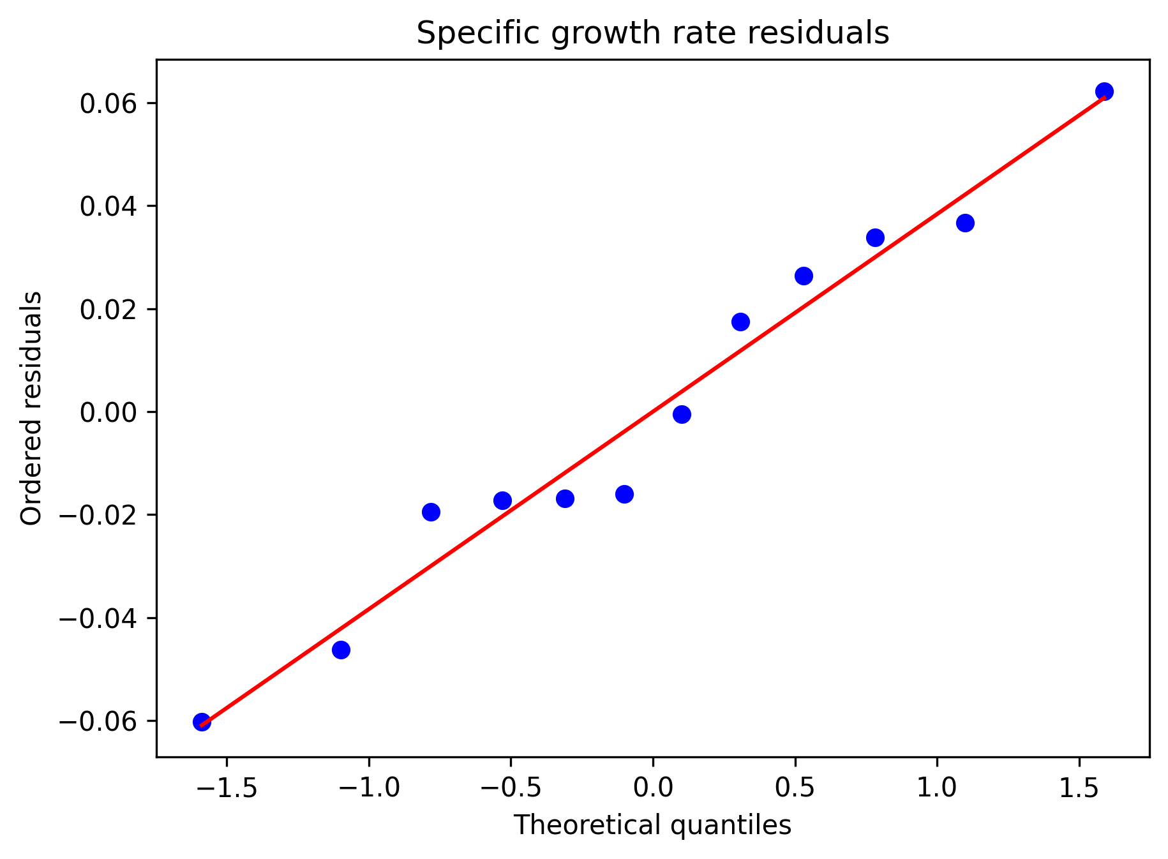
Figure S1. Normal Q-Q plot of residuals for specific growth rate.
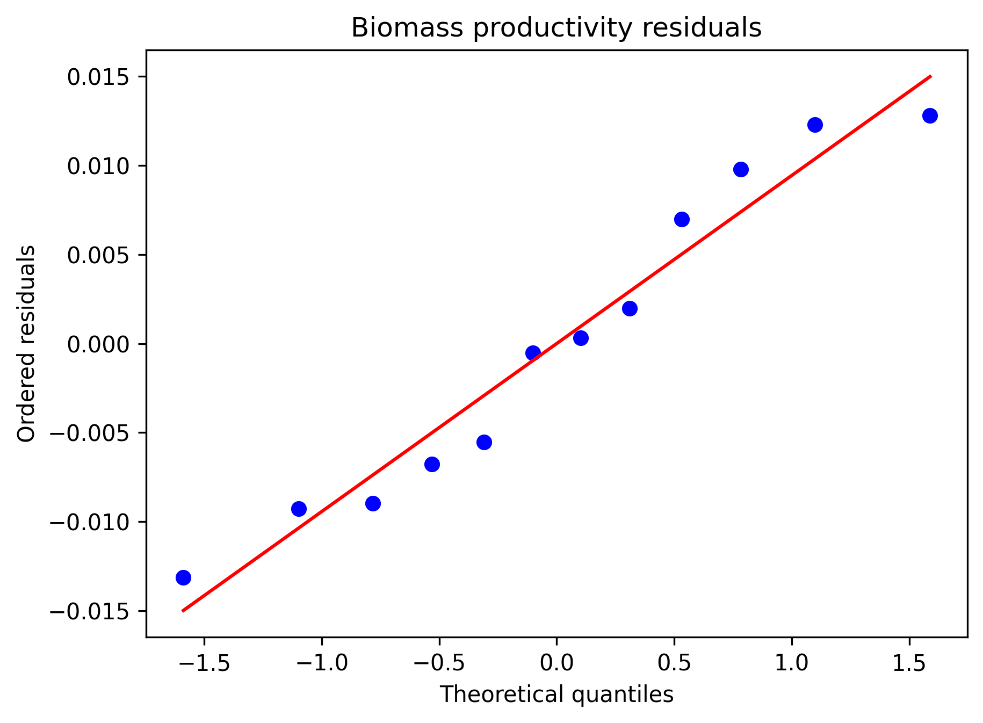
Figure S2. Normal Q-Q plot of residuals for biomass productivity.
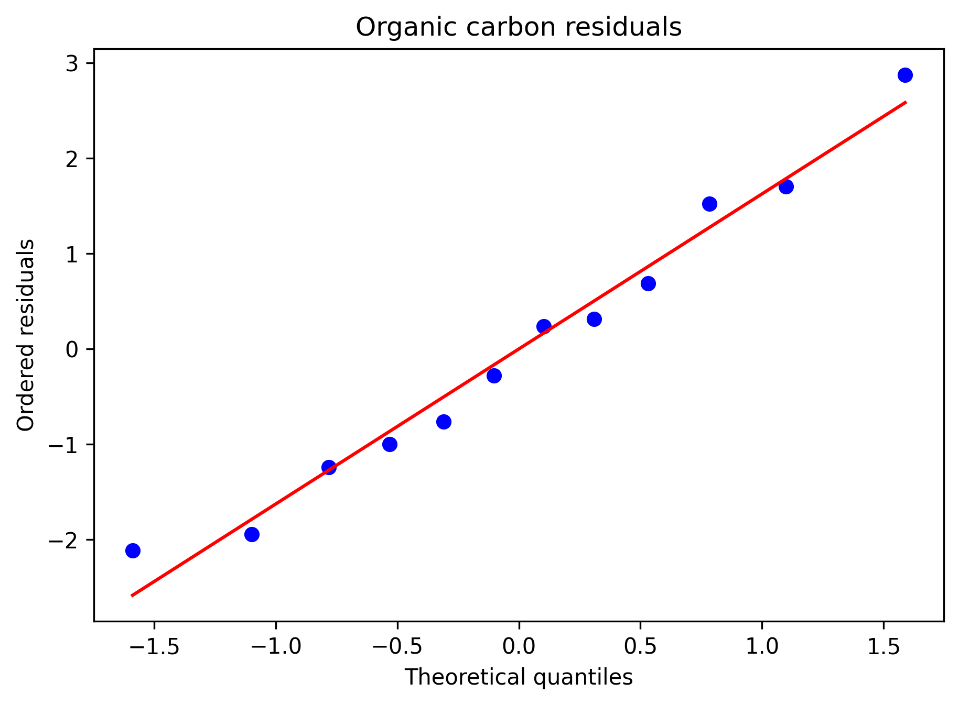
Figure S3. Normal Q-Q plot of residuals for organic carbon content.
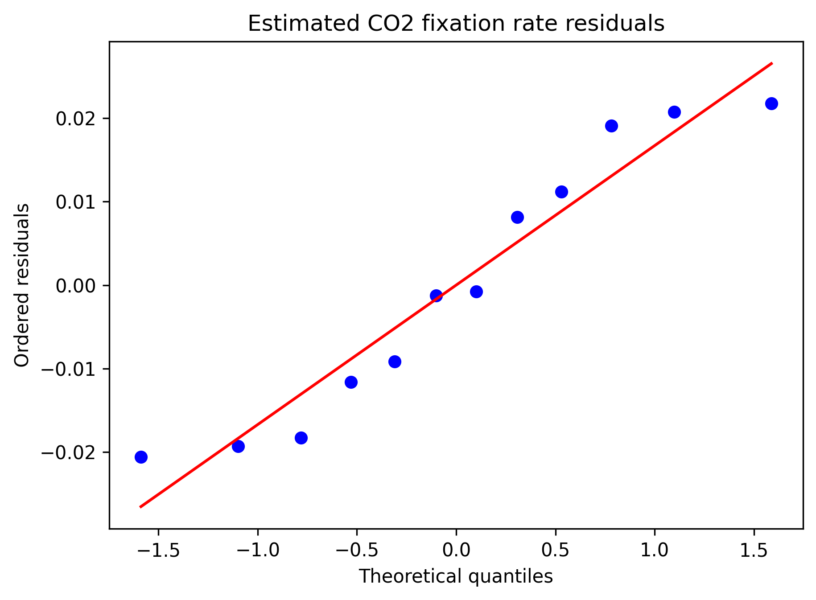
Figure S4. Normal Q-Q plot of residuals for biomass-based estimated CO2 fixation rate.

