Supplementary Information for

Heating and resin impregnation influence protein recovery and ZooMS identification of bone

Carli Peters¹, Anna Rufà^{1,2,3}, Huan Xia⁴, Frido Welker⁵, Vera Aldeias¹

- Interdisciplinary Center for Archaeology and the Evolution of Human Behaviour, Universidade do Algarve, Faro, Portugal
- Institut Català de Paleoecologia Humana i Evolució Social (IPHES-CERCA), Edifici W3, Campus Sescelades URV, 43007 Tarragona, Spain
- Departament d’Història i Història de l’Art, Universitat Rovira i Virgili (URV), Avinguda de Catalunya 35, 43002 Tarragona, Spain
- Center for Excellence in Archaeological Science and Cultural Heritage, Key Laboratory of Western China's Environmental Systems (Ministry of Education), College of Earth and Environmental Sciences, Lanzhou University, 730000 Lanzhou, China.
- Globe Institute, University of Copenhagen, Copenhagen, Denmark

This PDF file includes
Supporting text
Figures S1 to S10
Legend for Dataset S1
SI References

Other supporting materials for this manuscript include the following:
Dataset S1
R code, MALDI and FTIR data on OSF (Link for peer-review:
https://osf.io/wzx3m/overview?view_only=24f1e828138d448a87222f005e1fc4b4)

Supporting Text

1. Supplementary Methods
1.1. Experimental set-up
To assess temperature variability within the muffle furnace, we conducted a test run in which four cups were filled with 1 g calcium carbonate and heated to 550°C for 1 h. The weight loss of calcium carbonate was recorded, after which the variability between the cups was calculated to confirm that temperature variability within the muffle furnace was negligible.

1.2. Protein extraction
AmBic protocol: Approximately 10 mg of bone powder was immersed in 100 μl of 50 mM ammonium bicarbonate (AmBic) overnight. The AmBic was discarded, after which the samples were gelatinized in 100 μl of 50 mM AmBic at 65°C for 1 hour. Fifty μl of the supernatant was digested with 1 μl of 0.4 μg/μl trypsin solution (PierceTM Trypsin Protease, Thermo Scientific) for 18 hours at 37°C. Following enzymatic digestion, peptides were purified and concentrated using C18 ZipTips (PierceTM C18 Tips, Thermo Scientific).

Acid insoluble protocol: The extraction of the acid-insoluble bone collagen was based upon Buckley et al. [1] and Welker et al. [2]. Approximately 10 mg of bone powder was demineralized in 200 μl of 0.6 M hydrochloric acid (HCl) for 5 hours. The supernatant was removed and the samples were washed three times with 200 μl of 50 mM AmBic and gelatinized in 100 μl of 50 mM AmBic at 65°C for 1 hour. All of the supernatant was then digested with 2 μl of 0.4 μg/μl trypsin solution (PierceTM Trypsin Protease, Thermo Scientific) for 18 hours at 37°C. Fifty μl of the supernatant was then purified and concentrated as described above. The other 50 μl of supernatant was used for shotgun proteomic analysis.

Acid soluble protocol: The acid-soluble approach was based on the methodology described in van der Sluis et al. [3]. The acid supernatant that was removed during the acid-insoluble protocol was transferred to 30 kDa ultrafilter (Vivaspin® 500, Sartorius) and centrifuged until completely passed through the filter. Four hundred μl of 50 mM AmBic was added to the filter and centrifuged until completely passed through the filter. The proteins on top of the filter were resuspended in 100 μl of 50 mM AmBic, followed by digestion, purification and concentration as described previously.

2. Supplementary Figures
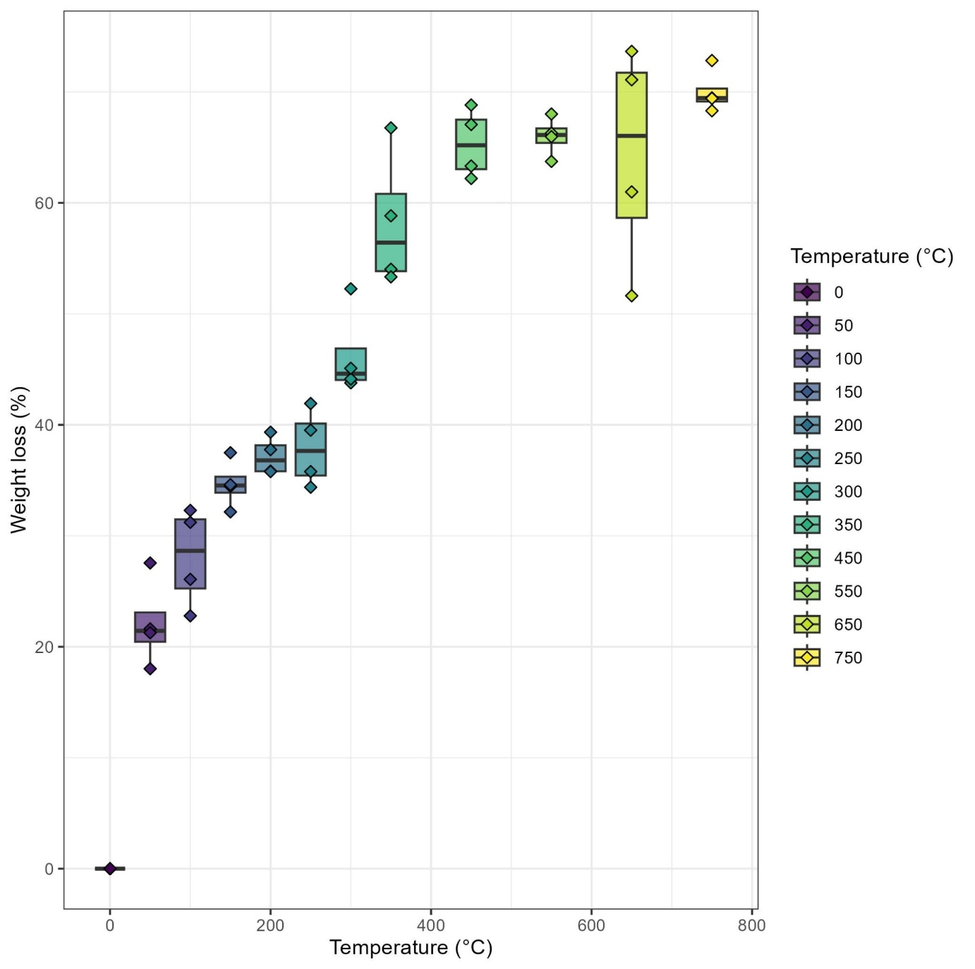
Figure S1. Percent weight loss (%) with increasing burning temperatures. Individual sample points are indicated.

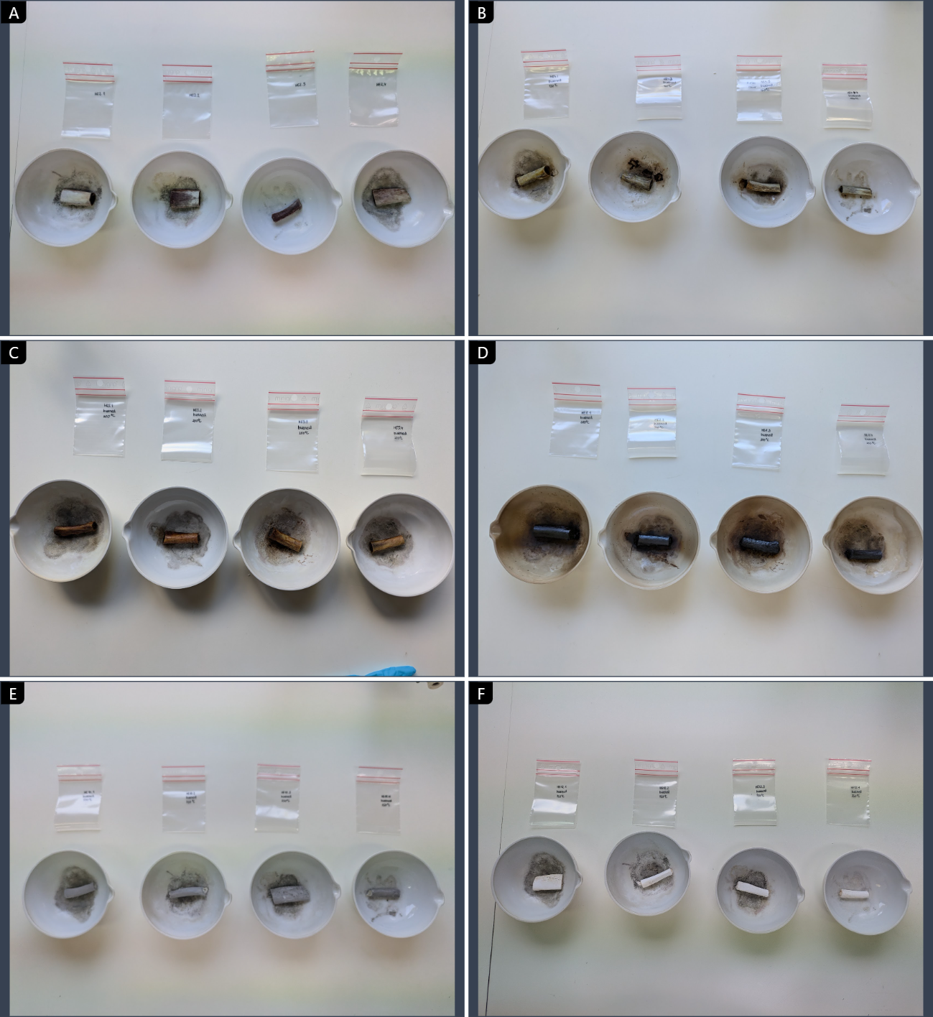Figure S2. Photographs of experimentally heated bones at A) 50°C (HE2), B) 150°C (HE4), C) 200°C (HE5), D) 300°C (HE7), E) 550°C (HE10), and F) 750°C (HE12).

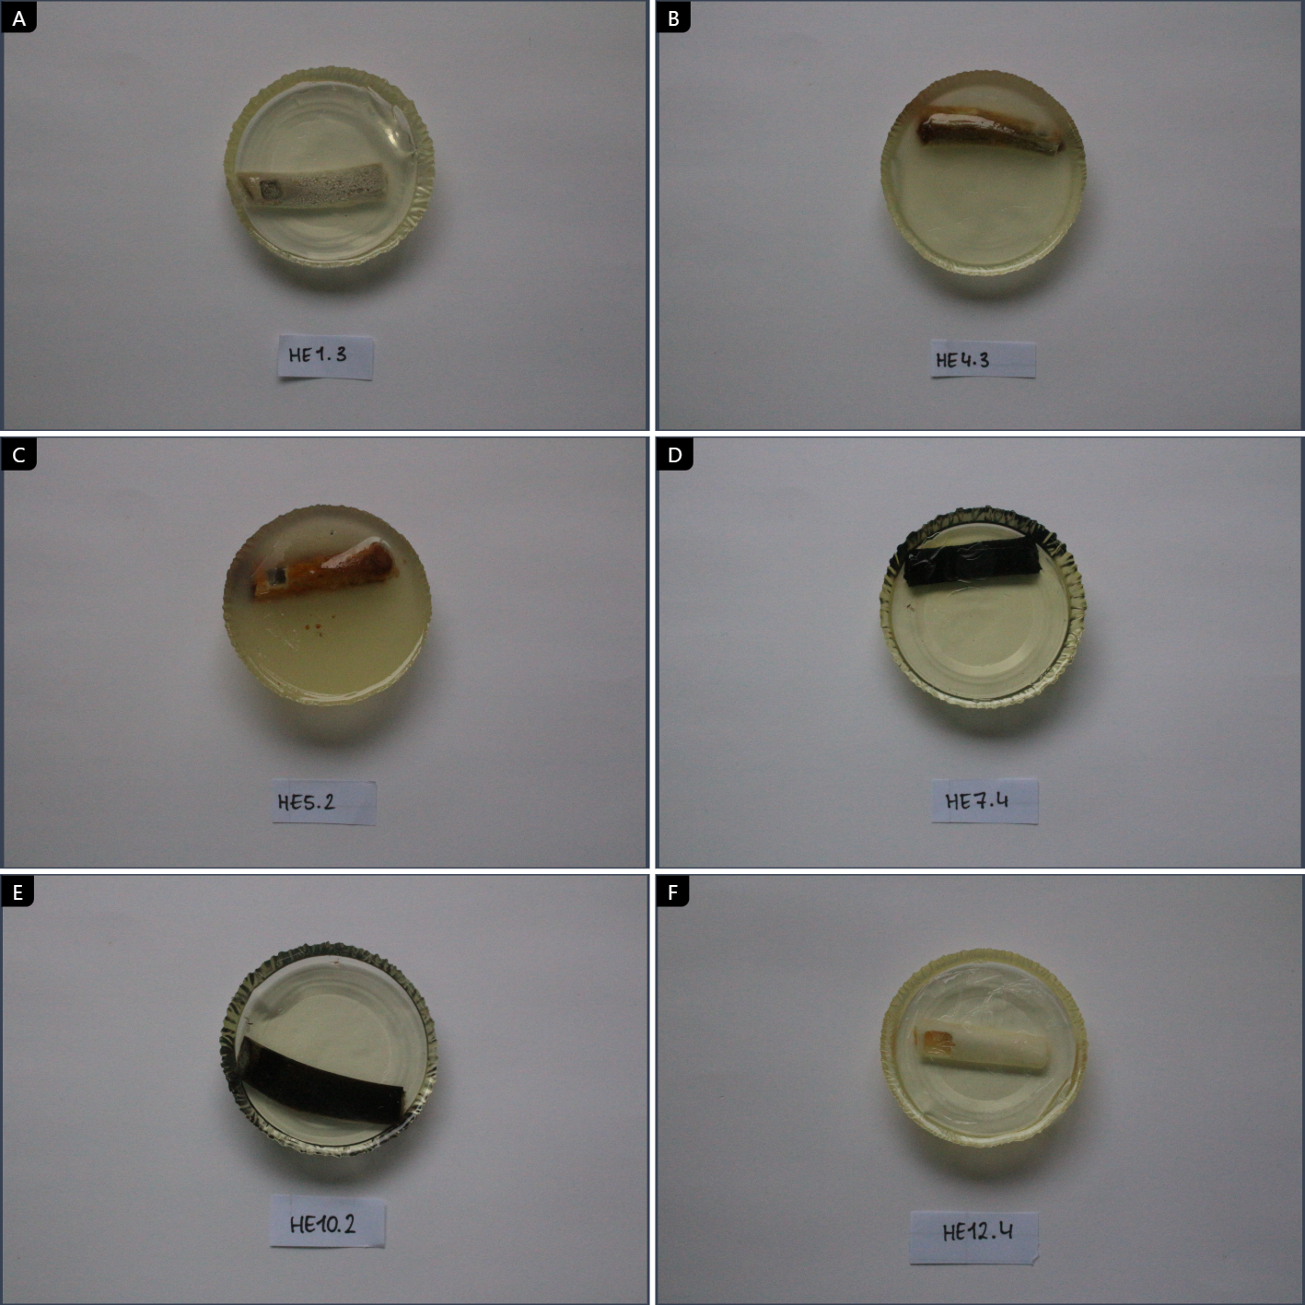Figure S3. Photographs of A) a resin-impregnated unheated bone (HE1.3), and experimentally heated bones followed by resin-impregnation at B) 150°C (HE4.3), C) 200°C (HE5.2), D) 300°C (HE7.4), E) 550°C (HE10.2), and F) 750°C (HE12.4).

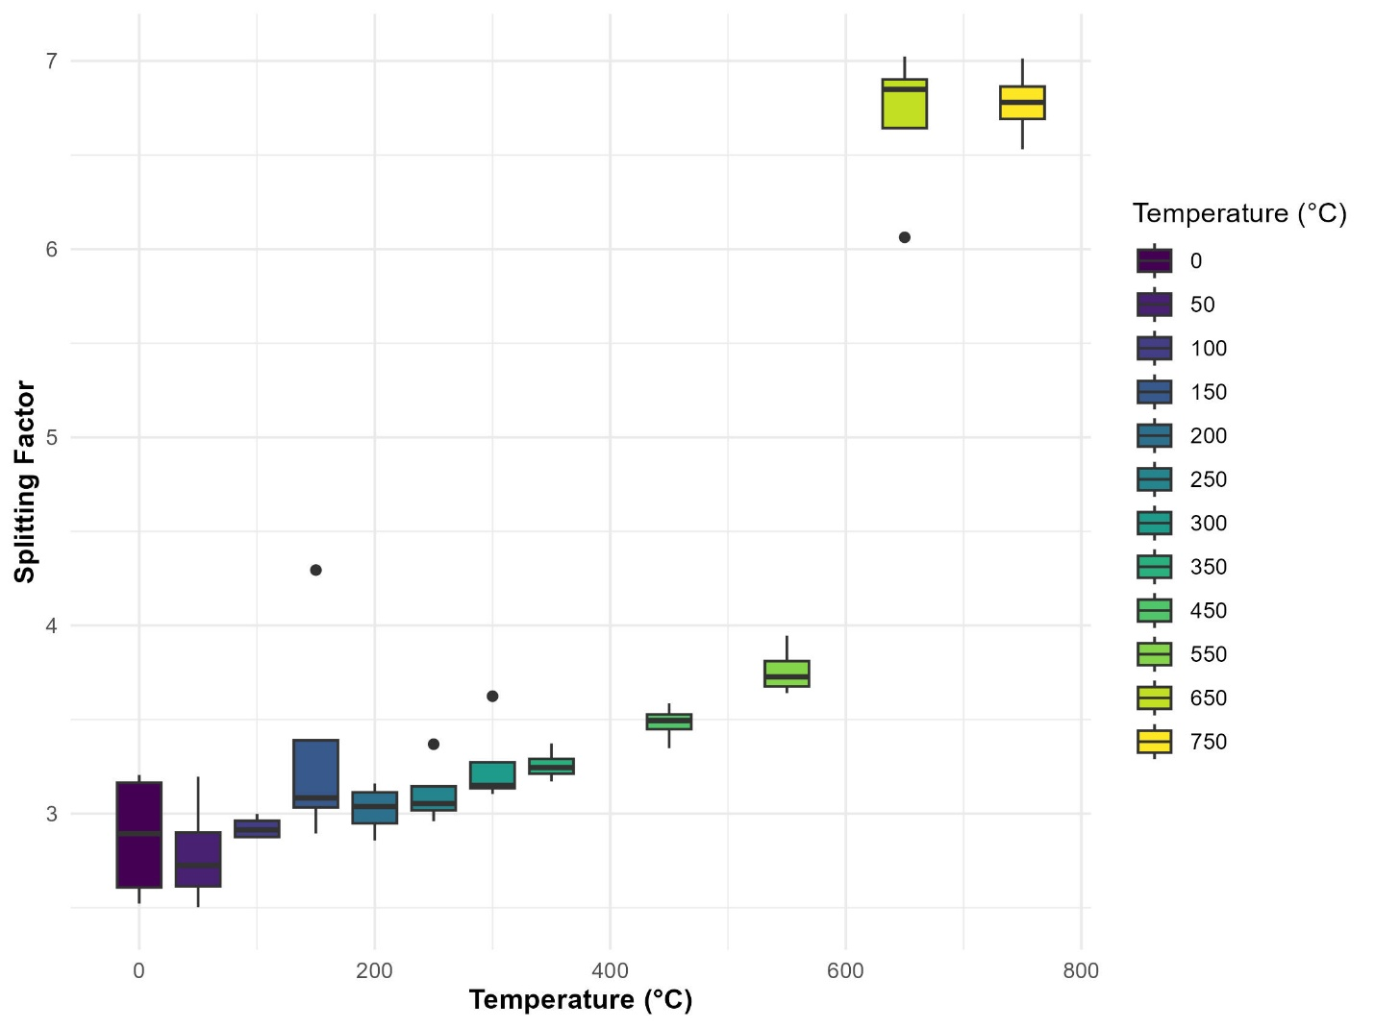
Figure S4. Splitting Factor (SF) calculated from FTIR data with increasing burning temperatures. Individual sample points are indicated. Replicates for intra-bone comparison were excluded from the dataset.
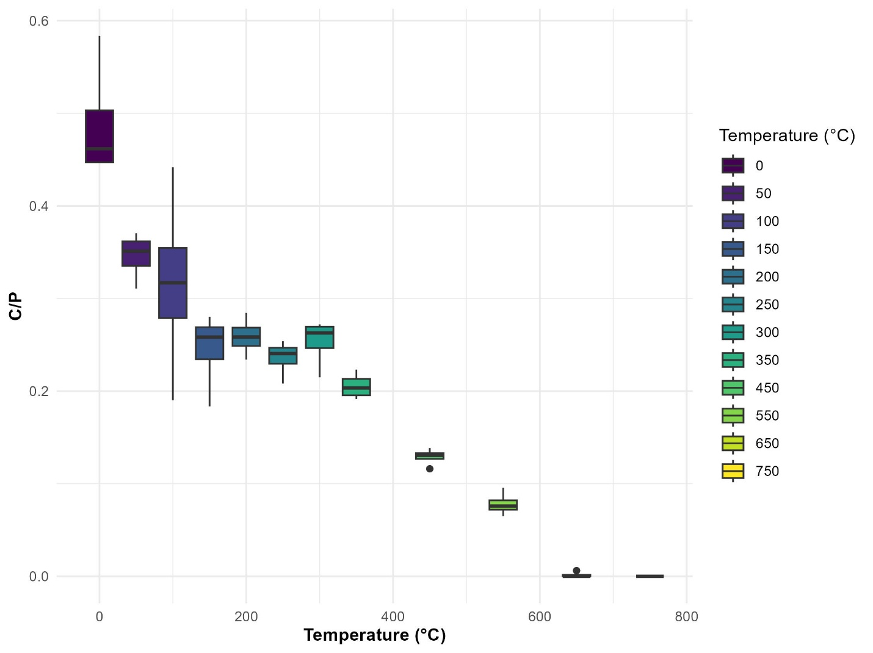
Figure S5. Carbonate-to-phosphate ratio (C/P) calculated from FTIR data with increasing burning temperatures. Individual sample points are indicated. Replicates for intra-bone comparison were excluded from the dataset.
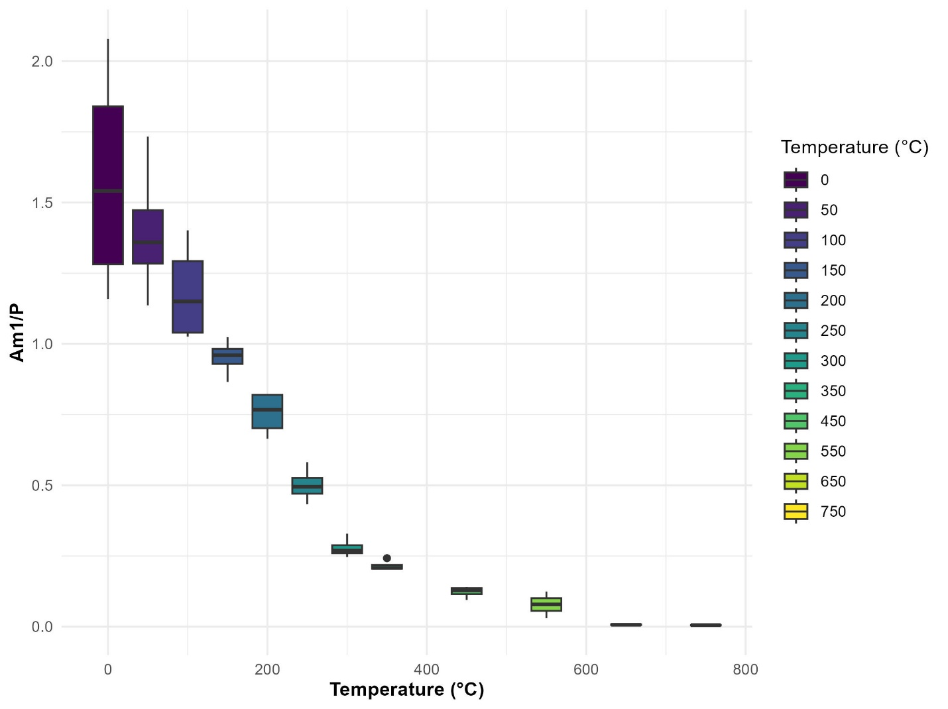
Figure S6. Amide 1-to-phosphate ratio (Am1/P) calculated from FTIR data with increasing burning temperatures. Individual sample points are indicated. Replicates for intra-bone comparison were excluded from the dataset.
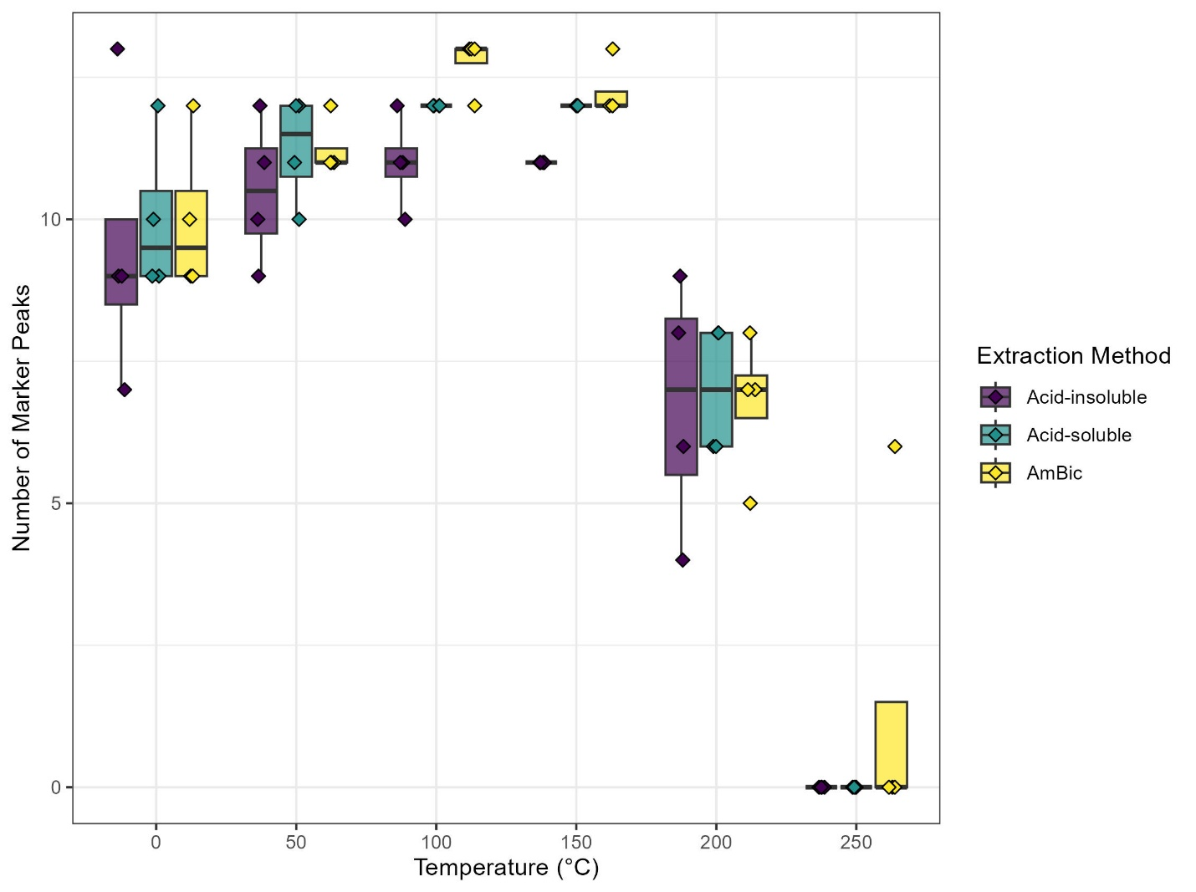
Figure S7. Number of identified peptide marker peaks for different extraction methods for samples that were not impregnated with resin. Individual sample points are indicated. Replicates for intra-bone comparison were excluded from the dataset. Bones burned at temperatures <300°C were excluded from the figure as no peptide marker peaks were present in these samples.

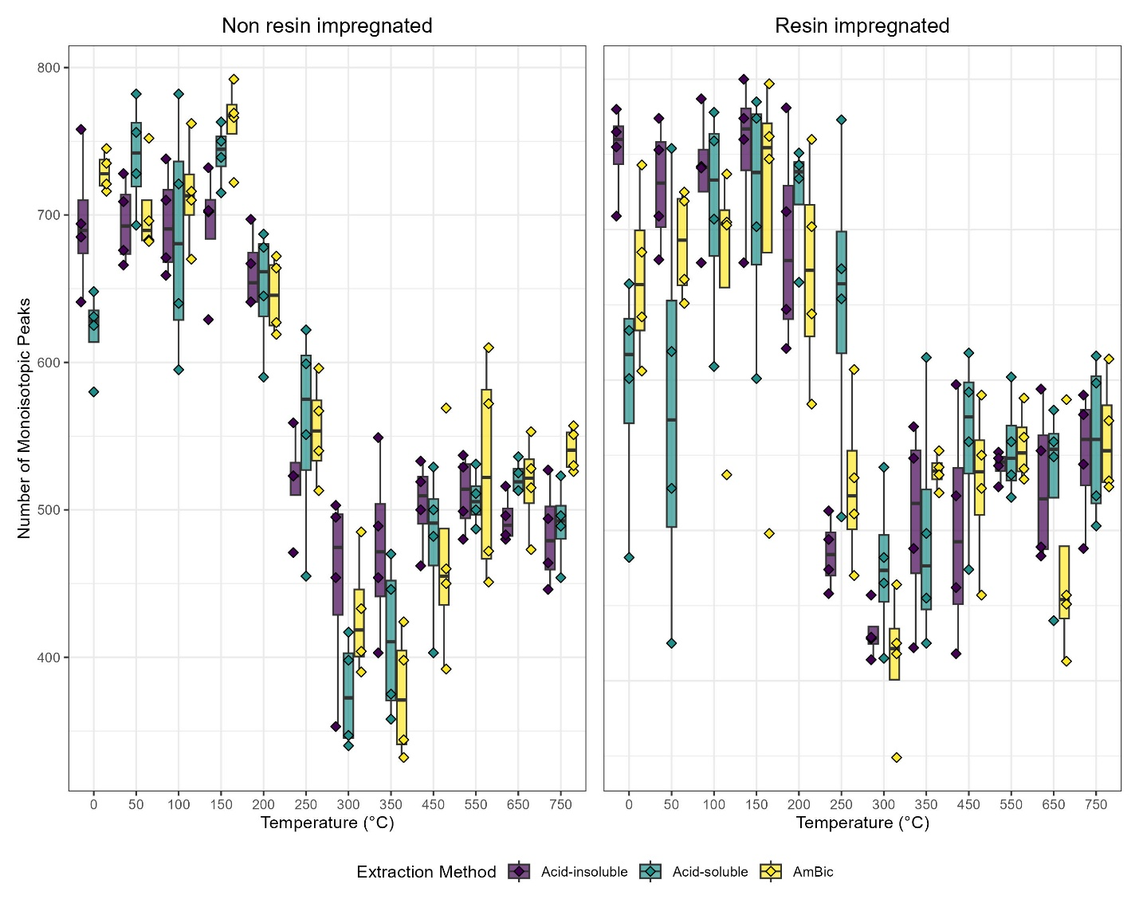
Figure S8. Number of monoisotopic peaks for different extraction methods. Individual sample points are indicated. Replicates for intra-bone comparison were excluded from the dataset.

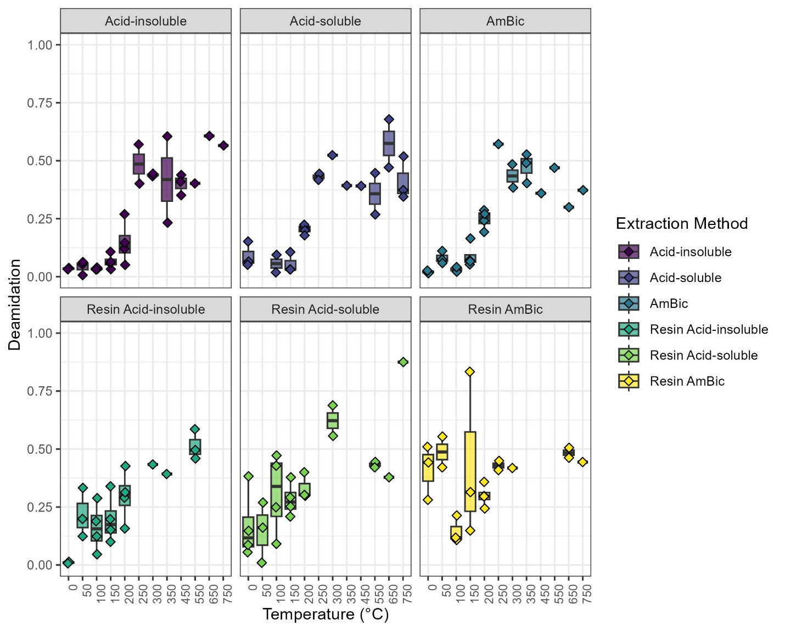
Figure S9. Deamidation rates for marker peptide COL1α1 507-518 (m/z 1105) in MALDI-ToF-MS data grouped per extraction method. Replicates for intra-bone comparison were excluded from the dataset.

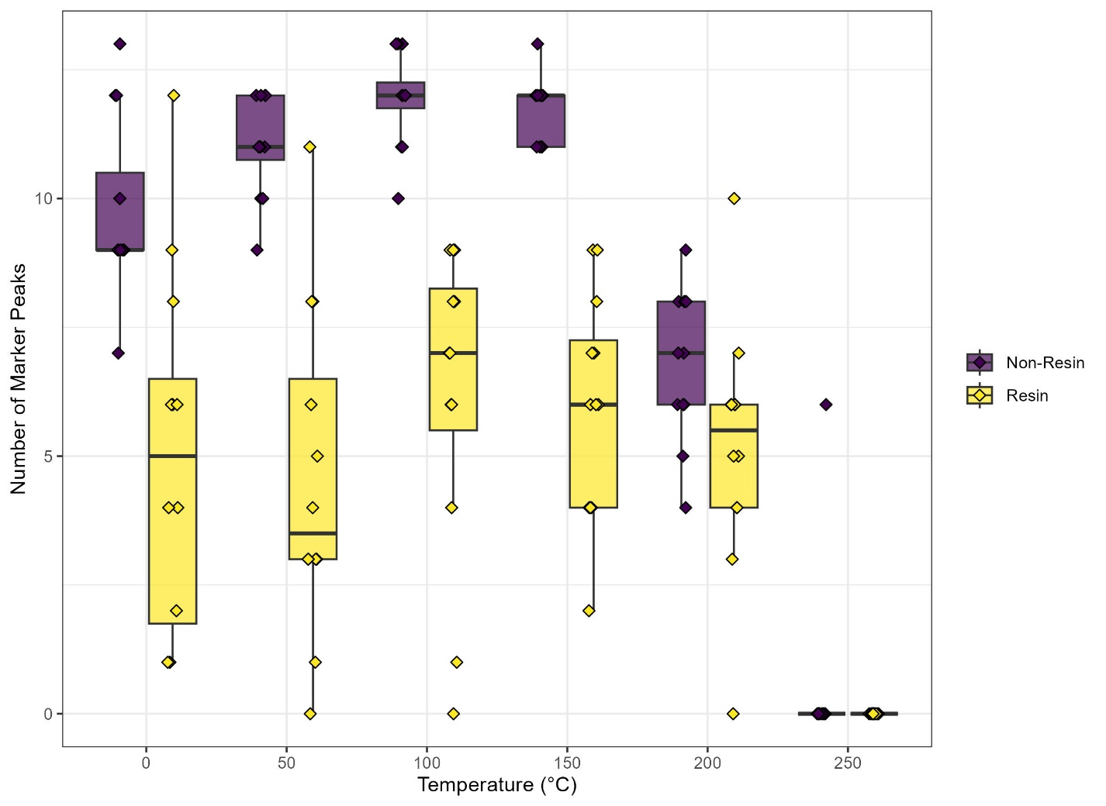Figure S10. Number of identified peptide marker peaks for non-resin-impregnated and resin-impregnated bones. Individual sample points are indicated. Replicates for intra-bone comparison were excluded from the dataset. Bones burned at temperatures >250°C were excluded from the figure as no peptide marker peaks were present in these samples.

Legends for Supplementary Datasets
Dataset S1. Overview of the experimental results.

SI References
[1] Buckley M, Collins M, Thomas-Oates J, Wilson JC. Species identification by analysis of bone collagen using matrix-assisted laser desorption/ionisation time-of-flight mass spectrometry. Rapid Commun Mass Spectrom 2009;23:3843–54.
[2] Welker F, Soressi M, Rendu W, Hublin J-J, Collins M. Using ZooMS to identify fragmentary bone from the Late Middle/Early Upper Palaeolithic sequence of Les Cottés, France. J Archaeol Sci 2015;54:279–86.
[3] van der Sluis LG, Hollund HI, Buckley M, De Louw PGB, Rijsdijk KF, Kars H. Combining histology, stable isotope analysis and ZooMS collagen fingerprinting to investigate the taphonomic history and dietary behaviour of extinct giant tortoises from the Mare aux Songes deposit on Mauritius. Palaeogeogr Palaeoclimatol Palaeoecol 2014;416:80–91.

