Supplementary Information

Engineering of LRP1-targeted peptide condensate with up-concentration regulatory effects in MASH

Jiahui Zhang^{a,} †, Xiaoxu Kang^{bc, †}, Pengfei Pei^{a,} *, Zilong Li ª, Shilong Zhaoª, Long Chenª, Peng Wei^{c}, Wei Jiangª, Yafang Wuª, Haixuan Caoª, Jiazhi Xieª, Yufeng Dingª, Lihong Liu^{b,} *, Shi-Zhong Luo^{a,} *, Lili Gong^{b,} *

ªState Key Laboratory of Green Biomanufacturing, College of Life Science and Technology, Beijing University of Chemical Technology, Beijing 100029, China
^{b}Institute of Clinical Medical Sciences, China Japan Friendship Hospital, Beijing 100029, China
^{c}School of Traditional Chinese Medicine, Beijing University of Chinese Medicine, Beijing 100029, China

Methods

- Peptide design, synthesis and purification
1.1 Structure preparation and molecular docking
Crystallographic structures of the murine LRP2 (PDB ID: 8EM4 ¹) and human Clusterin (CLU, PDB ID: 7ZET)², solved at resolutions of 2.83 Å and 2.80 Å, respectively, were obtained from the Protein Data Bank. Before docking and molecular dynamics (MD) simulations, all non-protein molecules (including glycans and water) were removed, retaining only the protein coordinates for subsequent analyses. Subsequently, molecular docking between LRP2 and CLU was performed using the HDOCK online server^{3,4}. The resulting docked complex model was opened and saved as a composite structure in PyMOL. The binding interface between the receptor and ligand was analyzed using the InterfaceResidues.py script (https://PyMOLwiki.org/index.php/InterfaceResidues). Based on the interface residue analysis, peptide sequences with potential high binding affinity to LRP2 were preliminarily identified. These peptide candidates were then docked to the LRP2 receptor using the HPEPDOCK server ^{5,6}, and the resulting peptide-receptor complex structures were used as starting conformations for subsequent MD simulations.
The structure of LRP1 was modeled by homology modeling that based on LRP2 with I-TASSER (https://zhanggroup.org/I-TASSER/)^{7,8}. The molecular docking of the peptides to LRP1 was performed as LRP2.

1.2 MD System Preparation and Equilibration
MD simulations of the LRP1/2-peptide complexes were performed using the GROMACS 2022.4 package ⁹. The structural files of the docked complexes were converted into topology files compatible with the AMBER99SB-ILDN force field using the pdb2gmx module¹⁰, and the TIP3P water model was applied. A dodecahedral periodic box was defined using the editconf module, with a distance of 1.2 nm from the complex to the box edges. The box was subsequently filled with an appropriate number of solvent water molecules. To achieve overall system neutrality, counterions (Na⁺ or Cl⁻) were added via the genion module, depending on the net charge of each system. Prior to production runs, energy minimization was performed using the steepest descent algorithm to eliminate unfavorable contacts and atomic overlaps.

1.3 Calculation of binding free energy
The MM-GBSA method was utilized for the calculation of the binding free energy between the LRP1/2 and the peptide inhibitors, using the gmx_MMPBSA tool¹¹⁻¹⁴, and the binding energy was calculated based on the energy minimization results of the GROMACS ¹⁵.

1.4 Peptide synthesis
Peptides were synthesized via a Fmoc solid-phase synthesis strategy on Wang resin, by successive coupling with L-amino acid. After completion of the synthesis, peptides were cleaved from the resin via treatment with TFA, H₂O, thiamazole, 2-hydroxy-1-ethanethiol, and phenol (82.5, 5, 5, 5, 2.5, v %) for 3-4 h, then precipitated in ether overnight, centrifuged to obtain the product, dissolved, and dried under vacuum at -60 °C to obtain a powder product.

1.5 Purification and characterization of peptides
The peptides were purified by a preparative HPLC system with eluting by gradient with acetonitrile–water. The purified fraction was similarly dried under vacuum at -60 °C to give the powdered product. The peptide was identified by LC-MS. All peptides used for in vitro and in vivo experiments were of >90% purity.

2 Phase separation characterization
2.1 In vitro phase separation imaging
Peptide stock solutions were prepared at 10 mM in PBS. For phase separation imaging, stock solutions were directly diluted to the desired concentration in PBS or PBS containing fluorescent dye. The resulting mixtures were immediately loaded into 96-well plates and incubated at 37 °C for 30 min before imaging. Images were captured using an inverted microscope (40× objective) or Leica SP8 confocal microscope (60× objective).

2.2 Turbidity assay
Sample preparation was identical to that for imaging. Turbidity was measured by absorbance at 620 nm in 384-well plates using a SpectraMax M2 microplate reader (Molecular Devices). All samples had four replicates.

2.3 Fluorescence recovery after photobleaching (FRAP)
FRAP experiments were performed using a Leica confocal microscope. Samples were prepared as described in Section 2.1. Photobleaching was conducted at 100% laser power using the 556 nm channel. Post-bleach images were captured at fixed time intervals. Fluorescence intensities in the bleached area were quantified using Leica software. Signals were normalized with pre-bleach intensity set to 100% and 0 s post-bleach set to 0. At least three samples were analysed and averaged to obtain FRAP curves using GraphPad Prism 8.0.

3. In vitro human plasma stability
For FHCpep, concentrations were set at 10 μM and 30 μM, with the serum proportion adjusted accordingly to assess phase-separation-dependent differences in stability. Samples of 10 μM FHCpep were collected at 0, 5, 10, and 20 min, whereas samples of 30 μM FHCpep were collected at 0, 0.5, 1, 2, 4, 6, 8, 12, and 24 h, as determined by their respective stability profiles. At each collection point, the reaction was quenched by the addition of TFA to a final concentration of 5% (v/v), and samples were stored at -20°C. Subsequently, samples were subjected to high-speed centrifugation, and the supernatants were collected for analysis by LC-MS at 254 nm. Area under the curve was determined and normalized to the first timepoint. Regression curves were fitted using a nonlinear regression model in GraphPad Prism 8.0.

4 Cellular experiments
4.1 Cell culture
Human hepatocellular carcinoma cells (HepG2), Murine monocyte-macrophage leukemia cells (RAW 264.7) were cultured in Dulbecco’s modified Eagle’s medium (DMEM) containing 10% FBS and 1% antibiotics (penicillin/streptomycin).

4.2 Cytotoxicity test by MTT assay
HepG2 and RAW264.7 cell suspensions were seeded into 96-well plates (8000 cells/well) and allowed to adhere for 24 h at 37°C. The culture medium was replaced with serum-free medium containing different concentrations of CLUpep and FHCpep (LLPS) (5, 10, 30, 60, 120 μmol/L). After 12 h, the supernatant was removed, and the cells were washed with PBS. Subsequently, 100 μL of MTT working solution was added to each well for another 4 h at 37 °C. The supernatant was then aspirated, and 100 μL of 10% SDS was added to each well to dissolve the purple formazan crystals. The optical density (OD) at 570 nm was measured using a SpectraMax M2 microplate reader (Molecular Devices, USA). Each group was performed with 5 replicates. The MTT working solution was prepared with an MTT stock solution (5 mg/mL) and DMEM at a 1:9 ratio. DMEM was used as the blank control. Cell viability was calculated using the formula: (experimental group - blank group) / (control group - blank group).

4.3 Imaging of coacervates on the cell surface
Cells were plated onto an 8-well Lab-Tek chamber glass (Thermos Fisher Science). At approximately 60% confluence, cells were treated with 2 ml of DMEM containing 30 μM peptide and incubated at 37°C for 2 h. Prior to imaging, the cells were washed with PBS and stained with DAPI. The images were taken by Leica SP8 confocal microscope with laser excitation wavelengths of 340 nm and 488 nm.

4.4 Immunofluorescence staining
FHCpep was co-incubated with cells for 2 h according to the method described in Section 2.4.3. After incubation, the cells were washed with PBS, fixed with 4% paraformaldehyde for 15 min, and washed again with PBS. The cells were then blocked with 5% BSA for 30 min and incubated with anti-LRP1 antibody overnight at 4°C. After washing with PBS, the cells were incubated with the corresponding fluorescent secondary antibody for 1 h. Cell nuclei were counterstained with DAPI for 10 min. Finally, the cells were observed and analyzed using a confocal laser scanning microscope.

4.5 Induction of cellular lipid accumulation model and detection of triglyceride (TG) and lipid droplets
An oleic acid (OA)-induced lipid accumulation model was established in HepG2 cells. At approximately 60% confluence, cells were incubated in DMEM supplemented with 0.2 mM OA for 24 h. After incubation, the medium was removed, and the cells were washed once with PBS. Subsequently, 2 mL of DMEM containing 10 μM or 30 μM peptide was added, and the cells were further incubated for 14-15 h. The experiment included a blank control group, an OA model group, and peptide-treated groups.
For TG detection, the treated cells were collected by digestion, washed, and centrifuged. The cell pellets were then lysed with 2% Triton X-100. The resulting cell lysates were used for both BCA protein concentration determination (562 nm) and TG content measurement (510 nm). The samples were mixed with GPO-PAP working reagent, and the TG content was calculated based on a standard curve generated using TG standards. Finally, TG levels were normalized to the corresponding protein concentration. Each group was analyzed in triplicate.
For lipid droplet detection, the treated cells were collected by digestion and washed. The cells were then incubated with Green Neutral Lipid Stain for 25 min to stain intracellular lipid droplets. After staining, the cells were washed three times with PBS, resuspended, and analyzed by flow cytometry using the FITC channel. Each group was analyzed in triplicate.

4.6 Induction of cellular inflammatory model
An inflammatory model was established in RAW264.7 macrophages using LPS and IFN-γ. When the cells reached approximately 80% confluence, the original culture medium was removed, and the cells were gently washed with PBS. Subsequently, DMEM containing LPS and IFN-γ was added together with peptides at the designed concentrations. Peptide concentration was 20 μM for CLUp1/2/3 peptide screening. Meanwhile, the concentration 10 μM (non-condensate-forming) and 30 μM (condensate-forming) were used in the subsequent condensate-forming related activity validation experiments. The cells were then incubated for another 14-15 h. The experiment included a blank control group, an LPS/IFN-γ model group, and peptide-treated groups.

4.7 Quantitative real-time PCR (RT-qPCR)
The mRNA expression levels of inflammation-related and fibrosis-related factors were determined by RT-qPCR. According to the manufacturers’ instructions, total RNA was extracted from cell samples using Lysis Buffer, while total RNA from tissue samples was extracted using TRIzol reagent (Invitrogen). The extracted total RNA was then reverse-transcribed into cDNA.
Quantitative real-time PCR (qPCR) was performed using SYBR Green PCR Master Mix (Applied Biosystems, USA) on a QuantStudio 5 Real-Time PCR System (Applied Biosystems, USA). Each sample was analyzed with three or five technical replicates. Relative gene expression levels were calculated using the 2^−ΔΔCt method, with 18S or β-actin used as the internal reference gene. All primer sequences are listed in Table S1.

4.8 Transcriptome sequencing and analysis
Total RNA was extracted using TRIzol reagent, and RNA integrity was assessed using a fragment analyzer. Samples with an RNA integrity number (RIN) greater than 7.0 were used for subsequent library construction. mRNA was enriched using oligo(dT) magnetic beads, followed by fragmentation and reverse transcription to generate strand-specific cDNA libraries. The libraries were then sequenced on an Illumina NovaSeq X Plus platform to generate 2 × 150 bp paired-end reads. After removing adaptor sequences and low-quality reads, high-quality clean reads were obtained and aligned to the reference genome using HISAT2. Gene expression levels were quantified using StringTie and expressed as FPKM values. Differentially expressed genes were identified using DESeq2, with FDR < 0.05 set as the screening threshold. All differentially expressed genes were used for heatmap analysis and related functional enrichment analysis.
For KEGG enrichment analysis, q < 0.05 was used as the significance threshold to identify significantly enriched pathways. For volcano plot analysis, differentially expressed genes were defined using the criteria of |log₂FC| ≥ 1 and q < 0.05. In gene set enrichment analysis (GSEA), gene sets with NES < 0 and FDR < 0.25 were considered to show a negative enrichment trend.

4.9 Western Blotting
The RAW264.7 cellular inflammatory model and drug treatment were performed as described in Section 2.4.6. At the end of treatment, the cells were washed with PBS and then lysed with RIPA lysis buffer supplemented with protease and phosphatase inhibitors to extract total protein. For tissue samples, tissue pieces were homogenized in RIPA lysis buffer containing protease and phosphatase inhibitors to extract total protein. The extracted protein samples were mixed with loading buffer and denatured at 100°C for 5 min. Subsequently, the protein samples were loaded onto 10% SDS-PAGE gels for electrophoretic separation and then transferred onto polyvinylidene fluoride (PVDF) membranes (Millipore). The PVDF membranes were blocked with 5% non-fat milk in TBST at 25°C for 2 h and then incubated with the corresponding primary antibodies overnight at 4°C. After washing with TBST, the membranes were incubated with horseradish peroxidase (HRP)-conjugated secondary antibodies at 25°C for 2 h. Finally, protein bands were visualized and imaged using a chemiluminescence imaging system.

5 Mouse studies
All animal experiments complied with the WMA Statement on animal use in biomedical research and were approved by the Animal Care and Use Committee of China-Japan Friendship Hospital (approval number: ZRDWLL250091). C57BL/6J mice (SPF grade) were purchased from Vital River Laboratory Animal Technology Co., Ltd. (Beijing, China). All mice were housed under specific pathogen-free (SPF) conditions with controlled temperature (22-24 °C), humidity (50-60%) and a 12 h light/dark cycle. Animals were maintained in accordance with the guiding principles.

5.1 In vivo fluorescence imaging in mice
FITC-labeled peptides (FITC-CLUpep and FITC-FHCpep) were used for in vivo fluorescence imaging in mice. FITC was conjugated to the side chain of lysine within the peptide sequence. For both FITC-CLUpep and FITC-FHCpep, two experimental conditions were established: a non-phase-separation concentration group and a phase-separation concentration group. For the non-phase-separation group, the incubation concentration was 10 μM, and the injection dose was 100 nmol kg⁻¹. For the phase-separation group, the incubation concentration was 60 μM, and the injection dose was 600 nmol kg⁻¹. Before injection, both peptides were pre-incubated for 30 min to allow the formation of the assembly states. The peptides were then administered to mice by intraperitoneal injection. At 2 h after injection, the mice were euthanized and dissected, and the major organs, including the heart, liver, spleen, lung, and kidney, were collected. Finally, ex vivo fluorescence imaging was performed to analyze the fluorescence distribution in different organs.

5.2 Establishment of the mouse MASH model
After entering the animal facility, all mice were randomly assigned to different experimental groups, with five mice in each group, and allowed to acclimate for 1 week. For the dietary intervention study, 6-8-week-old C57BL/6J mice were randomly assigned to groups (n = 5 per group) and fed a high-fat, choline-deficient diet containing 60% kcal from fat for 12-13 weeks to establish the CDHFD mouse model.
Starting from week 7 of dietary intervention, mice in the treatment groups received intraperitoneal administration of the indicated peptides. The experimental groups included the normal control group, model group, non-phase-separating peptide groups (incubation concentration, 10 μM; dose, 100 nmol kg⁻¹), and phase-separating peptide groups (incubation concentration, 60 μM; dose, 600 nmol kg⁻¹). Mice in the normal control and model groups received an equal volume of PBS. Body weight and food intake were monitored regularly throughout the treatment period.

5.3 Oral glucose tolerance test（OGTT）and insulin tolerance test（ITT）
For the oral glucose tolerance test (OGTT), mice were fasted for 12 h, and fasting blood glucose levels were measured from tail-tip blood samples. Subsequently, mice were orally administered glucose solution by gavage at a dose of 2 g/kg body weight. Blood glucose levels were measured at 15, 30, 60, and 120 min after glucose gavage. The glucose tolerance curve was plotted, and the area under the curve (AUC) was calculated.
For the insulin tolerance test (ITT), mice were fasted for 4 h, and basal blood glucose levels were measured from tail-tip blood samples. Subsequently, mice were intraperitoneally injected with insulin at a dose of 0.5 IU/kg body weight. Blood glucose levels were measured at 15, 30, 60, 90, and 120 min after insulin administration. The insulin tolerance curve was plotted, and the AUC was calculated.

5.4 Body composition measurement
Body composition was measured using a quantitative magnetic resonance system (EchoMRI). Before measurement, mice were placed in a specialized restraining tube to minimize movement-related interference. Non-invasive body composition analysis was then performed using the EchoMRI system to determine fat mass, lean mass, and body fluid content. No anesthesia was required during the measurement. All mice were measured under the same conditions to ensure data comparability.

5.5 Blood and tissue collection and processing
At the experimental endpoint, blood samples were collected from mice via orbital blood sampling and transferred into EP tubes. The blood samples were then centrifuged at 3500 rpm for 10 min, and the serum supernatant was collected for biochemical analysis using an automated biochemical analyzer.
After blood collection, the mice were euthanized using an approved method, and major tissues and adipose tissues were collected, including the liver, spleen, lung, kidney, epididymal adipose tissue, and inguinal adipose tissue. Some tissue samples were fixed in tissue fixative for subsequent histological staining and immunostaining analyses, while the remaining samples were rapidly stored at -80°C for subsequent protein, RNA, or other molecular biological experiments.

5.6 Histological staining of liver tissues
Liver tissue samples were fixed in 4% paraformaldehyde, embedded in paraffin, and sectioned into 5 μm-thick serial sections. After deparaffinization and rehydration, paraffin sections were stained with hematoxylin and eosin (H&E) to evaluate liver architecture, inflammatory cell infiltration, hepatocyte ballooning, and other pathological changes.
To evaluate hepatic lipid accumulation, liver tissues were embedded in OCT compound and prepared as frozen sections. The sections were fixed at room temperature and then stained with Oil Red O solution to detect neutral lipids and lipid droplets. After staining, the nuclei could be counterstained with hematoxylin, and the sections were mounted with an aqueous mounting medium. Lipid droplet accumulation in hepatocytes was observed under a light microscope. Oil Red O-positive areas appeared red and represented lipid deposition in liver tissues.
To evaluate hepatic collagen deposition and fibrosis, Masson’s trichrome staining and Sirius Red staining were performed. Paraffin-embedded sections were deparaffinized, rehydrated, and subjected to Masson’s trichrome or Sirius Red staining according to the manufacturers’ instructions. After staining, the sections were differentiated, dehydrated, cleared, mounted, and observed under a light microscope. Masson’s trichrome staining was used to visualize the distribution of collagen fibers, which are typically stained blue or green, whereas Sirius Red staining was used to further identify collagen deposition areas. The positive staining areas were subsequently quantified using ImageJ software.
These positive area of histological staining was quantified using ImageJ software and expressed as the percentage of positively stained area relative to the total tissue area.

5.7 Immunofluorescence analysis of liver tissues
For immunofluorescence staining, cells or frozen tissue sections were fixed with 4% paraformaldehyde at room temperature and permeabilized with 0.1% Triton X-100. After blocking with BSA to reduce nonspecific antibody binding, the samples were incubated with the corresponding primary antibodies overnight at 4°C. The next day, after washing with PBS, the samples were incubated with fluorescent secondary antibodies at room temperature for 1 h. Nuclei were counterstained with DAPI (Beyotime). Fluorescence images were acquired using an LSM 780 confocal microscope (Zeiss) and analyzed using ImageJ software.

6 Software and statistical analysis
All independent experiments were performed at least three times (n ≥ 3), and the specific sample size or number of replicates is indicated in the figure legends or main text. Data are presented as the mean ± standard deviation (SD). Statistical analysis and graph generation were performed using GraphPad Prism 8. Statistical analysis was performed using one-way ANOVA followed by post hoc multiple-comparisons tests. Statistical parameters are reported in the Fig.s and the corresponding legends. *P < 0.05, **P < 0.01, ***P < 0.001 versus the positive control; n.s., no significance. #P < 0.05, ##P < 0.01, ###P < 0.001 for the specified pairwise comparisons between the indicated groups; n.s., no significance.

Reference：
1 Beenken, A. et al. Structures of LRP2 reveal a molecular machine for endocytosis. Cell. 186, 821-836. e813 (2023).
2 Yuste-Checa, P. et al. Structural analyses define the molecular basis of clusterin chaperone function. Nature Structural & Molecular Biology. 32, 2035-2045 (2025).
3 Yan, Y., Tao, H., He, J. & Huang, S.-Y. The HDOCK server for integrated protein-protein docking. Nature Protocols. 15, 1829-1852 (2020).
4 Yan, Y., Zhang, D., Zhou, P., Li, B. & Huang, S.-Y. HDOCK: a web server for protein-protein and protein–DNA/RNA docking based on a hybrid strategy. Nucleic Acids Research. 45, W365-W373 (2017).
5 Zhou, P., Jin, B., Li, H. & Huang, S.-Y. HPEPDOCK: a web server for blind peptide–protein docking based on a hierarchical algorithm. Nucleic Acids Research. 46, W443-W450 (2018).
6 Tao, H., Zhang, Y., Huang, S.-Y. Improving protein-peptide docking results via pose-clustering and rescoring with a combined knowledge-based and MM-GBSA scoring function. Journal of Chemical Information and Modeling. 60, 2377-2387 (2020).
7 Zhou, X. et al. I-TASSER-MTD: a deep-learning-based platform for multi-domain protein structure and function prediction. Nature Protocols. 17, 2326-2353 (2022).
8 Zheng, W. et al. Folding non-homologous proteins by coupling deep-learning contact maps with I-TASSER assembly simulations. Cell Reports Methods. 1 (2021).
9 Abraham, M. J. et al. GROMACS: High performance molecular simulations through multi-level parallelism from laptops to supercomputers. SoftwareX. 1, 19-25 (2015).
10 Lindorff-Larsen, K. et al. Improved side‐chain torsion potentials for the Amber ff99SB protein force field. Proteins: Structure, Function, and Bioinformatics. 78, 1950-1958 (2010).
11 Kollman, P. A. et al. Calculating structures and free energies of complex molecules: combining molecular mechanics and continuum models. Accounts of Chemical Research. 33, 889-897 (2000).
12 Cheatham III, T. E., Srinivasan, J., Case, D. A., Kollman, P. A. Molecular dynamics and continuum solvent studies of the stability of polyG-polyC and polyA-polyT DNA duplexes in solution. Journal of Biomolecular Structure and Dynamics. 16, 265-280 (1998).
13 Foloppe, N. & Hubbard, R. Towards predictive ligand design with free-energy based computational methods? Current Medicinal Chemistry. 13, 3583-3608 (2006).
14 Valdés-Tresanco, M. S., Valdés-Tresanco, M. E., Valiente, P. A., Moreno, E. gmx_MMPBSA: a new tool to perform end-state free energy calculations with GROMACS. Journal of Chemical Theory and Computation. 17, 6281-6291 (2021).
15 Baker, N. A., Sept, D., Joseph, S., Holst, M. J. & McCammon, J. A. Electrostatics of nanosystems: application to microtubules and the ribosome. Proceedings of the National Academy of Sciences of the United States of America. 98, 10037-10041 (2001).

Graphic abstract

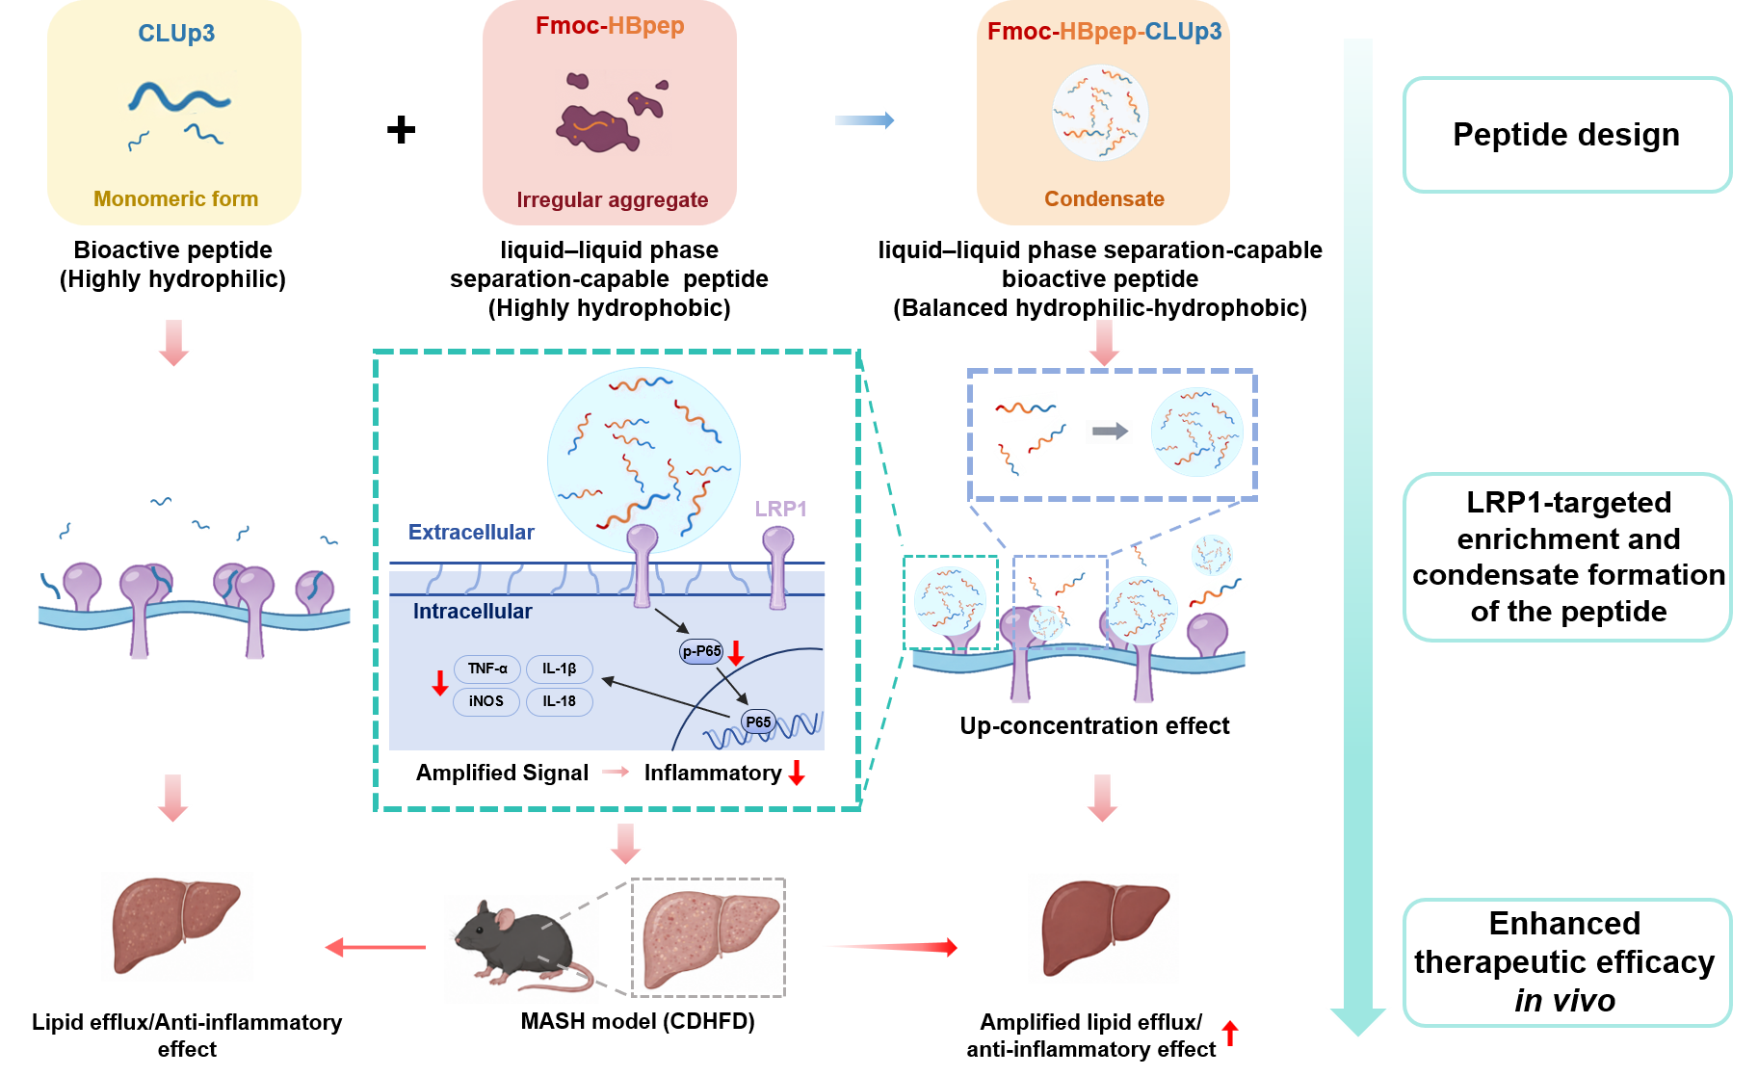

Table S1. The primers used in qPCR analysis

Target | Primer | Sequence (5’-3’)
18S | Forward | CGCCGCTAGAGGTGAAATTCT
18S | Reverse | CATTCTTGGCAAATGCTTTCG
iNOS | Forward | GTTCTCAGCCCAACAATACAAGA
iNOS | Reverse | GTGGACGGGTCGATGTCAC
TNF-α | Forward | CCCTCACACTCAGATCATCTTCT
TNF-α | Reverse | GCTACGACGTGGGCTACAG
IL-1β | Forward | GAAATGCCACCTTTTGACAGTG
IL-1β | Reverse | TGGATGCTCTCATCAGGACAG
NLRP3 | Forward | ATTACCCGCCCGAGAAAGG
NLRP3 | Reverse | TCGCAGCAAAGATCCACACAG
IL-18 | Forward | GACTCTTGCGTCAACTTCAAGG
IL-18 | Reverse | CAGGCTGTCTTTTGTCAACGA
Lipg | Forward | ATGCGAAACACGGTTTTCCTG
Lipg | Reverse | GTAGCTGGTACTCCAGTGGG
Il1r1 | Forward | GTGCTACTGGGGCTCATTTGT
Il1r1 | Reverse | GGAGTAAGAGGACACTTGCGAAT
Edn1 | Forward | GCACCGGAGCTGAGAATGG
Edn1 | Reverse | GTGGCAGAAGTAGACACACTC
Lepr | Forward | TGGTCCCAGCAGCTATGGT
Lepr | Reverse | ACCCAGAGAAGTTAGCACTGT
Tnfsf14 | Forward | GTTTCTCCTGAGACTGCATCAA
Tnfsf14 | Reverse | TGGCTCCTGTAAGATGTGCTG
Lcn2 | Forward | TGGCCCTGAGTGTCATGTG
Lcn2 | Reverse | CTCTTGTAGCTCATAGATGGTGC
TGF-β | Forward | CCACCTGCAAGACCATCGAC
TGF-β | Reverse | CTGGCGAGCCTTAGTTTGGAC
Col5a-1 | Forward | CTTCGCCGCTACTCCTGTTC
Col5a-1 | Reverse | CCCTGAGGGCAAATTGTGAAAA
Col5a-3 | Forward | CGGGGTACTCCTGGTCCTAC
Col5a-3 | Reverse | GCATCCCTACTTCCCCTTG

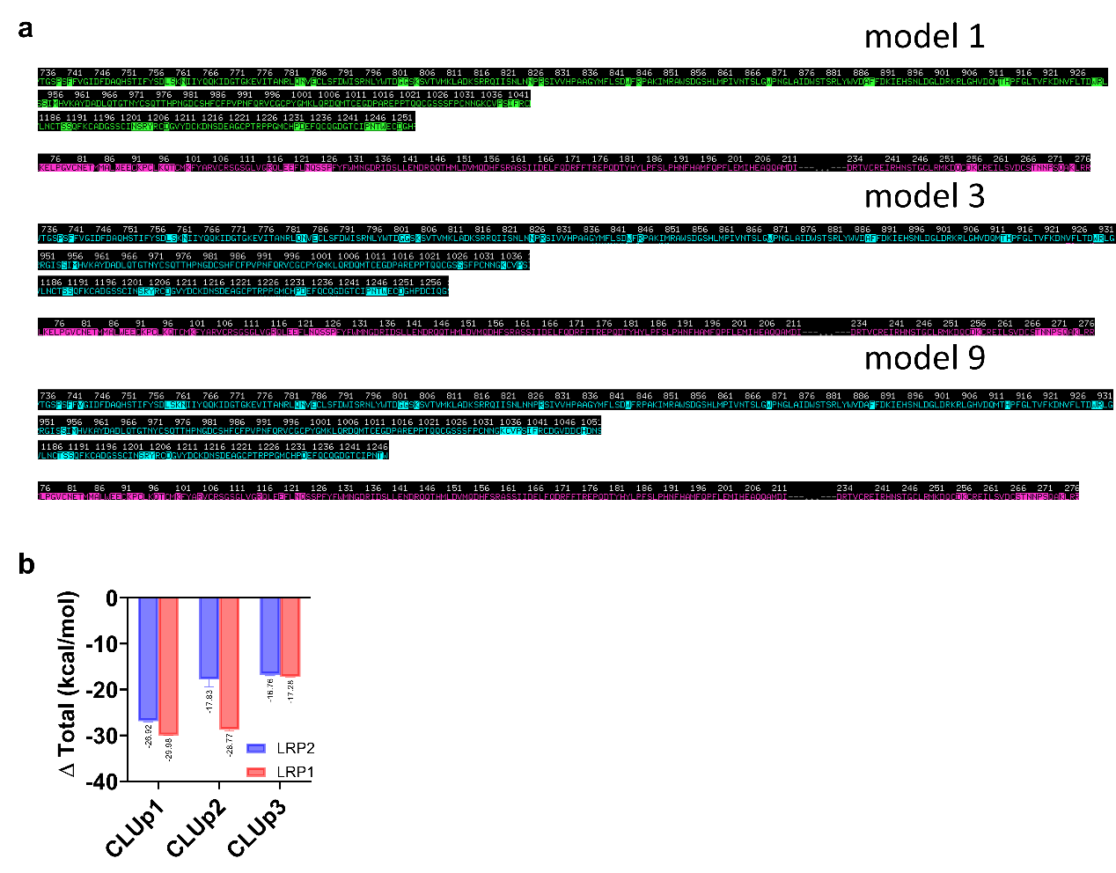
Figure S1. Design and characterization of CLU-binding peptides based on the protein–protein interface of LRP receptors. (a) Candidate peptide sequences (model1, model3 and model9) designed based on key residues at the CLU-LRP2 binding interface. (b) Calculated binding free energies (ΔG) for the interactions between the designed peptides and LRP 2/1.

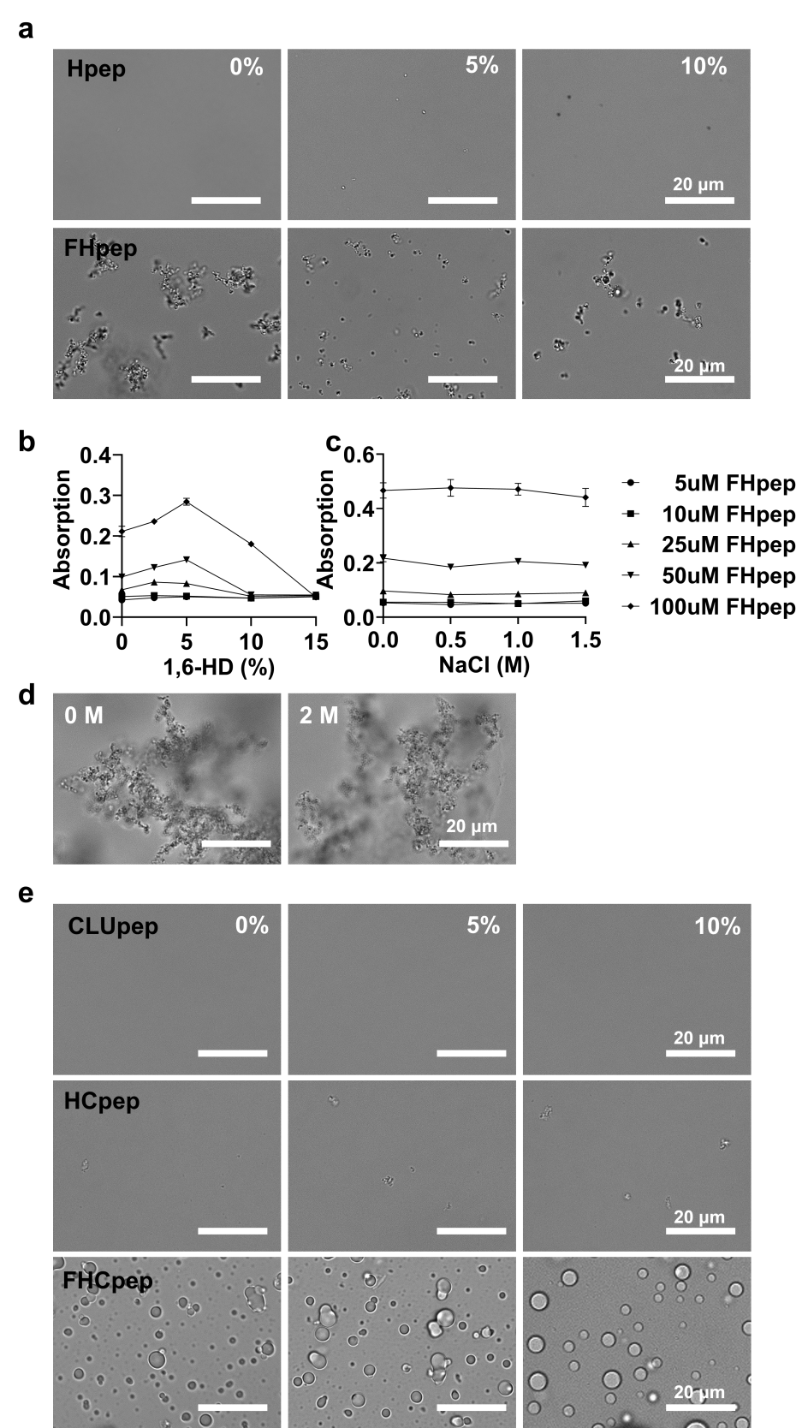
Figure S2. Characterization of the designed phase separation behaviors. (a) Assembly morphologies of Hpep and FHpep at different peptide concentrations under varying PEG conditions. (b-c) Turbidity curves of FHpep under different concentrations of 1,6-HD (b) or NaCl (c). (d) Assembly morphologies of FHpep in the 0 M and 2 M NaCl. (e) Assembly morphologies of peptides CLUpep, HCpep, and FHCpep under different PEG concentrations. All scale bars represent 20 μm.

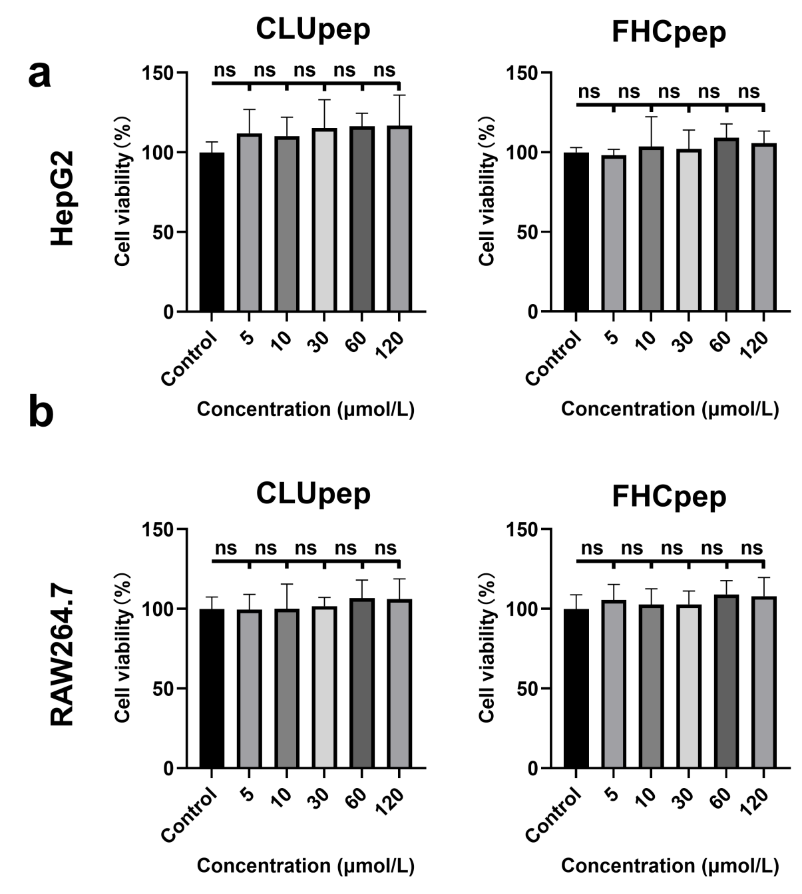

Figure S3. Cytotoxicity analysis of the peptides. (a–b) Cytotoxicity evaluation of CLUpep and FHCpep in HepG2 (a) and RAW264.7 (b) cells (mean ± SD, n = 6).

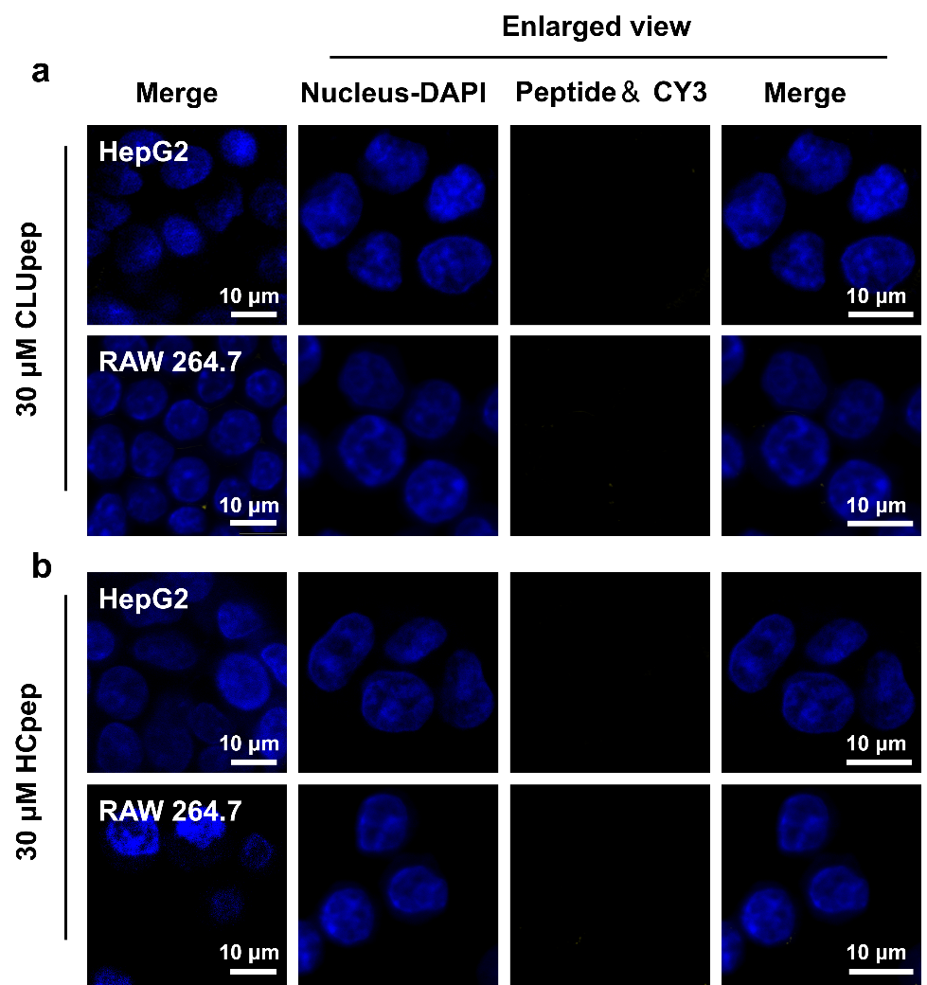

Figure S4. Intracellular distribution profiles of the designed peptides. Intracellular distribution of 30 μM CLUpep (a) and HCpep (b) after incubation with HepG2 and RAW264.7 cells for 2 h, imaged by confocal laser scanning microscopy. Scale bars: 10 μm.

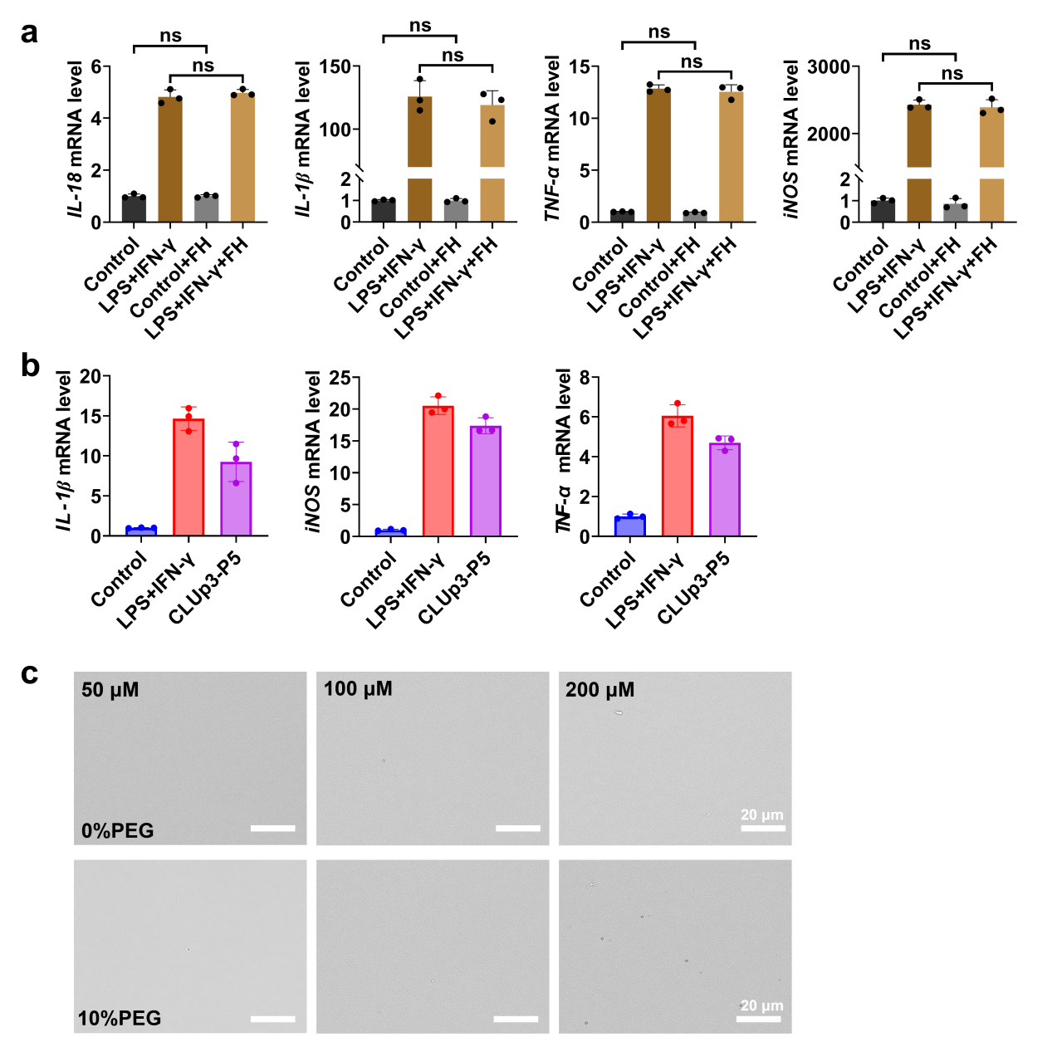

Figure S5. Anti-inflammatory activity of the designed peptides in RAW264.7 cells. (a) Effects of the FHpep on the expression of pro-inflammatory factors (TNF-α, iNOS, IL-1β, and IL-18) in normal and inflammation-induced RAW264.7 cells (mean ± SD, n = 5). (b) Effects of CLUp3-P5pep on the expression levels of pro-inflammatory factors (TNF-α, iNOS, and IL-1β) in RAW264.7 cells stimulated with LPS + IFN-γ (mean ± SD, n = 3). (c) Assembly morphologies of CLUp3-P5pep at different peptide concentrations under varying PEG conditions.

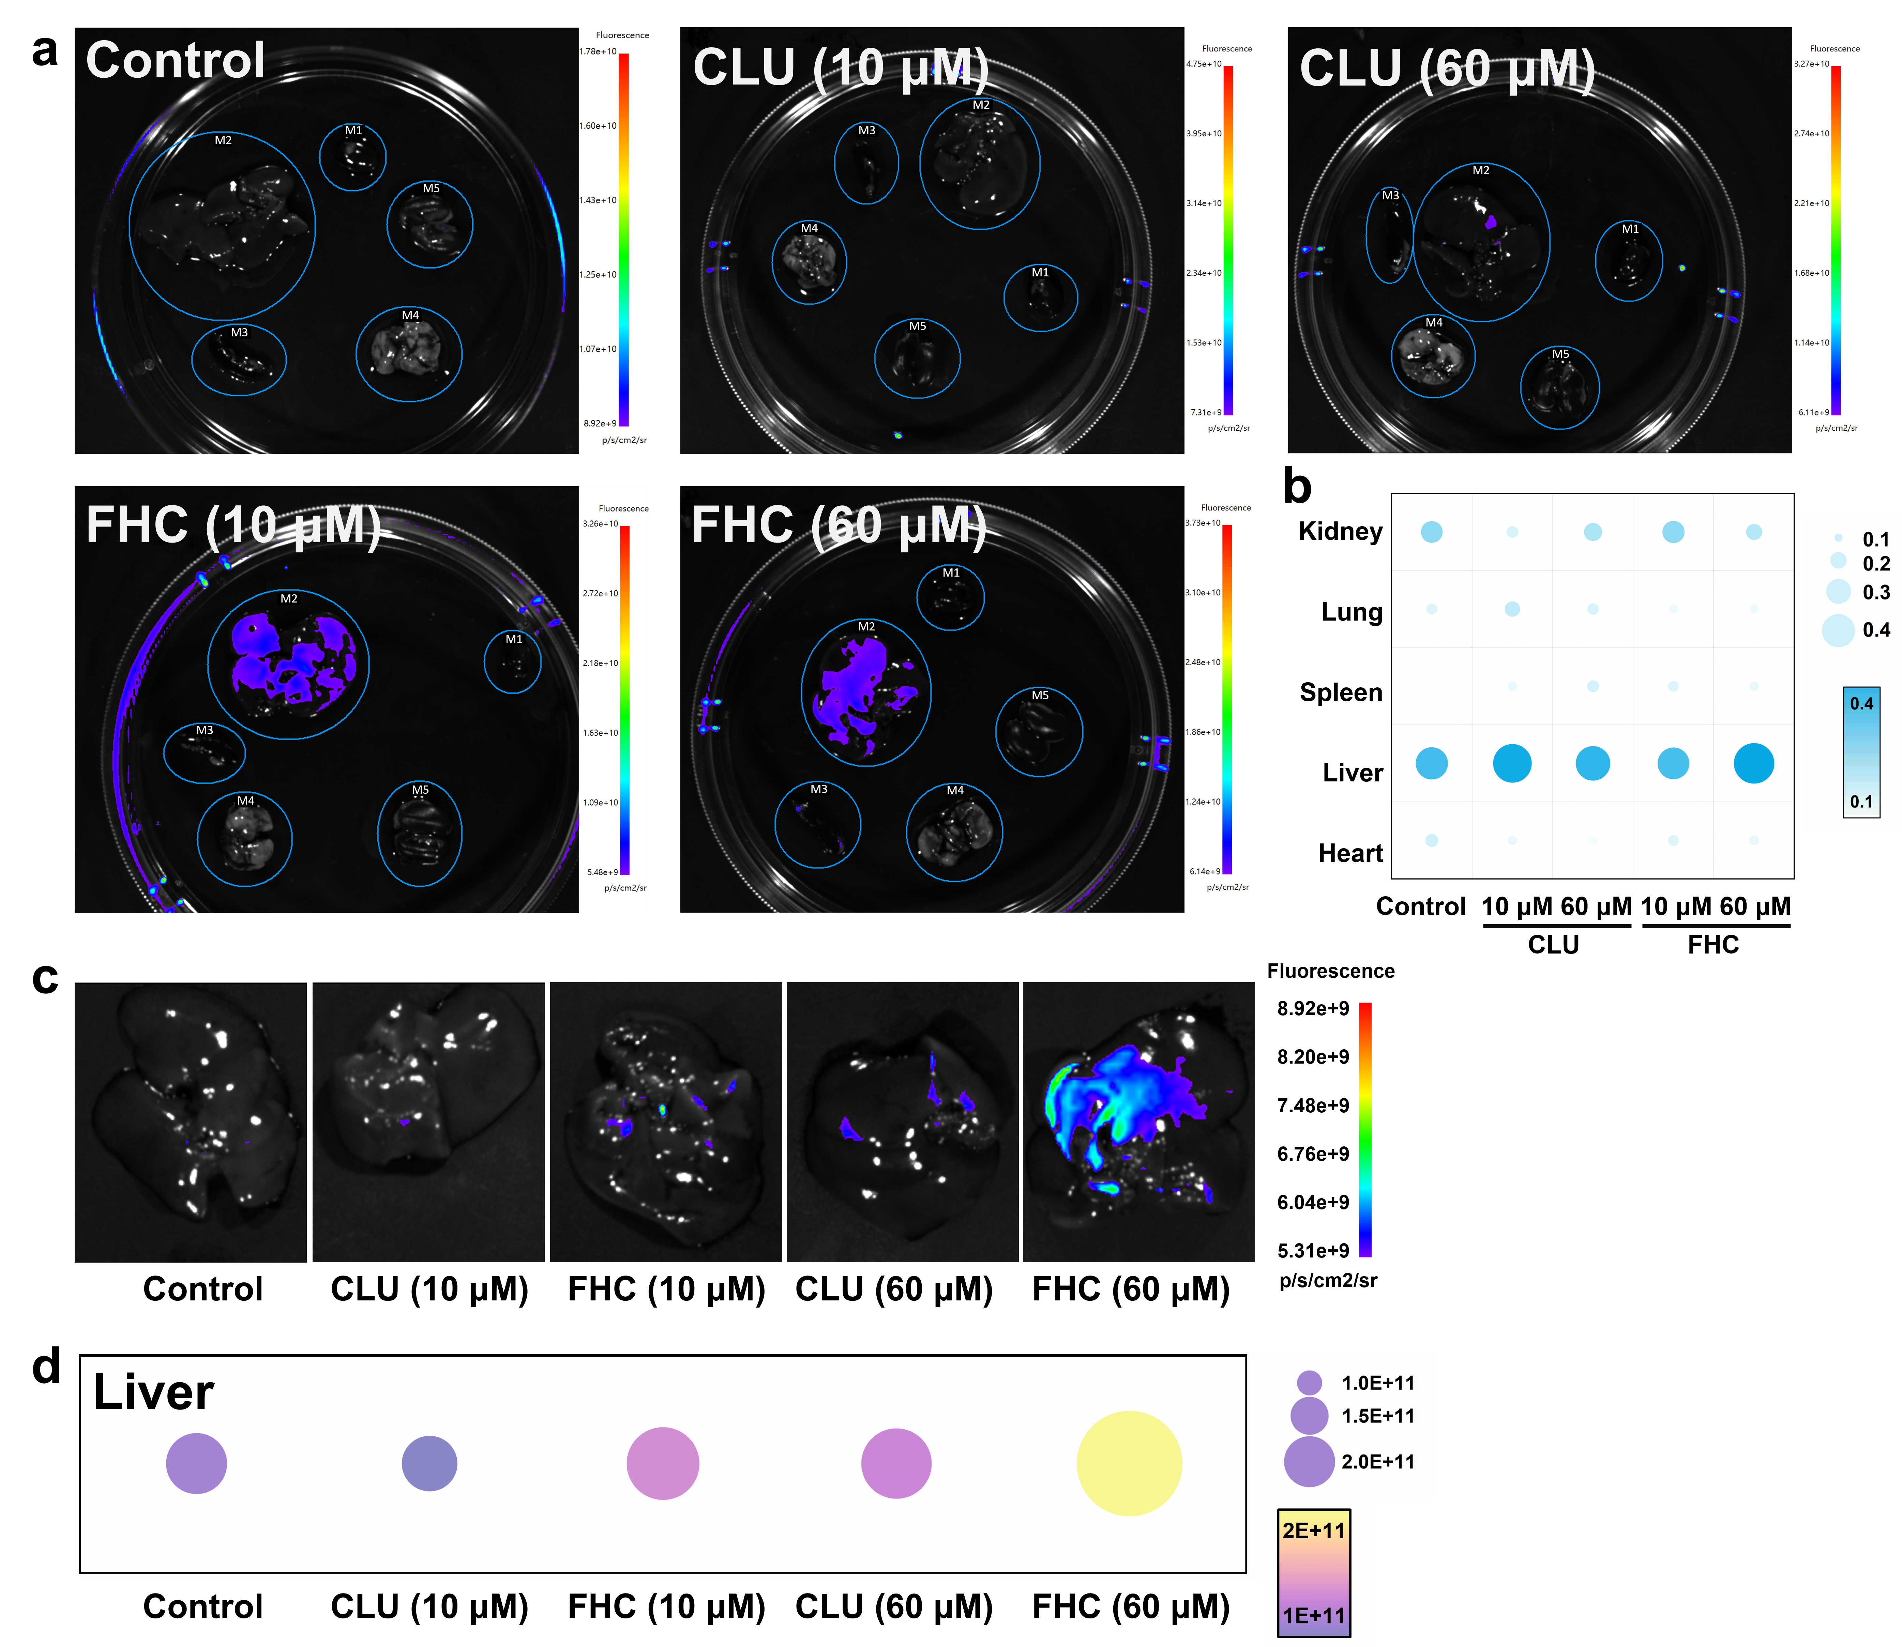
Figure S6. In vivo tissue distribution of the peptides in mice (M1–M5: heart, liver, spleen, lung, and kidney). (a) Distribution of different concentrations of FITC-CLUpep or FITC-FHCpep in the heart, liver, spleen, lung, and kidney of mice at 2 h after intraperitoneal injection. (b) Quantification of fluorescence intensity analysis of the heart, liver, spleen, lung, and kidney. (c) Representative fluorescence images of livers from mice in different groups. (d) Quantitative of fluorescence intensity analysis of the liver from mice in different groups.

Fig. S7. Metabolic improvement and anti-inflammatory evaluation of peptides in MASH mice. (a) Changes in body weight (ΔBody weight, %) after treatment initiation. Body weight was recorded every 4 days. (b-c) Quantitative analysis of whole-body fat mass (%) (b) and lean mass (%) (c) of mice in each experimental group. (d) Cumulative food intake after treatment initiation at week 7, Food intake was recorded every 4 days. (e) Representative Liver tissue phenotypes of mice in each group. (f-h) Analysis of organ-to-body weight ratios of liver (f), iWAT (g), and eWAT (h). (i-l) Analysis of serum biochemical parameters, including LDL-C (i), GLU (j), LDH (k) and CHO (l). (m) Representative images of whole-liver sections stained with H&E. (n–q) Quantitative analysis of hepatic pathological features assessed by Oil Red O (n), F4/80 (o), Masson (p), and Sirius Red (q). (mean ± SD, n = 5). Statistical analysis was performed using one-way ANOVA followed by post hoc multiple-comparisons tests. *P < 0.05, **P < 0.01, ***P < 0.001 versus the positive control; n.s., no significance. #P < 0.05 for the specified pairwise comparisons between the indicated groups; n.s., no significance.
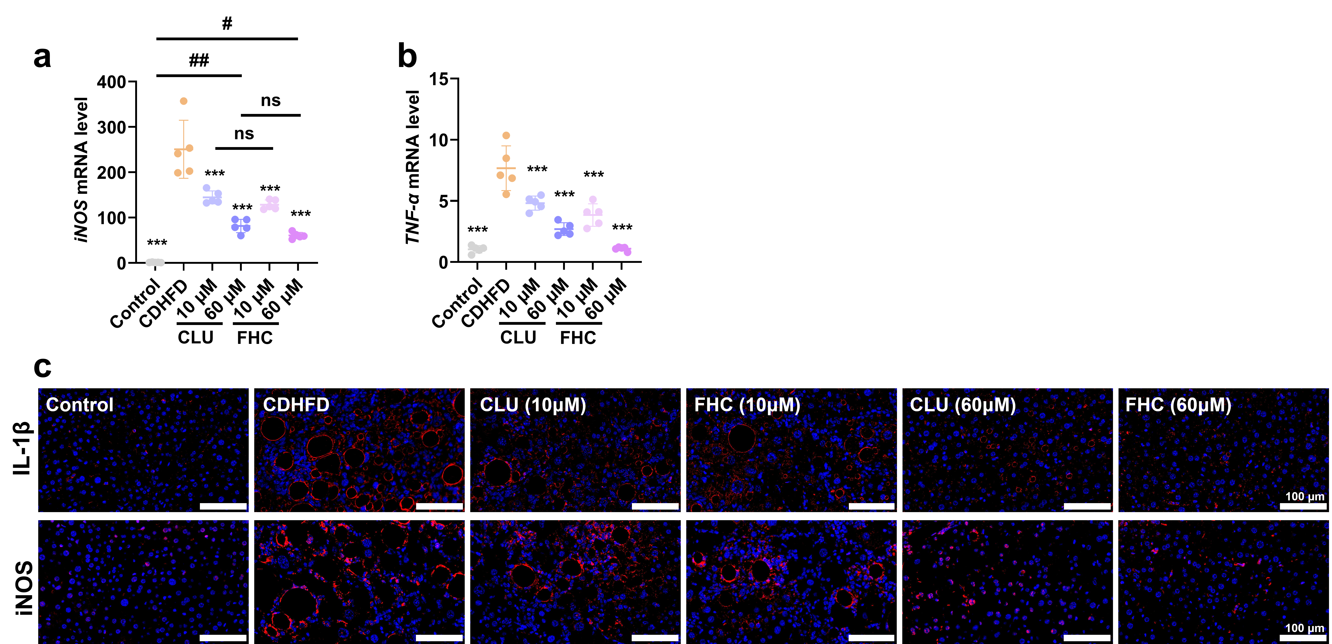
Fig. S8. Expression levels of metabolic and anti-inflammatory factor-related genes of peptides in Liver of mice. (a-b) Relative mRNA expression levels of pro-inflammatory factors iNOS (a) and TNF-α (b) in liver tissues. (c) Representative immunofluorescence staining of liver tissues, used to evaluate macrophage infiltration.

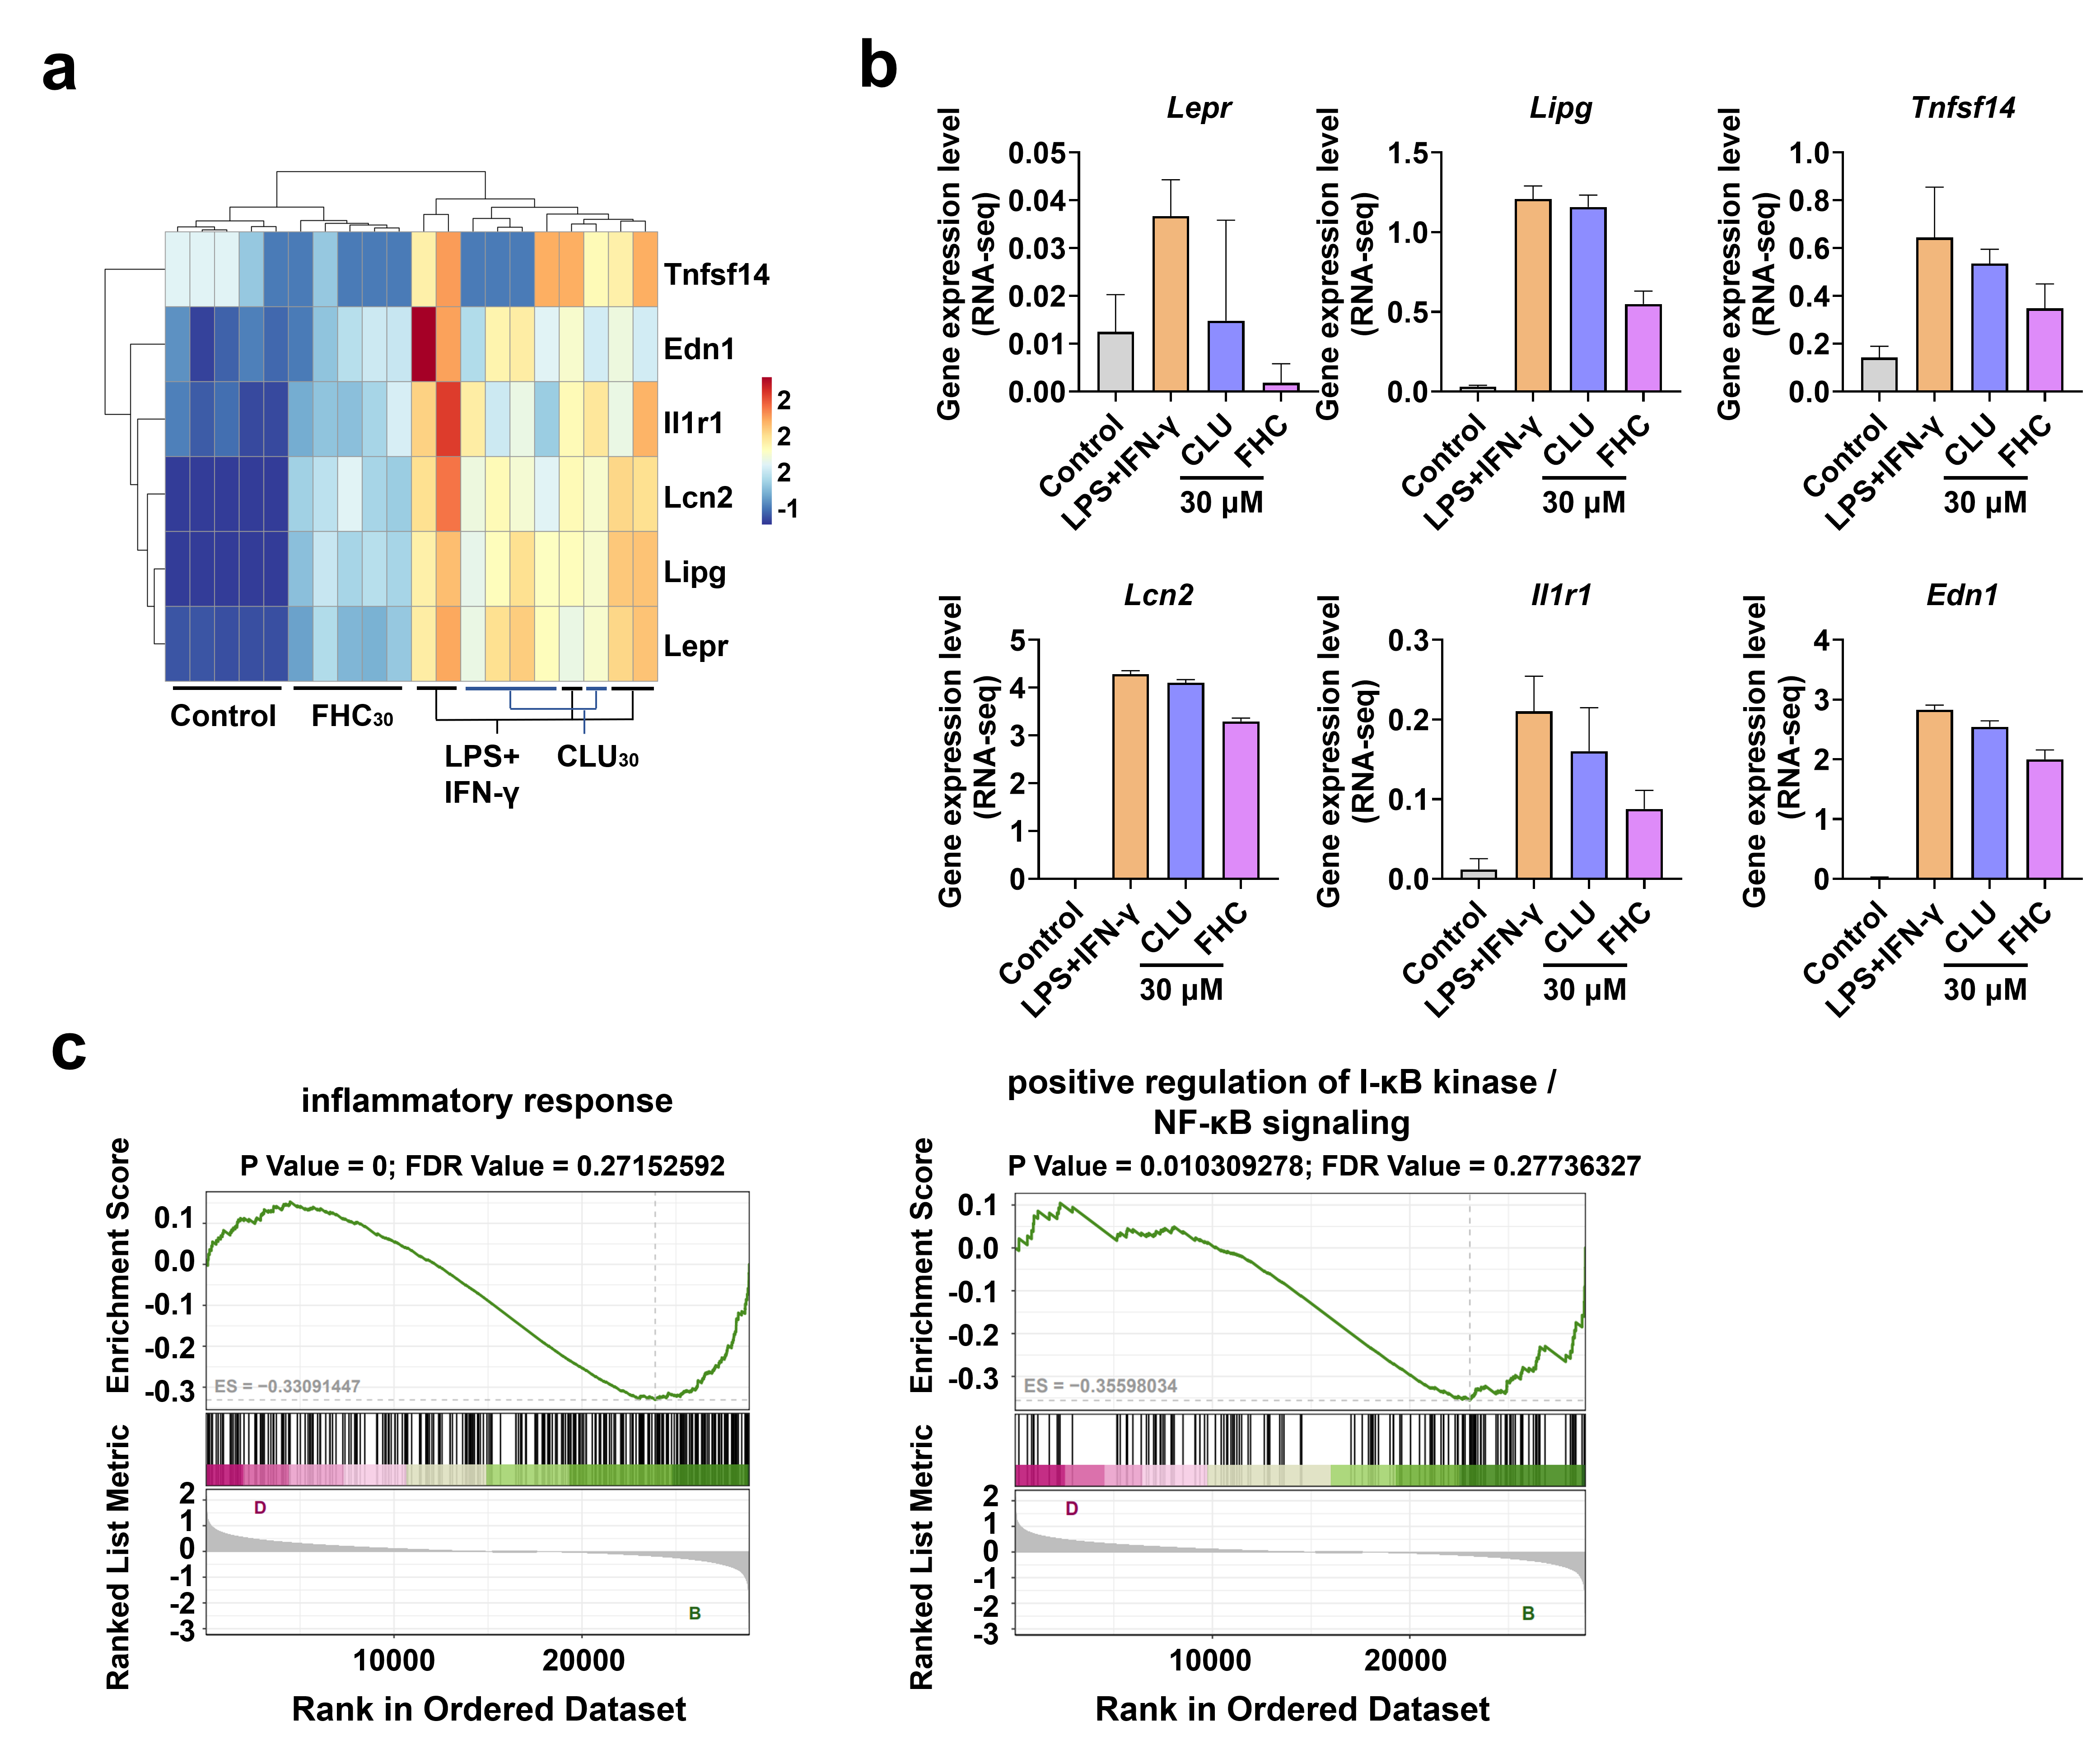

Figure S9. Transcriptomic analysis of peptide-mediated anti-inflammatory and lipid-lowering effects at the cellular level. (a) Clustered heatmap of inflammation-related pathway genes in different groups. (b) The expression of inflammation-related pathway genes among different groups. (c) GSEA showing differential enrichment of inflammation-related pathways in FHC₃₀ versus CLU₃₀

