Supporting Information
Pyrolysis-driven molecular reorganization controls photon absorption and reactive-intermediate formation in sewage sludge biochar-derived dissolved organic matter
Xufang Yu^{a,b,c,d}, Siyu Liuª, Yichun Wangª, Siyu Hangª, Limeng Shaoª, Wenchao Ji^{a,e}, Xingjun Fan^{a,e*}, Jianzhong Song^{b,c}

ª College of Resource and Environment, Anhui Science and Technology University, Fengyang 233100, P. R. China
^{b} State Key Laboratory of Advanced Environmental Technology, Guangzhou Institute of Geochemistry, Chinese Academy of Sciences, Guangzhou 510640, China
^{c} Guangdong Provincial Key Laboratory of Environmental Protection and Resources Utilization, Guangzhou Institute of Geochemistry, Chinese Academy of Sciences, Guangzhou 510640, China
^{d} University of Chinese Academy of Sciences, Beijing 100049, PR China
^{e} Anhui Province Key Laboratory of Biochar and Cropland Pollution Prevention, Bengbu 233400, P. R. China

* Corresponding author
- mail addresses: fanxj@ahstu.edu.cn (Xingjun Fan)

Text S1. HPSEC conditions and operational interpretation
BDOM samples were passed through 0.22-µm membranes before injection. A 100-µL aliquot was separated on a Polysep-GFC-P3000 analytical column protected by a Polysep-GFC-P guard column. The mobile phase was methanol/ultrapure water (1:9, v/v) containing 25 mmol L⁻¹ ammonium acetate, delivered isocratically at 1.0 mL min⁻¹. Elution was monitored using a diode-array detector (DAD); chromatograms at 254 nm were integrated to compare the operational retention-time fractions.
Retention-time windows F1-F6 were treated as operational fractions. Apparent molecular-size assignments were restricted to the validated calibration range. Because BDOM conformation, aggregation, and non-size-exclusion interactions with the stationary phase can affect retention, later elution was not interpreted as a unique molecular-weight class.

Text S2. PPL extraction and Orbitrap HRMS processing
BDOM aliquots were acidified before solid-phase extraction with Bond Elut PPL cartridges (500 mg, 6 mL). The cartridges were conditioned with methanol and acidified ultrapure water; samples were then loaded, rinsed with acidified water, dried, and eluted with methanol. Extracts were infused at 5 µL min⁻¹ into an Exactive Plus Orbitrap mass spectrometer operated in negative electrospray-ionization mode. The spray voltage was 3.0-4.0 kV, and spectra were acquired over m/z 90-900 at a resolving power of 140,000 at m/z 200.
Raw spectra were processed using TRFu (Fu et al., 2020). Molecular formulas containing C, H, O, N, and S were assigned using mass-error, signal-to-noise, elemental-range, isotope-pattern, and chemical-plausibility filters. Within each sample, duplicate formula assignments were consolidated before formula-presence and intensity-weighted summaries were calculated. The resulting data represent the PPL-extractable, negative-ESI-detectable fraction of BDOM and should not be interpreted as the complete dissolved molecular pool.
For an assigned formula CcHhOoNnSs, double-bond equivalents (DBE), the modified aromaticity index, and the nominal oxidation state of carbon (NOSC) were calculated as follows (Lu et al., 2024; Xu et al., 2025):
$$\text{DBE=1+}\frac{\text{1}}{\text{2}}\text{(2}\text{c}\text{-h+}\text{n}\text{)}$$ | (1)
$${\text{AI}}_{\text{mod}}\text{=}\frac{\text{1+}\text{c}\text{-0.5}\text{o}\text{-s-0.5(h+}\text{n}\text{)}}{\text{c}\text{-0.5}\text{o}\text{-s-}\text{n}}$$ | (2)
$$\text{NOSC}\text{=4-}\frac{\text{4}\text{c}\text{+h-3}\text{n}\text{-2}\text{o}\text{-2}\text{s}}{\text{c}}$$ | (3)
Intensity-weighted molecular descriptors were calculated as:
$${\text{X}}_{\text{W}}\text{=}\frac{\sum{\text{(}{\text{I}}_{\text{i}}\text{∙}{\text{X}}_{\text{i}}\text{)}}}{\sum{{\text{I}}_{\text{i}}}}$$ | (4)
where Xi is the descriptor for formula i and Ii is its peak intensity. Weighted values therefore describe the detected ion signal and not an absolute concentration-weighted BDOM average.

Text S3. Chemical actinometry and absorbed-photon rate
A solution containing 10 µmol L⁻¹ p-nitroanisole (PNA) and 10 mmol L⁻¹ pyridine was irradiated under the same optical geometry as the BDOM experiments. Samples were collected at 30-min intervals and analyzed by HPLC. The PNA quantum yield (Φ_{PNA}, mol Einstein⁻¹) was calculated as a function of pyridine concentration (Laszakovits et al., 2017):
$${\text{ϕ}}_{\text{PNA}}\text{=0.29[}\text{pyr}\text{]+0.00029}$$ | (6)
The total photon irradiance (${\text{E}}_{\text{p,tot}}^{\text{0}}$) (Einstein cm⁻² s⁻¹) were calculated as:
$${{\text{E}}_{\text{p}}^{\text{0}}}_{\text{,tot}}\text{=}\frac{{\text{k}}_{\text{obs}\text{,}\text{PNA}}{\text{∙}\text{[}\text{PNA}\text{]}}_{\text{0}}\text{∙}\text{z}}{\text{1000}\text{∙}{\text{Φ}}_{\text{PNA}}\text{∙}\sum_{\text{λ}}{{\text{ρ}}_{\text{λ}}}\text{∙}\text{(1-}{\text{10}}^{{\text{-}{\text{ε}}_{\text{λ}}\text{∙z∙[}\text{PNA}\text{]}}_{\text{0}}}\text{)}\text{∙}\text{Δλ}}$$ | (7)
where k_{obs,PNA} is the pseudo-first-order PNA loss constant, z = 1.33 cm is the optical path length of the irradiation tube, ε_{λ} is the PNA molar absorption coefficient, ρ_{λ} is the normalized relative photon distribution of the lamp, and Δλ = 1 nm. The spectral photon irradiance at each wavelength (${\text{E}}_{\text{p,λ}}^{\text{0}}$, Einstein cm⁻² s⁻¹ nm⁻¹) was then obtained by:
$${\text{E}}_{\text{p,λ}}^{\text{0}}\text{=}{\text{E}}_{\text{p,tot}}^{\text{0}}\text{∙}{\text{ρ}}_{\text{λ}}$$ | (8)
The absorbed-photon rate (Ra; Einstein L⁻¹ s⁻¹) of each BDOM solution was calculated by integrating spectral photon absorption from 290 to 400 nm (Laszakovits et al., 2017; Tu et al., 2022):
$${\text{R}}_{\text{a}}\text{=}\sum_{\text{λ}}{\frac{{\text{E}}_{\text{p,λ}}^{\text{0}}\text{(1-}{\text{10}}^{\text{-}{\text{α}}_{\text{λ}}\text{∙}\text{z}}\text{)}}{\text{z}}}$$ | (9)
where α_{λ} is the absorbance coefficient of the irradiated BDOM solution (cm⁻¹).

Text S4. Probe-based determination of PPRIs
Photochemically produced reactive intermediates (PPRIs) were quantified using 2,4,6-trimethylphenol (TMP), furfuryl alcohol (FFA), and terephthalic acid (TPA). The working solutions contained 100 µmol L⁻¹ TMP, 100 µmol L⁻¹ FFA, or 500 µmol L⁻¹ TPA. Irradiated probe blanks contained the corresponding probe without BDOM; dark controls contained both BDOM and probe but were not irradiated.
TMP was used to obtain a probe-specific, reactivity-weighted descriptor of triplet BDOM (³BDOM*). The steady-state concentration (${\text{[}{}_{}^{\text{3}}{{\text{DOM}}_{}^{\text{*}}}\text{]}}_{\text{SS}}$) and apparent quantum yield coefficient (f_{TMP}) of ³DOM* can be calculated by the following (Liu et al., 2024; Zhang et al., 2022b):
$${\text{[}{}_{}^{\text{3}}{{\text{DOM}}_{}^{\text{*}}}\text{]}}_{\text{SS}}\text{=}\frac{{\text{k}}_{\text{obs,TMP}}}{{\text{k}}_{{}_{}^{\text{3}}{{\text{DOM}}_{}^{\text{*}}}\text{, TMP}}}$$ | (10)
$${\text{f}}_{\text{TMP}}\text{=}\frac{{\text{k}}_{\text{obs,TMP}}}{{\text{R}}_{\text{a}}}$$ | (11)
where ${\text{k}}_{{}_{}^{\text{3}}{{\text{DOM}}_{}^{\text{*}}}\text{, TMP}}$ represents the second-order reaction rate constant of TMP and 3DOM* (3 × 10⁹ M⁻¹s⁻¹), ${\text{k}}_{\text{obs,TMP}}$ is the pseudo-first-order degradation rate constant of TMP. The coefficient f_{TMP} (M⁻¹) was interpreted as a TMP-reactivity-weighted apparent triplet descriptor, not as the absolute quantum yield of all BDOM triplet states.
FFA was employed as a selective chemical probe to quantify the steady-state concentration of ¹O₂ ([¹O₂]ss) and its formation rate (${\text{R}}_{{}_{}^{\text{1}}{{\text{O}}_{\text{2}}^{}}}$), which were calculated by following equations (Cai et al., 2024; Liu et al., 2022):
$${\text{[}{}_{}^{\text{1}}{{\text{O}}_{\text{2}}^{}}\text{]}}_{\text{SS}}\text{=}\frac{{\text{k}}_{\text{obs,FFA}}}{{\text{k}}_{{}_{}^{\text{1}}{{\text{O}}_{\text{2}}^{}\text{,FFA}}}}$$ | (12)
$${\text{R}}_{{}_{}^{\text{1}}{{\text{O}}_{\text{2}}^{}}}\text{=}\frac{{\text{k}}_{\text{obs,FFA}}}{{\text{k}}_{{}_{}^{\text{1}}{{\text{O}}_{\text{2}}^{}\text{,FFA}}}}\text{(}{\text{k}}_{{}_{}^{\text{1}}{{\text{O}}_{\text{2}}^{}\text{,FFA}}}\text{∙}{\text{[FFA]}}_{\text{0}}\text{+}{\text{K}}_{\text{d}}\text{)}$$ | (13)
where ${\text{k}}_{\text{obs,FFA}}$ denotes pseudo-first-order degradation rate constant of FFA, ${\text{k}}_{{}_{}^{\text{1}}{{\text{O}}_{\text{2}}^{}\text{,}\text{FFA}}}$ is the second-order rate constant between ¹O₂ and FFA (1.2 × 10⁸ M⁻¹s⁻¹), [FFA] is the initial concentration of FFA (20 μM), ${\text{k}}_{{}_{}^{\text{1}}{{\text{O}}_{\text{2}}^{}\text{,FFA}}}$ is the rate constant corresponding to the physical quenching of ¹O₂ by water (2.5 × 10⁵ s⁻¹) (Liu et al., 2022; Zhang et al., 2022a).
The apparent quantum yield of ¹O₂ (${\text{Φ}}_{{}_{}^{\text{1}}{{\text{O}}_{\text{2}}^{}}}$) could be calculate as (Cai et al., 2024):
$${\text{Φ}}_{{}_{}^{\text{1}}{{\text{O}}_{\text{2}}^{}}}\text{=}\frac{{\text{R}}_{{}_{}^{\text{1}}{{\text{O}}_{\text{2}}^{}}}}{{\text{R}}_{\text{a}}}$$ | (14)
•OH production was quantified using TPA, which forms 2-hydroxyterephthalic acid (hTPA) with an assumed product yield of 0.35:
TPA+•OH→2-hTPA
The formation rate of hTPA is related to •OH production as (Liu et al., 2024; Liu et al., 2022):
$$\frac{\text{d}\text{[h}\text{TPA}\text{]}}{\text{dt}}\text{=0.35}{\text{k}}_{\text{•OH,TPA}}\text{[TPA]}{\text{[•OH]}}_{\text{ss}}\text{=0.35}{\text{R}}_{\text{•OH}}$$ | (15)
where ${\text{k}}_{\text{•OH,TPA}}$ is the second-order constant between ∙OH and TPA (3.3 × 10⁹ M⁻¹s⁻¹), [TPA] denotes the initial concentration of TPA (500 μM). ${\text{[•OH]}}_{\text{ss}}$ and ${\text{Φ}}_{\text{•OH}}$ are the steady-state concentration and apparent quantum yield of •OH, which were then calculated by the follows (Liu et al., 2022):
$${\text{[•OH]}}_{\text{ss}}\text{=}\frac{{\text{R}}_{\text{•OH}}}{{\text{k}}_{\text{•OH,TPA}}\text{∙}\text{[}\text{TPA}\text{]}}$$ | (16)
$${\text{Φ}}_{\text{•OH}}\text{=}\frac{{\text{R}}_{\text{•OH}}}{{\text{R}}_{\text{a,DOM}}}$$ | (17)
Text S5. FTIR spectroscopy
Freeze-dried BDOM residues were mixed with spectroscopic-grade KBr and analyzed using a Nicolet iS10 Fourier-transform infrared spectrometer (Thermo Fisher Scientific, USA). Spectra were collected over the range of 4000–400 cm⁻¹ at a spectral resolution of 4 cm⁻¹, with 32 scans accumulated for each sample.

Table S1. Operational regions used for fluorescence regional integration. The labels denote fluorescence domains and do not establish unique molecular structures or sources.
Region | Operational EEM boundary | Conventional fluorescence assignment
I | Ex < 250 nm; Em < 330 nm | Tyrosine-/protein-like
II | Ex < 250 nm; 330 ≤ Em < 380 nm | Tryptophan-/protein-like
III | Ex < 250 nm; Em ≥ 380 nm | Fulvic-like
IV | Ex ≥ 250 nm; Em < 380 nm | Soluble microbial-byproduct-like
V | Ex ≥ 250 nm; Em ≥ 380 nm | Humic-like

Table S2. Mutually exclusive operational Van Krevelen domains used for formula-space summaries.
Operational class | H/C range | O/C range
Condensed-aromatic | 0.20 ≤ H/C < 0.67 | 0 ≤ O/C < 0.67
Highly oxygenated | 0.60 ≤ H/C < 1.50 | 0.67 ≤ O/C ≤ 1.20
Unsaturated-hydrocarbon-like | 0.67 ≤ H/C < 1.50 | 0 ≤ O/C < 0.10
CRAM-/lignin-like | 0.67 ≤ H/C < 1.50 | 0.10 ≤ O/C < 0.67
Lipid-like | 1.50 ≤ H/C ≤ 2.00 | 0 ≤ O/C < 0.30
Aliphatic-/protein-like | 1.50 ≤ H/C ≤ 2.20 | 0.30 ≤ O/C < 0.67
Carbohydrate-like | 1.50 ≤ H/C ≤ 2.40 | 0.67 ≤ O/C ≤ 1.20
Other | Outside the above domains | Outside the above domains

Table S3. HPLC conditions for actinometer, probe, and product analyses.
Probes | Mobile phases  (v/v) | Flow rate  (mL/min) | Injection volume  (μL) | Detection mode | Retention time  (min)
TMP | A:C = 50:50 | 1.0 | 30 | UV: 220 | 5.90
FFA | A:C = 30:70 | 0.6 | 30 | UV: 220 | 3.81
2-hTPA | A:D = 20:80 | 1.0 | 30 | Fluorescence:  Ex/Em = 315/425 | 4.08
PNA | B:C = 75:25 | 1.0 | 30 | UV: 220 | 6.18
Note: Mobile phases: A, acetonitrile; B, methanol; C, water; D, 0.1% trifluoroacetic acid in water. Separation were performed on an Eclipse XDB-C18 column (4.6 × 150 mm, 5 μm).

Table S4. Intensity-weighted molecular parameters of BDOM formulas identified by Orbitrap HRMS.
Sample | MWw | DBEw | DBE-Ow | DBE/Cw | DBE/Hw | AImod,w | NOSCw | H/Cw | O/Cw | N/Cw | S/Cw | Cw | Hw | Ow | Nw | Sw
BDOM200 | 284 | 4.78 | -0.87 | 0.39 | 0.35 | 0.19 | -0.26 | 1.45 | 0.47 | 0.06 | 0.04 | 12.67 | 18.46 | 5.65 | 0.69 | 0.41
BDOM300 | 275 | 5.96 | 1.69 | 0.45 | 0.36 | 0.23 | -0.33 | 1.39 | 0.32 | 0.14 | 0.01 | 13.34 | 18.54 | 4.27 | 1.76 | 0.09
BDOM400 | 253 | 7.12 | 3.17 | 0.57 | 0.57 | 0.41 | -0.16 | 1.13 | 0.32 | 0.10 | 0.01 | 12.67 | 14.42 | 3.95 | 1.32 | 0.14
BDOM500 | 252 | 2.79 | -1.48 | 0.23 | 0.18 | 0.10 | -0.74 | 1.77 | 0.41 | 0.03 | 0.07 | 11.54 | 19.79 | 4.27 | 0.29 | 0.66
BDOM600 | 288 | 3.70 | -0.74 | 0.26 | 0.20 | 0.11 | -0.72 | 1.71 | 0.36 | 0.05 | 0.05 | 14.12 | 23.52 | 4.44 | 0.67 | 0.45
BDOM700 | 333 | 5.27 | 0.68 | 0.31 | 0.34 | 0.21 | -0.76 | 1.57 | 0.28 | 0.06 | 0.03 | 17.51 | 27.29 | 4.59 | 0.82 | 0.32
Note: The subscript w denotes peak-intensity weighting.

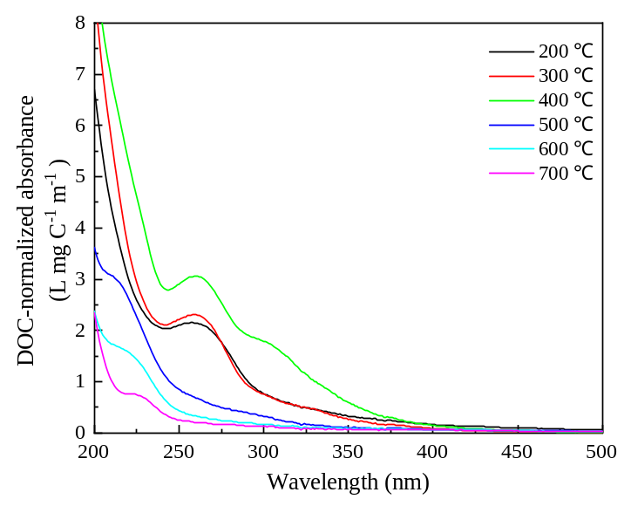
Fig. S1. DOC-normalized UV-Vis absorption spectra of BDOM200-BDOM700. The BDOM fractions were water-extracted from sludge-derived biochars produced at the corresponding pyrolysis temperatures.

Fig. S2. Wavelength-resolved HPSEC–DAD absorbance maps of BDOM200–BDOM700 as functions of retention time and detection wavelength.
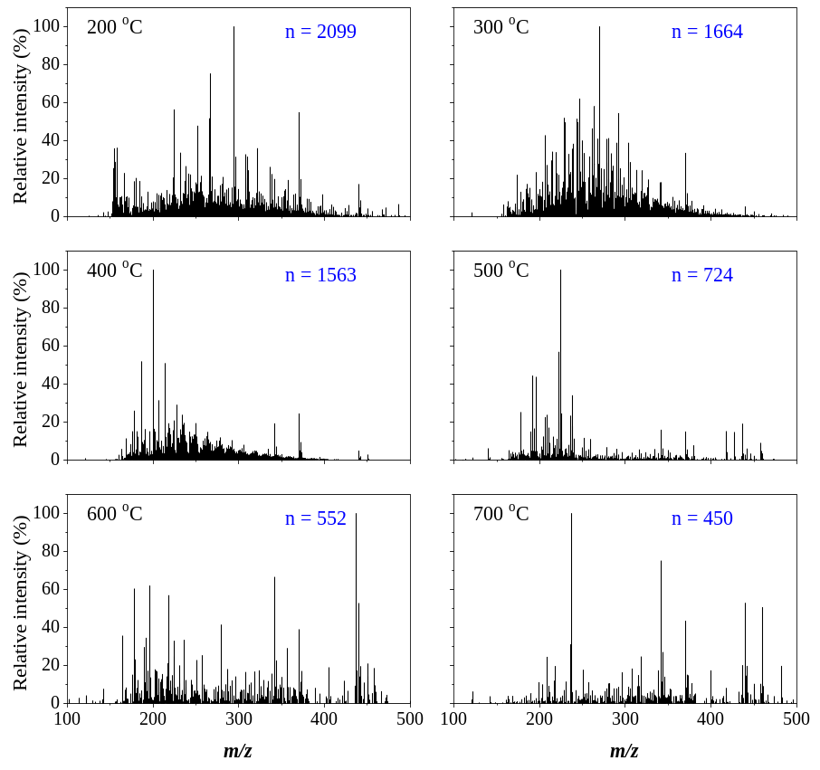
Fig. S3. Orbitrap HRMS spectra of BDOM200-BDOM700.

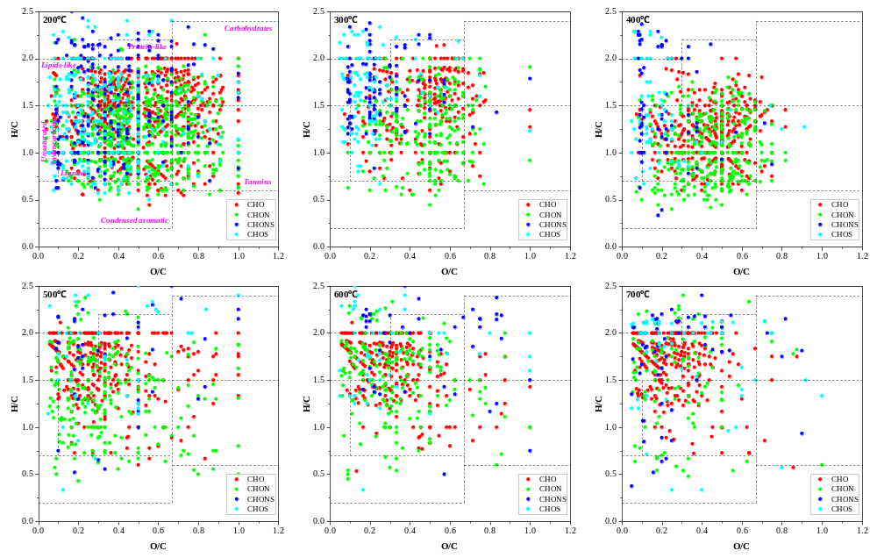
Fig. S4. Van Krevelen diagrams of assigned molecular formulas in BDOM200-BDOM700. Dashed regions indicate operational formula-space domains based on H/C and O/C ratios.

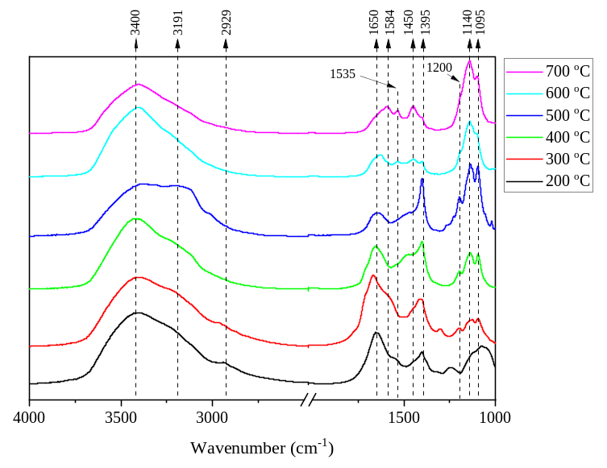
Fig. S5. FTIR spectra of freeze-dried BDOM200-BDOM700.

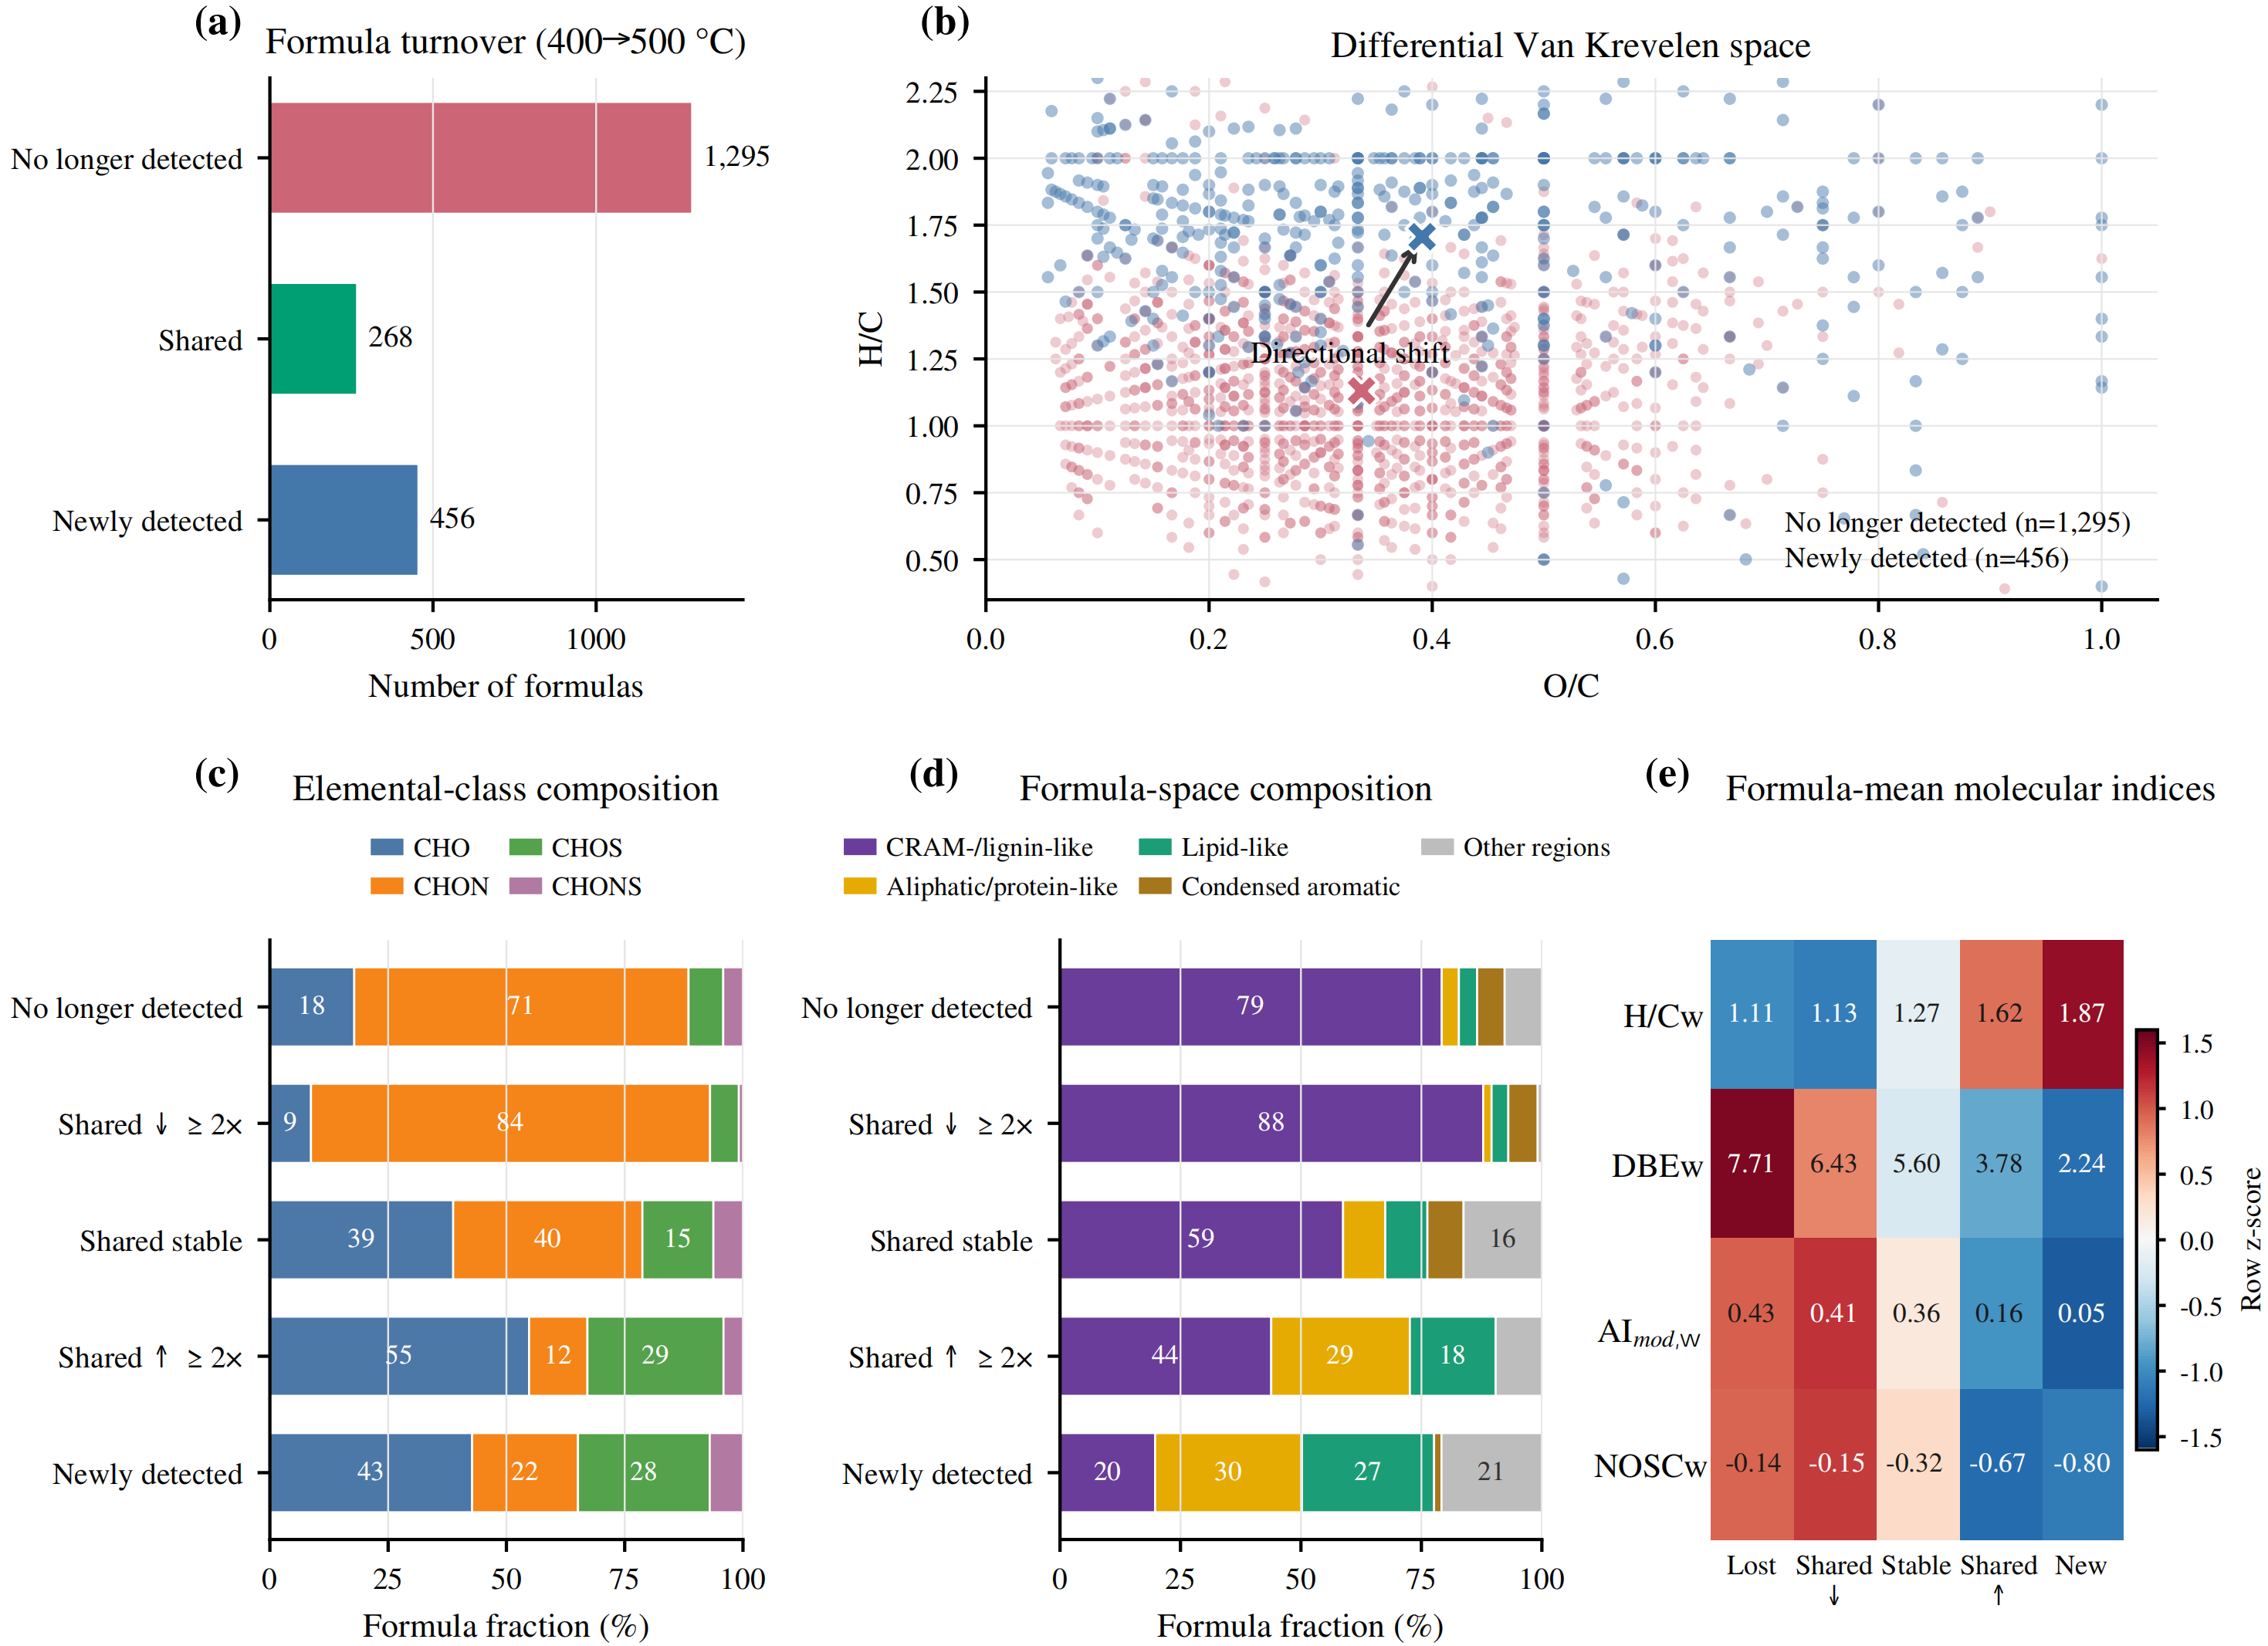
Fig. S6. Detection-based molecular-formula turnover and intensity-weighted compositional shifts of BDOM across the 400-500 ºC pyrolysis transition.

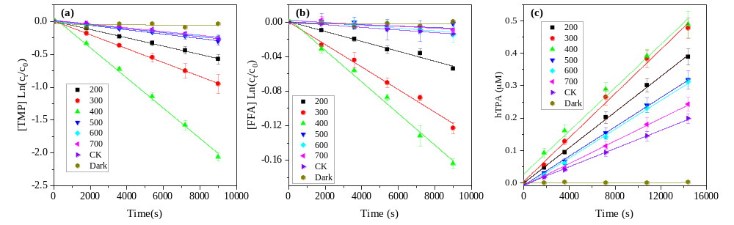Fig. S7. Kinetic plots for (a) TMP loss, (b) FFA loss, and (c) hTPA formation from TPA during irradiation of BDOM200-BDOM700. CK, irradiated probe blanks without BDOM; Dark, nonirradiated probe controls.

References:
Cai, T., Ming, Y., Zhang, X., Zheng, X., Shen, L., Lyu, X., Zhang, Q., 2024. Comparing photoactivities of dissolved organic matter released from rice straw return under varying alkali concentration: Insights from molecular structure and photoactive species. Chemical Engineering Journal 499, 156571.
Fu, Q.-L., Fujii, M., Riedel, T., 2020. Development and comparison of formula assignment algorithms for ultrahigh-resolution mass spectra of natural organic matter. Anal. Chim. Acta 1125, 247-257.
Laszakovits, J.R., Berg, S.M., Anderson, B.G., O’Brien, J.E., Wammer, K.H., Sharpless, C.M., 2017. p-Nitroanisole/Pyridine and p-Nitroacetophenone/Pyridine Actinometers Revisited: Quantum Yield in Comparison to Ferrioxalate. Environmental Science & Technology Letters 4, 11-14.
Liu, H., Tu, Y.-n., Lei, Y., Zhou, D., Zhao, Q., Li, Y., Pan, W., 2024. Photochemistry of plateau lake-derived dissolved organic matter: Reactive species generation and effects on 17β-estradiol photodegradation. Journal of Hazardous Materials 473, 134615.
Liu, Y., Wang, M., Yin, S., Xie, L., Qu, X., Fu, H., Shi, Q., Zhou, F., Xu, F., Tao, S., Zhu, D., 2022. Comparing Photoactivities of Dissolved Organic Matter Released from Rice Straw-Pyrolyzed Biochar and Composted Rice Straw. Environ. Sci. Technol. 56, 2803-2815.
Lu, Q., Han, Q., Liu, H., Feng, L., Liu, Y., Du, Z., Zhang, L., 2024. Molecular-level transformations of dissolved black carbon in UV-based advanced oxidation processes. Water Res. 260, 121962.
Tu, Y., Liu, H., Li, Y., Zhang, Z., Lei, Y., Zhao, Q., Tian, S., 2022. Radical chemistry of dissolved black carbon under sunlight irradiation: quantum yield prediction and effects on sulfadiazine photodegradation. Environmental Science and Pollution Research 29, 21517-21527.
Xu, C., Cao, T., Yan, X., Song, J., Zhong, Y., Peng, P.a., 2025. Quantification and molecular characterization of dissolved organic carbon released from leaf fragments, crop straw, and straw biochar. Journal of Environmental Sciences 158, 98-111.
Zhang, H., Zheng, Y., Wang, X.C., Zhang, Q., Dzakpasu, M., 2022a. Photochemical behavior of constructed wetlands-derived dissolved organic matter and its effects on Bisphenol A photodegradation in secondary treated wastewater. Sci. Total Environ. 845, 157300.
Zhang, T., Ma, H., Hong, Z., Fu, G., Zheng, Y., Li, Z., Cui, F., 2022b. Photo-Reactivity and Photo-Transformation of Algal Dissolved Organic Matter Unraveled by Optical Spectroscopy and High-Resolution Mass Spectrometry Analysis. Environ. Sci. Technol. 56, 13439-13448.

