Supplementary Materials
S1. Sensitivity Analysis Excluding PHQ-9 Item 3
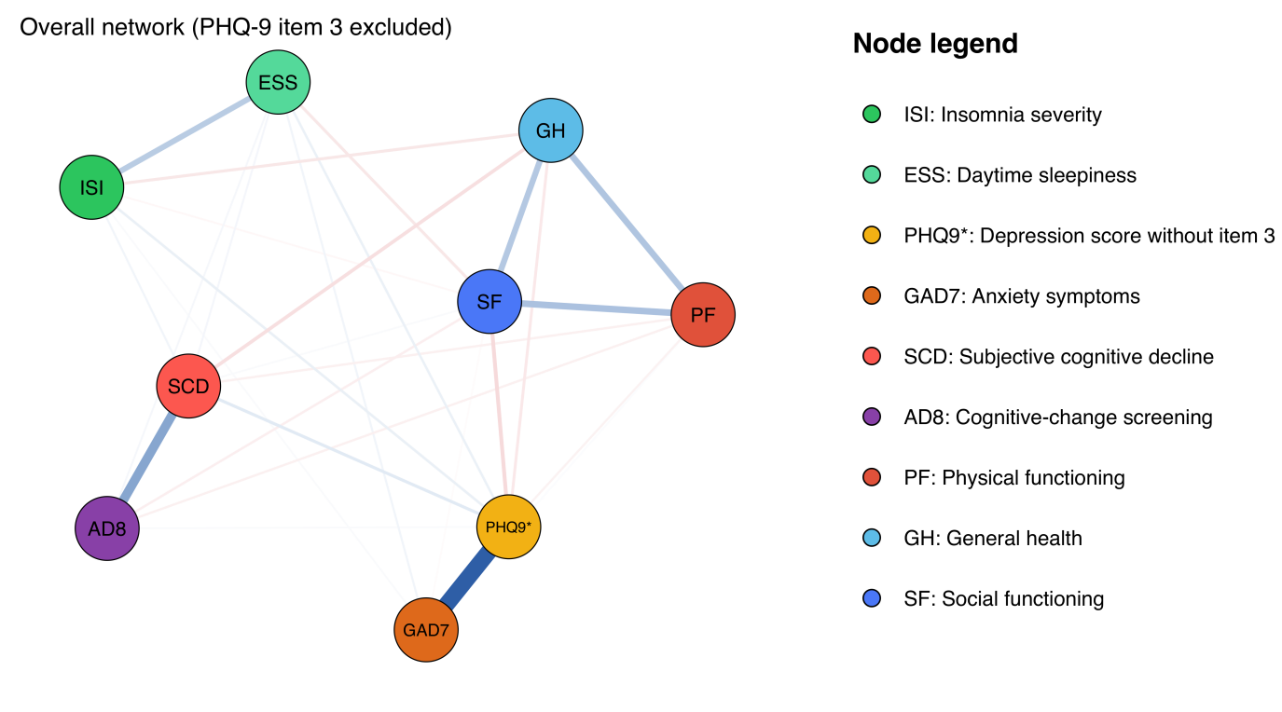
Figure S1. Overall health-indicator network after excluding PHQ-9 Item 3 from the depression score.
Note. Nodes represent health indicators; edges are EBICglasso regularised partial correlations after covariate residualisation. Blue and red edges indicate positive and negative associations, respectively. Node colours and abbreviations are defined in the legend within each network figure.
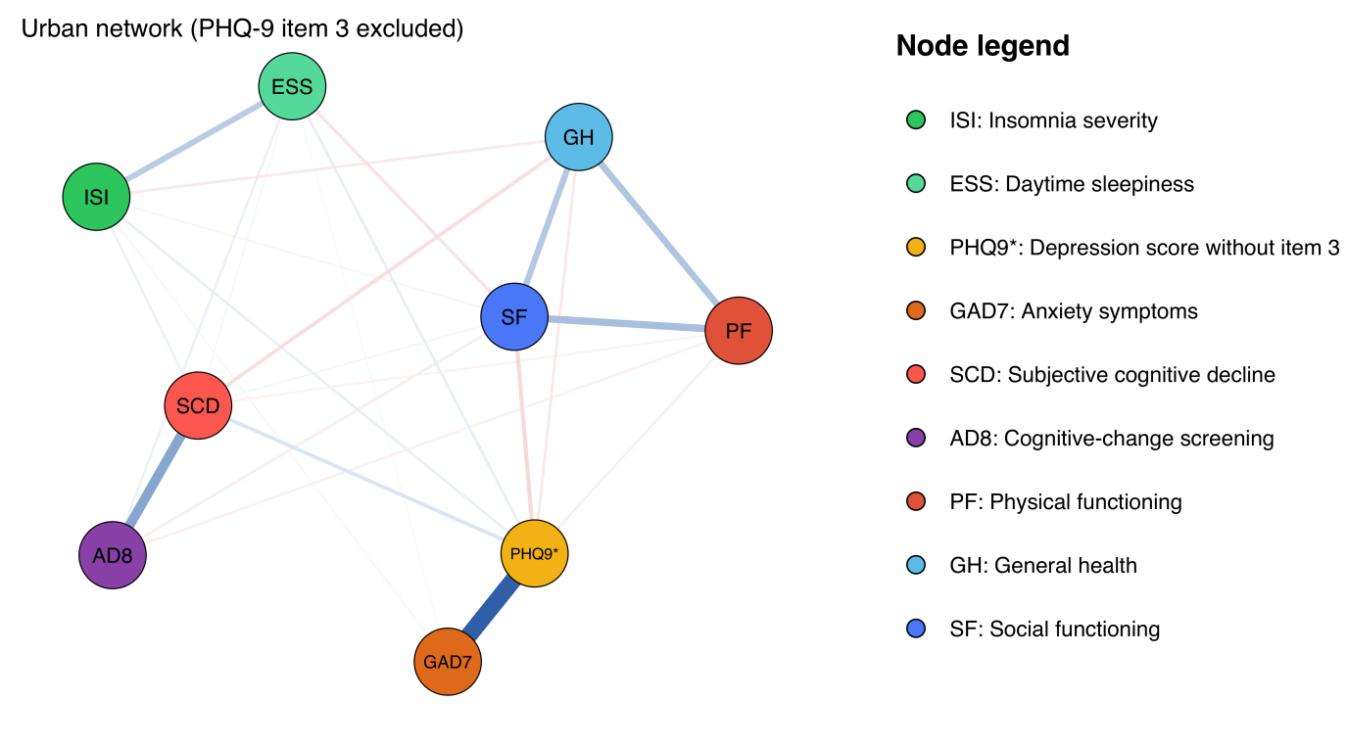
Figure S2. Urban health-indicator network after excluding PHQ-9 Item 3. The layout matches Figures S1 and S3.
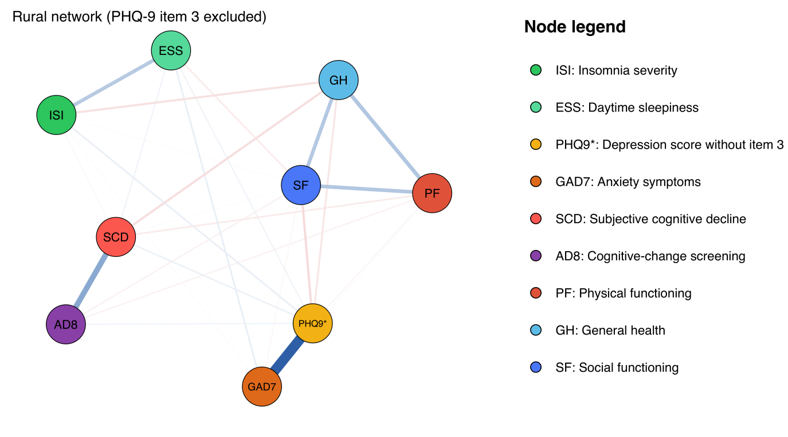
Figure S3. Rural health-indicator network after excluding PHQ-9 Item 3. The layout matches Figures S1 and S2.

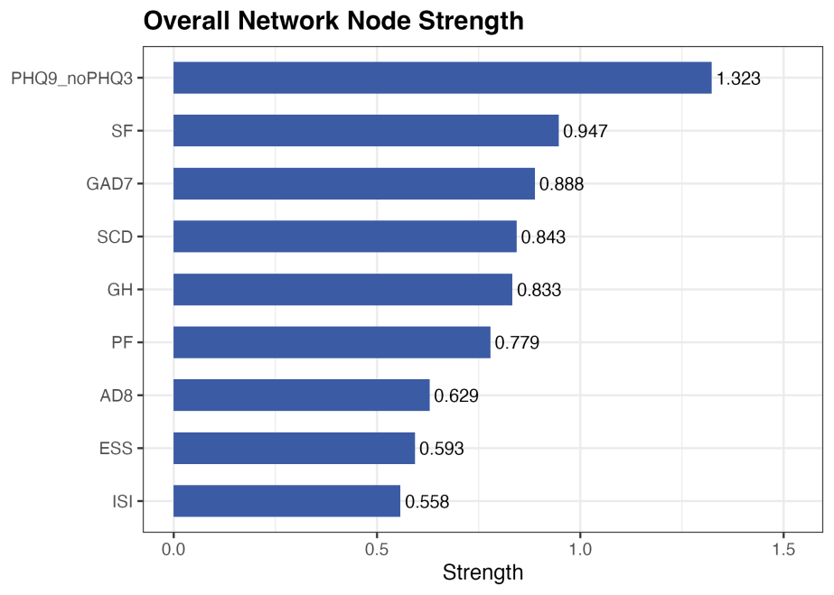
Figure S4. Node strength centrality for the sensitivity network (overall sample). Strength represents the sum of absolute edge weights connected to each node.

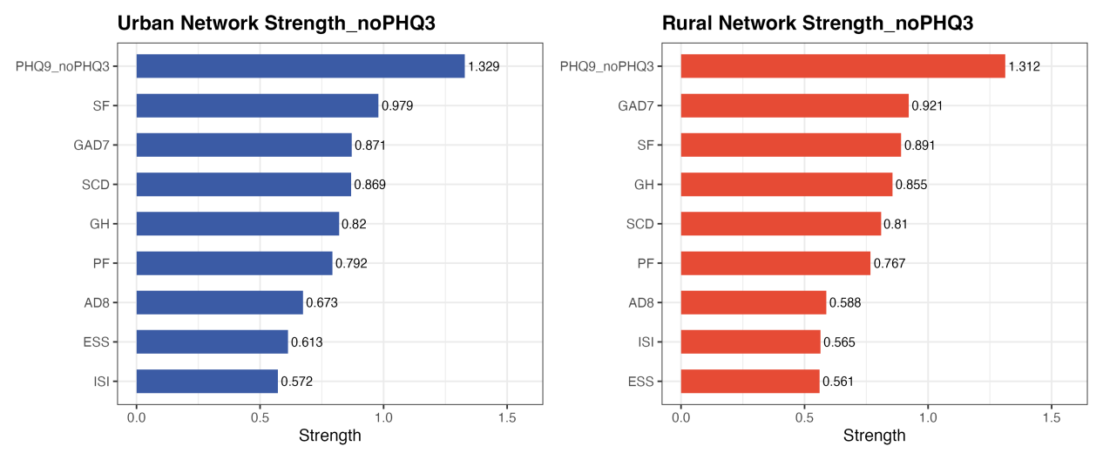
Figure S5. Node strength centrality for sensitivity networks in urban and rural subgroups.
Note. Values represent strength centrality based on networks estimated after excluding PHQ-9 Item 3.

S2. Robustness Check Using ggmModSelect
To evaluate whether the substantive findings reported in the main analysis are sensitive to the choice of EBICglasso as the network estimation procedure, the overall network was re-estimated using the ggmModSelect procedure (Isvoranu & Epskamp, 2023). ggmModSelect performs stepwise model search over candidate network structures and does not depend on a single regularisation tuning parameter, making it a valuable robustness comparator when the EBICglasso procedure issues a sparsity warning.
The two estimators produced highly convergent strength values (Pearson r=.986; Spearman ρ=.967). The leading nodes and strongest edges were preserved (Table S1 and Figure S6), supporting the descriptive robustness of the primary network while not eliminating uncertainty in its smallest edges.
Table S1. Strength centrality comparison between EBICglasso and ggmModSelect estimation methods.
Node | EBICglasso | ggmModSelect | Rank Difference
PHQ-9 | 1.401 | 1.398 | 0
SF | 0.946 | 0.926 | 0
GAD-7 | 0.845 | 0.845 | 0
SCD | 0.839 | 0.823 | 0
GH | 0.822 | 0.804 | 0
PF | 0.778 | 0.766 | 0
AD8 | 0.636 | 0.612 | 0
ESS | 0.583 | 0.567 | 0
ISI | 0.553 | 0.535 | 0
Note. Pearson r between EBICglasso and ggmModSelect strength values = .986; Spearman ρ between rank orderings = .967. Rank ordering was identical across the two methods, with all nine nodes occupying the same position. Values are rounded to three decimal places.
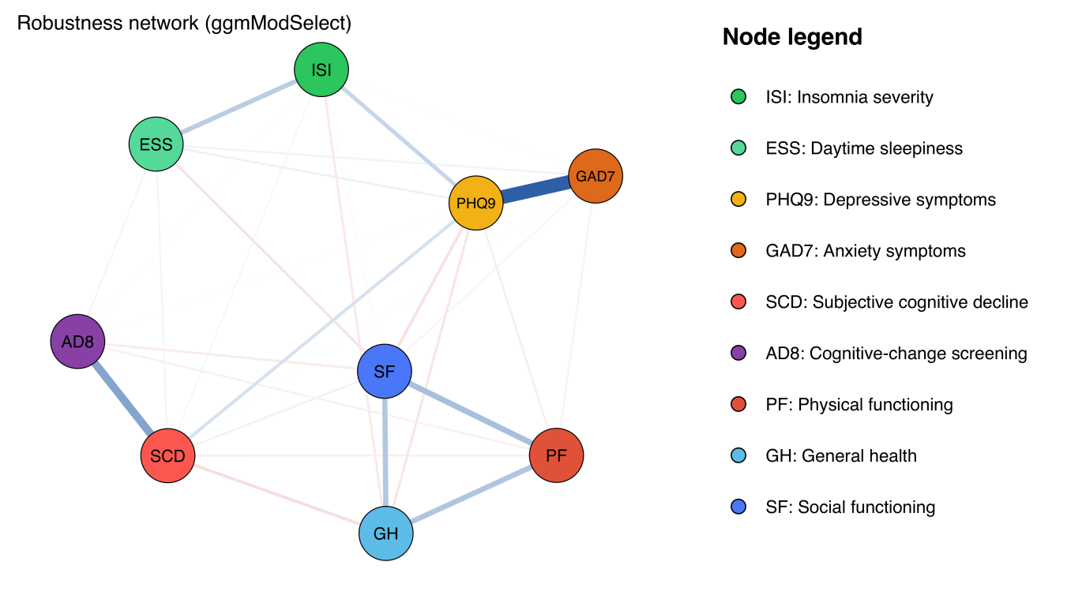
Figure S6. Overall health-indicator network estimated using ggmModSelect (alternative to EBICglasso).
Note. Cognitive-change screening (AD8) is a change-based screening measure rather than an objective performance test. Other node and edge conventions match the main manuscript.

S3. Sensitivity Analysis Excluding Social Functioning (SF)
Rationale and methods. The two-item SF subscale had low internal consistency (Cronbach's α=.38). We therefore removed SF and re-estimated the overall, urban, and rural eight-node networks. The analytic sample was held constant at N=32,523 (urban n=20,331; rural n=12,192). Each remaining node was residualised on sex, age, education, personal-income category, and pre-retirement occupational-rank category. EBICglasso (γ=.50), NCT (1,000 permutations), BH and Bonferroni correction, and 1,000-sample bootstrap analyses matched the primary analysis. Edge-weight concordance quantified agreement with the corresponding eight-node submatrices of the primary networks.
Summary. PHQ-9 remained the highest-strength node overall and in both residence groups. The urban–rural network-structure difference persisted (p=.001), but the global-strength difference was not significant (p=.232). Five edge differences survived BH correction. AD8 and ESS retained BH-significant strength differences; the GAD-7 difference did not (pBH=.101). Edge-weight concordance with the primary networks was high (Pearson r=.992–.995), and the strength CS coefficient was .75.
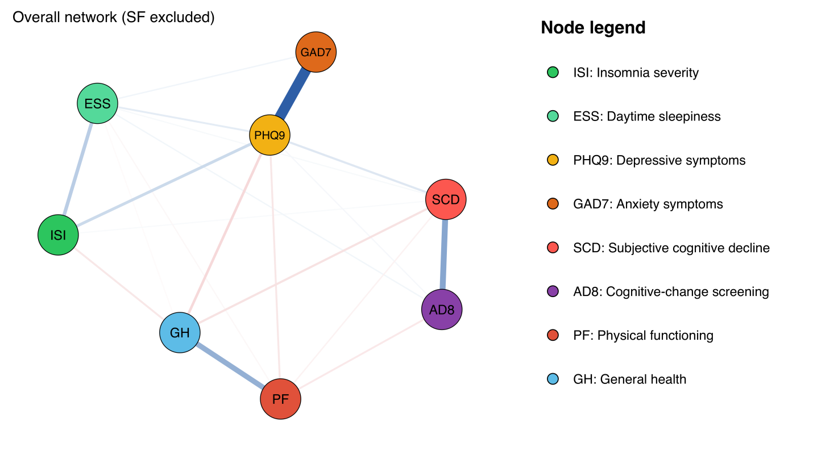
Figure S7A. Covariate-adjusted overall network after exclusion of SF.
Note. The analytic sample was unchanged. Blue and red edges indicate positive and negative regularised partial correlations, respectively. Node colours and abbreviations are defined in the figure legend.
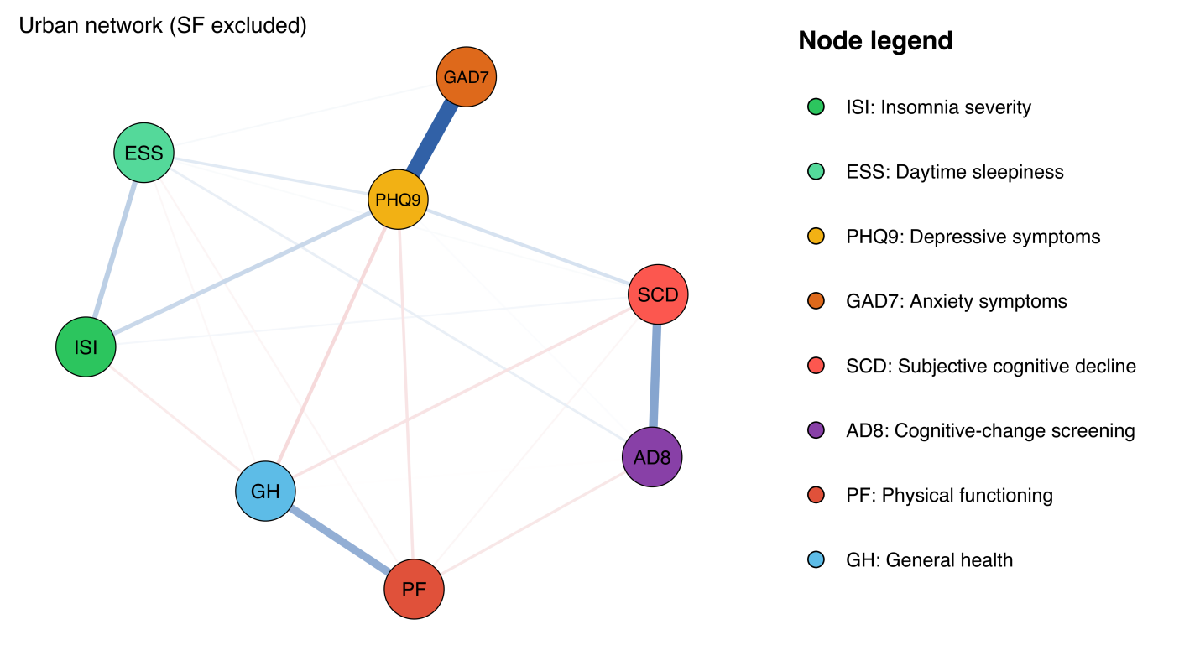
Figure S7B. Covariate-adjusted urban network after exclusion of SF.
Note. The layout and edge scaling match Figures S7A and S7C. Node colours and abbreviations are defined in the figure legend.
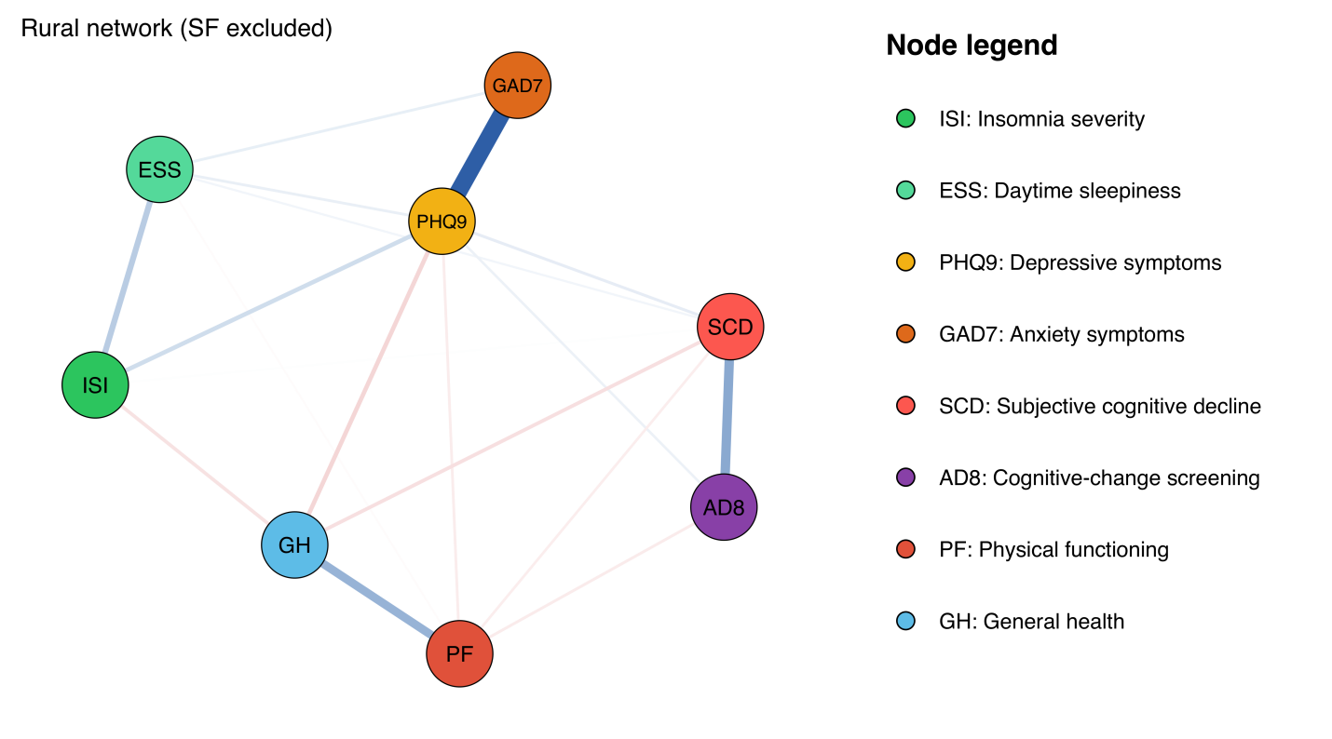
Figure S7C. Covariate-adjusted rural network after exclusion of SF.
Note. The layout and edge scaling match Figures S7A and S7B. Node colours and abbreviations are defined in the figure legend.
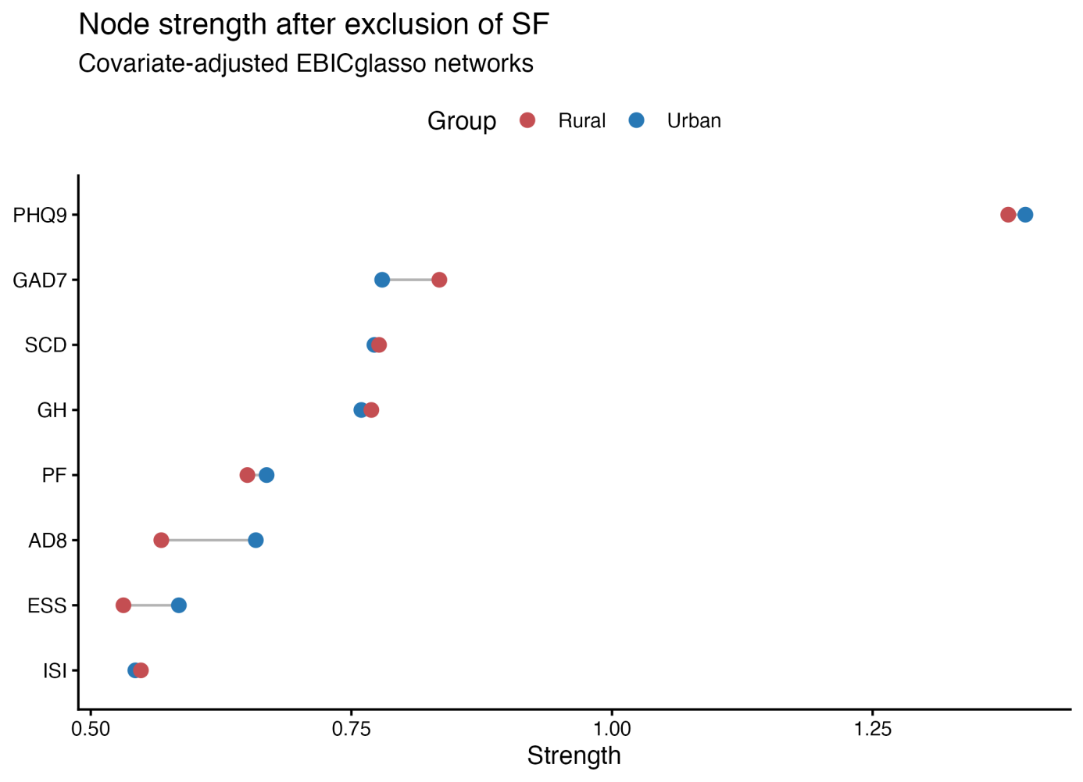
Figure S8. Urban and rural node strength after exclusion of SF.
Note. Strength is the sum of absolute incident edge weights.
Table S2. Global NCT results after exclusion of SF
Test | Statistic | p | Urban strength | Rural strength
Network structure invariance | 0.069 | 0.001
Global strength invariance | 0.052 | 0.232 | 3.081 | 3.029
Table S3. Node strength in urban and rural no-SF networks
Node | Urban | Rural | Δ U−R | Urban rank | Rural rank
ISI | 0.543 | 0.548 | -0.005 | 8 | 7
ESS | 0.585 | 0.531 | 0.053 | 7 | 8
PHQ9 | 1.397 | 1.380 | 0.016 | 1 | 1
GAD7 | 0.780 | 0.834 | -0.055 | 2 | 2
SCD | 0.772 | 0.777 | -0.004 | 3 | 3
AD8 | 0.658 | 0.568 | 0.091 | 6 | 6
PF | 0.669 | 0.650 | 0.018 | 5 | 5
GH | 0.760 | 0.769 | -0.010 | 4 | 4
Table S4. Node-level NCT results after exclusion of SF
Node | Δ U−R | Raw p | pBH | pBon
AD8 | 0.091 | 0.001 | 0.008 | 0.008
ESS | 0.053 | 0.005 | 0.020 | 0.040
GAD7 | -0.055 | 0.038 | 0.101 | 0.304
PHQ9 | 0.016 | 0.415 | 0.758 | 1.000
GH | -0.010 | 0.558 | 0.758 | 1.000
PF | 0.018 | 0.568 | 0.758 | 1.000
SCD | -0.004 | 0.808 | 0.826 | 1.000
ISI | -0.005 | 0.826 | 0.826 | 1.000
Table S5. Edge differences surviving BH correction after exclusion of SF
Edge |  | Urban | Rural | Δ U−R | Raw p | pBH | pBon
PHQ9–SCD |  | 0.136 | 0.093 | 0.042 | 0.001 | 0.009 | 0.028
ESS–AD8 |  | 0.085 | 0.015 | 0.069 | 0.001 | 0.009 | 0.028
PHQ9–AD8 |  | 0.029 | 0.075 | -0.046 | 0.001 | 0.009 | 0.028
ESS–GAD7 |  | 0.044 | 0.088 | -0.044 | 0.002 | 0.014 | 0.056
ISI–GH |  | -0.088 | -0.120 | 0.032 | 0.007 | 0.039 | 0.196
Table S6. Concordance between primary and no-SF networks
Network | Edge Pearson r | Edge Spearman ρ | Strength Pearson r | Strength Spearman ρ
Overall | 0.993 | 0.986 | 0.991 | 1.000
Urban | 0.992 | 0.992 | 0.990 | 0.976
Rural | 0.995 | 0.987 | 0.991 | 0.952
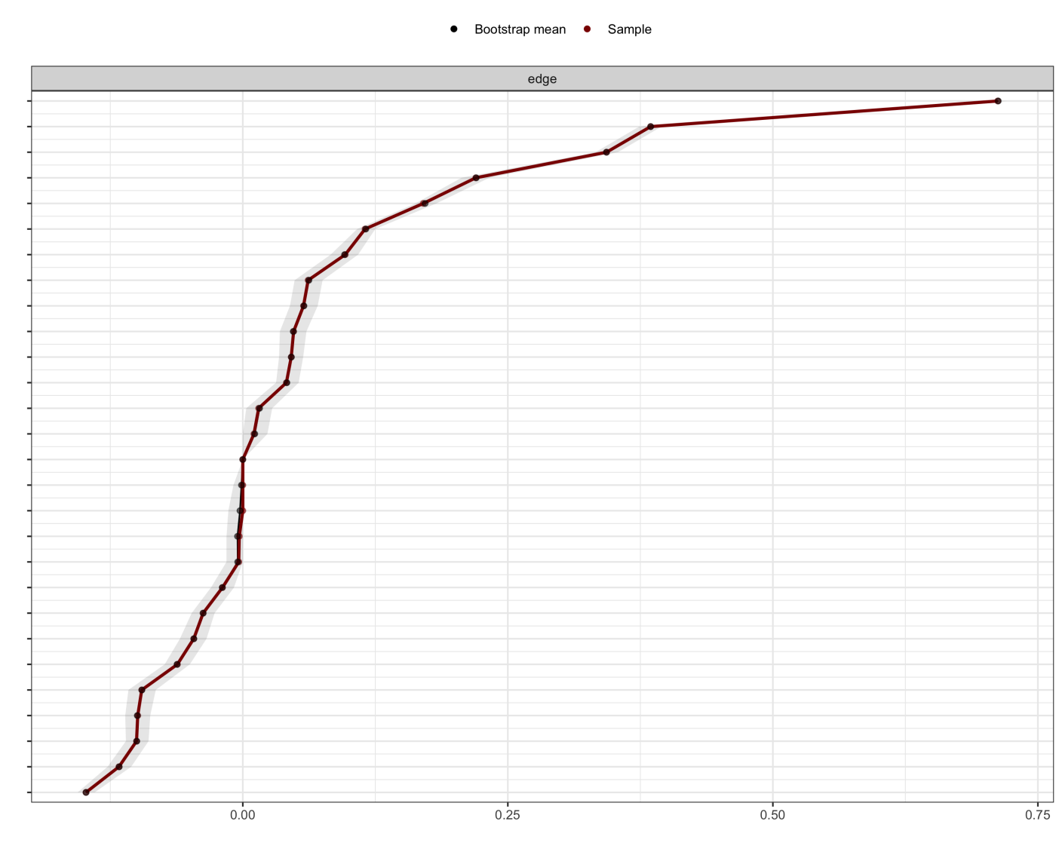
Figure S9. Nonparametric bootstrap intervals for no-SF overall-network edge weights (1,000 samples).
Note. Wider intervals indicate greater edge-weight uncertainty.
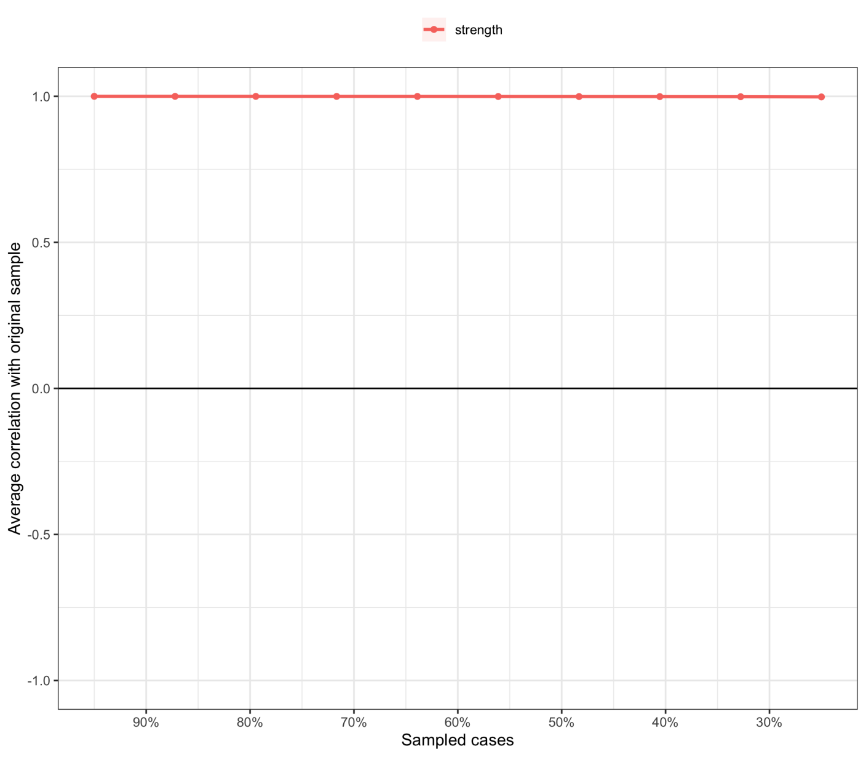
Figure S10. Case-dropping bootstrap stability of no-SF node strength (1,000 samples).
Note. The correlation-stability coefficient for strength was .75, the highest tested level.

S4. Primary Bridge-Strength Analysis
Methods. Bridge strength was calculated in the primary urban and rural nine-node networks as the sum of the absolute edge weights linking each node to nodes in other prespecified domains: sleep (ISI, ESS), mood (PHQ-9, GAD-7), cognition (SCD, AD8), and functioning/health (PF, GH, SF). Urban–rural differences were evaluated with 1,000 label permutations that preserved group sizes and re-estimated both EBICglasso networks. Two-sided permutation p-values used the plus-one correction, and BH correction was applied across the nine node tests.
Results. PHQ-9 had the highest bridge strength in both urban and rural networks. After BH correction, bridge strength was higher in the urban network for Cognitive-change screening (AD8; Δ=0.082, pBH=.0045) and daytime sleepiness (ESS; Δ=0.067, pBH=.0045). No other bridge-strength difference survived correction (Table S7 and Figure S11). These exploratory bridge estimates describe cross-domain connectivity and do not identify causal pathways.
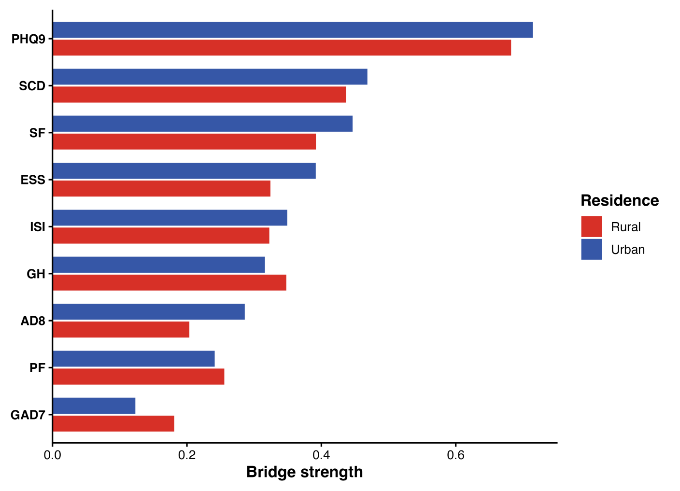
Figure S11. Bridge strength in the primary urban and rural networks.
Note. AD8=Cognitive-change screening; ESS=daytime sleepiness; GAD-7=anxiety symptoms; GH=general health; ISI=insomnia severity; PF=physical functioning; PHQ-9=depressive symptoms; SCD=subjective cognitive decline; SF=social functioning.
Table S7. Urban–rural bridge-strength differences in the primary networks
Node | Domain | Urban | Rural | Δ U−R | Raw p | pBH
PHQ9 | Mood | 0.715 | 0.682 | 0.032 | .124 | .186
SCD | Cognition | 0.469 | 0.437 | 0.032 | .248 | .319
SF | Function | 0.447 | 0.392 | 0.055 | .036 | .092
ESS | Sleep | 0.392 | 0.324 | 0.067 | <.001 | .004
ISI | Sleep | 0.349 | 0.323 | 0.027 | .366 | .411
GH | Function | 0.316 | 0.348 | -0.032 | .051 | .092
AD8 | Cognition | 0.286 | 0.204 | 0.082 | <.001 | .004
PF | Function | 0.241 | 0.256 | -0.014 | .626 | .626
GAD7 | Mood | 0.123 | 0.181 | -0.058 | .048 | .092
Note. Δ is urban minus rural. Raw p-values are based on 1,000 two-sided label permutations with the plus-one correction; pBH values control the false discovery rate across nine nodes.
Table S8. Variable-specific missingness in the 41,859 source records
Variable | Overall missing | Urban missing | Rural missing
Insomnia severity (ISI) | 17 (0.0%) | 10 (0.0%) | 7 (0.0%)
Daytime sleepiness (ESS) | 3,867 (9.2%) | 2,268 (8.9%) | 1,599 (9.8%)
Depressive symptoms (PHQ-9) | 0 (0.0%) | 0 (0.0%) | 0 (0.0%)
Anxiety symptoms (GAD-7) | 0 (0.0%) | 0 (0.0%) | 0 (0.0%)
Subjective cognitive decline (SCD) | 0 (0.0%) | 0 (0.0%) | 0 (0.0%)
Cognitive-change screening (AD8) | 0 (0.0%) | 0 (0.0%) | 0 (0.0%)
Physical functioning (PF) | 0 (0.0%) | 0 (0.0%) | 0 (0.0%)
General health (GH) | 0 (0.0%) | 0 (0.0%) | 0 (0.0%)
Social functioning (SF) | 0 (0.0%) | 0 (0.0%) | 0 (0.0%)
Female sex, n (%) | 0 (0.0%) | 0 (0.0%) | 0 (0.0%)
Age, years | 3 (0.0%) | 1 (0.0%) | 2 (0.0%)
Education category (1-10) | 0 (0.0%) | 0 (0.0%) | 0 (0.0%)
Personal-income category (1-8) | 5,735 (13.7%) | 3,023 (11.8%) | 2,712 (16.6%)
Pre-retirement occupational rank (1-5) | 0 (0.0%) | 0 (0.0%) | 0 (0.0%)
Note. Urban and rural denominators are 25,553 and 16,306 source records, respectively. The complete-case network sample has no missing values on these variables by definition.

Reproducibility
The accompanying R scripts read the de-identified analytic CSV, enforce the primary complete-case definition, produce the full baseline and missingness tables, apply BH correction to the primary node tests, reproduce the bridge-strength permutation analysis, hold the sample constant after SF exclusion, reproduce all no-SF tables and figures, save fitted objects or permutation results, and record session information. They do not install packages or alter the source CSV.

