Figure S1
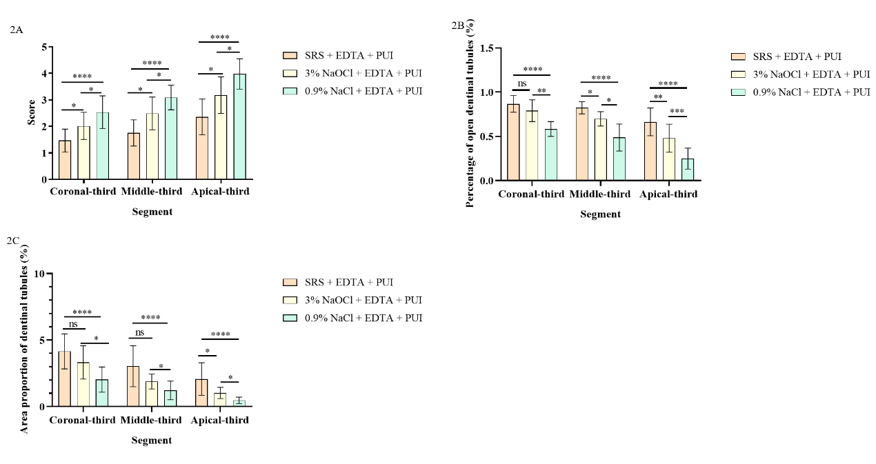
Fig. 2A. Statistical graph of Hülsmann scores for smear layer removal in the coronal, middle, and apical thirds of root canals after irrigation with the three test solutions combined with EDTA and PUI.
Fig. 2B. Statistical graph of dentinal tubule opening rates (%) in the coronal, middle, and apical thirds of root canals after irrigation with the three test solutions combined with EDTA and PUI.
Fig. 2C. Statistical graph of the percentage of exposed dentinal tubule area in the coronal, middle, and apical thirds of root canals after irrigation with the three test solutions combined with EDTA and PUI.
Notes: ns: P > 0.05; *: P < 0.05; **: P < 0.01; ***: P < 0.001; ****: P < 0.0001. The same notation applies to the subsequent figures.

Figure S2

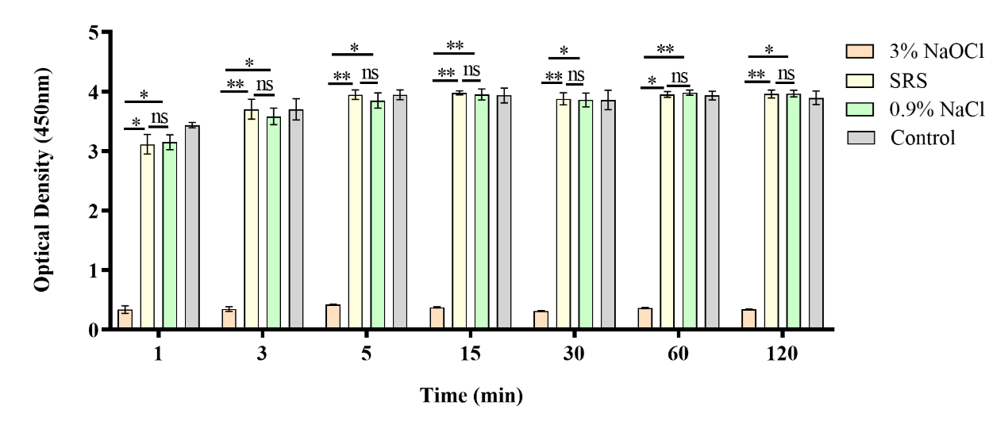
Figure .S2. OD values of L929 cells after exposure to 3% NaOCl, SRS, and 0.9% NaCl at different time points.
The figure shows that at 1, 3, 5, 15, 30, 60, and 120 minutes, the OD values of the 3% NaOCl group were significantly lower than those of the SRS and 0.9% NaCl groups, with statistically significant differences (P < 0.05). In contrast, the OD values of the SRS and 0.9% NaCl groups were comparable, with no statistically significant difference observed between them (P > 0.05).

Figure S3
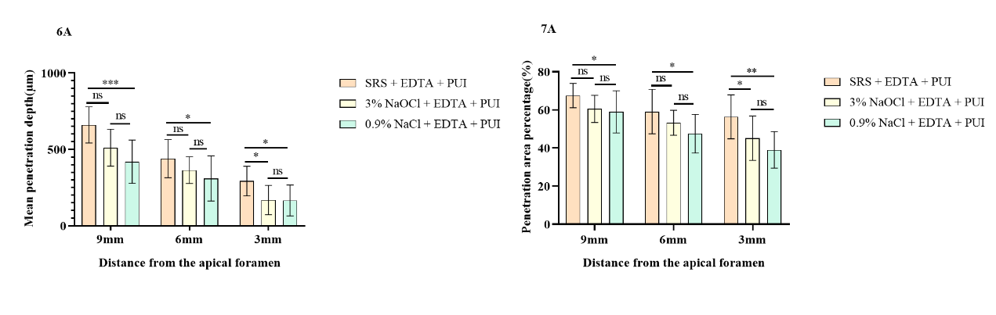
Fig. 6A. Mean penetration depth into dentinal tubules after irrigation with 3% NaOCl, SRS, and 0.9% NaCl combined with EDTA and PUI at different distances from the apex (3 mm, 6 mm, and 9 mm). Data are presented as mean ± standard deviation.
Fig. 7A. Penetration range into dentinal tubules after irrigation with 3% NaOCl, SRS, and 0.9% NaCl combined with EDTA and PUI at different distances from the apex (3 mm, 6 mm, and 9 mm). Data are presented as mean ± standard deviation.

