Supplementary Information
for
Enhancing Property Prediction of OLED Materials under Data Scarcity via Cognitive Eye-Tracking-Informed Attention Mechanism Models

This file includes:
Supplementary Results
Figs. S1 to S8
Tables S1 to S5

Contents

S1. Examples Gaze Trajectories for One Subject Responding to Diverse Molecular Stimuli
S2. Gaze Patterns for Two Representative Molecules During Viewing Sessions
S3. Distribution of Fixations and DSZs in Staged Attentions across All Experimental Trials
S4. Temporal Evolution of Fixation Duration
S5. Gaze Transition Velocity in Expert Staged Attention Mechanisms
S6. Prediction Results of Atomic Contributions to Molecular Orbitals for Typical D-A Molecules in the Test Set
S7. Misassignment of Electronic Distributions in Sulfoxides
S8. Impact of Cutoff Radius on Training Performance
S9. Impact of Batch Size on Training Performance
S10. Impact of the Forget Gate on Model Performance
S11. Saliency Maps for Identification of Critical Internal FMO Interactions

Supplementary Results
S1. Example Gaze Trajectories for One Subject Responding to Diverse Molecular Stimuli
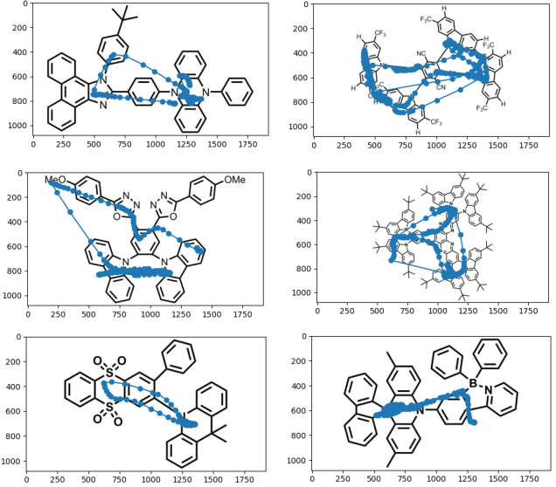
Figure S1 : Gaze trajectories of the subject shown in Fig. 1 during HOMO distribution inference for other representative donor-acceptor (D-A) structural molecules. The presented gaze trajectories illustrate the subject’s staged attention mechanisms regarding the electronic structure of D-A structured TADF material molecules. They depict the subject’s visual information acquisition concerning the donor and acceptor moieties, the bridging groups connecting them, key modifying substituents, and the subsequent information synthesis within the HOMO distribution regions.

S2. Gaze Patterns for Two Representative Molecules During Viewing Sessions
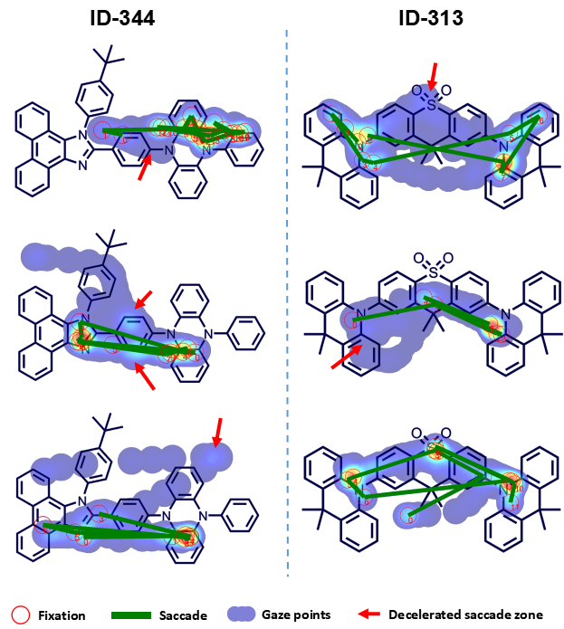
Fig. S2 : Gaze Patterns Revealing Cognitive Processing of HOMO Electronic Structures in OLED Molecules ID-344 and ID-313. Fixations, saccades, and Decision-Specific Zones (DSZs) were consistently observed across experts during cognitive processing of the HOMO electronic structure distribution in OLED molecules. While gaze trajectories exhibited individual variations reflecting distinct observation habits, all experts employed similar cognitive strategies manifested by: (1) clustering of gaze points with prolonged fixations on donor and acceptor moieties, (2) DSZ formation at bridge structures connecting donor/acceptor moieties, and (3) DSZ engagement with peripheral modifying groups. These patterns demonstrate an efficient deployment of accumulated prior knowledge during electronic structure interpretation.

S3. Distribution of Fixations and DSZs in Staged Attentions across All Experimental Trials
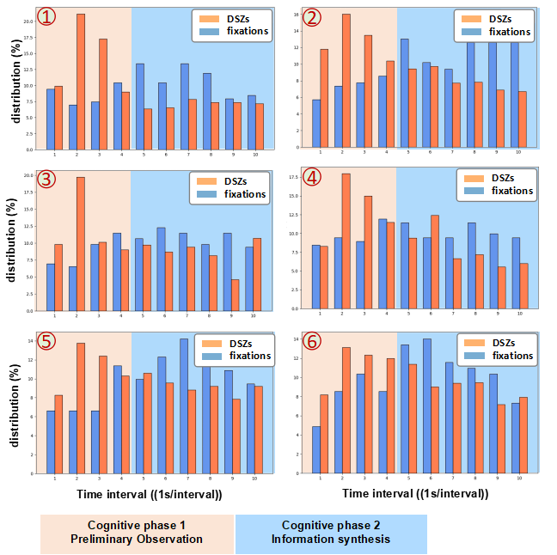
Fig. S3 : Temporal distribution of DSZs versus fixations across six experts analyzing OLED electronic structures. Stacked bars (1 second bins) indicate dominant visual behavior per interval (DSZ: orange; Fixation: blue). Phase 1 exhibited DSZ predominance, with DSZ occurrence frequency surpassing fixations in >79% of 1 second bins (orange bars > blue bars), often by twofold margins. This reflects experts’ strategy of leveraging DSZs for rapid overview acquisition. In Phase 2, fixation frequency surpassed that of DSZs in >89% of 1 second bins (blue > orange), showing a clear dominance and suggesting continued global information integration for electronic structure synthesis.

S4. Temporal Evolution of Fixation Duration
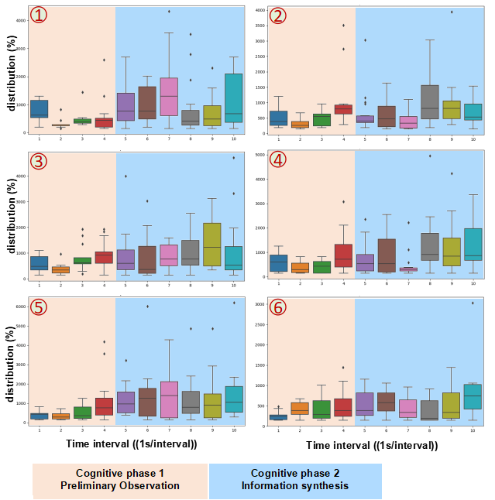
Fig. S4 : Evolution of single-fixation durations during analysis of OLED molecules by 6 experts. Box plots represent duration distributions per 1 second bin across six participants. Under the eye-mind assumption, prolonged fixations signify deeper information processing. This demonstrates how materials science experts spontaneous refine their understanding during the later stages of cognitive.

S5. Gaze Transition Velocity in Expert Staged Attention Mechanisms
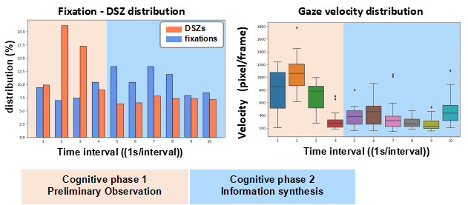
Fig. S5 : Distribution of gaze shift velocity during cognitive processing. Background colors demarcate two cognitive phases (Phase 1: Exploration; Phase 2: Integration). Box plots show velocity distributions within sequential 1 second bins. Box plots reveal a progressive deceleration in mean gaze point shift velocity during cognitive processing, accompanied by increasing fixation frequency. Notably, Phase 1 gaze velocity (~750 pixel/frame) nearly twice as high as that in Phase 2(~400 pixel/frame).

S6. Prediction Results of Atomic Contributions to Molecular Orbitals for Typical D-A Molecules in the Test Set
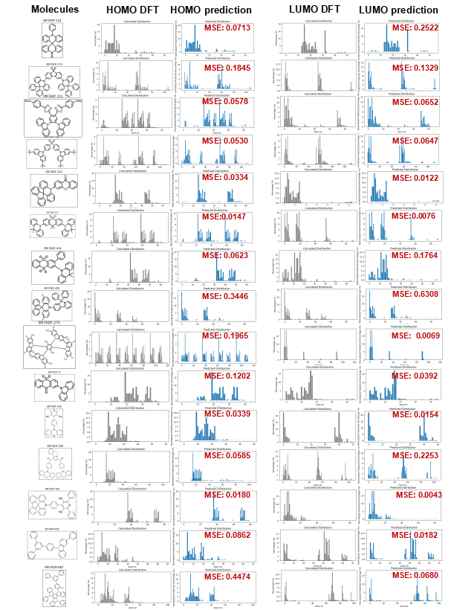
Fig. S6 : Comparison of predicted and DFT-calculated atomic contributions to the HOMO and LUMO of representative D-A molecules in the test set. From left to right: molecular structure, results of HOMO, results of LUMO.

S7. Misassignment of Electronic Distributions in Sulfoxides
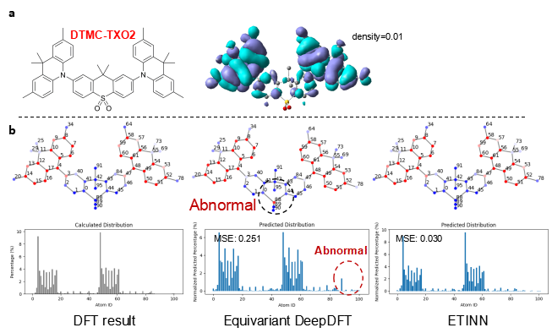
Fig. S7 : DFT-calculated HOMO distributions vs. DL models’ predictions of DTMC-TXO2. a, Molecular structure and spatial HOMO distribution. b, Atomic-site resolved HOMO contributions (DFT ground truth) and predictions from DL models, ETINN achieved a state-of-the-art result with an MSE of 0.030.

S8. Impact of Cutoff Radius on Training Performance
In general, increasing the cutoff radius can expand geometric encoding scope to incorporate more inter-group interactions. However, larger cutoffs substantially increase per-iteration sampling complexity and may induce overfitting in limited datasets.
Table S1: Model accuracy (MSE) at varying cutoff radius. During preliminary development, we observed that DeepDFT-based architectures with Transformer output layers exhibited pronounced sensitivity to cutoff selection. Test errors increased significantly at 4-8 Å cutoffs (ε_{d}(MSE) = 8.06).
Model | Sampling cutoff | Accumulation cutoff | ε_{d}(MSE)
Invariant DeepDFT + Transformers output | 8 | 8 | 2.87
Invariant DeepDFT + Transformers output | 4 | 8 | 2.04
Invariant DeepDFT + Transformers output | 4 | 4 | 2.61
Equivariant DeepDFT + Transformers output | 8 | 8 | 1.62
Equivariant DeepDFT + Transformers output | 4 | 8 | 8.06
Equivariant DeepDFT + Transformers output | 4 | 4 | 1.92

Table S2: Inference time at varying cutoff radius. Computational costs rising nonlinearly due to adjacency matrix expansion. Specifically, the O(N²) scaling of pairwise interactions within the cutoff radius disproportionately increases inference time.
Model | Sampling cutoff | Accumulation cutoff | Eval time (s)
Invariant DeepDFT + Transformers output | 8 | 8 | 1.27
Invariant DeepDFT + Transformers output | 4 | 8 | 0.88
Invariant DeepDFT + Transformers output | 4 | 4 | 0.87
Equivariant DeepDFT + Transformers output | 8 | 8 | 1.28
Equivariant DeepDFT + Transformers output | 4 | 8 | 1.14
Equivariant DeepDFT + Transformers output | 4 | 4 | 1.18

S9. Impact of Batch Size on Training Performance
Our initial experiments revealed that batch size critically influences electronic structure prediction in graph neural networks. Increasing batch size consistently elevated test MSE for both reference DeepDFT-Transformer architectures (Table S3) and our ETINN model (Table S4). The ε_{d}(MSE) exceeded 350% at batch sizes greater than 8.

Table S3: Model accuracy (MSE) at varying training batch size on DeepDFT-Transformer architectures.
Model | cutoff | Batch size | ε_{d}(MSE)
Invariant DeepDFT + Transformers output | 4-4 | 1 | 2.12
Invariant DeepDFT + Transformers output | 4-4 | 2 | 2.61
Equivariant DeepDFT + Transformers output | 4-4 | 1 | 1.92
Equivariant DeepDFT + Transformers output | 4-4 | 2 | 2.48

Table S4: Model accuracy (MSE) at varying training batch size on ETINN
Model | cutoff | Batch size | ε_{d}(MSE)
ETINN | 4-4 | 1 | 0.74
ETINN | 4-4 | 2 | 1.59
ETINN | 4-4 | 4 | 1.90
ETINN | 4-4 | 8 | 2.61

S10. Impact of the Forget Gate on Model Performance
Our analysis reveals that incorporating the forget gate enhances the model’s ability to generalize. Although the ETINN variant without the forget gate achieves higher accuracy on the test set, its capacity to suppress predictions violating chemical intuition diminishes when using PaiNN for molecular immediate encoding within the human cognitive mimetic module. In contrast, the model architecture incorporating the forget gate (as recommended in this work) demonstrates more consistent effectiveness in suppressing such chemically counter-intuitive predictions.

Table S5: Model accuracy (MSE) for ETINN with and without the forget gate.
Model | cutoff | Batch size | ε_{d}(MSE)
ETINN without forget gate | 4-4 | 1 | 0.58
ETINN (with forget gate) | 4-4 | 1 | 0.74

S11. Saliency Maps for Identification of Critical Internal FMO Interactions
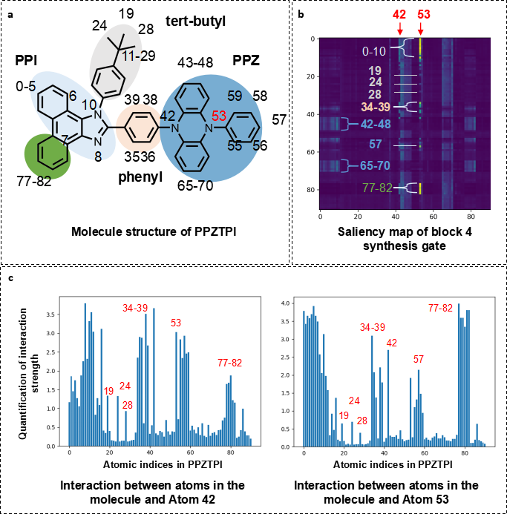
Fig. S8 : Quantitative interaction analysis via ETINN saliency mapping. a, PPZTPI molecular structure annotated with key moieties: PPI (acceptor), tert-butyl , PPZ (donor), phenyl bridge. b, Saliency map of information fusion gate outputs for HOMO prediction. c, Column-normalized interaction strengths showing donor-centered couplings (N53: primary center; N42: secondary center).
Fig. S8 quantifies interaction strengths between donor atoms (ID-42, ID-53) and molecular substructures via saliency mapping. Column-specific extraction of nitrogen-centered interactions Fig. S8c reveals differential coupling patterns:
- ID-42 shows stronger interactions with proximal bridge atoms (34-39) and tert-butyl groups (19/24/28) compared to ID-53; (2) In contrast, ID-53 shows enhanced electronic coupling to the donor moiety atoms (77–78, 1–10) than ID-42.
Bridge structures exert greater influence on donor electron distributions than tert-butyl groups, suggesting preferential bridge modification for donor engineering.

