Microbiome divergence across four major Indian riverine water ecosystems impacted by anthropogenic contamination: A comparative metagenomic analysis
Raj Kumar Regar^{1,3}, Mohan Kamthan^{1,5}, Vivek Kumar Gaur¹, Satyendra Pratap Singh², Seema Mishra^{2,6}, Sanjay Dwivedi², Aradhana Mishra², Natesan Manickam^{1,}* and Chandra Shekhar Nautiyal^{2,4,}*

¹Environmental Biotechnology Laboratory, CSIR-Indian Institute of Toxicology Research, Vishvigyan Bhavan, 31 Mahatma Gandhi Marg, Lucknow, Uttar Pradesh, 226001, India.
²CSIR-National Botanical Research Institute, Rana Pratap Marg, Lucknow, Uttar Pradesh 226 001, India.
³Department of Biochemistry, School of Dental Sciences, Babu Banarsi Das University, Lucknow, Uttar Pradesh, India.
⁴Swami Rama Himalayan University, Jolly Grant, Dehradun, 248016, India
⁵Present address: Department of Biochemistry, School of Chemical & Life Sciences, Jamia Hamdard, New Delhi 110062, India.
⁶Present address: Deen Dayal Upadhyaya Gorakhpur University, Gorakhpur-273009, India

*Corresponding Authors
Chandra Shekhar Nautiyal, Swami Rama Himalayan University, Jolly Grant, Dehradun-248016, India. E-mail: csnautiyal@srhu.edu.in, nautiyalnbri@lycos.com, Telephone: +91-9415511111

Natesan Manickam, Environmental Biotechnology Division, CSIR-Indian Institute of Toxicology Research, Vishvigyan Bhavan, 31 Mahatma Gandhi Marg, Lucknow-226001, India. E-mail: nmanickam@iitr.res.in, Telephone: +91-9450110787
Fig. S1. Rarefaction curve using filtered dataset.

Fig. S2. Dendrogram hierarchical clustering at species level (distance measure using bray and clustering algorithm).

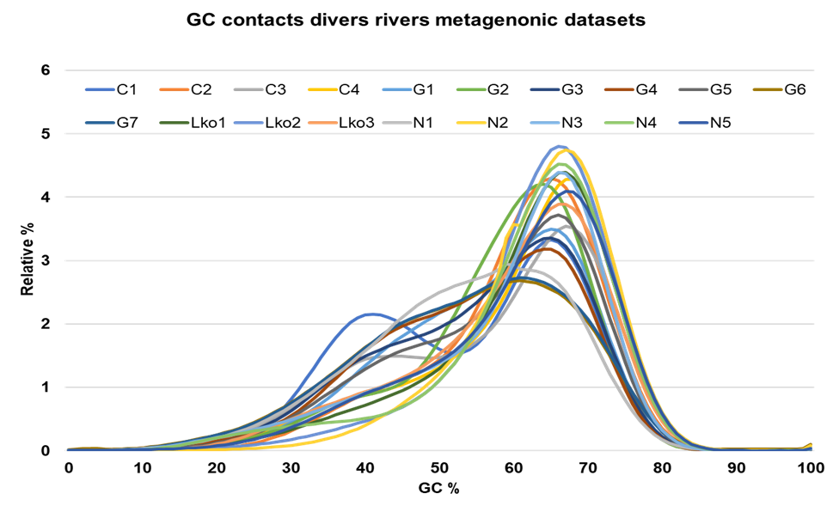
Fig. S3. GC content comparative profiling of all river metagenomic datasets.

Fig.S4. Heatmap depicting the Core bacterial Order in the selected stretches of studied rivers that remain unchanged in their composition across the samples. Where Y-axis represent the prevalence (20 %) and X-axis represent the detection threshold [Relative abundance % (0.01)].

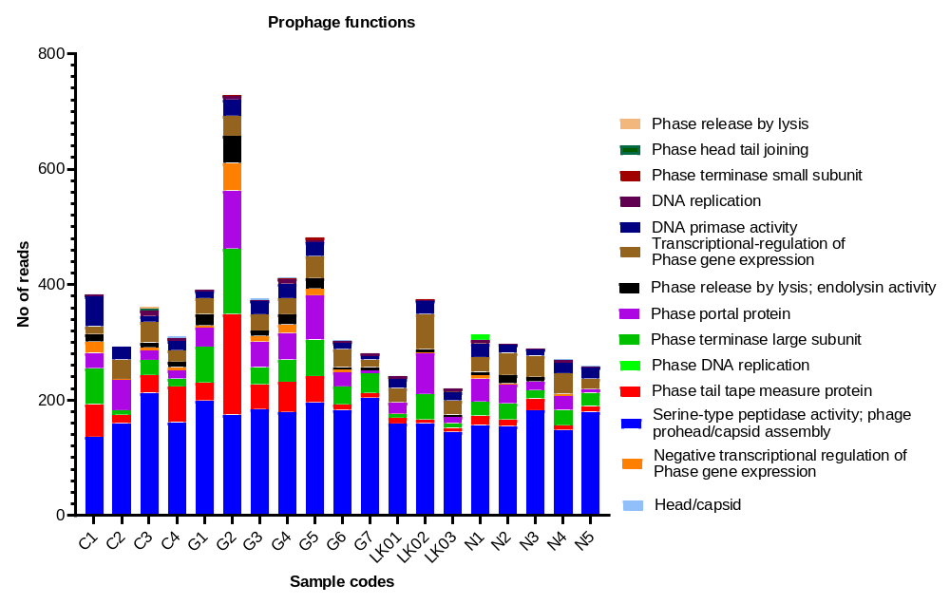
Fig. S5. Abundance of prophage specific function genes in various river water samples on the basic of available data.

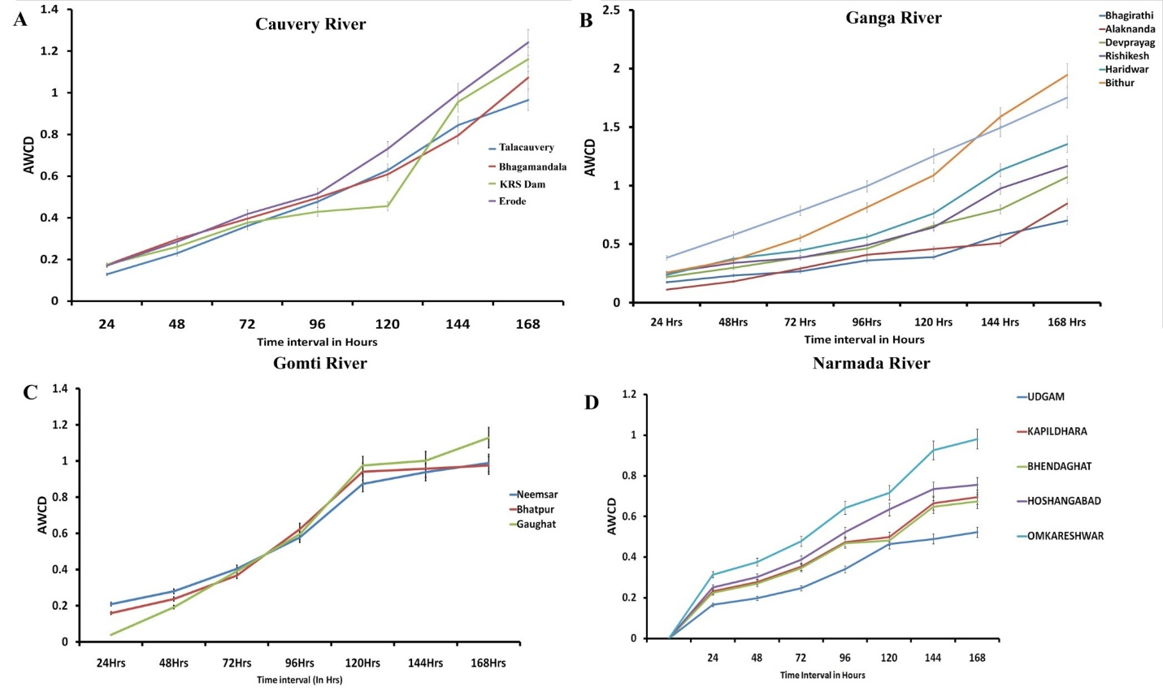

Fig. S6. Average well colour development of (A) Cauvery, (B) Ganga, (C) Gomti and (D) Narmada river water samples collected from different sites.

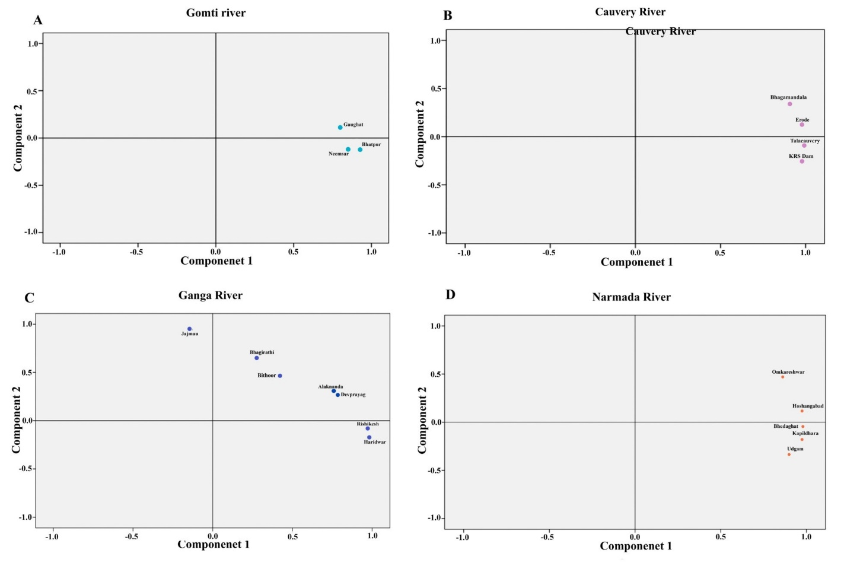
Fig. S7. (A-D): Principal component analysis (PCA) of (A) Gomti, (B) Cauvery, (C) Ganga and (D) Narmada river samples on the basis of carbon source utilization pattern.

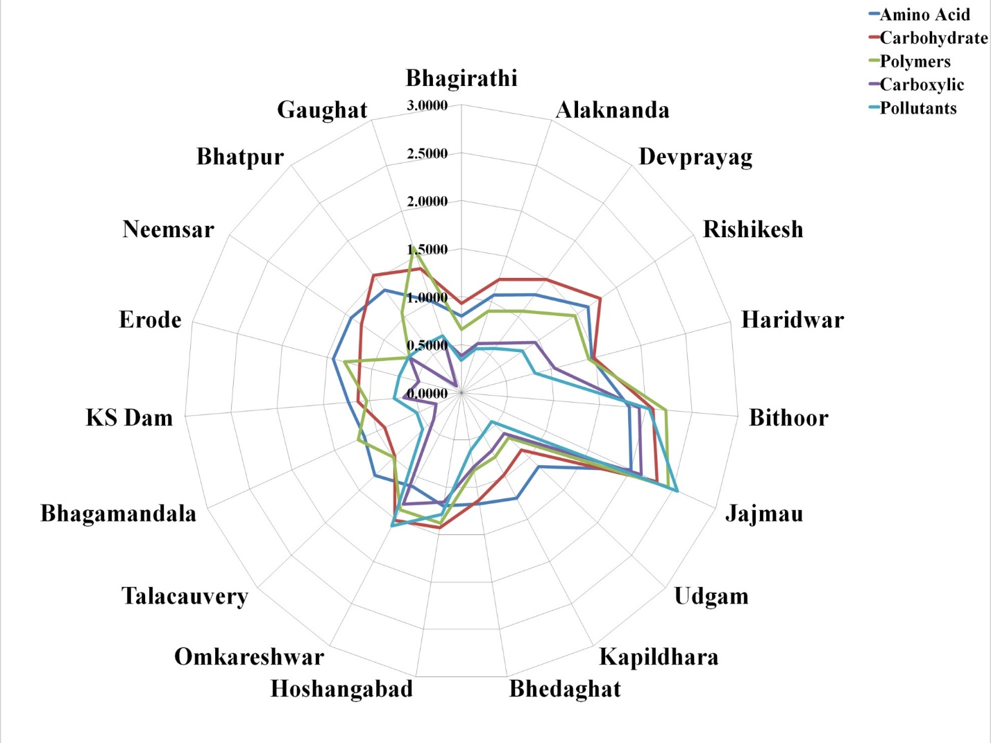

Fig. S8. Site specific carbon utilization pattern of all river samples in MT plate.

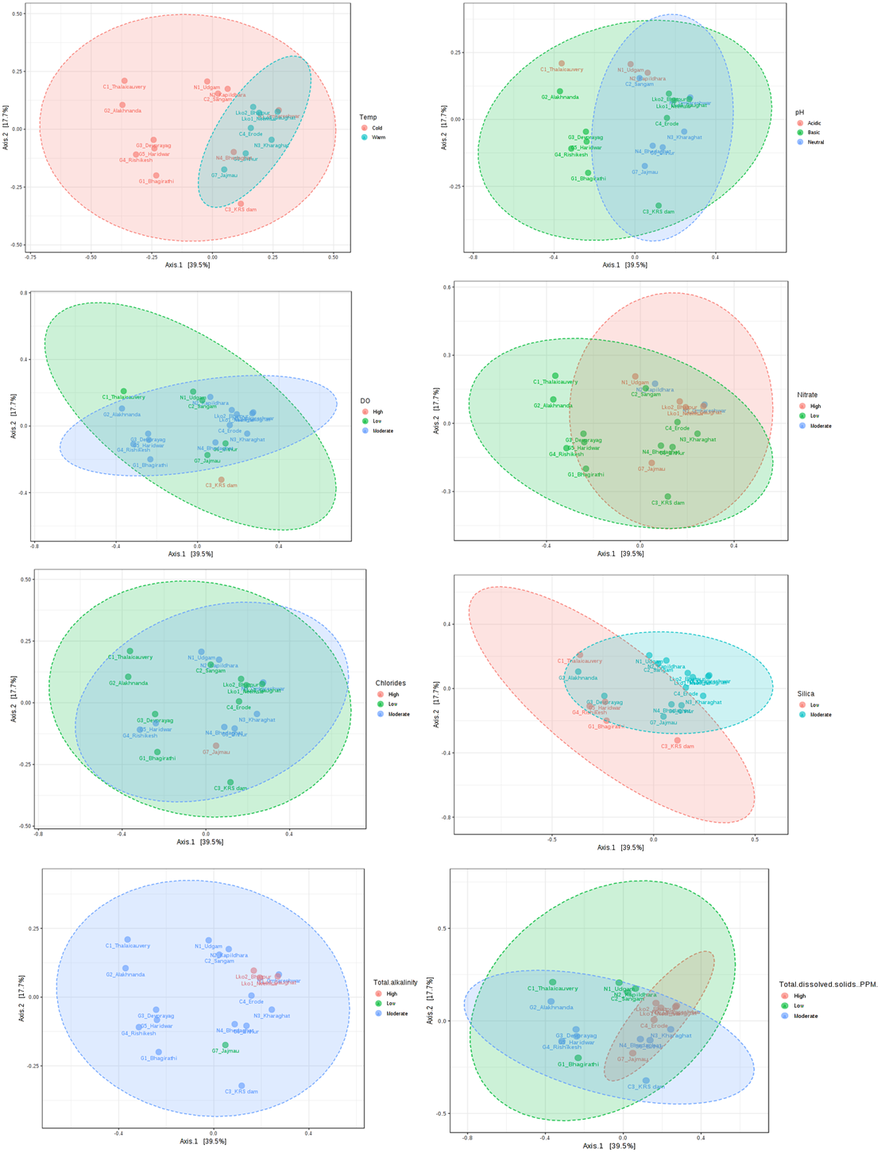
Fig. S9. ‘2-D PCoA’ plot using bray distance. The explained variances are shown in brackets in reference to physicochemical parameters of water samples

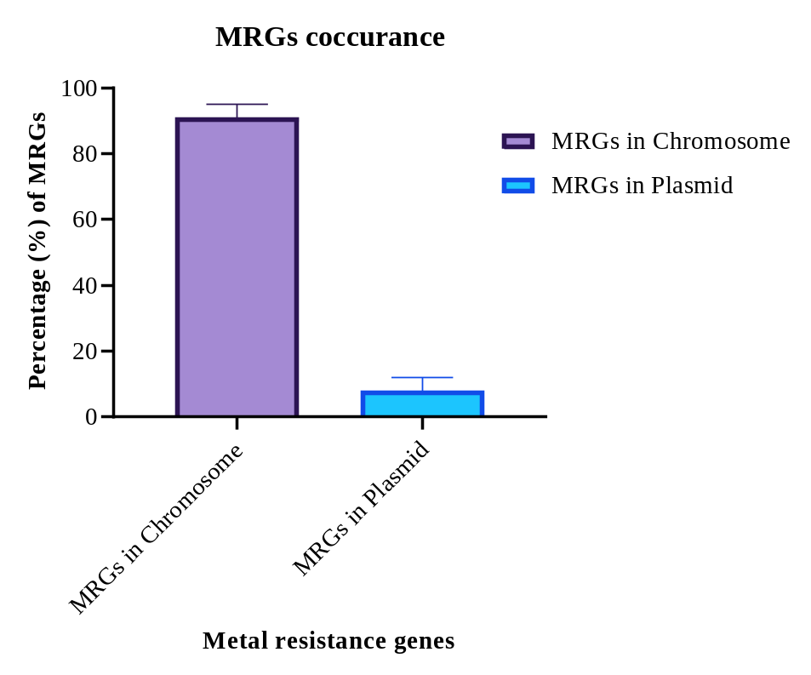
Fig. S10. Percentage abundance of Metal resistance genes (MRGs) situated on chromosomes and plasmid

