Appendix
Appendix 1 Section of initial coding (focus group 1)
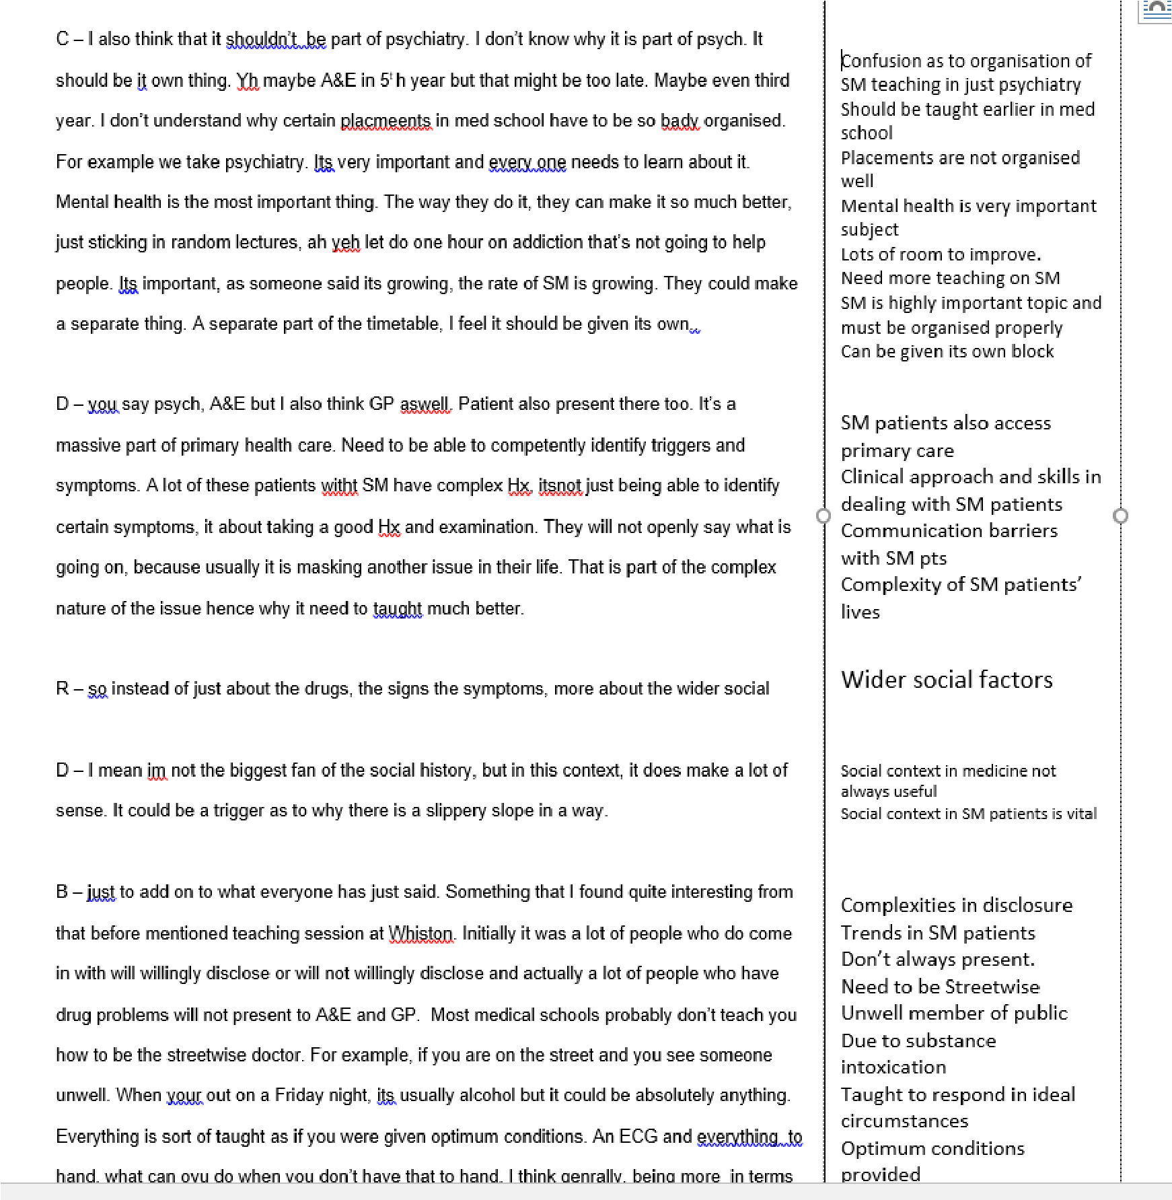

Appendix 2 – Section of initial coding transformed into focussed coding (focus group 1)
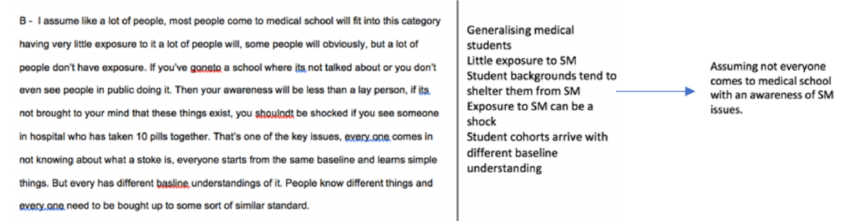
Appendix 3 Real life substance misuse knowledge memo

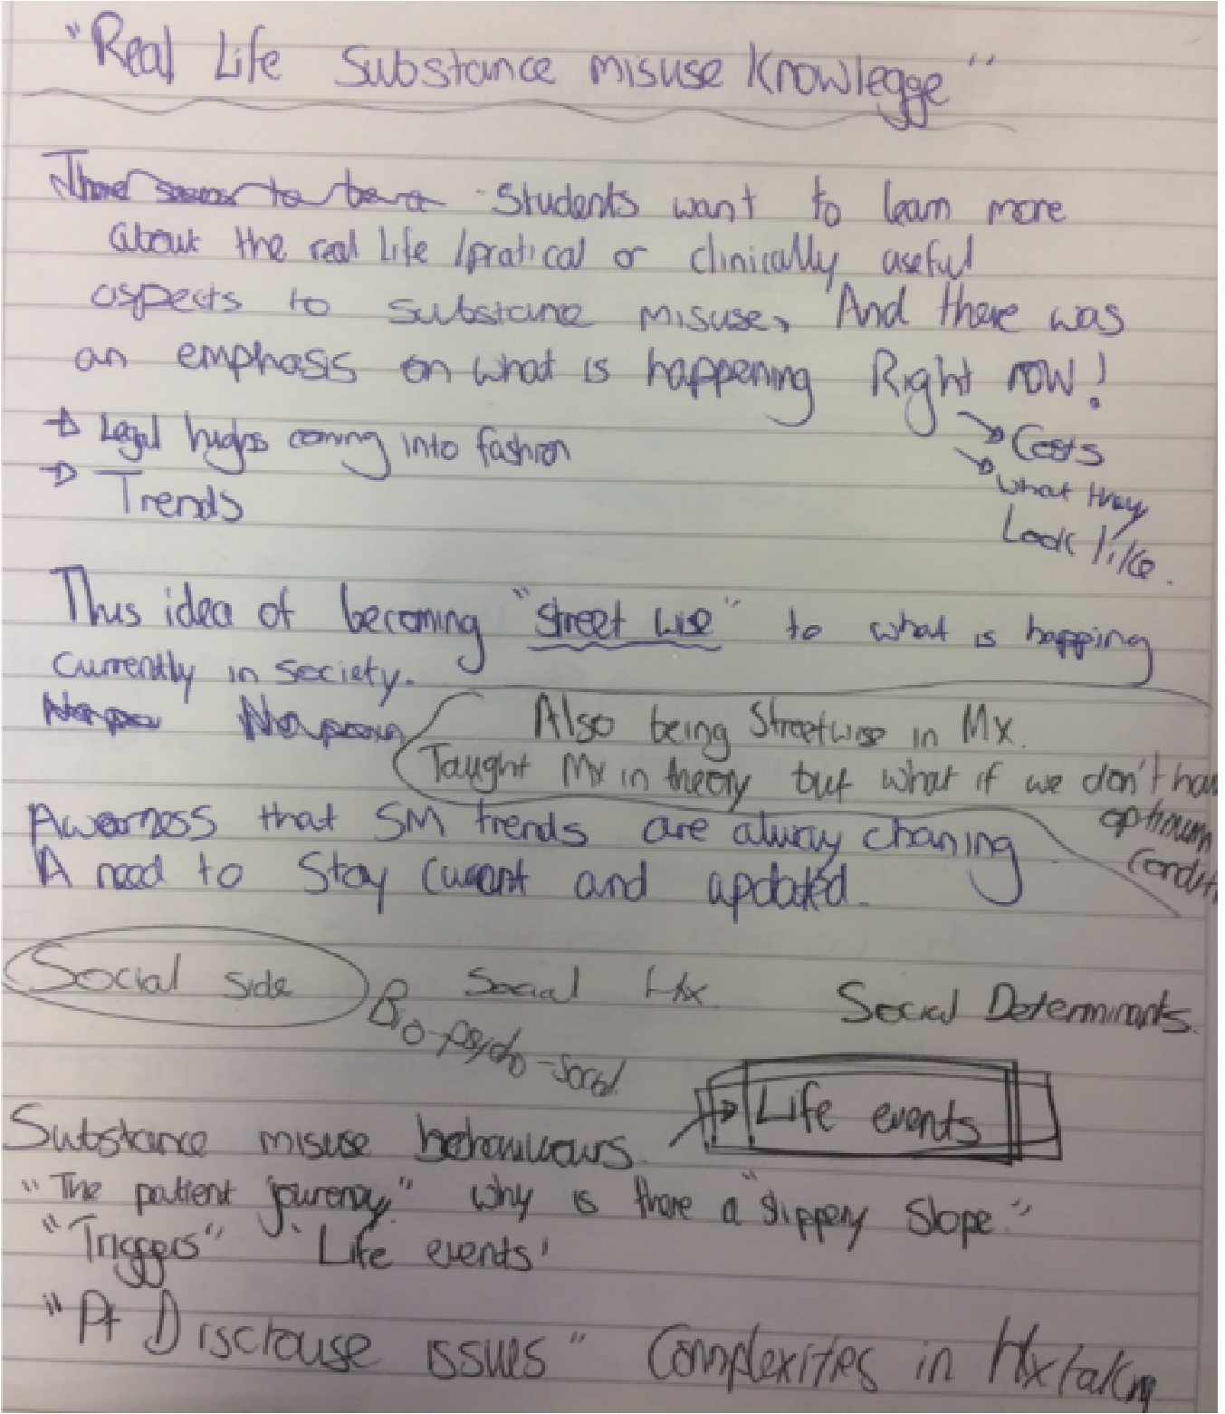

Appendix 4 – Pre-conceived idea / thoughts memo

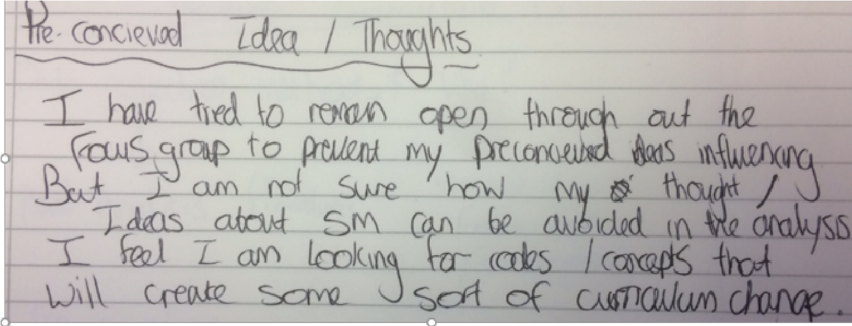

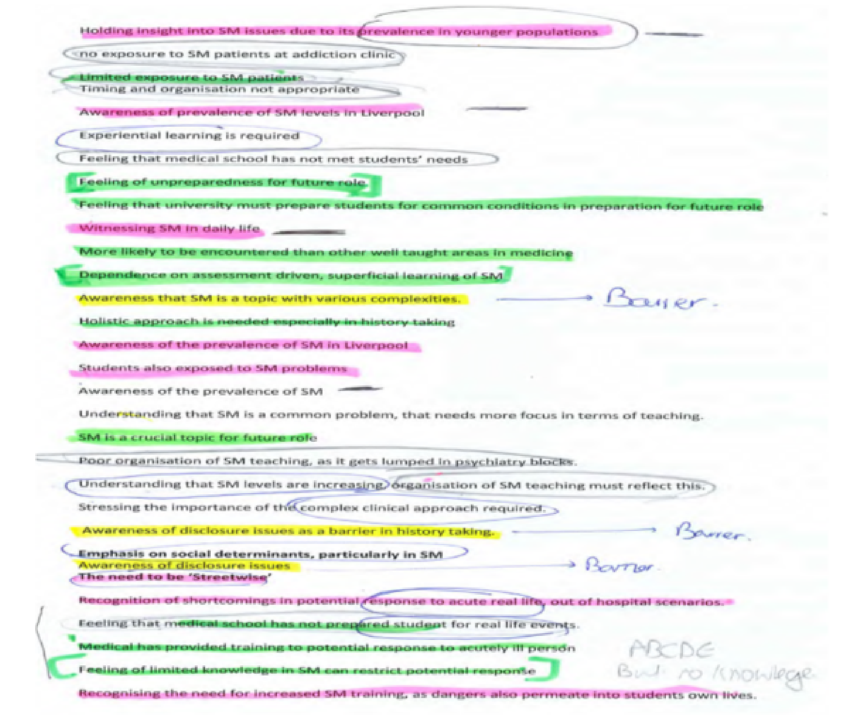
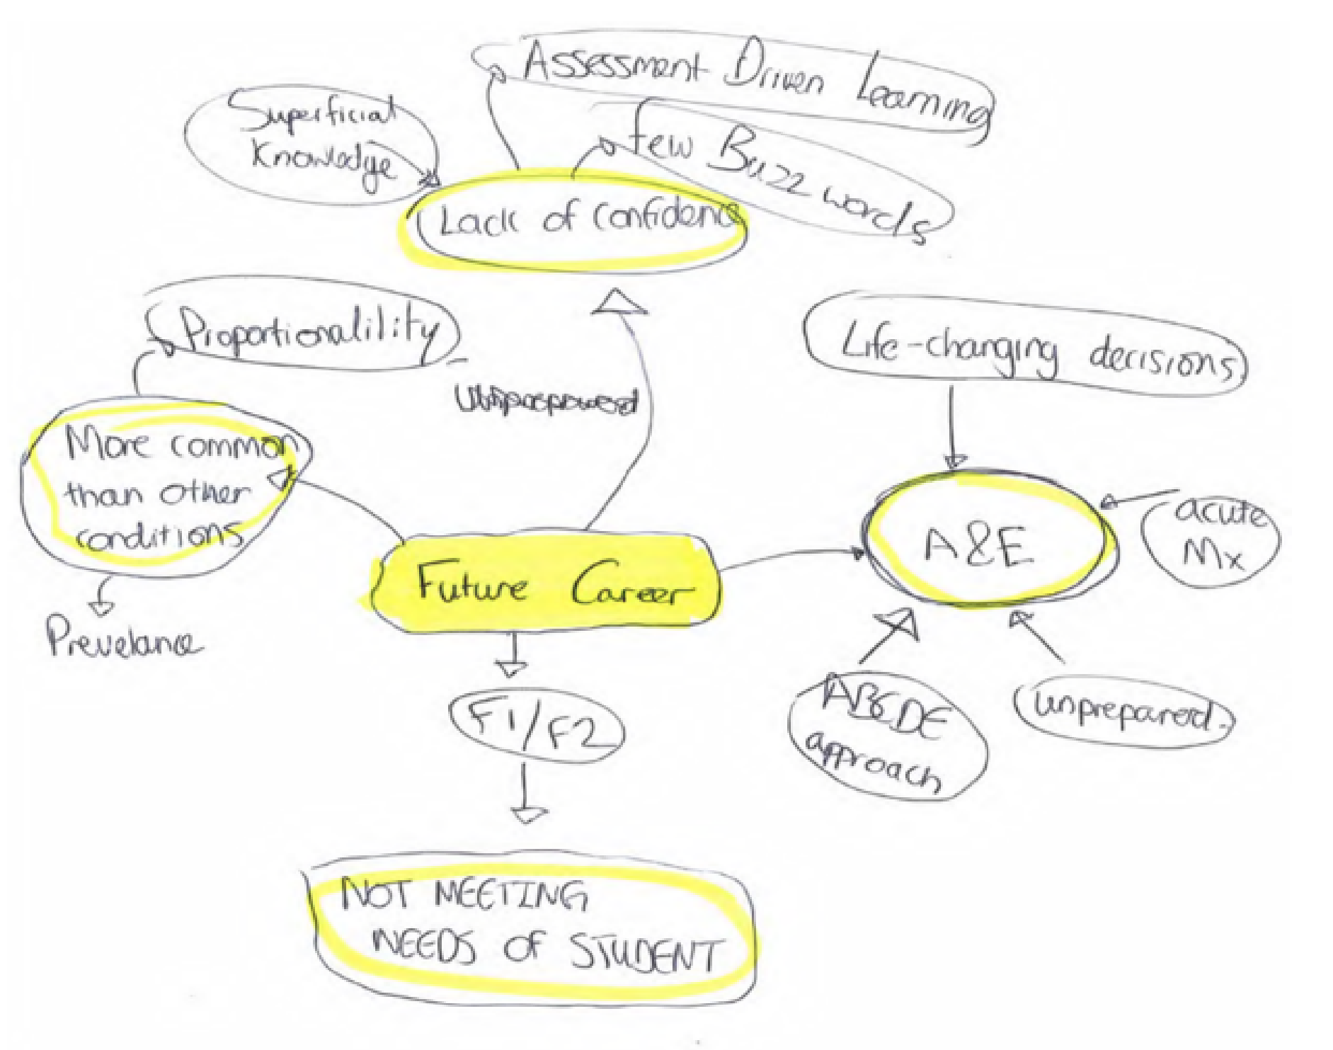
Appendix 5 – Formation of future Careers cluster

