TANSR-Vax Construct & Module Validation Report
Composite Publication-Style PCR and Blotting Validation Analysis
Executive Summary
This full-length, uncropped composite figure provides rigorous molecular confirmation of the TANSR-Vax construct and its three engineered modules across both nucleic acid and protein expression levels. Polymerase Chain Reaction (PCR) validates specific individual gene inserts and the full-length ~5.2 kb saRNA replicon, while Western and RNA blotting confirm robust module-specific protein expression and intact transcript integrity.
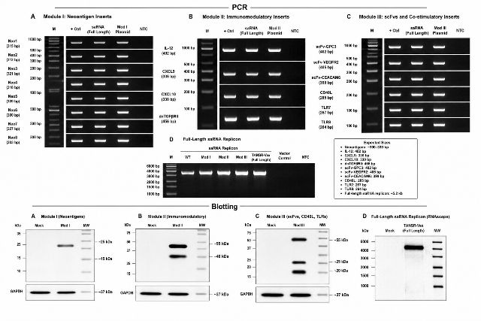Supplementary figure S1:
Upper Section — PCR Validation
Panel A. Module I: Neoantigen Inserts: Shows a molecular-weight ladder (M) followed by positive control, full-length saRNA, Module I plasmid, and no-template control (NTC) lanes.
• Eight neoantigen amplicons (Neo1–Neo8) are represented with expected product sizes of approximately 300–330 bp.
• Bands are clearly visible at the expected positions in the positive control, full-length saRNA, and Module I plasmid lanes, while the NTC remains completely negative.
Panel B. Module II: Immunomodulatory Inserts: Contains PCR products corresponding to IL-12, CXCL9, CXCL10, and dominant-negative TGF-β receptor II (dnTGFβRII).
• Expected sizes range from approximately 330 to 456 bp, with the largest product being dnTGFβRII.
• Positive control, full-length saRNA, and Module II plasmid consistently show the expected size-specific bands.
Panel C. Module III: scFvs and Co-stimulatory Inserts: Displays PCR validation of targeting scFv components (scFv-GPC3, scFv-VEGFR2, scFv-CEACAM6) and co-stimulatory ligands/receptors (CD40L, TLR7, and TLR8).
• Expected amplicons range from approximately 264 to 405 bp.
• The anticipated target bands appear distinctly in positive-control, full-length saRNA, and Module III plasmid lanes.
Panel D. Full-Length saRNA Replicon & Size Legend: Shows amplification of the full-length ~5.2 kb saRNA replicon construct.
• Lanes include molecular marker, wild type, Modules I–III, full-length TANSR-Vax, vector control, and NTC.
• Full-length constructs display a strong high-molecular-weight band near the ~5.2 kb expected size, while vector and NTC controls remain negative.
• A side legend summarizes the expected amplicon sizes across all panels and confirms the full-length saRNA replicon scale.
Lower Section — Blotting Validation
Panel A. Module I / Neoantigens Expression: Western blot comparing Mock, Module I, and molecular-weight marker lanes. A prominent band appears around 25 kDa, corresponding to the representative neoantigen expression product, with GAPDH at ~37 kDa serving as internal loading control.
Panel B. Module II / Immunomodulatory Proteins: Shows Mock, Module II, and molecular-weight marker lanes. Distinct expression bands are visible around 55 kDa and 40 kDa, representing expressed immunomodulatory protein components, normalized against GAPDH loading control.
Panel C. Module III / scFvs, CD40L, and TLRs: Shows Mock, Module III, and molecular-weight marker lanes. Several module-specific protein bands are distinctly visible at approximately 55 kDa, 25 kDa, and 20 kDa, with GAPDH present as the loading control.
Panel D. Full-Length saRNA Replicon Expression: Presents a high-molecular-weight RNA blot / RNAscope-style validation comparing Mock with full-length TANSR-Vax. A strong, specific signal appears in the TANSR-Vax lane at the expected multi-kilobase size, referenced against a molecular-weight ladder ranging from approximately 1,000 to 6,000 bp.

Overall Visual Summary & Scientific Interpretation
Overall, the figure is designed to demonstrate molecular confirmation of the TANSR-Vax construct at both nucleic-acid and protein-expression levels, with PCR verifying individual inserts and the full-length replicon, while blotting demonstrates expression of the engineered modules and provides loading or molecular-size controls.

