Molecular Dynamics (MD) Additional Analyses
Extended 100 ns Molecular Dynamics Simulation & Interaction Profiling Report
Executive Summary
This document presents comprehensive multi-panel scientific analytical results summarizing extended 100 ns molecular-dynamics (MD) simulations for several target protein–peptide complexes. The visual panels evaluate structural stability, conformational dynamics, per-residue energetic contributions, and key molecular interactions over time.
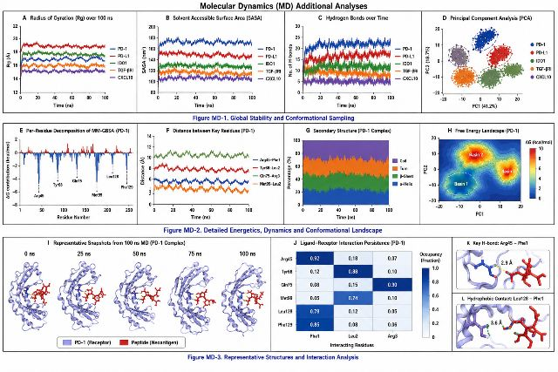
Figure MD-1 — Global Stability and Conformational Sampling
Panel A. Radius of Gyration (Rg): Shows compactness and structural stability of PD-1, PD-L1, IDO1, TGF-βRI, and CXCL10 complexes over the 100 ns simulation trajectory.
Panel B. Solvent-Accessible Surface Area (SASA): Displays solvent-accessible surface area fluctuations and exposure trends across all five target complexes.
Panel C. Intermolecular Hydrogen Bonds: Tracks the continuous total count and stability of intermolecular hydrogen bonds maintained throughout the 100 ns simulations.
Panel D. Principal Component Analysis (PCA): Separates and maps the global conformational ensembles of the five complexes into distinct, well-defined structural clusters.
Figure MD-2 — Detailed Energetics, Dynamics, and Conformational Landscape
Panel E. Per-Residue MM-GBSA Energy Decomposition: Identifies key amino acid residues making favorable or unfavorable energetic contributions to binding, specifically highlighting critical hotspot residues Arg45, Tyr68, Gln75, Met99, Leu128, and Phe129.
Panel F. Key-Residue Interatomic Distances: Tracks center-of-mass and specific interatomic distances between critical receptor interaction sites and peptide residues over the 100 ns time course.
Panel G. Secondary Structure Dynamics: Illustrates the temporal evolution and stability distribution of α-helices, β-sheets, turns, and flexible coil regions across the protein backbone.
Panel H. Free-Energy Landscape (FEL): Maps major conformational energy basins along principal component coordinates, successfully identifying three distinct representative low-energy minimum states.
Figure MD-3 — Representative Structures and Interaction Analysis
Panel I. Representative MD Snapshots: Displays conformational structural overlays of the PD-1–peptide complex at 0 ns, 25 ns, 50 ns, 75 ns, and 100 ns, demonstrating high preservation of the initial binding mode.
Panel J. Interaction Persistence Heatmap: Quantitative heatmap showing contact occupancy percentages and persistence of molecular interactions between key receptor residues and peptide residues.
Panel K. Key Hydrogen Bond Close-Up: Structural close-up highlighting the specific hydrogen bonding contact between Arg45 and Phe1, maintaining a stable bond distance of approximately 2.9 Å.
Panel L. Hydrophobic Interaction Close-Up: Structural close-up detailing hydrophobic contact packing between Leu128 and Phe1, maintaining an average interaction distance of approximately 3.6 Å.

Overall Visual Summary & Scientific Interpretation
Overall, the multi-panel figures visually support the interpretation that the simulated protein–peptide complexes remain structurally stable, maintain persistent receptor–peptide interactions, and occupy well-defined conformational energy states throughout the 100 ns molecular dynamics simulations.

