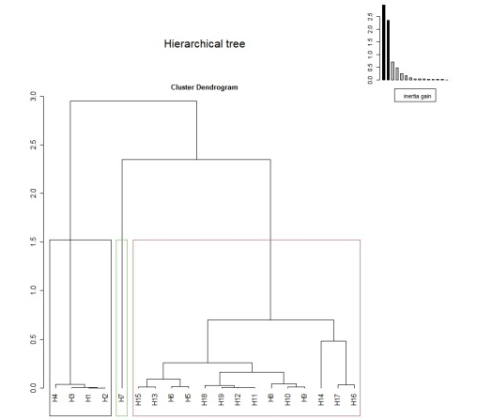
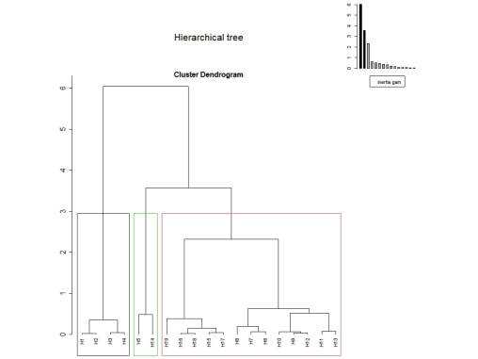
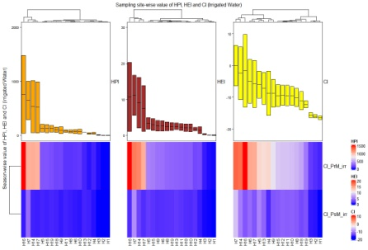
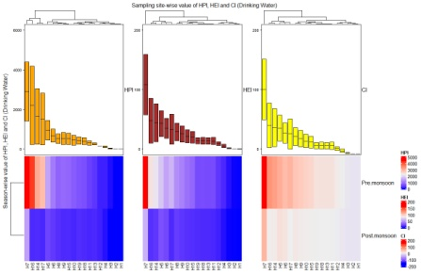
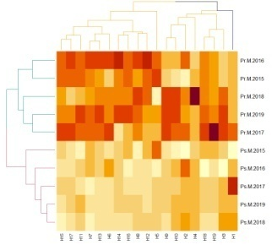
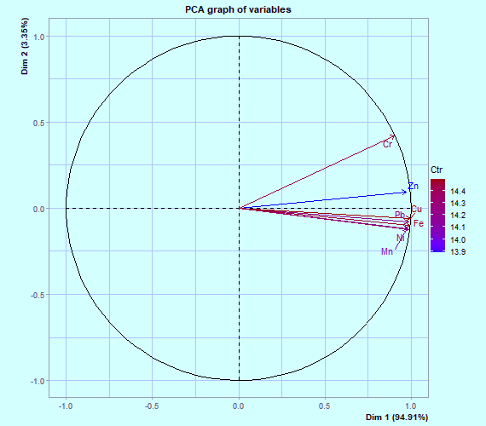
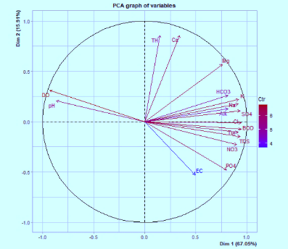
Physico-chemical variables factor map
Conclusions:
- Pollutants of anthropogenic origin from domestic, industrial and agricultural sources deteriorate the water quality.
- Pollution indices viz. WQI, HPI, HEI and CI were used to benchmark the water quality and found polluted at lower reach of river.
PCA and hierarchical cluster analysis for heavy metals contents of different sites
Hierarchical cluster analysis for physico-chemical variable contents of different sites
HPI, HEI and CI w.r.t. irrigation water
Hindon River, Uttar Pradesh, India
Heavy metals factor map
HPI, HEI and CI w.r.t. drinking water
Water Quality Index (WQI)

