Additional file 1:

Supplementary Information
Long-term seismic background level variations are consistent with volcanic activity at Kusatsu-Shirane volcano, Japan
Kobayashi T., Ichihara M., Terada A., Nogami K., and Yukutake Y.
Earth, Planets and Space

Contents:
S1. Sensitivity analysis of SBL to percentile selection
S2. Sensitivity analysis of SBL to selection of seismometer components
S3. Sensitivity of SBL and SBL ratio to the lower frequency bound
S4. Sensitivity of SBL and SBL ratio to reference period
S5. Evaluation of linear trends in SBL variations for each period
S6. Ground deformation by volcanic activity of Kusatsu-Shirane, Yugama area
S7. Polarization analysis of SBL vibrations

S1. Sensitivity analysis of SBL to percentile selection

For higher percentiles (particularly ≥40th), the SBL is more strongly affected by noise. Before the seismometer replacement, seasonal variations, especially increased noise during winter, are more pronounced. In addition, the SBL shows temporarily elevated levels following the 2011 Tohoku–Pacific Ocean earthquake, suggesting an influence of the event.
These results indicate that the use of the 20th percentile provides a stable estimate of the background seismic level while suppressing noise effects.

Figure S1: Comparison of SBL at KSHA calculated with different percentiles.
(a) SBL calculated at KSHA with different percentiles. Black dashed lines indicate the date of the Tohoku–Pacific Ocean earthquake (11 March 2011) and the seismometer replacement (13 November 2012).
(b) Ratio of SBL relative to that calculated with the 20th percentile. The dashed lines are the same as in (a).

S2. Sensitivity analysis of SBL to selection of seismometer components

To evaluate the influence of component selection, we compared SBL calculated from the vertical component, the two horizontal components, and all three components at all stations. Excluding periods affected by known data-quality problems, the temporal variations of SBL were broadly similar among these calculations, including during the 2014 and 2018 unrest periods. The ratios among the different component combinations remained generally stable through time at KSHA, KSAO, KSS, and KSW.
KSE showed a different behavior. When only the horizontal components were used, the SBL during the 2014 unrest was larger than that during the 2018 unrest, which is opposite to the relationship observed for the vertical-component SBL. However, the SBL calculated with all three components showed the same overall behavior as the vertical-component SBL, namely that the SBL during the 2018 unrest was larger than that during the 2014 unrest. Therefore, although the relative contribution of different wavefield components may vary at KSE, the principal temporal variations discussed in this study are not substantially affected by the use of only the vertical component for SBL calculation.

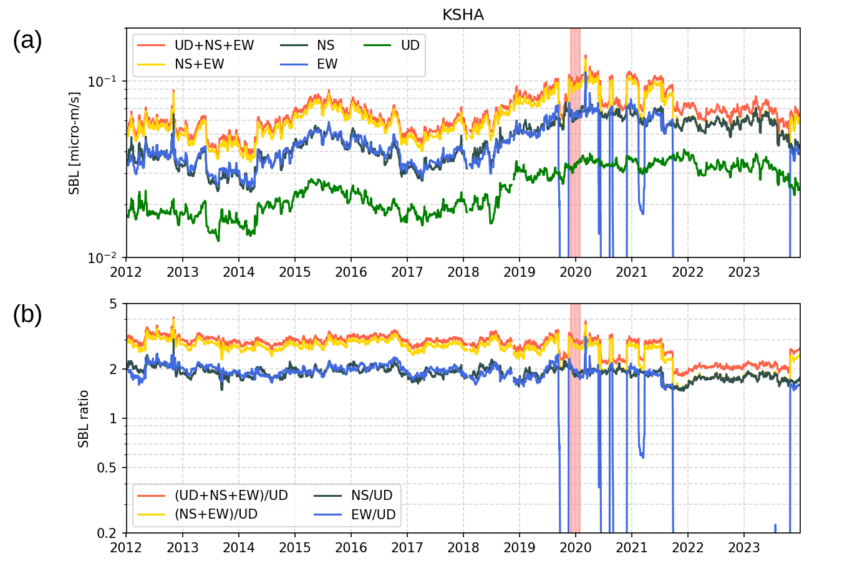

Figure S2: Comparison of SBL at KSHA calculated with different components.
(a) SBL at KSHA calculated with the vertical component, two horizontal components, and all three components. The red shaded area indicates the polarization analysis period (December 2019–January 2020). Periods affected by known data-quality problems in the EW component show anomalously low SBL values.
(b) Ratios of SBL relative to that calculated with only the vertical component. The red shaded area is the same as in (a).

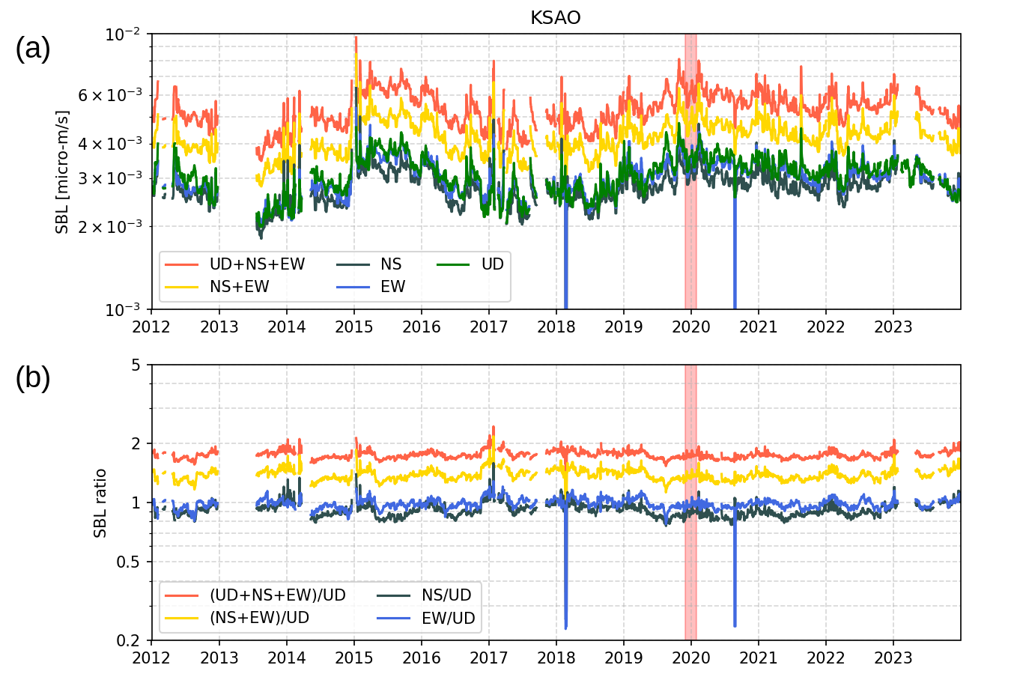

Figure S3: Same as Fig. S2, but for KSAO.

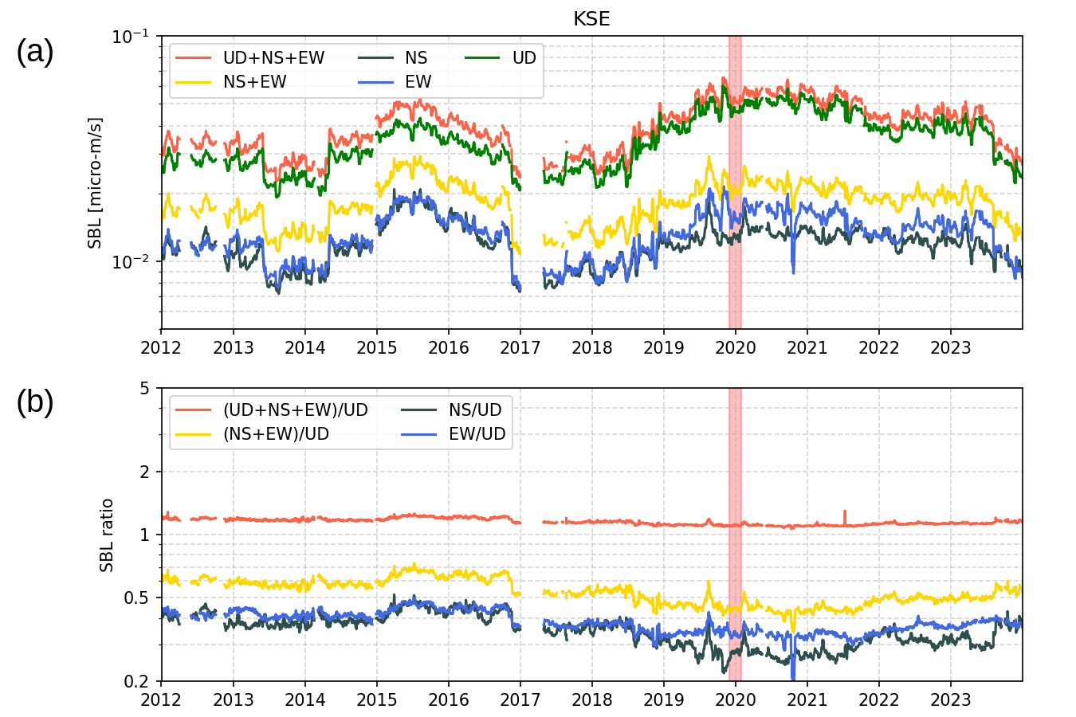

Figure S4: Same as Fig. S2, but for KSE.

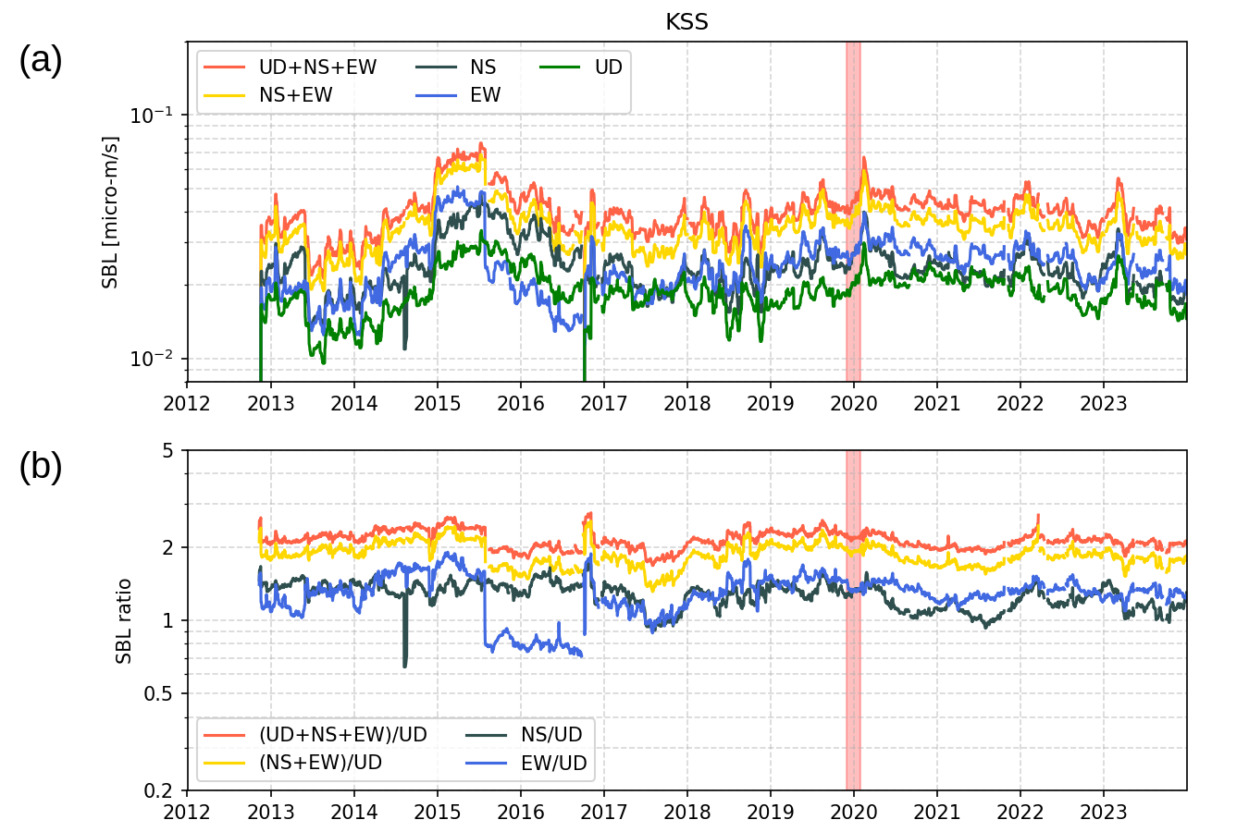

Figure S5: Same as Fig. S2, but for KSS.

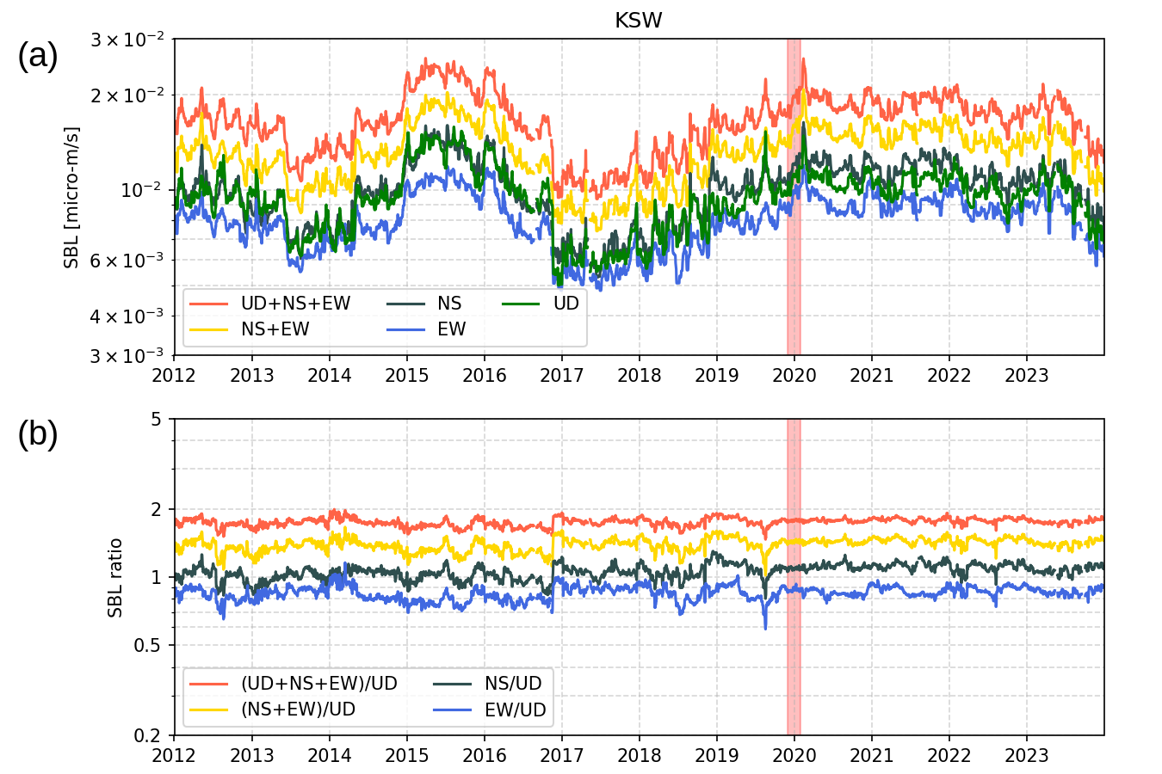

Figure S6: Same as Fig. S2, but for KSW.
S3. Sensitivity of SBL and SBL ratio to the lower frequency bound

To further evaluate the influence of the lower frequency bound on the main results, we compared the normalized SBLs and SBL ratios calculated with the 3.5–7.0 Hz band (Fig. S7) and 3.0–7.0 Hz band (Fig. S8). The comparison was made for the period after 2012, focusing on the period relevant to the 2014 and 2018 unrest episodes.
In both frequency bands, the normalized SBLs indicate that the amplitudes at KSHA and KSE were larger during the 2018 unrest than during the 2014 unrest, whereas the opposite relationship was observed at KSW, KSS, and KSAO. The SBL ratios further show that, for station pairs involving KSHA or KSE, the SBL ratios differed between the 2014 and 2018 unrests. In contrast, for pairs composed of any two of KSS, KSW, and KSAO, the SBL ratios remained approximately unity throughout both unrest periods.
These results support the robustness of the main results based on the 3.5–7.0 Hz band, at least for the period after 2012.

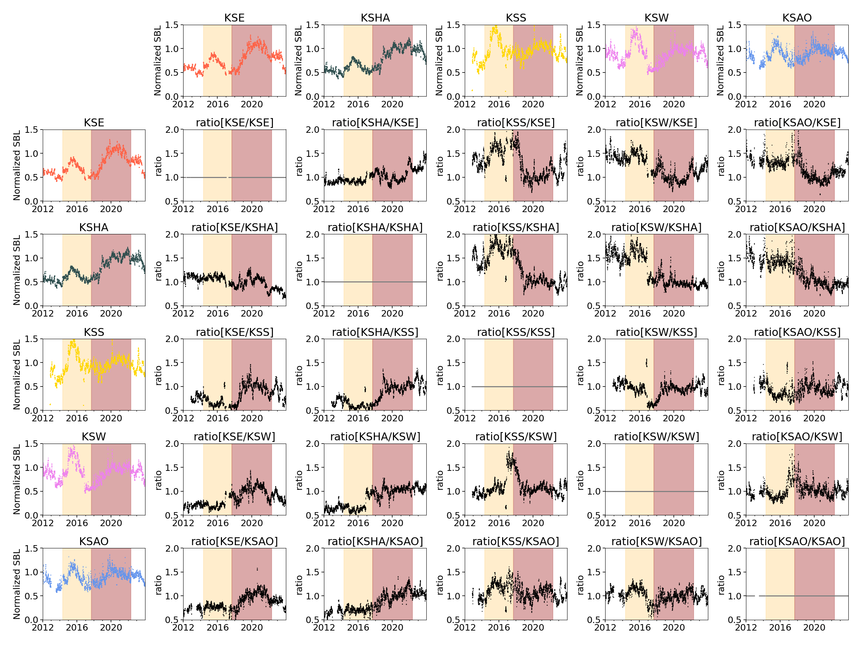

Figure S7: Normalized SBLs and SBL ratios for various station combinations calculated with the 3.5–7.0 Hz band.
Colored plots show the normalized SBLs, and black plots show their ratios, with the row direction corresponding to the denominator station. Data are shown for the period from 2012 to 2023. The orange and brown shaded areas indicate the 2014 unrest (Periods V–VI) and the 2018 unrest (Periods VII–IX), respectively.

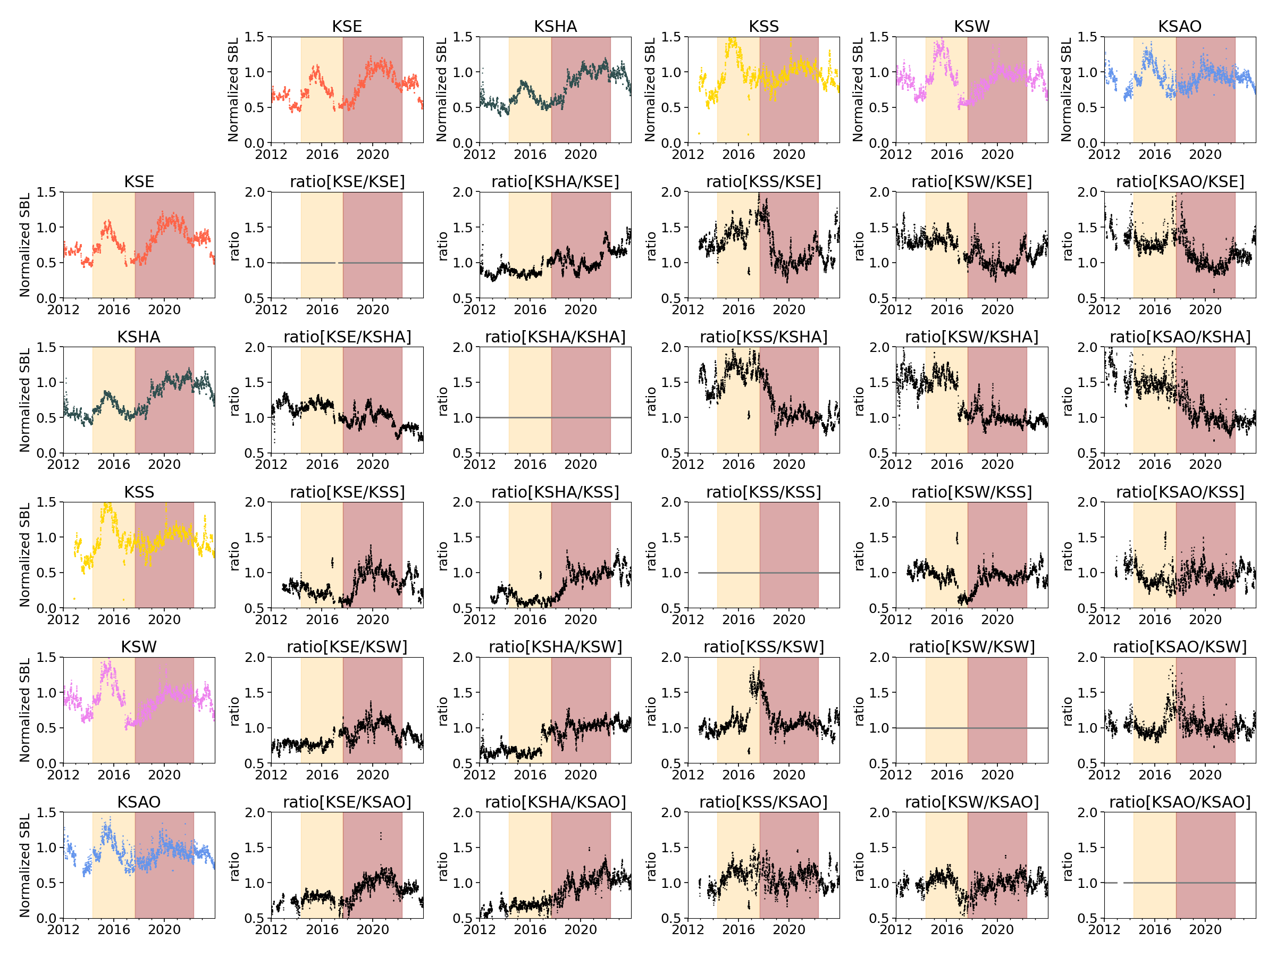

Figure S8: Same as Fig. S7, but calculated with the 3.0–7.0 Hz band.
S4. Sensitivity of SBL and SBL ratio to reference period

To evaluate the influence of the reference period on the main results, we compared the normalized SBLs and SBL ratios calculated with December 2019 to January 2020 (Fig. S7) and 11 November to 23 December 2012 (Fig. S9) as the reference periods. The two results show no substantial differences in their temporal trends. These results indicate that the main features discussed in this study are robust with respect to the choice of the reference period, although the absolute values differ due to normalization.

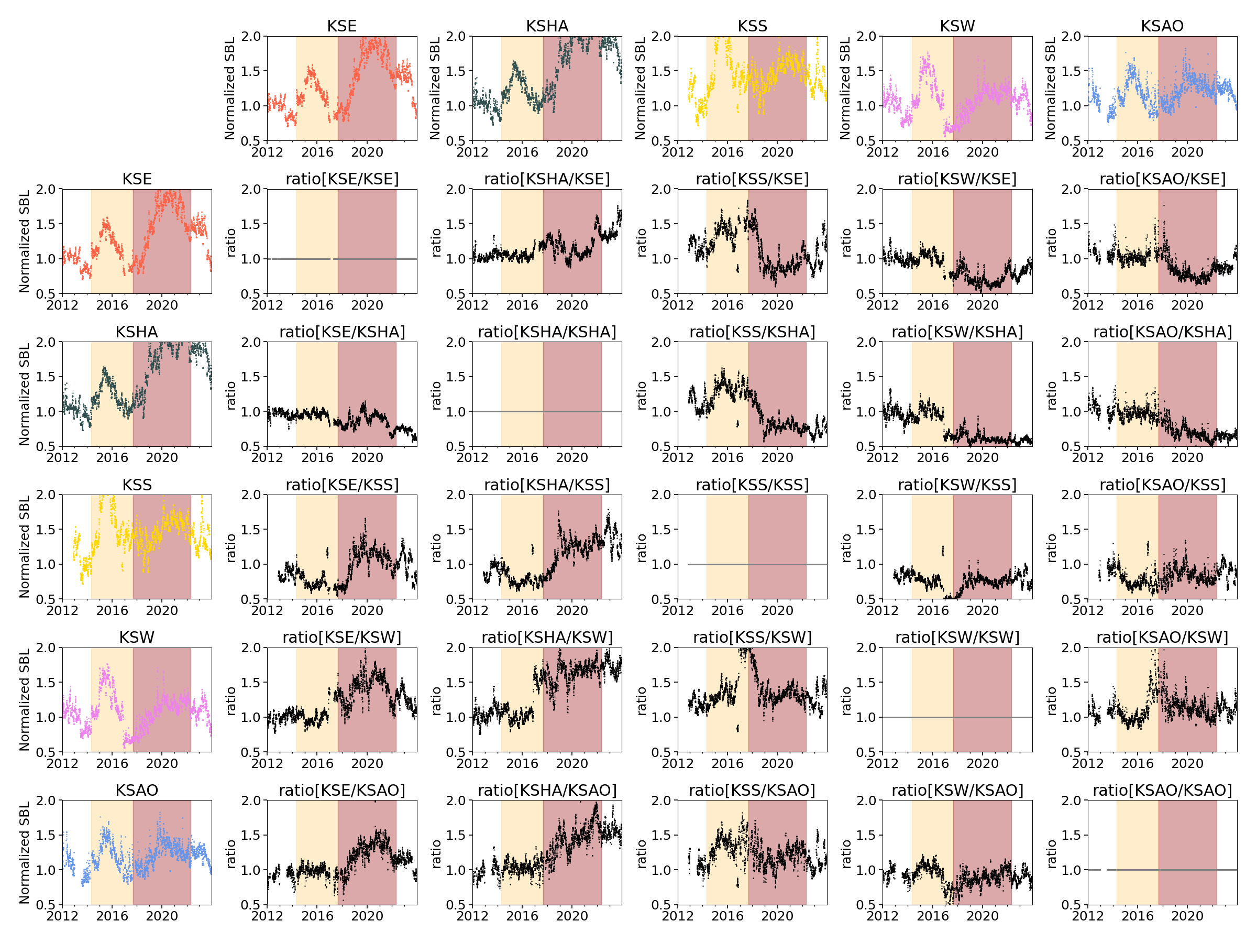

Figure S9: Same as Fig. S7, but with the mean SBL during the period from 11 November to 23 December 2012 as the reference.

S5. Evaluation of linear trends in SBL variations for each period

To quantitatively evaluate the long-term temporal trends of the SBL, we performed linear regression analysis for each period. We regressed log10(SBL) against elapsed time for each period. Figure S10 shows the SBL time series at station KSHA together with the linear trends estimated for each period.

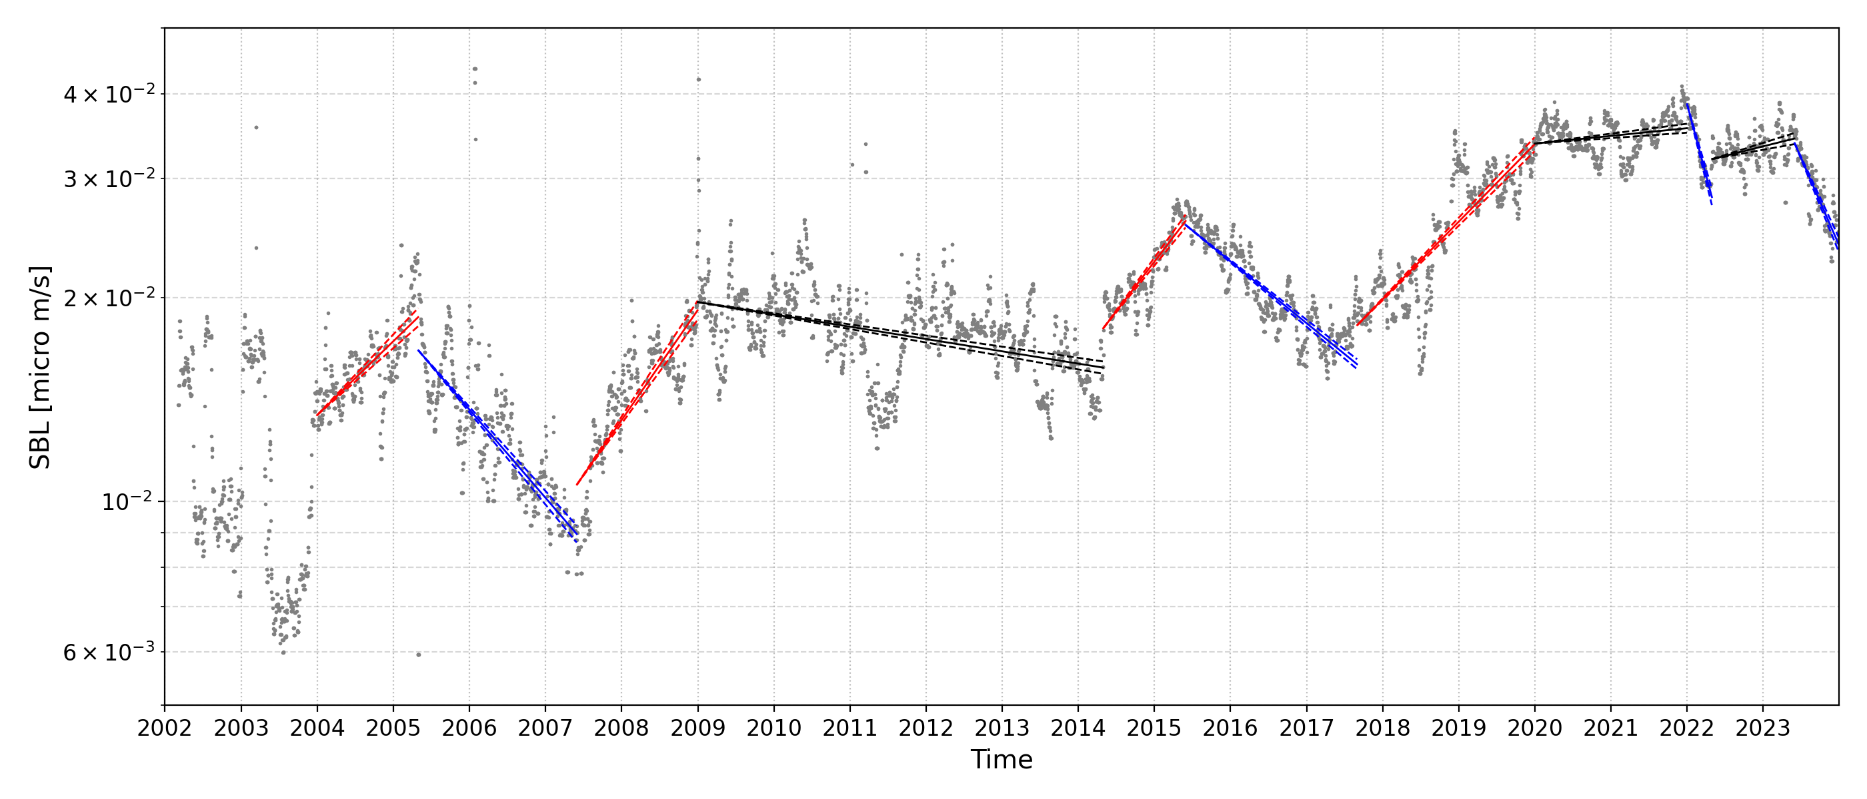

Figure S10: Time series of SBL at station KSHA with period-based linear trends.
Solid lines indicate the fitted regression lines, while dashed lines show the fitted trends corresponding to the 95% confidence limits of the slope, with the intercept fixed. Red and blue lines indicate increasing and decreasing trends, respectively, while black lines denote periods with weak or no substantial change. Details of the regression analysis are provided in Figure S11.

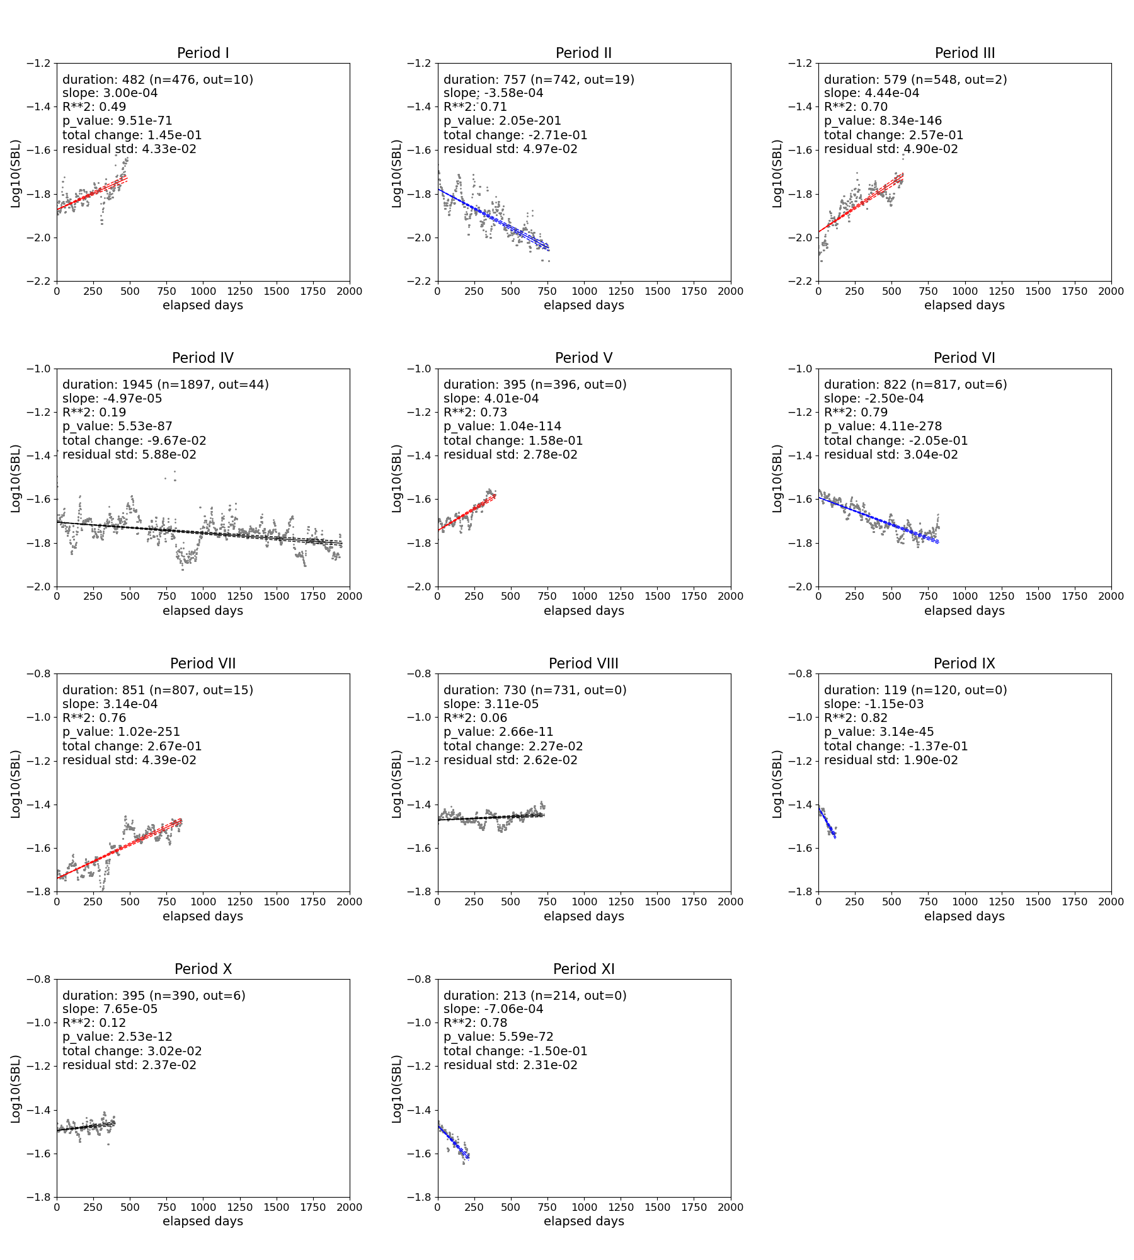

Figure S11: Detailed linear regression analysis for each period.
Each panel shows the SBL data and the corresponding linear regression for one period. We performed the regression on log10(SBL) as a function of elapsed time. Each panel lists the duration, slope, coefficient of determination (R²), p-value, total change, and residual standard deviation. Red and blue lines indicate increasing and decreasing trends, respectively, while black lines denote periods with small slopes (|slope| < 1 × 10⁻⁴), indicating minor changes in SBL.

S6. Ground deformation by volcanic activity of Kusatsu-Shirane, Yugama area

Two major sources of ground deformation have been reported to be associated with the volcanic activity around the Yugama crater of Kusatsu-Shirane volcano.
Shallow source beneath Yugama crater lake
JMA (2016) reported the presence of an inflation source located in the very shallow region directly beneath the Yugama crater (at an elevation of approximately 1660 m), based on the results of GNSS campaign observations conducted in July and November 2014. The GNSS stations used for the baseline length changes shown in Fig. 5e are the same as those used in that report. Therefore, we infer that the baseline length changes in Fig. 5e reflect the inflation of the shallow deformation source beneath Yugama. Similarly, an analysis of tiltmeter data around Yugama also revealed a shallow deformation source beneath the crater (Terada et al. 2025).
Deep source at approximately 2km northwest from the Yugama area
Munekane (2021) analyzed GEONET data and identified a deformation source located approximately 2 km northwest of the Yugama crater at a depth of about 4 km. According to that study, the Kusatsu-Shirane source was generally inflating after 2013, with distinct inflation episodes from late 2013 to 2015 and again from late 2017 onward, which corresponded to the periods of volcanic unrest around Yugama in 2014 and 2018, respectively.
Munekane (2021) reported results only for the period from 2013 to 2020 and therefore did not cover the full duration of our SBL analysis. To examine longer-term changes, we calculated the areal strain for the GNSS stations shown in Fig. 2a from the GEONET F5 data provided by the Geospatial Information Authority of Japan (Takamatsu et al. 2023). To reduce short-term fluctuations, a 30-day moving average was applied. Seasonal variations were extracted from the stable period of 2008–2010 and removed from the entire dataset using the obtained seasonal component. The resulting areal strain was compared with that estimated from the volume change reported by Munekane (2021). For simplicity, we fixed the latitude, longitude, and depth of the deformation source and used the elevation-modified Mogi model (Fukui 2008). Although the amplitude of the changes in 2014 differed slightly between the two datasets, their temporal trends were consistent, and both the amplitude and the trend showed good agreement after 2015. Therefore, we assumed that the areal strain reflects the behavior of the deep deformation source throughout the analysis period.

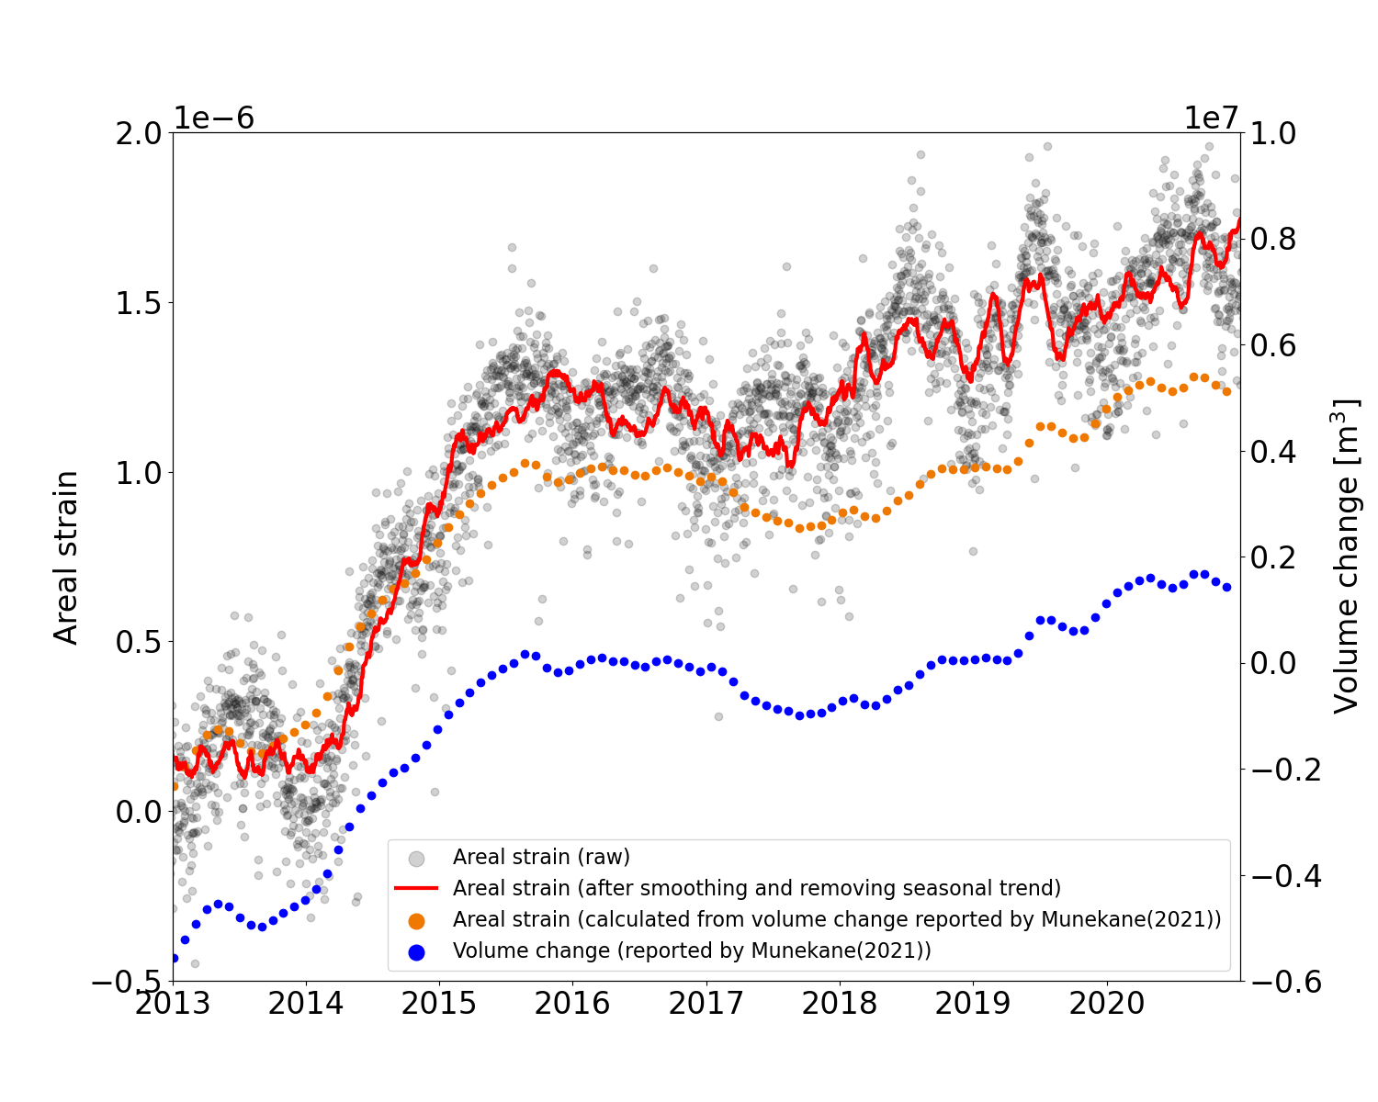
Figure S12: Comparison between areal strain calculated from GEONET and that inferred from the volume change reported by Munekane (2021).
Gray circles show the raw areal strain calculated from GEONET.
The red line shows the areal strain after smoothing and removing the seasonal trend.
Orange circles show the areal strain calculated from the volume change reported by Munekane (2021).
Blue circles (right axis) show the volume change reported by Munekane (2021).

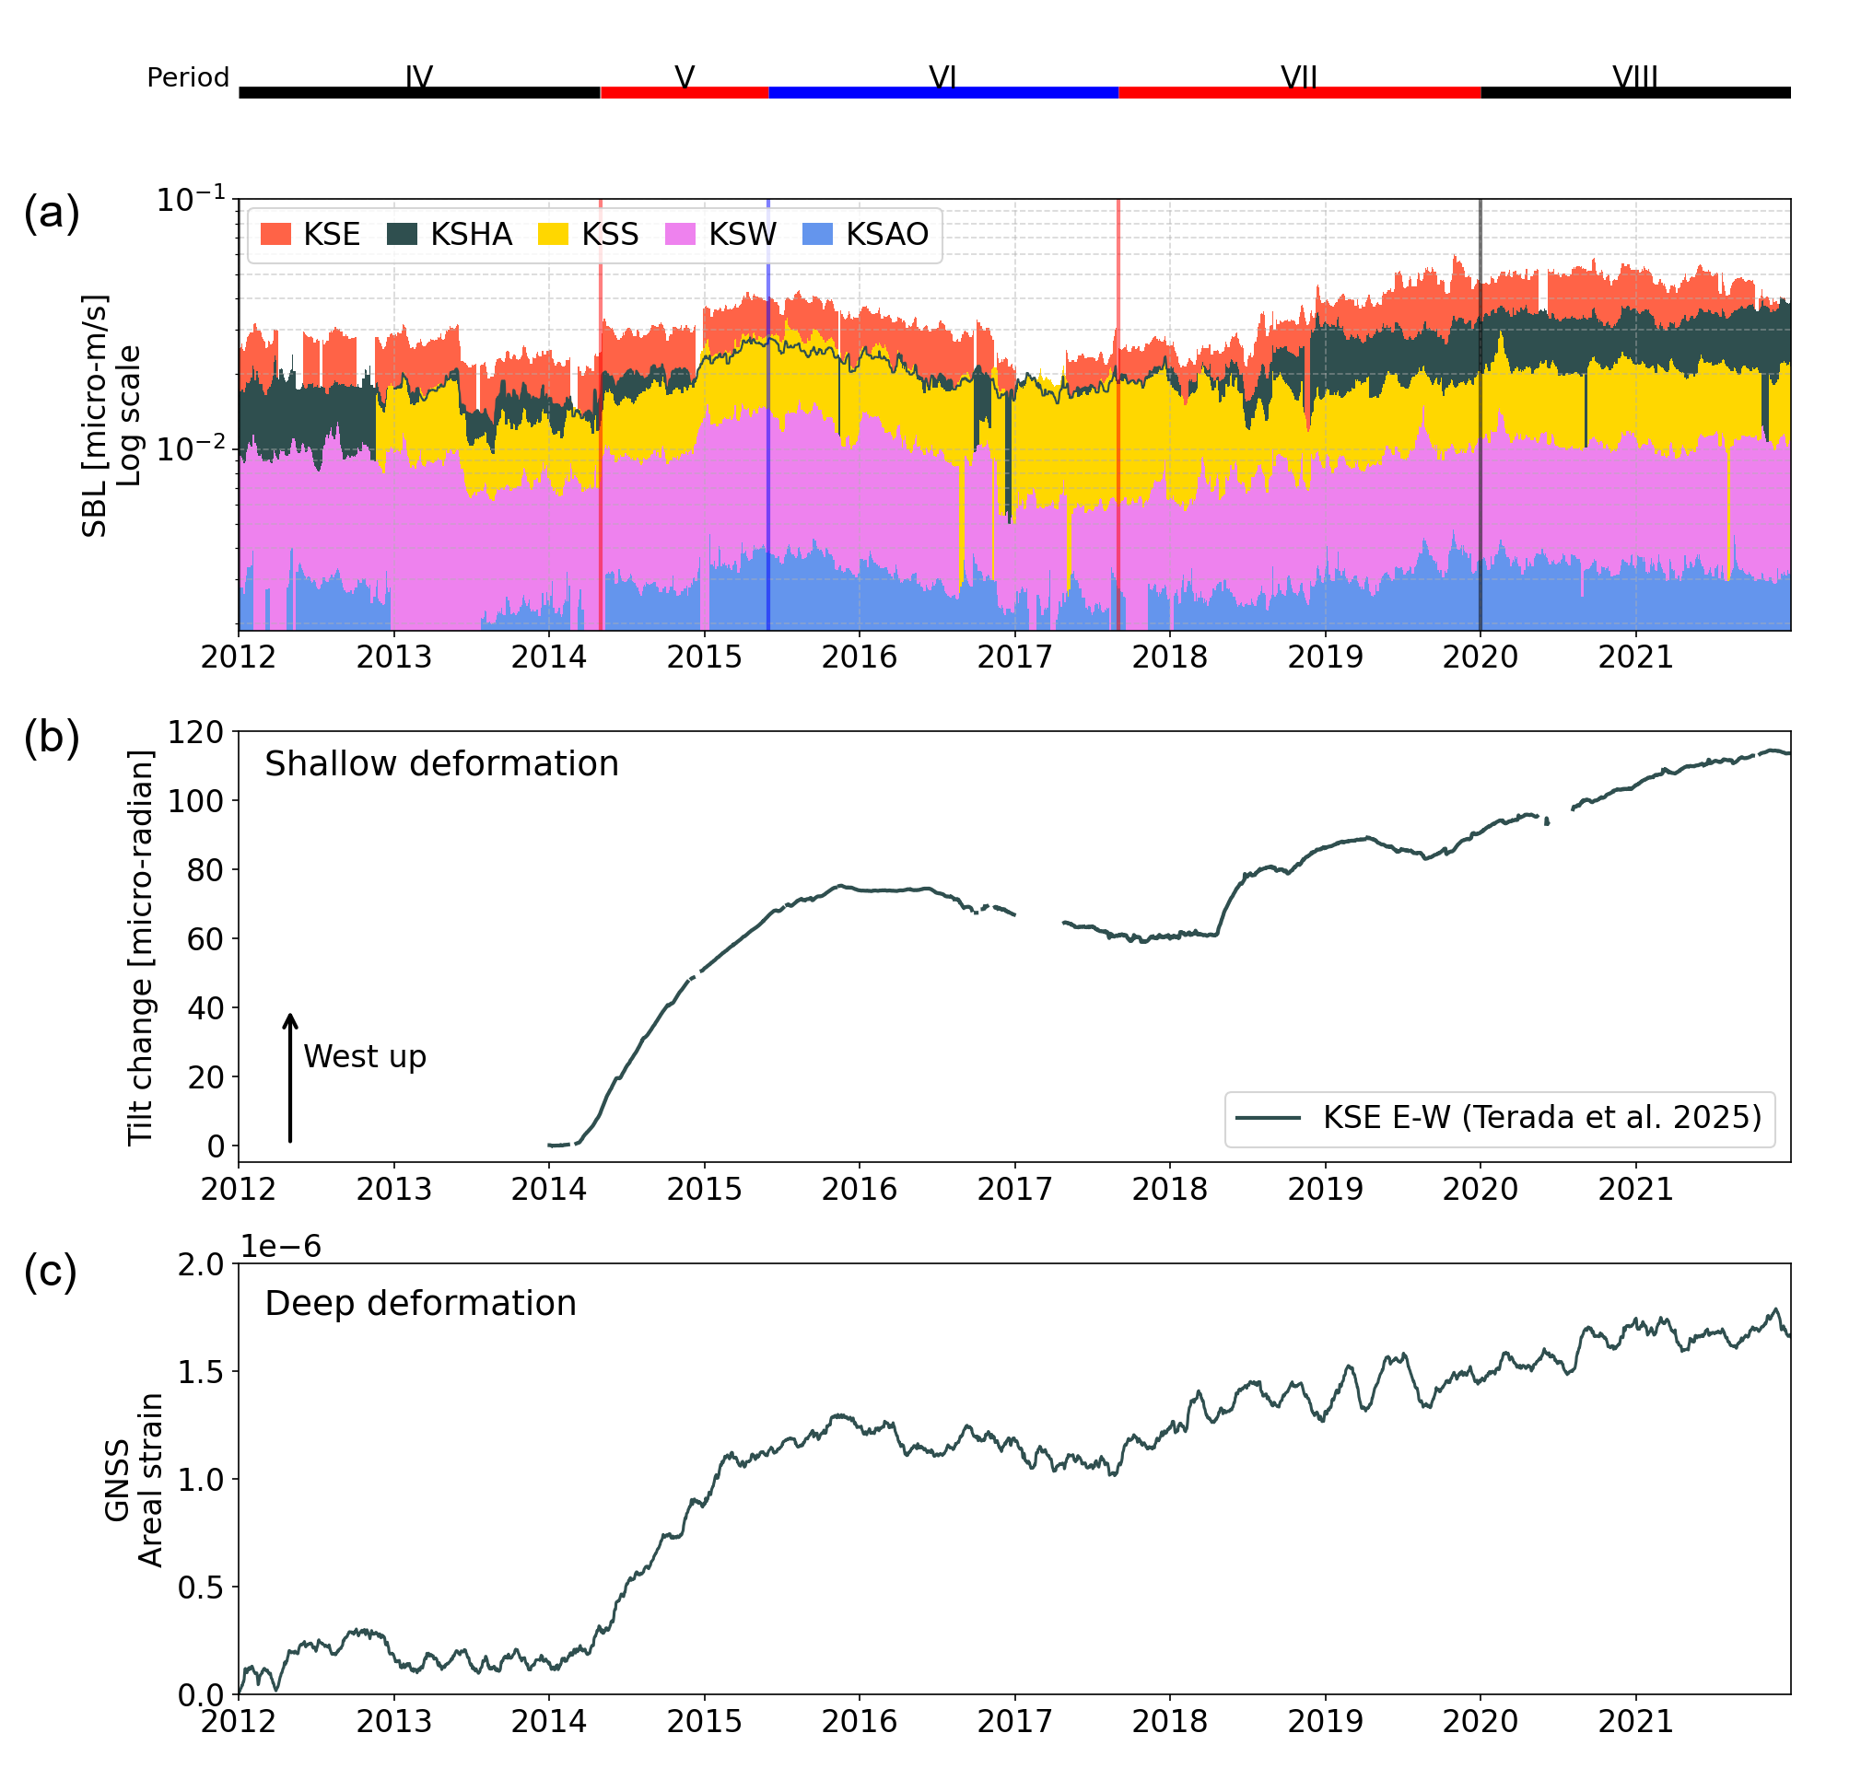

Figure S13: Comparison of SBL variations, long-term tilt changes, and areal strain.
(a) SBL at sites around the Yugama crater (KSE, KSHA, KSS, KSW, and KSAO).
(b) Long-term tilt changes in the E–W component at KSE, plotted using tiltmeter data from Terada et al. (2025).
(c) Smoothed and deseasonalized areal strain.

S7. Polarization analysis of SBL vibrations

Method
This analysis is based on the polarization analysis approach developed by Hirose and Ueda (2025), which extends the method of Meza‐Fajardo et al. (2015). Our approach differs from that of Hirose and Ueda (2025) in the way back azimuths are determined, and also in that kernel density estimation (KDE) is employed for estimating the directional distribution. The following sections describe the computational procedure, as well as the definitions of the probability density estimation and the joint probability used in this study. For detailed derivations of back-azimuth estimation for each frequency in each time window, the reader is referred to Hirose and Ueda (2025).
Step 1:
The polarization analysis was performed for waveform data within a 10.24-s time window using the method of Hirose and Ueda (2025). The analysis was applied to time windows where the seismic power percentile was between the 20th and 40th. After applying the NIP filter, the back azimuth corresponding to the frequency with the largest mean amplitude within the 3.5–7.0 Hz band was adopted as the back azimuth for that time window.
Step 2:
We estimated the density distribution of the back-azimuth dataset for each day using a non-parametric method.
$$\begin{aligned}\hat{f}\left(θ;h\right)=\frac{1}{n}\sum_{i=1}^{n}{K_{h}\left(θ-θ_{i}\right)}\#\left(1\right)\end{aligned}$$
where $K_{h}={K\left(θ/h\right)}/h$ is kernel function, and h is smoothing parameter (Taylor 2008). We used the von Mises distribution (Mardia and Jupp 2010) as the kernel.
$$\begin{aligned}K\left(θ;μ,κ\right)=\frac{1}{2πI_{0}\left(κ\right)}e^{κ\cos\left(θ-μ\right)}\#\left(2\right)\end{aligned}$$
where $I_{0}$ is the modified Bessel function of order 0. $κ$ is concentration parameter and is the reciprocal of h. From Equations (1) and (2), the kernel density estimation using the von Mises distribution as the kernel is given by:
$$\begin{aligned}\hat{f}\left(θ;κ\right)=\frac{1}{n\left(2π\right)I_{0}\left(κ\right)}\sum_{i=1}^{n}{exp\left\{κ\cos\left(θ-θ_{i}\right)\right\}}\#\left(3\right)\end{aligned}$$
In this study, we compared the estimated density distribution with the observed frequency distribution and adopted $κ$=50, which showed good agreement between the two. The half width at half maximum (HWHM) in this case is approximately 9.6°. The grid interval ($θ_{i}$ spacing) used for summing the kernel functions was set to 0.5°. In addition, datasets with fewer than 100 samples were excluded from the analysis.
Step 3:
The probability density distributions estimated for each day were averaged over the analysis period, and the resulting mean distribution was regarded as the probability density distribution for that period.
Step 4:
We applied the cross-bearings approach (Lehr et al. 2019; Hirose and Ueda 2025) to the probability density distributions of back azimuths estimated at each of the four observation sites to estimate the vibration source location. Specifically, the probability density distributions obtained in Step 3 were back-projected onto the grid. The joint probability of the intersecting beams is given by:
$$\begin{aligned}p\left(x_{j},y_{j}\right)=\frac{\prod_{i}^{M}{f_{i}\left(ϕ_{ij}\right)}}{\sum_{i=1}^{N}{\left(\prod_{i}^{M}{f_{i}\left(ϕ_{ij}\right)}\right)}}\#\left(4\right)\end{aligned}$$
where $ϕ_{ij}$ is the back azimuth at i-th station for a signal starting at a j-th search grid which location is $\left(x_{j},y_{j}\right)$. The grid covers the area from 36.62°N to 36.66°N in latitude and from 138.51°E to 138.56°E in longitude, with a spacing of 0.001° in both directions.

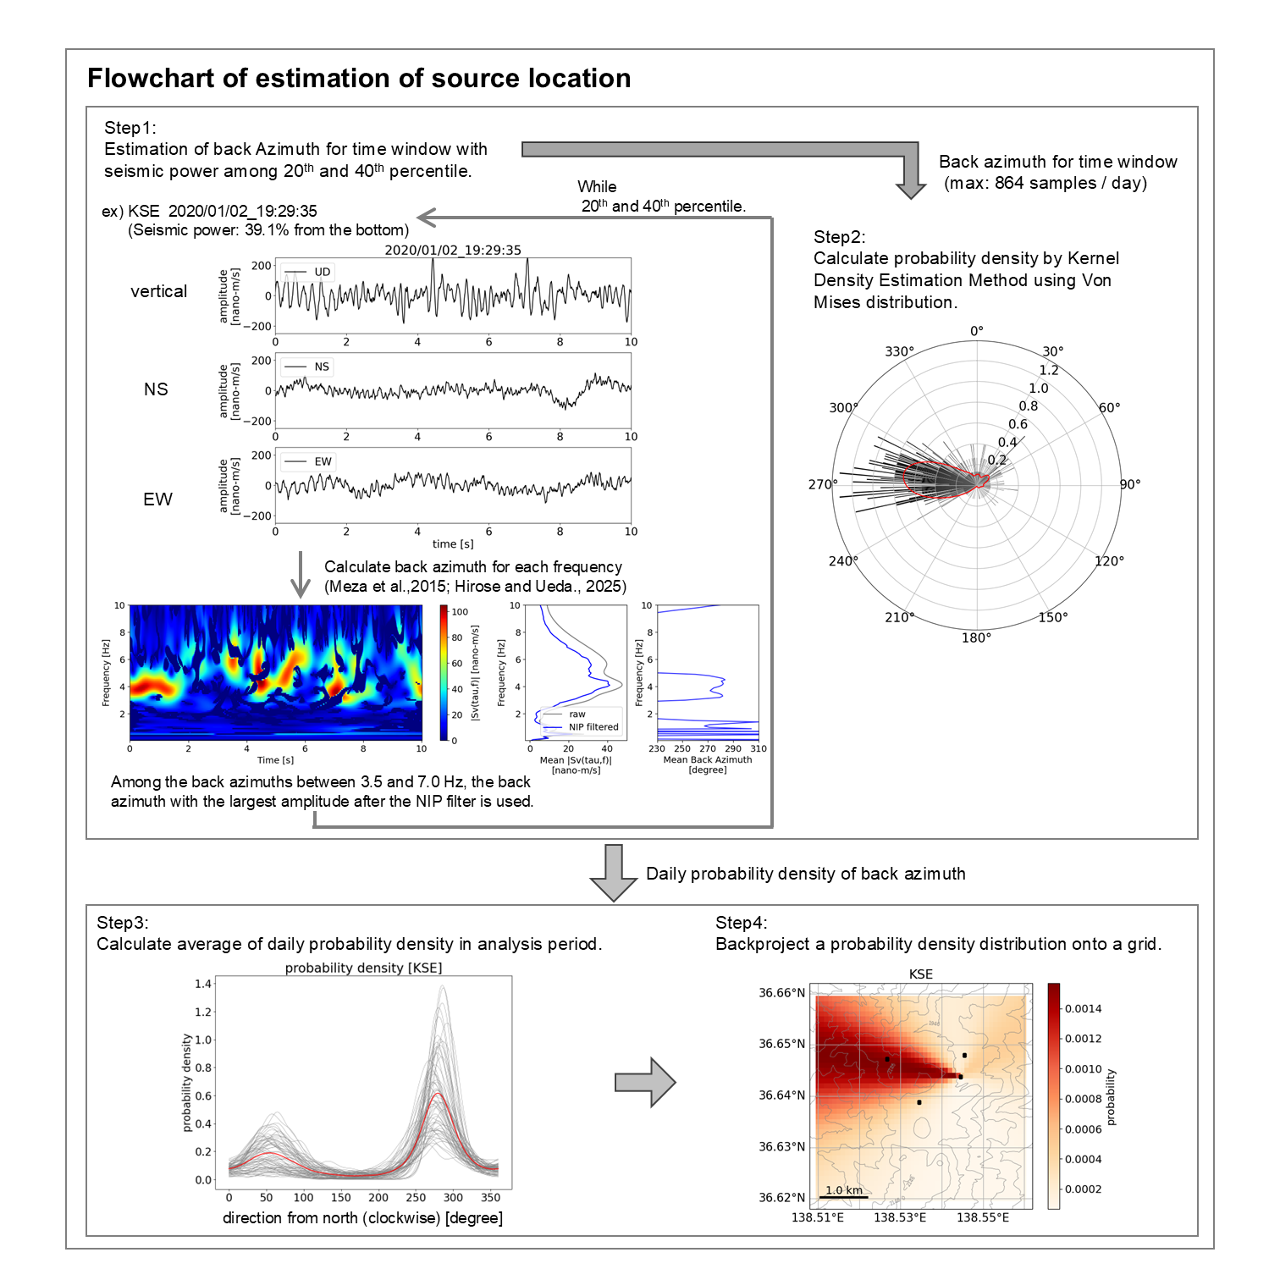
Figure S14: Schematic illustration of the calculation method for the polarization analysis and back-projection at each observation site.

Result
Figure S15 shows the probability distributions obtained by back-projecting the directional density distributions from each station onto the grid, together with the joint probability obtained by combining the results from multiple stations. The probability is high around the Yugama crater.

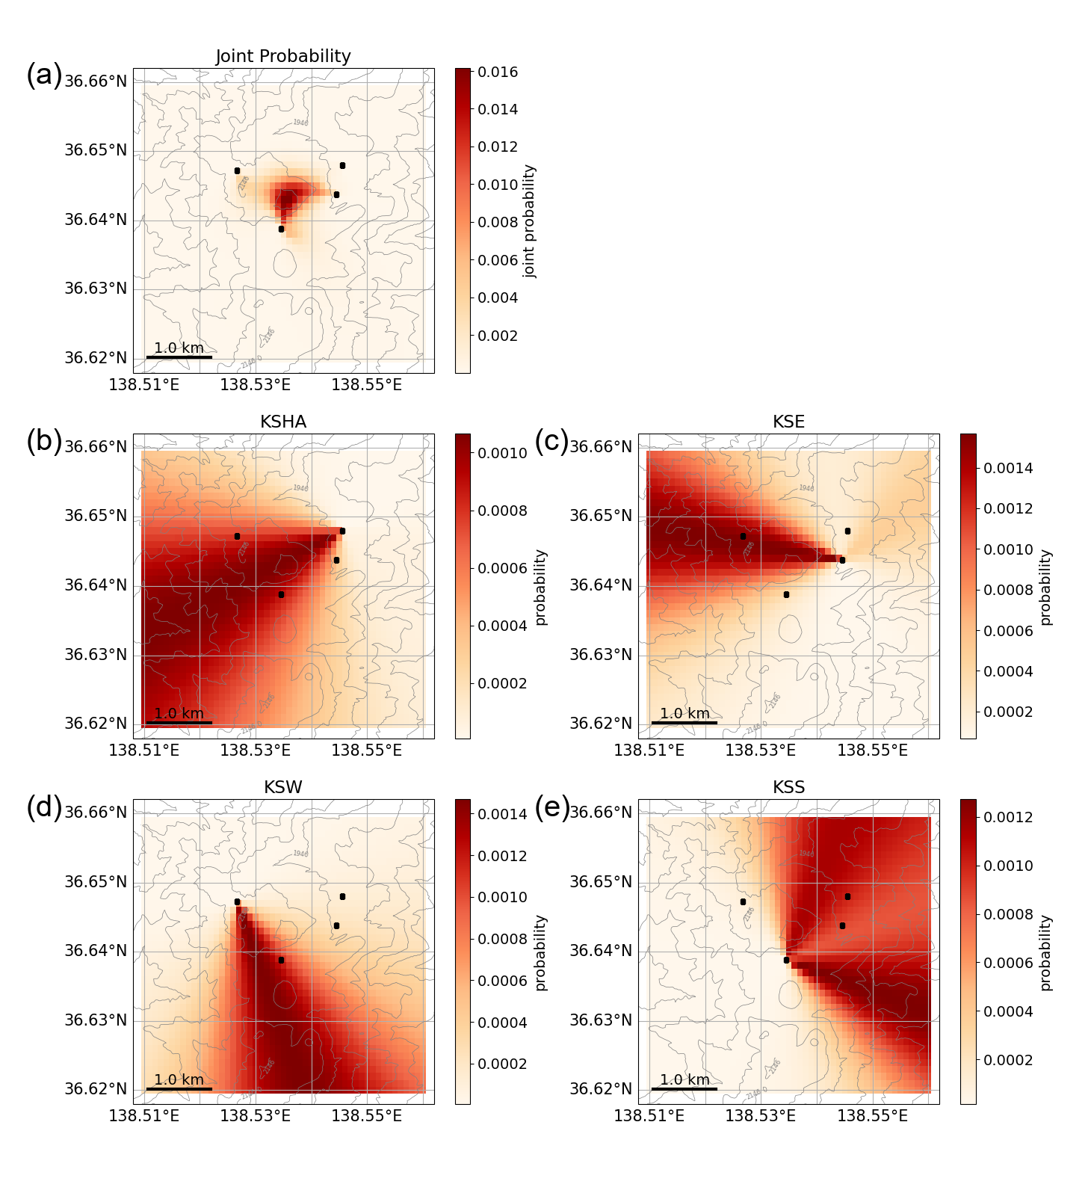
Figure S15: Location of the SBL source estimated by polarization analysis and the joint-probability method.
(a) Joint probability of the SBL source location.
(b–e) Probability distributions estimated from the polarization analysis at KSHA, KSE, KSW, and KSS, respectively.
Black squares indicate seismic stations used for the polarization analysis (KSE, KSHA, KSW, KSS).
References

Fukui K (2008) Studies on Evaluation Method of Volcanic Activity. TECHNICAL REPORTS OF THE METEOROLOGICAL RESEARCH INSTITUTE 105–122. https://www.mri-jma.go.jp/Publish/Technical/DATA/VOL_53/tec_rep_mri_53_141.pdf. Accessed 2 Nov 2025 (in Japanese)
Hirose T, Ueda H (2025) Seismic Wavefield Change Preceding the Eruption of Shinmoe-Dake, Kirishima Volcano, Japan, Inferred From Polarization Analysis. Journal of Geophysical Research: Solid Earth 130:e2024JB029358. https://doi.org/10.1029/2024JB029358
Japan Meteorological Agency (2016) Volcanic Activity of Kusatsu-Shiranesan Volcano (October 2014 –February 23, 2015). In: Report of the Coordinating Committee for Prediction of Volcanic Eruption. https://www.jma.go.jp/jma/kishou/shingikai/ccpve/Report/120/kaiho_120_06.pdf. Accessed 1 Nov 2025 (in Japanese)
Lehr J, Eckel F, Thorwart M, Rabbel W (2019) Low‐Frequency Seismicity at Villarrica Volcano: Source Location and Seismic Velocities. JGR Solid Earth 124:11505–11530. https://doi.org/10.1029/2018JB017023
Mardia KV, Jupp PE (eds) (2010) Directional statistics. J. Wiley, Chichester New York
Meza‐Fajardo KC, Papageorgiou AS, Semblat J-F (2015) Identification and Extraction of Surface Waves from Three‐Component Seismograms Based on the Normalized Inner Product. Bulletin of the Seismological Society of America 105:210–229. https://doi.org/10.1785/0120140012
Munekane H (2021) Modeling long-term volcanic deformation at Kusatsu-Shirane and Asama volcanoes, Japan, using the GNSS coordinate time series. Earth, Planets and Space 73:192. https://doi.org/10.1186/s40623-021-01512-2
Takamatsu N, Muramatsu H, Abe S, et al (2023) New GEONET analysis strategy at GSI: daily coordinates of over 1300 GNSS CORS in Japan throughout the last quarter century. Earth, Planets and Space 75:49. https://doi.org/10.1186/s40623-023-01787-7
Taylor CC (2008) Automatic bandwidth selection for circular density estimation. Computational Statistics & Data Analysis 52:3493–3500. https://doi.org/10.1016/j.csda.2007.11.003
Terada A, Aoyama H, Yamada T, Yamamoto M (2025) Geophysical Observations of Kusatsu–Shirane Volcano: Conceptual Model of the Hydrothermal System as a Site of Phreatic Eruptions. In: Ohba T, Terada A (eds) Kusatsu-Shirane Volcano. Springer Nature Switzerland, Cham, pp 159–184

