Supplementary Information

Anisotropy in thermoelectric properties of textured ZnSb nanomaterial by high Zn occupancy (132) crystallographic planes

Lalit Deora and Jasa Ram*
Thermoelectric Research Centre
DRDO, Defence Laboratory, Ratanada, Jodhpur – 342011
*Corresponding author email: jasa.ram.dl@gov.in

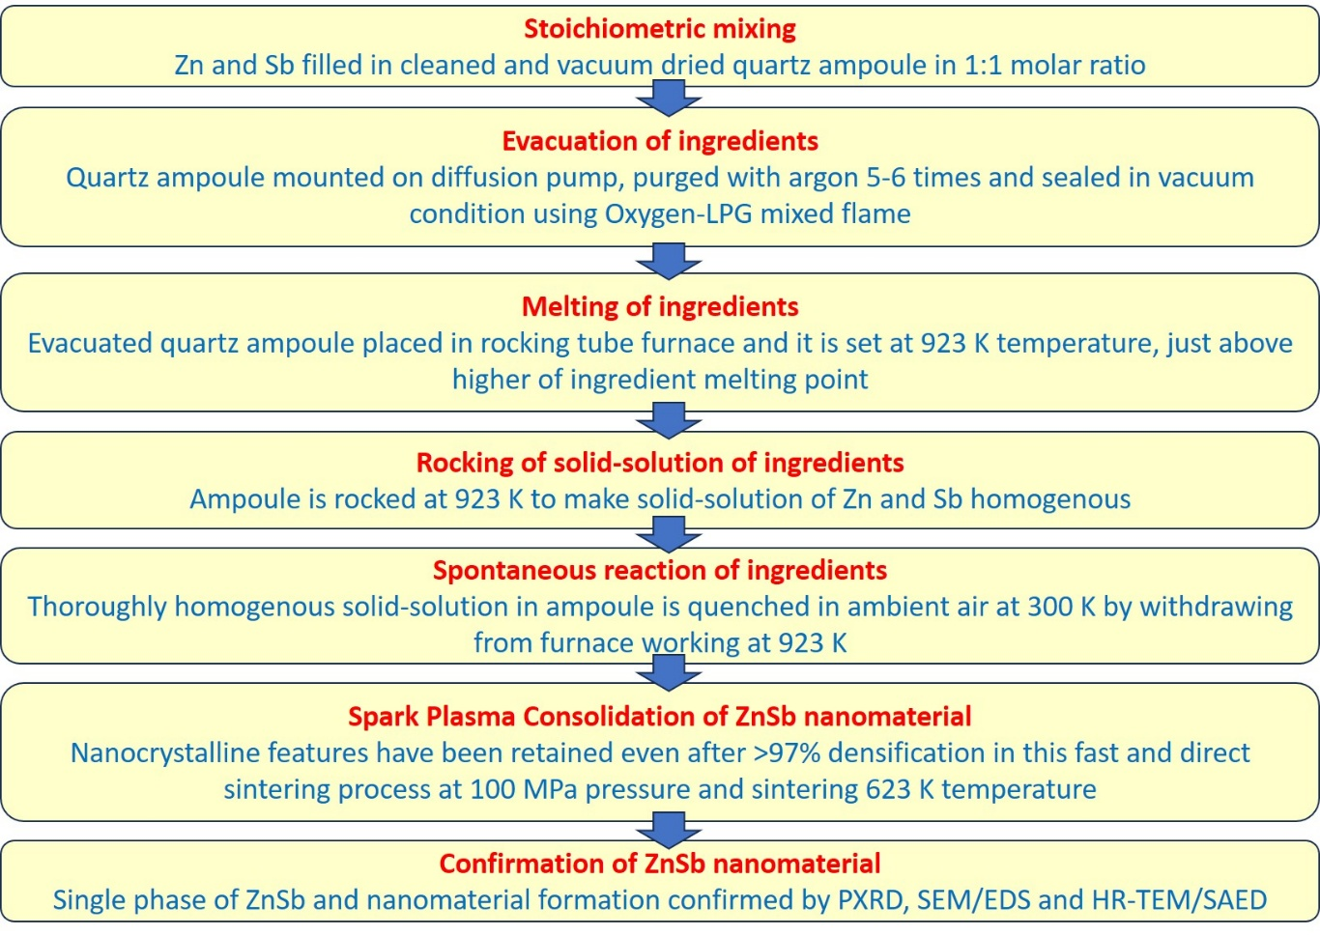
Figure s1: Flowchart of process steps in bottom-up physical synthesis process for ZnSb nanomaterial showing its cost and energy effectiveness.

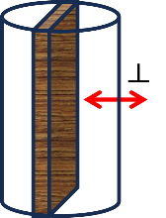
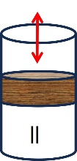
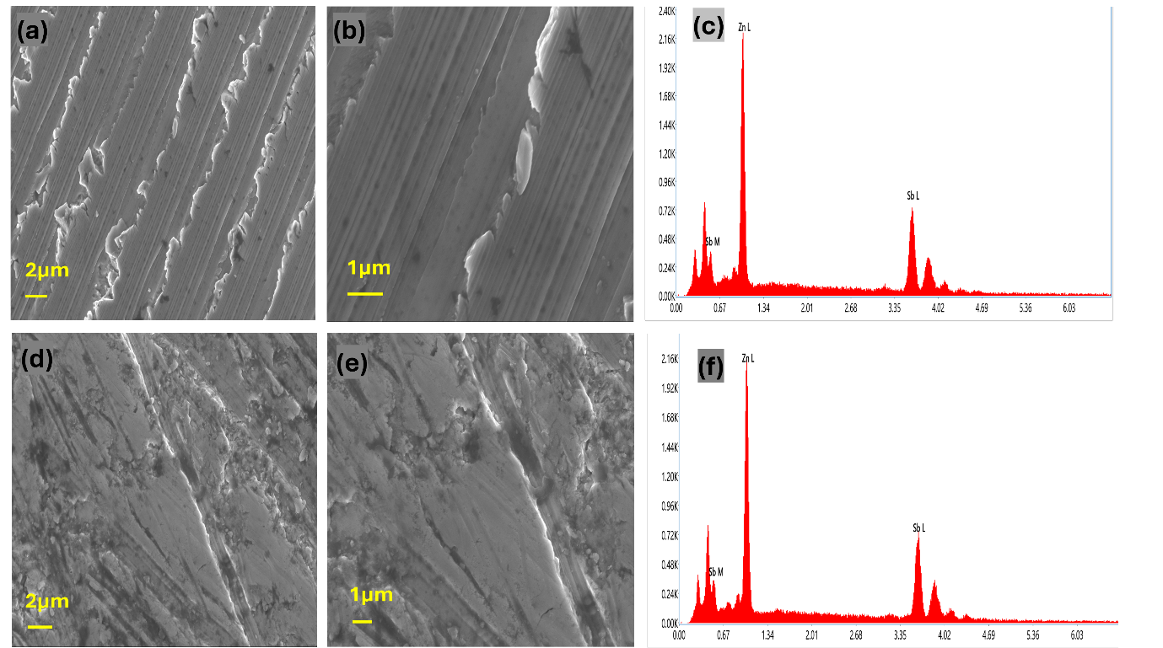
Figure s2: Field effect scanning electron microscopy with energy dispersive spectroscopy (FESEM-EDS) of the spark plasma sintered pellet of ZnSb, (a-c) as seen from the direction of pressing and (d-f) as seen from perpendicular to the pressing direction. FESEM images show good solid densification. Quantitative analysis of EDS spectra (c) and (b) show that estimated ratios of Zn and Sb are within 7% of planned 1:1 molar ratio.

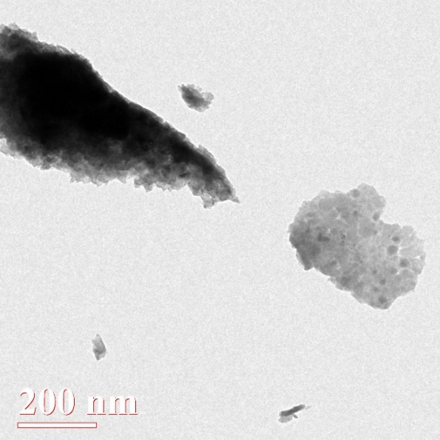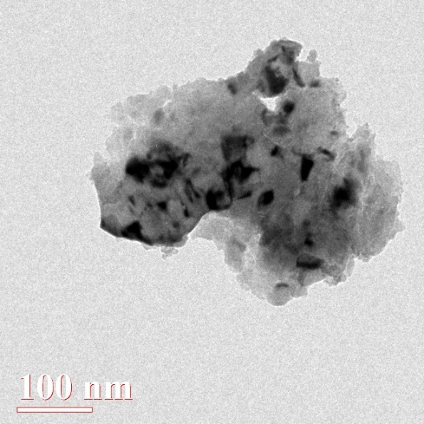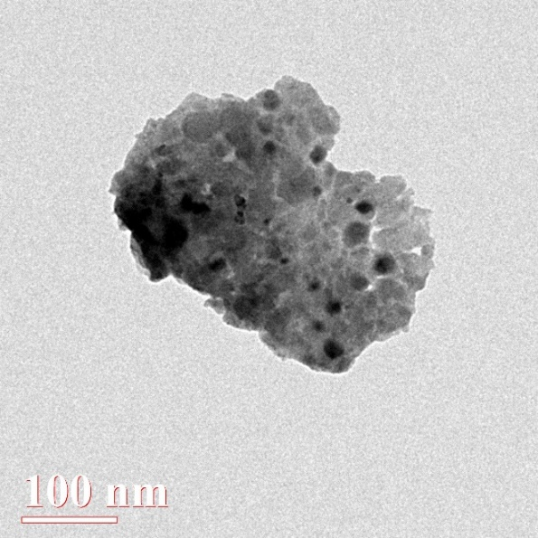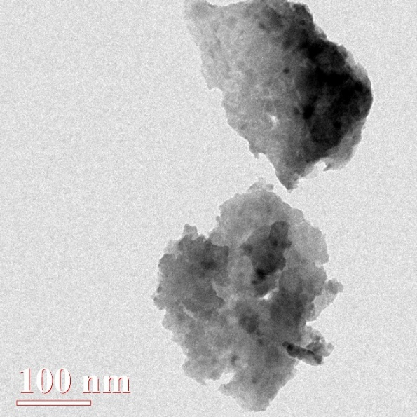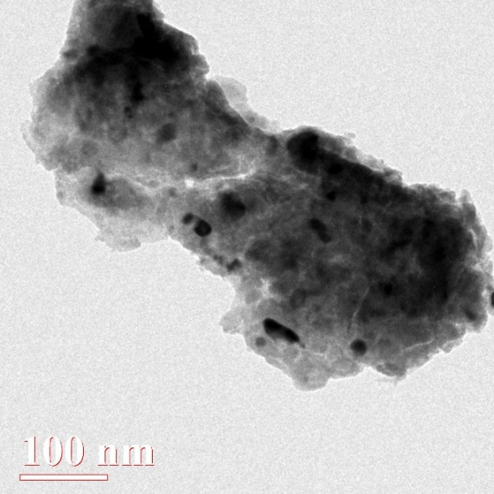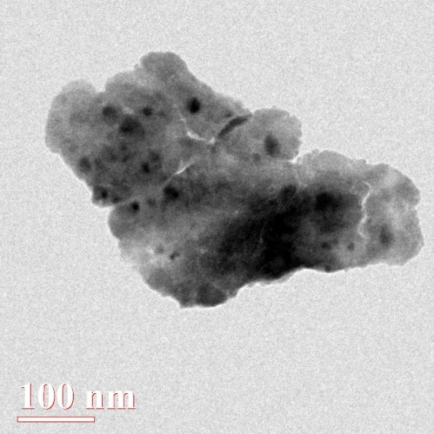
Figure s3: Some low-resolution HR-TEM images of ZnSb grains. It seems that such small sizes of crystallites observed in HR-TEM have not been able make significant diffraction contribution to broaden the PXRD patterns and average crystallite sizes calculated by Scherrer equation are significantly higher (85 nm).
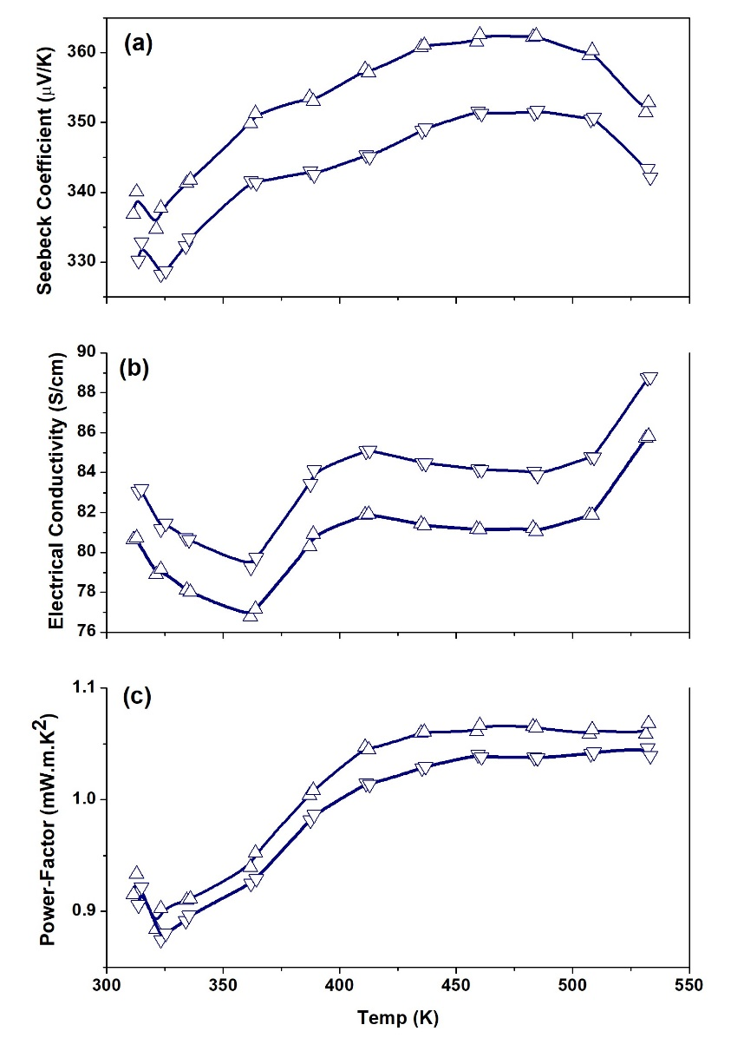
Figure s4: (a) Seebeck coefficient, (b) electrical conductivity and (c) Power-factor values of ZnSb nanomaterial by bottom-up physical process repeated in the direction of pressing by producing second batch of the composition.

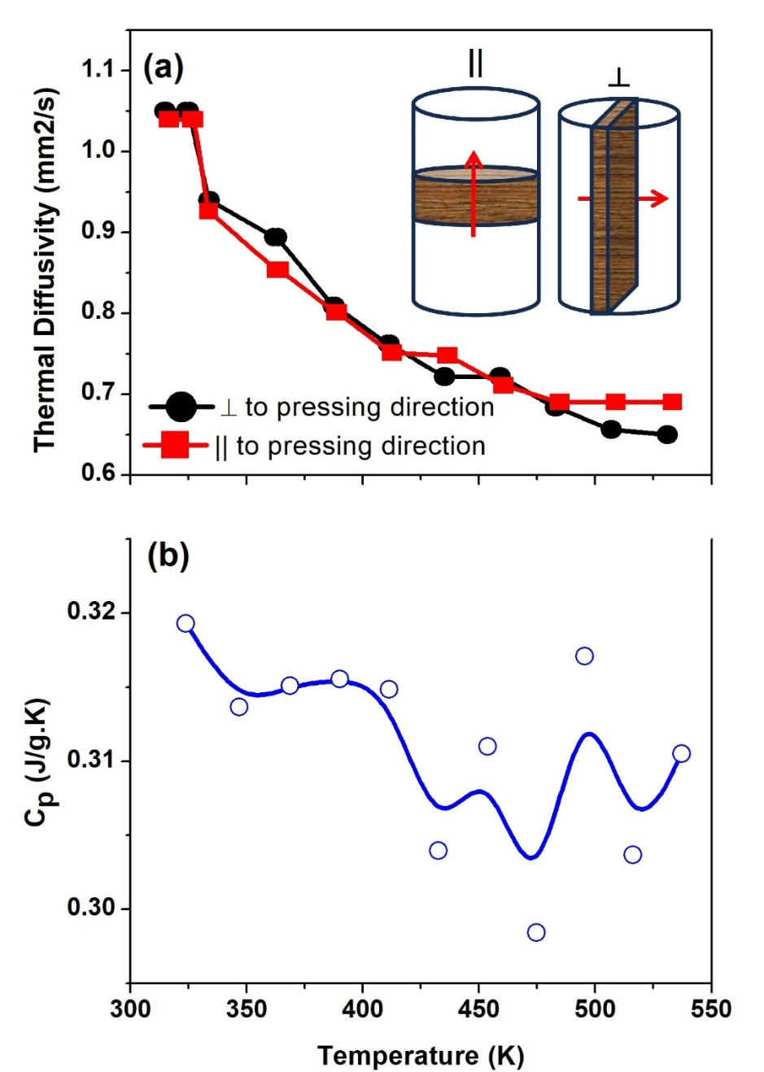
Figure s5: (a) Thermal diffusivity of ZnSb nanomaterial mostly remains below 1 mm²/s and (b) specific heat (about 58 J/mole-K) is somewhat higher than reported value of about 52 J/mole-K in ZnSb nanomaterial after SPS consolidation.

