SUPPLEMENTAL MATERIALS
Bidirectional Temporal Relationship between Obesity and Hyperinsulinemia: Longitudinal Observation from a Chinese Cohort
Chao Xu ^{1,2,3*}, Guangshuai Zhou ^{4,5*}, Meng Zhao^{1,2,3}, Xu Zhang^{1,2,3}, Li Fang^{1,2,3}, Qingbo Guan^{1,2,3}, Haiqing Zhang^{1,2,3}, Ling Gao^{2,3,6}, Tao Zhang^{4#}, Jiajun Zhao ^{1,2,3#}
¹ Department of Endocrinology and Metabolism, Shandong Provincial Hospital, Cheeloo College of Medicine, Shandong University, Jinan, Shandong,250021, China;
² Institute of Endocrinology, Shandong Academy of Clinical Medicine, Jinan 250021, Shandong, China;
³ Shandong Clinical Medical Center of Endocrinology and Metabolism, Jinan 250021, Shandong, China;
⁴ Department of Biostatistics, School of Public Health, Cheeloo College of Medicine, Shandong University, 250012, Jinan, Shandong, China;
⁵ Department of Quality Management Office, Zibo Central Hospital, Zibo 255036, Shandong, China
⁶Scientific Center, Shandong Provincial Hospital, Cheeloo College of Medicine, Shandong University, Jinan, Shandong,250021, China.

Running Title: Temporal Sequence between Obesity and insulin
The authors do not have any conflict of interest.
* These authors contributed equally.
#Correspondence & Reprints:
Jiajun Zhao, MD, PhD. Department of Endocrinology, Shandong Provincial Hospital affiliated to Shandong University, Jinan, Shandong, China.
Email: jjzhao@medmail.com.cn
Tao Zhang, MD, PhD, Department of Biostatistics, School of Public Health, Cheeloo College of Medicine, Shandong University. PO Box 100, 44 Wenhuaxi Road, Jinan, 250012, China.
Email: taozhang@sdu.edu.cn

Supplement Table S1. Pearson Correlation Coefficients Between BMI and Insulin，HOMA-IR or HOMA-%β*.
Variable | Baseline  BMI | Baseline  Insulin | Baseline  HOMA-IR | Baseline  HOMA-%β | Follow-up  BMI | Follow-up  Insulin | Follow-up  HOMA-IR
Baseline Insulin | 0.444 | … | … | … | … | … | …
Baseline HOMA-IR | 0.441 | 0.998 | … | … | … | … | …
Baseline HOMA-%β | 0.391 | 0.828 | 0.790 | … | … | … | …
Follow-up BMI | 0.770 | 0.401 | 0.399 | 0.341 | … | … | …
Follow-up Insulin | 0.424 | 0.572 | 0.570 | 0.482 | 0.485 | … | …
Follow-up HOMA-IR | 0.424 | 0.567 | 0.567 | 0.462 | 0.483 | 0.998 | …
Follow-up HOMA-%β | 0.337 | 0.503 | 0.485 | 0.568 | 0.411 | 0.831 | 0.794
BMI indicates body mass index. Insulin HOMA-IR and HOMA-%β were log-transformed for normal distribution.
*Adjusted for age, sex, smoking, drinking and follow-up years. Correlation coefficients >0.065 are significant (P<0.05).

Supplement Table S2. Pearson Correlation Coefficients Between WC and Insulin, HOMA-IR or HOMA-%β.
Variable | Baseline  WC | Baseline  Insulin | Baseline  HOMA-IR | Baseline  HOMA-%β | Follow-up  WC | Follow-up  Insulin | Follow-up  HOMA-IR
Baseline Insulin | 0.389 | … | … | … | … | … | …
Baseline HOMA-IR | 0.388 | 0.998 | … | … | … | … | …
Baseline HOMA-%β | 0.325 | 0.828 | 0.790 | … | … |  | …
Follow-up WC | 0.507 | 0.368 | 0.365 | 0.324 | … | … | …
Follow-up Insulin | 0.379 | 0.572 | 0.570 | 0.482 | 0.417 | … | …
Follow-up HOMA-IR | 0.378 | 0.567 | 0.567 | 0.462 | 0.418 | 0.998 | …
Follow-up HOMA-%β | 0.322 | 0.503 | 0.485 | 0.568 | 0.324 | 0.831 | 0.794
WC indicates waist circumference. Insulin HOMA-IR and HOMA-%β were log-transformed for normal distribution.
*Adjusted for age, sex, smoking, drinking and follow-up years. Correlation coefficients >0.065 are significant (P<0.05).

Supplement Table S3. Pearson Correlation Coefficients Between HC and Insulin, HOMA-IR or HOMA-%β*.
Variable | Baseline  HC | Baseline  Insulin | Baseline  HOMA-IR | Baseline  HOMA-%β | Follow-up  HC | Follow-up  Insulin | Follow-up  HOMA-IR
Baseline Insulin | 0.314 | … | … | … | … | … | …
Baseline HOMA-IR | 0.312 | 0.998 | … | … | … | … | …
Baseline HOMA-%β | 0.269 | 0.828 | 0.790 | … | … | …
Follow-up HC | 0.448 | 0.333 | 0.330 | 0.292 | … | … | …
Follow-up Insulin | 0.335 | 0.572 | 0.570 | 0.482 | 0.400 | … | …
Follow-up HOMA-IR | 0.328 | 0.567 | 0.567 | 0.462 | 0.399 | 0.998 | …
Follow-up HOMA-%β | 0.326 | 0.503 | 0.485 | 0.568 | 0.328 | 0.831 | 0.794
HC indicates hip circumference. Insulin HOMA-IR and HOMA-%β were log-transformed for normal distribution.
*Adjusted for age, sex, smoking, drinking and follow-up years. Correlation coefficients >0.065 are significant (P<0.05).

Supplement Table S4. Pearson Correlation Coefficients Between WHR and Insulin，HOMA-IR or HOMA-%β.
Variable | Baseline  WHR | Baseline  Insulin | Baseline  HOMA-IR | Baseline  HOMA-%β | Follow-up  WHR | Follow-up  Insulin | Follow-up  HOMA-IR
Baseline Insulin | 0.195 | … | … | … | … | … | …
Baseline HOMA-IR | 0.196 | 0.998 | … | … | … | … | …
Baseline HOMA-%β | 0.152 | 0.828 | 0.790 | … | … | … | …
Follow-up WHR | 0.255 | 0.198 | 0.197 | 0.174 | … | … | …
Follow-up Insulin | 0.151 | 0.572 | 0.570 | 0.482 | 0.200 | … | …
Follow-up HOMA-IR | 0.157 | 0.567 | 0.567 | 0.462 | 0.202 | 0.998 | …
Follow-up HOMA-%β | 0.068 | 0.503 | 0.485 | 0.568 | 0.138 | 0.831 | 0.794
WHR indicates waist-to-hip ratio. Insulin HOMA-IR and HOMA-%β were log-transformed for normal distribution.
*Adjusted for age, sex, smoking, drinking and follow-up years. Correlation coefficients >0.065 are significant (P<0.05).

Supplement Table S5. The cross-lagged path coefficients by sex, with adjustment for covariates.
 | Men (n=860) |  |  |  | Women (n=1633) |  |  | Sex difference
 | β₁ | β₂ |  | β₁ |  | β₂ |  | P for β₁ | P for β₂
BMI ↔ Insulin | 0.072* | 0.253* |  | 0.075* |  | 0.222* |  | 0.943 | 0.436
WC ↔ Insulin | 0.195* | 0.233* |  | 0.198* |  | 0.159* |  | 0.941 | 0.068
HC ↔ Insulin | 0.232* | 0.178* |  | 0.194* |  | 0.143* |  | 0.345 | 0.394
WHR ↔ Insulin | 0.167* | 0.116* |  | 0.148* |  | 0.054* |  | 0.644 | 0.139
BMI ↔ HOMA-IR | 0.071* | 0.254* |  | 0.076* |  | 0.225* |  | 0.905 | 0.466
WC ↔ HOMA-IR | 0.192* | 0.231* |  | 0.196* |  | 0.161* |  | 0.922 | 0.084
HC ↔ HOMA-IR | 0.229* | 0.176* |  | 0.192* |  | 0.142* |  | 0.359 | 0.408
WHR ↔ HOMA-IR | 0.166* | 0.115* |  | 0.146* |  | 0.058* |  | 0.627 | 0.173
BMI ↔ HOMA-%β | 0.062* | 0.207* |  | 0.045* |  | 0.153* |  | 0.686 | 0.186
WC ↔ HOMA-%β | 0.180* | 0.233* |  | 0.174* |  | 0.119* |  | 0.883 | 0.005
HC ↔ HOMA-%β | 0.215* | 0.184* |  | 0.166* |  | 0.130* |  | 0.228 | 0.189
WHR ↔ HOMA-%β | 0.140* | 0.121* |  | 0.139* |  | 0.011 |  | 0.981 | 0.009
Covariates included age, smoking, drinking and follow-up years.
BMI indicates body mass index; WC, waist circumference; HC, hip circumference; WHR, waist to hip ratio; HOMA-IR, homeostasis model assessment of insulin resistance; HOMA-%β, homeostasis model assessment of beta cell function. Insulin HOMA-IR and HOMA-%β were log-transformed for normal distribution.
β₁ describes the cross-lagged path coefficient from baseline Insulin, HOMA-IR or HOMA-%β to follow-up BMI/WC/HC/WHR; β₂ describes the cross-lagged path coefficient from baseline BMI/WC/HC/WHR to follow-up Insulin, HOMA-IR or HOMA-%β.
*P <0.05 for β₁ and β₂ being different from 0.

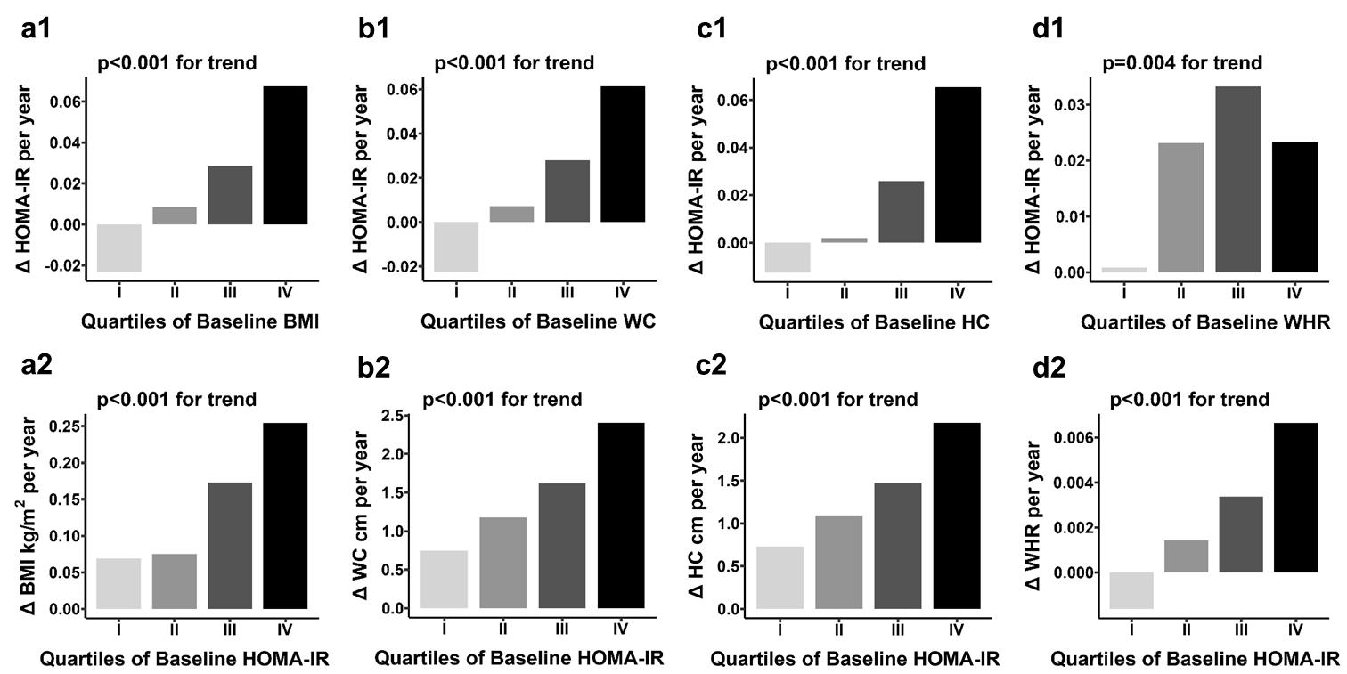
Supplement Figure S1. Yearly rates of change (Δ) of obesity measures and HOMA-IR by quartiles of their baseline values in the total sample, with adjustment of age, sex, smoking, drinking and their baseline values.
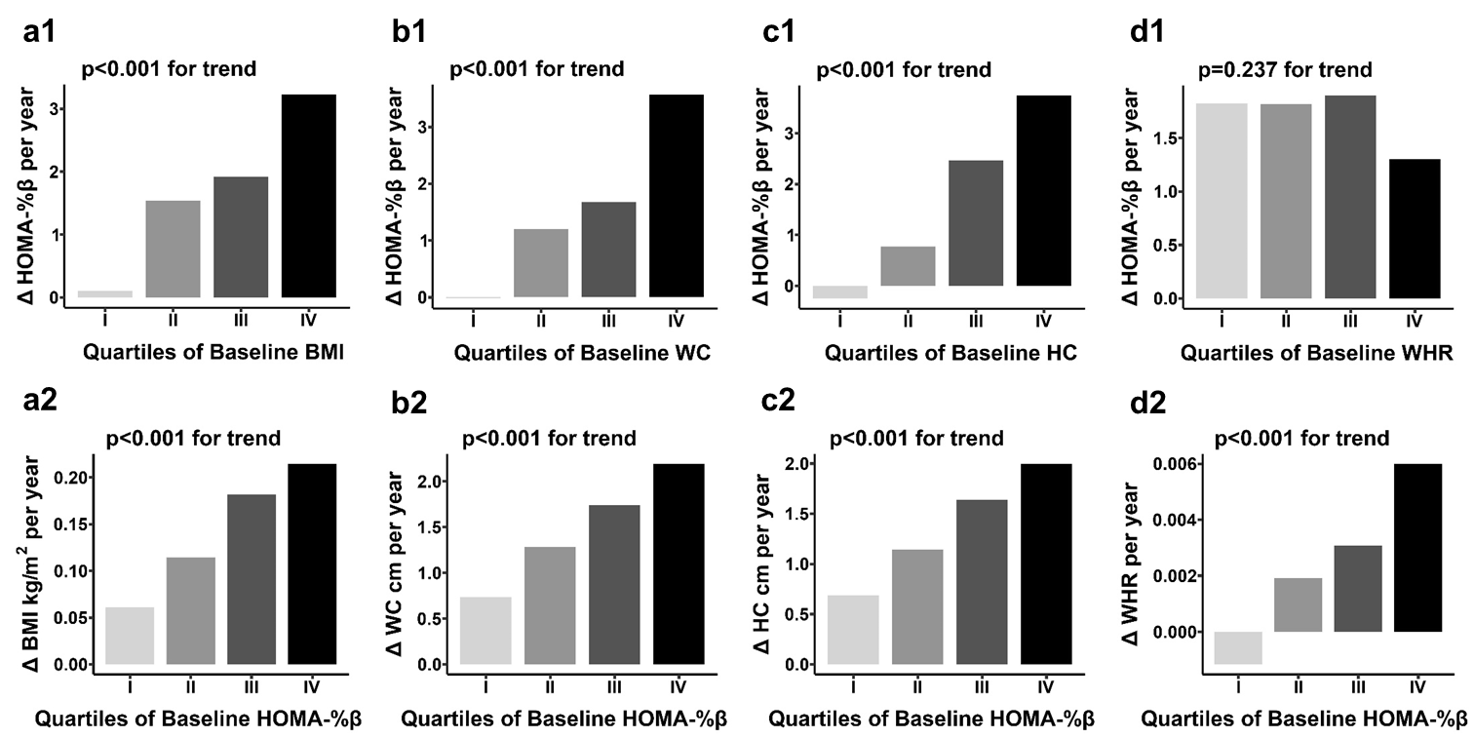
Supplement Figure S2. Yearly rates of change (Δ) of obesity measures and HOMA-%β by quartiles of their baseline values in the total sample, with adjustment of age, sex, smoking, drinking and their baseline values.

