Supplementary Information
Chiralify: A Framework for Fragmentation Modeling and Advanced Chiral Metabolite Annotation
Ruggiero Gorgoglione^{1,2,3,4}†, Valeria Impedovo^{3,4}†, Yujin Lee^{3,4}, Alessia Lodi^{3,4}*, Stefano Tiziani^{3,4,5,6,7}*
¹Department of Medicine and Surgery, LUM University, Casamassima, 70010, Italy.
²Biosciences, Biotechnologies and Biopharmaceutics Department, The University of Bari Aldo Moro, Bari, 70121, Italy.
³Department of Nutritional Sciences, College of Natural Sciences, The University of Texas at Austin, Austin, TX, 78712, USA.
⁴Dell Pediatric Research Institute, Dell Medical School, The University of Texas at Austin, Austin, TX, 78723, USA.
⁵Department of Pediatrics, Dell Medical School, The University of Texas at Austin, Austin, TX, 78723, USA.
⁶Division of Oncology, University of Texas at Austin Cancer Research Center, Dell Medical School, The University of Texas at Austin, Austin, 78712, TX, USA.

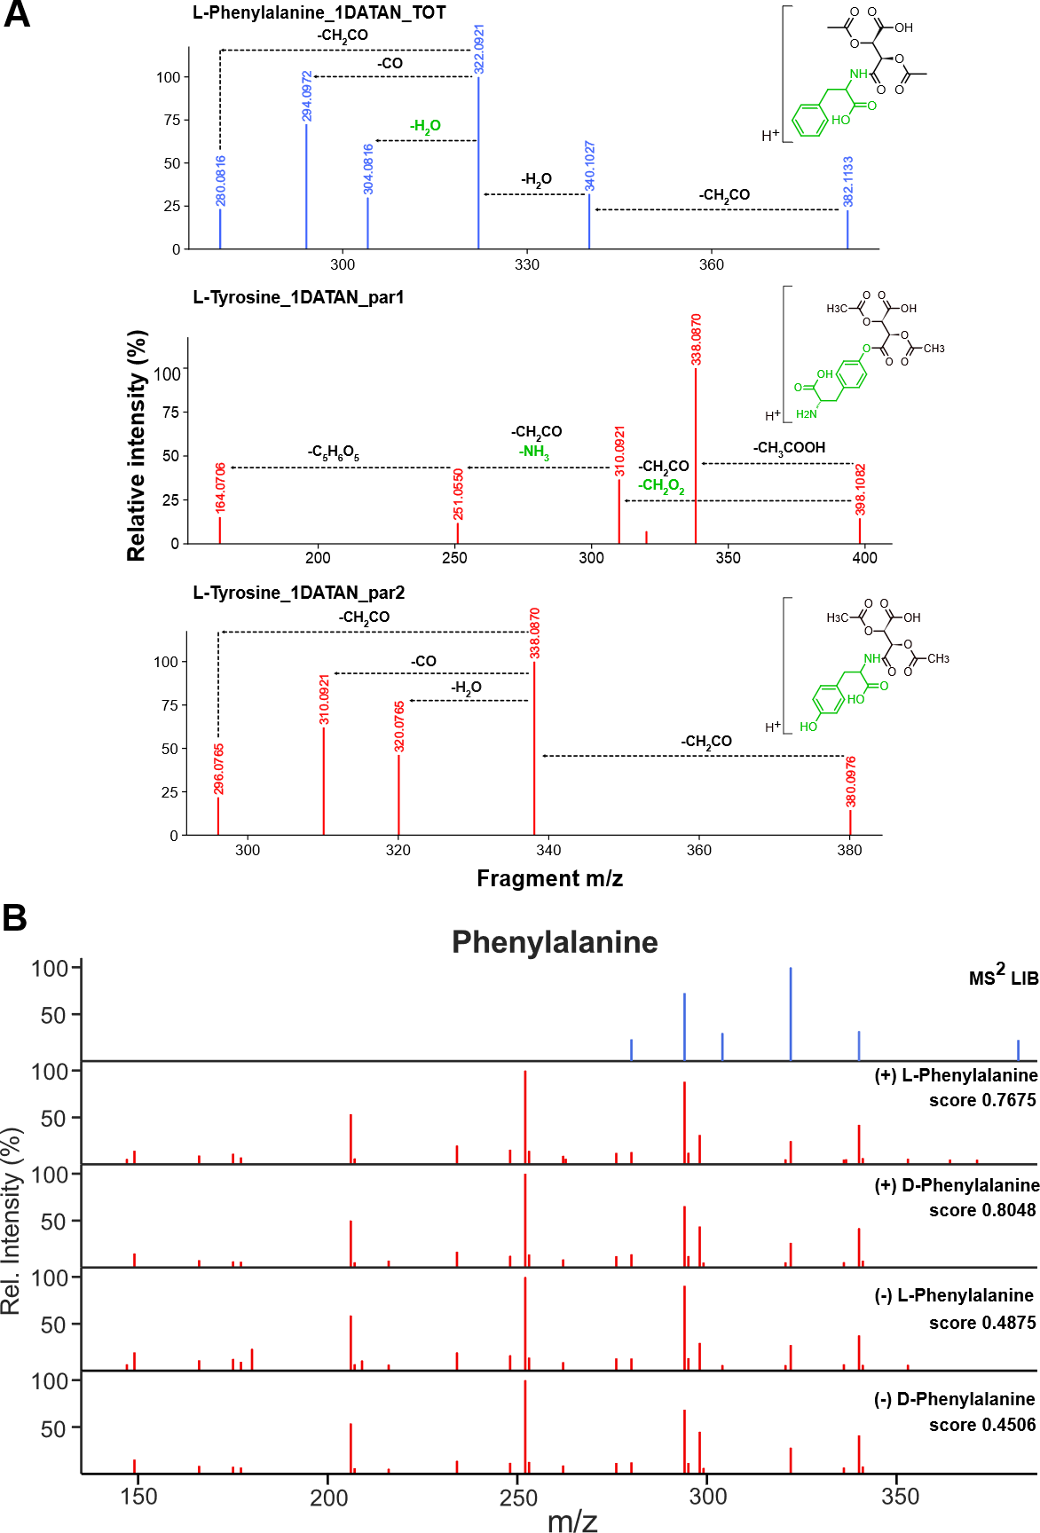
Supplementary Figure 1. Predicted and experimental spectra comparison. (A) Comparison of the predicted fragmentation spectra of ammonia-derivatized Phenylalanine_1DATAN_TOT and Tyrosine_1DATAN_par2 and hydroxy-derivatized Tyrosine_1DATAN_par1. The ammonia-derivatized aromatic amino acids show fragments generated from similar neutral losses, while the hydroxy-derivatized compound shows some different neutral losses including formate (CH₂O₂) and ammonia (NH₃). Notably, most losses occur on the DATAN moiety. (B) Spectral comparison between the predicted MS² spectra for phenylalanine and the experimental ones in (+)- and (-)-DATAN derivatized samples. The prediction of the MS² spectra for each entry of the library determines the score attributed to each assignment. The higher the similarity between experimental and real spectra, the higher is the score attributed to the assignment.
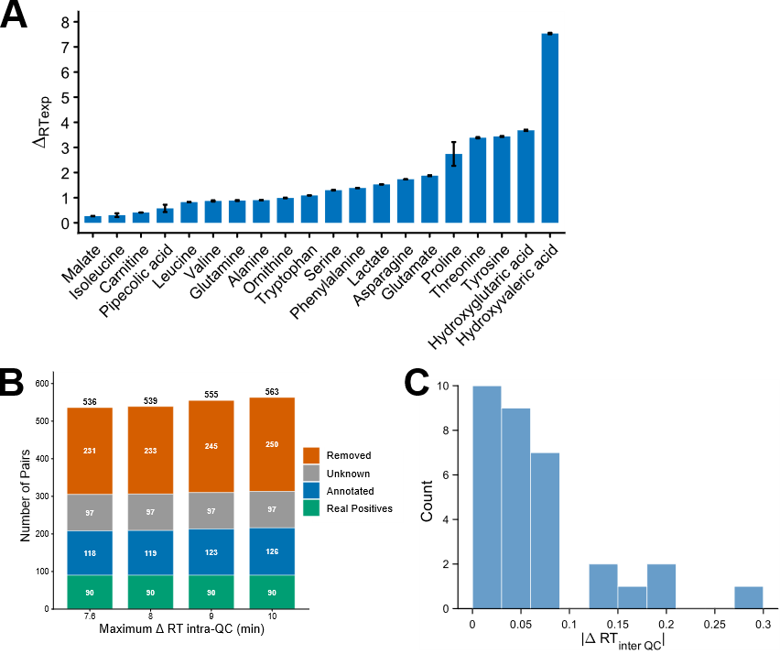
Supplementary Figure 2. Experimental optimization of the maximum ΔRT_intra-QC and ΔRT_inter-QC (A) Distribution of the ΔRT_intra-QC for each metabolite in the standard mix. The ΔRT ranges from a minimum of 0.27 minutes for malate to a maximum of 7.5 minutes for hydroxyvaleric acid. (B) Number of chiral pairs annotated by Chiralify when different maximum ΔRT_intra-QC are used. While the number of real positives remains the same, the number of candidate pairs slightly increases when a larger ΔRT window is used during candidate pair identification. (C) Distribution of the ΔRT_inter-QC for the standards calculated between the two derivatization modalities. Chiral pairs exhibit a maximum RT shift of 0.3 minutes between the two derivatization modalities.
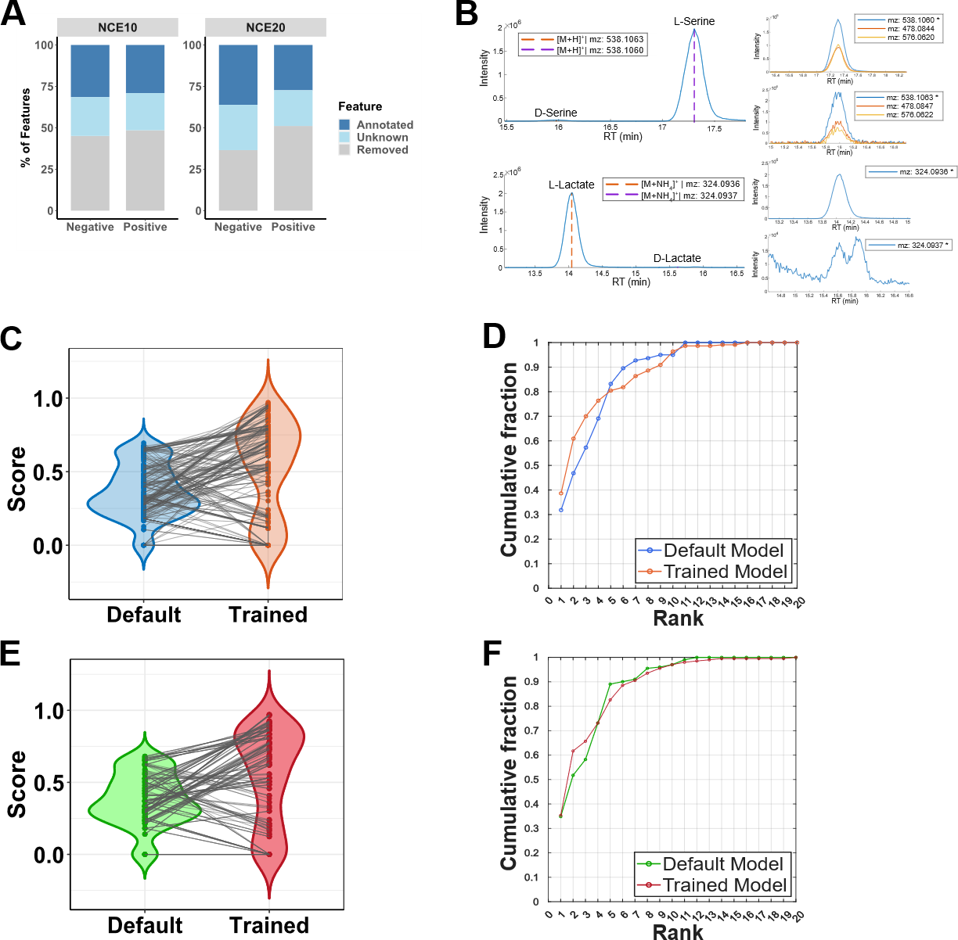
Supplementary Figure 3. Overview of the Chiralify performance (A) The results of Chiralify on the standard mix at NCE10 (left) and NCE20 (right). The bar plots show that at both collision energies, approximately 50% of the features (grey) are removed according to the chosen parameters. Only 20% of the features (light blue) remain unknown with the current small-molecules library, while the remaining 30% are annotated (dark blue). (B) Representative extracted-ion chromatograms demonstrating Chiralify’s ability to identify and annotate enantiomeric pairs with highly skewed abundance ratios. L/D-serine and L/D-lactate standards were analyzed at an L:D ratio of 1000:1, and Chiralify successfully detected the low-abundance D-enantiomeric peaks in the presence of the dominant L-enantiomers. (C) Comparison of the MS² scores attributed to each standard in the mix acquired on a Q-Exactive Hybrid quadrupole-Orbitrap MS and annotated using either the Default-Lib or the Trained-Lib at NCE20. (D) The CRF plot summarizes the distribution of assignment ranking positions at NCE 20 (Q-Exactive Hybrid quadrupole-Orbitrap MS). Compared to the Default-Lib, the Trained-Lib shows a steeper increase in CRF within the top five ranking positions, indicating a higher proportion of correct annotations being prioritized among the highest-scoring candidates. (E) MS² scores improvement for the standard mix acquired on an Orbitrap IQ-X Tribrid MS and annotated using either the Default-Lib or the Trained-Lib at NCE20. (F) Assignment ranking positions with the two libraries at NCE20 (Orbitrap IQ-X Tribrid MS).

Metabolite | Derivatized Monoisotopic Mass | Library RT | No of Chiral Centers | Class
L-Alanine | 305.07468106 | 10.54 | 1 | Amino Acid
D-Alanine | 305.07468106 | 9.3 | 1 | Amino Acid
L-Asparagine | 348.0804947 | 29.05 | 1 | Amino Acid
D-Asparagine | 348.0804947 | 27.2 | 1 | Amino Acid
L-Carnitine | 378.1394724 | 7.5 | 1 | Amino Acid
D-Carnitine | 378.1394724 | 7.9 | 1 | Amino Acid
Glycine | 291.059031 | 5.52 | 0 | Amino Acid
L-Glutamate | 363.080160364 | 8.3 | 1 | Amino Acid
D-Glutamate | 363.080160364 | 8.5 | 1 | Amino Acid
L-Glutamine | 344.085580092 | 27.2 | 1 | Amino Acid
D-Glutamine | 344.085580092 | 25.78 | 1 | Amino Acid
L-Hydroxyglutaric Acid | 364.064175952 | 12.86 | 1 | Hydroxy Acid
D-Hydroxyglutaric Acid | 364.064175952 | 16.2 | 1 | Hydroxy Acid
L-Hydroxyvaleric Acid | 334.089996776 | 46.9 | 1 | Hydroxy Acid
D-Hydroxyvaleric Acid | 334.089996776 | 51.5 | 1 | Hydroxy Acid
L-Isoleucine | 347.121631252 | 49.6 | 1 | Amino Acid
D-Isoleucine | 347.121631252 | 50.0 | 1 | Amino Acid
L-Lactate | 306.058696648 | 16.75 | 1 | Hydroxy Acid
D-Lactate | 306.058696648 | 17.95 | 1 | Hydroxy Acid
L-Leucine | 347.121631252 | 50.75 | 1 | Amino Acid
D-Leucine | 347.121631252 | 51.6 | 1 | Amino Acid
L-Malate | 350.048525888 | 7.73 | 1 | Hydroxy Acid
D-Malate | 350.048525888 | 8.75 | 1 | Hydroxy Acid
L-Ornithine | 564.143882816 | 11.1 | 1 | Amino Acid
D-Ornithine | 564.143882816 | 13.4 | 1 | Amino Acid
L-Phenylalanine | 381.105981188 | 54.17 | 1 | Amino Acid
D-Phenylalanine | 381.105981188 | 56.8 | 1 | Amino Acid
L-Pipecolic Acid | 345.105981188 | 34.9 | 1 | Amino Acid
D-Pipecolic Acid | 345.105981188 | 32.9 | 1 | Amino Acid
L-Proline | 331.090331124 | 19.3 | 1 | Amino Acid
D-Proline | 331.090331124 | 15.6 | 1 | Amino Acid
L-Serine | 537.096598276 | 19.4 | 1 | Amino Acid
D-Serine | 537.096598276 | 18.37 | 1 | Amino Acid
L-Threonine | 551.11224834 | 34.5 | 2 | Amino Acid
D-Threonine | 551.11224834 | 37.6 | 2 | Amino Acid
L-Tryptophan | 420.11688022 | 58.48 | 1 | Amino Acid
D-Tryptophan | 420.11688022 | 59.56 | 1 | Amino Acid
L-Tyrosine | 397.100895808 | 36 | 1 | Amino Acid
D-Tyrosine | 397.100895808 | 39.15 | 1 | Amino Acid
L-Valine | 333.105981188 | 33.92 | 1 | Amino Acid
D-Valine | 333.105981188 | 33.05 | 1 | Amino Acid
L-2-Aminoadipic Acid | 377.095810428 | 14.55 | 1 | Amino Acid
D-2-Aminoadipic Acid | 377.095810428 | 15.22 | 1 | Amino Acid
Supplementary Table S1. List of chiral and non chiral metabolites in the standard mix

Supplementary Table S2. The selected parameters for standards validation at NCE10 and NCE20.

Parameter | NCE 10 | NCE20
Minimum m/z MS1 (Da) | 290 | 290
Maximum m/z MS1 (Da) | 660 | 660
MS1 annotation tolerance (ppm) | 5e-06 | 5e-06
MS1 clustering tolerance (ppm) | 3.5e-06 | 4e-06
Minimum MS2 similarity score | 0.1 | 0.1
Minimum MS2 fragment count | 3 | 3
MS2 bin width (Da) | 0.01 | 0.01
Minimum MS2 relative intensity (%) | 5 | 4
Minimum m/z MS2 (Da) | 140 | 140
Minimum ΔRT intra-QC (min) | 0.2 | 0.2
Maximum ΔRT intra-QC (min) | 7.6 | 7.6
Maximum ΔRT inter-QC (min) | 0.4 | 0.5
Minimum RT inversion score | 0.05 | 0.2
Maximum RT inversion score | 7 | 14
Library for annotation | library_TrainedModel | library_TrainedModel
Selected adducts | [M+H]+|[M+NH4]+|[M+Na]+|[M+K]+ | [M+H]+|[M+NH4]+|[M+Na]+|[M+K]+
Adduct m/z shift | 1.00728|18.0338|22.9892|38.9632 | 1.00728|18.0338|22.9892|38.9632
Collision energy | msms10HCD | Msms20HCD
Number of parpool workers | 9 | 8

Cell Type | Cell Line | Parameters |  | Cell Type | Cell Line | Parameters
Acute Limphoblastic Leukemia | CCRFCEM | ms1_Min | 250 | Glioblastoma | A172 | 250
Acute Limphoblastic Leukemia | CCRFCEM | ms1_Max | 1000 | Glioblastoma | A172 | 1000
Acute Limphoblastic Leukemia | CCRFCEM | ms1_Toll_Ann | 5e-06 | Glioblastoma | A172 | 5e-06
Acute Limphoblastic Leukemia | CCRFCEM | ms1_Toll_Comp | 5e-06 | Glioblastoma | A172 | 5e-06
Acute Limphoblastic Leukemia | CCRFCEM | ms2Score_TRS | 0.1 | Glioblastoma | A172 | 0.07
Acute Limphoblastic Leukemia | CCRFCEM | Nmzlimit | 3 | Glioblastoma | A172 | 3
Acute Limphoblastic Leukemia | CCRFCEM | t | 0.01 | Glioblastoma | A172 | 0.01
Acute Limphoblastic Leukemia | CCRFCEM | minInt | 10 | Glioblastoma | A172 | 10
Acute Limphoblastic Leukemia | CCRFCEM | ms2_Min | 140 | Glioblastoma | A172 | 140
Acute Limphoblastic Leukemia | CCRFCEM | RT_min_intra | 0.2 | Glioblastoma | A172 | 0.2
Acute Limphoblastic Leukemia | CCRFCEM | RT_max_intra | 8 | Glioblastoma | A172 | 8
Acute Limphoblastic Leukemia | CCRFCEM | RT_max_INTER | 0.5 | Glioblastoma | A172 | 1
Acute Limphoblastic Leukemia | CCRFCEM | RTinvScore_Min | 0.1 | Glioblastoma | A172 | 0.1
Acute Limphoblastic Leukemia | CCRFCEM | RTinvScore_Max | 10 | Glioblastoma | A172 | 10
Acute Limphoblastic Leukemia | CCRFCEM | Input_Library | library_TrainedModel | Glioblastoma | A172 | library_TrainedModel
Acute Limphoblastic Leukemia | CCRFCEM | adducts | [M+H]+|[M+NH4]+|[M+Na]+|[M+K]+ | Glioblastoma | A172 | [M+H]+|[M+NH4]+|[M+Na]+|[M+K]+
Acute Limphoblastic Leukemia | CCRFCEM | massShift | 1.00728|18.0338|22.9892|38.9632 | Glioblastoma | A172 | 1.00728|18.0338|22.9892|38.9632
Acute Limphoblastic Leukemia | CCRFCEM | fragmentation | msms10HCD | Glioblastoma | A172 | msms10HCD
Acute Limphoblastic Leukemia | PF-382 | ms1_Min | 250 | Glioblastoma | U251 | 250
Acute Limphoblastic Leukemia | PF-382 | ms1_Max | 1000 | Glioblastoma | U251 | 1000
Acute Limphoblastic Leukemia | PF-382 | ms1_Toll_Ann | 5e-06 | Glioblastoma | U251 | 5e-06
Acute Limphoblastic Leukemia | PF-382 | ms1_Toll_Comp | 5e-06 | Glioblastoma | U251 | 5e-06
Acute Limphoblastic Leukemia | PF-382 | ms2Score_TRS | 0.1 | Glioblastoma | U251 | 0.1
Acute Limphoblastic Leukemia | PF-382 | Nmzlimit | 3 | Glioblastoma | U251 | 3
Acute Limphoblastic Leukemia | PF-382 | t | 0.01 | Glioblastoma | U251 | 0.01
Acute Limphoblastic Leukemia | PF-382 | minInt | 5 | Glioblastoma | U251 | 5
Acute Limphoblastic Leukemia | PF-382 | ms2_Min | 140 | Glioblastoma | U251 | 140
Acute Limphoblastic Leukemia | PF-382 | RT_min_intra | 0.2 | Glioblastoma | U251 | 0.2
Acute Limphoblastic Leukemia | PF-382 | RT_max_intra | 8 | Glioblastoma | U251 | 8
Acute Limphoblastic Leukemia | PF-382 | RT_max_INTER | 1 | Glioblastoma | U251 | 1
Acute Limphoblastic Leukemia | PF-382 | RTinvScore_Min | 0.1 | Glioblastoma | U251 | 0.1
Acute Limphoblastic Leukemia | PF-382 | RTinvScore_Max | 10 | Glioblastoma | U251 | 10
Acute Limphoblastic Leukemia | PF-382 | Input_Library | library_TrainedModel | Glioblastoma | U251 | library_TrainedModel
Acute Limphoblastic Leukemia | PF-382 | adducts | [M+H]+|[M+NH4]+|[M+Na]+|[M+K]+ | Glioblastoma | U251 | [M+H]+|[M+NH4]+|[M+Na]+|[M+K]+
Acute Limphoblastic Leukemia | PF-382 | massShift | 1.00728|18.0338|22.9892|38.9632 | Glioblastoma | U251 | 1.00728|18.0338|22.9892|38.9632
Acute Limphoblastic Leukemia | PF-382 | fragmentation | msms10HCD | Glioblastoma | U251 | msms10HCD
Supplementary Table S3. Selected cancer cell lines and parameters settings

Cell Type | Cell Line | Parameters |  | Cell Type | Cell Line
Pancreatic Cancer | Panc04.03 | ms1_Min | 250 | Prostate Cancer | LnCaP | 250
Pancreatic Cancer | Panc04.03 | ms1_Max | 1000 | Prostate Cancer | LnCaP | 1000
Pancreatic Cancer | Panc04.03 | ms1_Toll_Ann | 5e-06 | Prostate Cancer | LnCaP | 5e-06
Pancreatic Cancer | Panc04.03 | ms1_Toll_Comp | 5e-06 | Prostate Cancer | LnCaP | 1e-05
Pancreatic Cancer | Panc04.03 | ms2Score_TRS | 0.1 | Prostate Cancer | LnCaP | 0.1
Pancreatic Cancer | Panc04.03 | Nmzlimit | 3 | Prostate Cancer | LnCaP | 3
Pancreatic Cancer | Panc04.03 | t | 0.01 | Prostate Cancer | LnCaP | 0.01
Pancreatic Cancer | Panc04.03 | minInt | 5 | Prostate Cancer | LnCaP | 5
Pancreatic Cancer | Panc04.03 | ms2_Min | 140 | Prostate Cancer | LnCaP | 140
Pancreatic Cancer | Panc04.03 | RT_min_intra | 0.2 | Prostate Cancer | LnCaP | 0.2
Pancreatic Cancer | Panc04.03 | RT_max_intra | 8 | Prostate Cancer | LnCaP | 8
Pancreatic Cancer | Panc04.03 | RT_max_INTER | 0.5 | Prostate Cancer | LnCaP | 1
Pancreatic Cancer | Panc04.03 | RTinvScore_Min | 0.1 | Prostate Cancer | LnCaP | 0.1
Pancreatic Cancer | Panc04.03 | RTinvScore_Max | 10 | Prostate Cancer | LnCaP | 10
Pancreatic Cancer | Panc04.03 | Input_Library | library_TrainedModel | Prostate Cancer | LnCaP | library_TrainedModel
Pancreatic Cancer | Panc04.03 | adducts | [M+H]+|[M+NH4]+|[M+Na]+|[M+K]+ | Prostate Cancer | LnCaP | [M+H]+|[M+NH4]+|[M+Na]+|[M+K]+
Pancreatic Cancer | Panc04.03 | massShift | 1.00728|18.0338|22.9892|38.9632 | Prostate Cancer | LnCaP | 1.00728|18.0338|22.9892|38.9632
Pancreatic Cancer | Panc04.03 | fragmentation | msms10HCD | Prostate Cancer | LnCaP | msms10HCD
Pancreatic Cancer | Panc10.05 | ms1_Min | 250 | Prostate Cancer | PC3 | 250
Pancreatic Cancer | Panc10.05 | ms1_Max | 1000 | Prostate Cancer | PC3 | 1000
Pancreatic Cancer | Panc10.05 | ms1_Toll_Ann | 5e-06 | Prostate Cancer | PC3 | 5e-06
Pancreatic Cancer | Panc10.05 | ms1_Toll_Comp | 5e-06 | Prostate Cancer | PC3 | 7e-06
Pancreatic Cancer | Panc10.05 | ms2Score_TRS | 0.1 | Prostate Cancer | PC3 | 0.1
Pancreatic Cancer | Panc10.05 | Nmzlimit | 3 | Prostate Cancer | PC3 | 3
Pancreatic Cancer | Panc10.05 | t | 0.01 | Prostate Cancer | PC3 | 0.01
Pancreatic Cancer | Panc10.05 | minInt | 5 | Prostate Cancer | PC3 | 5
Pancreatic Cancer | Panc10.05 | ms2_Min | 140 | Prostate Cancer | PC3 | 140
Pancreatic Cancer | Panc10.05 | RT_min_intra | 0.2 | Prostate Cancer | PC3 | 0.2
Pancreatic Cancer | Panc10.05 | RT_max_intra | 8 | Prostate Cancer | PC3 | 8
Pancreatic Cancer | Panc10.05 | RT_max_INTER | 1 | Prostate Cancer | PC3 | 1
Pancreatic Cancer | Panc10.05 | RTinvScore_Min | 0.1 | Prostate Cancer | PC3 | 0.1
Pancreatic Cancer | Panc10.05 | RTinvScore_Max | 10 | Prostate Cancer | PC3 | 10
Pancreatic Cancer | Panc10.05 | Input_Library | library_TrainedModel | Prostate Cancer | PC3 | library_TrainedModel
Pancreatic Cancer | Panc10.05 | adducts | [M+H]+|[M+NH4]+|[M+Na]+|[M+K]+ | Prostate Cancer | PC3 | [M+H]+|[M+NH4]+|[M+Na]+|[M+K]+
Pancreatic Cancer | Panc10.05 | massShift | 1.00728|18.0338|22.9892|38.9632 | Prostate Cancer | PC3 | 1.00728|18.0338|22.9892|38.9632
Pancreatic Cancer | Panc10.05 | fragmentation | msms10HCD | Prostate Cancer | PC3 | msms10HCD

