Supplementary Material

Table S1: Spearman correlation between non-invasive biomarkers, including fecal calprotectin, fecal immunochemical test, and serum C-reactive protein, in patients with inflammatory bowel disease

Biomarker | Comparison | Spearman’s r | P-value
LAA | FEIA | 0.96 | < 0.05
LAA | CLIA | 0.95 | < 0.05
FEIA | CLIA | 0.95 | < 0.05
FIT | LAA | 0.62 | < 0.05
FIT | FEIA | 0.61 | < 0.05
FIT | CLIA | 0.58 | < 0.05
CRP | LAA | 0.14 | 0.11
CRP | FEIA | 0.16 | 0.07
CRP | CLIA | 0.14 | 0.10
CRP | FIT | 0.19 | 0.03

Abbreviations: LAA = latex agglutination assay; FEIA = fluoroenzyme immunoassay; CLIA = chemiluminescent immunoassay; FIT = fecal immunochemical test; CRP = C-reactive protein

Figure S1: Area under Receiver operating characteristic (AUROC) curves demonstrating the performance of non-invasive biomarkers for predicting endoscopic remission in (A) overall IBD, (B) ulcerative colitis, and (C) Crohn’s disease.
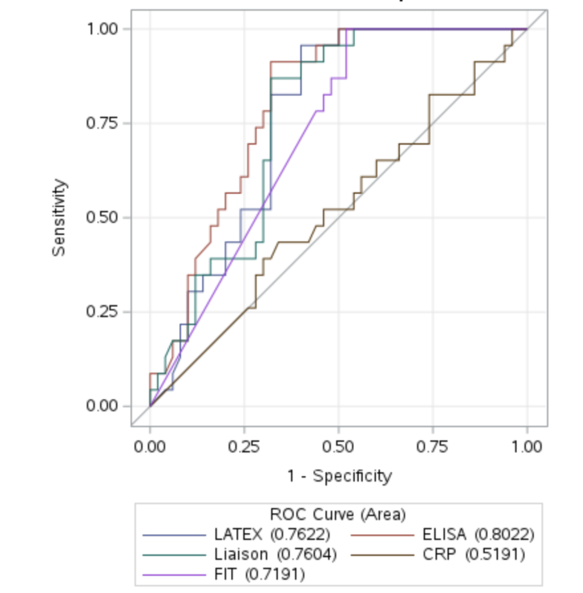
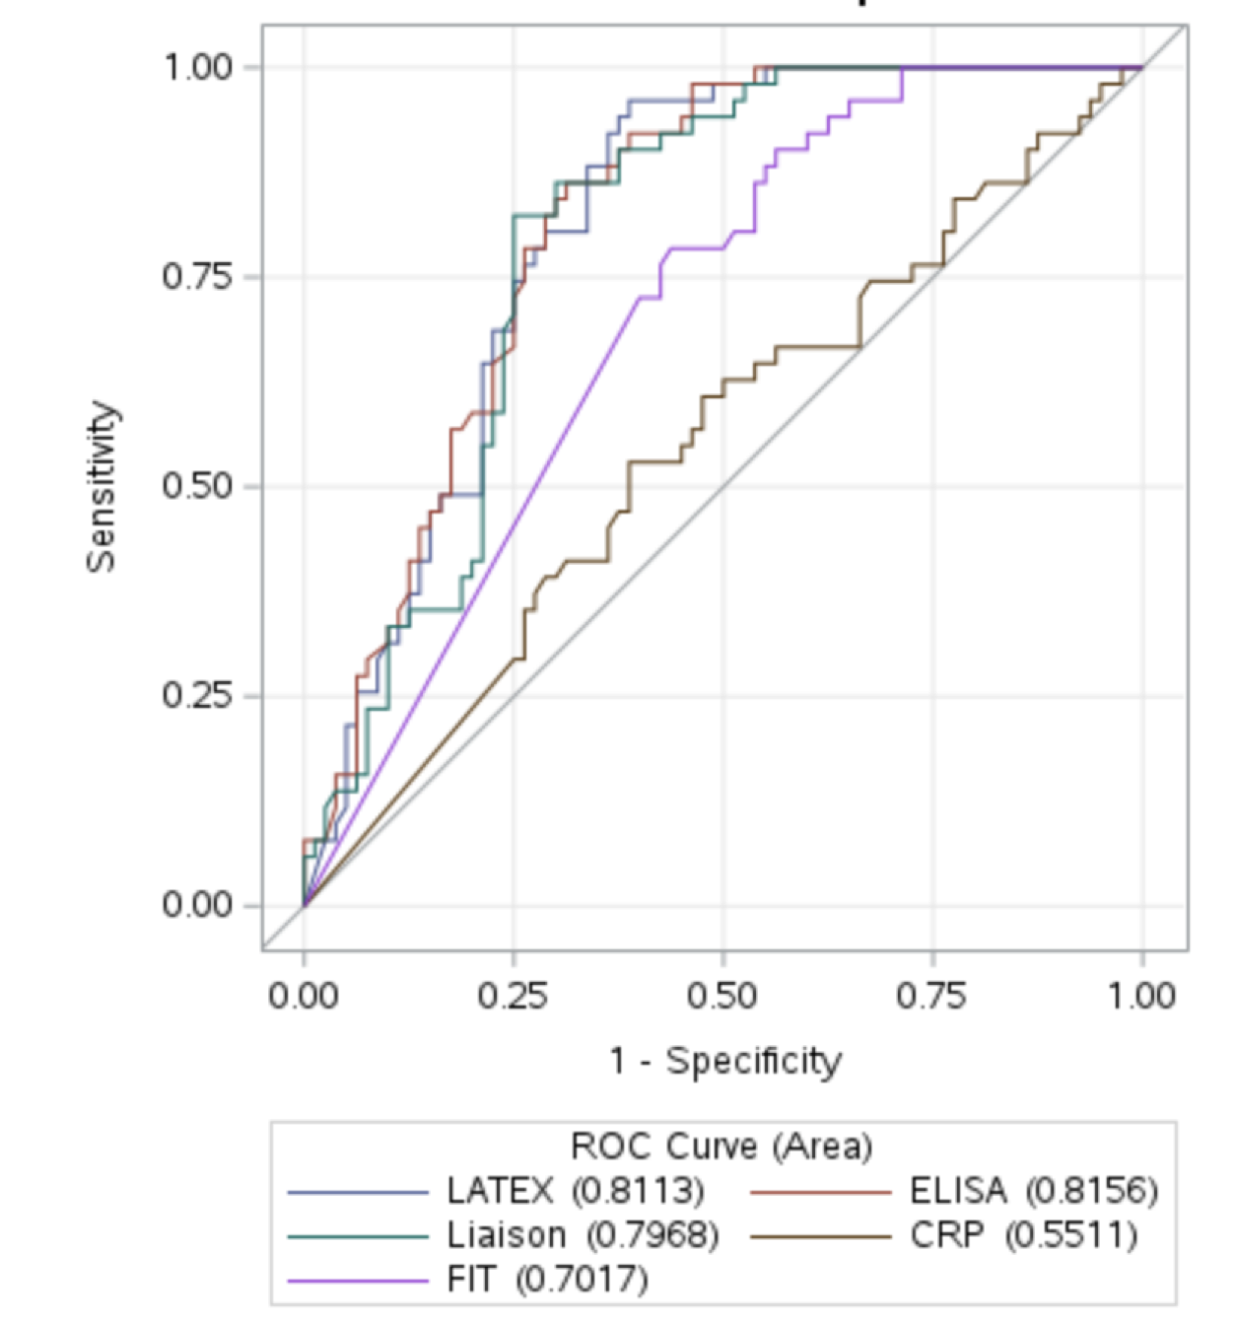
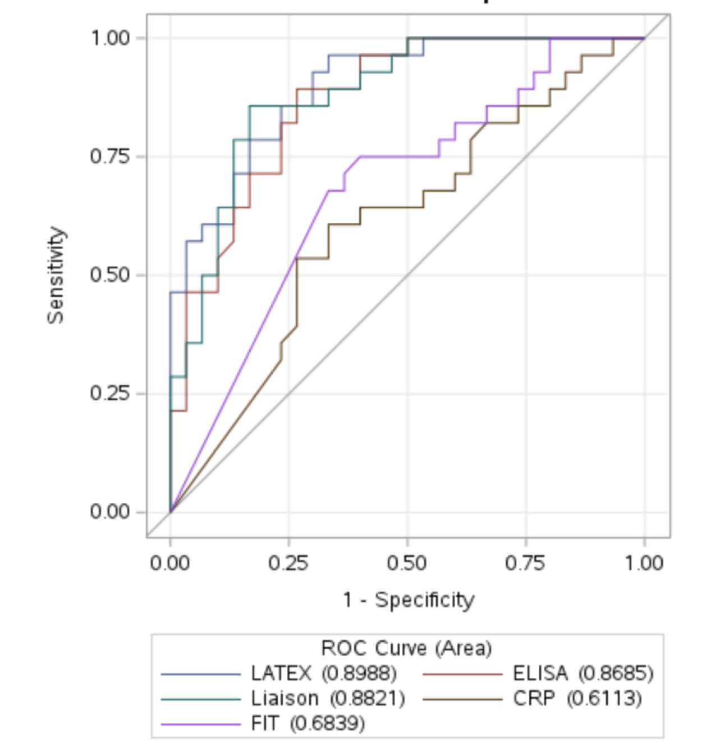
A
B
C

