Supplementary Information
Supplementary Methods
Section 1 Scenario setting and CDR demand calibration
We used GCAM-CDR v1.0.2 to construct one Reference scenario and four alternative net-zero scenarios for 2020-2050. The Reference scenario follows standard GCAM assumptions without a global climate mitigation policy. The four alternative scenarios all achieve global net-zero greenhouse gas emissions in 2050 and are differentiated by the level of CDR demand and whether international CDR trade is enabled. LowCDR-Trade and HighCDR-Trade use global CDR demands of 0.67 and 11.86 GtCO2 in 2050, respectively; LowCDR-NoTrade and HighCDR-NoTrade keep the same regional CDR demands as the corresponding trade scenarios but require each region to meet its demand domestically.
CDR demand was implemented using an elastic demand source in GCAM-CDR. The resulting S-curve links annual CDR demand to the carbon price, with slow initial growth at low prices and rapid growth once carbon prices rise. The carbon-price parameters for LowCDR and HighCDR were calibrated from the 95th and 5th percentiles of 2050 carbon prices in the scenario database, corresponding to 1749.57 and 142.90 USD2010/tCO2, respectively. Four CDR technologies compete to satisfy this demand: direct air capture (DAC), bioenergy with carbon capture and storage (BECCS), ocean enhanced weathering (OEW), and terrestrial enhanced weathering (TEW).
Section 2 Representation of CDR trade
International CDR trade is represented through an Armington-style trading system. Under trade, regional CDR demands are pooled into a global CDR credit market, and CDR supply is allocated across regions according to regional CDR prices, the weighted global carbon price, an Armington elasticity of substitution, and regional capacity weights. The capacity weight is calculated as each region's share of GDP in the Reference scenario at each model period. This setup treats imported and domestic CDR credits as interchangeable from the buyer's perspective. Under no-trade scenarios, each region must satisfy its own CDR demand using domestic resources only.
Section 3 Atmospheric chemistry simulation
We used the chemical transport model GEOS-Chem v14.0.0 (http://geos-chem.org) to simulate global air quality measured by PM2.5 concentrations under the Reference, LowCDR-Trade, LowCDR-NoTrade, HighCDR-Trade, and HighCDR-NoTrade scenarios. The simulations cover 2020-2050 at 4 deg x 5 deg horizontal resolution with 47 vertical levels. The top of the lowest model layer is approximately 100 m. Following GEOS-Chem recommendations, chemical and transport operator durations were set to 20 min and 10 min, respectively, with non-local boundary-layer mixing. Each simulation used a one-month spin-up to reduce sensitivity to initial conditions. Meteorological inputs were derived from the MERRA-2 assimilated meteorological fields.
The anthropogenic emissions inventories were compiled from EDGAR v4.3.1 and CEDS v2. EDGAR provides agricultural waste-burning emissions, while CEDS provides emissions from international shipping (SHP), waste (WST), solvent production and application (SLV), residential, commercial and other combustion (RCO), transportation (TRA), industrial activities (IND), energy (ENE), and agriculture (AGR). The inventory processing included NO, CO, SO2, NH3, BC, OC, and NMVOC; the subsequent driver analysis focuses on the PM2.5-relevant precursor groups BC, OC, NH3, NMVOC, SO2, and NOX. The mapping between GCAM-CDR sectors and GEOS-Chem inventory sectors is shown in Table S1. For each sector, annual emissions from GCAM-CDR were first aggregated according to the mapping and then spatially downscaled using region-to-grid ratios from the compiled reference inventory.
We used satellite-derived PM2.5 estimates from the Atmospheric Composition Analysis Group at 0.1 deg x 0.1 deg resolution to validate the GEOS-Chem PM2.5 simulations. Outliers and negative values were removed before aggregating the observational data to the 4 deg x 5 deg GEOS-Chem grid. Model performance was evaluated with mean bias (MB), normalized mean bias (NMB), normalized mean error (NME), root mean square error (RMSE), and Pearson correlation coefficient (R):
$$\begin{aligned}MB=\frac{\sum_{1}^{n}{\left({\hat{y}}_{n}-y_{n}\right)}}{n}×100\%\#S4\end{aligned}$$
$$\begin{aligned}NME=\frac{\sum_{1}^{n}{\left|{\hat{y}}_{n}-y_{n}\right|}}{\sum_{1}^{n}{y_{n}}}×100\%\#S5\end{aligned}$$
$$\begin{aligned}NMB=\frac{\sum_{1}^{n}{\left({\hat{y}}_{n}-y_{n}\right)}}{\sum_{1}^{n}{y_{n}}}×100\%\#S6\end{aligned}$$
$$\begin{aligned}RMSE=\sqrt{\frac{1}{n}×\sum_{1}^{n}{{\left({\hat{y}}_{n}-y_{n}\right)}^{2}}}\#S7\end{aligned}$$
$$\begin{aligned}R=\frac{\sum{\left({\hat{y}}_{n}-{\overline{\hat{y}}}_{n}\right)\left(y_{n}-{\overline{y}}_{n}\right)}}{\sqrt{{\sum{\left({\hat{y}}_{n}-{\overline{\hat{y}}}_{n}\right)}}^{2}{\sum{\left(y_{n}-{\overline{y}}_{n}\right)}}^{2}}}\#S8\end{aligned}$$
where MB, NME, NMB, RMSE, and R represent mean bias, normalized mean error, normalized mean bias, root mean square error, and Pearson correlation coefficient, respectively; M and O represent modeled and observational values, respectively. Monthly model validation is shown in Figure S1 and Table S2.

Table S1. Sector mapping between the emissions inventory sectors used in GEOS-Chem and the sectors represented in GCAM-CDR.
Sectors in emission inventory | Sectors in GCAM-CDR
ENE | backup_electricity; csp_backup; district heat; elec_biomass (conv); elec_biomass (IGCC); elec_coal (conv pul); elec_coal (IGCC); elec_gas (CC); elec_gas (steam/CT); elec_refined liquids (CC); elec_refined liquids (steam/CT); electricity; electricity_net_ownuse
AGR | beef; biomass; corn; dairy; fibercrop;  foddergrass; fodderherb; misccrop; oilcrop; othergrain; palmfruit; pork; poultry; rice; roottuber; sheepgoat; sugarcrop; unmanagedland; wheat
IND | cement; gas pipeline; H₂ central production; H₂ forecourt production; industrial energy use; industrial feedstocks; industrial processes; N fertilizer; process heat cement
RCO | comm cooling; comm heating; comm others; resid cooling; resid heating; resid others; urban processes
TRA | trn_aviation_intl; trn_freight; trn_freight_road; trn_pass; trn_pass_road; trn_pass_road_bus; trn_pass_road_LDV; trn_pass_road_LDV_2W; trn_pass_road_LDV_4W
SHP | trn_shipping_intl
SLV | gas processing

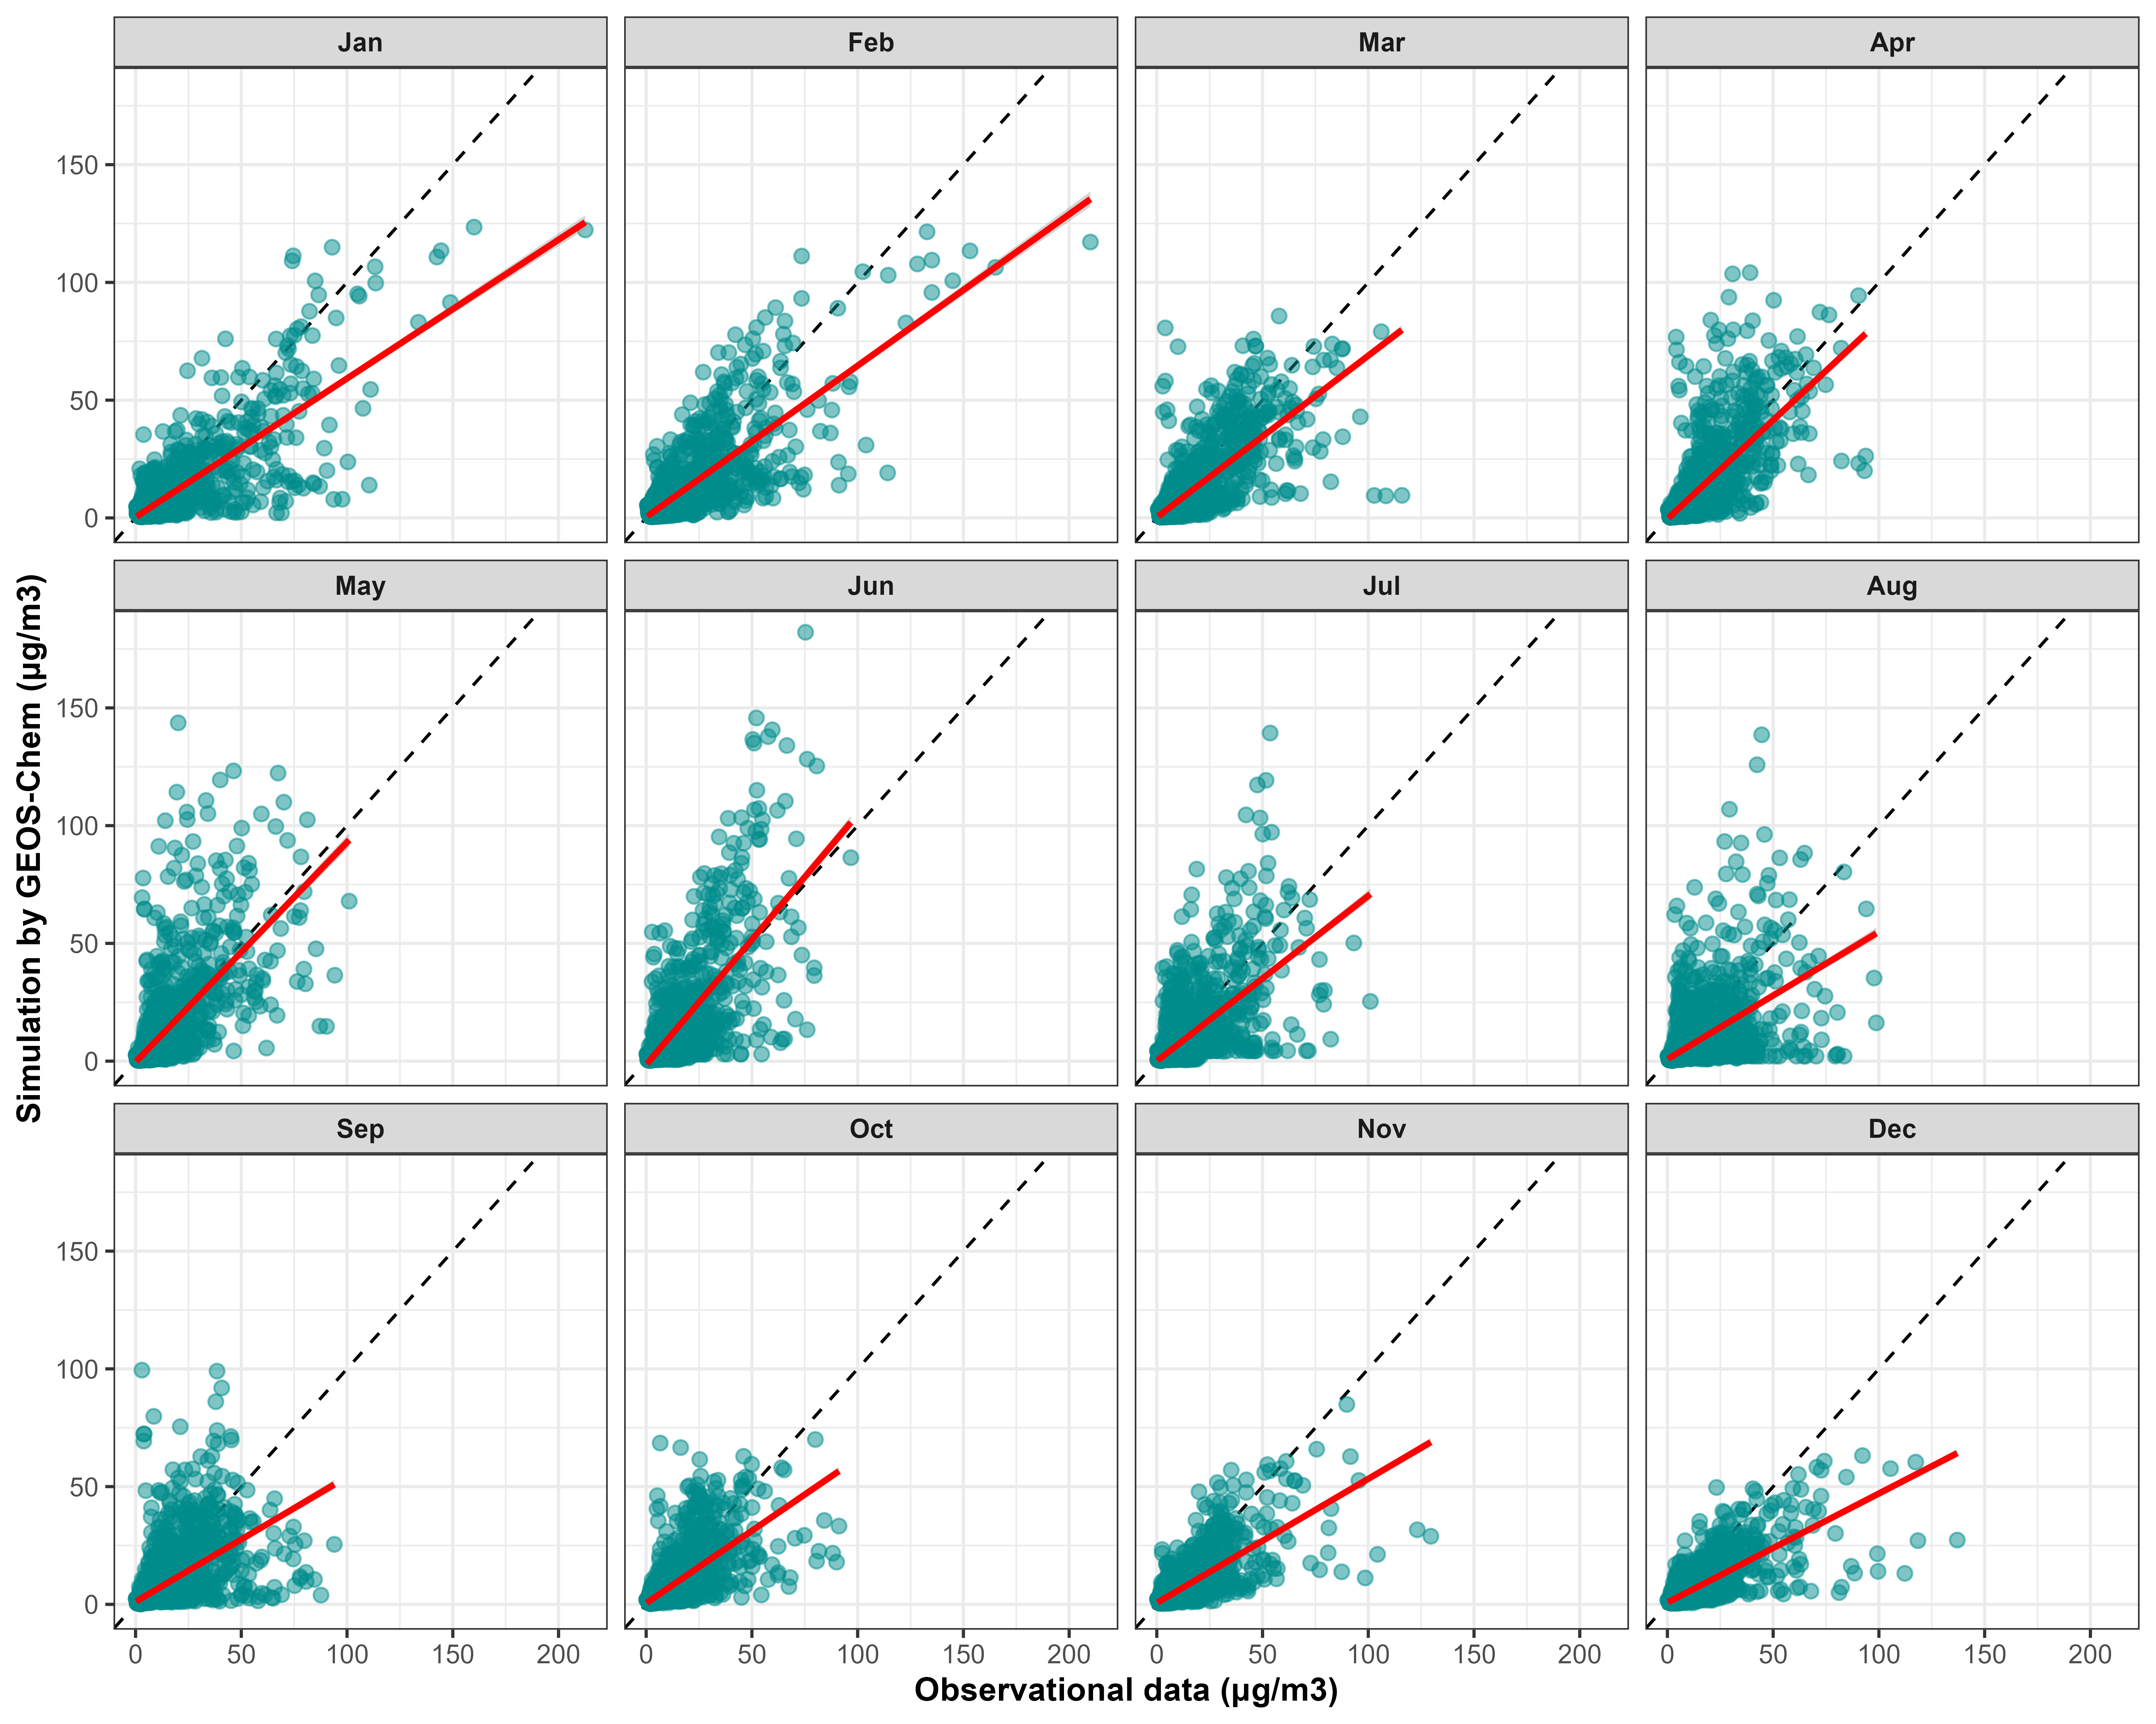
Figure S1. Monthly validation of GEOS-Chem PM2.5 simulations against satellite-derived PM2.5 estimates. The red line denotes the fitted linear relationship and each point denotes one grid cell.

Table S2. Monthly GEOS-Chem model validation statistics.
Month | MB (μg/m³) | NMB (%) | NME (%) | RMSE (μg/m³)
1 | -3.63 | -37.75 | 53.39 | 9.92
2 | -2.86 | -31.64 | 52.15 | 9.09
3 | -2.37 | -28.30 | 48.21 | 8.07
4 | -1.67 | -21.68 | 52.37 | 8.15
5 | -0.84 | -11.90 | 60.03 | 9.82
6 | -1.06 | -14.07 | 60.77 | 9.84
7 | -2.32 | -29.41 | 58.82 | 9.05
8 | -2.82 | -35.57 | 62.96 | 10.34
9 | -2.54 | -32.84 | 57.55 | 9.58
10 | -2.19 | -31.27 | 49.91 | 7.14
11 | -2.68 | -38.39 | 50.37 | 7.28
12 | -3.04 | -42.64 | 52.07 | 8.01
Average | -2.33 | -29.62 | 54.88 | 8.86
Section 4 Health impact assessment
We estimated health impacts due to PM_{2.5} pollution by assessing annual PM_{2.5}-related premature mortality for each five-year age group from 0 to 95+ in each region:
$$\begin{aligned}∆Mort=y_{o}×\left(1-\frac{1}{RR\left(c\right)}\right)×Pop\#\left(6\right)\end{aligned}$$
where premature mortality is attributable to ambient PM2.5 exposure, the baseline mortality rate is age- and disease-specific, and the exposure population is resolved by five-year age group. Relative risks and baseline mortality rates were derived from the Global Burden of Disease (GBD), while regional age-specific population was derived from the IIASA SSP database. We included six PM2.5-related outcomes: chronic obstructive pulmonary disease (COPD), diabetes mellitus type II, ischemic heart disease (IHD), lung cancer, lower respiratory infections, and stroke.
We scaled these curves of RR derived from GBD by the theoretical minimum risk exposure level (TMREL):
$$\begin{aligned}{RR}_{scaled}\left(c\right)=\left\{\begin{matrix}1 & c≤5.9 μg/m^{3} \\ \frac{RR\left(c\right)}{RR\left(4.15\right)} & c>5.9 μg/m^{3}\end{matrix}\right.\#\left(7\right)\end{aligned}$$
where PM2.5 concentration is evaluated against the theoretical minimum risk exposure level (TMREL). We used 4.15 ug/m3 as the midpoint of the GBD TMREL range (2.4-5.9 ug/m3). Relative risk was set to 1 for exposures below the upper TMREL bound (5.9 ug/m3), and the remaining relative-risk predictions were scaled by 1000 draws at the TMREL midpoint. The input data used for health impact assessment are summarized in Table S3. The comparison with GBD mortality estimates is shown in Figure S2; the close agreement in populous regions such as China, India, and Southeast Asia indicates that the approach captures regional PM2.5-related mortality patterns used in the scenario assessment.
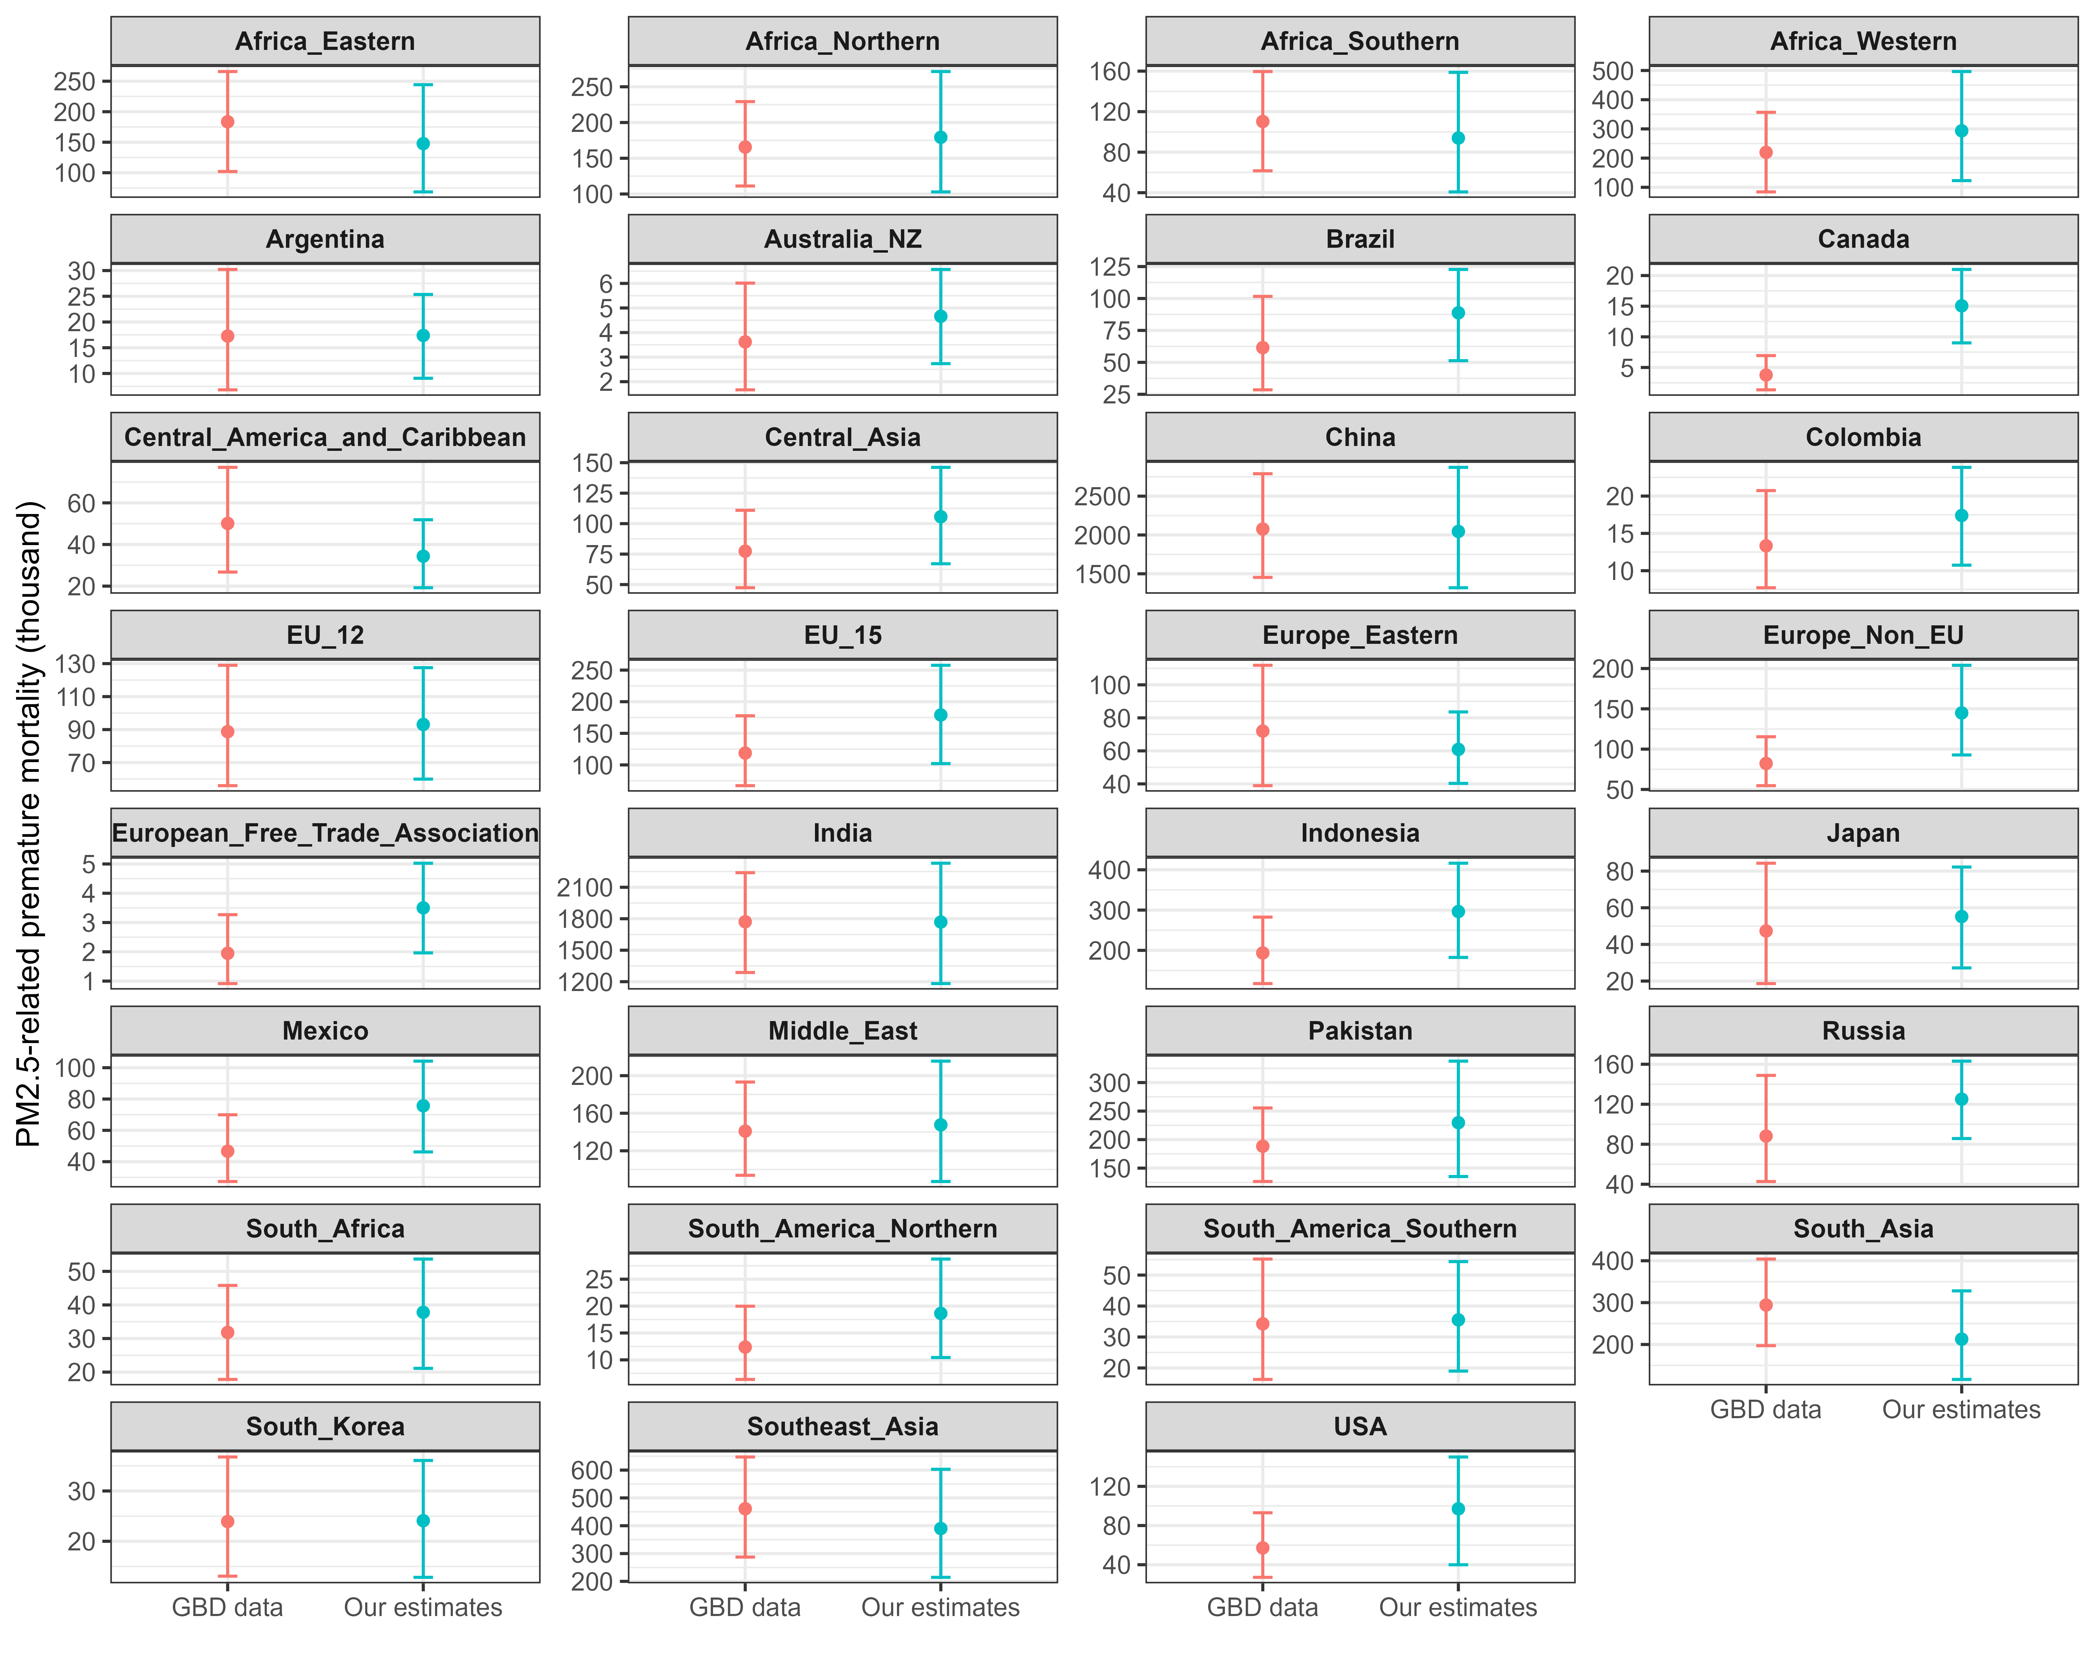
Figure S2. Differences between estimated PM2.5-related premature deaths in this study and GBD estimates at the GCAM-region scale in 2020. Error bars denote 95% confidence intervals.

Table S3. Summary of input data for health impact assessment.
Parameters | Description | Resolution | Data source
m0 | Age- and disease-specific baseline mortality rates | National scale | GBD
RR | Age- and disease-specific relative risks | National scale | GBD
C | Annual mean PM2.5 exposure concentration | Grid scale / GCAM-region scale | GEOS-Chem simulations calibrated with IQAir 2020 hindcast estimates
P | Exposed population for each five-year age group under SSP1 | National / regional scale | IIASA SSP database
Based on the annual PM_{2.5}-related premature deaths, we estimated health co-benefits resulting from net-zero emissions, that is, the cumulated avoided PM_{2.5}-related premature deaths by net-zero emissions from 2020 to 2050:
$$\begin{aligned}{HB}_{A}=\int_{2020}^{2050}{H_{ref}\left(t\right)dt}-\int_{2020}^{2050}{H_{A}\left(t\right)dt}\#\left(8\right)\end{aligned}$$
where ${HB}_{A}$ denotes health co-benefits under an alternative scenario; $H_{ref}\left(t\right)$ and $H_{A}\left(t\right)$ denote the functions between annual mortality and time under the Reference and alternative scenarios, respectively.

Table S4. Literature values of a statistical life used for regional VSL calibration. PPP: purchasing power parity.
Section 5 Monetary health co-benefits and CDR opportunity cost
Regional PM2.5-related premature deaths were monetized using the value of a statistical life (VSL). VSL values were harmonized to the study currency year and then projected from 2020 to 2050 using regional GDP growth with an income elasticity of 0.5, consistent with the main manuscript. Monetary health co-benefits were calculated as the avoided PM2.5-related deaths under each net-zero scenario relative to the Reference scenario multiplied by the corresponding regional VSL.
The CDR opportunity cost is defined as the reduction in monetary health co-benefits when CDR demand increases from LowCDR to HighCDR, normalized by the additional cumulative CDR deployment. This metric is reported in USD2020 per tCO2 and provides a common monetary basis for comparing regions with different air pollution levels, exposure risks, and VSLs. The global mean opportunity cost rises from 4.3 USD2020/tCO2 without CDR trade to 6.2 USD2020/tCO2 with CDR trade, while the regional sign and magnitude depend on whether sustained fossil-fuel emissions outweigh reductions in biomass-related emissions.
Nation | VSL | PPP | Source
USA | 7.09 | 2019$ | Banzhaf H S. The value of statistical life: a meta-analysis of meta-analyses. Journal of Benefit-Cost Analysis, 2022, 13(2): 182-197.
USA | 10.267 | 2015$ | The U.S. Department of Health and Human Services
UK | 2.5 | 2015$ | The United Kingdom Treasury
China | 1.16 | 2010$ | Roy R. The cost of air pollution: health impacts of road transport. 2014.
India | 0.71 | 2010$
Australia | 4.66 | 2010$
Austria | 4.36 | 2010$
Belgium | 4.16 | 2010$
Canada | 4.34 | 2010$
Chile | 2.28 | 2010$
Czech Republic | 3.26 | 2010$
Denmark | 4.10 | 2010$
Estonia | 2.69 | 2010$
Finland | 3.94 | 2010$
France | 3.74 | 2010$
Germany | 4.13 | 2010$
Greece | 3.35 | 2010$
Hungary | 2.75 | 2010$
Iceland | 5.29 | 2010$
Ireland | 4.45 | 2010$
Israel | 3.47 | 2010$
Italy | 3.55 | 2010$
Japan | 3.64 | 2010$
Korea | 3.59 | 2010$
Luxembourg | 7.46 | 2010$
Mexico | 2.15 | 2010$
Netherlands | 4.46 | 2010$
New Zealand | 3.49 | 2010$
Norway | 5.52 | 2010$
Poland | 2.49 | 2010$
Portugal | 2.97 | 2010$
Slovak Republic | 2.87 | 2010$
Slovenia | 3.44 | 2010$
Spain | 3.63 | 2010$
Sweden | 4.16 | 2010$
Switzerland | 4.57 | 2010$
Turkey | 2.40 | 2010$
United Kingdom | 4.22 | 2010$
United States | 5.34 | 2010$
OECD | 3.98 | 2005$ | Lindhjem H, Navrud S, Biausque V, et al. Mortality risk valuation in environment, health and transport policies. 2012.
EU-27 | 4.77 | 2005$
China | 0.69 | 2019$ | Cao C, Song X, Cai W, et al. Estimating the value of a statistical life in China: A contingent valuation study in six representative cities. Chinese Journal of Population, Resources and Environment, 2023, 21(4): 269-278.
Australia | 6.31 | 2000$ | Viscusi, W.K. (2018). Value of Life. In: The New Palgrave Dictionary of Economics. Palgrave Macmillan, London. https://doi.org/10.1057/978-1-349-95189-5_1323
Austria | 9.77 | 2000$
Canada | 7.07 | 2000$
Hong Kong | 2.56 | 2000$
India | 2.25 | 2000$
Japan | 14.58 | 2000$
South Korea | 1.20 | 2000$
Switzerland | 12.93 | 2000$
Taiwan | 1.35 | 2000$
UK | 6.31 | 2000$
USA | 7.29 | 2019$ | Sweis, N.J. Revisiting the value of a statistical life: an international approach during COVID-19. Risk Manag 24, 259–272 (2022). https://doi.org/10.1057/s41283-022-00094-x
Brazil | 1.01 | 2019$
India | 0.20 | 2019$
Mexico | 1.01 | 2019$
UK | 4.76 | 2019$
Italy | 3.85 | 2019$
France | 4.76 | 2019$
Spain | 3.34 | 2019$
Peru | 0.71 | 2019$
Iran | 0.61 | 2019$
Colombia | 0.71 | 2019$
Russian Federation | 1.21 | 2019$
South Africa | 0.71 | 2019$
Chile | 1.62 | 2019$
Belgium | 5.26 | 2019$
Germany | 5.37 | 2019$
Canada | 5.16 | 2019$
Argentina | 1.21 | 2019$
Indonesia | 0.40 | 2019$
Iraq | 0.61 | 2019$
Ecuador | 0.71 | 2019$
Turkey | 1.11 | 2019$
Pakistan | 0.20 | 2019$
Netherlands | 5.87 | 2019$
Sweden | 6.18 | 2019$
Egypt | 0.30 | 2019$
Bolivia | 0.40 | 2019$
China | 1.11 | 2019$
Bangladesh | 2.23 | 2019$
Saudi Arabia | 2.53 | 2019$
Romania | 1.42 | 2019$
Philippines | 0.40 | 2019$
Guatemala | 0.51 | 2019$
Ukraine | 0.40 | 2019$
Poland | 1.72 | 2019$
Panama | 1.62 | 2019$
Honduras | 0.30 | 2019$
Portugal | 2.53 | 2019$
Kazakhstan | 0.91 | 2019$
Ireland | 6.88 | 2019$
Switzerland | 9.52 | 2019$
Dominican Republic | 0.91 | 2019$
Algeria | 0.40 | 2019$
Afghanistan | 0.06 | 2019$
Japan | 4.66 | 2019$
Morocco | 0.40 | 2019$
Kyrgyzstan | 0.10 | 2019$
Nigeria | 0.20 | 2019$
World | 1.32 | 2019$
India | 1.27 | 2011$ | S.D. Ghude, D.M. Chate, C. Jena, G. Beig, R. Kumar, M.C. Barth, et al. Premature mortality in India due to PM2.5 and ozone exposure Geophysical Research Letters, 43 (2016), pp. 4650-4658
Australia | 5.67 | 2017$ | Ananthapavan, J.; Moodie, M.; Milat, A.J.; Carter, R. Systematic Review to Update ‘Value of a Statistical Life’ Estimates for Australia. Int. J. Environ. Res. Public Health 2021, 18, 6168. https://doi.org/10.3390/ijerph18116168
Poland | 3.47 | 2002$ | Giergiczny, M. Value of a Statistical Life—the Case of Poland. Environ Resource Econ 41, 209–221 (2008). https://doi.org/10.1007/s10640-007-9188-2

Statistical analysis
Section 6 Principal component analysis
The PCA dataset includes region-level changes in eight variables as CDR deployment scales from LowCDR to HighCDR: cumulative emissions of BC, OC, NH3, NMVOC, SO2, and NOX; cumulative CDR deployment; and the reduction in monetary health co-benefits. We conducted the Kaiser-Meyer-Olkin (KMO) test to determine whether the dataset was suitable for dimensionality reduction. The overall KMO measure was 0.72, indicating sufficient shared information among variables. Parallel analysis was then used to determine the number of retained components (Figure S3). Two principal components were retained; the first and second components explain 56% and 21% of the total variation, respectively.
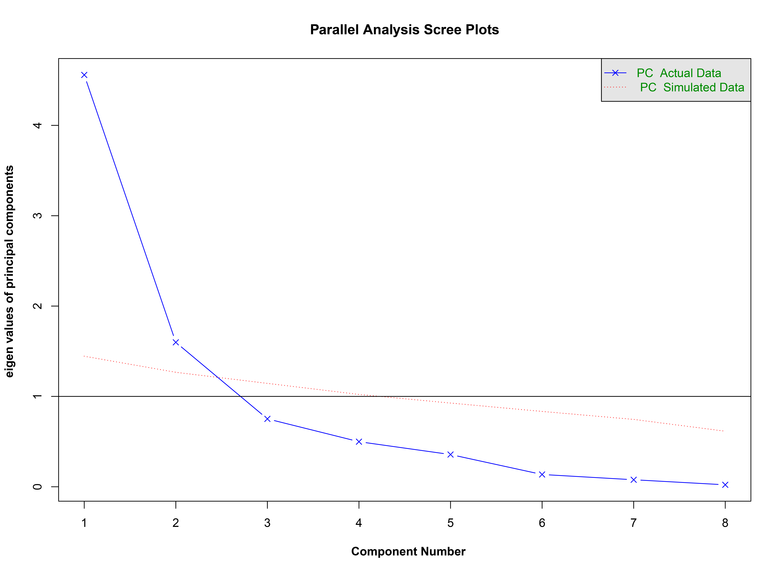
Figure S3. Parallel analysis for PCA. Principal components with eigenvalues exceeding those from simulated random data were retained.

Section 7 Logistic regression and dominance analysis
We used logistic regression to identify which changes in energy consumption and CDR deployment are most strongly associated with the presence of global CDR trade. The response variable is binary, with y = 1 representing Trade scenarios and y = 0 representing NoTrade scenarios. Explanatory variables include region-level changes from LowCDR to HighCDR in 2050 for CDR deployment by technology and primary energy consumption by fuel. The model uses a binomial probability distribution and a logit link function:
$$\begin{aligned}\log\left(\frac{μ_{y}}{1-μ_{y}}\right)=β_{o}+\sum_{j=1}^{n}{β_{j}×X_{j}}\#\left(9\right)\end{aligned}$$
where $μ_{y}$ is the conditional mean of y, that is, the probability that y =1 given a set of x values, $\frac{μ_{y}}{1-μ_{y}}$ is the odd that y = 1, and $\log\left(\frac{μ_{y}}{1-μ_{y}}\right)$ is the log odds and the link function. The probability distribution is binomial. In this case, y = 1 and y = 0 represent CDR trade and CDR NoTrade, respectively.
Backward stepwise selection was used to retain statistically meaningful predictors, and dominance analysis was used to decompose the relative contribution of the retained variables. The six retained predictors are the variables reported in Figure 4b of the main manuscript. A larger dominance estimate indicates that the variable contributes more to classifying whether CDR trade is enabled, after accounting for overlap among predictors.

Additional results
Section 8 Regional primary-energy response to CDR
The main manuscript shows that moving from LowCDR to HighCDR increases global fossil-fuel consumption in 2050 by 106.0 EJ with CDR trade and by 90.2 EJ without CDR trade. CDR trade also reduces the reliance on biomass-based decarbonization: biomass consumption in 2050 is 129.4 EJ under HighCDR-Trade, compared with 160.5 EJ under HighCDR-NoTrade. This shift occurs because trade makes DAC more competitive relative to BECCS, allowing more fossil-based technologies to remain in the energy system while reducing some biomass-related energy and land requirements.
Section 9 Regional PM2.5 and mortality patterns
The complete regional PM_{2.5} trajectories show that net-zero scenarios reduce PM2.5 concentrations relative to the Reference scenario in most regions, but higher CDR deployment weakens these air-quality gains by allowing additional fossil-fuel use and associated precursor emissions. The strongest deterioration from LowCDR to HighCDR occurs in regions with high baseline PM_{2.5} exposure or slower end-of-pipe controls, including India, Pakistan, China, and South Asia. These concentration changes are propagated through the health-impact assessment to estimate region-specific premature deaths and monetary health co-benefits.
Section 10 Land-use displacement and NH3 response
In some regions, CDR trade reduces biomass consumption and therefore reduces emissions from biomass-based decarbonization pathways, such as biofuel refining and biomass heat in industry. However, NH₃ emissions can still rise when land formerly used for purpose-grown biomass is reallocated to other agricultural activities, livestock, or food crops. This mechanism helps explain why NH₃ changes are not always aligned with the regional decline in biomass energy consumption and why NO_{X}, SO₂, and NMVOC are more directly associated with the loss of monetary health co-benefits in the PCA results.
Figure S4. Regional population-weighted PM2.5 concentrations from 2020 to 2050 under the Reference and four net-zero scenarios. Concentrations were simulated by GEOS-Chem and calibrated with 2020 hindcast observations.

Figure S5. Regional cumulative CO2 reductions under LowCDR and HighCDR pathways from 2020 to 2050. Values represent cumulative reductions relative to the Reference scenario.
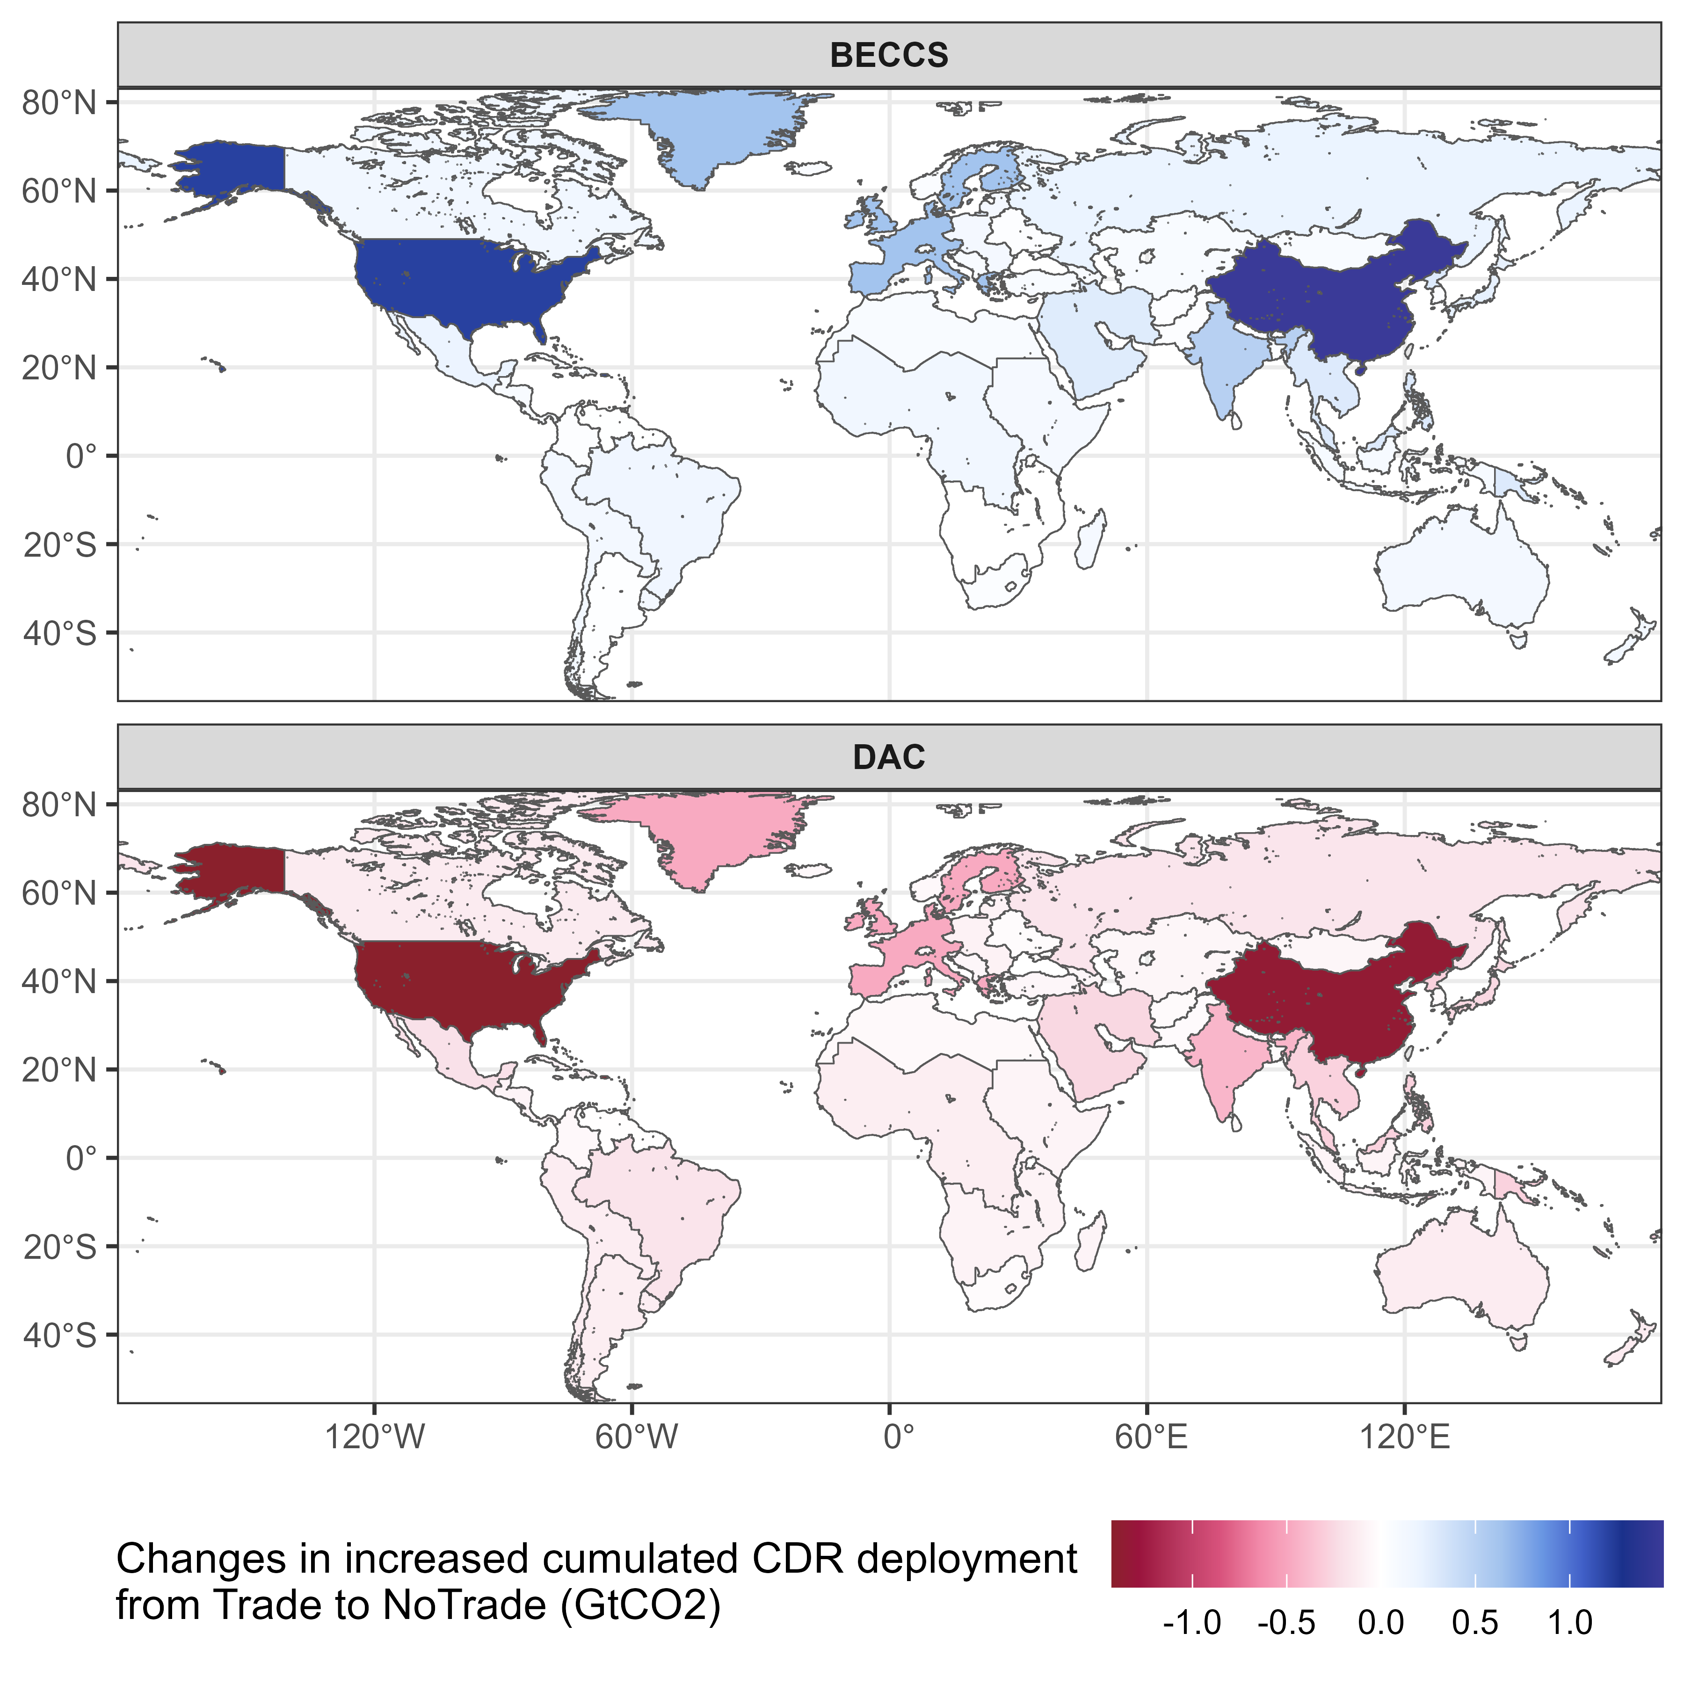
Figure S6. Changes in increased cumulative BECCS and DAC deployment from Trade to NoTrade scenarios. Blue indicates larger deployment increments under NoTrade, whereas red indicates larger deployment increments under Trade.

