Supplement 1
Confirmation of basal cell markers in NHBECs of LCC. (a) Time course of this experiment. (b) NHBECs in LCC on day 3 were attached to glass slides using cytospin and immunostained with antibodies specific for CK5 and CK14. The upper panel shows CK5-stained cells, and the lower panel shows CK14-stained cells. From left to right: CK5, CK14, DAPI, and merged proteins. (c) Changes in CK5 and CK14 mRNA expression levels before and after differentiation. CK5 and CK14 mRNA expression levels before (day 3) and after differentiation in ALI (day 10) cultures were measured using real-time PCR. Results are expressed as mean ± SD, n = 3; **p< 0.01.
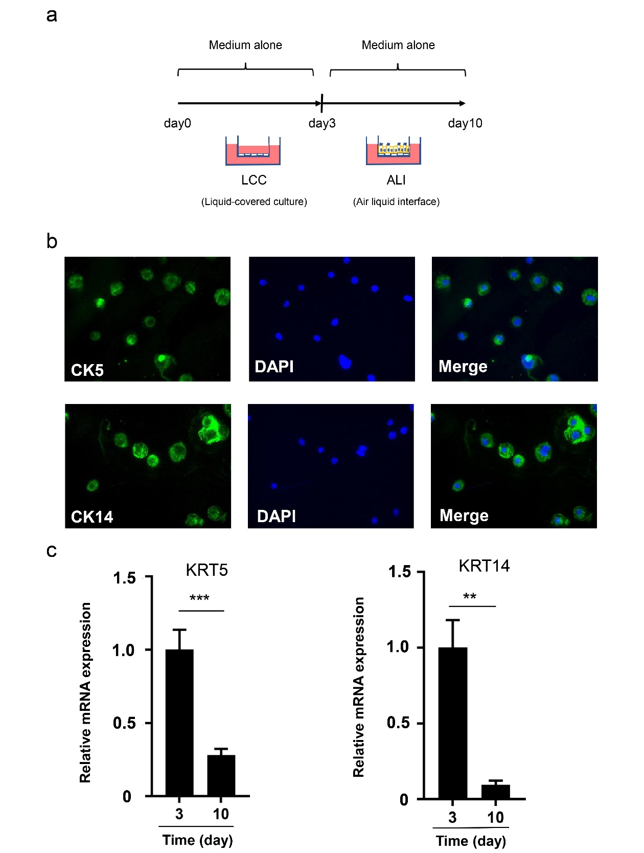

Supplement 2
Validation of TLR3 and TRIF knockdown efficiency in VA10 cells.
VA10 cells were transfected with control siRNA, siTLR3, or siTRIF for 24 h. The mRNA expression levels of TLR3 (left) and TRIF (right) were measured using RT-qPCR. The results are expressed as mean ± SD, n = 3; ****p < 0.0001.
