Table S1 5-Fold Cross Validation for ML Models
Estimator | RMSE_Folds | R2_Folds | RMSE_mean | RMSE_STD | R2_mean | R2_STD
Random Forest | 0.158, 0.151, 0.153, 0.147, 0.150 | 0.401, 0.450, 0.453, 0.426, 0.440 | 0.152 | 0.004 | 0.434 | 0.021
XGBoost | 0.153, 0.145, 0.151, 0.149, 0.153 | 0.442, 0.487, 0.465, 0.406, 0.423 | 0.15 | 0.003 | 0.444 | 0.032

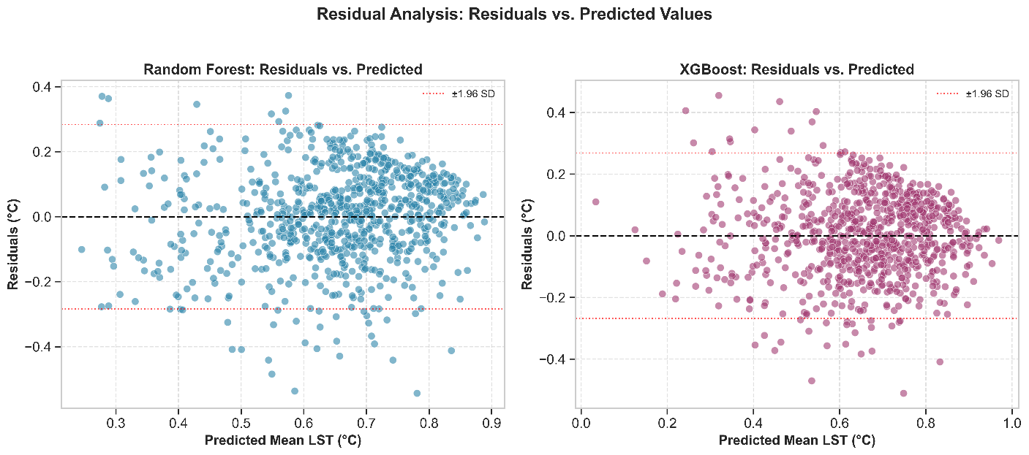
Figure S1: Residual Plots for ML Models

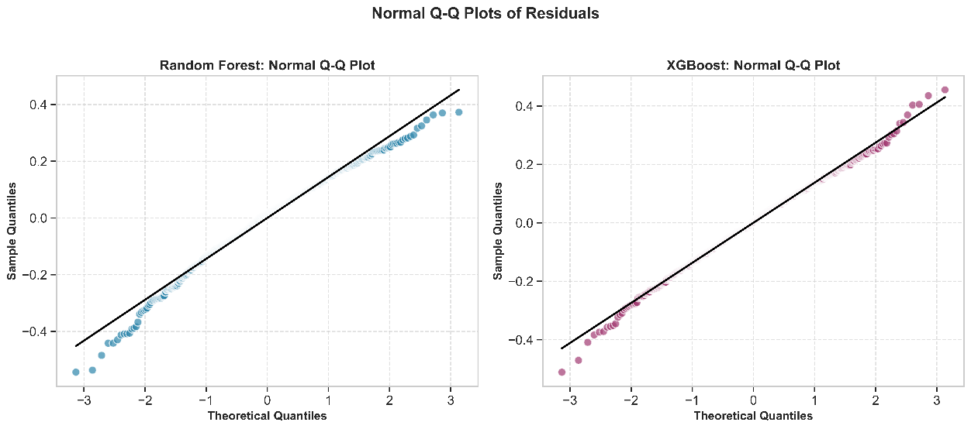
Figure S2: Q-Q plots of Residuals

