Supplementary materials
Supplementary Table 1. ICD-10 code definitions of pancreatic disease and comorbidities

Disease | ICD-10 codes
Benign pancreaticobiliary disease | D13.5, D13.6, D13.7
Malignant pancreatic disease | C25.0-C25.9
Any malignancy (except for nonmelanoma skin cancer) | C00-C53, C54, C55-C76, C81-C85, C88, C90-C97
Metastatic solid tumor | C77-C80
Dementia | F00, F01, F02, F03, F051, G30, G311
Renal disease | I12.0, I13.1, N03.2-N03.7, N05.2-N05.7, N18, N19, N25.0, Z49.0-49.2, Z94.0, Z99.2
Rheumatic disease | M05, M06, M315, M32, M33, M34, M351, M353, M360
Liver disease | B15.0, B15.9, B16.0, B16.2, B16.9, B17.1, B17.9, B18.1, B18.2, B18.9, B19.0, B19.9, Z86.1, K70.0-K70.4, K70.9, K71.1-K71.3, K71.6-K71.9, K72.0, K72.1, K72.9, K73, K74, K76, I85.0, I85.9, I86.4, I98.2, Z944
Cardiac arrhythmia | I441, I442, I443, I456, I459, I47, I48, I49, R000, R001, R008, T821, Z450, Z950
Chronic pulmonary disease | I278, I279, J40, J41, J42, J43, J44, J45, J46, J47, J60, J61, J62, J63, J64, J65, J66, J67, J684, J701, J703
Hypertension | I10, I11, I12, I13, I15
Diabetes | E10, E11, E14

ICD-10, International Classification of Diseases, 10th Revision

Supplementary Table 2. Definitions of diabetes, cardiac and cerebrovascular events

Outcome | ICD-10 or disease code | Detail
Cardiac event | I20, I21, I22, I24 as acute coronary syndromes  I25 as chronic heart disease  I50 as heart failure | Of participants coded, only those hospitalized were treated as having experienced events
Cardiac event | 150260350, 150284310, 150318310, 150359310,  150153910,150374910, 150375010, 150375110,  150263310, 150375210, 150375310, 150375410,  150145910, 150146010, 150318410, 150318510 | Percutaneous coronary intervention or coronary artery bypass grafting
Cerebrovascular event | I60, I61, I62, I63, I64 as stroke  8838736, 8838748, 8838750 as other cerebrovascular events | Of patients coded, only those hospitalized were treated as having experienced events

ICD-10, International Classification of Diseases, 10th Revision
Supplementary Table 3. Participant characteristics before propensity score matching

Variable | Category | Control  (n = 1314051) | Pancreatectomy  (n = 284) | SMD
Sex | Male | 564199 (42.9) | 124 (43.7) | 0.015
Age (year) |  | 59.29 (17.86) | 71.30 (9.19) | 0.846
Age (year) | 20-44 | 309766 (23.6) | 6 (2.1) | 0.966
 | 45-49 | 60894 (4.6) | 2 (0.7)
 | 50-54 | 59891 (4.6) | 6 (2.1)
 | 55-59 | 80927 (6.2) | 11 (3.9)
 | 60-64 | 191606 (14.6) | 21 (7.4)
 | 65-69 | 213758 (16.3) | 67 (23.6)
 | 70-74 | 123045 (9.4) | 70 (24.6)
 | 75-79 | 137313 (10.4) | 48 (16.9)
 | 80-84 | 75176 (5.7) | 40 (14.1)
 | ≥ 85 | 61675 (4.7) | 13 (4.6)
Index year | 2013-2014 | 898073 (68.3) | 54 (19.0) | 1.115
 | 2015-2016 | 113427 (8.6) | 63 (22.2)
 | 2017-2018 | 105101 (8.0) | 69 (24.3)
 | 2019-2020 | 102017 (7.8) | 49 (17.3)
 | 2021-2022 | 95433 (7.3) | 49 (17.3)
Diabetes | Presence | 177507 (13.5) | 136 (47.9) | 0.803
Dyslipidemia | Presence | 236656 (18.0) | 88 (31.0) | 0.305
Hypertension | Presence | 356069 (27.1) | 128 (45.1) | 0.381
Liver disease | Presence | 109979 (8.4) | 71 (25.0) | 0.458
Renal disease | Presence | 8873 (0.7) | 3 (1.1) | 0.041
Dementia | Presence | 25482 (1.9) | 3 (1.1) | 0.073
Rheumatic disease | Presence | 29436 (2.2) | 16 (5.6) | 0.175
Peripheral vascular disease | Presence | 54034 (4.1) | 21 (7.4) | 0.141
Chronic pulmonary disease | Presence | 161967 (12.3) | 50 (17.6) | 0.148
Cardiac arrhythmias | Presence | 55069 (4.2) | 37 (13.0) | 0.319
Hypothyroidism | Presence | 14087 (1.1) | 7 (2.5) | 0.106

SMD, standardized mean difference. Age (year) is presented as mean (standard deviation); all other variables are shown as number (percentage).

Supplementary Figure 1. Study design and analytical timeline for the pancreatectomy and control cohorts
The baseline covariate assessment period comprised the 365 days preceding the index date. The index date was the date of surgery for the pancreatectomy cohort and the prespecified cohort-entry date for the control cohort. Although the diagram displays the overall observation period from the index date, cardiac and cerebrovascular events occurring during the first 365 days after the index date were excluded from the outcome analysis. Outcome follow-up therefore began 365 days after the index date and continued until the occurrence of the outcome of interest, death, disenrollment, or September 30, 2022, whichever occurred first.
Supplementary Figure 2. Subgroup analysis of clinical outcomes by type of pancreatic resection
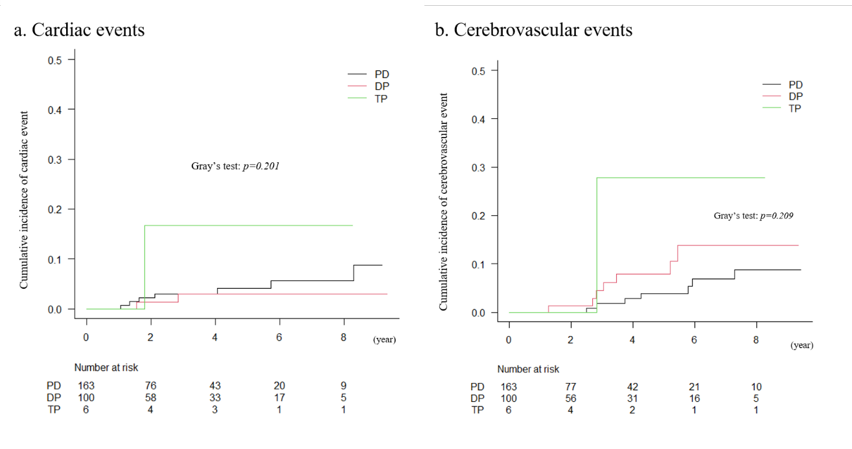
Cumulative incidence curves are shown for each outcome stratified by surgical procedure: pancreaticoduodenectomy (PD), total pancreatectomy (TP), and distal or partial (including central) pancreatectomy (DP). No statistically significant differences in cumulative incidence were detected among surgical types for (a) cardiac events (Gray’s P = 0.201), or (b) cerebrovascular events (Gray’s P = 0.209).

