Title: Disentangling postseismic deformation from noisy GNSS data using vbICA approach: Application to the 2021 Mw7.4 Maduo Earthquake, Tibetan Plateau
Zhijun Liu ¹, Qiang Qiu ², Jing Liu-Zeng ^{1, *}, Yunfeng Tian ³, Bin Zhao ⁴, Peng Wang ⁵, Wenqian Yao ¹, Yanxiu Shao ¹, Wenxin Wang ¹, Longfei Han ⁶
¹ Institute of Surface-Earth System Science, School of Earth System Science, Tianjin University, Tianjin, 300072, China
² State Key Laboratory of Tropical Oceanography, South China Sea Institute of Oceanology, Chinese Academy of Sciences, Guangzhou, China
³ National Institute of Natural Hazards, Ministry of Emergency Management of China, Beijing, China
⁴ Key Laboratory of Earthquake Geodesy, Institute of Seismology, China Earthquake Administration, Wuhan 430071, China
⁵ State Key Laboratory of Earthquake Dynamics, Institute of Geology, China Earthquake Administration, Beijing, China
⁶ The First Monitoring and Application Center, China Earthquake Administration, Tianjin 300180, China

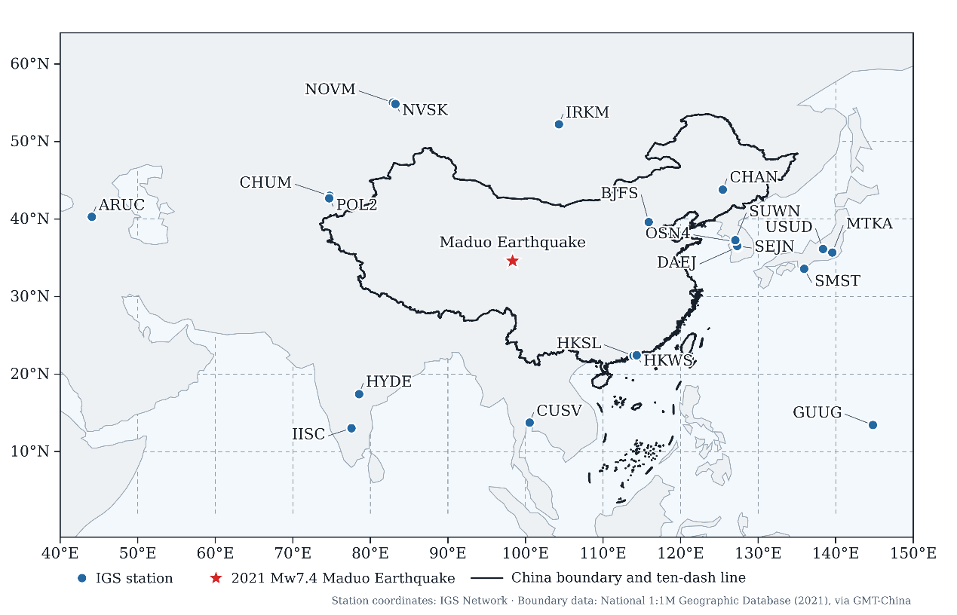
Fig. S1 Distribution of the 21 IGS reference stations used in GNSS processing. Blue circles indicate IGS stations included in the regional processing network, and the red star marks the 2021 Mw 7.4 Maduo earthquake. The black line outlines the boundary of China; dashed lines denote the graticule. Station coordinates were obtained from the IGS network, and boundary data were obtained from Natural Earth.

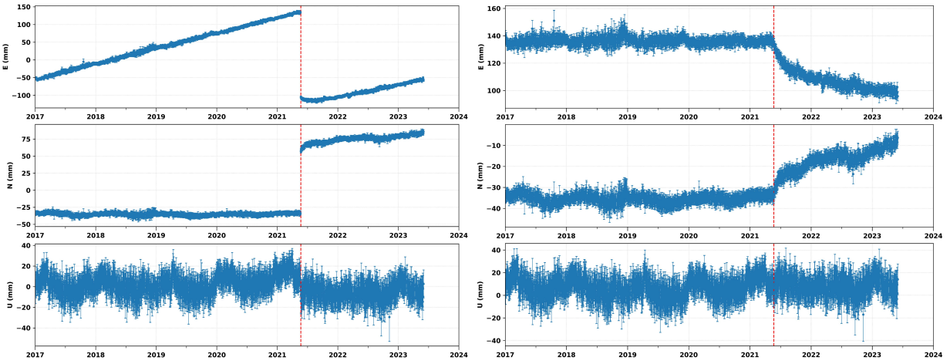
Fig. S2 Example of GNSS coordinate time-series preprocessing at station QHMD (location shown in Fig. 1). (a) Raw three-component GNSS coordinate time series. (b) Time series after coseismic and non-tectonic offset corrections and removal of the long-term linear trend. The vertical red dashed line marks the 22 May 2021 Mw 7.4 Maduo earthquake.

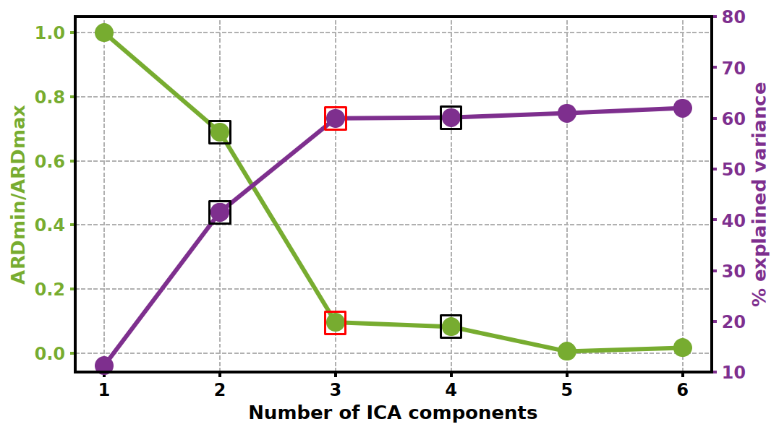
Figure S3. Selection of the number of independent components for the vbICA decomposition of the preprocessed east-component GNSS position time series during the pre-earthquake interval. The green curve shows the normalized ARD metric, and the purple curve shows cumulative explained variance. The selected three-component solution is highlighted.

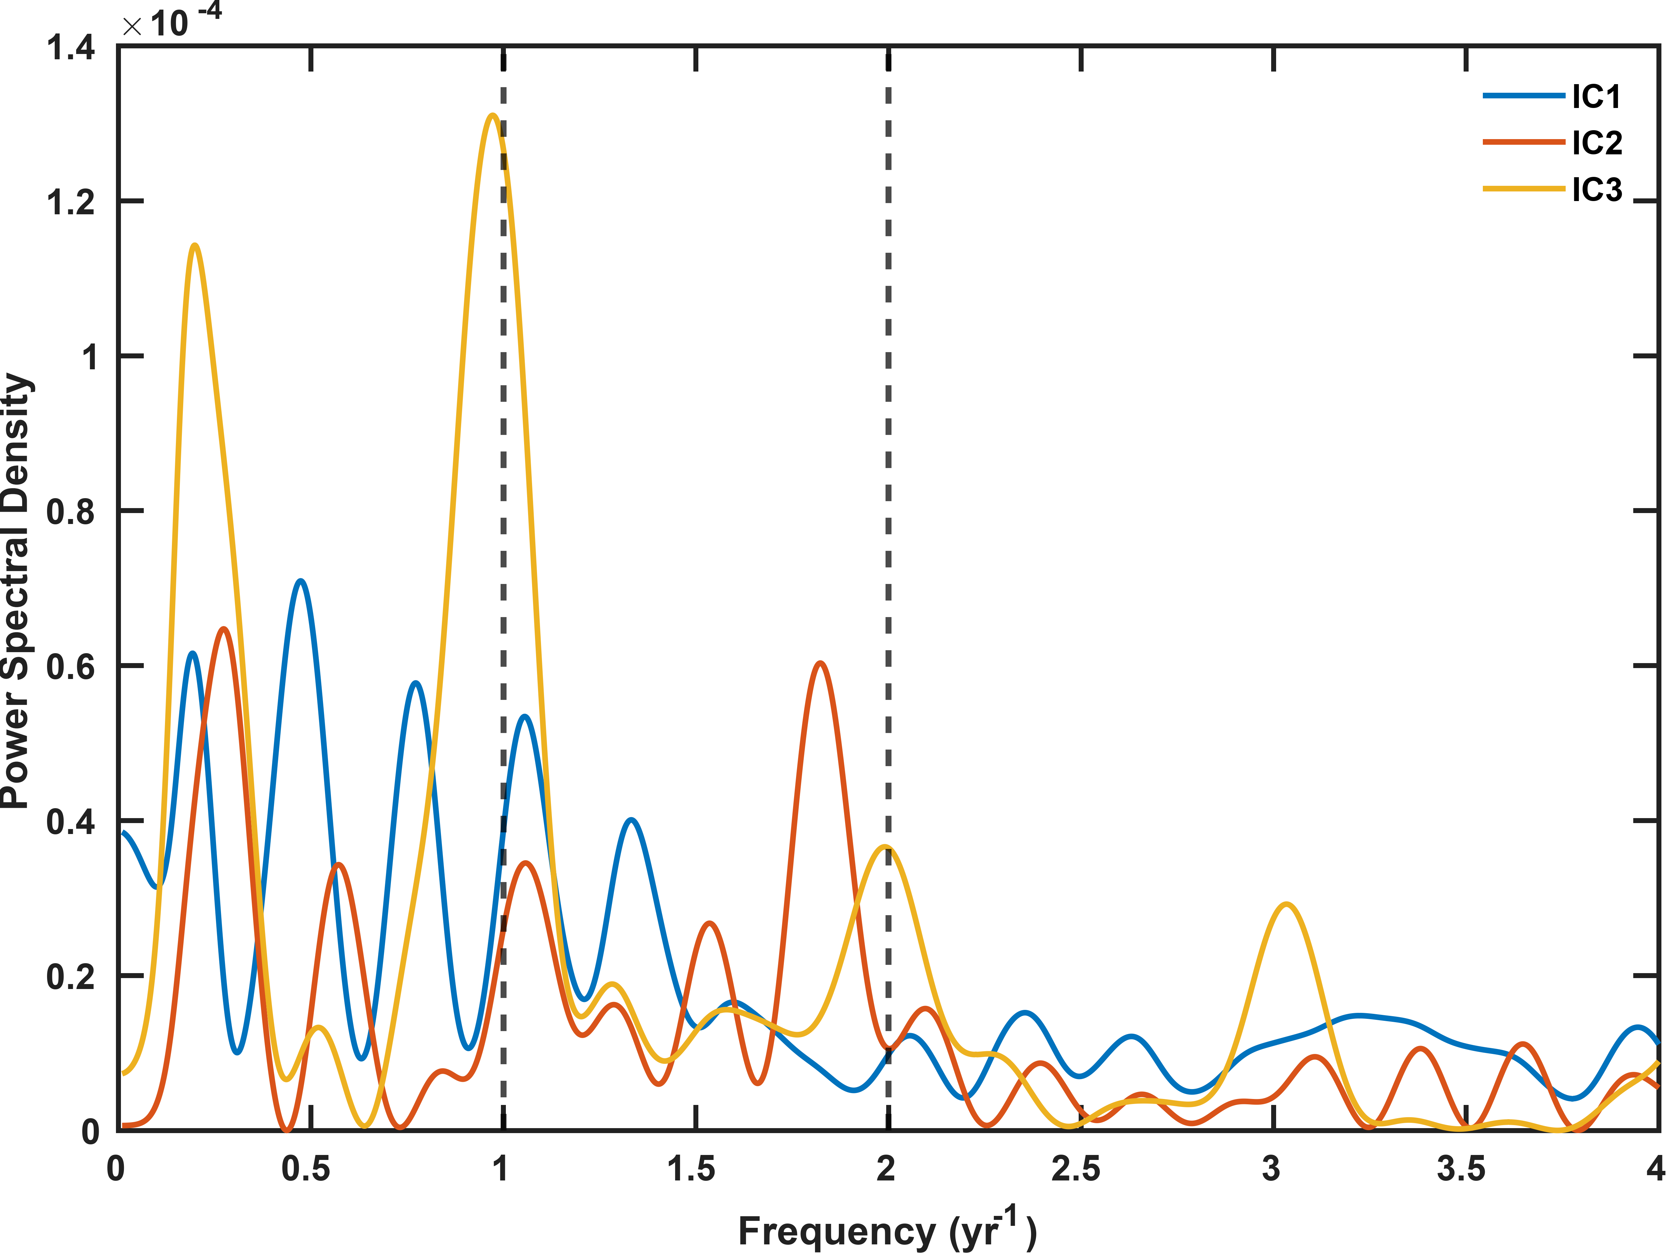
Figure S4. Power spectral densities of the temporal functions of the three independent components retained from the east-component decomposition. Vertical dashed lines mark the annual and semiannual frequencies of 1 and 2 yr−1, respectively.

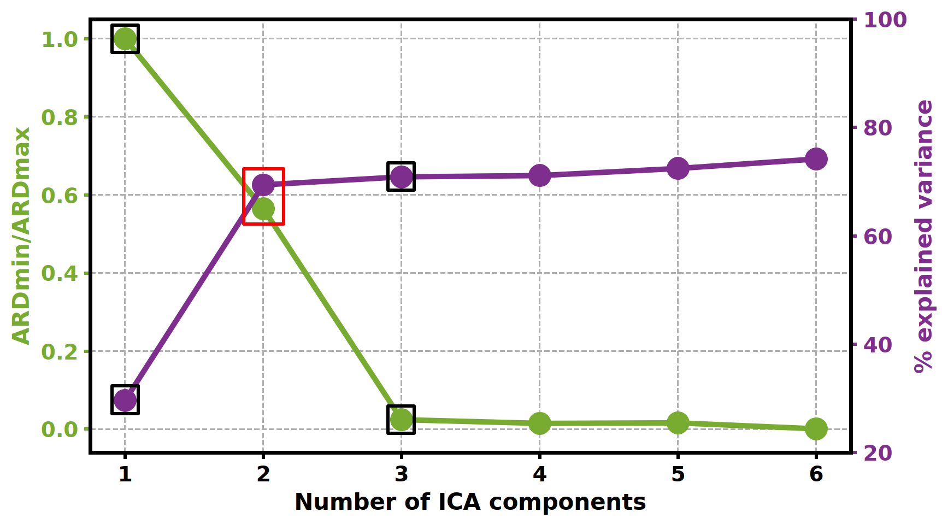
Figure S5. Same as Figure S3, but for the north-component GNSS position time series. The selected two-component solution is highlighted.

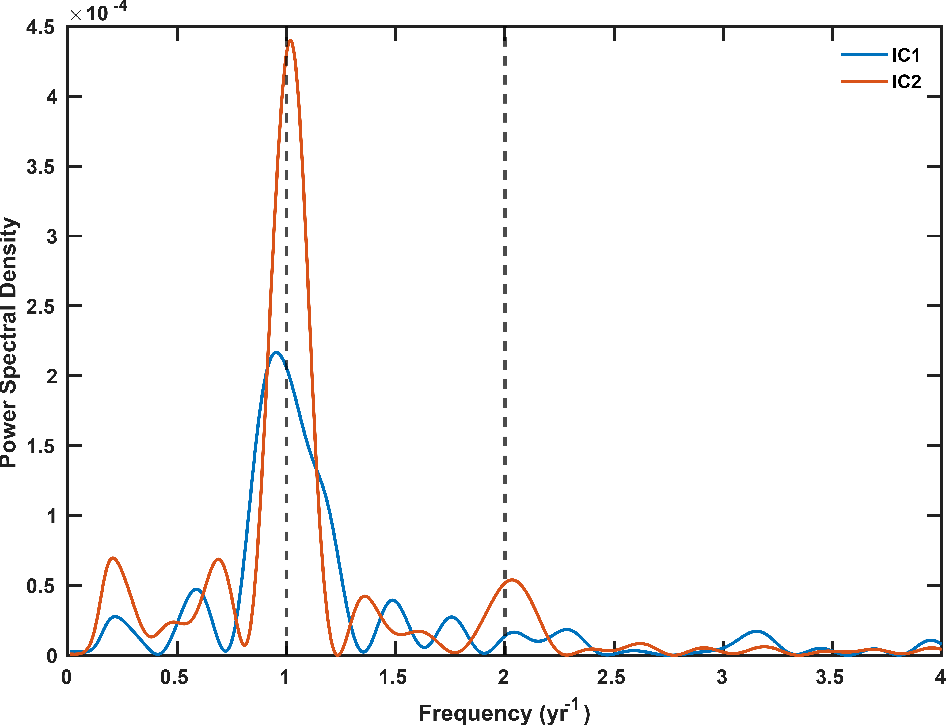
Figure S6. Power spectral densities of the temporal functions of the two independent components retained from the north-component decomposition. Vertical dashed lines mark the annual and semiannual frequencies of 1 and 2 yr−1, respectively.

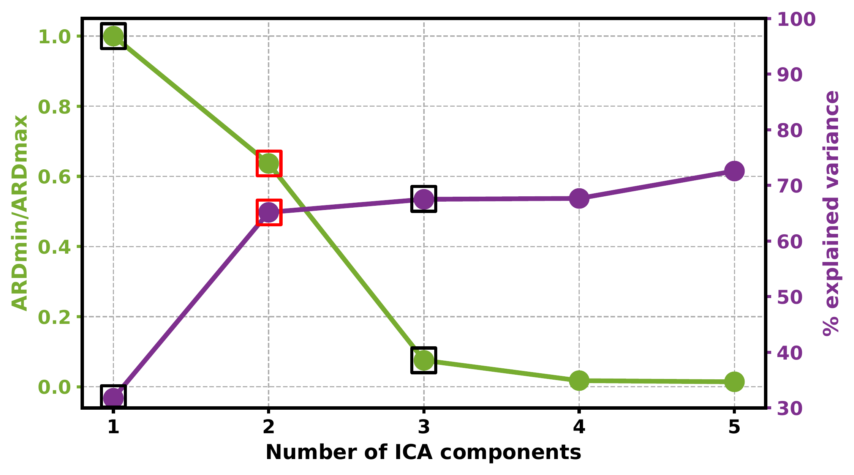
Figure S7. Selection of the number of independent components for the vbICA decomposition of the preprocessed vertical-component GNSS position time series during the pre-earthquake interval. The selected two-component solution is highlighted.

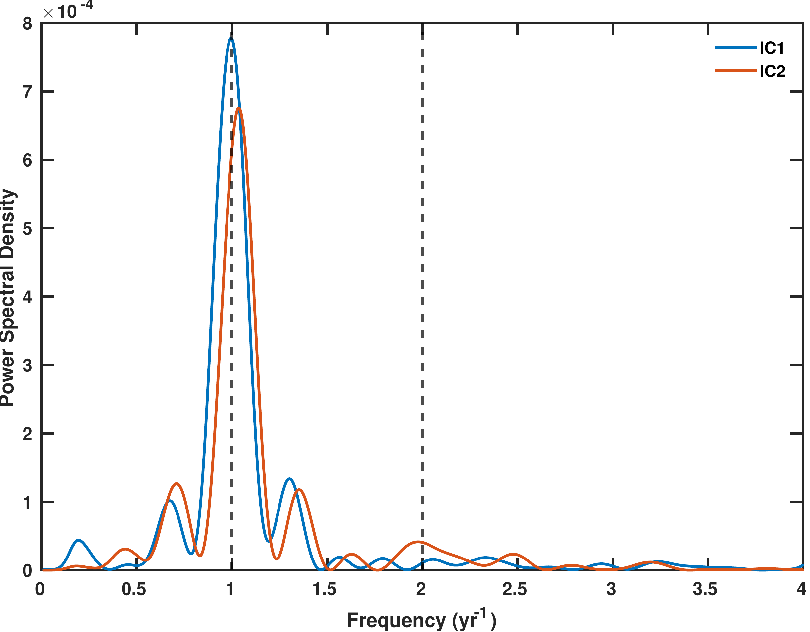
Figure S8. Power spectral densities of the temporal functions of the two independent components retained from the vertical-component decomposition. Vertical dashed lines mark the annual and semiannual frequencies of 1 and 2 yr−1, respectively.

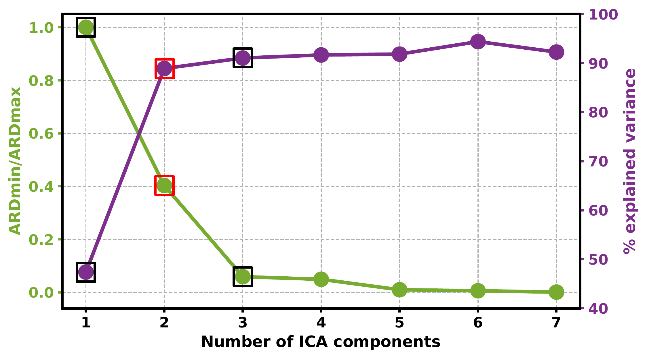
Figure S9. Selection of the number of independent components for the separate vbICA decomposition of the seasonally corrected east-component GNSS position time series. The green curve shows the normalized ARD metric, and the purple curve shows cumulative explained variance. The selected two-component solution is highlighted.

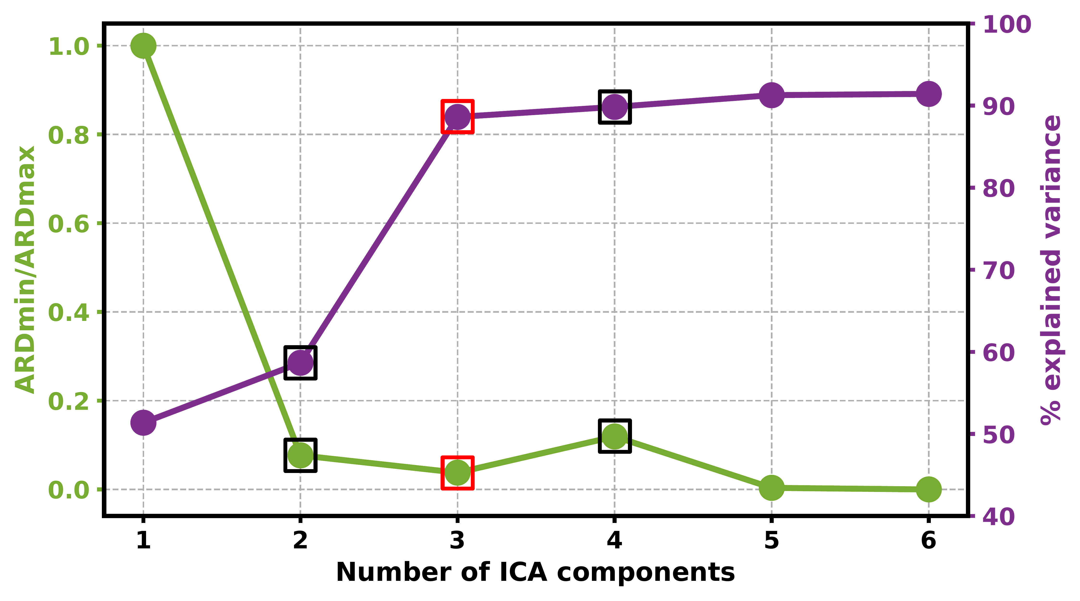
Figure S10. Same as Figure S9, but for the north-component GNSS position time series. The selected three-component solution is highlighted.

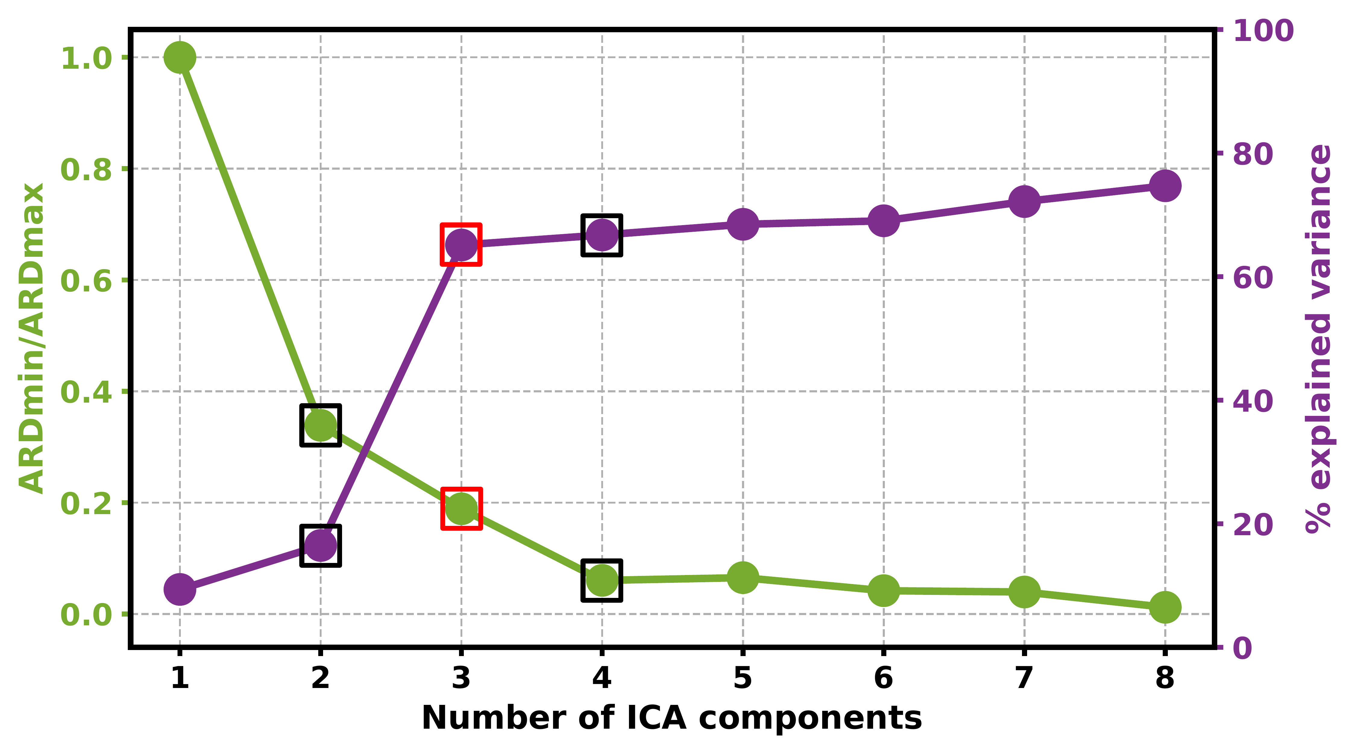
Figure S11. Same as Figure S9, but for the vertical-component GNSS position time series. The selected three-component solution is highlighted.

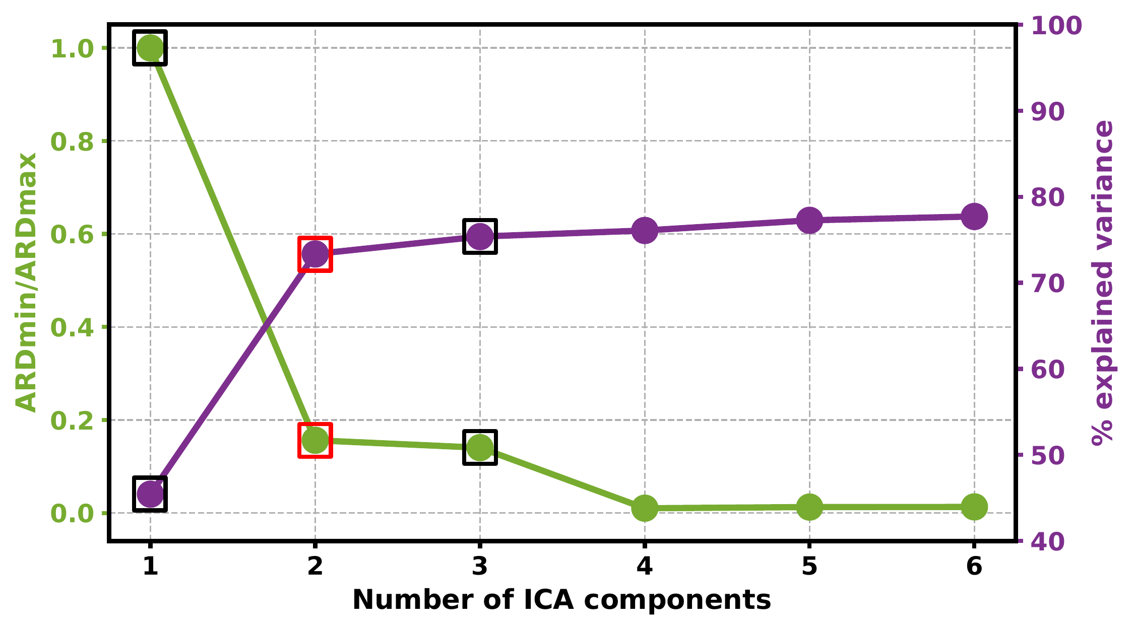
Fig. S12 Selection of the number of independent components for the vbICA decomposition of the seasonally corrected three-component GNSS time series used to extract the postseismic decay signal. The green curve shows the normalized Automatic Relevance Determination (ARD) metric, and the purple curve shows the cumulative explained variance. Black boxes indicate the adjacent one- and three-component solutions; red boxes mark the two-component solution retained for the postseismic signal decomposition.

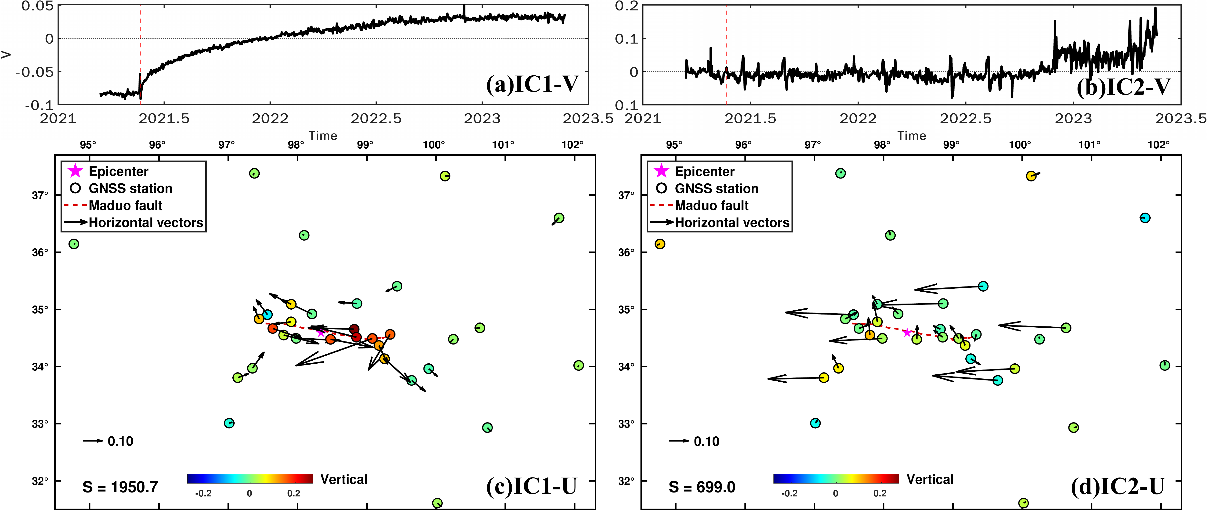
Fig. 13 Postseismic components from seasonally corrected three-component GNSS time series. The components were extracted by applying vbICA to the seasonally corrected east, north, and vertical GNSS time series from all 32 stations. Panels (a) and (b) show the dimensionless temporal functions of IC1 and IC2, respectively; the vertical red dashed lines mark the 22 May 2021 Mw 7.4 Maduo earthquake. Panels (c) and (d) show the corresponding spatial responses of IC1 and IC2. Arrows denote horizontal spatial responses, and color-filled circles denote vertical spatial responses at GNSS station locations. The reference horizontal vector and vertical-response color scale are shown in each panel. The magenta star marks the earthquake epicenter, and the red dashed line indicates the mapped Maduo surface rupture. The value S is the component-specific reconstruction weight used to reconstruct the GNSS coordinate time series and is expressed in millimeters.

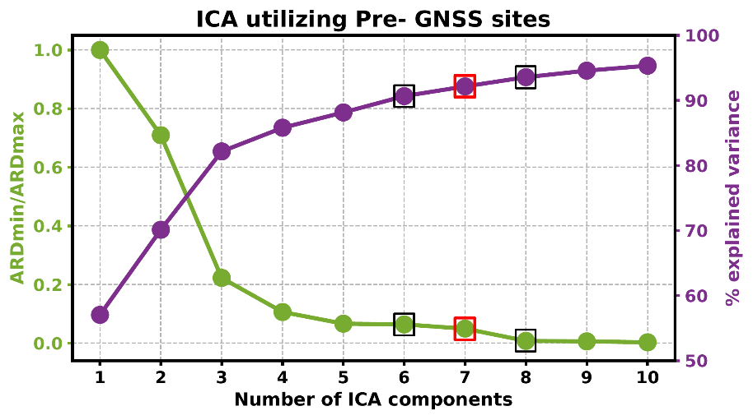
Fig. S14 Selection of the number of independent components for vbICA decomposition of the preprocessed three-component GNSS coordinate time series from the 19 continue stations. The green curve shows the normalized Automatic Relevance Determination (ARD) metric, and the purple curve shows the cumulative explained variance. Black boxes indicate the six- and eight-component solutions; red boxes mark the seven-component solution retained for the regional common-component analysis.

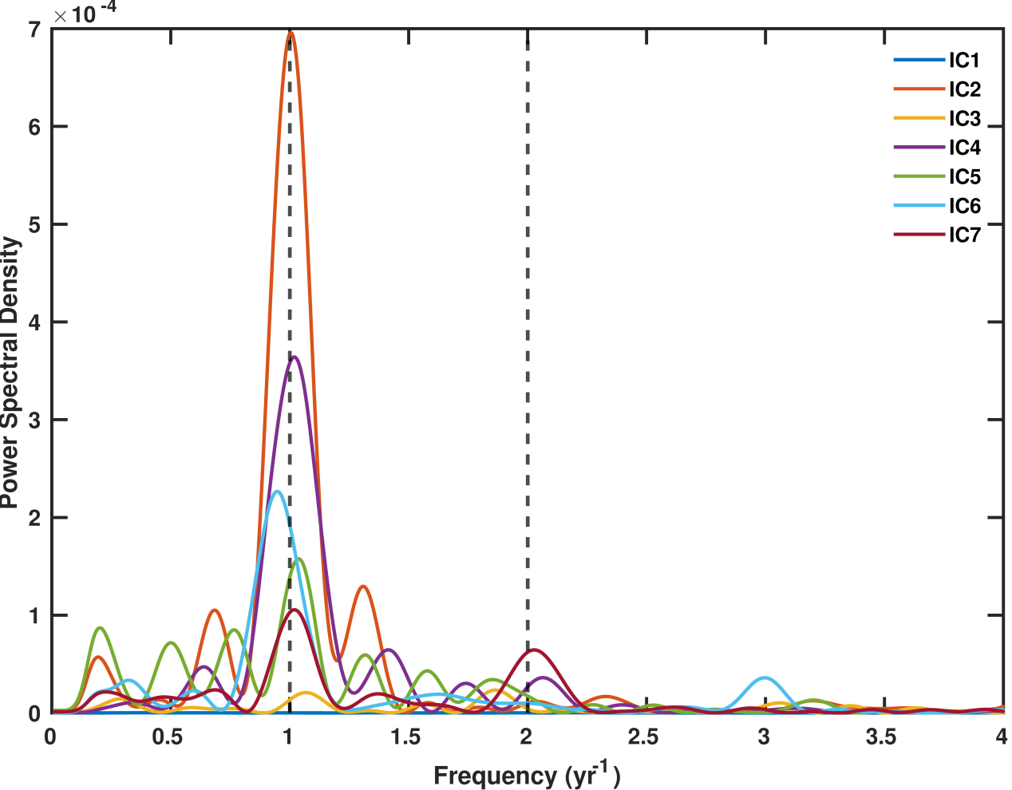
Fig. S15 Power spectral densities of the seven temporal functions (IC1-IC7) obtained from the joint three-component vbICA decomposition of the preprocessed GNSS position time series from the 19 continuous GNSS stations installed before the earthquake. The vertical dashed lines at 1 and 2 yr^-1 mark the annual and semiannual frequencies, respectively.

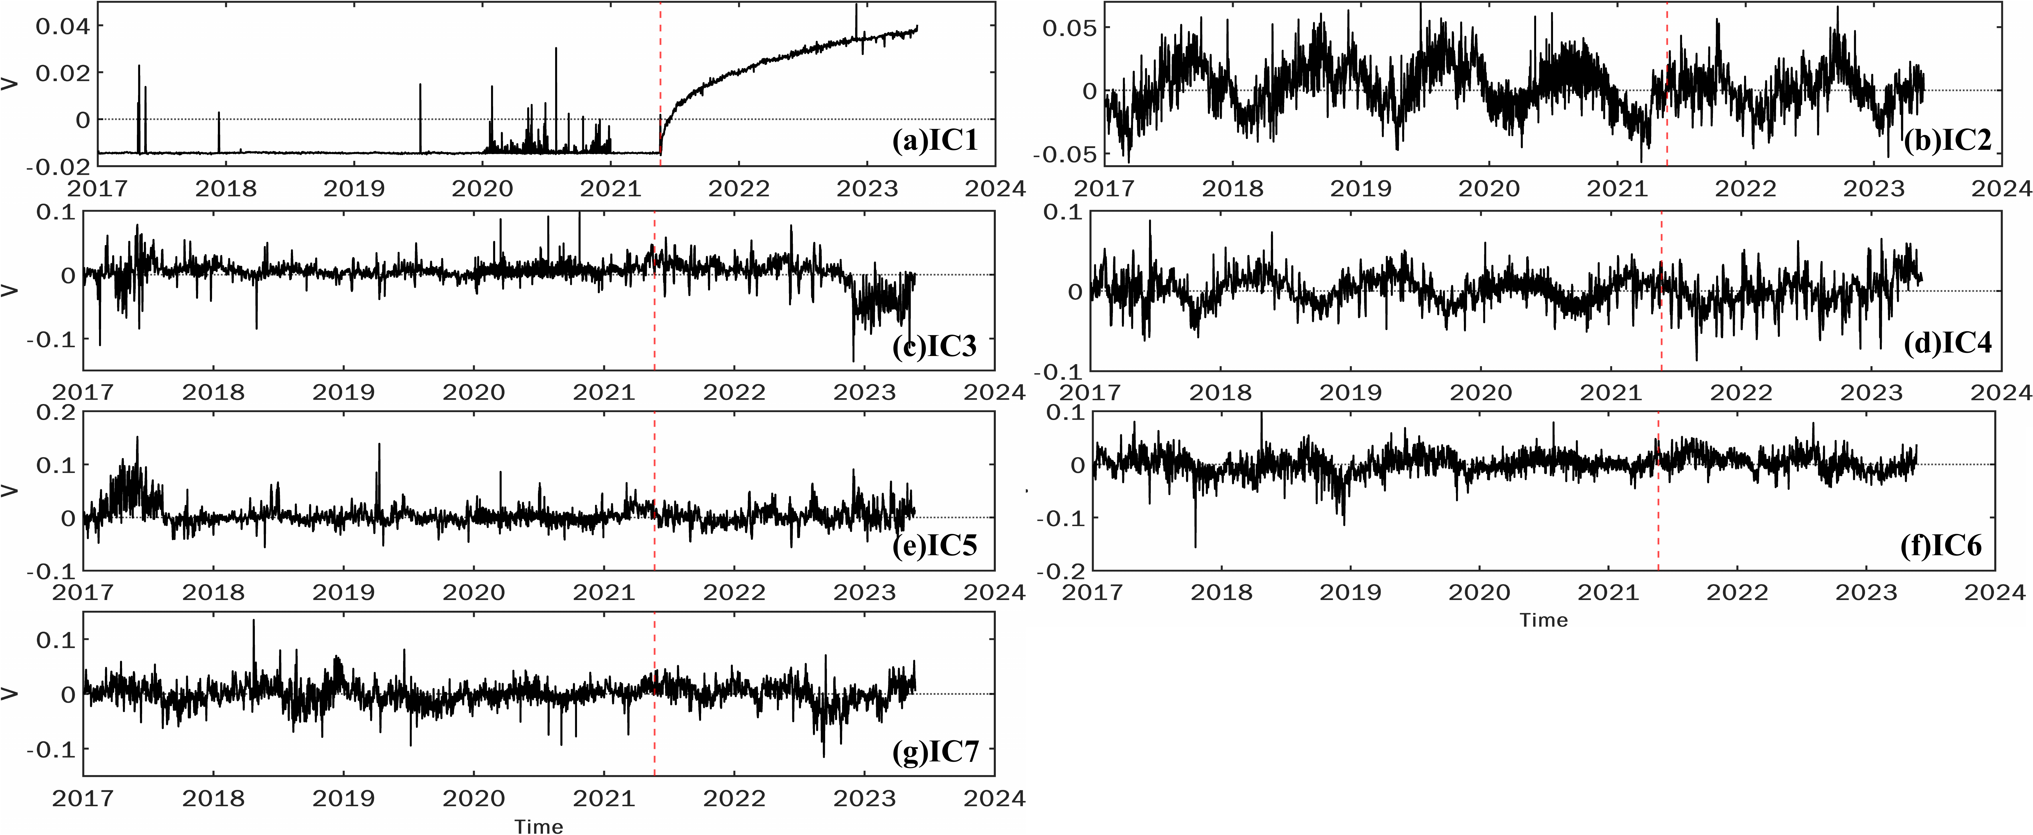
Fig. S16 Temporal functions of the seven independent components (IC1-IC7) obtained from the joint three-component vbICA decomposition of the preprocessed GNSS position time series spanning the pre-earthquake and postseismic intervals at the 19 continuous GNSS stations installed before the earthquake. Panels (a)-(g) show IC1-IC7, respectively. The vertical red dashed line marks the epoch of the 2021 Mw 7.4 Maduo earthquake. The temporal functions are dimensionless.

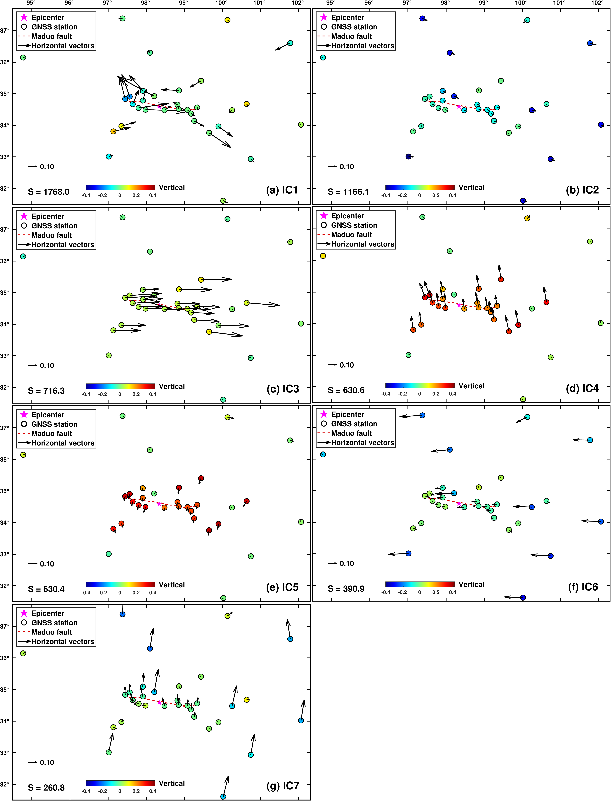
Fig. S17 Spatial responses of the seven independent components (IC1-IC7) shown in Fig. S16, obtained from the joint three-component vbICA decomposition of the preprocessed GNSS position time series at the 19 continuous GNSS stations installed before the earthquake. Panels (a)-(g) show the spatial responses of IC1-IC7, respectively. Arrows show horizontal spatial responses, and colour-coded circles show vertical spatial responses; the horizontal reference vector is given in each panel. The magenta star marks the epicentre of the 2021 Mw 7.4 Maduo earthquake, and the red dashed line denotes the mapped coseismic surface rupture. S is the component-specific scaling factor used to reconstruct station displacement time series and is expressed in millimetres.

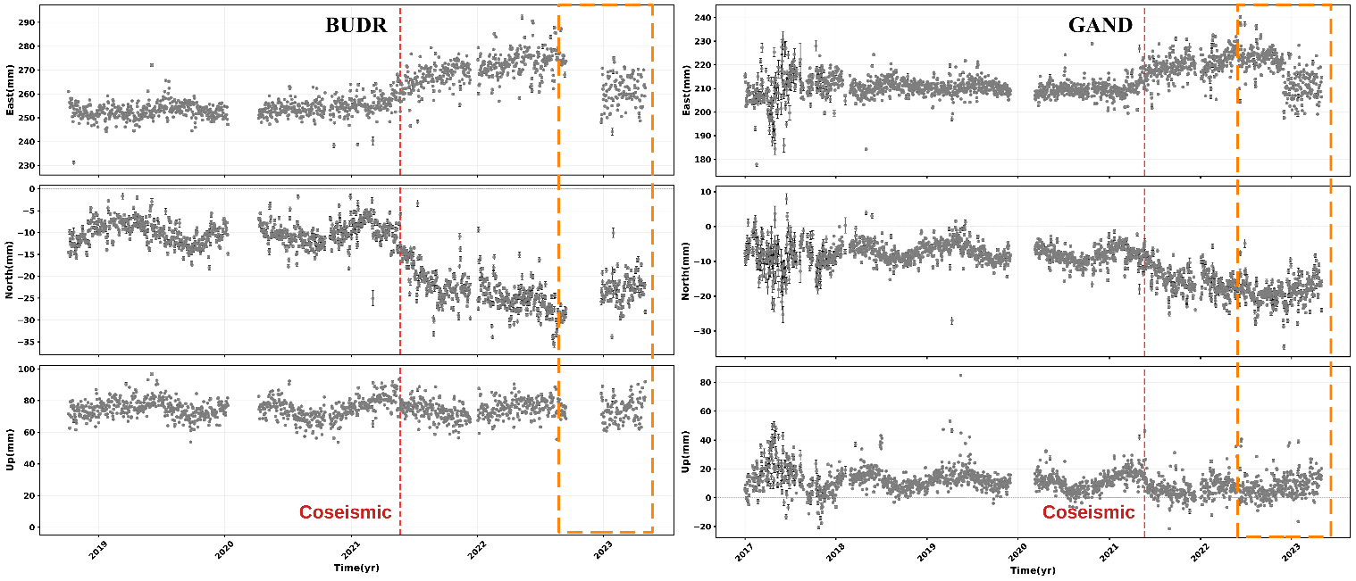
Fig. S18 GNSS coordinate time series at stations BUDR and GAND, illustrating postseismic data gaps in the station records. East, north, and vertical components are shown from top to bottom. The red dashed line marks the coseismic epoch of the 22 May 2021 Mw 7.4 Maduo earthquake. Orange dashed boxes delineate intervals without available GNSS observations.

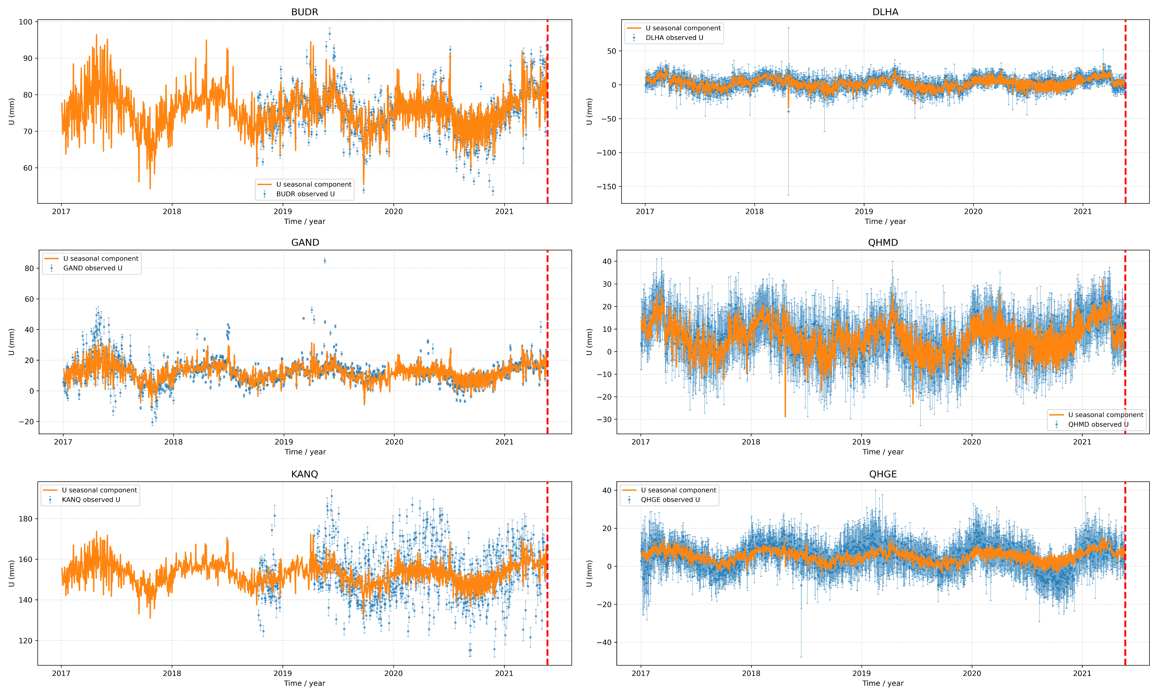
Fig. S19 Comparison of reconstructed seasonal displacement time series and detrended vertical GNSS observations at six representative stations. The seasonal displacement time series were reconstructed from the seasonal components identified by the initial separate vertical-component vbICA decomposition of the preprocessed GNSS position time series. Orange curves show the reconstructed vertical seasonal displacement time series, and blue symbols show the detrended vertical GNSS observations. The vertical red dashed line marks the epoch of the 2021 Mw 7.4 Maduo earthquake.

Table S1 Quantitative comparison of horizontal postseismic decay time series derived from joint three-component vbICA, single-component vbICA, and station-wise trajectory-model fitting
Station | Component | RMSE（mm） | Two-year cumulative displacement difference (|mm|) | Correlation coefficient
BUDR | E-Single Vs Joint | 1.41 | 0.12 | 0.9921
BUDR | E-Single Vs Fitting | 0.64 | 2.29 | 0.9870
BUDR | N-Single Vs Joint | 1.65 | 1.01 | 0.9828
BUDR | N-Single Vs Fitting | 0.82 | 0.72 | 0.9760
GAND | E-Single Vs Joint | 0.64 | 0.45 | 0.9921
GAND | E-Single Vs Fitting | 1.15 | 0.14 | 0.9872
GAND | N-Single Vs Joint | 0.59 | 0.55 | 0.9828
GAND | N-Single Vs Fitting | 2.58 | 2.48 | 0.9882
HSHX | E-Single Vs Joint | 1.23 | 1.23 | 0.9921
HSHX | E-Single Vs Fitting | 1.28 | 3.22 | 0.9881
HSHX | N-Single Vs Joint | 0.38 | 0.58 | 0.9828
HSHX | N-Single Vs Fitting | 0.31 | 0.14 | 0.9843
JDUO | E-Single Vs Joint | 2.98 | 2.87 | 0.9921
JDUO | E-Single Vs Fitting | 3.07 | 0.75 | 0.9872
JDUO | N-Single Vs Joint | 0.27 | 0.15 | 0.9828
JDUO | N-Single Vs Fitting | 1.15 | 1.18 | 0.9746
KANQ | E-Single Vs Joint | 0.70 | 0.81 | 0.9921
KANQ | E-Single Vs Fitting | 3.23 | 2.73 | 0.9879
KANQ | N-Single Vs Joint | 1.08 | 1.80 | 0.9828
KANQ | N-Single Vs Fitting | 1.72 | 0.09 | 0.9774
LAJA | E-Single Vs Joint | 0.15 | 0.35 | 0.9921
LAJA | E-Single Vs Fitting | 1.39 | 1.76 | 0.9807
LAJA | N-Single Vs Joint | 0.87 | 1.09 | 0.9828
LAJA | N-Single Vs Fitting | 1.55 | 1.80 | 0.9502
QHBM | E-Single Vs Joint | 0.24 | 0.75 | 0.9921
QHBM | E-Single Vs Fitting | 0.29 | 0.54 | 0.9826
QHBM | N-Single Vs Joint | 0.30 | 0.53 | 0.9828
QHBM | N-Single Vs Fitting | 0.34 | 0.59 | 0.9793
QHDL | E-Single Vs Joint | 0.46 | 0.41 | 0.9921
QHDL | E-Single Vs Fitting | 2.02 | 3.39 | 0.9347
QHDL | N-Single Vs Joint | 0.45 | 0.65 | 0.9828
QHDL | N-Single Vs Fitting | 1.10 | 1.69 | 0.9879
QHMD | E-Single Vs Joint | 2.76 | 1.03 | 0.9921
QHMD | E-Single Vs Fitting | 2.88 | 2.71 | 0.9881
QHMD | N-Single Vs Joint | 1.02 | 1.63 | 0.9828
QHMD | N-Single Vs Fitting | 1.72 | 0.30 | 0.9781
QHMQ | E-Single Vs Joint | 0.56 | 0.29 | 0.9921
QHMQ | E-Single Vs Fitting | 1.85 | 2.55 | 0.9762
QHMQ | N-Single Vs Joint | 0.22 | 0.16 | 0.9828
QHMQ | N-Single Vs Fitting | 1.43 | 2.14 | 0.9648
QSHE | E-Single Vs Joint | 1.25 | 0.13 | 0.9921
QSHE | E-Single Vs Fitting | 1.04 | 0.61 | 0.9850
QSHE | N-Single Vs Joint | 1.35 | 2.06 | 0.9828
QSHE | N-Single Vs Fitting | 0.57 | 0.63 | 0.9887
WENQ | E-Single Vs Joint | 0.89 | 0.46 | 0.9921
WENQ | E-Single Vs Fitting | 1.15 | 1.22 | 0.9876
WENQ | N-Single Vs Joint | 0.36 | 0.34 | 0.9828
WENQ | N-Single Vs Fitting | 1.07 | 0.53 | 0.9737

Quantitative Comparison of Horizontal Postseismic Time Series
The component-wise vbICA solutions were used as the reference for evaluating the three-component joint vbICA solutions and the fitted postseismic time series. The E and N components were evaluated separately. Before comparison, all time series were referenced to the earthquake epoch (t = 0, corresponding to decimal year 2021.389041) and expressed in millimeters.
For each pair of time series, the comparison was performed over their common post-event time interval, bounded by 0 and 730.5 days. Both curves were linearly interpolated onto a daily grid; when the final common epoch did not coincide with an integer day, that endpoint was also included. Three quantitative metrics were calculated: the root-mean-square error (RMSE), the difference in two-year cumulative displacement, and the Pearson correlation coefficient.
Notation. Let S_{i} denote the displacement from the component-wise vbICA solution at the ith daily epoch, and let C_{i} denote the corresponding displacement from either the three-component joint vbICA solution or the fitted postseismic time series. The total number of samples within the common interval is n.

Root-mean-square error
The RMSE measures the average amplitude difference between the reference and comparison time series:
$RMSE=\sqrt{\frac{1}{n}\sum_{i=1}^{n}{{\left(S_{i}-C_{i}\right)}^{2}}}$ (1)
A smaller RMSE indicates closer agreement in displacement amplitude between the two time series. The RMSE is reported in millimeters.

Difference in two-year cumulative displacement
The cumulative displacement over two years was calculated as the displacement change between the earthquake epoch and T = 730.5 days:
$D_{S}^{2yr}=S\left(T\right)-S\left(0\right)$ (2)
$D_{C}^{2yr}=C\left(T\right)-C\left(0\right)$ (3)
The signed difference in two-year cumulative displacement was then defined as
${ΔD}^{2yr}=D_{S}^{2yr}-D_{C}^{2yr}$ (4)
where the component-wise vbICA solution is the reference. A positive value indicates that the component-wise vbICA solution produces a more positive, or less negative, two-year displacement than the comparison curve, whereas a negative value indicates the opposite. To quantify the difference in displacement magnitude without regard to its sign, the absolute difference was also reported:
$\left|{ΔD}^{2yr}\right|=\left|D_{S}^{2yr}-D_{C}^{2yr}\right|$ (5)
The values at T = 730.5 days were obtained by linear interpolation when this epoch was not directly sampled. Linear extrapolation was permitted only when the end of a time series was within one day of the target epoch.

Pearson correlation coefficient
The similarity in temporal evolution between the two time series was evaluated using the Pearson correlation coefficient:
$r=\frac{\sum_{i=1}^{n}{\left(S_{i}-\overline{S}\right)\left(C_{i}-\overline{C}\right)}}{\left.\sqrt{\sum_{i=1}^{n}{{\left(S_{i}-\overline{S}\right)}^{2}}}\sqrt{\sum_{i=1}^{n}{{\left(C_{i}-\overline{C}\right)}^{2}}}\right.}$ (6)
Here, S̄ and C̄ are the mean displacements of the component-wise vbICA and comparison time series, respectively. Values of r close to 1 indicate highly consistent temporal evolution, whereas lower values indicate increasing differences in the shapes of the two curves. If either time series has zero variance over the comparison interval, r is undefined.

