Supplemental materials
Supplemental figures
- Supplemental Figure 1 Association of AIP and BRI and the risk of CHD incidence
- Supplemental Figure 2 Association of AIP and BRI and the risk of stroke incidence
- Supplemental Figure 3 Association of AIP and BRI and the risk of HF incidence
- Supplemental Figure 4 Restricted cubic spline plot of AIP、BRI and CHD
- Supplemental Figure 5 Restricted cubic spline plot of AIP、BRI and stroke
- Supplemental Figure 6 Restricted cubic spline plot of AIP、BRI and HF
- Supplemental Figure 7 The Fine-Gray competitive risk model
Supplemental Tables
- Supplemental Table 1 List of relevant codes
- Supplemental Table 2 Subgroup analysis for the association of the AIP on CVD risk
- Supplemental Table 3 Subgroup analysis for the association of the BRI on CVD risk
- Supplemental Table 4 E-values for outcomes
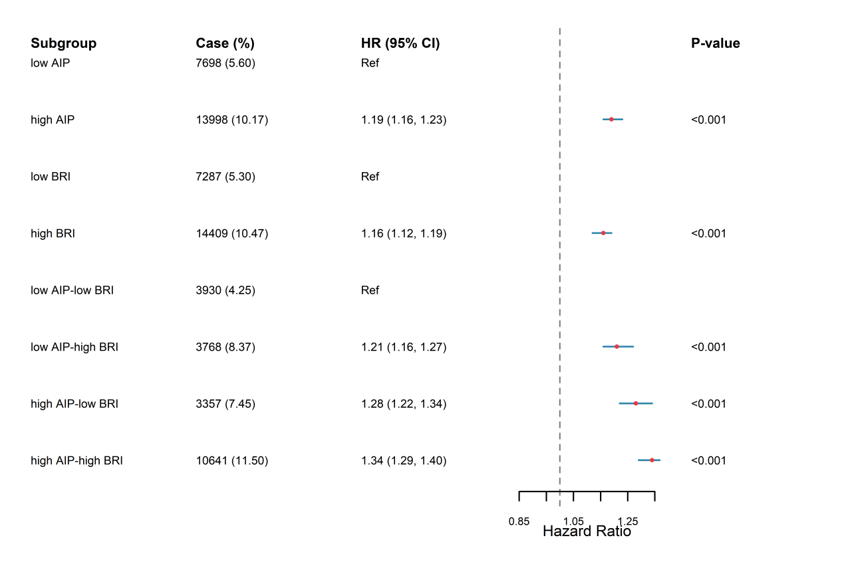
Supplemental Figure 1 Association of AIP and BRI and the risk of CHD incidence
Based on model3:adjusted for sex, age, ethnic background, qualifications, smoking status, alcohol intake frequency, SBP, DBP, hypertension, diabetes, TC, UA, CRP, IPAQ activity group, Townsend deprivation index at recruitment. The "low AIP" group referred to AIP ≤ median; the "high AIP" group referred to AIP > median; the "low BRI" group referred to BRI ≤ median; the "high BRI" group referred to BRI > median. The "low AIP + low BRI" group referred to AIP ≤ median and BRI ≤ median; the "low AIP + high BRI" group referred to AIP ≤ median and BRI > median; the "high AIP + low BRI" group referred to AIP > median and BRI ≤ median; the "high AIP + high BRI" group referred to AIP > median and BRI > median. Abbreviations: CHD: coronary heart disease; AIP: atherogenic index of plasma; BRI: body roundness index; CI: confidence interval
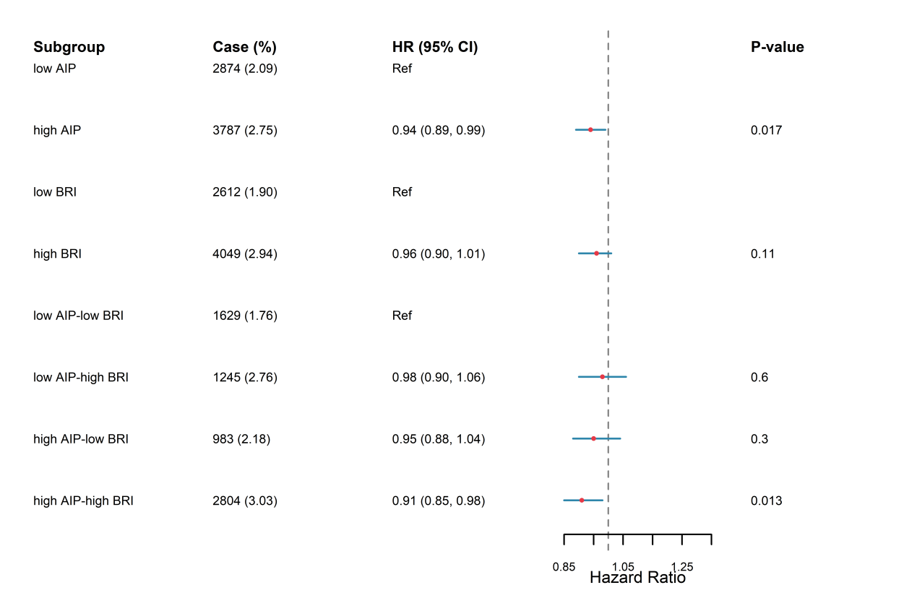
Supplemental Figure 2 Association of AIP and BRI and the risk of stroke incidence
Based on model3:adjusted for sex, age, ethnic background, qualifications, smoking status, alcohol intake frequency, SBP, DBP, hypertension, diabetes, TC, UA, CRP, IPAQ activity group, Townsend deprivation index at recruitment. The "low AIP" group referred to AIP ≤ median; the "high AIP" group referred to AIP > median; the "low BRI" group referred to BRI ≤ median; the "high BRI" group referred to BRI > median. The "low AIP + low BRI" group referred to AIP ≤ median and BRI ≤ median; the "low AIP + high BRI" group referred to AIP ≤ median and BRI > median; the "high AIP + low BRI" group referred to AIP > median and BRI ≤ median; the "high AIP + high BRI" group referred to AIP > median and BRI > median. Abbreviations: AIP: atherogenic index of plasma; BRI: body roundness index; CI: confidence interval
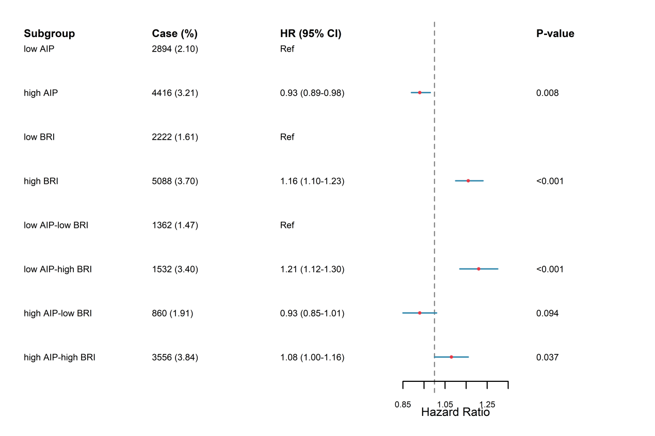
Supplemental Figure 3 Association of AIP and BRI and the risk of HF incidence
Based on model3:adjusted for sex, age, ethnic background, qualifications, smoking status, alcohol intake frequency, SBP, DBP, hypertension, diabetes, TC, UA, CRP, IPAQ activity group, Townsend deprivation index at recruitment. The "low AIP" group referred to AIP ≤ median; the "high AIP" group referred to AIP > median; the "low BRI" group referred to BRI ≤ median; the "high BRI" group referred to BRI > median. The "low AIP + low BRI" group referred to AIP ≤ median and BRI ≤ median; the "low AIP + high BRI" group referred to AIP ≤ median and BRI > median; the "high AIP + low BRI" group referred to AIP > median and BRI ≤ median; the "high AIP + high BRI" group referred to AIP > median and BRI > median. Abbreviations: HF: heart failure; AIP: atherogenic index of plasma; BRI: body roundness index; CI: confidence interval

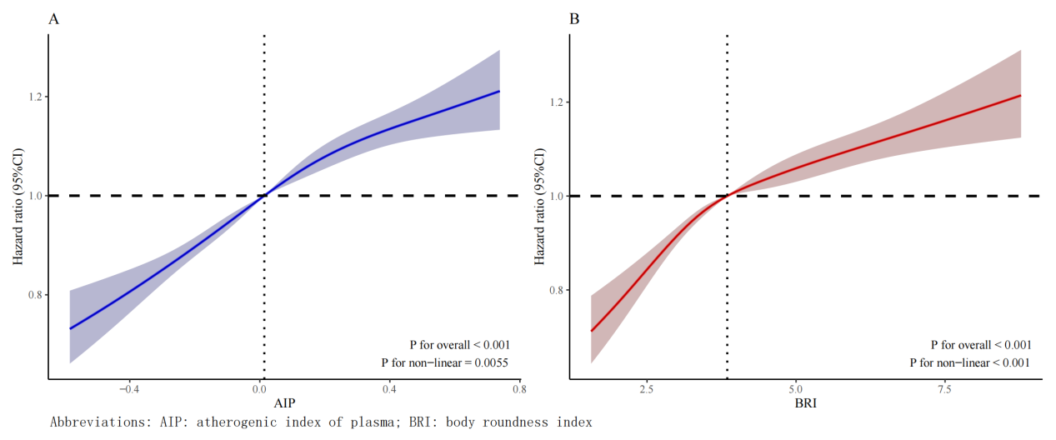
Supplemental Figure 4 Restricted cubic spline plot of AIP、BRI and CHD
Based on model3:adjusted for sex, age, ethnic background, qualifications, smoking status, alcohol intake frequency, SBP, DBP, hypertension, diabetes, TC, UA, CRP, IPAQ activity group, Townsend deprivation index at recruitment; (A) Association between AIP and CHD. (B) Association between BRI and CHD. Abbreviations: CHD: coronary heart disease; AIP: atherogenic index of plasma; BRI: body roundness index
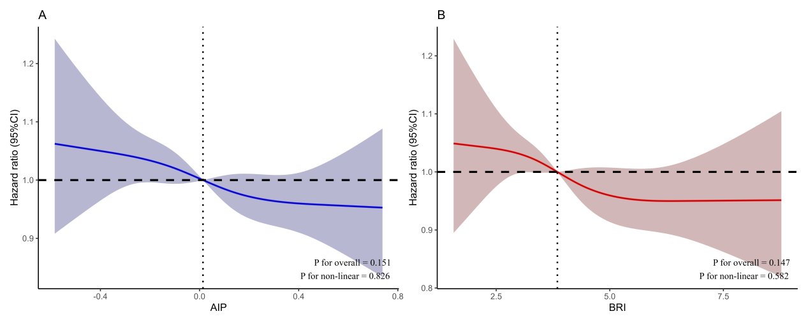
Supplemental Figure 5 Restricted cubic spline plot of AIP、BRI and stroke
Based on model3:adjusted for sex, age, ethnic background, qualifications, smoking status, alcohol intake frequency, SBP, DBP, hypertension, diabetes, TC, UA, CRP, IPAQ activity group, townsend deprivation index at recruitment; (A) Association between AIP and CHD. (B) Association between BRI and CHD. Abbreviations: AIP: atherogenic index of plasma; BRI: body roundness index
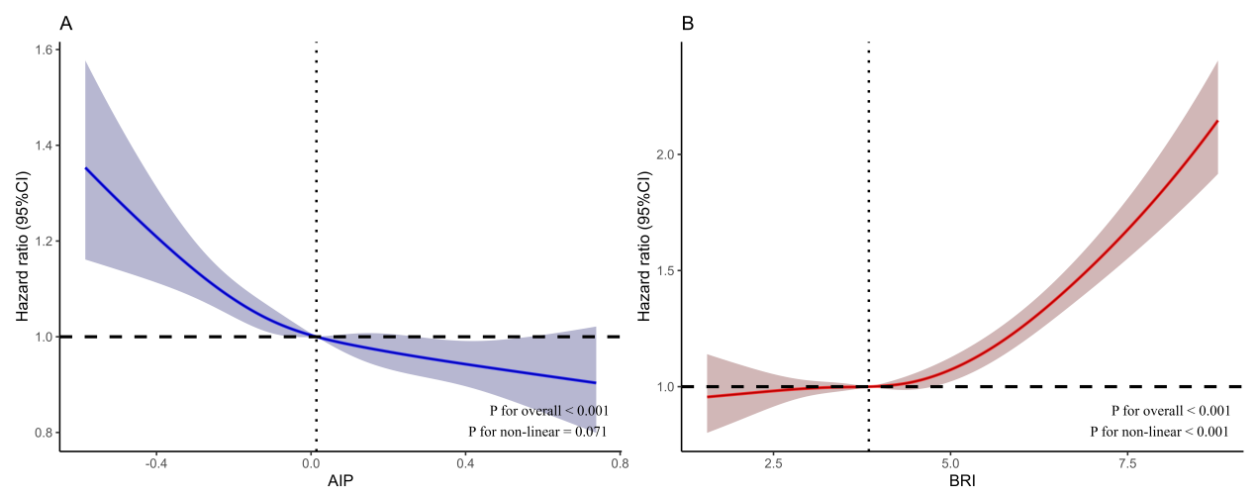
Supplemental Figure 6 Restricted cubic spline plot of AIP、BRI and HF
Based on model3:adjusted for sex, age, ethnic background, qualifications, smoking status, alcohol intake frequency, SBP, DBP, hypertension, diabetes, TC, UA, CRP, IPAQ activity group, Townsend deprivation index at recruitment; (A) Association between AIP and CHD. (B) Association between BRI and CHD. Abbreviations: HF: heart failure; AIP: atherogenic index of plasma; BRI: body roundness index
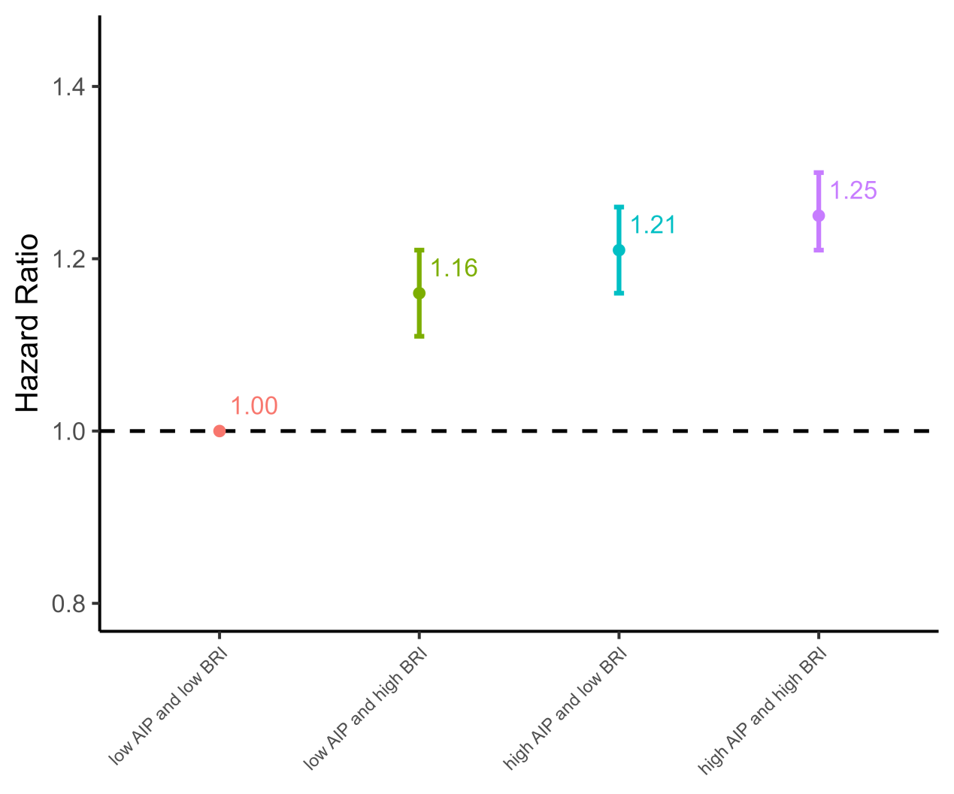
Supplemental Figure 7 The Fine-Gray competitive risk model
Based on model3:adjusted for sex, age, ethnic background, qualifications, smoking status, alcohol intake frequency, SBP, DBP, hypertension, diabetes, TC, UA, CRP, IPAQ activity group, Townsend deprivation index at recruitment. The "low AIP" group referred to AIP ≤ median; the "high AIP" group referred to AIP > median; the "low BRI" group referred to BRI ≤ median; the "high BRI" group referred to BRI > median. The "low AIP + low BRI" group referred to AIP ≤ median and BRI ≤ median; the "low AIP + high BRI" group referred to AIP ≤ median and BRI > median; the "high AIP + low BRI" group referred to AIP > median and BRI ≤ median; the "high AIP + high BRI" group referred to AIP > median and BRI > median. Abbreviations: CVD death: cardiovascular death; AIP: atherogenic index of plasma; BRI: body roundness index
Supplemental Table 1 List of relevant codes
Serial Number | Description | Field ID
1 | Age | 21022
2 | Sex | 31
3 | Ethnicity | 21000
4 | Educational attainment | 6138
5 | Physical activity | 22032
6 | Townsend Deprivation Index | 22189
7 | Smoking status | 20116
8 | Alcohol consumption frequency | 1558
9 | Height | 12144
10 | Waist circumference | 48
11 | SBP | 4080
12 | DBP | 4079
13 | Antidiabetic/antihypertensive/lipid-lowering medications | 6153,6177
14 | HbA1c | 30750
15 | TC | 26037
16 | TG | 23407
17 | HDL-C | 23410
18 | UA | 30880
19 | CRP | 30710
SBP: systolic blood pressure; DBP: diastolic blood pressure; HbA1c: Glycated haemoglobin TC: total cholesterol; TG: triglycerides; HDL-C: high-density lipoprotein cholesterol; UA: uric acid; CRP: C-reactive protein
Supplemental Table 2 Subgroup analysis for the association of the AIP on CVD risk
 | low AIP | high AIP | P for interaction
Age |  |  | <0.001
≤60 | Ref | 1.16 (1.12,1.21)
>60 | Ref | 1.04 (1.01,1.08)
Sex |  |  | 0.010
Female | Ref | 1.12 (1.07,1.16)
Male | Ref | 1.08 (1.04,1.11)
Ethnicbackground |  |  | 0.103
White | Ref | 1.15 (1.06,1.24)
Other ethnic group | Ref | 1.09 (1.06,1.12)
Qualifications |  |  | 0.050
no College or University degree | Ref | 1.09 (1.06,1.13)
College or University degree | Ref | 1.11 (1.06,1.16)
Smoking status |  |  | 0.001
No | Ref | 1.13 (1.09,1.17)
Prevous | Ref | 1.08 (1.04,1.12)
Current | Ref | 1.03 (0.96,1.11)
Hypertension |  |  | <0.001
No | Ref | 1.20 (1.13,1.27)
Yes | Ref | 1.07 (1.04,1.10)
Diabetes |  |  | 0.001
No | Ref | 1.11 (1.08,1.14)
Yes | Ref | 1.00 (0.94,1.07)
Based on model3:adjusted for sex, age, ethnic background, qualifications, smoking status, alcohol intake frequency, SBP, DBP, hypertension, diabetes, TC, UA, CRP, IPAQ activity group, Townsend deprivation index at recruitment. The "low AIP" group referred to AIP ≤ median; the "high AIP" group referred to AIP > median. Abbreviations: CVD: cardiovascular disease; AIP: atherogenic index of plasma; BRI: body roundness index
Supplemental Table 3 Subgroup analysis for the association of the BRI on CVD risk
 | low BRI | high BRI | P for interaction
Age |  |  | <0.001
≤60 | Ref | 1.17 (1.12,1.21)
>60 | Ref | 1.11 (1.08,1.15)
Sex |  |  | 0.075
Female | Ref | 1.11 (1.06,1.16)
Male | Ref | 1.11 (1.08,1.15)
Ethnicbackground |  |  | 0.221
White | Ref | 1.15 (1.06,1.25)
Other ethnic group | Ref | 1.11 (1.08,1.14)
Qualifications |  |  | 0.051
no College or University degree | Ref | 1.11 (1.07,1.14)
College or University degree | Ref | 1.12 (1.07,1.17)
Smoking status |  |  | 0.001
No | Ref | 1.12 (1.08,1.16)
Prevous | Ref | 1.13 (1.09,1.18)
Current | Ref | 1.04 (0.97,1.12)
Hypertension |  |  | <0.001
No | Ref | 1.15 (1.08,1.22)
Yes | Ref | 1.10 (1.07,1.13)
Diabetes |  |  | <0.001
No | Ref | 1.12 (1.09,1.15)
Yes | Ref | 1.00 (0.93,1.08)
Based on model3:adjusted for sex, age, ethnic background, qualifications, smoking status, alcohol intake frequency, SBP, DBP, hypertension, diabetes, TC, UA, CRP, IPAQ activity group, Townsend deprivation index at recruitment. The "low BRI" group referred to BRI ≤ median; the "high BRI" group referred to BRI > median. Abbreviations: CVD: cardiovascular disease; AIP: atherogenic index of plasma; BRI: body roundness index
Supplemental Table 4 E-values for outcomes
 | HR | (95% CI) | E-value | E-value lower
AIPBRI
low AIP and low BRI | Ref |  | Ref
low AIP and high BRI | 1.16 | (1.12,1.20) | 1.59 | 1.49
high AIP and low BRI | 1.15 | (1.14,1.20) | 1.57 | 1.54
high AIP and high BRI | 1.20 | (1.16,1.24) | 1.69 | 1.59
The "low AIP + low BRI" group referred to AIP ≤ median and BRI ≤ median; the "low AIP + high BRI" group referred to AIP ≤ median and BRI > median; the "high AIP + low BRI" group referred to AIP > median and BRI ≤ median; the "high AIP + high BRI" group referred to AIP > median and BRI > median. Abbreviations: AIP: atherogenic index of plasma; BRI: body roundness index; CI: confidence interval

